Supplement to the 6th Edition (2017) Florida Building Code, Residential

Note 1: Throughout the document, change International Building Code to Florida Building Code, Building; change the International Energy Conservation Code to the Florida Building Code, Energy Conservation; change the International Existing Building Code to Florida Building Code, Existing Building; change the International Fire code to Florida Fire Prevention Code; change International Fuel Gas Code to Florida Building Code, Fuel Gas; change the International Mechanical Code to Florida Building Code, Mechanical; change the International Plumbing Code to Florida Building Code, Plumbing; change the International Residential Code to Florida Building Code, Residential.

Chapter 1 SCOPE AND ADMINISTRATION

No change

Chapter 2 DEFINITIONS

SECTION 202 DEFINITIONS

Revise as follows:

ACCESSIBLE. Signifies access that requires the removal of an access panel or similar removable obstruction.

ACCESS (TO) That which enables a device, appliance or equipment to be reached by ready access or by a means that first requires the removal or movement of a panel, door or similar obstruction.

ACCESSIBLE, READILY. Signifies access without the necessity for removing a panel or similar obstruction.

READY ACESS (TO) That which enables a device, appliance or equipment to be directly reached, without requiring the removal or movement of any panel, door or similar obstruction.

Revise as follows:

CLEANOUT. An accessible opening in the drainage system used for the removal of possible obstruction and located to allow for access.

FIXTURE FITTING.
Supply fitting. A fitting that controls the volume or directional flow or both of water and that is either attached to or accessible is accessed from a fixture or is used with an open or atmospheric discharge. Waste fitting. A combination of components that conveys the sanitary waste from the outlet of a fixture to the connection of the sanitary drainage system.
(RB2-16)

FULL-OPEN VALVE. A water control or shut off component in the water supply system piping that, where adjusted for maximum flow, the flow path through the component's closure member is not a restriction in the component's through-flow area.
(P3-15)

BATTERY SYSTEM, STATIONARY STORAGE. A rechargeable energy storage system consisting of electrochemical storage batteries, battery chargers, controls, and associated electrical equipment designed to provide electrical power to a building. The system is typically used to provide standby or emergency power, an uninterruptable power supply, load shedding, load sharing or similar capabilities.
(RB171-16 AM)

[BS]DRILLEDSHAFT. A cast-in-place deep foundation element ,also referred to as caisson, drilled pier, and bored pile, constructed by drilling a hole (with or without permanent casing or drilling fluid) into soil or rock and filling it with fluid concrete after the drilling equipment is removed.

Socketed drilled shaft. A drilled shaft with a permanent pipe or tube casing that extends down to bedrock and an uncased socket drilled into the bedrock.
(S7605)

[RB] LABELED. Equipment, materials or products to which have been affixed a label, seal, symbol or other identifying mark of a nationally recognized testing laboratory, inspection approved agency or other organization concerned with product evaluation that maintains periodic inspection of the production of the above labeled items and whose labeling indicates either that the equipment, material or product meets identified standards or has been tested and found suitable for a specified purpose.
(CA7691)/(I-Code)

[RB]LIGHT-FRAME CONSTRUCTION. A type of c Construction with whose vertical and horizontal structural elements that are primarily formed by a system of repetitive wood or cold-formed steel framing members.
(S7478)/(I-Code)/(G2-16 Part II)

BUILDING-INTEGRATED PHOTOVOLTAIC ROOF PANEL. A photovoltaic panel that functions as a component of the building envelope.
(R8177)/(I-Code)

VAPOR DIFFUSION PORT. An assembly constructed or installed within a roof assembly at an opening in the roof deck to convey water vapor from an unvented attic to the outside atmosphere.

(S8329)

VAPOR PERMEABLE MEMBRANE. The property of having a moisture vapor permeance rating of 5 perms (2.9 × 10¹⁰ kg/Pa x s x m²) or greater , when tested in accordance with the desiccant method using Procedure A or Procedure B of ASTM E96. A vapor permeable material permits the passage of moisture vapor.
(7606 A1 Only) Move to building

FENESTRATION. Skylights, roof windows, vertical windows (fixed or moveable), opaque doors, glazed doors, glazed block and combination opaque/glazed doors. Fenestration includes products with glass and nonglass glazing materials.

FENESTRATION. Products classified as either vertical fenestration or skylights and sloped glazing, installed in such a manner as to preserve the weather resistant barrier of the wall or roof in which they are installed. Fenestration includes products with glass or other transparent or translucent materials.

FENESTRATION, VERTICAL. Windows that are fixed or movable, opaque doors, glazed doors, glazed block and combination opaque and glazed doors installed in a wall at less than 15 degrees from vertical.
(S7504 G1)/(I-Code)

BALANCED VENT ILAT ION. Any combination of concurrently operating mechanical exhaust and mechanical supply whereby the total mechanical exhaust airflow rate is within 10% of the total mechanical supply airflow rate.
(M8152 A1 only)

Chapter 3 BUILDING PLANNING

Revise as follows:

R301.2.1 Wind design criteria.

Buildings and portions thereof shall be constructed in accordance with the wind provisions of this code using the ultimate design wind speed in Table R301.2(1) as determined from Figure R301.2(4). Where different construction methods and structural materials are used for various portions of a building, the applicable requirements of this section for each portion shall apply. Where not otherwise specified, the wind loads listed in Table R301.2(2) adjusted for height and exposure using Table R301.2(3) shall be used to determine design load performance requirements for wall coverings, curtain walls, roof coverings, exterior windows, skylights, and exterior doors (other than garage doors). Where loads for garage doors are not otherwise specified, the loads listed in Table R301.2(4) adjusted for height and exposure using Table R301.2(3) shall be used to determine design load performance requirements. Asphalt shingles shall be designed for wind speeds in accordance with Section R905.2.4. Metal roof shingles shall be designed for wind speeds in accordance with Section R905.4.4. A continuous load path shall be provided to transmit the applicable uplift forces from the roof assembly to the foundation.
(R7967 A2+Original)

R301.2.1.1Wind limitations and wind design required. The prescriptive provisions of this code for wood construction, cold-formed steel light-frame construction, and masonry construction shall not apply to the design of buildings where the ultimate design wind speed, V_{ult}, from Figure R301.2(4) equals or exceeds 115 miles per hour (51 m/s). The prescriptive provisions of this code include the sizing and attachment requirements specified in Sections R502, R503, R505, R602, R603, R606, R802 and R804.

Exceptions:
1.For concrete construction, the wind provisions of this code shall apply in accordance with the limitations of Sections R401, R402, R404 and R608.
2.For structural insulated panels, the wind provisions of this code shall apply in accordance with the limitations of Section R610.
3.Roof sheathing shall be installed in accordance with Section R803.

In regions where the ultimate design wind speed, V_{ult}, from Figure R301.2(4) equals or exceeds 115 miles per hour (51 m/s), the design of concrete, masonry, wood, and steel buildings for wind loads shall be in accordance with one or more of the following methods:

1. AF&PA Wood Frame Construction Manual (WFCM).
2. Concrete and masonry walls are permitted to be designed in accordance with ICC Standard for Residential Construction in High-Wind Regions (ICC 600).
3. ASCE Minimum Design Loads for Buildings and Other Structures (ASCE 7).
4. AISI Standard for Cold-Formed Steel Framing— Prescriptive Method For One- and Two-Family Dwellings (AISI S230.
5. Florida Building Code, Building; or
6. The MAF Guide to Concrete Masonry Residential Construction in High Wind Areas shall be permitted for applicable concrete masonry buildings for a basic wind speed of 130 mph (58 m/s) or less in Exposure B and 110 mph (49 m/s) or less in Exposure C in accordance with Figure R301.2(4) as converted in accordance with R301.2.1.3.

Exceptions:

1. Footings and foundations shall comply with Chapter 4.
2. Exterior windows and doors shall comply with Section R609.
3. For structural insulated panels, the provisions of this code apply in accordance with the limitations of Section R610.
4. Exterior wall coverings and soffits shall comply with Chapter 7
5. Roof sheathing shall be attached in accordance with Section R803.
6. Roof coverings shall comply with Chapter 9.
7. For concrete construction, the provisions of this code apply in accordance with the limitations of Section R608.2.

The elements of design not addressed by the methods in Items 1 through 6 shall be in accordance with the provisions of this code.
(R8144 A2+A3+Original)

Delete Table R301.2(2) in its entirety:

TABLE R301.2(2)
COMPONENT AND CLADDING LOADS FOR A BUILDING WITH A MEAN
ROOF HEIGHT OF 30 FEET LOCATED IN EXPOSURE B (ASD) (psf)^{a, b, c, d, e, f}

(table values not shown for brevity)

For SI: 1 foot = 304.8 mm, 1 square foot = 0.0929 m2, 1 mile per hour = 0.447 m/s, 1 pound per square foot = 0.0479 kPa.
a. The effective wind area shall be equal to the span length multiplied by an effective width. This width shall be permitted to be not less than one-third the span
length. For cladding fasteners, the effective wind area shall not be greater than the area that is tributary to an individual fastener.
b. For effective areas between those given, the load shall be interpolated or the load associated with the lower effective area shall be used.
c. Table values shall be adjusted for height and exposure by multiplying by the adjustment coefficient in Table R301.2(3).
d. See Figure R301.2(7) for location of zones.
e. Plus and minus signs signify pressures acting toward and away from the building surfaces.
f. Table values have been multiplied by 0.6 to convert component and cladding pressures to ASD.

Add new Table R301.2(2) as follows:
TABLE R301.2(2)
COMPONENT AND CLADDING LOADS FOR A BUILDING WITH A MEAN
ROOF HEIGHT OF 30 FEET LOCATED IN EXPOSURE B (ASD) (psf)^{a, b, c, d, e, f}

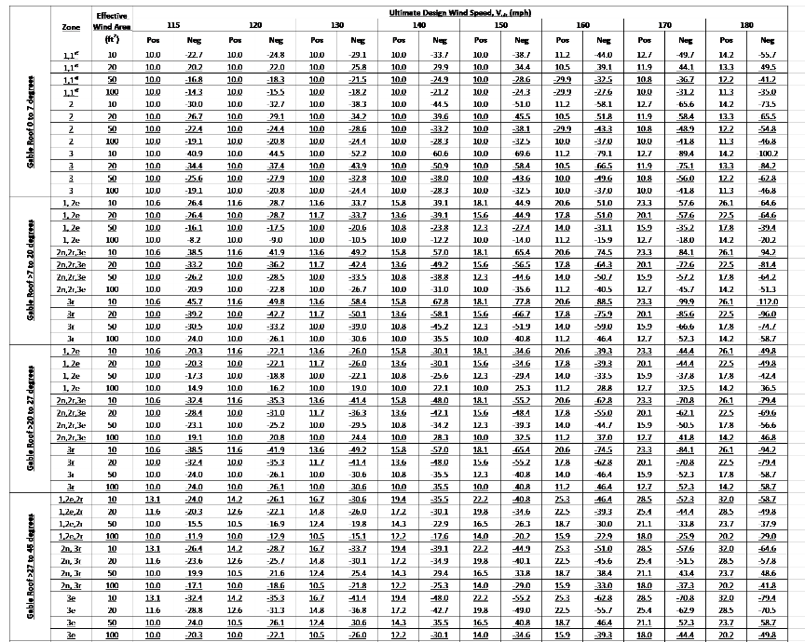
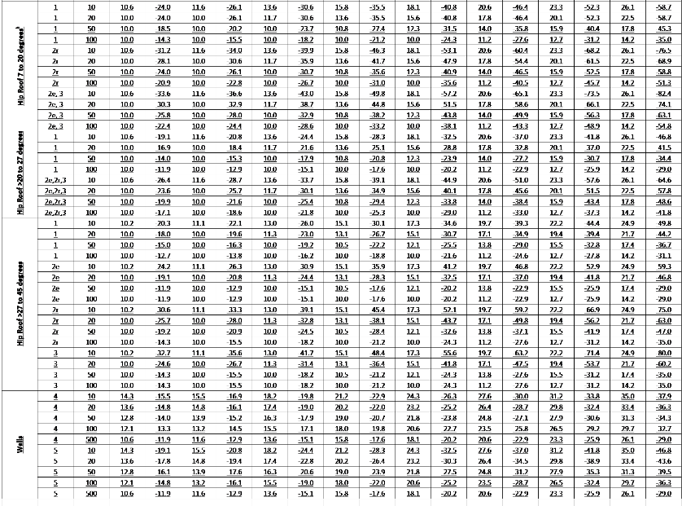

For SI: 1 foot = 304.8 mm, 1 square foot = 0.0929 m2, 1 mile per hour = 0.447 m/s, 1 pound per square foot = 0.0479 kPa.

a. The effective wind area shall be equal to the span length multiplied by an effective width. This width shall be permitted to be not less than one-third the span
length. For cladding fasteners, the effective wind area shall not be greater than the area that is tributary to an individual fastener.
b. For effective areas between those given, the load shall be interpolated or the load associated with the lower effective area shall be used.
c. Table values shall be adjusted for height and exposure by multiplying by the adjustment coefficient in Table R301.2(3).
d. See Figure R301.2(7) for location of zones.
e. Plus and minus signs signify pressures acting toward and away from the building surfaces.
f. Table values have multiplied by 0.6 to convert component and cladding pressures to ASD.
g. Loads in Zone 1’ are permitted to be determined in accordance with ASCE 7.
h. Where the ratio of the building mean roof height to length or width is less than 0.8, uplift loads are permitted to be determined in accordance with ASCE 7.

TABLE R301.2(3)
HEIGHT AND EXPOSURE ADJUSTMENT COEFFICIENTS FOR TABLE R301.2(2)
MEAN ROOF HEIGHT (ft) | EXPOSURE CATEGORY
 | B | C | D
15 | 0.82 1.00 | 1.21 | 1.47
20 | 0.89 1.00 | 1.29 | 1.55
25 | 0.94 1.00 | 1.35 | 1.61
30 | 1.00 | 1.40 | 1.66
35 | 1.05 | 1.45 | 1.70
40 | 1.09 | 1.49 | 1.74
45 | 1.12 | 1.53 | 1.78
50 | 1.16 | 1.56 | 1.81
55 | 1.19 | 1.59 | 1.84
60 | 1.22 | 1.62 | 1.97
Delete Figure R301.2(7) in its entirety:

(figure not shown for brevity)

For SI: 1 foot = 304.8 mm, 1 degree = 0.0175 rad.
Note: a = 4 feet in all cases.

FIGURE R301.2(7)
COMPONENT AND CLADDING PRESSURE ZONES

Add new Figure R301.2(7) as follows:

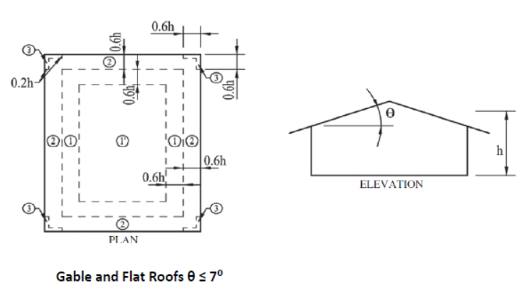

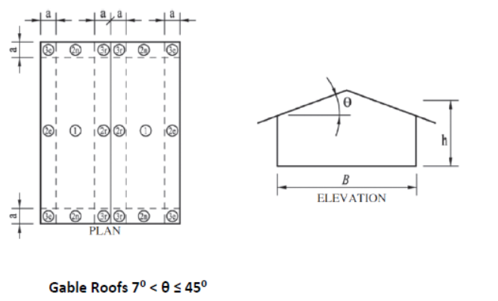

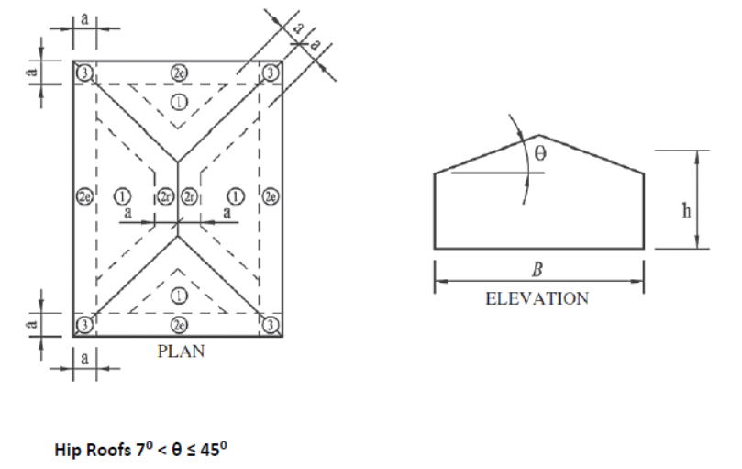

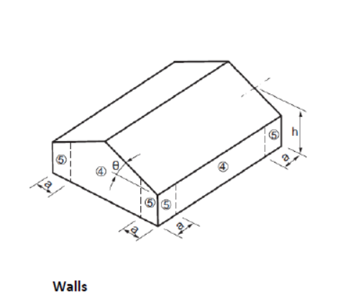

For SI: 1 foot = 304.8 mm, 1 degree = 0.0175 rad.
Note: a = 4 feet in all cases.

FIGURE R301.2(7)
COMPONENT AND CLADDING PRESSURE ZONES
(S7262)

TABLE R301.2(4)
NOMINAL (ASD) GARAGE DOOR WIND LOADS FOR A BUILDING WITH A MEAN ROOF HEIGHT OF 30 FEET LOCATED IN EXPOSURE B (PSF) 1,2,3,4,5

Door Size |  | ULTIMATE DESIGN WIND SPEED (Vult) DETERMINED IN ACCORDANCE WITH SECTION R301.2.1 (MPH-3 SECOND GUST)
Width(ft) | Height(ft) | 100 mph |  | 110 mph |  | 120 mph |  | 130 mph |  | 140 mph |  | 150 mph |  | 160 mph |  | 170 mph |  | 180 mph |  | 190 mph |  | 200 mph
9 | 7 | +9.610.0 | -10.9 | +11.4 | -12.9 | +13.7 | -15.5 | +16.1 | -18.2 | +18.5 | -20.9 | +21.3 | -24.1 | +24.3 | -27.5 | +27.6 | -31.2 | +30.6 | -34.6 | +34.2 | -38.6 | +38.0 | -43.0
16 | 7 | +9.210.0 | -10.3 | +10.9 | -12.2 | +13.1 | -14.6 | +15.5 | -17.2 | +17.7 | -19.7 | +20.4 | -22.7 | +23.3 | -26.0 | +26.4 | -29.4 | +29.3 | -32.6 | +32.7 | -36.5 | +36.4 | -40.6
78 mph |  | 85 mph |  | 93 mph |  | 101 mph |  | 108 mph |  | 116 mph |  | 124 mph |  | 132 mph |  | 139 mph |  | 147 mph |  | 155 mph
Nominal Design Wind Speed (Vasd) converted from Vult per Section R301.2.1.3

For SI: 1 foot = 304.8 mm, 1 mile per hour = 1.609 km/h, 1 psf = 47.88 N/m2.

1.For door sizes or wind speeds between those given above the load may be interpolated, otherwise use the load associated with the lower door size.

2.Table values shall be adjusted for height and exposure by multiplying by the adjustment coefficient in Table R301.2(3). Minimum positive wind load shall be 10 PSF and minimum negative wind load shall be 10 PSF.

3.Plus and minus signs signify pressures acting toward and away from the building surfaces.

4.Negative pressures assume door has 2 feet of width in building's end zone.

5.Table values include the 0.6 load reduction factor.
(S7616)

R301.2.4 Floodplain construction. Buildings and structures constructed in whole or in part in flood hazard areas (including A or V Zones) as established in Table R301.2(1), and substantial improvement and restoration repair of substantial damage of buildings and structures in flood hazard areas, shall be designed and constructed in accordance with Section R322. Buildings and structures that are located in more than one flood hazard area shall comply with the provisions associated with the most restrictive
flood hazard area. Buildings and structures located in whole or in part in identified floodways shall be designed and constructed in accordance with ASCE 24
(ADM 72-16)

TABLE R301.5
MINIMUM UNIFORMLY DISTRIBUTED LIVE LOADS (in pounds per square foot)
USE | LIVE LOAD
Uninhabitable attics without storage^{b} | 10
Uninhabitable attics with limited storage^{b,g} | 20
Habitable attics and attics served with fixed stairs | 30
Balconies (exterior) and decks^{e} | 40
Fire escapes | 40
Guards and handrails^{d} | 200^{h}
Guard in-fill components^{t} | 50^{h}
Passenger vehicle garagesª | 50ª
Rooms other than sleeping rooms | 40
Sleeping rooms | 30
Stairs | 40^{c}
For SI: 1 pound per square foot = 0.0479 kPa, 1 square inch = 645 mm ² ,1 pound = 4.45 N.

a. Elevated garage floors shall be capable of supporting a 2,000-pound load applied over a 20-square-inch area.
b. Uninhabitable attics without storage are those where the clear height between joists and rafters is not more than 42 inches, or where there are not two or more adjacent trusses with web configurations capable of accommodating an assumed rectangle 42 inches in height by 24 inches in width, or greater, within the plane of the trusses. This live load need not be assumed to act concurrently with any other live load requirements.
c. Individual stair treads shall be designed for the uniformly distributed live load or a 300-pound concentrated load acting over an area of 4 square inches, whichever produces the greater stresses.
d. A single concentrated load applied in any direction at any point along the top.
e. See Section R507.1 for decks attached to exterior walls .
f. Guard in-fill components (all those except the handrail), balusters and panel fillers shall be designed to withstand a horizontally applied normal load of 50 pounds on an area equal to 1 square foot. This load need not be assumed to act concurrently with any other live load requirement.
g. Uninhabitable attics with limited storage are those where the clear height between joists and rafters is not greater than 42 inches, or where there are two or more adjacent trusses with web configurations capable of accommodating an assumed rectangle 42 inches in height by 24 inches in width, or greater, within the plane of the trusses. The live load need only be applied to those portions of the joists or truss bottom chords where all of the following conditions are met:
1. The attic area is accessible accessed from an opening not less than 20 inches in width by 30 inches in length that is located where the clear height in the attic is not less than 30 inches.
2. The slopes of the joists or truss bottom chords are not greater than 2 inches vertical to 12 units horizontal.
3. Required insulation depth is less than the joist or truss bottom chord member depth.
The remaining portions of the joists or truss bottom chords shall be designed for a uniformly distributed concurrent live load of not less than 10 pounds per square foot.
h. Glazing used in handrail assemblies and guards shall be designed with a safety factor of 4. The safety factor shall be applied to each of the concentrated loads applied to the top of the rail, and to the load on the in-fill components. These loads shall be determined independent of one another, and loads are assumed not to occur with any other live load.

R302.1 Exterior walls. Construction, projections, openings and penetrations of exterior
walls of dwellings and accessory buildings shall comply with Table R302.1(1); or dwellings equipped throughout with an automatic sprinkler system installed in accordance with Section P2904 shall comply with Table R302.1(2).

Exceptions:

1. Walls, projections, openings or penetrations in walls perpendicular to the line used to determine the fire separation distance.

2. Walls of dwellings individual dwelling units and their accessory structures located on the same lot.

3. Detached tool sheds and storage sheds, playhouses and similar structures exempt from permits are not required to provide wall protection based on location on the lot. Projections beyond the exterior wall shall not extend over the lot line.

4. Detached garages accessory to a dwelling located within 2 feet (610 mm) of a lot line are permitted to have roof eave projections not exceeding 4 inches (102mm).

5. Foundation vents installed in compliance with this code are permitted.
(F7539)/(I-Code)

TABLE R302.1 EXTERIOR WALLS
 | EXTERIOR WALL ELEMENT |  | MINIMUM  FIRE-RESISTANCE RATING | MINIMUM FIRE SEPARATION DISTANCE
 | Walls | Fire-resistance rated | 1 hour—tested in accordance with ASTM E 119 or UL 263 with exposure from outside or calculated per Florida Building Code-Building | 0 feet
 |  | Not fire-resistance rated | 0 hours | 3 feetª
 | Projections | Not allowed | N/A | < 2 feet
 |  | Fire-resistance rated | 1 hour on the underside, or heavy timber, or fire-retardant-  treated wood.^{b, c} | 2 feetª
 |  | Not fire-resistance rated | 0 hours | 3 feet
 | Openings in walls | Not allowed | N/A | < 3 feet
 |  | Unlimited | 0 hours | 3 feetª
 | Penetrations | All | Comply with Section R302.4 | < 3 feet
 |  |  | None required | 3 feetª
For SI: 1 foot = 304.8 mm.
N/A = Not Applicable.
a. For residential subdivisions where all dwellings are equipped throughout with an automatic sprinkler system installed in accordance with Section P2904, the fire separation distance for nonrated exterior walls and rated projections shall be permitted to be reduced to 0 feet, and unlimited unprotected openings and penetrations shall be permitted, where the adjoining lot provides an open setback yard that is 6 feet or more in width on the opposite side of the property line.
b. The roof eave fire-resistanceratingshallbepermittedtobereducedto0hoursontheundersideoftheeaveiffireblockingisprovidedfromthewalltopplatetotheundersideofthe roof sheathing.
c. The roof eave fire-resistance rating shall be permitted to be reduced to 0 hours on the underside of the eave provided that gable vent openings are not installed.
(F7957)/(I-Code)

R302.3 Two-family dwellings.Dwelling units in two-family dwellings shall be separated from each other by wall and floor assemblies having not less than a 1-hour fire-resistance rating where tested in accordance with ASTM E 119 or, UL 263 or in accordance with Section 722 703.3 of the Florida Building Code-Building. Fire-resistance-rated floor/ceiling and wall assemblies shall extend to and be tight against the exterior wall, and wall assemblies shall extend from the foundation to the underside of the roof sheathing.

Exceptions: No change to existing text.
(F7810 A1+Original)/(I-Code)

R302.4.2 Membrane penetrations. Membrane penetrations shall comply with Section R302.4.1. Where walls are required to have a fire-resistance rating, recessed fixtures shall be installed so that the required fire-resistance rating will not be reduced.

Exceptions:

1. Membrane penetrations of not more than 2-hour fire-resistance-rated walls and partitions by steel electrical boxes that do not exceed 16 square inches (0.0103 m2) in area provided that the aggregate area of the openings through the membrane does not exceed 100 square inches (0.0645 m2) in any 100 square feet (9.29 m2) of wall area. The annular space between the wall membrane and the box shall not exceed 1/8 inch (3.1 mm). Such boxes on opposite sides of the wall shall be separated by one of the following:
1.1. By a horizontal distance of not less than 24 inches (610 mm) where the wall or partition is constructed with individual noncommunicating stud cavities.
1.2. By a horizontal distance of not less than the depth of the wall cavity where the wall cavity is filled with cellulose loose-fill, rockwool or slag mineral wool insulation.
1.3. By solid fire blocking in accordance with Section R302.11.
1.4. By protecting both boxes with listed putty pads.
1.5. By other listed materials and methods.
2. Membrane penetrations by listed electrical boxes of any materials provided that the boxes have been tested for use in fire-resistance-rated assemblies and are installed in accordance with the instructions included in the listing. The annular space between the wall membrane and the box shall not exceed 1/8 inch (3.1 mm) unless listed otherwise. Such boxes on opposite sides of the wall shall be separated by one of the following:
2.1. By the horizontal distance specified in the listing of the electrical boxes.
2.2. By solid fireblocking in accordance with Section R302.11.
2.3. By protecting both boxes with listed putty pads.
2.4. By other listed materials and methods.
3. The annular space created by the penetration of a fire sprinkler provided that it is covered by a metal escutcheon plate.
4. Ceiling membrane penetrations by listed luminaires or by luminaires protected with listed materials that have been tested for use in fire-resistance-rated assemblies and are installed in accordance with the instructions included in the listing.
(F7335) /(I-Code)

R302.7 Under-stair protection. Enclosed accessible space under stairs that is accessed by a door or access panel, shall have walls, under-stair surface and any soffits protected on the enclosed side with 1 /2-inch (12.7 mm) gypsum board.

R302.10.1 Insulation. Insulation Insulating materials, including facings, such as vapor retarders and vapor-permeable membranes installed within floor-ceiling assemblies, roof-ceiling assemblies, wall assemblies, crawl spaces and attics attics shall have comply with the requirements of this section. They shall exhibit a flame spread index not to exceed 25 with an accompanying and a smoke-developed index not to exceed 450 where tested in accordance with ASTM E 84 or UL 723. Insulating materials, where tested in accordance with the requirements of this section, shall include facings, where used, such as vapor retarders, vapor permeable membranes and similar coverings.

Exceptions:

1. Where such materials are installed in concealed spaces, the flame spread index and smoke- developed index limitations do not apply to the facings, provided that the facingis installed in substantial contact with the unexposed surface of the ceiling, floor or wall finish.
2. Cellulose fiber loose-fill insulation, that is not spray applied, complying with the requirements of Section R302.10.3, shall not be required to meet the smoke-developed index of not more than 450 and shall be required to meet a smoke-developed index of not more than 450 where tested in accordance with CAN/UL CS102.2.
3. Foam plastic insulation shall comply with Section R316.
(F7540) /(I-Code)

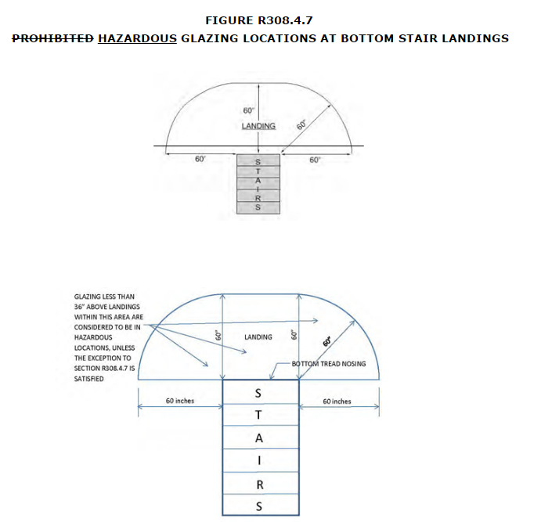

(F7814)/(I-Code)/(RB73-16)

R308.4.2 Glazing adjacent to doors. Glazing in an individual fixed or operable panel adjacent to a door shall be considered to be a hazardous location where the bottom exposed edge of the glazing is less than 60 inches (1524 mm) above the floor or walking surface and it meets either of the following conditions:

1. Where the glazing is within 24 inches (610mm) of either side of the door in the plane of the door in a closed position.
2. Where the glazing is on a wall perpendicular to less than 180 degrees from the plane of the door in a closed position and within 24 inches (610 mm) of the hinge side of an in-swinging door.

Exceptions:

1. Decorative glazing.
2. Where there is an intervening wall or other permanent barrier between the door and the glazing.
3. Where access through the door is to a closet or storage area 3 feet (914 mm) or less in depth. Glazing in this application shall comply with Section R308.4.3.
4. Glazing that is adjacent to the fixed panel of patio doors.
(F7813)/(I-Code)

R308.4.3 Glazing in windows. Glazing in an individual fixed or operable panel that meets all of the following conditions shall be considered to be a hazardous location:

1. The exposed area of an individual pane is larger than 9 square feet (0.836 m2),
2. The bottom edge of the glazing is less than 18 inches (457 mm) above the floor,
3. The top edge of the glazing is more than 36 inches (914 mm) above the floor; and
4. One or more walking surfaces are within 36 inches (914 mm), measured horizontally and in a straight line, of the glazing.

Exceptions:

1. Decorative glazing.
2. Where glazing is adjacent to a walking surface and a horizontal rail is installed on the accessible side(s) of the glazing 34 to 38 inches (864 to 965 mm) above the walking surface. The rail shall be capable of withstanding a horizontal load of 50 pounds per linear foot (730 N/m) without contacting the glass and have a cross-sectional height of not less than 11 / inches (38 mm).
2
3. Outboard panes in insulating glass units and other multiple glazed panels where the bottom edge of the glass is 25 feet (7620 mm) or more above grade, a roof, walking surfaces or other horizontal [within 45 degrees (0.79 rad) of horizontal] surface adjacent to the glass exterior.

R308.4.6 Glazing adjacent to stairs and ramps. Glazing where the bottom exposed edge of the glazing is less than 36 inches (914 mm) above the plane of the adjacent walking surface of stairways, landings between flights of stairs and ramps shall be considered to be a hazardous location.

Exceptions:

1. Where glazing is adjacent to a walking surface and a horizontal rail is installed on the accessible side(s) of the glazing at 34 to 38 inches (864 to 965 mm) above the walking surface. The rail shall be capable of withstanding a horizontal load of 50 pounds per linear foot (730 N/m) without contacting the glass and have a cross-sectional height of not less than 11 / inches (38 mm).
2
2. Glazing 36 inches (914 mm) or more measured horizontally from the walking surface.

R308.6.2 Materials. The following types of glazing shall be permitted to be used:

1. Laminated glass with not less than a 0.015-inch (0.38 mm) polyvinyl butyral interlayer for glass panes 16 square feet (1.5 m2) or less in area located such that the highest point of the glass is not more than 12 feet (3658 mm) above a walking surface or other accessible area; for higher or larger sizes, the interlayer thickness shall be not less than 0.030 inch (0.76 mm).
2. Fully tempered glass.
3. Heat-strengthened glass.
4. Wired glass.
5. Approved rigid plastics.

R308.6.5 Screens not required. Screens shall not be required where fully tempered glass is used as single glazing or the inboard pane in multiple glazing and either of the following conditions are met:

1. Glass area 16 square feet (1.49 m2) or less. Highest point of glass not more than 12 feet (3658 mm) above a walking surface or other accessible area, nominal glass thickness not more than 3 /16 inch (4.8 mm), and (for multiple glazing only) the other pane or panes fully tempered, laminated or wired glass.
2. Glass area greater than 16 square feet (1.49 m2). Glass sloped 30 degrees (0.52 rad) or less from vertical, and highest point of glass not more than 10 feet (3048 mm) above a walking surface or other accessible area.
(RB2-16)

R308.6 Skylights and sloped glazing.
Skylights and sloped glazing shall comply with the following sections.

R308.6.1 Definitions.
The following terms are defined in Chapter 2:

SKYLIGHT, UNIT.

SKYLIGHTS AND SLOPED GLAZING.

TUBULAR DAYLIGHTING DEVICE (TDD).

R308.6.2 Materials.
The following types of glazing shall be permitted to be used:
1. Laminated glass with not less than a 0.015-inch (0.38 mm) polyvinyl butyral interlayer for glass panes 16 square feet (1.5 m²) or less in area located such that the highest point of the glass is not more than 12 feet (3658 mm) above a walking surface or other accessible area; for higher or larger sizes, the interlayer thickness shall be not less than 0.030 inch (0.76 mm).
2. Fully tempered glass.
3. Heat-strengthened glass.
4. Wired glass.
5. Approved rigid plastics.

R308.6.3 Screens, general.
For fully tempered or heat-strengthened glass, a retaining broken glass retention screen meeting the requirements of Section R308.6.7 shall be installed below the full area of the glass, except for fully tempered glass that meets either condition (1) or (2) listed in Section R308.6.5.

R308.6.4 Screens with multiple glazing.
Where the inboard pane is fully tempered, heat-strengthened or wired glass, a broken glass retention retaining screen meeting the requirements of Section R308.6.7 shall be installed below the full area of the glass, except for condition (1) or (2) listed in Section R308.6.5. Other panes in the multiple glazing shall be of any type listed in Section R308.6.2.

R308.6.5 Screens not required.
Screens shall not be required where laminated glass complying with item (1) of Section R308.6.2 is used as single glazing or the inboard pane in multiple glazing.
Screens shall not be required where fully tempered glass is used as single glazing or the inboard pane in multiple glazing and either of the following conditions are met:
1. Glass area 16 square feet (1.49 m²) or less. Highest point of glass not more than 12 feet (3658 mm) above a walking surface or other accessible area, nominal glass thickness not more than ³/₁₆ inch (4.8 mm), and (for multiple glazing only) the other pane or panes fully tempered, laminated or wired glass.
2. Glass area greater than 16 square feet (1.49 m²). Glass sloped 30 degrees (0.52 rad) or less from vertical, and highest point of glass not more than 10 feet (3048 mm) above a walking surface or other accessible area.

R308.6.6 Glass in greenhouses.
Any glazing material is permitted to be installed without screening in the sloped areas of greenhouses, provided that the greenhouse height at the ridge does not exceed 20 feet (6096 mm) above grade.

R308.6.7 Screen characteristics.
The screen and its fastenings shall be capable of supporting twice the weight of the glazing, be firmly and substantially fastened to the framing members, be installed within 4 inches (102 mm) of the glass and have a mesh opening of not more than 1 inch by 1 inch (25 mm by 25 mm).
(F7831)

R310.3 Emergency escape and rescue doors. Where a door is provided as the required emergency escape and rescue opening, it shall be permitted to be a side-hinged door or a slider. Where the opening is below the adjacent ground elevation grade, it shall be provided with a bulkhead enclosure an area well.

Delete and substitute as follows:
R310.3.2 Bulkhead enclosures Area Wells. Bulkhead enclosures shall provide direct access from the basement. The bulkhead enclosure shall provide the minimum net clear opening equal to the door inthe fully open position.
Area wells shall have a width of not less than 36 inches (914 mm). The area of the area well shall allowthe emergency escape and rescue door to be fully opened.
Add new text as follows:
R310.3.2.1 Ladder and steps. Area wells with a vertical depth greater than 44 inches (1118 mm) shall be equipped with a permanently affixed ladder or steps usable with the door in the fully open position. Ladders or steps required by this section shall not be required to comply with Sections R311.7 andR311.8.Ladders or rungs shall have an inside width of not less than12 inches (305mm), shall project not less than 3 inches (76 mm) from the wall and shall be spaced not more than 18 inches (457 mm) on center vertically for the full height of the exterior stairwell.
Revise as follows:
R310.3.2.1R310.3.2.2 Drainage. Bulkhead enclosures Area wells shall be designed for proper drainage by connecting to the building's foundation drainage system required by Section R405.1 or by an approved alternative method.
Exception: A drainage system for bulkhead enclosures area wells is not required where the foundation is on well-drained soil or sand-gravel mixture soils in accordance with the United Soil Classification System, Group I Soils, as detailed in Table R405.1
(F7685)/RB96-16

Revise as follows:
R310.5 Dwelling additions. Where dwelling additions occur that contain sleeping rooms, an emergency escape and rescue opening shall be provided in each new sleeping room. Where dwelling additions occur that have basements, an emergency escape and rescue opening shall be provided in the new basement.

Exceptions:

1. An emergency escape and rescue opening is not required in a new basement that contains a sleeping room with an emergency escape and rescue opening.
2. An emergency escape and rescue opening is not required in a new basement where there is an emergency escape and rescue opening in an existing basement that is accessible accessed from the new basement.

R311.3 Floors and landings at exterior doors. There shall be a landing or floor on each side of each exterior door. The width of each landing shall be not less than the door served. Every landing shall have a dimension of not less than 36 inches (914 mm) measured in the direction of travel. The slope at exterior landings shall not exceed 1 / unit vertical in 12 units horizontal (2 percent).
4

Exception: Exterior balconies less than 60 square feet (5.6 m2) and only accessible accessed from a door are permitted to have a landing less than 36 inches (914 mm) measured in the direction of travel.
(RB2-16)

R311.7.1 Width.
Stairways shall be not less than 36 inches (914 mm) in clear width at all points above the permitted handrail height and below the required headroom height. Handrails shall not project more than 41/2 inches (114 mm) on either side of the stairway and the. The clear width of the stairway at and below the handrail height, including treads and landings, shall be not less than 311/2 inches (787 mm) where a handrail is installed on one side and 27 inches (698 mm) where handrails are provided on both sides.

Exception: The width of spiral stairways shall be in accordance with Section R311.7.10.1.

Add new text as follows:
R311.7.8.5 Handrail Projection Handrails shall not project more than 41/2 inches (114 mm) on either side of the stairway.
Exception: Where nosings of landings, floors, or passing flights project into the stairway reducing the required clearance at passing handrails, the handrail shall project not more than 61/2 inches (165 mm) into the stairway, provided the required stair width and required handrail clearance are not reduced
(F7687)/(RB101-16)

R311.7.3 Vertical rise. A flight of stairs shall not have a vertical rise larger than 147 151 inches (3734 3835.4 mm) between floor levels or landings.
(F7706)/(RB103-16)

R311.7.5.3 Nosings.
The Nosings at treads, landings and floors of stairways shall have a radius of curvature at the nosing shall be not greater than 9/16 inch (14 mm) or a bevel not exceeding 1/2 inch (12.7 mm). A nosing projection not less than 3/4 inch (19 mm) and not more than 11/4 inches (32 mm) shall be provided on stairways with solid risers. The greatest nosing projection shall not exceed the smallest nosing projection by more than 3/8 inch (9.5 mm) between two stories, including the nosing at the level of floors and landings within a stairway. Beveling of nosings shall not exceed 1/2 inch (12.7 mm).
Exception: A nosing projection is not required where the tread depth is not less than 11 inches (279 mm).
(F7688 G1)/(105-16)

R311.7.8 Handrails. Handrails shall be provided on not less than one side of each continuous run of treads or flight with four or more risers.
(F7734)/(RB107-16)

R311.7.11 Alternating tread devices. Alternating tread devices shall not be used as an element of a means of egress. Alternating tread devices shall be permitted provided that the required means of egress stairway or ramp serves the same space at each adjoining level or where a means of egress is not required. The clear width at and below the handrails shall be not less than 20 inches (508 mm).

Exception: Alternating tread devices are allowed to be used as an element of a means of egress for lofts, mezzanines, and similar areas of 200 gross square feet or less and not providing exclusive access to a kitchen or bathroom.

R311.7.12 Ships ladders. Ships ladders shall not be used as an element of a means of egress. Ships ladders shall be permitted provided that a required means of egress stairway or ramp serves the same space at each adjoining level or where a means of egress is not required. The clear width at and below the handrails shall be not less than 20 inches.

Exception: Ships ladders are allowed to be used as an element of a means of egress for lofts, mezzanines, and similar areas of 200 gross square feet or less and not providing exclusive access toa kitchen or bathroom.
(F7816)/(I-Code)

R312.1.1 Where required. Guards shall be located along provided for those portions of open-sided walking surfaces, including stairs, ramps and landings, that are located more than 30 inches (762 mm) measured vertically to the floor or grade below at any point within 36 inches (914 mm) horizontally to the edge of the open side. Insect screening shall not be considered as a guard.
(F7735)/RB117-16)

R314.2.2 Alterations, repairs and additions. Where alterations, repairs or additions requiring a permit occur, or where one or more sleeping rooms are added or created in existing dwellings, the individual dwelling unit shall be equipped with smoke alarms located as required for new dwellings.
Exceptions:
1. Work involving the exterior surfaces of dwellings, such as the replacement of roofing or siding, the addition or replacement of windows or doors, or the addition of a porch or deck, are exempt from the requirements of this section.
2. Installation, alteration or repairs of plumbing or mechanical systems are exempt from the requirements of this section.
(F7337)/(I-Code)

R316.5.4 Crawl spaces. The thermal barrier specified in Section R316.4 is not required where all of the following apply:

1. Crawl space access is required by SectionR408.4
2. Entry is made only for purposes of repairs or maintenance.
3. The foam plastic insulation has been tested in accordance with Section R316.6 or the foam plastic insulation is protected against ignition using one of the following ignition barrier materials:
3.1. 1-½ inch-thick (38 mm) mineral fiber insulation;
3.2. ¼ inch-thick (6.4 mm) wood structural panels;
3.3 ³ /₈ inch (9.5 mm)particleboard;

3.4. ¼ inch (6.4 mm)hardboard;
3.5 ³ /₈ inch (9.5 mm) gypsum board; or
3.6. Corrosion-resistant steel having a base metal thickness of 0.016 inch (0.406 mm).
3.7. . ¼ inch (6.4 mm) fiber-cement panel, soffit or backer board.
(F7817)/(I-Code)

R317.1 Location required. Protection of wood and wood- based products from decay shall be provided in the following locations by the use of naturally durable wood or wood that is preservative-treated in accordance with AWPA U1 for the species, product, preservative and end use. Preservatives shall be listed in Section 4 of AWPA U1.
"Remaining text unchanged"

R317.3.1 Fasteners for preservative-treated wood. Fasteners, including nuts and washers, for preservative-treated wood shall be of hot-dipped, zinc-coated galvanized steel, stainless steel, silicon bronze or copper. Staples shall be of stainless steel. Coating types and weights for connectors in contact with preservative-treated wood shall be in accordance with the connector manufacturer's recommendations. In the absence of manufacturer's recommendations, a minimum of ASTM A 653 type G185 zinc-coated galvanized steel, or equivalent, shall be used.

Exceptions:

1. one/two (1 /2)-inch-diameter (12.7 mm) or greater steelbolts.

2. Fasteners other than nails, staples, and timber rivets shall be permitted to be of mechanically deposited zinc-coated steel with coating weights in accordance with ASTM B 695, Class 55 minimum.

3. Plain carbon steel fasteners in SBX/DOT and zinc borate preservative-treated wood in an interior, dry environment shall be permitted.

R317.3.3 Fasteners for fire-retardant-treated wood used in exterior applications or wet or damp locations. Fasteners, including nuts and washers, for fire-retardant-treated wood used in exterior applications or wet or damp locations shall be of hot-dipped, zinc-coated galvanized steel, stainless steel, silicon bronze or copper. Fasteners other than nails, staples, and timber rivets shall be permitted to be of mechanically deposited zinc-coated steel with coating weights in accordance with ASTM B 695, Class 55 minimum.
(S7629)/(I-Code)

R322.1 General. Buildings and structures constructed in whole or in part in flood hazard areas, including A or V Zones and Coastal A Zones, as established in Table R301.2(1), and substantial improvement and restoration repair of substantial damage of buildings and structures in flood hazard areas, shall be designed and constructed in accordance with the provisions contained in this section. Buildings and structures that are located in more than one flood hazard area shall comply with the provisions associated with the most restrictive flood hazard area. Buildings and structures located in whole or in part in identified floodways shall be designed and constructed in accordance with ASCE 24.
(ADM 72-16)

R322.1.6 Protection of mechanical, plumbing and electrical systems.

Electrical systems, equipment and components; heating, ventilating, air conditioning; plumbing appliances and plumbing fixtures; duct systems; and other service equipment shall be located at or above the elevation required in Section R322.2 or R322.3. If replaced as part of a substantial improvement, electrical systems, equipment and components; heating, ventilating, air conditioning and plumbing appliances and plumbing fixtures; duct systems; and other service equipment shall meet the requirements of this section. Systems, fixtures, and equipment and components shall not be mounted on or penetrate through walls intended to break away under flood loads.

Exception: Locating electrical systems, equipment and components; heating, ventilating, air conditioning; plumbing appliances and plumbing fixtures; duct systems; and other service equipment is permitted below the elevation required in Section R322.2 or R322.3 provided that they are designed and installed to prevent water from entering or accumulating within the components and to resist hydrostatic and hydrodynamic loads and stresses, including the effects of buoyancy, during the occurrence of flooding to the design flood elevation in accordance with ASCE 24. Equipment for pools, spas and water features shall be permitted below the elevation required in Section R322.2 or R322.3 provided it is elevated to the extent practical and is anchored to prevent floatation and resist flood forces and is supplied by branch circuits that have ground-fault circuit interrupter protection. Electrical wiring systems are permitted to be located below the required elevation provided that they conform to the provisions of the electrical part of this code for wet locations.
(SP7680-R1)

Revise as follows:

R322.3.3 Foundations. Buildings and structures erected in coastal high-hazard areas and Coastal A Zones shall be supported on pilings or columns and shall be adequately anchored to such pilings or columns. The space below the elevated building shall be either free of obstruction or, if enclosed with walls, the walls shall meet the requirements of Section R322.3.4. Pilings shall have adequate soil penetrations to resist the combined wave and wind loads (lateral and uplift). Water-loading values used shall be those associated with the design flood. Wind-loading values shall be those required by this code. Pile embedment shall include consideration of decreased resistance capacity caused by scour of soil strata surrounding the piling. Pile systems design and installation shall be certified in accordance with Section R322.3.6. Spread footing, mat, raft or other foundations that support columns shall not be permitted where soil investigations that are required in accordance with Section R401.4 indicate that soil material under the spread footing, mat, raft or other foundation is subject to scour or erosion from wave- velocity flow conditions. If permitted, spread footing, mat, raft or other foundations that support columns shall be designed in accordance with ASCE 24. Slabs, pools, pool decks and walkways shall be located and constructed to be structurally independent of buildings and structures and their foundations to prevent transfer of flood loads to the buildings and structures during conditions of flooding, scour or erosion from wave-velocity flow conditions, unless the buildings and structures and their foundations are designed to resist the additional flood load.

Exception: In Coastal A Zones, stem wall foundations supporting a floor system above and backfilled with soil or gravel to the underside of the floor system shall be permitted provided the foundations are designed to account for wave action, debris impact, erosion and local scour. Where soils are susceptible to erosion and local scour, stem wall foundations shall have deep footings to account for the loss of soil.

Add new text as follows:

R322.3.4 Concrete slabs. Concrete slabs used for parking, floors of enclosures, landings, decks, walkways, patios and similar uses that are located beneath structures, or slabs that are located such that if undermined or displaced during base flood conditions could cause structural damage to the building foundation, shall be designed and constructed in accordance with one of the following:

1. To be structurally independent of the foundation system of the structure, to not transfer flood loads to the main structure, and to be frangible and break away under flood conditions prior to base flood conditions. Slabs shall be a maximum of 4 inches (102 mm) thick, shall not have turned-down edges, shall not contain reinforcing, shall have isolation joints at pilings and columns, and shall have control or construction joints in both directions spaced not more than 4 feet (1219 mm) apart.

2. To be self-supporting, structural slabs capable of remaining intact and functional under base flood
conditions, including erosion and local scour, and the main structure shall be capable of resisting any
added flood loads and effects of local scour caused by the presence of the slabs.

(RB160-16 AMPC2)

R322.3.4 R322.3.5 Walls below design flood elevation. Walls and partitions are permitted below the elevated floor, provided that such walls and partitions are not part of the structural support of the building or structure and:
1. Electrical, mechanical and plumbing system components are not to be mounted on or penetrate through walls that are designed to break away under flood loads; and
2. Are constructed with insect screening or open lattice; or
3. Are designed to break away or collapse without causing collapse, displacement or other structural damage to the elevated portion of the building or supporting foundation system. Such walls, framing and connections shall have a resistance of not less than 10 (479 Pa) and not more than 20 pounds per square foot (958 Pa) as determined using allowable stress design; or
4. Where wind loading values of this code exceed 20 pounds per square foot (958 Pa), as determined using allowable stress design, the construction documents shall include documentation prepared and sealed by a registered design professional that:
4.1 The walls and partitions below the design flood elevation have been designed to collapse from a water load less than that which would occur during the base flood.
4.2 The elevated portion of the building and supporting foundation system have been designed to withstand the effects of wind and flood loads acting simultaneously on structural and nonstructural building components. Water-loading values used shall be those associated with the design flood. Wind-loading values shall be those required by this code.
5. Walls intended to break away under flood loads as specified in Item 3 or 4 have flood openings that meet the criteria in Section R322.2.2, Item 2.

R322.3.5 R322.3.6 Enclosed areas below design flood elevation. Enclosed areas below the design flood elevation shall be used solely for parking vehicles, building access or storage.

R322.3.5.1 R322.3.6.1 Protection of building envelope. An exterior door that meets the requirements of Section R609 shall be installed at the top of stairs that provide access to the building and that are enclosed with walls designed to break away in accordance with Section 322.3.5.

R322.3.6 R322.3.7 Stairways and ramps. Stairways and ramps that are located below the lowest floor elevations specified in Section R322.3.2 shall comply with one or more of the following:
1. Be designed and constructed with open or partially open risers and guards.
2. Stairways and ramps not part of the required means of egress shall be designed and constructed to break away during design flood conditions without causing damage to the building or structure, including foundation.
3. Be retractable, or able to be raised to or above the lowest floor elevation, provided that the ability to be retracted or raised prior to the onset of flooding is not contrary to the means of egress requirements of the code.
4. Be designed and constructed to resist flood loads and minimize transfer of flood loads to the building or structure, including foundation.
Areas below stairways and ramps shall not be enclosed with walls below the design flood elevation unless such walls are constructed in accordance with Section R322.3.5.

R322.3.6 R322.3.8 Decks and porches. Attached decks and porches shall meet the elevation requirements of Section R322.3.2 and shall either meet the foundation requirements of this section or shall be cantilevered from or knee braced to the building or structure. Self-supporting decks and porches that are below the elevation required in Section R322.3.2 shall not be enclosed by solid, rigid walls, including walls designed to break away. Self-supporting decks and porches shall be designed and constructed to remain in place during base flood conditions or shall be frangible and break away under base flood conditions.

R322.3.6 R322.3.9 Construction documents. The construction documents shall include documentation that is prepared and sealed by a registered design professional that the design and methods of construction to be used meet the applicable criteria of this section.

R322.3.7 R322.3.10 Tanks. Underground tanks shall be anchored to prevent flotation, collapse and lateral movement under conditions of the base flood. Above-ground tanks shall be installed at or above the elevation required in Section R322.3.2. Where elevated on platforms, the platforms shall be cantilevered from or knee braced to the building or shall be supported on foundations that conform to the requirements of Section R322.3.
(SP8052)/(I-Code)

R322.3.7 Stairways and ramps. Stairways and ramps that are located below the lowest floor elevations specified in Section R322.3.2 shall comply with one or more of the following:

1. Be designed and constructed with open or partially open risers and guards.
2. Stairways and ramps not part of the required means of egress shall be designed and constructed to break away during design flood conditions without causing damage to the building or structure, including foundation.
3. Be retractable, or able to be raised to or above the lowest floor elevation, provided that the ability to be retracted or raised prior to the onset of flooding is not contrary to the means of egress requirements of the code.
4. Be designed and constructed to resist flood loads and minimize transfer of flood loads to the building or structure, including foundation.

Areas below stairways and ramps shall not be enclosed with walls below the design flood elevation unless such walls are constructed in accordance with Section R322.3.5.
(RB161-16 AMPC1)

Add new text as follows:

R322.3.8 Decks and porches. Attached decks and porches shall meet the elevation requirements of Section R322.3.2 and shall either meet the foundation requirements of this section or shall be cantilevered from or knee braced to the building or structure. Self-supporting decks and porches that are below the elevation required in Section R322.3.2 shall not be enclosed by solid, rigid walls, including walls designed to break away. Self-supporting decks and porches shall be designed and constructed to remain in place during base flood conditions or shall be frangible and break away under base flood conditions.
(RB162-16)

R324.4.1 Roof live load. Roof load. structures that provide support for photovoltaic panel systems shall be designed for applicable roof live load. The design of roof structures need not include roof live load in the areas covered by photovoltaic panel systems. Portions of roof structures not covered by photovoltaic panels shall be designed for roof live load. Roof structures that provide support for photovoltaic panel systems shall be designed for live load, LR, for the load case where the photovoltaic panel system is not present.

Portions of roof structures not covered with photovoltaic panel systems shall be designed for dead loads and roof loads in accordance with Sections R301.4 and R301.6. Portions of roof structures covered with photovoltaic panel systems shall be designed for the following load cases:

1. Dead load (including photovoltaic panel weight) plus snow load in accordance with Table R301.2(1).

2. Dead load (excluding photovoltaic panel weight) plus roof live load or snow load, whichever is greater, in accordance with Section R301.6.
(S7493)/(I-Code)

SECTION 324

SOLAR ENERGY SYSTEMS

R324.1 General. Solar energy systems shall comply with the provisions of this section.

R324.2 Solar thermal systems. Solar thermal systems shall be designed and installed in accordance with Chapter 23 and the Florida Fire Prevention Code.

R324.3 Photovoltaic systems. Photovoltaic systems shall be designed and installed in accordance with Sections R324.3.1 through R324.6.1 and NFPA 70. Inverters shall be listed and labeled in accordance with UL 1741. Systems connected to the utility grid shall use inverters listed for utility interaction.

R324.3.1 Equipment listings. Photovoltaic panels and modules shall be listed and labeled in accordance with UL 1703.

R324.4 Rooftop-mounted photovoltaic systems. Rooftopmounted photovoltaic panel systems installed on or above the roof covering shall be designed and installed in accordance with Section R909.

R324.4.1 Roof live load. Roof structures that provide support for photovoltaic panel systems shall be designed for applicable roof live load. The design of roof structures need not include roof live load in the areas covered by photovoltaic panel systems. Portions of roof structures not covered by photovoltaic panels shall be designed for roof live load. Roof structures that provide support for photovoltaic panel systems shall be designed for live load, LR, for the load case where the photovoltaic panel system is not present.

R324.5 Building-integrated photovoltaic systems. Building-integrated photovoltaic systems that serve as roof coverings shall be designed and installed in accordance with Section R905.

R324.5.1 Photovoltaic shingles. Photovoltaic shingles shall comply with Section R905.16.

R324.6 Ground-mounted photovoltaic systems. Ground-mounted photovoltaic systems shall be designed and installed in accordance with Section R301.

R324.6.1 Fire separation distances. Ground-mounted photovoltaic systems shall be subject to the fire separation distance requirements determined by the local jurisdiction.

SECTION 324

SOLAR ENERGY SYSTEMS

R324.1 General. Solar energy systems shall comply with the provisions of this section.

R324.2 Solar thermal systems. Solar thermal systems shall be designed and installed in accordance with Chapter 23 and the Florida Fire Prevention Code.

R324.3 Photovoltaic systems. Photovoltaic systems shall be designed and installed in accordance with Sections R324.3.1through R324.7.1, NFPA 70 and the manufacturer’s installation instructions.

R324.3.1 Equipment listings. Photovoltaic panels and modules shall be listed and labeled in accordance with UL 1703. Inverters shall be listed and labeled in accordance with UL 1741. Systems connected to the utility grid shall use inverters listed for utility interaction.

R324.4 Rooftop-mounted photovoltaic systems. Rooftop-mounted photovoltaic panel systems installed on or above the roof covering shall be designed and installed in accordance with this section.

R324.4.1 Structural requirements. Rooftop-mounted photovoltaic panel systems shall be designed to structurally support the system and withstand applicable gravity loads in accordance with Chapter 3. The roof on which these systems are installed shall be designed and constructed to support the loads imposed by such systems in accordance with Chapter 8.

R324.4.1.1 Roof load. Portions of roof structures not covered with photovoltaic panel systems shall be designed for dead loads and roof loads in accordance with Sections R301.4 and R301.6. Portions of roof structures covered with photovoltaic panel systems shall be designed for the following load cases:

1. Dead load (including photovoltaic panel weight) plus snow load in accordance with Table R301.2(1).

2. Dead load (excluding photovoltaic panel weight)plus roof live load or snow load, whichever is greater, in
accordance with Section R301.6.

R324.4.1.2 Wind load. Rooftop-mounted photovoltaic panel or module systems and their supports shall be designed and installed to resist the component and cladding loads specified in Table R301.2(2), adjusted for height and exposure in accordance with Table R301.2(3).

R324.4.2 Fire classification. Rooftop-mounted photovoltaic panel systems shall have the same fire classification as the roof assembly required in Section R902.

R324.4.3 Roof penetrations. Roof penetrations shall be flashed and sealed in accordance with Chapter 9.

R324.5 Building-integrated photovoltaic systems. Building-integrated photovoltaic systems that serve as roof coverings shall be designed and installed in accordance with Section R905.

R324.5.1 Photovoltaic shingles. Photovoltaic shingles shall comply with Section R905.16.

R324.5.2 Fire classification. Building-integrated photovoltaic systems shall have a fire classification in accordance with Section R902.3.

R324.6 Roof access and pathways. Roof access, pathways and setback requirements shall be provided in accordance with Sections R324.6.1 through R324.6.2.1. Access and minimum spacing shall be required to provide emergency access to the roof, to provide pathways to specific areas of the roof, provide for smoke ventilation opportunity areas, and to provide emergency egress from the roof.

Exceptions:

1. Detached, nonhabitable structures, including but not limited to detached garages, parking shade structures, carports, solar trellises and similar structures, shall not be required to provide roof access.

2. Roof access, pathways and setbacks need not be provided where the code official has determined that rooftop operations will not be employed.

3. These requirements shall not apply to roofs with slopes of two units vertical in 12 units horizontal (17-percent slope) or less.

R324.6.1 Pathways. Not fewer than two pathways, on separate roof planes from lowest roof edge to ridge and not less than 36 inches (914 mm) wide, shall be provided on all buildings. Not fewer than one pathway shall be provided on the street or driveway side of the roof. For each roof plane with a photovoltaic array, a pathway not less than 36 inches wide (914 mm) shall be provided from the lowest roof edge to ridge on the same roof plane as the photovoltaic array, on an adjacent roof plane, or straddling the same and adjacent roof planes. Pathways shall be over areas capable of supporting fire fighters accessing the roof. Pathways shall be located in areas with minimal obstructions such as vent pipes, conduit, or mechanical equipment.

R324.6.2 Setback at ridge. For photovoltaic arrays occupying not more than 33 percent of the plan view total roof area, not less than an 18-inch (457 mm) clear setback is required on both sides of a horizontal ridge. For photovoltaic arrays occupying more than 33 percent of the plan view total roof area, not less than a 36-inch (914 mm) clear setback is required on both sides of a horizontal ridge.

R324.6.2.1 Alternative setback at ridge. Where an automatic sprinkler system is installed within the dwelling in accordance with NFPA 13D or Section P2904, setbacks at ridges shall comply with one of the following:

1. For photovoltaic arrays occupying not more than 66 percent of the plan view total roof area, not less than an 18-inch (457 mm) clear setback is required on both sides of a horizontal ridge.

2. For photovoltaic arrays occupying more than 66 percent of the plan view total roof area, not less than a 36-inch (914 mm) clear setback is required on both sides of a horizontal ridge.

R324.6.2.2 Emergency escape and rescue opening. Panels and modules installed on dwellings shall not be placed on the portion of a roof that is below an emergency escape and rescue opening. A pathway not less than 36 inches (914 mm) wide shall be provided to the emergency escape and rescue opening.

R324.7 Ground-mounted photovoltaic systems. Ground-mounted photovoltaic systems shall be designed and installed in accordance with Section R301.

R324.7.1 Fire separation distances. Ground-mounted photovoltaic systems shall be subject to the fire separation distance requirements determined by the local jurisdiction.
(S7345)/ (RB164-16)

SECTION R328

STATIONARY STORAGE BATTERY SYSTEMS

R328.1 General. Stationary storage battery system shall comply with the provisions of this section.

R328.2 Equipment listings. Stationary storage battery systems shall be listed and labeled for residential use in accordance with UL 9540.

Exceptions:

1. Where approved, repurposed unlisted battery systems from electric vehicles are allowed to be installed outdoors or in detached sheds located not less than 5 feet (1524 mm) from exterior walls, property lines and public ways.

2. Battery systems that are an integral part of an electric vehicle are allowed provided that the installation complies with Section 625.48 of NFPA 70.

3. Battery systems less than 1 kWh (3.6 Mega joules).
R328.3 Installation. Stationary storage battery systems shall be installed in accordance with the manufacturer’s instructions and their listing, if applicable, and shall not be installed within the habitable space of a dwelling unit.

R328.3 Installation. Stationary storage battery systems shall be installed in accordance with the manufacturer’s instructions and their listing, if applicable, and shall not be installed within the habitable space of a dwelling unit.

R328.5 Electrical installation. Stationary storage battery systems shall be installed in accordance with NFPA 70. Inverters shall be listed and labeled in accordance with UL 1741 or provided as part of the UL 9540 listing. Systems connected to the utility grid shall use inverters listed for utility interaction.

R328.6 Ventilation. Indoor installations of stationary storage battery systems that include batteries that produce hydrogen or other flammable gases during charging shall be provided with ventilation in accordance with Section M1307.4.

R327.7 Protection from impact. Stationary storage battery systems installed in a location subject to vehicle damage shall be protected by approved barriers.

(E7350)/ (RB171-16 AM)

Chapter 4 FOUNDATIONS

Revise as follows:

R402.1.2 Wood treatment. All lumber and plywood shall be pressure-preservative treated and dried after treatment in accordance with AWPA U1 (Commodity Specification A, Use Category 4B and Section 5.2 Special Requirement 4.2), and shall bear the label of an accredited agency. Where lumber and/or plywood is cut or drilled after treatment, the treated surface shall be field treated with copper naphthenate, the concentration of which shall contain a minimum of 2-percent copper metal, by repeated brushing, dipping or soaking until the wood absorbs no more preservative.

(S7737)/(RB154-16)

R403.1.4 Minimum depth. Exterior footings shall be placed not less than 12 inches (305 mm) below the finished grade undisturbed of ground surface. Where applicable, the depth of footings shall also conform to Sections R403.1.4.1 through R403.1.4.2.

(S7514 Commission)

R403.1.6 Foundation anchorage.

Wood sill plates and wood walls supported directly on continuous foundations shall be anchored to the foundation in accordance with this section.

Cold-formed steel framing shall be anchored directly to the foundation or fastened to wood sill plates anchored to the foundation in accordance with Section R505.3.1 or R603.3.1, as applicable. Anchorage of cold-formed steel framing and Wood sill plates supporting cold-formed steel framing shall be anchored to the foundation in accordance with this section and Section R505.3.1 or R603.3.1.

Wood sole plates at all exterior walls on monolithic slabs, wood sole plates of braced wall panels at building interiors on monolithic slabs and all wood sill plates shall be anchored to the foundation with minimum 1/2-inch- diameter (12.7 mm) anchor bolts spaced a maximum of 6 feet (1829 mm) on center or approved anchors or anchor straps spaced as required to provide equivalent anchorage to 1/2-inch-iameter (12.7 mm) anchor bolts. Bolts shall extend a minimum of 7 inches (178 mm) into concrete or grouted cells of concrete masonry units. The bolts shall be located in the middle third of the width of the plate. A nut and washer shall be tightened on each anchor bolt. There shall be a minimum of two bolts per plate section with one bolt located not more than 12 inches (305 mm) or less than seven bolt diameters from each end of the plate section. Interior bearing wall sole plates on monolithic slab foundation that are not part of a braced wall panel shall be positively anchored with approved fasteners. Sill plates and sole plates shall be protected against decay and termites where required by Sections R317 and R318.

Exceptions:

1. Walls 24 inches (610 mm) total length or shorter connecting offset braced wall panels shall be anchored to the foundation with a minimum of one anchor bolt located in the center third of the plate section and shall be attached to adjacent braced wall panels at corners as shown in Item 9 of Table R602.3(1).

2. Connection of walls 12 inches (305 mm) total length or shorter connecting offset braced wall panels to the foundation without anchor bolts shall be permitted. The wall shall be attached to adjacent braced wall panels at corners as shown in Item 9 of Table R602.3(1).
(S7699 G1+G2)/(I-Code)

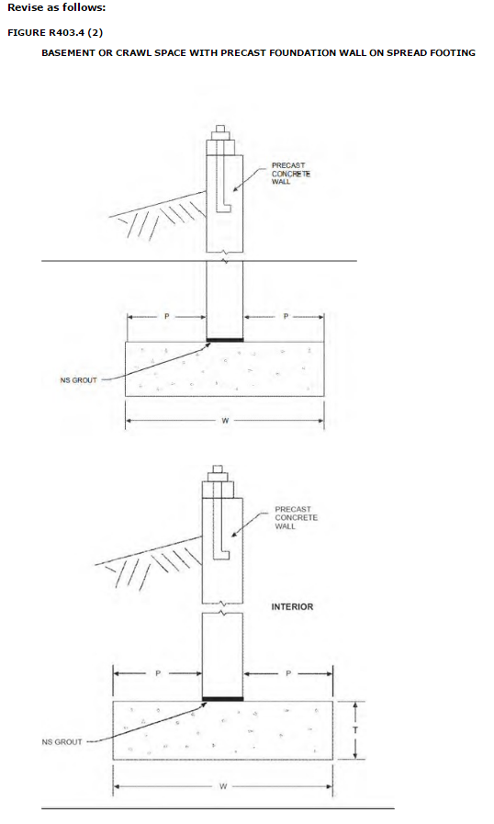

(S7653)/(RB181-16)

R405.1 Concrete or masonry foundations. Drains shall be provided around concrete or masonry foundations that retain earth and enclose habitable or usable spaces located below grade. Drainage tiles, gravel or crushed stone drains, perforated pipe or other approved systems or materials shall be installed at or below the area to be protected top of the footing or below the bottom of the slab and shall discharge by gravity or mechanical means into an approved drainage system. Gravel or crushed stone drains shall extend not less than 1 foot (305 mm) beyond the outside edge of the footing and 6 inches (152 mm) above the top of the footing and be covered with an approved filter membrane material. The top of open joints of drain tiles shall be protected with strips of building paper. Except where otherwise recommended by the drain manufacturer, perforated drains shall be surrounded with an approved filter membrane or the filter membrane shall cover the washed gravel or crushed rock covering the drain. Drainage tiles or perforated pipe shall be placed on a minimum of 2 inches (51 mm) of washed gravel or crushed rock not less than one sieve size larger than the tile joint opening or perforation and covered with not less than 6 inches (152 mm) of the same material.

Exception: A drainage system is not required where the foundation is installed on well-drained ground or sand-gravel mixture soils according to the Unified Soil Classification System, Group I soils, as detailed in Table R405.1.

(S7654)/(RB184-16)

R408.3 Unvented crawl space. Ventilation openings in under-floor spaces specified in Sections R408.1 and R408.2 shall not be required where the following items are provided:

1. Exposed earth is covered with a continuous Class I vapor retarder. Joints of the vapor retarder shalloverlapby6inches(152mm)andshallbesealedortaped.Theedgesofthevaporretarder shall extend not less than 6 inches (152 mm) up the stem wall and shall be attached and sealed to the stem wall or insulation.
2. One of the following is provided for the under-floorspace:
2.1.Continuously operated mechanical exhaust ventilation at a rate equal to 1 cubic foot per minute (0.47 L/s) for each 50 square feet (4.7 m2) of crawl space floor area, including an air pathwaytothecommonarea(suchasaductortransfergrille),andperimeterwallsinsulated in accordance with the Florida Building Code, Energy Conservation.
2.2.Conditioned air supply sized to deliver at a rate equal to 1 cubic foot per minute (0.47 L/s) for each 50 square feet (4.7 m2) of under-floor area, including a return air pathway to the common area (such as a duct or transfer grille), and perimeter walls insulated in accordance with the Florida Building Code, Energy Conservation.
2.3.Plenum in existing structures complying with Section M1601.5, if under-floor space is used as a plenum.
2.4. Dehumidification sized to provide 70 pints (33 liters) of moisture removal per day for every 1,000 ft2 (93 m2) of crawl space floor area.
(S7655)/(RB187-16)

Chapter 5 FLOORS

Revise as follows:

R502.1.3 Structural glued laminated timbers.
Glued laminated timbers shall be manufactured and identified as required in ANSI/AITC A190.1, ANSI 117 and ASTM D3737.
(S7948)/(RB189-16)

R502.2 Design and construction. Floors shall be designed in accordance with Section R301.2.1.1 or ANSI AWC NDS. Floors shall be designed and constructed in accordance with the provisions of this chapter, Figure R502.2 and Sections R317 and R318 or in accordance with ANSI AWC NDS.

Further revise the original modification as follows:

Delete Sections R502.2.1 through R502.10 including all subsections, figures, and tables. Show sections as "Reserved" to maintain section numbering.

Revise as follows:

R503.1 Design and construction. Floors sheathing shall be in accordance with Section R301.2.1.1 or ANSI AWC NDS. Lumber sheathing. Maximum allowable spans for lumber used as floor sheathing shall conform to Tables R503.1, R503.2.1.1(1) and R503.2.1.1(2)

R503.1.1 End joints. End joints in lumber used as subflooring shall occur over supports unless end-matched lumber is used, in which case each piece shall bear on not less than two joists. Subflooring shall be permitted to be omitted where joist spacing does not exceed 16 inches (406 mm) and a 1-inch (25 mm) nominal tongue-and-groove wood strip flooring is applied perpendicular to the joists.

Further revise the original modification as follows:

Delete Sections R503.2 through R503.3.3 including all subsections, figures, and tables. Show sections as "Reserved" to maintain section numbering.

(S8147 A2+Original)

R504.3 Materials. Framing materials, including sleepers, joists, blocking and plywood subflooring, shall be pressure-preservative treated and dried after treatment in accordance with AWPA U1 (Commodity Specification A, Use Category 4B and Section 5.2 Special Requirement 4.2), and shall bear the label of an accredited agency.
(S7737)/(I-Code)

Delete Section R505, Cold-Formed Steel Floor Framing, in its entirety and replace with the following:
SECTION R505 COLD-FORMED STEEL FLOOR FRAMING
R505.1 General. In accordance with Section R301.2.1.1, the design of cold-formed steel floor framing shall be in accordance with AISI S230, Standard for Cold-Formed Steel Framing— Prescriptive Method For One- and Two-Family Dwellings
(S7856)/(RB195-16)

R506.1 General. Concrete slab-on-ground floors shall be designed and constructed in accordance with the provisions of ACI 332 and this section. Floors shall be a minimum 3 ½ inches (89 mm) thick (for expansive soils, see Section R403.1.8). The specified compressive strength of concrete shall be as set forth in Section R402.2. Footings for concrete slab-on-grade floors shall be in accordance with Chapter 4.
(S8147 A2+Original)

SECTION R507
EXTERIOR DECKS

R507.1 Decks. Wood-framed decks shall be in accordance with this section or Section R301 for. For decks using materials and conditions not prescribed herein. Where supported by attachment in this section, refer to an exterior wall, decks shall be positively anchored to the primary structure and designed for both vertical and lateral loads Section R301.
Such attachment shall not be accomplished by the use of toenails or nails subject to withdrawal. Where positive connection to the primary building structure cannot be verified during inspection, decks shall be self-supporting. For decks with cantilevered framing members connections to exterior walls or other framing members shall be designed and constructed to resist uplift resulting from the full live load specified in Table R301.5 acting on the cantilevered portion of the deck.

R507.3 R507.2 Plastic composite deck boards, stair treads, guards, or handrails. Plastic composite exterior deck boards, stair treads, guards and handrails shall comply with the requirements of ASTM D 7032 and the requirements of Section 507.3 507.2.

R507.3.1 R507.2.1 Labeling. Plastic composite deck boards and stair treads, or their packaging, shall bear a label that indicates compliance to ASTM D 7032 and includes the allowable load and maximum allowable span determined in accordance with ASTM D 7032. Plastic or composite handrails and guards, or their packaging, shall bear a label that indicates compliance to ASTM D 7032 and includes the maximum allowable span determined in accordance with ASTM D 7032.

R507.3.2 R507.2.2 Flame spread index. Plastic composite deck boards, stair treads, guards, and handrails shall exhibit a flame spread index not exceeding 200 when tested in accordance with ASTM E 84 or UL 723 with the test specimen remaining in place during the test.

Exception: Plastic composites determined to be noncombustible.

R507.3.3 R507.2.3 Decay resistance. Plastic composite deck boards, stair treads, guards and handrails containing wood, cellulosic or other biodegradable materials shall be decay resistant in accordance with ASTM D 7032.

R507.3.4 R507.2.4 Termite resistance. Where required by Section 318, plastic composite deck boards, stair treads, guards and handrails containing wood, cellulosic or other biodegradable materials shall be termite resistant in accordance with ASTM D 7032.

507.3.5 R507.2.5 Installation of plastic composites. Plastic composite deck boards, stair treads, guards and handrails shall be installed in accordance with this code and the manufacturer's instructions.

R507.3 Deck footings. Deck footings shall be sized to carry the imposed loads from the deck structure to the ground as shown in Figure R507.3. The footing depth shall be in accordance with Section R403.1.4.

FIGURE R507.8.1 R507.3
TYPICAL DECK POSTS TO DECK FOOTINGS
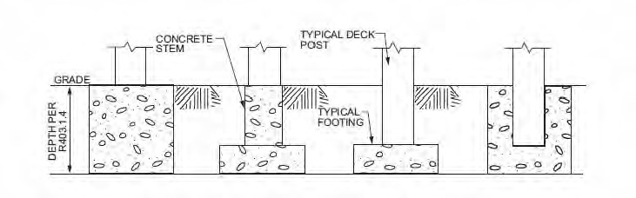

R507.8 R507.4 Deck posts. For single-level wood-framed decks with beams sized in accordance with Table R507.6 R507.5, deck post size shall be in accordance with Table R507.8 R507.4.

TABLE R507.8 R507.4 DECK POST HEIGHTa

DECK POST SIZE | MAXIMUM HEIGHTª
4 × 4 | 8 ft
4 × 6 | 8 ft
6 × 6 | 14 ft
For SI: 1 foot = 304.8 mm.
a. Measured to the underside of the beam.

R507.8.1 R507.4.1 Deck post to deck footing. Posts shall bear on footings in accordance with Section R403 and Figure R507.8.1 R507.3. Posts shall be restrained to prevent lateral displacement at the bottom support. Such lateral restraint shall be provided by manufactured connectors installed in accordance with Section R507 and the manufacturers' instructions or a minimum post embedment of 12 inches (305 mm) in surrounding soils or concrete piers.

R507.6 R507.5 Deck Beams. Maximum allowable spans for wood deck beams, as shown in

Figure R507.6 R507.5, shall be in accordance with Table R507.6 R507.5. Beam plies shall be fastened with two rows of 10d (3-inch × 0.128-inch) nails minimum at 16 inches (406 mm) on center along each edge. Beams shall be permitted to cantilever at each end up to one-fourth of the actual beam span.
Splices of multispan beams shall be located at interior post locations.

TABLE R507. 6 R507.5
DECK BEAM SPAN LENGTHSa, b (ft. - in.)
SPECIES^{c} | SIZE^{d} | DECK JOIST SPAN LESS THAN OR EQUAL TO: (feet)
 |  | 6 | 8 | 10 | 12 | 14 | 16 | 18
Southern pine | 2 – 2 × 6 | 6-11 | 5-  11 | 5-4 | 4-  10 | 4-6 | 4-3 | 4-0

 | 2 – 2 × 8 | 8-9 | 7-7 | 6-9 | 6-2 | 5-9 | 5-4 | 5-0
 | 2 – 2 × 10 | 10-4 | 9-0 | 8-0 | 7-4 | 6-9 | 6-4 | 6-0
 | 2 – 2 × 12 | 12-2 | 10-  7 | 9-5 | 8-7 | 8-0 | 7-6 | 7-0
 | 3 – 2 × 6 | 8-2 | 7-5 | 6-8 | 6-1 | 5-8 | 5-3 | 5-0
 | 3 – 2 × 8 | 10-  10 | 9-6 | 8-6 | 7-9 | 7-2 | 6-8 | 6-4
 | 3 – 2 × 10 | 13-0 | 11-  3 | 10-0 | 9-2 | 8-6 | 7-  11 | 7-6
 | 3 – 2 × 12 | 15-3 | 13-  3 | 11-  10 | 10-  9 | 10-  0 | 9-4 | 8-  10
Douglas fir-larch^{e} , hem-fir^{e} , spruce-pine-fir^{e} , redwood, western cedars, ponderosa pine^{f} , red pinef | 3 × 6 or 2 –  2 x 6 | 5-5 | 4-8 | 4-2 | 3-  10 | 3-6 | 3-1 | 2-9
 | 3 × 8 or 2 –  2 × 8 | 6-10 | 5-  11 | 5-4 | 4-  10 | 4-6 | 4-1 | 3-8
 | 3 × 10 or 2 –  2 × 10 | 8-4 | 7-3 | 6-6 | 5-  11 | 5-6 | 5-1 | 4-8
 | 3 × 12 or 2 –  2 × 12 | 9-8 | 8-5 | 7-6 | 6-  10 | 6-4 | 5-  11 | 5-7
 | 4 × 6 | 6-5 | 5-6 | 4-11 | 4-6 | 4-2 | 3-  11 | 3-8
 | 4 × 8 | 8-5 | 7-3 | 6-6 | 5-  11 | 5-6 | 5-2 | 4-  10
 | 4 × 10 | 9-11 | 8-7 | 7-8 | 7-0 | 6-6 | 6-1 | 5-8
 | 4 × 12 | 11-5 | 9-  11 | 8-10 | 8-1 | 7-6 | 7-0 | 6-7
 | 3 – 2 × 6 | 7-4 | 6-8 | 6-0 | 5-6 | 5-1 | 4-9 | 4-6
 | 3 – 2 × 8 | 9-8 | 8-6 | 7-7 | 6-  11 | 6-5 | 6-0 | 5-8
 | 3 – 2 × 10 | 12-0 | 10-  5 | 9-4 | 8-6 | 7-  10 | 7-4 | 6-  11
 | 3 – 2 × 12 | 13-  11 | 12-  1 | 10-9 | 9-  10 | 9-1 | 8-6 | 8-1
For SI: 1 inch = 25.4 mm, 1 foot = 304.8 mm, 1 pound per square foot = 0.0479 kPa, 1 pound = 0.454 kg.
a. Ground snow load, live load = 40 psf, dead load = 10 psf, L/Δ = 360 at main span, L/Δ = 180 at cantilever with a 220-pound point load applied at the end.
b. Beams supporting deck joists from one side only.
c. No. 2 grade, wet service factor.
d. Beam depth shall be greater than or equal to depth of joists with a flush beam condition.
e. Includes incising factor.
f. Northern species. Incising factor not included.

FIGURE R507.6 R507.5

TYPICAL DECK BEAM SPANS

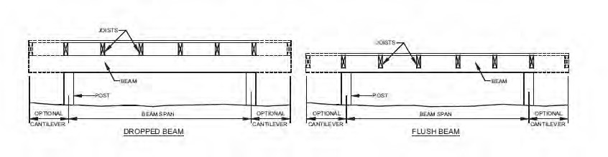

R507.7.1 R507.5.1 Deck post to deck beam. Deck beams shall be attached to deck posts in accordance with Figure R507.7.1 R507.5.1 or by other equivalent means capable to resist lateral displacement.

Manufactured post-to-beam connectors shall be sized for the post and beam sizes. All bolts shall have washers under the head and nut.

Exception: Where deck beams bear directly on footings in accordance with Section R507.8.1 R507.4.1.

R507.5 R507.6 Deck joists. Maximum allowable spans for wood deck joists, as shown in Figure R507.5 R507.6, shall be in accordance with Table R507.5 R507.6. Maximum allowable spacing for joists shall be limited by the decking material in accordance with Table R507.7. Deck joists shall be permitted to cantilever not greater than one-fourth of the actual, adjacent joist span.

R507.5.1 R507.6.1 Lateral restraint at supports. Joist ends and bearing locations shall be provided with lateral restraint to prevent rotation. Where lateral restraint is provided by joist hangers or blocking between joists, their depth shall equal not less than 60 percent of the joist depth. Where lateral restraint is provided by rim joists, they shall be secured to the end of each joist with not less than (3) 10d (3-inch × 0.128-inch) nails or (3) No. 10 × 3-inch (76 mm) long wood screws.

R507.7 R507.6.2 Deck joist and deck beam bearing. The ends of each joist and beam shall have not less than 11 / inches (38 mm) of bearing on wood or metal and not less than 3 inches (76 mm) on concrete or masonry for the entire width of the beam. Joist framing into the side of a ledger board or beam shall be supported by approved joist hangers. Joists bearing on a beam shall be connected to the beam to resist lateral displacement.
2

TABLE R507.5R507.6
DECK JOIST SPANS FOR COMMON LUMBER SPECIES^{f} (ft. - in.)

SPECIESª | SIZE | SPACING OF DECK JOISTS WITH NO CANTILEVER ^{b}  (inches) |  |  | SPACING OF DECK JOISTS WITH CANTILEVERS ^{c,f}  (inches)
 |  | 12 | 16 | 24 | 12 | 16 | 24
Southern pine | 2 × 6 | 9-11 | 9-0 | 7-7 | 6-8 | 6-8 | 6-8
 | 2 × 8 | 13-1 | 11-10 | 9-8 | 10-1 | 10-1 | 9-8
 | 2 × 10 | 16-2 | 14-0 | 11-5 | 14-6 | 14-0 | 11-5
 | 2 × 12 | 18-0 | 16-6 | 13-6 | 18-0 | 16-6 | 13-6
Douglas fir-larch^{d} , hem- fir^{d}spruce-pine-fir^{d} | 2 × 6 | 9-6 | 8-8 | 7-2 | 6-3 | 6-3 | 6-3
 | 2 × 8 | 12-6 | 11-1 | 9-1 | 9-5 | 9-5 | 9-1
 | 2 × 10 | 15-8 | 13-7 | 11-1 | 13-7 | 13-7 | 11-1
 | 2 × 12 | 18-0 | 15-9 | 12-10 | 18-0 | 15-9 | 12-10
Redwood, western cedars, ponderosa pine^{e}, red pine^{e} | 2 × 6 | 8-10 | 8-0 | 7-0 | 5-7 | 5-7 | 5-7
 | 2 × 8 | 11-8 | 10-7 | 8-8 | 8-6 | 8-6 | 8-6
 | 2 × 10 | 14-11 | 13-0 | 10-7 | 12-3 | 12-3 | 10-7
 | 2 × 12 | 17-5 | 15-1 | 12-4 | 16-5 | 15-1 | 12-4
For SI: 1 inch = 25.4 mm, 1 foot = 304.8 mm, 1 pound per square foot = 0.0479 kPa, 1 pound = 0.454 kg.
a. No. 2 grade with wet service factor.
b. Ground snow load, live load = 40 psf, dead load = 10 psf, L/Δ = 360.
c. Ground snow load, live load = 40 psf, dead load = 10 psf, L/Δ = 360 at main span, L/Δ = 180 at cantilever with a 220-pound point load applied to end.
d. Includes incising factor.
e. Northern species with no incising factor
f. Cantilevered spans not exceeding the nominal depth of the joist are permitted.

R507.4 R507.7 Decking. Maximum allowable spacing for joists supporting decking shall be in accordance with Table R507.4R507.7. Wood decking shall be attached to each supporting member with not less than (2) 8d threaded nails or (2) No. 8 wood screws.

TABLE R507.4 R507.7

MAXIMUM JOIST SPACING
MATERIAL TYPE AND NOMINAL SIZE | MAXIMUM ON-CENTER JOIST SPACING
 | Perpendicular to joist | Diagonal to joist ª
1¹ /₄ -inch-thick wood | 16 inches | 12 inches
2-inch-thick wood | 24 inches | 16 inches
Plastic composite | In accordance with Section R507.3R507.2 | In accordance with Section R507.3R507.2
For SI: 1 inch = 25.4 mm, 1 foot = 304.8 mm, 1 degree = 0.01745 rad.
a. Maximum angle of 45 degrees from perpendicular for wood deck boards

R507.8 Vertical and lateral supports Where supported by attachment to an exterior wall, decks shall be positively anchored to the primary structure and designed for both vertical and lateral loads. Such attachment shall not be accomplished by the use of toenails or nails subject ot withdrawal. For decks with cantilevered framing members, connection to exterior walls or other framing members shall be designed and constructed to resist uplift resulting from the full live load specified in Table R301.5 acting on the cantilevered portion of the deck. Where positive connection to the primary building structure cannot be verified during inspection, decks shall be self-supporting.

R507.8.1 Vertical supports. Vertical loads shall be transferred to band joists with ledgers in accordance with this section.

R507.2.1 R507.8.1.1 Ledger details. Deck ledgers installed in accordance with Section R507.2 shall be a minimum 2-inch by 8-inch (51 mm by 203 mm) nominal, pressure-preservative-treated southern pine, incised pressure-preservative-treated Hem-fir, or approved, naturally durable, No. 2 grade or better lumber. Deck ledgers installed in accordance with Section R507.2 shall ledgers shall not support concentrated loads from beams or girders. Deck ledgers shall not be supported on stone or masonry veneer.

R507.2.2 R507.8.1.2 Band joist details. Band joists attached by a ledger in accordance with Section R507.2 shall be a minimum 2-inch-nominal (51 mm), solid-sawn, spruce-pine-fir lumber or a minimum 1- inch by 91 /2-inch (25 mm × 241 mm) dimensional, Douglas fir, laminated veneer lumber. Band joists attached by a ledger in accordance with Section R507.2 shall be fully supported by a wall or sill plate below.

R507.2.3 R507.8.1.3 Ledger to band joist fastener details. Fasteners used in deck ledger connections in accordance with Table R507.2R507.8.1.3(1) shall be hot-dipped galvanized or stainless steel and shall be installed in accordance with Table R507.2.1R507.8.1.3(2) and Figures R507.2.1(1R507.8.1.3(1) and R507.2.1(2R507.8.1.3(2).

R507.2.4 R507.8.2 Deck lateral load connection. The lateral load connection required by Section R507.1 shall be permitted to be in accordance with Figure R507.2.3(1) or R507.2.3(2).

Where the lateral load connection is provided in accordance with Figure R507.2.3(1R507.8.2(1), hold- down tension devices shall be installed in not less than two locations per deck, within 24 inches of each end of the deck. Each device shall have an allowable stress design capacity of not less than 1,500 pounds (6672 N).

Where the lateral load connections are provided in accordance with Figure R507.2.3(2R507.8.2(2), the hold-down tension devices shall be installed in not less than four locations per deck, and each device shall have an allowable stress design capacity of not less than 750 pounds (3336 N).

TABLE R507.2 R507.8.1.3(1)
DECK LEDGER CONNECTION TO BAND JOIST^{a,} ^{b} (Deck live load = 40 psf, deck dead load = 10 psf, snow load ≤ 40 psf)

CONNECTION DETAILS | JOIST SPAN
 | 6′ and less | 6′1″ to 8′ | 8′1² to 10′ | 10′1″ to  12′ | 12′1″ to  14′ | 14′1″ to  16′ | 16′1″ to  18′
 | On-center spacing of fasteners
1 /₂ -inch diameter lag screw with ¹ /₂ -inch maximum sheathing^{c,} ^{d} | 30 | 23 | 18 | 15 | 13 | 11 | 10
1 /₂ -inch diameter bolt with ¹ /₂ -inch maximum sheathing^{d} | 36 | 36 | 34 | 29 | 24 | 21 | 19
1 /₂ -inch diameter bolt with 1-inch maximum sheathing^{e} | 36 | 36 | 29 | 24 | 21 | 18 | 16
For SI: 1 inch = 25.4 mm, 1 foot = 304.8 mm, 1 pound per square foot = 0.0479 kPa.
a. Ledgers shall be flashed in accordance with Section R703.4 to prevent water from contacting the house band joist.
b. Snow load shall not be assumed to act concurrently with live load.
c. The tip of the lag screw shall fully extend beyond the inside face of the band joist.
d. Sheathing shall be wood structural panel or solid sawn lumber.
e. Sheathing shall be permitted to be wood structural panel, gypsum board, fiberboard, lumber or foam sheathing. Up to ¹ /₂ -inch thickness of stacked washers shall be permitted to substitute for up to ¹ /₂ inch of allowable sheathing thickness where combined with wood structural panel or lumber sheathing.

TABLE R507.2.1 R507.8.1.3(2)
PLACEMENT OF LAG SCREWS AND BOLTS IN DECK LEDGERS AND BAND JOIST

MINIMUM END AND EDGE DISTANCES AND SPACING BETWEEN ROWS
 | TOP EDGE | BOTTOM EDGE | ENDS | ROW SPACING
Ledgerª | 2 inches^{d} | 3 /₄ inch | 2 inches^{b} | 1⁵ /₈ inches^{b}
Band Joist^{c} | 3 /₄ inch | 2 inches | 2 inches^{b} | 1⁵ /₈ inches^{b}
For SI: 1 inch = 25.4 mm.
a. Lag screws or bolts shall be staggered from the top to the bottom along the horizontal run of the deck ledger in accordance with Figure R507.2.1(1R507.8.1.3(1).
b. Maximum 5 inches.
c. For engineered rim joists, the manufacturer's recommendations shall govern.
d. The minimum distance from bottom row of lag screws or bolts to the top edge of the ledger shall be in accordance with Figure R507.2.1(1R507.8.1.3(1).

FIGURE R507.7.1 R507.5.1

DECK BEAM TO DECK POST

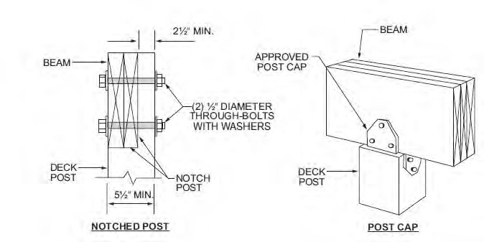
For SI: 1 inch = 25.4 mm.

FIGURE R507.5 R507.6

TYPICAL DECK JOIST SPANS
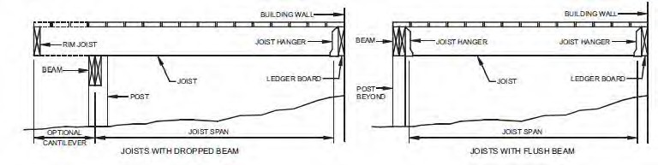

FIGURE R507.2.1(2 R507.8.1.3(2)
PLACEMENT OF LAG SCREWS AND BOLTS IN BAND JOISTS
(Portions of figure not shown remain unchanged)

FIGURE R507.2.1(1) R507.8.1.3(1)
PLACEMENT OF LAG SCREWS AND BOLTS IN LEDGERS
(Portions of figure not shown remain unchanged)

FIGURE R507.2.3(2) R507.8.2(2)
DECK ATTACHMENT FOR LATERAL LOADS
(Portions of figure not shown remain unchanged)

FIGURE R507.2.3(1) R507.8.2(1)
DECK ATTACHMENT FOR LATERAL LOADS
(Portions of figure not shown remain unchanged)

(RB198-16)

Chapter 6 WALL CONSTRUCTION

Revise as follows:

R602.1.3 Structural glued-laminated timbers. Glued-laminated timbers shall be manufactured and identified as required in ANSI/AITC A190.1, ANSI 117 and ASTM D 3737.

(RB189-16)

R602.1.11 Structural insulated panels. Structural insulated panels shall be manufactured and identified in accordance with ANSI/APA PRS 610.1.
(S7780)/(I-Code)

R602.1.3 Structural glued-laminated timbers.
Glued-laminated timbers shall be manufactured and identified as required in ANSI/AITC A190.1, ANSI 117 and ASTM D3737.
(S7949) /(I-Code)

Revise rows 30 and 31 and footnote "f" of Table R602.3(1) as follows:
30 | 3/8" – 1/2" | 6d common (2" × 0.113") nail (subfloor, wall)^{i}  8d common (21/2" × 0.131") nail (roof) | 6 | 12 6^{f}
31 | 19/32" – 1" | 8d common nail (21/2" × 0.131") | 6 | 12 6^{f}

f. Where the ultimate design wind speed is 130 mph or less, nails for attaching wood structural panel roof sheathing to gable end wall framing shall be spaced 6 inches on center. Where the ultimate design wind speed is greater than 130 mph, nails for attaching panel roof sheathing to intermediate supports shall be spaced 6 inches on center for minimum 48-inch distance from ridges, eaves and gable end walls; and 4 inches on center to gable end wall framing.
For wood structural panel roof sheathing attached to gable end roof framing and to intermediate supports within 48 inches of the roof edges and ridges, nails shall be spaced at 4 inches on center where the ultimate design wind speed is greater than 130 mph in Exposure B or greater than 115 mph in Exposure C.
(S8096)/(I-Code)/Delete

R602.3 Design and construction. Where the ultimate design wind speed, V_{ult}, equals or exceeds 115 mph, e Exterior walls of wood-frame construction shall be designed in accordance with Section R301.2.1.1 or ANSI AWC NDS. Where ultimate design wind speed, V_{ult}, is less than 115 mphEexterior walls of wood-frame construction shall be designed and constructed in accordance with the provisions of this chapter and Figures R602.3(1) and R602.3(2), or in accordance with AWC NDS. Components of exterior walls shall be fastened in accordance with Tables R602.3(1) through R602.3(4). Wall sheathing shall be fastened directly to framing members and, where placed on the exterior side of an exterior wall, shall be capable of resisting the wind pressures listed in Table R301.2(2) adjusted for height and exposure using Table R301.2(3) and shall conform to the requirements of Table R602.3(3). Wall sheathing used only for exterior wall covering purposes shall comply with Section R703. Studs shall be continuous from support at the sole plate to a support at the top plate to resist loads perpendicular to the wall. The support shall be a foundation or floor, ceiling or roof diaphragm or shall be designed in accordance with accepted engineering practice.

Exception: Jack studs, trimmer studs and cripple studs at openings in walls that comply with Tables R602.7(1) and R602.7(2).

Delete Section R602.3.1 through Section R602.12.8 including all subsections, tables and figures.

TABLE R602.3(1)
FASTENING SCHEDULE

(table contents not shown for brevity)

TABLE R602.3(2)
ALTERNATE ATTACHMENTS TO TABLE R602.3(1)

(table contents not shown for brevity)

(S8151A1+Original)/(S8227/RB227)/(S8243/RB228)/(S8239/RB226)/(S8247/RB229))/(S7482/RB230-16))/(S7484/RB231-16)/(S7784/I-Code)/(S7786/I-Code)/(S7787/I-Code)/(S7809/I-Code)/ (S8252/I-Code)/(S7946/I-Code)/(S7789/I-Code)/ (S7797/I-Code)/(S7799/I-Code)/(S7799/I-Code)

Delete Section R603, Cold-Formed Steel Wall Framing, in its entirety and replace with the following:

Section R603 COLD-FORMED STEEL WALL FRAMING
R603.1 General. In accordance with Section R301.2.1.1, the design of cold-formed steel wall framing shall be in accordance with AISI S230, Standard for Cold-Formed Steel Framing— Prescriptive Method For One- and Two-Family Dwellings.
(S7857)

Revise as follows:

R606.1 General. Masonry construction shall be designed and constructed in accordance with the provisions of this section and Section R301.2.1.1, TMS 402, TMS 403, or in accordance with the provisions of TMS 402/ ACI 530/ASCE 5 404.
(RB249-16)/S8144 A2+A3+Original)

R606.2.3 AAC masonry. AAC masonry units shall conform to ASTM C1691 and ASTM C 1386 C1693 for the strength class specified.
(S7418)/(S8363)/(I-Code)

R606.2.6 Second hand units. Adhered manufactured stone masonry veneer units. Adhered manufactured stone masonry veneer units shall conform to ASTM C1670.
RENUMBER AND MODIFY REMAINING SECTIONS AS INDICATED.
R606.2.6 7 Second hand units. NO CHANGE TO TEXT.
R606.2.7 8 Mortar. Except for mortars listed in Sections R606.2.8 9, R606.2.9 10 and R606.2.10 11, mortar for use in masonry construction shall meet the proportion specifications of Table R606.2.7 8 or the property specifications of ASTM C270. The type of mortar shall be in accordance with Sections R606.2.7 8.1, R606.2.7 8.2 and R606.2.7 8.3.
R606.2.7 8.1 Foundation walls. NO CHANGE TO TEXT.
R606.2.7 8.2 Masonry in Seismic Design Categories A, B and C. NO CHANGE TO TEXT.
R606.2.7 8.3 Masonry in Seismic Design Categories
D0, D1 and D2. NO CHANGE TO TEXT.
R606.2.8 9 Surface-bonding mortar. Surface-bonding mortar shall comply with ASTM C887. Surface bonding of concrete masonry units shall comply with ASTM C946.
R606.2.9 10 Mortar for AAC masonry. Thin-bed mortar for AAC masonry shall comply with Article 2.1 C.1 of TMS 602/ACI 530.1/ASCE 6. Mortar used for the leveling courses of AAC masonry shall comply with Article 2.1 C.2 of TMS 602/ACI 530.1/ASCE 6.
R606.2.10 11 Mortar for adhered masonry veneer. NO CHANGE TO TEXT.
R606.2.11 12 Grout. Grout shall consist of cementitious material and aggregate in accordance with ASTM C476 or the proportion specifications of Table R606.2.11 12. Type M or Type S mortar to which sufficient water has been added to produce pouring consistency shall be permitted to be used as grout.
R606.2.12 13 Metal reinforcement and accessories. Metal reinforcement and accessories shall conform to Article 2.4 of TMS 602/ACI 530.1/ASCE 6. Where provided in exterior walls, joint reinforcement shall be a minimum No. 9-gauge ladder-type stainless steel, hot dipped galvanized, or epoxy coated in accordance with TMS 602/ACI 530.1/ ASCE 6 Section 2.4E1, 2.4F1b, or 2.4F2a as appropriate
TABLE R606.2.7 8
MORTAR PROPORTIONS^{a, b}
NO CHANGE TO TEXT OF TABLE.
TABLE R606.2.11 12
GROUT PROPORTIONS BY VOLUME FOR MASONRY CONSTRUCTION
NO CHANGE TO TEXT OF TABLE.
(S8373)

R606.6.4 Lateral support. Masonry walls shall be laterally supported in either the horizontal or the vertical direction in accordance with Section R301.2.1.1, TMS 403 or TMS 402/ACI 530/ASCE 5. The maximum spacing between lateral supports shall not exceed the distances in Table R606.6.4. Lateral support shall be provided by cross walls, pilasters, buttresses or structural frame members where the limiting distance is taken horizontally, or by floors or roofs where the limiting distance is taken vertically.
(S8144 A2+A3+Original)

Delete Table R606.6.4 and show as "Reserved:"

TABLE R606.6.4
SPACING OF LATERAL SUPPORT FOR MASONRY WALLS
Reserved

Delete Section R606.6.4.1 through R606.4.2.2 and show as reserved:

R606.6.4.1 Horizontal lateral support. Reserved.
R606.6.4.1.1 Bonding pattern. Reserved.
R606.6.4.1.2 Metal reinforcement. Reserved.
R606.6.4.2 Vertical lateral support. Reserved.
R606.6.4.2.1 Roof structures. Reserved.
R606.4.2.2 Floor diaphragms. Reserved.
Delete Section R606.11 and Figures R606.11(1), R606.11(2), and R606.11(3). Show as "Reserved" to maintain section numbering.
R606.11 Anchorage. Reserved.
FIGURE R606.11(1)
ANCHORAGE REQUIREMENTS FOR MASONRY WALLS LOCATED IN SEISMIC DESIGN CATEGORY A, B OR C AND WHERE WIND LOADS ARE LESS THAN 30 PSF
(Reserved)

FIGURE R606.11(2)
REQUIREMENTS FOR REINFORCED GROUTED MASONRY CONSTRUCTION IN SEISMIC DESIGN CATEGORY C
(Reserved)

FIGURE R606.11(3)
REQUIREMENTS FOR REINFORCED MASONRY CONSTRUCTION IN SEISMIC DESIGN CATEGORY D0, D1 OR D2
(Reserved)

Delete Section R606.12 including all subsections, figures, and tables. Show as reserved to maintain section numbering.
(S8144 A2+A3+Original)

R609.7.2.1 Masonry, concrete or other structural substrate.
Where the wood shim or buck thickness is less than 1-1/2 inches (38 mm), window and glass door assemblies shall be anchored through the jamb, or by jamb clip and anchors shall be embedded directly into the masonry, concrete or other substantial substrate material. Unless otherwise tested, bucks shall extend beyond the interior face of the window or door frame such that full support of the frame is provided. Anchors shall adequately transfer load from the window or door frame into the rough opening substrate [see Figures R609.7.2(1) and R6097.2(2)].

Where the wood shim or buck thickness is 1-1/2 inches (38 mm) or more, and the buck is securely fastened to the masonry, concrete or other substantial substrate, and the buck extends beyond the interior face of the window or door frame, window and glass door assemblies shall be anchored through the jamb, or by jamb clip, or through the flange to the secured wood buck. Unless otherwise tested, bucks shall extend beyond the interior face of the window or door frame such that full support of the frame is provided. Anchors shall be embedded into the secured wood buck to adequately transfer load from the window or door frame assembly [see Figures R609.7.2(3), R6097.2(4) and R609.7.2(5)].
(S8222-R1)

SECTIONR610
STRUCTURAL INSULATED PANEL WALL
CONSTRUCTION
R610.1 General.
No change
R610.2 Applicability limits.
The provisions of this section shall control the construction of exterior structural insulated panel walls and interior load-bearing structural insulated panel walls for buildings not greater than 60 feet (18 288 mm) in length perpendicular to the joist or truss span, not greater than 40 feet (12 192 mm) in width parallel to the joist or truss span and not greater than two stories in height with each wall not greater than 10 feet (3048 mm) high. Exterior walls installed in accordance with the provisions of this section shall be considered as load-bearing walls. Structural insulated panel walls constructed in accordance with the provisions of this section shall be limited to sites where the ultimate design wind speed (Vult) is not greater than 155 miles per hour (69 m/s), Exposure B or 140 miles per hour (63 m/s) Exposure C, the ground snow load is not greater than 70 pounds per square foot (3.35 kPa), and the seismic design category is A, B or C.

R610.3 Materials.
SIPs shall comply with the following criteria requirements of ANSI/APA PRS 610.1:
R610.3.1 Core.
The core material shall be composed of foam plastic insulation meeting one of the following requirements:
1. 1.ASTM C578 and have a minimum density of 0.90 pounds per cubic feet (14.4 kg/m3).
2. 2.Polyurethane meeting the physical properties shown in Table R610.3.1.
3. 3.An approved alternative.
All cores shall meet the requirements of Section R316.

TABLE R610.3.1
MINIMUM PROPERTIES FOR POLYURETHANE INSULATION USED AS SIPS CORE
PHYSICAL PROPERTY | POLYURETHANE
Density, core nominal (ASTM D1622) | 2.2 lb/ft3
Compressive resistance at yield or 10% deformation, whichever occurs first (ASTM D1621) | 19 psi (perpendicular to rise)
Flexural strength, min. (ASTM C203) | 30 psi
Tensile strength, min. (ASTM D1623) | 35 psi
Shear strength, min. (ASTM C273) | 25 psi
Substrate adhesion, min. (ASTM D1623) | 22 psi
Water vapor permeance of 1.00-in. thickness, max. (ASTM E96) | 2.3 perm
Water absorption by total immersion, max. (ASTM C272) | 4.3% (volume)
Dimensional stability (change in dimensions), max. [ASTM D2126 (7 days at 158°F/100% humidity and 7 days at -20°F)] | 2%
For SI: 1 pound per cubic foot = 16.02 kg/m3, 1 pound per square inch = 6.895 kPa, °C = [(°F) - 32]1.8.

R610.3.2 Facing.
Facing materials for SIPs shall be wood structural panels conforming to DOC PS 1 or DOC PS 2, each having a minimum nominal thickness of 7/16 inch (11 mm) and shall meet the additional minimum properties specified in Table R610.3.2. Facing shall be identified by a grade mark or certificate of inspection issued by an approved agency.

TABLE R610.3.2
MINIMUM PROPERTIESa FOR ORIENTED STRAND BOARD FACER MATERIAL IN SIP WALLS
THICKNESS(in.) | PRODUCT | FLATWISE STIFFNESSb(lbf-in2/ft) |  | FLATWISE STRENGTHc(lbf-in/ft) |  | TENSIONc(lbf/ft) |  | DENSITYd(pcf)
 |  | Along | Across | Along | Across | Along | Across
7/16 | Sheathing | 55,600 | 16,500 | 1,040 | 460 | 7,450 | 5,800 | 34
For SI: 1 inch = 25.4 mm, 1 lbf-in2/ft = 9.415 × 10-6 kPa/m, 1 lbf-in/ft = 3.707 × 10-4 kN/m, 1 lbf/ft = 0.0146 N/mm, 1 pound per cubic foot = 16.018 kg/m3.
1. a.Values listed in Table R610.3.2 are qualification test values and are not to be used for design purposes.
2. b.Mean test value shall be in accordance with Section 7.6 of DOC PS 2.
3. c.Characteristic test value (5th percent with 75% confidence).
4. d.Density shall be based on oven-dry weight and oven-dry volume.

R610.3.3 Adhesive.
Adhesives used to structurally laminate the foam plastic insulation core material to the structural wood facers shall conform to ASTM D2559 or approved alternative specifically intended for use as an adhesive used in the lamination of structural insulated panels. Each container of adhesive shall bear a label with the adhesive manufacturer’s name, adhesive name and type and the name of the quality assurance agency.

R610.3.41 Lumber.
The minimum lumber framing material used for SIPs prescribed in this document is NLGA graded No. 2 Spruce-pine-fir. Substitution of other wood species/grades that meet or exceed the mechanical properties and specific gravity of No. 2 Spruce-pine-fir shall be permitted.

R610.3.52 SIP screws.
Screws used for the erection of SIPs as specified in Section R610.5 shall be fabricated from steel, shall be provided by the SIP manufacturer and shall be sized to penetrate the wood member to which the assembly is being attached by not less than 1 inch (25 mm). The screws shall be corrosion resistant and have a minimum shank diameter of 0.188 inch (4.7 mm) and a minimum head diameter of 0.620 inch (15.5 mm).

R610.3.63 Nails.
Nails specified in Section R610 shall be common or galvanized box unless otherwise stated.

R610.4 SIP wall panels.
SIPs shall comply with Figure R610.4 and shall have minimum panel thickness in accordance with Tables R610.5(1) and R610.5(2) for above-grade walls. SIPs shall be identified by grade mark or certificate of inspection issued by an approved agency in accordance with ANSI/APA PRS 610.1.
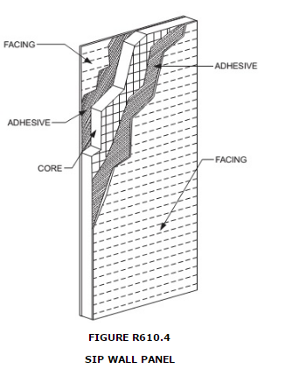

R610.4.1 Labeling.
Panels shall be identified by grade mark or certificate of inspection issued by an approved agency. Each (SIP) shall bear a stamp or label with the following minimum information:
1. 1.Manufacturer name/logo.
2. 2.Identification of the assembly.
3. 3.Quality assurance agency.

R610.5 Wall construction.
Exterior walls of SIP construction shall be designed and constructed in accordance with the provisions of this section and Tables R610.5(1) and R610.5(2) and Figures R610.5(1) through R610.5(5). SIP walls shall be fastened to other wood building components in accordance with Tables R602.3(1) through R602.3(4). Framing shall be attached in accordance with Table R602.3(1) unless otherwise provided for in Section R610.
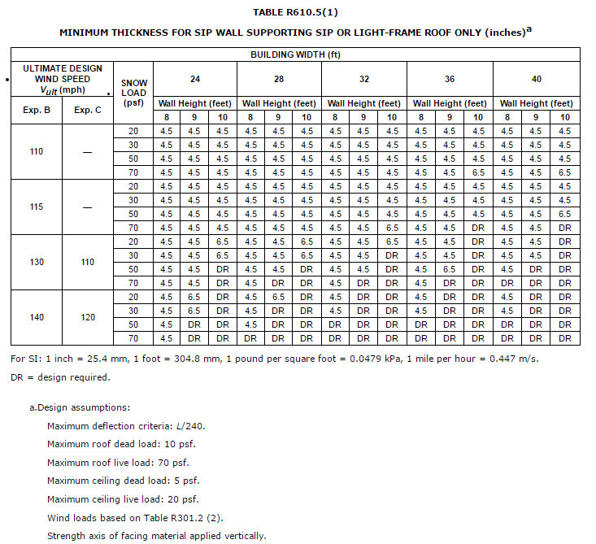
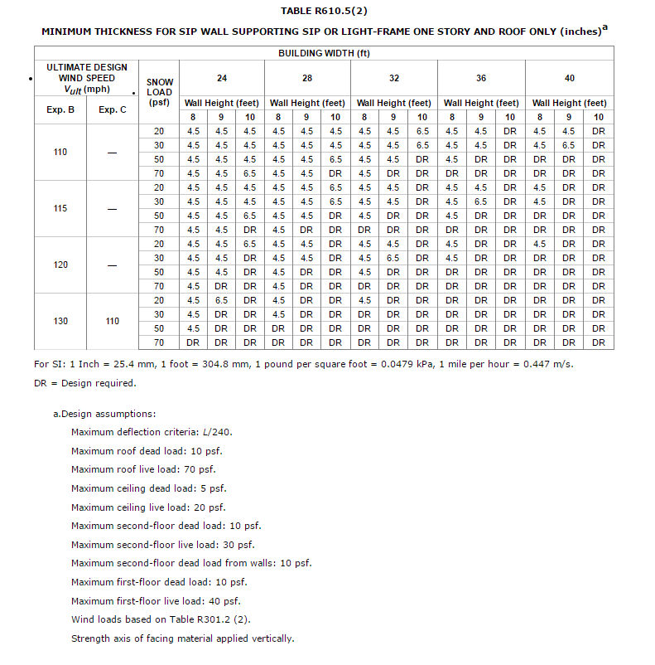
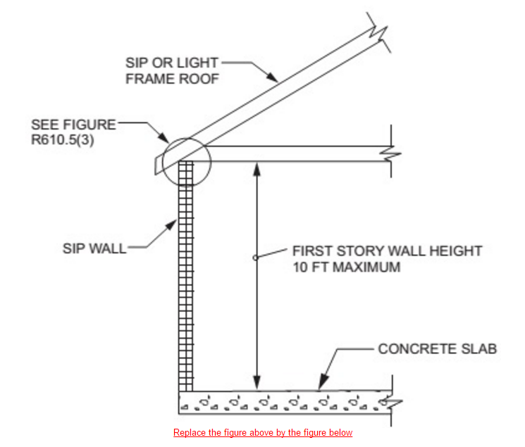
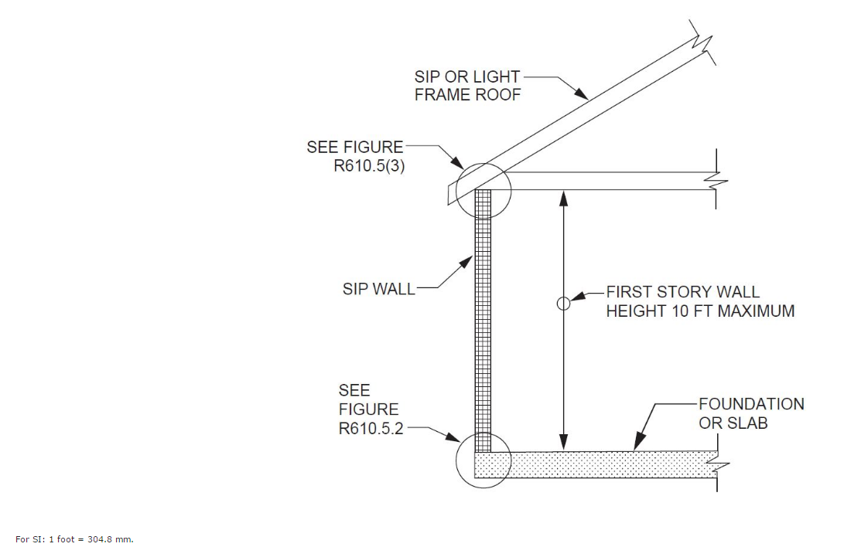
Note: Figures illustrate SIP-specific attachment requirements. Other connections shall be made in accordance with Tables R602.3(1) and (2), as appropriate.
FIGURE R610.5(1)
MAXIMUM ALLOWABLE HEIGHT OF SIP WALLS
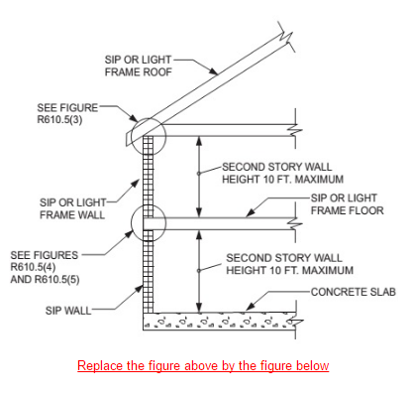
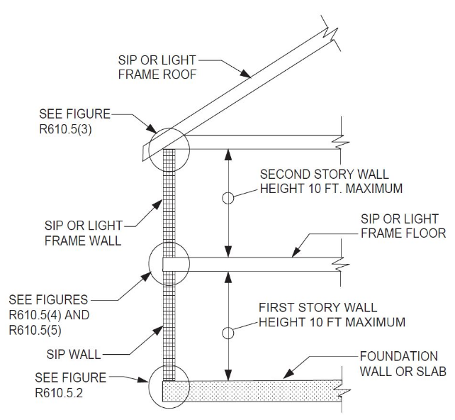
For SI: 1 inch = 25.4 mm.
Note: Figures illustrate SIP-specific attachment requirements. Other connections shall be made in accordance with Tables R602.3(1) and (2), as appropriate.
FIGURE R610.5(2)
MAXIMUM ALLOWABLE HEIGHT OF SIP WALLS
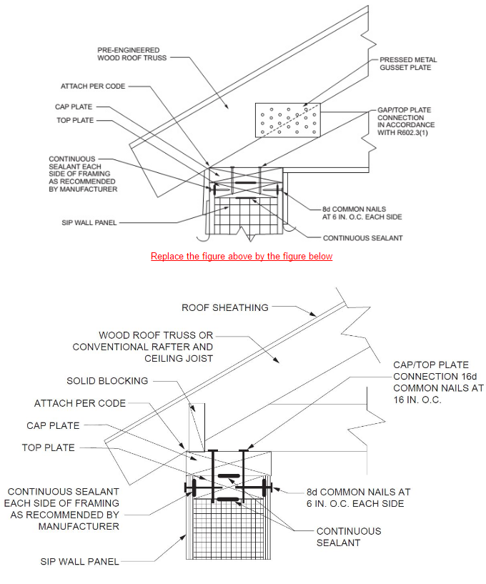
For SI: 1 inch = 25.4 mm.
Note: Figures illustrate SIP-specific attachment requirements. Other connections shall be made in accordance with Tables R602.3(1) and (2) as appropriate.
FIGURE R610.5(3)
TRUSSED ROOF TO TOP PLATE CONNECTION
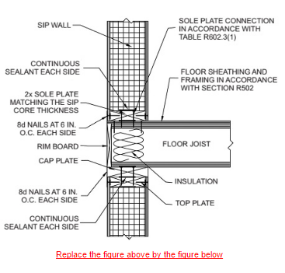
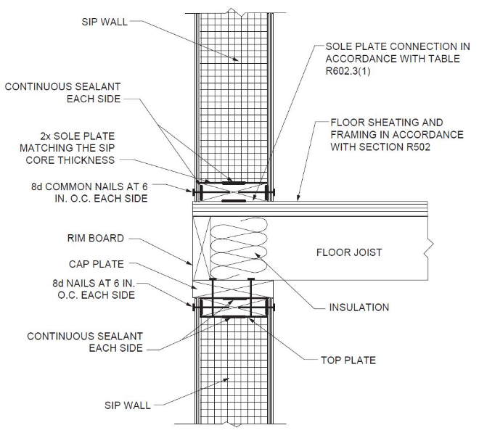
For SI: 1 inch = 25.4 mm.

Note: Figures illustrate SIP-specific attachment requirements. Other connections shall be made in accordance with Tables R602.3(1) and (2), as appropriate.

FIGURE R610.5(4)
SIP WALL-TO-WALL PLATFORM FRAME CONNECTION
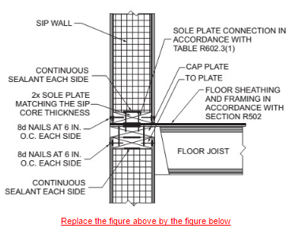
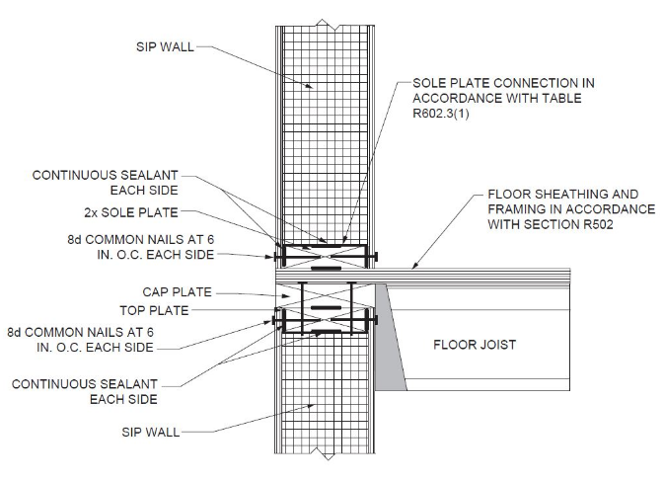
For SI: 1 inch = 25.4 mm.
Note: Figures illustrate SIP-specific attachment requirements. Other connections shall be made in accordance with Tables R602.3(1) and (2), as appropriate.

FIGURE R610.5(5)
SIP WALL-TO-WALL BALLOON FRAME HANGING FLOOR CONNECTION
(I-Joist floor shown for Illustration only)

R610.5.1 Top plate connection.
SIP walls shall be capped with a double top plate installed to provide overlapping at corner, intersections and splines in accordance with Figure R610.5.1. The double top plates shall be made up of a single 2 by top plate having a width equal to the width of the panel core, and shall be recessed into the SIP below. Over this top plate a cap plate shall be placed. The cap plate width shall match the SIP thickness and overlap the facers on both sides of the panel. End joints in top plates shall be offset not less than 24 inches (610 mm).
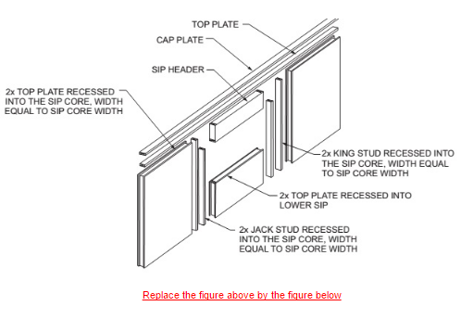
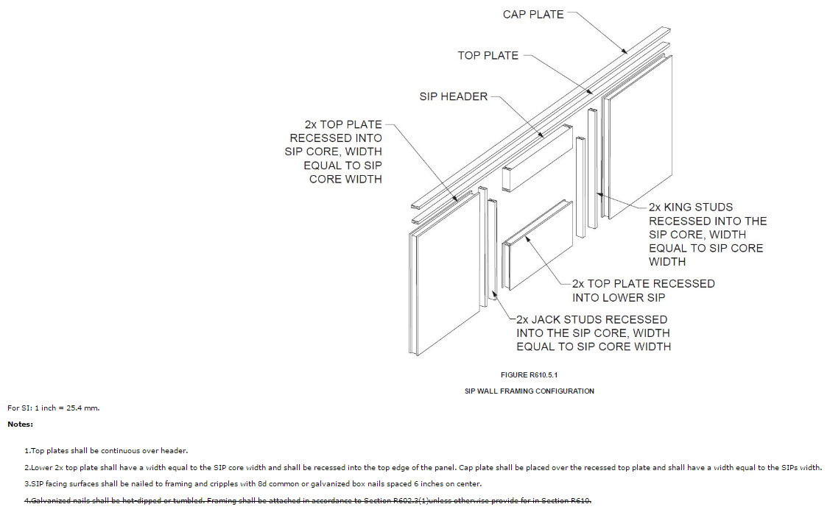
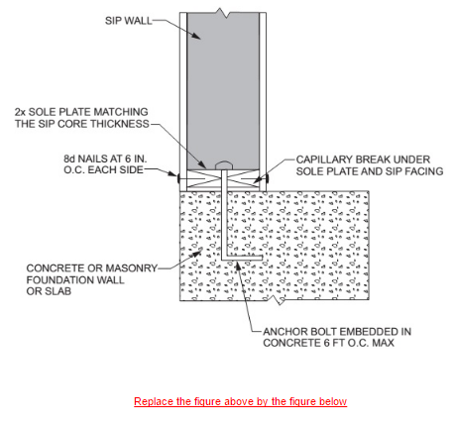

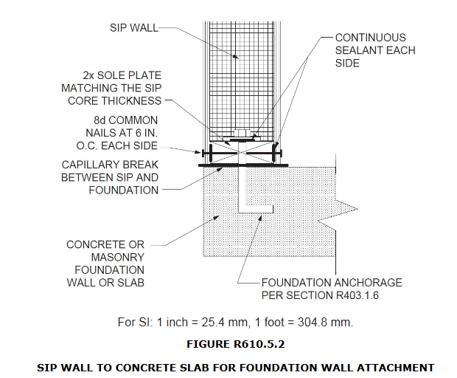

R610.5.3 Panel-to-panel connection.
SIPs shall be connected at vertical in-plane joints in accordance with Figure R610.8 or by other approved methods.

R610.5.4 Corner framing.
Corner framing of SIP walls shall be constructed in accordance with Figure R610.5.4.

R610.5.3 Wall bracing.
SIP walls shall be braced in accordance with Section R602.10. SIP walls shall be considered continuous wood structural panel sheathing (Bracing Method CS-WSP) for purposes of computing required bracing. SIP walls shall meet the requirements of Section R602.10.4.2 except that SIP corners shall be fabricated as shown in Figure R610.9. Where SIP walls are used for wall bracing, the SIP bottom plate shall be attached to wood framing below in accordance with Table R602.3(1).

R610.6 Interior load-bearing walls.
Interior load-bearing walls shall be constructed as specified for exterior walls.

R610.7 Drilling and notching.
The maximum vertical chase penetration in SIPs shall have a maximum side dimension of 2 inches (51 mm) centered in the panel. Vertical chases shall have a minimum spacing of 24 inches (610 mm) on center. A maximum of two horizontal chases shall be permitted in each wall panel—one at 14 inches (360 mm) plus or minus 2 inches (51 mm) from the bottom of the panel and one at 48 inches (1220 mm) plus or minus 2 inches (51 mm) from the bottom edge of the SIPs panel. Additional penetrations are permitted where justified by analysis.

R610.8 Connection.
SIPs shall be connected at vertical in-plane joints in accordance with Figure R610.8 or by other approved methods.
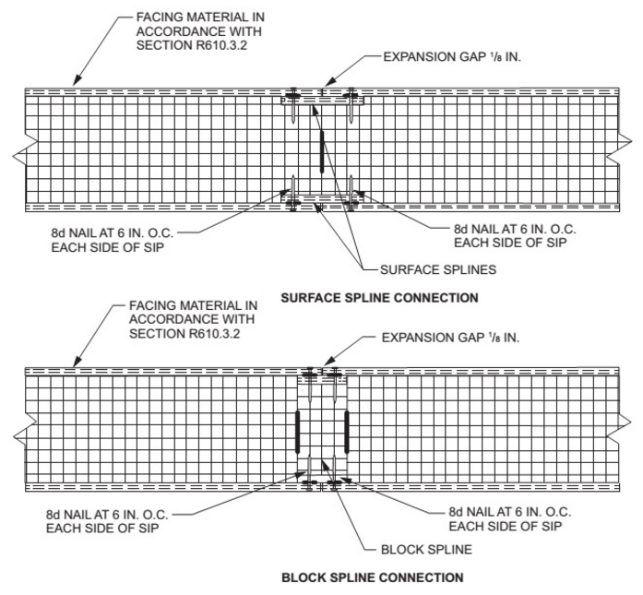
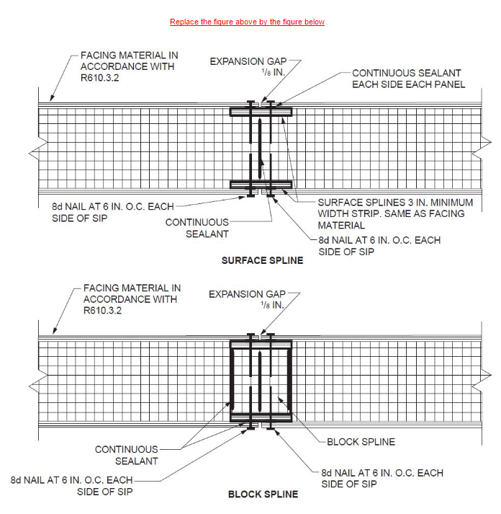
For SI: 1 inch = 25.4 mm.
FIGURE R610.8

TYPICAL SIP WALL PANEL-TO-PANEL CONNECTION DETAILS FOR VERTICAL IN-PLANE JOINTS
R610.9 Corner framing.
Corner framing of SIP walls shall be constructed in accordance with Figure R610.9.
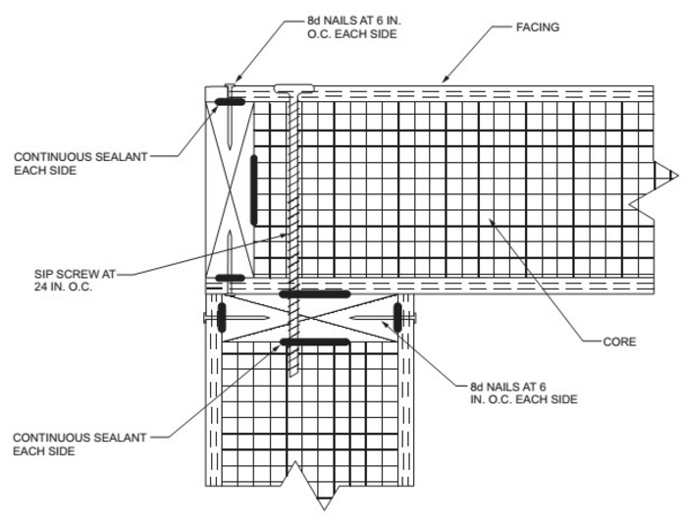
Replace the figure above by the figure below
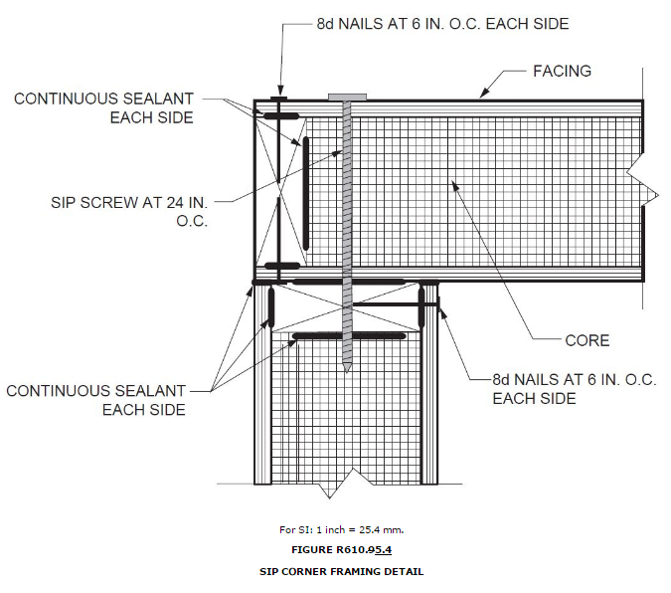
R610.108 Headers.
SIP headers shall be designed and constructed in accordance with Table R610.108 and Figure R610.5.1. SIP headers shall be continuous sections without splines. Headers shall be not less than 117/8 inches (302 mm) deep. Headers longer than 4 feet (1219 mm) shall be constructed in accordance with Section R602.7. The strength axis of the factors on the header shall be oriented horizontally.
TABLE R610.108
MAXIMUM SPANS FOR 117/8-INCH-DEEP OR DEEPER SIP HEADERS (feet)ª

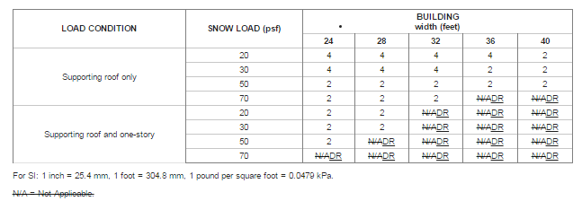

a. Design assumptions:
Maximum deflection criterion: L/360240.
Maximum roof dead load: 10 psf.
Maximum ceiling load: 5 psf.
Maximum ceiling live load: 20 psf.
Maximum second-floor live load: 30 psf.
Maximum second-floor dead load: 10 psf.
Maximum second-floor dead load from walls: 10 psf.
Maximum first-floor dead load: 10 psf.
Wind load based on Table R301.2(2).
Strength axis of facing material applied horizontally.
DR = Design Required
b. Building width is in the direction of horizontal framing members supported by the header.
c. The table provides for roof slopes between 3:12 and 12:12.
d. The maximum roof overhang is 24 inches (610 mm).

R610.108.1 Wood structural panel box headers.
Wood structural panel box headers shall be allowed where SIP headers are not applicable. Wood structural panel box headers shall be constructed in accordance with Figure R602.7.3 and Table R602.7.3.
(S7781)/(I-Code)

Chapter 7 WALL COVERING

Revise as follows:

R702.3.3 Cold-formed steel framing. Cold-formed steel framing supporting gypsum board and gypsum panel products shall be not less than 11/4 inches (32 mm) wide in the least dimension. Non-load-bearing cold-formed steel framing shall comply with AISI S220 and ASTM C645, Section 10. Load-bearing cold- formed steel framing shall comply with AISI S200 and ASTM C 955, Section 8 S240.
(S8355)/(S7989) /(I-Code)

R702.7.3 Minimum clear airspaces and vented openings for vented cladding.
For the purposes of this section, vented cladding shall include the following minimum clear airspaces. Other openings with the equivalent vent area shall be permitted.
1. Vinyl lap, polypropylene, or horizontal aluminum siding applied over a weather-resistive barrier as specified in Table R703.3(1).
2. Brick veneer with a clear airspace as specified in Table R703.8.4.
3. Other approved vented claddings.
(S7707) /(I-Code)

R703.1.1 Water resistance. The exterior wall envelope shall be designed and constructed in a manner that prevents the accumulation of water within the wall assembly by providing a water-resistant barrier behind the exterior veneer as required by Section R703.2 and a means of draining to the exterior water that enters the assembly. Protection against condensation in the exterior wall assembly shall be provided in accordance with Section R702.7 of this code.
Exceptions:
1. A weather-resistant exterior wall envelope shall not be required over concrete or masonry walls designed in accordance with Chapter 6 and flashed in accordance with Section R703.4. or R703.8.
2. Compliance with the requirements for a means of drainage, and the requirements of Sections R703.2 and R703.4, shall not be required for an exterior wall envelope that has been demonstrated to resist wind-driven rain through testing of the exterior wall envelope, including joints, penetrations and intersections with dissimilar materials, in accordance with ASTM E331 under the following conditions:

REMAINDER OF SECTION UNCHANGED.
(S8387) /(I-Code)

R703.1.1 Water resistance. The exterior wall envelope shall be designed and constructed in a manner that prevents the accumulation of water within the wall assembly by providing a water-resistant

barrier behind the exterior veneer cladding as required by Section R703.2 and a means of draining to the exterior water that enters the assembly. Protection against condensation in the exterior wall assembly shall be provided in accordance with Section R702.7 of this code penetrate the exterior cladding.
(S7779) /(I-Code)

R703.2 Water-resistive barrier. One layer of No. 15 asphalt felt, free from holes and breaks, complying with ASTM D226 for Type 1 felt or other approved water-resistive barrier shall be applied over studs or sheathing of all exterior walls. SuchNo.15 asphalt felt or material shall be applied horizontally, with the upper layer lapped over the lower layer not less than 2 inches (51 mm). Where joints occur, felt shall be lapped not less than 6 inches (152 mm). The Other approved materials shall be installed in accordance with the water-resistive barrier manufacturer’s installation instructions. The No. 15 asphalt felt or other approved water-resistive barrier material shall be continuous to the top of walls and terminated at penetrations and building appendages in a manner to meet the requirements of the exterior wall envelope as described in Section R703.1. The water-resistive barrier is not required for detached accessory buildings.
(S8352) /(I-Code)

R703.4 Flashing. Approved corrosion-resistant metal flashing, vinyl flashing, self-adhered membranes and mechanically attached flexible flashing shall be applied shingle-fashion in a manner to prevent entry of water into the wall cavity or penetration of water the building structural framing components. or in accordance with the manufacturer’s instructions. Metal flashing shall be corrosion resistant. Fluid-applied membranes used as flashing shall be applied in accordance with the manufacturer's instructions. All flashing shall be applied in a manner to prevent the entry of water into the wall cavity or penetration of water to the building structural framing components. Self-adhered membranes used as flashing shall comply with AAMA 711. All exterior fenestration products shall be sealed at the juncture with the building wall with a sealant complying with AAMA 800 or ASTM C920 Class 25 Grade NS or greater for proper joint expansion and contraction, ASTM C1281, AAMA 812, or other approved standard as appropriate for the type of sealant. Fluid-applied membranes used as flashing in exterior walls shall comply with AAMA 714. The flashing shall extend to the surface of the exterior wall finish. Approved corrosion resistant flashing shall be installed at the following locations:
(S8396 A1 Only)

R703.7 Exterior plaster. Installation of these materials shall be in compliance with ASTM C926, ASTM C1063 or C1787 and the provisions of this code.
R703.7.1 Lath. Lath and lath attachments shall be of corrosion-resistant materials. Expanded metal or woven wire lath shall be attached with 11/2- 1 ½ inch-long (38 mm), 11
gage nails having a 7/16-inch (11.1 mm) head, or 7/8 1-1/2-inch long (22.2 mm), 16 gage staples, spaced not more than 6 inches (152 mm) in accordance with ASTM C1063 or C17887, or as otherwise approved.

Rationale:
- A. C1063 is specifically for metal lath. However, there is a standard for Non-Metallic Lath, C1787; which has FBC approval and is recognized and referenced in C926. The proposal clarifies already approved products and methods.
- B. 7/8-inch staples are approved for open-framed construction only; which we do not have in Florida where framed walls are sheathed. To achieve the required penetration ¾-inch into framing members, a staple would need to be 1-1/2 inch to accommodate ½ sheathing. Sheathing is not a framing member as defined in C1063 and referenced in C1787. The change clarifies the requirement and eliminates confusion.

C1063. 3.2.4 framing member, n—studs, joist, runners (track), bridging, bracing, and related accessories manufactured or supplied in wood or light gauge steel.
- C. C1063 requires lath fasteners at, “not more than 7 inches on center, along framing members…” However, there are other requirements for different types of lath. As such, it would be better to direct the user to the appropriate referenced ASTM standard which includes all the requirements for each specific condition rather than to have one requirement that does not address all installations.

R703.7.2 Plaster. Plastering with portland cement plaster shall be not less than three coats where applied over metal any type of code-approved lath or wire lath and shall be not less than two coats where directly applied over masonry, concrete, clay brick, stone or tile. pressure-preservative treated wood or decay-resistant wood as specified in Section R317.1 or gypsum backing. If the plaster surface is completely covered by veneer or other facing material or is completely concealed, plaster application need be only two coats, provided the total thickness is as set forth in Table R702.1(1).
On wood-frame construction with an on-grade floor slab system, exterior plaster shall be applied to cover, but not extend below, lath, paper and screed. Cement plaster shall be in accordance with ASTM C926. Cement materials shall be in accordance with one of the following:
- Masonry cement conforming to ASTM C91 Type M, S or N.
- Portland cement conforming to ASTM C150 Type I, II or III.
- Blended hydraulic cement conforming to ASTM C595 Type IP, IS(S<70), IL or IT(S<70).
- Hydraulic cement conforming to ASTM C1157 Type GU, HE, MS, HS or MH.
- Plaster (stucco) cement conforming to ASTM C1328.

On wood-frame construction with an on-grade floor system, exterior plaster shall be applied to cover, but not extend below, lath, paper and screed.
The proportion of aggregate to cementitious material shall be as set in Table R702.1(3).

Use corrected (simple editorial changes) Table R702.1(3) as included with the original proposed Modification S7833, with one additional editorial change. In column 3 top row the “I(S<70)” is missing an “S” should be “IS(S<70)”.

I could not reproduce the Table in the same format.

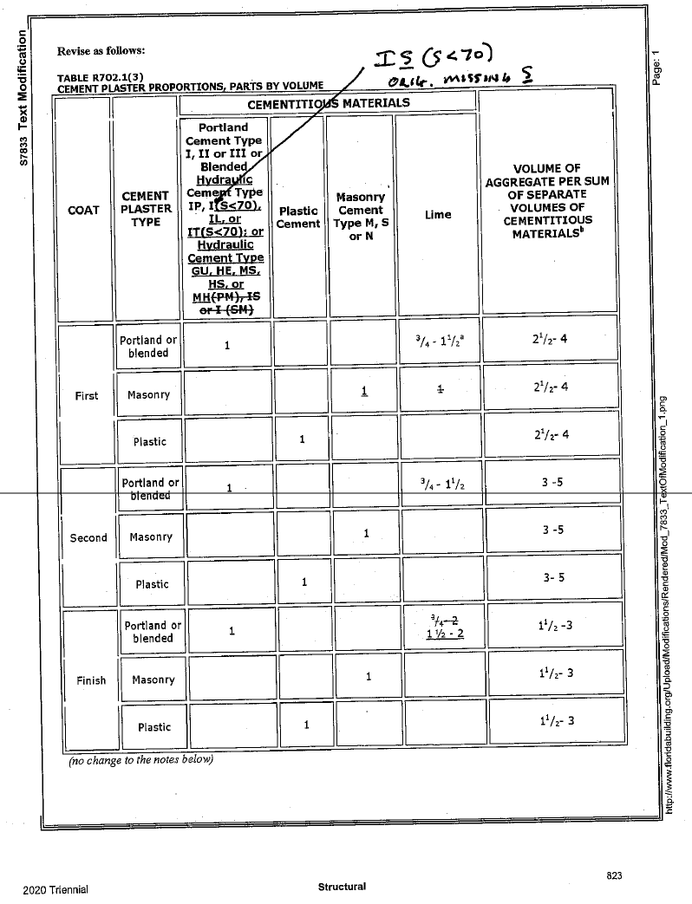

(S7833 commission)

Section: R703.8.4

TABLE R703.8.4

TIE ATTACHMENT AND AIRSPACE REQUIREMENTS

BACKING AND TIE | MINIMUM TIE | MINIMUM TIE FASTENERª | AIRSPACE^{c}
Wood stud backing with  corrugated sheet metal | 22 U.S. gauge  (0.0299 in.) × ⁷ /₈in.  wide | 8d common nail ^{b}  (2¹ /₂ in. × 0.131 in.) | Nominal 1 in. between sheathing and veneer
Wood stud backing with metal strand wire | W1.7 (No. 9 U.S. gauge;  0.148 in.) with hook embedded in mortar joint | 8d common nail ^{b}(2¹ /₂in. ×  0.131 in.) | Minimum nominal 1 in. between sheathing and veneer | Maximum 4¹ /₂in. between backing and veneer
Cold-formed steel stud backing with adjustable metal strand wire | W1.7 (No. 9 U.S. gauge;  0.148 in.) with hook embedded in mortar joint | No. 10 screw extending through the steel framing a minimum of three exposed threads | Minimum nominal 1 in. between sheathing and veneer | Maximum 4¹ /₂in. between backing and veneer
For SI: 1 inch = 25.4 mm.
a. In Seismic Design Category D ₀ , D ₁ or D ₂ , the minimum tie fastener shall be an 8d ring-shank nail (2 ¹ / ₂ in. × 0.131 in.) or a No. 10 screw extending through the steel framing a minimum of three exposed threads.
b. All fasteners shall have rust-inhibitive coating suitable for the installation in which they are being used, or be manufactured from material not susceptible to corrosion.
c. An airspace that provides drainage shall be permitted to contain some mortar from construction.
(S7627) /(I-Code)

R703.8.4 Anchorage.
Masonry veneer shall be anchored to the supporting wall studs with corrosion-resistant metal ties embedded in mortar or grout and extending into the veneer a minimum of 11/2 inches (38 mm), with not less than 5/8-inch (15.9 mm) mortar or grout cover to outside face. Masonry veneer shall conform to Table R703.8.4(1). For masonry veneer tie attachment through insulating sheathing not greater than 2 inches (51 mm) in thickness to not less than 7/16 performance category wood structural panel, see Table R703.8.4(2).

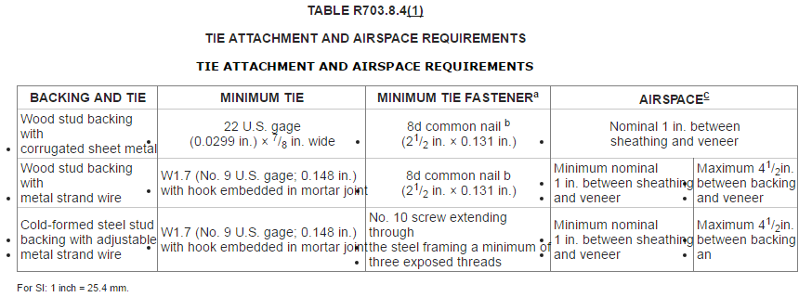
a. In Seismic Design Category D0, D1 or D2, the minimum tie fastener shall be an 8d ring-shank nail (21/2 in. × 0.131 in.) or a No. 10 screw extending through the steel framing a minimum of three exposed threads.
b. All fasteners shall have rust-inhibitive coating suitable for the installation in which they are being used, or be manufactured from material not susceptible to corrosion.
c. An airspace that provides drainage shall be permitted to contain mortar from construction.

Add the following new Table R703.8.4(2)
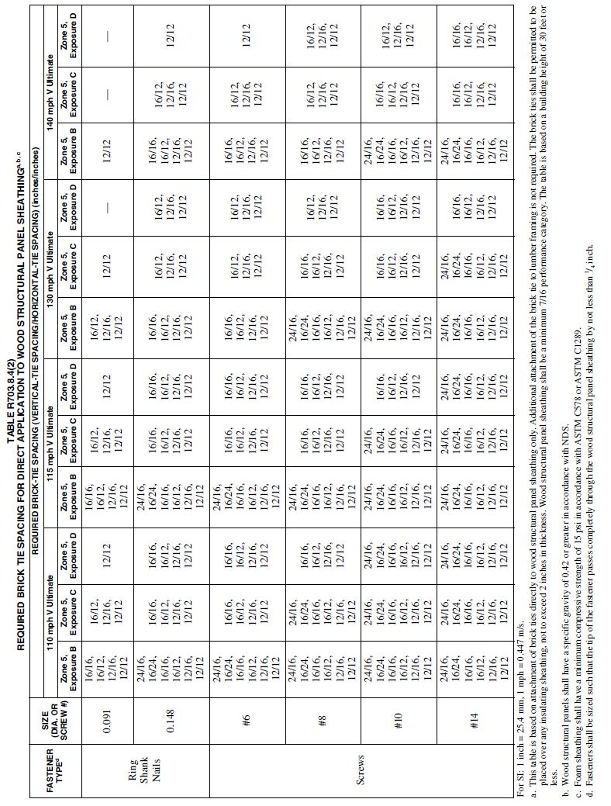

(S7844) /(I-Code)

Delete without substitution:

R703.11.2.3 Manufacturer specification.
Where the vinyl siding manufacturer’s product specifications provide an approved design wind pressure rating for installation over foam plastic sheathing, use of this design wind pressure rating shall be permitted and the siding shall be installed in accordance with the manufacturer’s instructions.
(S7746) /(I-Code)

R703.14 Polypropylene siding.

Polypropylene siding shall be certified and labeled as conforming to the requirements of ASTM D7254 and those of Section R703.14.3 by an approved quality control agency and shall conform to the fire separation distance requirements of Section R703.14.2.
(F7711) /(I-Code)

R703.14.3 Flame spread index.
The certification of the flame spread index shall be accompanied by a test report stating that all portions of the test specimen ahead of the flame front remained in position during the test in accordance with ASTM E84 or UL 723.
(F7711) /(I-Code)

Section: R703.16.1, R703.16.2
Revise as follows:

TABLE R703.16.1

CLADDING MINIMUM FASTENING REQUIREMENTS FOR DIRECT ATTACHMENT OVER FOAM PLASTIC SHEATHING TO SUPPORT CLADDING WEIGHTª
CLADDING FASTENER THROUGH  FOAM SHEATHING INTO: | CLADDING FASTENER TYPE AND MINIMUM SIZE^{b} | CLADDING FASTENER VERTICAL SPACING  (inches) | MAXIMUM THICKNESS OF FOAM SHEATHING^{c}  (inches)
 |  |  | 16? o.c. Fastener Horizontal Spacing |  |  |  | 24" o.c. Fastener Horizontal Spacing
 |  |  | Cladding Weight: |  |  |  | Cladding Weight:
 |  |  | 3 psf | 11 psf | 18 psf | 25 psf | 3  psf | 11 psf | 18  psf | 25 psf
Steel Framing (minimum penetration of steel thickness + 3  threads) | No. 8 screw  into 33 mil steel  or thicker | 6 | 3.00 | 2.953 | 2.20 | 1.45 | 3.00 | 2.35 | 1.25 | DR
 |  | 8 | 3.00 | 2.55 | 1.60 | 0.605 | 3.00 | 1.805 | DR | DR
 |  | 12 | 3.00 | 1.805 | DR | DR | 3.00 | 0.6575 | DR | DR
 | No. 10  screw into 33 mil steel | 6 | 4.00 | 3.50 | 2.70 | 1.952 | 4.00 | 2.903 | 1.70 | 0.55
 |  | 8 | 4.00 | 3.10 | 2.05 | 1.00 | 4.00 | 2.25 | 0.70 | DR
 |  | 12 | 4.00 | 2.25 | 0.70 | DR | 3.70 | 1.05 | DR | DR
 | No. 10  screw into 43 mil steel or thicker | 6 | 4.00 | 4.00 | 4.00 | 3.60 | 4.00 | 4.00 | 3.45 | 2.70
 |  | 8 | 4.00 | 4.00 | 3.70 | 3.002 | 4.00 | 3.85 | 2.80 | 1.805
 |  | 12 | 4.00 | 3.85 | 2.80 | 1.805 | 4.00 | 3.05 | 1.50 | DR
For SI: 1 inch = 25.4 mm, 1 mil = 0.0254 mm, 1 pound per square foot = 0.0479 kPa, 1 pound per square inch = 6.895 kPa. DR = Design required.
o.c. = on center

a. Steel framing shall be minimum 33 ksi steel for 33 mil and 43 mil steel, and 50 ksi steel for 54 mil steel or thicker.
b. Screws shall comply with the requirements of ASTM C1513.
c. Foam sheathing shall have a minimum compressive strength of 15 psi in accordance with ASTM C 578 or ASTM C1289.

TABLE R703.16.2
FURRING MINIMUM FASTENING REQUIREMENTS FOR APPLICATION OVER FOAM PLASTIC SHEATHING TO SUPPORT CLADDING WEIGHTª
FURRING MATERIAL | FRAMING MEMBER | FASTENER TYPE AND MINIMUM SIZE^{b} | MINIMUM PENETRATION INTO WALL FRAMING  (inches) | FASTENER SPACING IN FURRING  (inches) | MAXIMUM THICKNESS OF FOAM SHEATHING^{d}  (inches)
 |  |  |  |  | 16? o.c. Furringe |  |  |  | 24? o.c. Furringe
 |  |  |  |  | Cladding Weight: |  |  |  | Cladding Weight:
 |  |  |  |  | 3  psf | 11  psf | 18  psf | 25  psf | 3 psf | 11  psf | 18  PSF | 25 psf
Minimum 33 mil Steel Furring or Minimum 1  × Wood Furring^{c} | 33 mil Steel Stud | No. 8  screw | Steel thickness + 3 threads | 12 | 3.00 | 1.805 | DR | DR | 3.00 | 0.65 | DR | DR
 |  |  |  | 16 | 3.00 | 1.00 | DR | DR | 2.85 | DR | DR | DR
 |  |  |  | 24 | 2.85 | DR | DR | DR | 2.20 | DR | DR | DR
 |  | No. 10  screw | Steel thickness + 3 threads | 12 | 4.00 | 2.25 | 0.70 | DR | 3.704 | 1.05 | DR | DR
 |  |  |  | 16 | 3.85  4 | 1.45 | DR | DR | 3.40 | DR | DR | DR
 |  |  |  | 24 | 3.40 | DR | DR | DR | 2.70 | DR | DR | DR
 | 43 mil or thicker SteelStud | No. 8  Screw | Steel thickness + 3 threads | 12 | 3.00 | 1.805 | DR | DR | 3.00 | 0.65 | DR | DR
 |  |  |  | 16 | 3.00 | 1.00 | DR | DR | 2.85 | DR | DR | DR
 |  |  |  | 24 | 2.85 | DR | DR | DR | 2.20 | DR | DR | DR
 |  | No. 10  screw | Steel thickness + 3 threads | 12 | 4.00 | 3.85 | 2.80 | 1.805 | 4.00 | 3.05 | 1.50 | DR
 |  |  |  | 16 | 4.00 | 3.30 | 1.95 | 0.605 | 4.00 | 2.25 | DR | DR
 |  |  |  | 24 | 4.00 | 2.25 | DR | DR | 4.00 | 0.65 | DR | DR
For SI: 1 inch = 25.4 mm, 1 mil = 0.0254 mm, 1 pound per square foot = 0.0479 kPa, 1 pound per square inch = 6.895 kPa. DR = Design required. o.c. = on center

a. Wood furring shall be Spruce-pine-fir or any softwood species with a specific gravity of 0.42 or greater. Steel furring shall be minimum 33 ksi steel. Steel studs shall be minimum 33 ksi steel for 33mil and 43 mil thickness, and 50 ksi steel for 54 mil steel or thicker.

Screws shall comply with the requirements of ASTM C1513.
c. Where the required cladding fastener penetration into wood material exceeds ³/₄ inch and is not more than 1¹/₂ inches, a minimum 2-inch nominal wood furring or an approved design shall be used.
d. Foam sheathing shall have a minimum compressive strength of 15 psi in accordance with ASTM C 578 or ASTM C1289. Furring shall be spaced not more than 24 inches (610 mm) on center, in a vertical or horizontal orientation. In a vertical orientation, furring shall be located over wall studs and attached with the required fastener spacing. In a horizontal orientation, the indicated 8-inch and 12-inch fastener spacing in furring shall be achieved by use of two fasteners into studs at 16 inches and 24 inches on center, respectively
(S7945)/(I-Code)

Section: R703.15.1, R703.15.2
Revise as follows:
TABLE R703.15.1
CLADDING MINIMUM FASTENING REQUIREMENTS FOR DIRECT ATTACHMENT OVER FOAM PLASTIC SHEATHING TO SUPPORT CLADDING WEIGHTª
CLADDING FASTENER THROUGH FOAD SHEATHING | CLADDING FASTENER TYPE AND MINIMUM SIZE^{b} | CLADDINGFASTENER VERTICAL SPACING  (inches) | MAXIMUM THICKNESS OF FOAM SHEATHING^{c}(inches)
 |  |  | 16? o.c. Fastener Horizontal Spacing |  |  |  | 24? o.c. Fastener Horizontal Spacing
 |  |  | Cladding Weight: |  |  |  | Cladding Weight:
 |  |  | 3 psf | 11 psf | 18 psf | 25 psf | 3 psf | 11 psf | 18 psf | 25 psf
Wood Framing (minimum 1¹ /₄ -inchpenetration) | 0.113?  diameter nail | 6 | 2.00 | 1.45 | 0.75 | DR | 2.00 | 0.8575 | DR | DR
 |  | 8 | 2.00 | 1.00 | DR | DR | 2.00 | 0.55 | DR | DR
 |  | 12 | 2.00 | 0.55 | DR | DR | 1.852 | DR | DR | DR
 | 0.120?  diameter nail | 6 | 3.00 | 1.70 5 | 0.90 | 0.55 | 3.00 | 1.0575 | 0.50 | DR
 |  | 8 | 3.00 | 1.20 | 0.60 | DR | 3.00 | 0.70 5 | DR | DR
 |  | 12 | 3.00 | 0.70 5 | DR | DR | 2.15 | DR | DR | DR
 | 0.131?  diameter nail | 6 | 4.00 | 2.15 | 1.20 | 0.75 | 4.00 | 1.35 | 0.70 | DR
 |  | 8 | 4.00 | 1.55 | 0.80 | DR 0.5 | 4.00 | 0.9075 | DR | DR
 |  | 12 | 4.00 | 0.9075 | DR | DR | 2.70 | 0.50 | DR | DR
 | 0.162?  diameter nail | 6 | 4.00 | 3.55 4 | 2.05 | 1.40 5 | 4.00 | 2.25 | 1.25 | 0.80 1
 |  | 8 | 4.00 | 2.55 3 | 1.45 | 0.95 1 | 4.00 | 1.60 5 | 0.85 | 0.5075
 |  | 12 | 4.00 | 1.60 2 | 0.85 | 0.5075 | 4.00 | 0.95 1 | DR | DR
For SI: 1 inch = 25.4 mm, 1 pound per square foot = 0.0479 kPa, 1 pound per square inch = 6.895 kPa. DR = Design required.
o.c. = on center
Wood framing shall be Spruce-pine-fir or any wood species with a specific gravity of 0.42 or greater in accordance with AWC NDS.
b. Nail fasteners shall comply with ASTM F 1667, except nail length shall be permitted to exceed ASTM F 1667 standard lengths.
Foam sheathing shall have a minimum compressive strength of 15 psi in accordance with ASTM C 578 or ASTM C1289.
TABLE R703.15.2
FURRING MINIMUM FASTENING REQUIREMENTS FOR APPLICATION OVER FOAM PLASTIC SHEATHING TO SUPPORT CLADDING WEIGHT^{a,} ^{b}
FURRING MATERIAL | FRAMING MEMBER | FASTENER TYPE AND MINIMUM SIZE | MINIMUM PENETRATION INTO WALL FRAMING  (inches) | FASTENER SPACING IN FURRING  (inches) | MAXIMUM THICKNESS OF FOAM SHEATHING^{d}  (inches)
 |  |  |  |  | 16? o.c. Furring^{e} |  |  |  | 24? o.c. Furring^{e}
 |  |  |  |  | Siding Weight: |  |  |  | Siding Weight:
 |  |  |  |  | 3  psf | 11  psf | 18  psf | 25  psf | 3 psf | 11  psf | 18  psf | 25  psf
Minimum 1× Wood Furring^{c} | Minimum 2× Wood Stud | 0.131?  diameter nail | 1¹ /₄ | 8 | 4.00 | 2.45 | 1.45 | 0.95  1 | 4.00 | 1.60  5 | 0.85 | DR
 |  |  |  | 12 | 4.00 | 1.  605 | 0.85 | DR | 4.  003 | 0.95  1 | DR | DR
 |  |  |  | 16 | 4.00 | 1.10 | DR | DR | 3.05 | 0.60  5 | DR | DR
 |  | 0.162?  diameter nail | 1¹ /₄ | 8 | 4.00 | 4.00 | 2.45 | 1.605 | 4.00 | 2.75 | 1.45 | 0.85  75
 |  |  |  | 12 | 4.00 | 2.75 | 1.45 | 0.85  75 | 4.00 | 1.65 | 0.75 | DR
 |  |  |  | 16 | 4.00 | 1.905 | 0.95 | DR | 4.00 | 1.05 | DR | DR
 |  | No.10 wood screw | 1 | 12 | 4.00 | 2.30 | 1.20 | 0.70  5 | 4.00 | 1.40  5 | 0.60 | DR
 |  |  |  | 16 | 4.00 | 1.6 5 | 0.75 | DR | 4.00 | 0.90  1 | DR | DR
 |  |  |  | 24 | 4.00 | 0.901 | DR | DR | 2.853 | DR | DR | DR
 |  | 1 /₄ ? lag | 1¹ /₂ | 12 | 4.00 | 2.6  53 | 1.50 | 0.90  1 | 4.00 | 1.65  2 | 0.80 | DR0.5
 |  |  |  | 16 | 4.00 | 1.9 5 | 0.95 | 0.50 | 4.00 | 1.105 | DR | DR
 |  | screw |  |  |  |  |  | DR
 |  |  |  | 24 | 4.00 | 1.10  5 | DR | DR | 3.25  4 | 0.50  75 | DR | DR
For SI: 1 inch = 25.4 mm, 1 pound per square foot = 0.0479 kPa, 1 pound per square inch = 6.895 kPa. DR = Design required.

o.c. = on center

Wood framing and furring shall be Spruce-pine-fir or any wood species with a specific gravity of 0.42 or greater in accordance with AWCNDS.

b. Nail fasteners shall comply with ASTM F 1667, except nail length shall be permitted to exceed ASTM F 1667 standard lengths.

c. Where the required cladding fastener penetration into wood material exceeds³ /₄ inch and is not more than 1¹ /₂ inches, a minimum 2× wood furring or an approved design shall beused.

d. Foam sheathing shall have a minimum compressive strength of 15 psi in accordance with ASTM C 578 or ASTM C1289.

Furring shall be spaced not more than 24 inches on center, in a vertical or horizontal orientation. In a vertical orientation, furring shall be located over wall studs and attached with the required fastener spacing. In a horizontal orientation, the indicated 8-inch and 12-inch fastener spacing in furring shall be achieved by use of two fasteners into studs at 16 inches and 24 inches on center, respectively.
(S7944)/(I-Code)
SECTION R704
SOFFITS
R704.1 Wind resistance of soffits. Soffits and their attachments shall be capable of resisting wind loads specified in Tables R301.2(2) and R301.2(3) for walls using an effective wind area of 10 square feet.

R704.2 Soffit installation. Soffit installation shall comply with Section R704.2.1, Section R704.2.2, Section R704.2.3, Section R704.2.4.

R704.2.1 Vinyl soffit panels. Vinyl soffit panels shall be installed using fasteners specified by the manufacturer and shall be fastened at both ends to a supporting component such as a nailing strip, fascia or subfascia component in accordance with Figure R704.2.1. Where the unsupported span of soffit panels is greater than 12 inches, intermediate nailing strips shall be provided in accordance with Figure R704.2.2 unless a larger span is permitted in accordance with the manufacturer’s product approval specification. Vinyl soffit panels shall be installed in accordance with the manufacturer’s product approval specification and limitations of use. Fascia covers shall be installed in accordance with the manufacturer’s product approval specification and limitations of use.

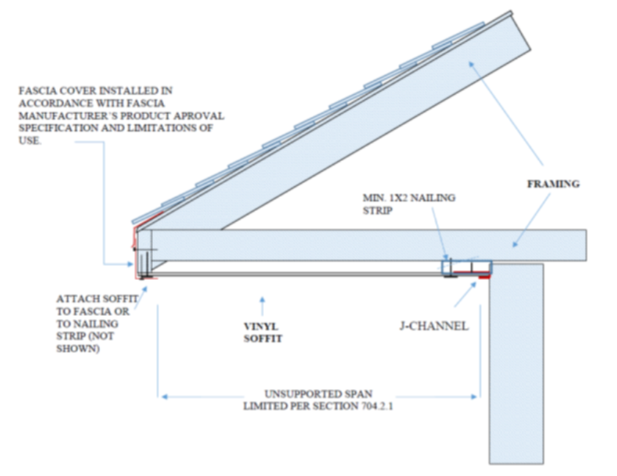

FIGURE R704.2.1
TYPICAL SINGLE SPAN VINYL SOFFIT PANEL SUPPORT
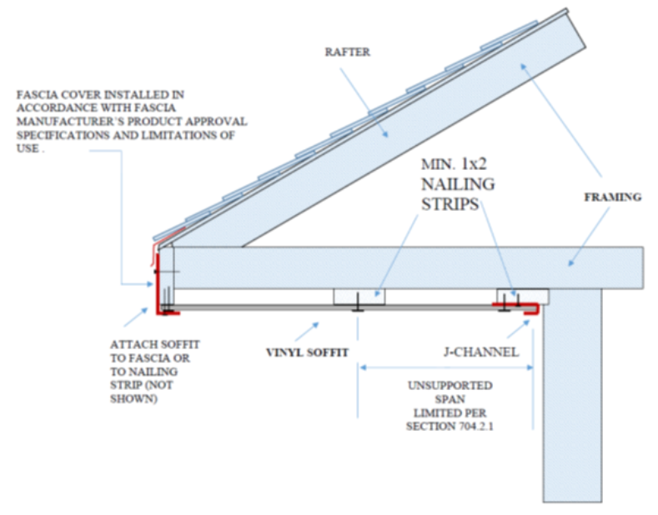

FIGURE R704.2.2
TYPICAL MULTI-SPAN VINYL SOFFIT PANEL SUPPORT
R704.2.2 Fiber-cement soffit panels. Fiber-cement soffit panels shall be a minimum of 1/4 inch thick and shall comply with the requirements of ASTM C1186, Type A, minimum Grade II or ISO 8336, Category A, minimum Class 2. Panel joints shall occur over framing or over wood structural panel sheathing. Soffit panels shall be installed with spans and fasteners in accordance with the manufacturer’s product approval specification and limitations of use.
R704.2.3 Hardboard soffit panels. Where the design wind pressure is 30 psf or less, soffit panels shall be a minimum of 7/16 inch in thickness and shall be fastened to framing or nailing strips with 2 ½ ” x 0.113” siding nails spaced not more than 6 inches on center at panel edges and 12 inches on center at intermediate supports. Where the design wind pressure is greater than 30 psf, hardboard soffit panels shall be installed in accordance with the manufacturer’s product approval specification and limitations of use.
R704.2.4 Wood structural panel soffit prescriptive alternative. Wood structural panel soffit panels are permitted to be installed in accordance with Table R704.2.4.
Table 704.2.4
Installation Requirements for Wood Structural Panel, Closed Soffit^{b,c,d,e,f}

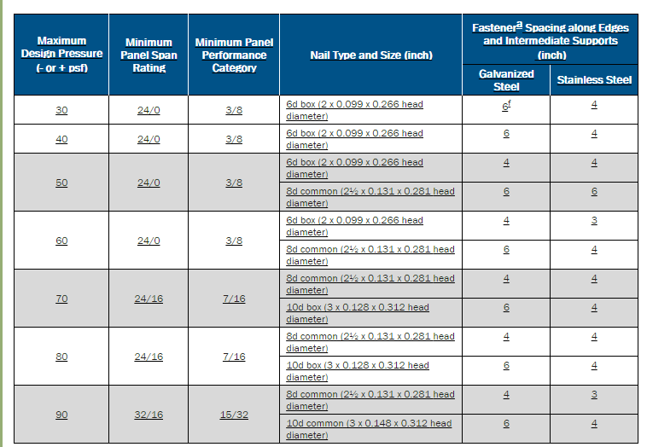

a. Fasteners shall comply with Sections R703.3.2 and R703.3.3.
b. Maximum spacing of soffit framing members shall not exceed 24 inches.
c. Wood structural panels shall be of an exterior exposure grade.
d. Wood structural panels shall be installed with strength axis perpendicular to supports with a minimum of two continuous spans.
e. Wood structural panels shall be attached to soffit framing members with specific gravity of at least 0.42. Framing members shall be minimum 2x3 nominal with the larger dimension in the cross section aligning with the length of fasteners to provide sufficient embedment depths.
f. Spacing at intermediate supports is permitted to be 12 inches on center.

(S7821 A2 Only)

Chapter 8 ROOF-CEILING CONSTRUCTION

Revise as follows:

R802.1.2 Structural glued laminated timbers.
Glued laminated timbers shall be manufactured and identified as required in ANSI/AITC A190.1, ANSI 117 and ASTM D3737.
(S7950)/(RB189-16)

R802.1.8 Prefabricated wood I-joists. Structural capacities and design provisions for prefabricated wood I-joists shall be established and monitored in accordance with ASTM D5055.
(S7764) /(I-Code)

R802.2 Design and construction. Wood roof framing shall be in accordance with Section R301.2.1.1 or ANSI AWC NDS. The framing details required in Section R802 apply to roofs having a minimum slope of three units vertical in 12 units horizontal (25-percent slope) or greater. Roof-ceilings shall be designed and constructed in accordance with the provisions of this chapter and Figures R606.11(1), R606.11(2) and R606.11(3) or in accordance with AWC NDS. Components of roof-ceilings shall be fastened in accordance with Table R602.3(1)

Further revise Section R802.3 as follows:

Delete Sections R802.3, R802.4, R802.5, and R802.6 including all subsections, tables and figures. Show sections, tables and figures as "Reserved" to maintain section numbering.

Further revise as follows:
Delete Sections R802.8, R802.8.1 and R802.9 and show as "Reserved."

Delete Section R802.11 including all subsections, tables and figures. Show sections, tables and figures as "Reserved" to maintain section numbering.
(S8150 A1+Original)/ (S7972)/(S7715)

R803.2.2 Allowable spans. The minimum thickness and span rating maximum allowable spans for wood structural panel roof sheathing shall not exceed the values set forth in Table R803.2.2 R503.2.1.1(1), or APA E30.

R803.2.3Installation.
Wood structural panel used as roof sheathing shall be installed with joints staggered in accordance with Section R803.2.3.1 for wood roof framing or with Table R804.3 for cold-formed steel roof framing. Wood structural panel roof sheathing shall not cantilever more than 9 inches beyond the gable end wall unless supported by gable overhang framing.

R803.2.3.1 Sheathing fastenings.
Wood structural panel sheathing shall be fastened to roof framing in accordance with Table R803.2.3.1. with Where the sheathing thickness is 15/32 inches and less, sheathing shall be fastened with ASTM F1667 RSRS-01 (2 ³/₈" × 0.113") nails. Where the sheathing thickness is greater than 15/32 inches, sheathing shall be fastened with ASTM F1667 RSRS-03 (2 ½" × 0.131") nails or ASTM F1667 RSRS-04 (3" × 0.120") nails. at 6 inches (152 mm) on center at edges and 6 inches (152 mm) on center at intermediate framing, unless roof diaphragm design requires a closer spacing. RSRS-01, RSRS-03, and RSRS-04 is are ring shank roof sheathing nails meeting the specifications in ASTM F1667.
Where roof framing with a specific gravity, 0.42 = G < 0.49 is used, spacing of ring-shank fasteners shall be 4 inches on center in nailing zone 3 in accordance with Figure R803.2.3.1 where V_{ult} is 165 mph or greater.

Exceptions:
1.Where roof framing with a specific gravity, 0.42 = G < 0.49 is used, spacing of ring-shank fasteners shall be permitted at 12 inches (305 mm) on center at intermediate framing in nailing zone 1 for any V_{ult} and in nailing zone 2 for V_{ult} less than or equal to 140 mph in accordance with Figure R803.2.3.1.

2.Where roof framing with a specific gravity, G = 0.49 is used, spacing of ring-shank fasteners shall be permitted at 12 inches (305 mm) on center at intermediate framing in nailing zone 1 for any V_{ult} and in nailing zone 2 for V_{ult} less than or equal to 150 mph in accordance with Figure R803.2.3.1.

3.Where roof framing with a specific gravity, G = 0.49 is used, 8d common or 8d hot-dipped galvanized box nails at 6 inches (152 mm) on center at edges and 6 inches (152 mm) on center at intermediate framing shall be permitted for V_{ult} less than or equal to 130 mph in accordance with Figure R803.2.3.1.

Table R803.2.2
Minimum Roof Sheathing Thickness
Roof Sheathing Thickness
Rafter/Truss Spacing  24 in. o.c. | Wind Speed
 | 115 mph | 120 mph | 130 mph | 140 mph | 150 mph | 160 mph | 170 mph | 180 mph
Minimum Sheathing Thickness, inches  (Panel Span Rating)  Exposure B | 7/16  (24/16) | 7/16  (24/16) | 7/16  (24/16) | 7/16  (24/16) | 15/32  (32/16) | 19/32  (40/20) | 19/32  (40/20) | 19/32  (40/20)
Minimum Sheathing Thickness, inches  (Panel Span Rating)  Exposure C | 7/16  (24/16) | 7/16  (24/16) | 15/32  (32/16) | 19/32  (40/20) | 19/32  (40/20) | 19/32  (40/20) | 19/32  (40/20) | 23/32  (48/24)
Minimum Sheathing Thickness, inches  (Panel Span Rating)  Exposure D | 15/32  (32/16) | 19/32  (40/20) | 19/32  (40/20) | 19/32  (40/20) | 19/32  (40/20) | 19/32  (40/20) | 23/32  (48/24) | 23/32  (48/24)

Table R803.2.1
Roof Sheathing Attachment^{a,b}
Roof Sheathing Attachment
Rafter/Truss Spacing  24 in. o.c. | Wind Speed
 | 115 mph |  | 120 mph |  | 130 mph |  | 140 mph |  | 150 mph |  | 160 mph |  | 170 mph |  | 180 mph
 | E | F | E | F | E | F | E | F | E | F | E | F | E | F | E | F
Exposure B
Rafter/Truss SG = 0.42 | 6 | 6 | 6 | 6 | 6 | 6 | 6 | 6 | 6 | 6 | 4 | 4 | 4 | 4 | 4 | 4
Rafter/Truss SG = 0.49 | 6 | 12 | 6 | 12 | 6 | 6 | 6 | 6 | 6 | 6 | 6 | 6 | 6 | 6 | 6 | 6
Exposure C
Rafter/Truss SG = 0.42 | 6 | 6 | 6 | 6 | 6 | 6 | 4 | 4 | 4 | 4 | 4 | 4 | 3 | 3 | 3 | 3
Rafter/Truss SG = 0.49 | 6 | 6 | 6 | 6 | 6 | 6 | 6 | 6 | 6 | 6 | 6 | 6 | 4 | 4 | 4 | 4
Exposure D
Rafter/Truss SG = 0.42 | 6 | 6 | 6 | 6 | 4 | 4 | 4 | 4 | 4 | 4 | 3 | 3 | 3 | 3 | 3 | 3
Rafter/Truss SG = 0.49 | 6 | 6 | 6 | 6 | 6 | 6 | 6 | 6 | 4 | 4 | 4 | 4 | 4 | 4 | 4 | 4

E = Nail spacing along panel edges (inches)
F = Nail spacing along intermediate supports in the panel field (inches)
a. For sheathing located a minimum of 4 feet from the perimeter edge of the roof, including 4 feet on each side of ridges and hips, nail spacing is permitted to be 6 inches on center along panel edges and 6 inches on center along intermediate supports in the panel field.
b. Where rafter/truss spacing is less than 24 inches on center, roof sheathing fastening is permitted to be in accordance with the AWC WFCM or the AWC NDS.

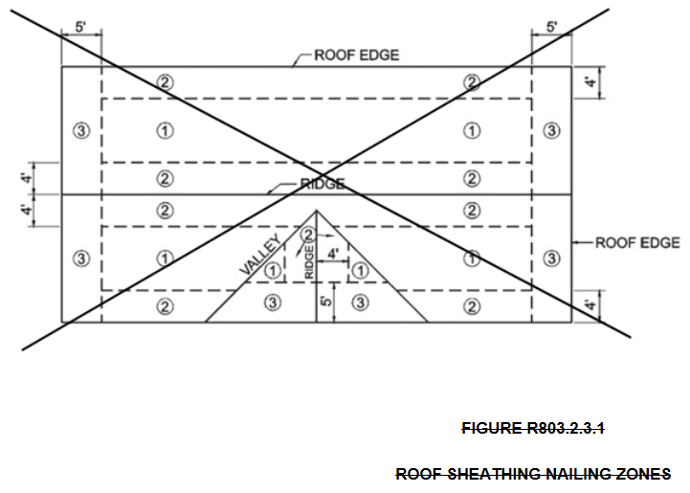

(S7715)/(S8092 G1+G2)

Delete Section R804, Cold-Formed Steel Roof Framing, in its entirety and replace with the following:

SECTION R804 COLD-FORMED STEEL ROOF FRAMING

R804.1 General. In accordance with Section R301.2.1.1, the design of cold-formed steel roof framing shall be in accordance with AISI S230, Standard for Cold-Formed Steel Framing— Prescriptive Method For One- and Two-Family Dwellings.

(S7858)

R806.1 Ventilation required.

Enclosed attics and enclosed rafter spaces formed where ceilings are applied directly to the underside of roof rafters shall have cross ventilation for each separate space by ventilating openings protected against the entrance of rain or snow. Ventilation openings shall have a least dimension of 1/16 inch (1.6 mm) minimum and 1/4 inch (6.4 mm) maximum. Ventilation openings having a least dimension larger than 1/4 inch (6.4 mm) shall be provided with corrosion-resistant wire cloth screening, hardware cloth, perforated vinyl, or similar material with openings having a least dimension of 1/16 inch (1.6 mm) minimum and 1/4 inch (6.4 mm) maximum. Openings in roof framing members shall conform to the requirements of Section R802.7. Required ventilation openings shall open directly to the outside air and shall be protected to prevent the entry of birds, rodents, snakes and other similar creatures.

R806.2 Minimum vent area.

The minimum net free ventilating area shall be 1/150 of the area of the vented space.

Exception: The minimum net free ventilation area shall be 1/300 of the vented space provided one or more of the following conditions are met:

1.In Climate Zones 6, 7 and 8, a Class I or II vapor retarder is installed on the warm-in-winter side of the ceiling.

2.Not less than 40 percent and not more than 50 percent of the required ventilating area is provided by ventilators located in the upper portion of the attic or rafter space. Upper ventilators shall be located not more than 3 feet (914 mm) below the ridge or highest point of the space, measured vertically, with the balance of the required ventilation provided by eave or cornice vents. Where the location of wall or roof framing members conflicts with the installation of upper ventilators, installation more than 3 feet (914 mm) below the ridge or highest point of the space shall be permitted.

R806.3 Vent and insulation clearance.

Where eave or cornice vents are installed, blocking, bridging and insulation shall not block the free flow of air. Not less than a 1-inch (25 mm) space shall be provided between the insulation and the roof sheathing and at the location of the vent.
(S8398)

R806.2 Minimum vent area.

The minimum net free ventilating area shall be ¹/₁₅₀ of the area of the vented space.

Exception: The minimum net free ventilation area shall be ¹/₃₀₀ of the vented space provided one or more of the following conditions are met:

1. In Climate Zones 6, 7 and 8, a Class I or II vapor retarder is installed on the warm-in-winter side of the ceiling.

2. Not less than 40 percent and not more than 50 percent of the required ventilating area is provided by ventilators located in the upper portion of the attic or rafter space. Upper ventilators shall be located not more than 3 feet (914 mm) below the ridge or highest point of the space, measured vertically, with the. The balance of the required ventilation provided by eave or cornice vents shall be located in the bottom one-third of the attic space. Where the location of wall or roof framing members conflicts with the installation of upper ventilators, installation more than 3 feet (914 mm) below the ridge or highest point of the space shall be permitted.
(S7714) /(I-Code)

R806.5 Unvented attic and unvented enclosed rafter assemblies.
Unvented attics and unvented enclosed roof framing assemblies created by ceilings that are applied directly to the underside of the roof framing members and structural roof sheathing applied directly to the top of the roof framing members/rafters, shall be permitted where all the following conditions are met:

1. The unvented attic space is completely within the building thermal envelope.

2. No interior Class I vapor retarders are installed on the ceiling side (attic floor) of the unvented attic assembly or on the ceiling side of the unvented enclosed roof framing assembly.

3. Where wood shingles or shakes are used, a minimum 1/4-inch (6.4 mm) vented airspace separates the shingles or shakes and the roofing underlayment above the structural sheathing.

4. In Climate Zones 5, 6, 7 and 8, any air-impermeable insulation shall be a Class II vapor retarder, or shall have a Class 11 vapor retarder coating or covering in direct contact with the underside of the insulation.

5. Insulation shall be located in accordance with the following:

5.1. Item 5.1.1, 5.1.2, 5.1.3 or 5.1.4 shall be met, depending on the air permeability of the insulation directly under the structural roof sheathing. Where air-permeable insulation is located on top of the attic floor or on top of the attic ceiling Item 5.2 shall be met.

5.1.1. Where air-impermeable insulation is provided, it shall be applied in direct contact with the underside of the structural roof sheathing.

.1.2. Where air-permeable insulation is provided inside the building thermal envelope, it shall be installed in accordance with Section 5.1.1. In addition to the air-permeable installed directly below the structural sheathing, rigid board or sheet insulation shall be installed directly above the structural roof sheathing in accordance with the R-values in Table R806.5 for condensation control.

5.1.3. Where both air-impermeable and air-permeable insulation are provided, the air-impermeable insulation shall be applied in direct contact with the underside of the structural roof sheathing in accordance with Item 5.1.1 and shall be in accordance with the R-values in Table R806.5 for condensation control. The air-permeable insulation shall be installed directly under the air impermeable insulation.

5.1.4. Alternatively, sufficient rigid board or sheet insulation shall be installed directly above the structural roof sheathing to maintain the monthly average temperature of the underside of the structural roof sheathing above 45°F (7°C). For calculation purposes, an interior air temperatureof68°F (20°C) is assumed and the exterior air temperature is assumed to be the monthly averageoutside air temperature of the three coldest months.

5.2. In Climate Zones 1, 2 and 3, air-permeable insulation installed in unvented attics on the top of the attic floor, or on top of the ceiling shall meet the following requirements:

5.2.1. An approved vapor diffusion port shall be installed not more than 12 inches (305 mm) from the highest point of the roof, measured vertically from the highest point of the roof to the lower edge of the port.

5.2.2. The port area shall be greater than or equal to 1:600 of the ceiling area. Where there are multiple ports in the attic, the sum of the port areas shall be greater than or equal to the area requirement.
5.2.3. The vapor-permeable membrane in the vapor diffusion port shall have a vapor permeance rating of greater than or equal to 20 perms when tested in accordance with Procedure A of ASTM E96.

5.2.4. The vapor diffusion port shall serve as an air barrier between the attic and the exterior of the building.

5.2.5. The vapor diffusion port shall protect the attic against the entrance of rain and snow.

5.3. Where preformed insulation board is used as the air-impermeable insulation layer, it shall be sealed at the perimeter of each individual sheet interior surface to form a continuous layer.
(S8329)

R807.1 Attic access. Buildings with combustible ceiling or roof construction shall have an attic access opening to attic areas that have a vertical height of 30 inches (762 mm) or greater over an area of not less than 30 square feet (2.8 m2). The vertical height shall be measured from the top of the ceiling framing members to the underside of the roof framing members.
The rough-framed opening shall be not less than 22 inches by 30 inches (559 mm by 762 mm) and shall be located in a hallway or other readily accessible location with ready access. Where located in a wall, the opening shall be not less than 22 inches wide by 30 inches high (559 mm wide by 762 mm high). Where the access is located in a ceiling, minimum unobstructed headroom in the attic space shall be 30 inches (762 mm) at some point above the access measured vertically from the bottom of ceiling framing members. See Section M1305.1.3 for access requirements where mechanical equipment is located
in attics.
(RB2-16)

Chapter 9 ROOF ASSEMBLIES

Revise as follows:

R902.4 Rooftop-mounted photovoltaic panels and modules panel systems.
Rooftop-mounted photovoltaic panel systems installed on or above the roof covering shall be tested, listed and identified with a fire classification in accordance with UL 1703 and UL 2703. Class A, B or C photovoltaic panel systems and modules shall be installed in jurisdictions designated by law as requiring their use or where the edge of the roof is less than 3 feet (914 mm) from a lot line.
(R7865) /(I-Code)

Revise as follows:

R905.1.1 Underlayment. Unless otherwise noted uUnderlayment for asphalt shingles, metal roof shingles, mineral surfaced roll roofing, slate and slate-type shingles, wood shingles, wood shakes and metal roof panels for roof slopes 2:12 and greater shall conform to the applicable standards listed in this chapter. Underlayment materials required to comply with ASTM D226, D1970, D4869 and D6757 shall bear a label indicating compliance to the standard designation and, if applicable, type classification indicated in Table R905.1.1. Underlayment for roof slopes 2:12 and greater shall be applied and attached in accordance with Section R905.1.1.1, R905.1.1.2, or R905.1.1.3 as applicable Table R905.1.1.

R905.1.1.1 Underlayment for asphalt, metal, mineral surfaced, slate and slate-type roof coverings. Underlayment for asphalt shingles, metal roof shingles, mineral surfaced roll roofing, slate and slate-type shingles, wood shingles, wood shakes and metal roof panels shall comply with one of the following methods:

1. The entire roof deck shall be covered with an approved self-adhering polymer modified bitumen underlayment complying with ASTM D1970 installed in accordance with both the underlayment manufacturer’s and roof covering manufacturer’s installation instructions for the deck material, roof ventilation configuration and climate exposure for the roof covering to be installed.

2. A minimum 4-inch-wide (102 mm) strip of self-adhering polymer-modified bitumen membrane complying with ASTM D1970, installed in accordance with the manufacturer’s instructions for the deck material, shall be applied over all joints in the roof decking. An approved underlayment in accordance with Table R905.1.1.1 for the applicable roof covering shall be applied over the entire roof over the 4-inch- wide (102 mm) membrane strips.

Exception: A reinforced synthetic underlayment that is approved as an alternate to underlayment complying with ASTM D226 Type II and having a minimum tear strength of 15 lbf in accordance with ASTM D1970 or ASTM D4533 of 20 pounds and a minimum tensile strength of 20 lbf/inch in accordance with ASTM D5035 shall be permitted to be applied over the entire roof over the 4-inch wide (102 mm) membrane strips. This underlayment shall be installed and attached in accordance with the underlayment attachment methods of Table R905.1.1.1 for the applicable roof covering and slope and the underlayment manufacturer’s installation instructions , except metal cap nails shall be required where the ultimate design wind speed, V_{ult}, equals or exceeds 150 mph.

3. A minimum 3 ¾-inch wide (96 mm) strip of self-adhering flexible flashing tape complying with AAMA 711-13, Level 3 (for exposure up to
176° F (80° C)), installed in accordance with the manufacturer’s instructions for the deck material, shall be applied over all joints in the roof decking. An approved underlayment in accordance with Table R905.1.1.1 for the applicable roof covering shall be applied over the entire roof over the 4-inch-wide (102 mm) flashing strips.

Exception: A reinforced synthetic underlayment that is approved as an alternate to underlayment complying with ASTM D226 Type II and having a minimum tear strength of 15 lbf in accordance with ASTM D4533 and a minimum tensile strength of 20 lbf/inch in accordance with ASTM D5035 shall be permitted to be applied over the entire roof over the 4-inch wide (102 mm) membrane strips. This underlayment shall be installed and attached in accordance with the underlayment attachment methods of Table R905.1.1.1 for the applicable roof covering and slope and the underlayment manufacturer’s installation instructions.

4. Two layers of ASTM D226 Type II or ASTM D4869 Type III or Type IV underlayment shall be installed as follows: Apply a 19-inch (483 mm) strip of underlayment felt parallel to and starting at the eaves, fastened sufficiently to hold in place. Starting at the eave, apply 36- inchwide (914 mm) sheets of underlayment, overlapping successive sheets 19 inches (483 mm), end laps shall be 6 inches and shall be offset by 6 feet. The underlayment shall be attached to a nailable deck with corrosion-resistant fasteners with one row centered in the field of the sheet with a maximum fastener spacing of 12 inches (305 mm) o.c., and one row at the end and side laps fastened 6 inches (152 mm) o.c. Underlayment shall be attached using annular ring or deformed shank nails with metal or plastic caps with a nominal cap diameter of not less than 1 inch. Metal caps are required where the ultimate design wind speed, V_{ult}, equals or exceeds 170 mph. Metal caps shall have a thickness of not less than 32-gage sheet metal. Power-driven metal caps shall have a minimum thickness of 0.010 inch. Minimum thickness of the outside edge of plastic caps shall be 0.035 inch. The cap nail shank shall be not less than 0.083 inch for ring shank cap nails. Cap nail shank shall have a length sufficient to penetrate through the roof sheathing or not less than 3/4 inch into the roof sheathing.

5. Two layers of a reinforced synthetic underlayment that has a Product Approval as an alternate to underlayment complying with ASTM D226 Type II shall be permitted to be used. Synthetic underlayment shall have a minimum tear strength of 15 lbf in accordance with ASTM D4533, a minimum tensile strength of 20 lbf/inch in accordance with ASTM D5035, and shall meet the liquid water transmission test of Section 8.6 of ASTM D4869. Synthetic underlayment shall be installed as follows: Apply a strip of synthetic underlayment that is half the width of a full sheet parallel to and starting at the eaves, fastened sufficiently to hold in place. Starting at the eave, apply full sheets of reinforced synthetic underlayment, overlapping successive sheets half the width of a full sheet plus the width of the manufacturers single ply overlap. End laps shall be 6 inches and shall be offset by 6 feet. Synthetic underlayment shall be attached to a nailable deck with corrosion-resistant fasteners with a maximum fastener spacing measured horizontally and vertically of 12 inches (305 mm) o.c. between side laps, and one row at the end and side laps fastened 6 inches (152 mm) o.c. Synthetic underlayment shall be attached using annular ring or deformed shank nails with metal or plastic caps with a nominal cap diameter of not less than 1 inch. Metal caps are required where the ultimate design wind speed, V_{ult}, equals or exceeds 170 mph. Metal caps shall have a thickness of not less than 32-gage sheet metal. Power-driven metal caps shall have a minimum thickness of 0.010 inch. Minimum thickness of the outside edge of plastic caps shall be 0.035 inch. The cap nail shank shall be not less than 0.083 inch for ring shank cap nails. Cap nail shank shall have a length sufficient to penetrate through the roof sheathing or not less than 3/4 inch into the roof sheathing.

Exception: Compliance with Section R905.1.1.1 is not required for structural metal panels that do not require a substrate or underlayment.

TABLE R905.1.1.1
UNDERLAYMENT WITH SELF-ADHERING STRIPS OVER ROOF DECKING JOINTS
Roof Covering | Underlayment Type | Underlayment Attachment
 |  | 2:12 = Roof Slope < 4:12 | Roof Slope > 4:12
 |  |  | Underlayment shall be applied shingle fashion, parallel to and
 |  |  | starting from the eave and lapped 4 inches (51 mm), end laps
 |  |  | shall be 6 inches and shall be offset by 6 feet. The
 |  |  | underlayment shall be attached to a nailable deck with two
Asphalt Shingles, Metal Roof Panels, Photovoltaic Shingles | ASTM D226 Type II ASTM D4869 Type III  or IV ASTM D 6757 | Apply in accordance with Section R905.1.1.1 Item 4 or Section R905.1.1.3 Item 3 as applicable to the type of roof covering. | staggered rows in the field of the sheet with a maximum  fastener spacing of 12 inches (305 mm) o.c., and one row at the end and side laps fastened 6 inches (152 mm) o.c.  Underlayment shall be attached using annular ring or deformed shank nails with metal or plastic caps with a nominal cap diameter of not less than 1 inch. Metal caps are required where the ultimate design wind speed, Vult, equals or exceeds 170 mph. Metal caps shall have a thickness of not  less than 32-gage sheet metal. Power-driven metal caps shall
ASTM D226 Type II ASTM D4869 Type III
or IV
Metal Roof Shingles, |  |  | have a minimum thickness of 0.010 inch. Minimum thickness
Mineral-Surface Roll |  |  | of the outside edge of plastic caps shall be 0.035 inch. The cap
Roofing, Slate and |  |  | nail shank shall be not less than 0.083 inch for ring shank cap
Slate-type Shingles, |  |  | nails and 0.091 inch for smooth shank cap nails. Cap nail
Wood Shingles, |  |  | shank shall have a length sufficient to penetrate through the
Wood Shakes |  |  | roof sheathing or not less than 3/4 inch into the roof
 |  |  | sheathing.

TABLE R905.1.1
UNDERLAYMENT TABLE
Roof Covering Section | Roof Slope 2:12 and Less Than 4:12 Underlayment | Underlayment Attachmenta | Roof Slope 4:12 and Greater Underlayment | Underlayment Attachmenta
Asphalt shingles R905.2 | ASTM D226 Type I or II  ASTM D4869 Type II, III or IV  ASTM D6757 | 1 | ASTM D226 Type II ASTM D4869 Type III or IV  ASTM D 6757 | 2
 | ASTM D1970 | 3 | ASTM D 1970 | 3
Concrete and Clay Tile  R905.3 | See Section R905.3.3
Metal roof shingles R905.4 | ASTM D226 Type I or II  ASTM D4869 Type II, III or IV  ASTM D6757 | 1 | ASTM D226 Type II ASTM D4869 Type IV | 2
 | ASTM D1970 | 3 | ASTM D1970 | 3
Mineral-surfaced roll roofing R905.5 | ASTM D226 Type I or II  ASTM D4869 Type II,  III or IV | 1 | ASTM D226 Type II ASTM D4869 Type IV | 2
 | ASTM D1970 | 3 | ASTMD 1970 | 3
Slate and slate type shingles R905.6 | ASTM D226 Type I or II  ASTM D4869 Type II, III or IV | 1 | ASTM D226 Type II ASTM D4869 Type IV | 2
 | ASTM D1970 | 3 | ASTM D1970 | 3

Wood shingles R905.7 | ASTM D226 Type I or II  ASTM D4869 Type II, III or IV | 1 | ASTM D226 Type II ASTM D4869 Type IV | 2
Wood shakes R905.8 | Limited to roof slopes 4:12  and Greater | ASTM D226 Type II ASTM D4869 Type IV | 2 | 2
Metal roof panels R905.10 | ASTM D226 Type I or II  ASTM D4869 Type II, III or IV | 1 | ASTM D226 Type II ASTM D4869 Type IV ASTM D6757
 | ASTM D1970 | 3 | ASTM D1970 | 3
Photovoltaic Shingles R905.17 | ASTM D226 Type I or II  ASTM D4869 Type II, III or IV  ASTM D6757 | 1 | ASTM D226 Type II ASTM D4869 Type IV ASTM D6757 | 2
 | ASTM D1970 | 3 | ASTM D1970 | 3

aUnderlayment Attachment
1. Roof slopes from two units vertical in 12 units horizontal (17-percent slope), and less than four units vertical in 12 units horizontal (33-percent slope). Apply a 19-inch (483 mm) strip of underlayment felt parallel to and starting at the eaves, fastened sufficiently to hold in place. Starting at the eave, apply 36-inchwide (914 mm) sheets of underlayment, overlapping successive sheets 19 inches (483 mm), end laps shall be 6 inches and shall be offset by 6 feet. The underlayment shall be attached to a nailable deck with corrosion-resistant fasteners with one row centered in the field of the sheet with a maximum fastener spacing of 12 inches (305 mm) o.c., and one row at the end and side laps fastened 6 inches (152 mm) o.c. Underlayment shall be attached using metal or plastic cap nails with a nominal cap diameter of not less than 1 inch. Metal caps shall have a thickness of not less than 32-gage sheet metal. Power-driven metal caps shall have a minimum thickness of 0.010 inch. Minimum thickness of the outside edge of plastic caps shall be 0.035 inch. The cap nail shank shall be not less than 0.083 inch for ring shank cap nails and 0.091 inch for smooth shank cap nails. Cap nail shank shall have a length sufficient to penetrate through the roof sheathing or not less than 3/4 inch into the roof sheathing.
2. Roof slopes of four units vertical in 12 units horizontal (33-percent slope) or greater. Underlayment shall be applied shingle fashion, parallel to and starting from the eave and lapped 4 inches (51 mm), end laps shall be 6 inches and shall be offset by 6 feet. The underlayment shall b e attached to a nailable deck with two staggered rows in the field of the sheet with a maximum fastener spacing of 12 inches (305 mm) o.c., and one row at the end and side laps fastened 6 inches (152 mm) o.c. Underlayment shall be attached using metal or plastic cap nails with a nominal cap diameter of not less than 1 inch. Metal caps shall have a thickness of not less than 32-gage sheet metal. Power- driven metal caps shall have a minimum thickness of 0.010 inch. Minimum thickness of the outside edge of plastic caps shall be 0.035 inch. The cap nail shank shall be not less than 0.083 inch for ring shank cap nails and 0.091 inch for smooth shank cap nails. Cap nail shank shall have a length s ufficient to penetrate through the roof sheathing or not less than 3/4 inch into the roof sheathing.
3. Roof slopes from two units vertical in 12 units horizontal (17-percent slope) and greater. The entire roof deck shall be covered with an approved self-adhering polymer modified bitumen underlayment complying with ASTM D1970(2015a) installed in accordance with both the underlayment manufacturer’s and roof covering manufacturer’s installation instructions for the deck material, roof ventilation configuration and climate exposure for the roof covering to be installed.
Exception: A minimum 4-inch-wide (102 mm) strip of self-adhering polymer-modified bitumen membrane complying with ASTM D1970(2015a), installed in accordance with
the manufacturer’s instructions for the deck material, shall be applied over all joints in the roof decking. An approved underlayment in accordance with Table R905.1.1 for the applicable roof covering shall be applied over the entire roof over the 4-inch-wide (102 mm) membrane strips.

R905.1.1.2 Underlayment for concrete and clay tile. Underlayment for concrete and clay tile shall comply with one of the following methods:

1. The entire roof deck shall be covered with an approved self-adhering polymer modified bitumen underlayment complying with ASTM D1970 installed in accordance with both the underlayment manufacturer’s and roof covering manufacturer’s installation instructions for the deck material, roof ventilation configuration and climate exposure for the roof covering to be installed.

2. A minimum 4-inch-wide (102 mm) strip of self-adhering polymer-modified bitumen membrane complying with ASTM D1970, installed in accordance with the manufacturer’s instructions for the deck material, shall be applied over all joints in the roof decking. An underlayment complying with Section R905.3.3 shall be applied over the entire roof over the 4-inch-wide (102 mm) membrane strips.

3. A minimum 3 ¾-inch wide (96 mm) strip of self-adhering flexible flashing tape complying with AAMA 711-13, Level 3 (for exposure up to 176° F (80° C), installed in accordance with the manufacturer’s instructions for the deck material, shall be applied over all joints in the roof decking. An underlayment complying with Section R905.3.3 shall be applied over the entire roof over the 4-inch-wide (102 mm) flashing strips.

4. Two layers of ASTM D226 Type II or ASTM D4869 Type III or Type IV underlayment shall be installed as follows: Apply a 19-inch (483 mm) strip of underlayment felt parallel to and starting at the eaves, fastened sufficiently to hold in place. Starting at the eave, apply 36-inchwide (914 mm) sheets of underlayment, overlapping successive sheets 19 inches (483 mm), end laps shall be 6 inches and shall be offset by 6 feet. The underlayment shall be attached to a nailable deck with corrosion-resistant fasteners with one row centered in the field of the sheet with a maximum fastener spacing of 12 inches (305 mm) o.c., and one row at the end and side laps fastened 6 inches (152 mm) o.c. Underlayment shall be attached using annular ring or deformed shank nails with metal or plastic caps with a nominal cap diameter of not less than 1 inch. Metal caps are required where the ultimate design wind speed, V_{ult}, equals or exceeds 170 mph. Metal caps shall have a thickness of not less than 32-gage sheet metal. Power-driven metal caps shall have a minimum thickness of 0.010 inch. Minimum thickness of the outside edge of plastic caps shall be 0.035 inch. The cap nail shank shall be not less than 0.083 inch for ring shank cap nails. Cap nail shank shall have a length sufficient to penetrate through the roof sheathing or not less than 3/4 inch into the roof sheathing.

Exception: Compliance with Section R905.1.1.2 is not required where a fully adhered underlayment is applied in accordance with Section R905.3.3.

R905.1.1.3 Underlayment for wood shakes and shingles. Underlayment for wood shakes and shingles shall comply with one of the following methods:

1. A minimum 4-inch-wide (102 mm) strip of self-adhering polymer-modified bitumen membrane complying with ASTM D1970, installed
in accordance with the manufacturer’s instructions for the deck material, shall be applied over all joints in the roof decking. An approved underlayment in accordance with Table R905.1.1.1 for the applicable roof covering shall be applied over the entire roof over the 4-inch- wide (102 mm) membrane strips.

2. A minimum 3 ¾-inch wide (96 mm) strip of self-adhering flexible flashing tape complying with AAMA 711-13, Level 3 (for exposure up to
176° F (80° C)), installed in accordance with the manufacturer’s instructions for the deck material, shall be applied over all joints in the roof decking. An underlayment complying with Table R905.1.1.1 for the applicable roof covering shall be applied over the entire roof over the 4-inch-wide (102 mm) flashing strips.

3. Two layers of ASTM D226 Type II or ASTM D4869 Type III or Type IV underlayment shall be installed as follows: Apply a 19-inch (483 mm) strip of underlayment felt parallel to and starting at the eaves, fastened sufficiently to hold in place. Starting at the eave, apply 36- inchwide (914 mm) sheets of underlayment, overlapping successive sheets 19 inches (483 mm), end laps shall be 6 inches and shall be offset by 6 feet. The underlayment shall be attached to a nailable deck with corrosion-resistant fasteners with one row centered in the field of the sheet with a maximum fastener spacing of 12 inches (305 mm) o.c., and one row at the end and side laps fastened 6 inches (152 mm) o.c. Underlayment shall be attached using annular ring or deformed shank nails with metal or plastic caps with a nominal cap diameter of not less than 1 inch. Metal caps are required where the ultimate design wind speed, V_{ult}, equals or exceeds 170 mph. Metal caps shall have a thickness of not less than 32-gage sheet metal. Power-driven metal caps shall have a minimum thickness of 0.010 inch. Minimum thickness of the outside edge of plastic caps shall be 0.035 inch. The cap nail shank shall be not less than 0.083 inch for ring shank cap nails. Cap nail shank shall have a length sufficient to penetrate through the roof sheathing or not less than 3/4 inch into the roof sheathing.

(R7694 A1+A2+Original + handout/ Commission)/(R7571)/(R7665)
/

R905.2.6.1 Classification of asphalt shingles. Asphalt shingles shall be classified in accordance with ASTM D3161, TAS 107 or ASTM D7158 to resist the basic wind speed per Figure R301.2(4). Shingles classified as ASTM D3161 Class D or classified as ASTM D7158 Class G are acceptable for use where Vasd is equal to or less than 100 mph. Shingles classified as ASTM D3161 Class F, TAS 107 or ASTM D7158 Class H are acceptable for use for all wind speeds. Asphalt shingle wrappers shall be labeled to indicate compliance with one of the required classifications, as shown in Table R905.2.6.1.
(R8288)

R905.2.8.5 Drip edge. Provide drip edge at eaves and gables of shingle roofs. Overlap to be a minimum of 3 inches (76 mm). Eave drip edges shall extend 1/2 inch (13 mm) below sheathing and extend back on the roof a minimum of 2 inches (51 mm). Drip edge at gables shall be installed over the underlayment. Drip edge at eaves shall be permitted to be installed either over or under the underlayment. If installed over the underlayment, there shall be a minimum 4 inch (51 mm) width of roof cement installed over the drip edge flange. Drip edge shall be mechanically fastened a maximum of 12 inches (305 mm) on center. Where the Vasd as determined in accordance with Section R301.2.1.3 is 110 mph (177 km/h) or greater or the mean roof height exceeds 33 feet (10 058 mm), drip edges shall be mechanically fastened a maximum of 4 inches (102 mm) on center.
(R8290)

905.3.2 Deck slope. Clay and concrete roof tile shall be installed on roof slopes in accordance with the recommendations of FRSA/TRI Florida High Wind Concrete and Clay Roof Tile Installation Manual, Fifth Sixth Edition where the V_{asd} is determined in accordance with Section R301.2.1.3 or the recommendations of RAS 118, 119 or 120.

905.3.3 Underlayment.

Required underlayment shall comply with the underlayment manufacturer’s installation instructions in accordance with the FRSA/TRI Florida High Wind Concrete and Clay Roof Tile Installation Manual, Fifth Sixth Edition where the V_{asd} is determined in accordance with Section R301.2.1.3 or

905.3.3.1 Slope and underlayment requirements.

Refer to manufacturer’s installation instructions, FRSA/TRI Florida High Wind Concrete and Clay Roof Tile Installation Manual, Fifth Sixth Edition where the V_{asd} is determined in accordance with Section R301.2.1.3 or RAS 118, 119 or 120 for underlayment and slope requirements for specific roof tile systems.

905.3.6 Fasteners.

Nails shall be corrosion resistant and not less than 11 gage, ⁵/₁₆-inch (11 mm) head, and of sufficient length to penetrate the deck not less than ³/₄inch (19 mm) or through the thickness of the deck, whichever is less or in accordance with the FRSA/TRI Florida High Wind Concrete and Clay Roof Tile Installation Manual, Fifth Sixth Edition where the V_{asd} is determined in accordance with Section R301.2.1.3 or in accordance with the recommendations of RAS 118, 119 or 120. Attaching wire for clay or concrete tile shall not be smaller than 0.083 inch (2.1 mm).

905.3.7 Application.

Tile shall be applied in accordance with this chapter and the manufacturer’s installation instructions, recommendations of the FRSA/TRI Florida High Wind Concrete and Clay Roof Tile Installation Manual, Fifth Sixth Edition or the recommendations of RAS 118, 119 or 120.

905.3.7.1 Hip and ridge tiles.

Hip and ridge tiles shall be installed in accordance with FRSA/TRI Florida High Wind Concrete and Clay Roof Tile Installation Manual, Fifth Sixth Edition where the V_{asd} is determined in accordance with Section R301.2.1.3 or the recommendations of RAS 118, 119 or 120.

905.3.8 Flashing.

At the juncture of roof vertical surfaces, flashing and counter flashing shall be provided in accordance with this chapter and the manufacturer’s installation instructions, recommendations of the FRSA/TRI Florida High Wind Concrete and Clay Roof Tile Installation Manual, Fifth Sixth Edition where the V_{asd} is determined in accordance with Section R301.2.1.3 or the recommendations of RAS 111, 118, 119 or 120.
(R7353)
R905.4.4.1 Wind Resistance of Metal roof shingles. Metal roof shingles applied to a solid or closely fitted deck shall be tested in accordance with ASTM D3161, FM 4474, UL 580, UL 1897 or TAS 107. Metal roof shingles tested in accordance with ASTM D3161 shall meet the classification requirements of Table R905.2.4.1 for the appropriate maximum basic wind speed and the metal shingle packaging shall bear a label to indicate compliance with ASTM D3161 and the required classification in Table R905.4.4.1.
Add new table as follows:
TABLE R905.4.4.1
CLASSIFICATION OF METAL ROOF SHINGLES TESTED IN ACCORDANCE WITH ASTM D3161
MAXIMUM BASIC WIND SPEED FROM FIGURE 1609A, B, C or ASCE-7 R301.2(4) or ASCE-7 | Vasd | ASTM D3161
110 | 85 | D or F
116 | 90 | D or F
129 | 100 | D or F
142 | 110 | F
155 | 120 | F
168 | 130 | F
181 | 140 | F
194 | 150 | F

(R7967 A2+Original)

TABLE R905.8.5

WOOD SHAKE MATERIAL REQUIREMENTS
MATERIAL | MINIMUM GRADES | APPLICABLE GRADING RULES
Wood shakes of naturally durable wood | 1 | Cedar Shake and Shingle Bureau
Tapersawn shakes of naturally durable wood | 1 or 2 | Cedar Shake and Shingle Bureau
Preservative-treated shakes and shingles of naturally durable wood | 1 | Cedar Shake and Shingle Bureau
Fire-retardant-treated shakes and shingles of naturally durable wood | 1 | Cedar Shake and Shingle Bureau
Preservative-treated tapersawn shakes of Southern pine treated in accordance with AWPA Standard U1 (Commodity Specification A, Special Requirement 4.6 Use Category 3B and Section 5.6) | 1 or 2 | Forest Products Laboratory of the Texas Forest Services
(R7782) /(I-Code)

Revise as follows:

TABLE R906.2
MATERIAL STANDARDS FOR ROOF INSULATION
Cellular glass board | ASTM C 552
Mineral wool board | ASTM C 726
Composite boards | ASTM C 1289, Type III, IV, V or VI
Expanded polystyrene | ASTM C 578
Extruded polystyrene board | ASTM C 578
Perlite board | ASTM C 728
Polyisocyanurate board | ASTM C 1289, Type I or II
Wood fiberboard | ASTM C 208
Fiber-reinforced gypsum board | ASTM C 1278
Glass-faced gypsum board | ASTM C 1177
(R7806)

Table R905.11.2
Remove Standard CGSB 37-GP-56M from Modified Bitumen Roof Membrane Standards

R905.12.2 Material standards.
Thermoset single-ply roof coverings shall comply with ASTM D4637, or ASTM D5019 or CGSB 37-GP-52M.

R905.13.2 Material standards.
Thermoplastic single-ply roof coverings shall comply with ASTM D4434, ASTM D6754, or ASTM D6878 or CGSB CAN/CGSB 37.54.
(R8400) /(I-Code)

R905.15.3 Application.
Liquid-applied roofing shall be installed in accordance with this chapter and the manufacturer’s approved installation instructions. The approved allowable uplift resistance for the liquid-applied coatings shall be equal to or greater than the uplift resistance for the roof based on Table R301.2(2).
(R7730)

R905.17.1 Wind resistance. Rooftop mounted photovoltaic systems shall be designed for wind loads in accordance with ASCE 7 for component and cladding in accordance with Chapter 16 of the Florida Building Code, Building using an effective wind area based on the dimensions of a single unit frame.
(R7426)

SECTION R907
ROOFTOP-MOUNTED PHOTOVOLTAIC SYSTEMS

R907.1 Rooftop-mounted photovoltaic systems. Rooftop-mounted photovoltaic panel systems shall be designed and installed in accordance with Section R324, NFPA 70 and the Florida Fire Prevention Code.

Reserved.

R907.2 Wind resistance.

Reserved.

R907.3 Fire classification.

Reserved.

R907.4 Installation.

Reserved.

R907.5 Photovoltaic panels and modules.

Reserved.
(R7347)/(RB164-16)

SECTIONR 909

ROOFTOP-MOUNTED PHOTOVOLTAIC PANEL SYSTEMS

R909.1 General.

Reserved.

R909.2 Structural requirements.

Reserved.

R909.3 Installation.

Reserved.
(R7348)/(RB164-16)

Chapter 10 CHIMNEYS AND FIREPLACES

Revise as follows:

R1001.2.1 Ash dump cleanout. Cleanout openings located within foundation walls below fireboxes, when provided, shall be equipped with ferrous metal or masonry doors and frames constructed to remain tightly closed except when in use. Cleanouts shall be accessible located to allow access and located so that ash removal will not create a hazard to combustible materials.

R1003.9.2 Spark arrestors. Where a spark arrestor is installed on a masonry chimney, the spark arrestor shall meet all of the following requirements:

1. The net free area of the arrestor shall be not less than four times the net free area of the outlet of the chimney flue it serves.
2. The arrestor screen shall have heat and corrosion resistance equivalent to 19-gage galvanized steel or 24-gage stainless steel.
3. Openings shall not permit the passage of spheres having a diameter greater than 1 /2 inch (12.7 mm) nor block the passage of spheres having a diameter less than 3 / inch (9.5 mm).
2
8
4. The spark arrestor shall be accessible located with access for cleaning and the screen or chimney cap shall be removable to allow for cleaning of the chimney flue.
(RB2-16)

R1005.8 Insulation shield. Where factory-built chimneys pass through insulated assemblies, an insulation shield constructed of steel having a minimum thickness of 0.0187 inch (0.4712 mm) (No. 26 gage) shall be installed to provide clearance between the chimney and the insulation material.
The clearance shall not be less than the clearance to combustibles specified by the chimney manufacturer's installation instructions. Where chimneys pass through attic space, the shield shall terminate not less than 2 inches (51 mm) above the insulation materials and shall be secured in place to prevent displacement. Insulation shields provided as part of a listed chimney system shall be installed inaccordance with the manufacturer's installation instructions.
(F8042) /(I-Code)

CHAPTER 11 [RE] ENERGY EFFICIENCY

No change

Chapter 12 MECHANICAL ADMINISTRATION
No change

Chapter 13 GENERAL MECHANICAL SYSTEM REQUIREMENTS

Revise as follows:

M1305.1 Appliance access for inspection service, repair and replacement. Appliances shall
be accessible located to allow for access for inspection, service, repair and replacement without removing permanent construction, other appliances, or any other piping or ducts not connected to
the appliance being inspected, serviced, repaired or replaced. A level working space not less than 30 inches deep and 30 inches wide (762 mm by 762 mm) shall be provided in front of the control side to service an appliance.
(RB2-16)

Chapter 14 HEATING AND COOLING EQUIPMENT AND APPLIANCES

Revise as follows:

M1407.4 Access. Duct heaters shall be accessible located to allow access for servicing, and clearance shall be maintained to permit adjustment, servicing and replacement of controls and heating elements.
(RB2-16)

M1411.6 Insulation of refrigerant piping.
Piping and fittings for refrigerant vapor (suction) lines shall be insulated with insulation having a thermal resistivity of not less than R-4 R-3and having external surface permeance not exceeding 0.05 perm [2.87 ng/(s · m² · Pa)] when tested in accordance with ASTM E96.
(M8360)

Chapter 15 EXHAUST SYSTEMS

Revise as follows:
M1502.3.1 Exhaust termination outlet and passageway size. The passageway of dryer exhaust duct terminals shall be undi inished in size and shall provide an open area of not less than 12.5 square inches (8,065 sq mm).
(RM11-15)

M1502.4.1 Material and size.
Exhaust ducts shall have a smooth interior finish and be constructed of metal having a minimum thickness of 0.0157 inches (28 gauge). The duct shall be 4 inches (102 mm) nominal in diameter.

Exception: Exhaust ducts may be 4 inches nominal in diameter Schedule 40 PVC when horizontally run beneath the slab.
(M8362) /(I-Code)

M1502.4.2 Duct installation. Exhaust ducts shall be supported at intervals not to exceed 12 feet (3658 mm) and shall be secured in place. The insert end of the duct shall extend into the adjoining duct or fitting in the direction of airflow. Exhaust duct joints shall be sealed in accordance
with Section M1601.4.1 and shall be mechanically fastened. Ducts shall not be joined with screws or similar fasteners that protrude more than 1/8 inch (3.2 mm) into the inside of the duct. Where dryer exhaust ducts are enclosed in wall or ceiling cavities, such cavities shall allow the installation of the duct without deformation.
(RM12-15 AM)/(M8364)

M1503.4 Makeup air required. Exhaust hood systems capable of exhausting in excess of 400 cubic feet per minute (0.19 m3/s) shall be mechanically or naturally provided with makeup air at a rate approximately equal to the exhaust air rate. Such makeup air systems shall be equipped with not less than one damper. Each damper shall be a gravity damper or an electrically operated damper that automatically opens when the exhaust system operates. Dampers shall be accessible located to allow access for inspection, service, repair and replacement without removing permanent construction or any other ducts not connected to the damper being inspected, serviced, repaired or replaced.

No change to the remaining text
(RB2-16)

M1507.3.2 System controls. The whole-house mechanical ventilation system shall be provided with controls that enable manual override. Controls shall include text or a symbol indicating their function.
(M8205)

M1507.3.3 Mechanical ventilation rate. The whole-house mechanical ventilation system shall provide outdoor air at a continuous rate of not less than that determined in accordance with Table M1507.3.3(1) or Equation 15-1.

Ventilation rate in cubic feet per minute = (0.01 X total square (Equation 15-1)
foot area of house) + 7.5 X number of bedrooms + 1

Exceptions:

1. The whole-house mechanical ventilation system is permitted to operate intermittently where the system has controls that enable operation for not less than 25-percent of each 4-hour segment and the ventilation rate prescribed in Table M1507.3.3(1) is multiplied by the factor determined in accordance with Table M1507.3.3(2).

2. The minimum mechanical ventilation rate determined in accordance with Table M1507.3.3(1) or Equation 15- 1 shall be reduced by 30%, provided that both of the following conditions apply:

2.1. A ducted system supplies ventilation air directly to each bedroom and to one or more of the following rooms:
2.1.1. Living room.
2.1.2 Dining room.
2.1.3 Kitchen.

2.2. The whole-house ventilation system is a balanced ventilation system.

(M8152 A1 only)

Chapter 16 DUCT SYSTEMS

Revise as follows:

M1601.1.2 Underground duct systems. Underground duct systems shall be constructed
of approved concrete, clay, metal or plastic. The maximum duct temperature for plastic ducts shall not be greater than 150°F (66°C). Metal ducts shall be protected from corrosion in an approved manner or shall be completely encased in concrete not less than 2 inches (51 mm) thick. Nonmetallic ducts shall be installed in accordance with the manufacturer's instructions. Plastic pipe and fitting materials shall conform to cell classification 12454-B of ASTM D 1248 or ASTM D 1784 and external loading properties of ASTM D 2412. Ducts shall slope to an accessible a point for drainage that has access. Where encased in concrete, ducts shall be sealed and secured prior to any concrete being poured. Metallic ducts having an approved protective coating and nonmetallic ducts shall be installed in accordance with the manufacturer's instructions.

M1601.4.1 Joints, seams and connections. Longitudinal and transverse joints, seams and connections in metallic and nonmetallic ducts shall be constructed as specified in SMACNA HVAC Duct Construction Standards—Metal and Flexible and NAIMA Fibrous Glass Duct Construction Standards. Joints, longitudinal and transverse seams, and connections in ductwork shall be securely fastened and sealed with welds, gaskets, mastics (adhesives), mastic-plus-embedded-fabric systems, liquid sealants or tapes. Tapes and mastics used to seal fibrous glass ductwork shall be listed and labeled in accordance with UL 181A and shall be marked "181A-P" for pressure-sensitive tape, "181 A-M" for mastic or "181 A-H" for heat-sensitive tape.
Tapes and mastics used to seal metallic and flexible air ducts and flexible air connectors shall comply with UL 181B and shall be marked "181 B-FX" for pressure-sensitive tape or "181 BM" for mastic. Duct connections to flanges of air distribution system equipment shall be sealed and mechanically fastened. Mechanical fasteners for use with flexible nonmetallic air ducts shall comply with UL 181B and shall be marked 181B-C. Crimp joints for round metallic ducts shall have a contact lap of not less than 1 inch (25 mm) and shall be mechanically fastened by means of not less than three sheet-metal screws or rivets equally spaced around the joint.
Closure systems used to seal all ductwork shall be installed in accordance with the manufacturers' instructions.

Exceptions:

1. Spray polyurethane foam shall be permitted to be applied without additional joint seals.
2. Where a duct connection is made that is partially inaccessible without access, three screws or rivets shall be equally spaced on the exposed portion of the joint so as to prevent a hinge effect.
3. For ducts having a static pressure classification of less than 2 inches of water column (500 Pa), additional closure systems shall not be required for continuously welded joints and seams and locking-type joints and seams of other than the snap-lock and button-lock types.
(RB2-16)

M1602.2 Return air openings.
Return air openings for heating, ventilation and air conditioning systems shall comply with all of the following:
1.Openings shall not be located less than 10 feet (3048 mm) measured in any direction from an open combustion chamber or draft hood of another appliance located in the same room or space.

2. The amount of return air taken from any room or space shall be not greater than the flow rate of supply air delivered to such room or space.

3 .Return and transfer openings shall be sized in accordance with the appliance or equipment manufacturers’ installation instructions, Manual D or the design of the registered design professional.

4. Return air shall not be taken from a closet, bathroom, toilet room, kitchen, garage, mechanical room, boiler room, furnace room or unconditioned attic.

Exceptions:
1. Taking return air from a kitchen is not prohibited where such return air openings serve the kitchen only, and are located not less than 10 feet (3048 mm) from the cooking appliances.
2. Dedicated forced-air systems serving only the garage shall not be prohibited from obtaining return air from the garage

3. Dedicated independent dehumidification systems shall be allowed to take return air from spaces such as closets and bathrooms and discharge the air back into the spaces provided that the air be filtered and dehumidified prior to the air being reintroduced back into the spaces.
(Remaining text unchanged

4. Taking return air from a closet is not prohibited where such return air taken from closets shall serve only the closet and may be taken from closets that have no dedicated supply duct. Where return air is taken from a closet smaller than 30 ft2 (2.8 m2) the return air shall be no more than 30 cfm (15 l/s), shall serve only the closet, and shall not require a dedicated supply duct. Where return air is taken from a closet smaller than 30 ft2 (2.8 m2) the closet door shall be undercut a minimum of 1.5 inches (38 mm) or the closet shall include a louvered door or transfer grille with a minimum net free area of 30 inch2 (194 cm2).

(Remaining text unchanged)
(M7800 A3 only)

Chapter 17 COMBUSTION AIR

No change

Chapter 18 CHIMNEYS AND VENTS

Revise as follows:

M1803.3.5 Access. The entire length of a connector shall be accessible allow access for inspection, cleaning and replacement.

M1803.4.3 Connection to masonry fireplace flue. A connector shall extend from the appliance to the flue serving a masonry fireplace to convey the flue gases directly into the flue. The connector shall be accessible allow access or removable for inspection and cleaning of both the connector and the flue. Listed direct-connection devices shall be installed in accordance with their listing.
(RB2-16)

CHAPTER 19 SPECIAL APPLIANCES, EQUIPMENT AND SYSTEMS

No change

Chapter 20 BOILERS AND WATER HEATERS

No change

CHAPTER 21 HYDRONIC PIPING

No change

Chapter 22 SPECIAL PIPING AND STORAGE SYSTEMS

Revise as follows:

M2204.2 Shutoff valves. A readily accessible manual shutoff valve shall be installed to allow for ready access and be located between the oil supply tank and the burner. Where the shutoff valve is installed in the discharge line of an oil pump, a pressure-relief valve shall be incorporated to bypass or return surplus oil. Valves shall comply with UL 842.
(RB2-16)

Chapter 23 SOLAR THERMAL ENERGY SYSTEMS

Revise as follows:

M2301.2.1 Access. Solar energy collectors, controls, dampers, fans, blowers and pumps shall be accessible located to allow access for inspection, maintenance, repair and replacement.
(RB2-16)

Chapter 24 FUEL GAS

Note: Changes to this chapter should be consistent with the changes to Chapter 24 of the 2018 IRC

SECTION G2403 (202) DEFINITIONS

TOILET, GAS-FIRED An appliance, comprised of a toilet and an incinerator that is manufactured and installed as one
complete unit, and is used to reduce human fecal matter to ash
(FG1-15)

JOINT, MECHANICAL. A general form of gas-tight joints obtained by the joining of metal parts through a positive holding mechanical construction, such as press press-connect joint, flanged joint, threaded joint, flared join tor compression joint.
(FG3-15)

FURNACE, CENTRAL
A self-contained appliance ir, and designed to supply heated air through ducts to spaces remote from or adjacent to the appliance location.
Down flow furnace. A furnace designed with airflow discharge vertically downward at or near the bottom of the furnace.
Force d air furnace with cooling unit. A single-package unit, consisting of a gas-fired forced-air furnace of one of the types listed below combined with an electrically or fuel gas-powered summer air-conditioning system, contained in a common casing.
Forced-air type. A central furnace equipped with a fan or blower that provides the primary means for circulation of air.
Gravity furnace with booster fan. A furnace equipped with a booster fan that does not materially restrict free circulation of air by gravity flow when the fan is not in operation.
Gravity type. A central furnace depending primarily on circulation of air by gravity.
Horizontal forced-air type. A furnace with airflow through the appliance essentially in a horizontal path.
Multiple-position furnace. A furnace designed so that it can be installed with the airflow discharge in the upflow, horizontal or downflow direction.
Upflow furnace. A furnace designed with airflow discharge vertically upward at or near the top of the furnace. This classification includes "highboy" furnaces with the blow remounted below the heating element and" lowboy" furnaces with the blower mounted beside the heating element.
(FG4-15)

[M] PIPING. Where used in this code, "piping" refers to either pipe or tubing, or both.
Pipe. A rigid conduit of iron, steel, copper, brass copper-alloy or plastic.
Tubing. Semirigid conduit of copper, aluminum, plastic or steel.
(FG5-15)

REGULATOR, GAS APPLIANCE.
for controlling pressure to the manifold of the appliance. Types of appliance regulators are as follows:

Adjustable.

1. Spring type, limited adjustment. A regulator in which the regulating force acting upon the diaphragm is derived principally from a spring, the loading of which is adjustable over a range of not more than 15 percent of the outlet pressure at the midpoint of the adjustment range.
2. Spring type, standard adjustment. A regulator in which the regulating force acting upon the diaphragm is derived principally from a spring, the loading of which is adjustable. The adjustment means shall be concealed.

Multistage. A regulator for use with a single gas whose adjustment means is capable of being positioned manually or automatically to two or more predetermined outlet pressure settings. Each of these settings shall be adjustable or nonadjustable. The regulator may modulate outlet pressures automatically between its maximum and minimum predetermined outlet pressure settings.

Nonadjustable.

1. Spring type, nonadjustable. A regulator in which the regulating force acting uponthe diaphragm is derived principally from a spring, the loading of which is not field adjustable.
2. Weight type. A regulator in which the regulating force acting upon the diaphragm is derived from a weight or combination of weights.
(FG6-15)

Regulator, Monitoring A pressure regulator set in series with another pressure regulator for the purpose of automatically taking control of the pressure downstream of the monitored regulator when that pressure exceeds a set minimum.
(FG7-15)

Regulator, Series A pressure regulator in series with one or more other pressure regulators.
(FG8-15)

UNIT HEATER.
High-static pressure type. A self-contained, automatically controlled, vented appliance having integral means for circulation of air against 0.2 inch (15 mm H2O) or greater static pressure. Such appliance is equipped with provisions for attaching an outlet air duct and, where the appliance is for indoor installation remote from the space to be heated, is also equipped with provisions for attaching an inlet air duct.
Low-static pressure type. A self-contained, automatically controlled, vented appliance, intended for installation in the space to be heated without the use of ducts, having integral means for circulation of air. Such units are allowed to be equipped with louvers or face extensions made in accordance with the manufacturer's specifications.

A self-contained, automatically controlled, vented, fuel-gas-burning space-heating appliance, intended for installation in the space to be heated without the use of ducts, and having integral means for circulation of air.
(FG10-15)

[M] PIPING. Where used in this code, "piping" refers to either pipe or tubing, orboth. Pipe. A rigid conduit of iron, steel, copper, brass copper-ally or plastic.
Tubing. Semirigid conduit of copper, copper-alloy, aluminum, plastic or steel.
(FG43-15)

G2406.2 (303.3) Prohibited locations. Appliances shall not be located in sleeping rooms, bathrooms, toilet rooms, storage closets or surgical rooms, or in a space that opens only into such rooms or spaces, except where the installation complies with one of the following:

1. The appliance is a direct-vent appliance installed in accordance with the conditions of the listing and the manufacturer's instructions.

2. Vented room heaters, wall furnaces, vented decorative appliances, vented gas fireplaces, vented gas fireplace heaters and decorative appliances for installation in vented solid fuel- burning fireplaces are installed in rooms that meet the required volume criteria of Section 304.5.

3. A single wall-mounted unvented room heater is installed in a bathroom and such unvented room heater is equipped as specified in Section 621.6 and has an input rating not greater than 6,000 Btu/h (1.76 kW). The bathroom shall meet the required volume criteria of Section 304.5.

4. A single wall-mounted unvented room heater is installed in a bedroom and such unvented room heater is equipped as specified in Section 621.6 and has an inputrating not greater than 10,000 Btu/h (2.93 kW). The bedroom shall meet the required volume criteria of Section 304.5.

5. The appliance is installed in a room or space that opens only into a bedroom or bathroom, and such room or space is used for no other purpose and is provided with a solid weather-stripped door equipped with an approved self-closing device. All combustion air shall be taken directly from the outdoors in accordance with Section 304.6.

6. A clothes dryer is installed in a residential bathroom or toilet room having a permanent opening with an area of not less than 100 square inches (0.06 m2) that communicates with a space outside of a sleeping room, bathroom, toilet room or storage closet.

(FG11-15 AM)

G2407.5.3 (304.5.3) Indoor opening size and location. Openings used to connect indoor spaces shall be sized and located in accordance with Sections 304.5.3.1 and 304.5.3.2 (see Figure 304.5.3).
Correlation with NFPA – G2407.5.3

G2407.5.3.1 (304.5.3.1) Combining spaces on the same story. Where combining spaces on the same story, each opening shall have a minimum free area of 1 square inch per ducts with the outdoors or spaces that freely communicate with the outdoors. 1,000 Btu/h (2200 mm²/kW) of the total input rating of all appliances in the space, but not less than 100 square inches (0.06 m²). One permanent opening shall commence within 12 inches (305 mm) of the top and one permanent opening shall commence within 12 inches (305 mm) of the bottom of the enclosure. The mini- mum dimension of air openings shall be not less than 3 inches (76 mm).

(Correlation with NFPA)

Correlation with NFPA – G2407.5.3.2

G2407.5.3.2 (304.5.3.2) Combining spaces in different stories. The volumes of spaces in different stories shall be considered to be communicating spaces where such spaces are connected by one or more permanent openings in doors or floors having a total minimum free area of 2 square inches per 1,000 Btu/h (4402 mm²/kW) of total input rating of all appliances.

(Correlation with NFPA)

G2411.2 (310.2) CSST. This section applies to corrugated stainless steel tubing (CSST) that is not listed with an arc-resistant jacket or coating system in accordance with ANSI LC 1/CSA 6.26. CSST gas piping systems and piping systems containing one or more segments of CSST shall be electrically continuous and bonded to the electrical service grounding electrode sys- tem or, where provided, the lightning protection grounding electrode system.
Correlation with NFPA – G2411.10.2
G2411.2.1 (310.2.1) Point of connection. The bonding jumper shall connect to a metallic pipe, pipe fitting or CSST fitting.
G2411.2.2 (310.2.2) Size and material of jumper. The bonding jumper shall be not smaller than 6 AWG copper wire or equivalent.

(Correlation with NFPA)

G2411.2.3 (310.2.3) Bonding jumper length. The length of the bond- ing jumper between the connection to a gas piping system and the connection to a grounding electrode system shall not exceed 75 feet (22 860 mm). Any additional grounding electrodes installed to meet this requirement shall be bonded to the electrical service grounding electrode sys- tem or, where provided, the lightning protection grounding electrode system.
Correlation with NFPA – G2411.2.3

G2411.2.4 (310.2.4) Bonding connections. Bonding connections shall be in accordance with NFPA 70.

G2411.2.5 (310.2.5) Connection devices. Devices used for making the bonding connections shall be listed for the application in accordance with UL 467.

(Correlation with NFPA)

G2411.3 (310.3) Arc-resistant CSST. This section applies to corru- gated stainless steel tubing (CSST) that is listed with an arc- resistant jacket or coating system in accordance with ANSI LC 1/CSA 6.26. The CSST shall be electrically continuous and bonded to an effective ground fault current path. Where any CSST component of a piping system does not have an arc-resistant jacket or coating system, the bonding requirements of Section 310.2 shall apply. Arc-resistant-jacketed CSST shall be considered to be bonded where it is connected to an appliance that is connected to the appliance grounding conductor of the circuit that supplies that appliance.
Correlation with NFPA – G2411.3

(Correlation with NFPA)

Correlation with NFPA – G2413.4
G2413.4 (402.4) Sizing tables and equations. This section applies to piping materials other than noncorrugated stainless steel tubing. Where Tables 402.4(1) through 402.4(37) are used to size piping or tubing, the pipe length shall be determined in accordance with Section 402.4.1, 402.4.2 or 402.4.3.
Where Equations 4-1 and 4-2 are used to size piping or tubing, the pipe or tubing shall have smooth inside walls and the pipe length shall be determined in accordance with Section 402.4.1, 402.4.2 or 402.4.3.
No change to the remaining text

(Correlation with NFPA)

G2413.5 (402.5) Noncorrugated stainless steel tubing. Noncorrugated stainless steel tubing shall be sized in accordance with Equations 4-1 and 4-2 of Section 402.4 in conjunction with Section 402.4.1, 402.4.2 or 402.4.3.
Correlation with NFPA – G2413.5
Renumber remaining section as applicable

(Correlation with NFPA)

G2413.7 (402.7) Maximum operating pressure. The maximum operating pressure for piping systems located inside buildings shall not exceed 5 pounds per square inch gauge (psig) (34 kPa gauge) except where one or more of the following conditions are met:
Correlation with NFPA – G2413.7 (1) and (2)
1. The piping joints are welded or brazed.
2. The piping joints are flanged and pipe-to-flange connections are made by welding or brazing.
3. The piping is located in a ventilated chase or otherwise enclosed for protection against accidental gas accumulation.

(Correlation with NFPA)

G2413.7.1 (402.7.1) Operation below -5°F (-21°C). LP-gas systems designed to operate below -5°F (-21°C) or with butane or a propane-butane mix shall be designed to either accommo- date liquid LP-gas or prevent LP-gas vapor from condens- ing into a liquid
Correlation with NFPA – G2413.7.1

(Correlation with NFPA)

GAS PIPING INSTALLATIONS
Gas | Natural
Inlet Pressure | Less than 2 psi
Pressure Drop | 3.0 in. w.c.
Specific Gravity | 0.60

Correlation with NFPA – Table G2413.4(16)

Table G2413.4(16) [Table 402.4(16)]
Corrugated Stainless Steel Tubing

INTENDED USE: INITIAL SUPPLY PRESSURE OF 8.0-INCH W.C. OR GREATER
TUBE SIZE (EHD)
Flow  Designation | 13 | 15 | 18 | 19 | 23 | 25 | 30 | 31 | 37 | 39 | 46 | 48 | 60 | 62
Length (ft) | Capacity in Cubic Feet of Gas Per Hour
5 | 120 | 160 | 277 | 327 | 529 | 649 | 1,180 | 1,370 | 2,140 | 2,423 | 4,430 | 5,010 | 8,800 | 10,100
10 | 83 | 112 | 197 | 231 | 380 | 462 | 828 | 958 | 1,530 | 1,740 | 3,200 | 3,560 | 6,270 | 7,160
15 | 67 | 90 | 161 | 189 | 313 | 379 | 673 | 778 | 1,250 | 1,433 | 2,540 | 2,910 | 5,140 | 5,850
20 | 57 | 78 | 140 | 164 | 273 | 329 | 580 | 672 | 1,090 | 1,249 | 2,200 | 2,530 | 4,460 | 5,070
25 | 51 | 69 | 125 | 147 | 245 | 295 | 518 | 599 | 978 | 1,123 | 1,960 | 2,270 | 4,000 | 4,540
30 | 46 | 63 | 115 | 134 | 225 | 270 | 471 | 546 | 895 | 1,029 | 1,790 | 2,070 | 3,660 | 4,140
40 | 39 | 54 | 100 | 116 | 196 | 234 | 407 | 471 | 778 | 897 | 1,550 | 1,800 | 3,180 | 3,590
50 | 35 | 48 | 89 | 104 | 176 | 210 | 363 | 421 | 698 | 806 | 1,380 | 1,610 | 2,850 | 3,210
60 | 32 | 44 | 82 | 95 | 161 | 192 | 330 | 383 | 639 | 739 | 1,260 | 1,470 | 2,600 | 2,930
70 | 29 | 41 | 76 | 88 | 150 | 178 | 306 | 355 | 593 | 686 | 1,170 | 1,360 | 2,420 | 2,720
80 | 27 | 38 | 71 | 82 | 141 | 167 | 285 | 331 | 555 | 644 | 1,090 | 1,280 | 2,260 | 2,540
90 | 26 | 36 | 67 | 77 | 133 | 157 | 268 | 311 | 524 | 609 | 1,030 | 1,200 | 2,140 | 2,400
100 | 24 | 34 | 63 | 73 | 126 | 149 | 254 | 295 | 498 | 579 | 974 | 1,140 | 2,030 | 2,280
150 | 19 | 27 | 52 | 60 | 104 | 122 | 206 | 240 | 409 | 477 | 793 | 936 | 1,660 | 1,860
200 | 17 | 23 | 45 | 52 | 91 | 106 | 178 | 207 | 355 | 415 | 686 | 812 | 1,440 | 1,610
250 | 15 | 21 | 40 | 46 | 82 | 95 | 159 | 184 | 319 | 373 | 613 | 728 | 1,290 | 1,440
300 | 13 | 19 | 37 | 42 | 75 | 87 | 144 | 168 | 234 | 342 | 559 | 665 | 1,180 | 1,320

For SI: 1 inch = 25.4 mm, 1 foot = 304.8 mm, 1 pound per square inch = 6.895 kPa, 1-inch water column = 0.2488 kPa, 1 British thermal unit per hour = 0.2931 W, 1 cubic foot per hour = 0.0283 m3/h, 1 degree = 0.01745 rad.
Notes:
1. Table includes losses for four 90-degree bends and two end fittings. Tubing runs with larger numbers of bends or fittings shall be increased by an equivalent length of tubing to the following equation:
L = 1.3n where L is additional length (feet) of tubing and n is the number of additional fittings or bends.
2. EHD—Equivalent Hydraulic Diameter, which is a measure of the relative hydraulic efficiency between different tubing sizes. The greater the value of EHD, the greater the gas capacity of the tubing.
3. Table entries have been rounded to three significant digits.

(Correlation with NFPA)

GAS PIPING INSTALLATIONS
Gas | Natural
Inlet Pressure | Less than 2 psi
Pressure Drop | 6.0 in. w.c.
Specific Gravity | 0.60

Table G2413.4(17) [Table 402.4(17)]
Corrugated Stainless Steel Tubing
Correlation with NFPA – Table G2413.4(17)
INTENDED USE: INITIAL SUPPLY PRESSURE OF 11.0-INCH W.C. OR GREATER
TUBE SIZE (EHD)
Flow  Designation | 13 | 15 | 18 | 19 | 23 | 25 | 30 | 31 | 37 | 39 | 46 | 48 | 60 | 62
Length (ft) | Capacity in Cubic Feet of Gas Per Hour
5 | 173 | 229 | 389 | 461 | 737 | 911 | 1,690 | 1,950 | 3,000 | 3,375 | 6,280 | 7,050 | 12,400 | 14,260
10 | 120 | 160 | 277 | 327 | 529 | 649 | 1,180 | 1,370 | 2,140 | 2,423 | 4,430 | 5,010 | 8,800 | 10,100
15 | 96 | 130 | 227 | 267 | 436 | 532 | 960 | 1,110 | 1,760 | 1,996 | 3,610 | 4,100 | 7,210 | 8,260
20 | 83 | 112 | 197 | 231 | 380 | 462 | 828 | 958 | 1,530 | 1,740 | 3,120 | 3,560 | 6,270 | 7,160
25 | 74 | 99 | 176 | 207 | 342 | 414 | 739 | 855 | 1,370 | 1,564 | 2,790 | 3,190 | 5,620 | 6,400
30 | 67 | 90 | 161 | 189 | 313 | 379 | 673 | 778 | 1,250 | 1,433 | 2,540 | 2,910 | 5,140 | 5,850
40 | 57 | 78 | 140 | 164 | 273 | 329 | 580 | 672 | 1,090 | 1,249 | 2,200 | 2,530 | 4,460 | 5,070
50 | 51 | 69 | 125 | 147 | 245 | 295 | 518 | 599 | 978 | 1,123 | 1,960 | 2,270 | 4,000 | 4,540
60 | 46 | 63 | 115 | 134 | 225 | 270 | 471 | 546 | 895 | 1,029 | 1,790 | 2,070 | 3,660 | 4,140
70 | 42 | 58 | 106 | 124 | 209 | 250 | 435 | 505 | 830 | 956 | 1,660 | 1,920 | 3,390 | 3,840
80 | 39 | 54 | 100 | 116 | 196 | 234 | 407 | 471 | 778 | 897 | 1,550 | 1,800 | 3,180 | 3,590
90 | 37 | 51 | 94 | 109 | 185 | 221 | 383 | 444 | 735 | 848 | 1,460 | 1,700 | 3,000 | 3,390
100 | 35 | 48 | 89 | 104 | 176 | 210 | 363 | 421 | 698 | 806 | 1,380 | 1,610 | 2,850 | 3,210
150 | 28 | 39 | 73 | 85 | 145 | 172 | 294 | 342 | 573 | 664 | 1,130 | 1,320 | 2,340 | 2,630
200 | 24 | 34 | 63 | 73 | 126 | 149 | 254 | 295 | 498 | 579 | 974 | 1,140 | 2,030 | 2,280
250 | 21 | 30 | 57 | 66 | 114 | 134 | 226 | 263 | 447 | 520 | 870 | 1,020 | 1,820 | 2,040
300 | 19 | 27 | 52 | 60 | 104 | 122 | 206 | 240 | 409 | 477 | 793 | 936 | 1,660 | 1,860

For SI: 1 inch = 25.4 mm, 1 foot = 304.8 mm, 1 pound per square inch = 6.895 kPa, 1-inch water column = 0.2488 kPa, 1 British thermal unit per hour = 0.2931 W, 1 cubic foot per hour = 0.0283 m3/h, 1 degree = 0.01745 rad.
Notes:
1. Table includes losses for four 90-degree bends and two end fittings. Tubing runs with larger numbers of bends or fittings shall be increased by an equivalent length of tubing to the following equation:
L = 1.3n where L is additional length (feet) of tubing and n is the number of additional fittings or bends.
2. EHD—Equivalent Hydraulic Diameter, which is a measure of the relative hydraulic efficiency between different tubing sizes. The greater the value of EHD, the greater the gas capacity of the tubing.
3. Table entries have been rounded to three significant digits.

(Correlation with NFPA)

G2414.4 (403.4) Metallic pipe. Metallic pipe shall comply with Sections 403.4.1 through 403.4.4.
Correlation with NFPA – G2414.4 and (1)-(3)
G2414.4.1 (403.4.1) Cast iron. Cast-iron pipe shall not be used.
G2414.4.2 (403.4.2) Steel. Steel, stainless steel and wrought-iron pipe shall be not lighter than Schedule 10 and shall comply with the dimensional standards of ASME B36.10M and one of the following standards:
1. ASTM A53/A53M.
2. ASTM A106.
3. ASTM A312.

(Correlation with NFPA)
Correlation with NFPA – G2414.5
G2414.5 (403.5) Metallic tubing. Tubing shall not be used with gases corrosive to the tubing material.
G2414.5.1 (403.5.1) Steel tubing. Steel tubing shall comply with ASTM A254.
G2414.5.2 (403.5.2) Stainless steel. Stainless steel tubing shall comply with ASTM A268 or ASTM A269.
G2414.5.3 (403.5.3) Copper and copper alloy tubing. Copper tubing shall comply with Standard Type K or L of ASTM B88 or ASTM B280.
Copper and copper alloy tubing shall not be used if the gas contains more than an average of 0.3 grains of hydro- gen sulfide per 100 standard cubic feet of gas (0.7 milligrams per 100 liters).

(Correlation with NFPA)
Correlation with NFPA – G2414.6
G2414.6 (403.6) Plastic pipe, tubing and fittings. Polyethylene plastic pipe, tubing and fittings used to supply fuel gas shall conform to ASTM D2513. Such pipe shall be marked “Gas” and “ASTM D2513.”
Polyamide pipe, tubing and fittings shall be identified and conform to ASTM F2945. Such pipe shall be marked “Gas” and “ASTM F2945.”
Polyvinyl chloride (PVC) and chlorinated polyvinyl chlo- ride (CPVC) plastic pipe, tubing and fittings shall not be used to supply fuel gas.

(Correlation with NFPA)

G2414.10 (403.10) Metallic piping joints and fittings. The type of pip- ing joint used shall be suitable for the pressure-temperature conditions and shall be selected giving consideration to joint tightness and mechanical strength under the service conditions. The joint shall be able to sustain the maximum end force caused by the internal pressure and any additional forces caused by temperature expansion or contraction, vibration, fatigue or the weight of the pipe and its contents.
Correlation with NFPA – G2414.10

G2414.10.1 (403.10.1) Pipe joints. Schedule 40 and heavier pipe joints shall be threaded, flanged, brazed, welded or assembled with press-connect fittings listed in accordance with ANSI LC4/CSA 6.32. Pipe lighter than Schedule 40 shall be connected using press-connect fittings, flanges, brazing or welding. Where nonferrous pipe is brazed, the brazing materials shall have a melting point in excess of 1,000°F (538°C). Brazing alloys shall not contain more than 0.05- percent phosphorus.

G2414.10.2 (403.10.2) Copper tubing joints. Copper tubing joints shall be assembled with approved gas tubing fittings, shall be brazed with a material having a melting point in excess of 1,000°F (538°C) or assembled with press-connect fittings listed in accordance with ANSI LC-4/CSA 6.32. Brazing alloys shall not contain more than 0.05-percent phosphorus.

G2414.10.3 (403.10.3) Stainless steel tubing joints. Stainless steel tub- ing joints shall be welded, assembled with approved tub- ing fittings, brazed with a material having a melting point in excess of 1,000°F (578°C), or assembled with press- connect fittings listed in accordance with ANSI LC4/CSA 6.32.

(Correlation with NFPA)

Revise as follows:

G2415.11 (404.11) Protection against corrosion. Metallic
Steel pipe or tubing exposed to corrosive action, such as soil condition or moisture, shall be protected in an approved manner. Zinc coatings (galvanizing) shall not be deemed adequate protection for gas piping underground. Where dissimilar metals are joined underground, an insulating coupling or fitting shall be used. Piping shall not be laid in contact accordance with cinders Sections G2415.11.1 through G2415.11.5.

Add new text as follows:

G2415.11.1 (404.11.1) Galvanizing Zinc coating shall not be deemed adequate protection for underground gas piping.

G2415.11.2 (404.11.2) Protection methods. Underground piping shall comply with one or more of the following:

1. The piping shall be made of corrosion-resistant material that is suitable for the environment in which it will be installed.
2. Pipe shall have a factory-applied, electrically-insulating coating. Fittings and joints between sections of coated pipe shall be coated in accordance with the coating manufacturer's instructions.
3. The piping shall have a cathodic protection system installed and the system shall be monitored and maintained in accordance with an approved program.

Delete without substitution:

G2415.11.2 (404.11.2) Protective coatings and wrapping. Pipe protective coatings and wrappings shall be approved for the application and shall be factory applied.

Exception: Where installed in accordance with the manufacturer's instructions, field application of coatings and wrappings shall be permitted for pipe nipples, fittings and locations where the factory coating or wrapping has been damaged or necessarily removed at joints.

Add new text as follows:

G2415.11.3 (404.11.3) Dissimilar metals. Where dissimilar metals are joined underground, an insulating coupling or fitting shall be used.
G2415.11.4 (404.11.4) Protection of risers. Steel risers connected to plastic piping shall be cathodically protected by means of a welded anode, except where such risers are anodeless risers.

G2415.11.5 (404.11.1)G2415.11.5 (404.11.5) Prohibited use. No change to text.
(FG24-15)

Revise as follows:

G2415.14 (404.14) Piping underground beneath buildings. Piping installed underground beneath buildings is prohibited except where the piping is encased in a conduit of wrought iron, plastic pipe, steel pipe, a listed sleeve system or other approved conduit material designed to withstand the superimposed loads. The conduit shall be protected from corrosion in accordance with Section 404.11 and shall be installed in accordance with Section 404.14.1 or
404.14.2.
(FG25-15)

G2415.17.3 (404.17.3) Tracer. A yellow insulated copper tracer wire or other approved conductor, or a product specifically designed for that purpose, shall be installed adjacent to underground nonmetallic piping. Access shall be provided above ground at each end of the nonmetallic piping. The tracer wire size shall be not less than 18 AWG and the insulation type shall be suitable for direct burial.
(FG26-15)

G2417.2 (406.2) Test medium. The test medium shall be air, nitrogen, carbon dioxide or an inert gas. Oxygen shall not be used as a test medium.
Correlation with NFPA – G2417.2

(Correlation with NFPA)

G2420.5.1 (409.5.1) Located within same room. The shutoff valve shall be located in the same room as the appliance. The shutoff valve shall be within 6 feet (1829 mm) of the appliance, and shall be installed upstream of the union, connector or quick disconnect device it serves. Such shutoff valves shall be provided with access. Shutoff valves serving movable appliances, such as cooking appliances and clothes dryers, shall be considered to be provided with access where installed behind such appliances. Appliance shutoff valves located in the firebox of a fireplace shall be installed in accordance with the appliance manufacturer's instructions.
(FG29-15)

G2420.6 (409.7) Shutoff valves in tubing systems. Shutoff valves installed in tubing systems shall be rigidly and securely supported independently of the tubing.
(FG31-15)

Revise as follows:

G2421.2 (410.2) MP regulators. MP pressure regulators shall comply with the following:
1. The MP regulator shall be approved and shall be suitable for the inlet and outlet gas pressures for the application.
2. The MP regulator shall maintain a reduced outlet pressure under lock-up (no-flow) conditions.
3. The capacity of the MP regulator, determined by published ratings of its manufacturer, shall be adequate to supply the appliances served.
4. The MP pressure regulator shall be provided with access. Where located indoors, the regulator shall be vented to the outdoors or shall be equipped with a leaklimiting device, in either case complying with Section 410.3.
5. A tee fitting with one opening capped or plugged shall be installed between the MP regulator and its upstream shutoff valve. Such tee fitting shall be positioned to allow connection of a pressure- measuring instrument and to serve as a sediment trap.
6. A tee fitting with one opening capped or plugged shall be installed not less than 10 pipe diameters downstream of the MP regulator outlet. Such tee fitting shall be positioned to allow connection of a pressure-measuring instrument. The tee fitting is not required where the MP regulator serves an appliance that has a pressure test port on the gas control inlet side and the appliance is located in the same room as the MP regulator.
7. Where connected to rigid piping, a union shall be installed within 1 foot(304mm) of either side of the MP regulator.

(FG32-15 AM)

G2421.4 (410.4) Excess flow valves. Where automatic excess flow valves are installed, they shall be listed for the application in accordance with ANSI Z21.93/CSA 6.30, and shall be sized and installed in accordance with the manufacturer's instructions.
(FG33-15)

Correlation with NFPA –G2423.2.3

Correlation with NFPA – G2423.3, Exception (1),(2)

G2427.3.3 (503.3.3) Mechanical draft systems. Mechanical draft systems shall comply with the following:
Correlation with NFPA – G2427.3.3
1. Mechanical draft systems shall be listed in accordance with UL 378 and shall be installed in accordance with the manufacturer’s instructions for both the appliance and the mechanical draft system.

(Correlation with NFPA)

G2427.4.1 (503.4.1) Plastic piping. Where plastic piping is used to vent an appliance, the appliance shall be listed for use with such venting materials and the appliance manufacturer’s installation instructions shall identify the specific plastic piping material. The plastic pipe venting materials shall be labeled in accordance with the product standards specified by the appliance manufacturer or shall be listed and labeled in accordance with UL 1738.
Correlation with NFPA – G2427.4.1, G2427.4.1.1, G2427..4.2
G2427.4.1.1.(503.4.1.1) Plastic vent joints. Plastic pipe and fittings used to vent appliances shall be installed in accordance with the appliance manufacturer’s instructions. Plastic pipe venting materials listed and labeled in accordance with UL 1738 shall be installed in accordance with the vent manufacturer’s instructions. Where a primer is required, it shall be of a contrasting color.
G2427.4.2 (503.4.2) Special gas vent. Special gas vent shall be listed and labeled in accordance with UL 1738 and installed in accordance with the special gas vent manufacturer’s instructions.

G2427.5.1 (503.5.1) Factory-built chimneys. Factory-built chimneys shall be listed in accordance with UL 103 and installed in accordance with the manufacturer’s instructions. Factory- built chimneys used to vent appliances that operate at a positive vent pressure shall be listed for such application.
Correlation with NFPA – G2427.5.1

(Correlation with NFPA)

Correlation with NFPA – G2427.5.3
G2427.5.2 (503.5.3) Masonry chimneys. Masonry chimneys shall be built and installed in accordance with NFPA 211 and shall be lined with an approved clay flue lining, a chimney lining system listed and labeled in accordance with UL 1777 or other approved material that will resist corrosion, erosion, softening or cracking from vent gases at temperatures up to 1,800°F (982°C).

No change to the remaining text

(Correlation with NFPA)

Table G2427.4 (503.4)
TYPE OF VENTING SYSTEM TO BE USED
Correlation with NFPA – Table G2427.4
APPLIANCES | TYPE OF VENTING SYSTEM
Listed Category I appliances  Listed appliances equipped with draft hood Appliances listed for use with Type B gas vent | Type B gas vent (Section 503.6) Chimney (Section 503.5)  Single-wall metal pipe (Section 503.7)  Listed chimney lining system for gas venting (Section 503.5.3) Special gas vent listed for these appliances (Section 503.4.2)
Listed vented wall furnaces | Type B-W gas vent (Sections 503.6, 608)
Category II, Category III and Category IV appliances | As specified or furnished by manufacturers of listed appliances (Sections 503.4.1, 503.4.2)
Incinerators | In accordance with NFPA 82
Appliances that can be converted for use with solid fuel | Chimney (Section 503.5)
Unlisted combination gas and oil-burning appliances | Chimney (Section 503.5)
Listed combination gas and oil-burning appliances | Type L vent (Section 503.6) or chimney (Section 503.5)
Combination gas and solid fuel-burning appliances | Chimney (Section 503.5)
Appliances listed for use with chimneys only | Chimney (Section 503.5)
Unlisted appliances | Chimney (Section 503.5)
Decorative appliances in vented fireplaces | Chimney
Gas-fired toilets | Single-wall metal pipe (Section 626)
Direct-vent appliances | See Section 503.2.3
Appliances with integral vent | See Section 503.2.4

(Correlation with NFPA)

G2427.5.6.4 (503.5.7.4) Combination gas- and oil fuel-burning appliances. Where a single chimney flue serves a listed combination gas- and oil fuel-burning appliance, such flue shall be sized in accordance with appliance manufacturer’s instructions
Correlation with NFPA – G2427.5.7.4

(Correlation with NFPA)

G2427.5.10 (503.5.11) Insulation shield. Where a factory-built chimney passes through insulated assemblies, an insulation shield constructed of steel having a thickness of not less than 0.0187 inch (0.475 mm) shall be installed to provide clearance between the chimney and the insulation material. The clearance shall be not less than the clearance to combustibles specified by the chimney manufacturer’s installation instructions. Where chimneys pass through attic space, the shield shall terminate not less than 2 inches (51 mm) above the installation materials and shall be secured in place to prevent displacement. Insulation shields provided as part of a listed chimney system shall be installed in accordance with the manufacturer’s installation instructions.
Correlation with NFPA – G2427.5.11

(Correlation with NFPA)

Add as a new section
G2427.6.1 (503.6.1) Materials. Type B and BW gas vents shall be listed in accordance with UL 441. Vents for listed combination gas- and oil-burning appliances shall be listed in accordance with UL 641.
Correlation with NFPA – G2427.5.11

Renumber remaining sections

(Correlation with NFPA)

G2427.7.7 (503.7.7) Single-wall penetrations of combustible walls. A single-wall metal pipe shall not pass through a combustible exterior wall unless guarded at the point of passage by a ventilated metal thimble not smaller than the following:
1. For listed appliances with draft hoods and appliances listed for use with Type B gas vents, the thimble shall be not less than 4 inches (102 mm) larger in diameter than the metal pipe. Where there is a run of not less than 6 feet (1829 mm) of metal pipe in the open between the draft hood outlet and the thimble, the thimble shall be permitted to be not less than 2 inches (51 mm) larger in diameter than the metal pipe.
Correlation with NFPA – G2427.7.7 Exception
2. For unlisted appliances having draft hoods, the thimble shall be not less than 6 inches (152 mm) larger in diameter than the metal pipe.
3. For residential and low-heat appliances, the thimble shall be not less than 12 inches (305 mm) larger in diameter than the metal pipe.

Exception: In lieu of thimble protection, all combustible material in the wall shall be removed a sufficient distance from the metal pipe to provide the specified clearance from such metal pipe to combustible material. Any material used to close up such opening shall be noncombustible.

(Correlation with NFPA)

G2427.8 (503.8) Venting system termination location. The location of venting system terminations shall comply with the following (see Appendix C):
Correlation with NFPA – G2427.8

(Correlation with NFPA)

Add as a new table

TABLE G2427.8 (503.8) THROUGH-THE-WALL,
DIRECT-VENT TERMINATION CLEARANCES
DIRECT-VENT APPLIANCE INPUT RATING  Correlation with NFPA – Table G2427.8  (Btu/hr) | THROUGH-THE-WALL VENT TERMINAL CLEARANCE FROM ANY AIR OPENING INTO THE BUILDING  (inches)
< 10,000 | 6
≥ 10,000 ≤ 50,000 | 9
> 50,000 ≤ 150,000 | 12
> 150,000 | In accordance with the appliance manufacturer’s instructions and not less than the clearances specified in Section 503.8, Item 2
For SI: 1 inch = 25.4 mm, 1 Btu/h = 0.2931 W.

(Correlation with NFPA)

[M] G2439.3 (614.4) Exhaust installation. Exhaust ducts for clothes dryers shall terminate on the outside of the building and shall be equipped with a backdraft damper. Screens shall not be installed at the duct termination. Ducts shall not be connected or installed with sheet metal screws or other fasteners that will obstruct the flow. Clothes dryer exhaust ducts shall not be connected to a vent connector, vent or chimney. Clothes dryer exhaust ducts shall not extend into or through ducts or plenums. Clothes dryer exhaust ducts shall be sealed in accordance with Section 603.9 of the International Mechanical Code.
Correlation with NFPA – G2439.4
G2439.4.1 (614.4.1) Exhaust termination outlet and passageway. The passageway of dryer exhaust duct terminals shall be undiminished in size and shall provide an open area of not less than 12.5 square inches (8065 mm²).

(Correlation with NFPA)

Add as a new section

[M] G2439.7.2 (614.8.2) Duct installation. Exhaust ducts shall be sup- ported at 4-foot (1219 mm) intervals and secured in place. The insert end of the duct shall extend into the adjoining duct or fitting in the direction of airflow. Ducts shall not be joined with screws or similar fasteners that protrude more than ¹/8 inch (3.2 mm) into the inside of the duct. Where dryer exhaust ducts are enclosed in wall or ceiling cavities, such cavities shall allow the installation of the duct without deformation.
Correlation with NFPA – G2439.8.2

(Correlation with NFPA)

Delete without substitution:

G2442.2 (618.2) Forced-air furnaces. The minimum unobstructed total area of outdoor and return air ducts or openings to a forced air warm-air furnace shall be not less than 2 square inches for each 1,000 Btu/h (4402 mm2/W) output rating capacity of the furnace and not less than that specified in the furnace manufacturer's installation instructions. The minimum unobstructed total area of supply ducts from a forced-air warm-air furnace shall be not less than 2 square inches for each 1,000 Btu/h (4402 mm2/W) output rating capacity of the furnace and not less than that specified in the furnace manufacturer's installation instructions.

Exception: The total area of supply air ducts and outdoor and return air ducts shall not be required to be
larger than the minimum size required by the furnace manufacturer's installation instructions.
(FG37-15)

G2447.2 (623.2) Prohibited location. Cooking appliances designed, tested, listed and labeled for use in commercial occupancies shall not be installed within dwelling units orwithin any area where domestic cooking operations occur.

ExceptionExceptions:
1. Appliances that are also listed as domestic cooking appliances.
2.Where the installation is designed by a licensed Professional
Engineer, in compliance with the manufacturer’s installation instructions.
(FG40-15AM)

CHAPTER 25 PLUMBING ADMINISTRATION

Revise as follows:

P2503.7 Water-supply system testing. Upon completion of the water-supply system or a section of it, the system or portion completed shall be tested and proved tight under a water pressure of not less than the working pressure of the system or, for piping systems other than plastic, by an air test of not less than 50 psi (345 kPa). This pressure shall be held for not less than 15 minutes. The water used for tests shall be obtained from a potable water source.

Exception: For PEX piping systems, testing with a compressed gas shall be an alternative to hydrostatic testing where compressed air or other gas pressure testing is specifically authorized by all of the manufacturer's instructions for the PEX pipe and fittings products installed at the time the system is being tested, and compressed air or other gas testing is not otherwise prohibited by applicable codes, laws, or regulations outside of this code.
(P20-15 Part II AMPC2)

CHAPTER 26 GENERAL PLUMBING REQUIREMENTS

Revise as follows:

P2602.1 General. The water-distribution and drainage system of any building or premises where plumbing fixtures are installed shall be connected to a public water supply or sewer system, respectively, if available. Where either a public water-supply or sewer system, or both, are not available, or connection to them is not feasible, an individual water supply or individual (private) sewage-disposal system, or both, shall be provided. Individual water supplies shall be constructed and installed in accordance with the applicable state and local laws. Where such laws do not address all of the requirements set forth in NGWA-01, individual water supplies shall comply with NGWA-01 for those requirements not addressed by state and local laws.
(P98-15 Part II)

Revise as follows:

P2605.1 General. Piping shall be supported in accordance with the following:

1. Piping shall be supported to ensure alignment and prevent sagging, and allow movement associated with the expansion and contraction of the piping system.
2. Piping in the ground shall be laid on a firm bed for its entire length, except where support is otherwise provided.
3. Hangers and anchors shall be of sufficient strength to maintain their proportional share of the weight of pipe and contents and of sufficient width to prevent distortion to the pipe. Hangers and strapping shall be of approved material that will not promote galvanic action. Rigid support sway bracing shall be provided at changes in direction greater than 45 degrees (0.79 rad) for pipe sizes 4 inches (102 mm) and larger.
4. Where horizontal pipes 4 inches (102 mm) and larger convey drainage or waste, and where a pipe fitting changes the flow direction greater than 45 degrees (0.79 rad), rigid bracing or other rigid support arrangements shall be installed to resist movement of the upstream pipe in a direction opposite the pipe flow. A change of flow direction into a vertical pipe shall not require the upstream pipe to be braced.
5. Piping shall be supported at distances not to exceed those indicated in Table P2605.1.
(P19-15 Part II)

CHAPTER 27 PLUMBING FIXTURES

Revise as follows:

TABLE P2701.1
PLUMBING FIXTURES, FAUCETS AND FIXTURE FITTINGS
MATERIAL | STANDARD
Floor-affixed supports for off-the-floor plumbing fixtures for public use | ASME A 112.6.1M
Framing-affixed supports for off-the-floor water closets with concealed tanks | ASME A 112.6.2

P2702.4 Carriers for wall-hung water closets. Carriers for wall-hung water closets shall conform to ASME A112.6.1 or ASME A112.6.2.
(P51-15 Part II)

SECTION P2704
ACCESS TOSLIP JOINT CONNECTIONS

P2704.1 General Slip joints. Slip joints connections shall be installed only for tubular waste piping and only between the trap outlet of a fixture and the connection to the drainage piping. Slip joint connections shall be made with an approved elastomeric sealing gasket and shall be installed only on the trap outlet, trap inlet and within the trap seal. Fixtures with concealed slip-joint Slip joint connections shall be provided with accessible. Such access shall provide an access panel or utility space opening that is not less than 12 inches (305 mm305mm) in its smallest dimension or other approved arrangement so as to provide access to the slip connections for inspection and repair.

(P53-15 Part II)

Revise as follows:

P2713.1 1 Bathtub waste outlets and overflows. Bathtubs shall be equipped with a waste outlet and an overflow outlet. The outlets shall be connected to waste tubing or piping that is less than 11/ ₂ 2 inches (38 mm) in diameter. The waste outlet shall be equipped with a water-tight stopper. Where an overflow is installed, the overflow shall be not less than 11/2 inches (38 mm) in diameter.
(P55-15 Part II)

CHAPTER 28 WATER HEATERS
Revise as follows:

P2801.6 Required pan. Where a storage tank-type water heater or a hot water storage tank is installed in a location where water leakage from the tank will cause damage, the tank shall be installed in a pan constructed of one of the following:

1. Galvanized steel or aluminum of not less than 0.0236 inch (0.6010 mm) in thickness.
2. Plastic not less than 0.036 inch (0.9 mm) in thickness.
3. Other approved materials.

A plastic pan shall not be installed beneath a gas-fired water heater shall be constructed of material having a flame spread index of 25 or less and a smoke-developed index of 450 or less when tested in accordance with ASTM E 84 or UL 723.
(RP5-15)

P2804.6.1 Requirements for discharge pipe. The discharge piping serving a pressure-relief valve, temperature-relief valve or combination valve shall:

1. Not be directly connected to the drainage system.
2. Discharge through an air gap located in the same room as the water heater.
3. Not be smaller than the diameter of the outlet of the valve served and shall discharge full size to the air gap.
4. Serve a single relief device and shall not connect to piping serving any other relief device or equipment.
5. Discharge to the floor, to the pan serving the water heater or storage tank, to a waste receptor or to the outdoors.
6. Discharge in a manner that does not cause personal injury or structural damage.
7. Discharge to a termination point that is readily observable by the building occupants.
8. Not be trapped.
9. Be installed to flow by gravity.
10. Terminate not more than 6 inches (152 mm) and not less than two times the discharge pipe diameter above the floor or waste receptor flood level rim.
11. Not have a threaded connection at the end of the piping.
12. Not have valves or tee fittings.
13. Be constructed of those materials indicated in Section P2906.5 or materials tested, rated and approved for such use in accordance with ASME A112.4.1.
14. Be one nominal size larger than the size of the relief-valve outlet, where the relief-valve discharge piping is constructed of PEX or PE-RT tubing installed with insert fittings. The outlet end of such tubing shall be fastened in place.

(P93-15 Part II)
CHAPTER 29 WATER SUPPLY AND DISTRIBUTION

Add new text as follows:

2902.3.7 Fixture distribution. Where two or more toilet rooms are provided for each sex, the required number of lavatories shall be distributed proportionately to the required number of water closets.
(P46-15 Part II)

Revise as follows:

TABLE P2903.9.4 VALVES

MATERIAL | STANDARD
Chlorinated polyvinyl chloride (CPVC) plastic | ASME A112.4.14, ASME A112.18.1/CSA B125.1,ASTM F 1970, CSA B125.3; MSS SP-122
Copper or copper alloy | ASME A112.4.14, ASME A112.18.1/CSA B125.1,ASME B16.34, CSA B125.3, MSS SP-67, MSS SP-80, MSS SP-110; MSS SP-139
Gray and ductile iron | ASTM A126, AWWA C500, AWWA C504, AWWA C507, MSS SP-42, MSS SP-67, MSS SP-70, MSS SP-71, MSS SP-72, MSS SP-78
Cross-linked polyethylene (PEX) plastic | ASME A112.4.14, ASME A112.18.1/CSA B125.1, CSA B125.3,NSF 359
Polypropylene (PP) plastic | ASME A112.4.14, ASTM F 2389
Polyvinyl chloride (PVC) plastic | ASME A112.4.14, ASTM F 1970; MSS SP-122
(P124-15 Part II)

P2903.5 Water hammer. The flow velocity of the water distribution system shall be controlled to reduce the possibility of water hammer. A water hammer arrestor shall be installed where quick-closing valves are utilized. Water-hammer arrestors shall be installed in accordance with the manufacturer's instructions. Water-hammer arrestors shall conform to ASSE 1010.
(RP10-15)

Add new section:
P2905.3 Hot water supply to fixtures. The developed length of hot water piping, from the source of hot water to the fixtures that require hot water, shall not exceed 100 feet. Water heaters and recirculating system piping shall be considered to be sources of hot water.
(P7193)

TABLE P2906.6 PIPE FITTINGS

MATERIAL | STANDARD
Fittings for polyethylene of raised temperature (PE-RT) plastic tubing | ASSE 1061; ASTM F 1807; ASTM F2098; ASTM F 2159; ASTM F 2735; ASTM F 2769
(RP12-15)

TABLE P2906.4 WATER SERVICE PIPE
MATERIAL | STANDARD
Cross-linked polyethylene (PEX) plastic tubing | ASTM F 876; ASTM F 877; CSA B137.5
(Portions of table not shown remain unchanged)

TABLE P2906.5 WATER DISTRIBUTION PIPE
MATERIAL | STANDARD
Cross-linked polyethylene (PEX) plastic tubing | ASTM F 876; ASTM F 877; CSA B137.5
(Portions of table not shown remain unchanged)
(P113-15 Part II)

P2906.5 Water-distribution pipe. Water-distribution piping within dwelling units shall conform to NSF 61 and shall conform to one of the standards indicated in Table P2906.5. Hot-water-distribution Water distribution pipe and tubing shall have a pressure rating of not less than 100 psi at 180°F (689 kPa at 82°C).

(P115-15 Part II AM)

Add new text as follows:

P2906.6.1 Saddle tap fittings. The use of saddle tap fittings and combination saddle tap and valve fittings shall be prohibited.
(RP13-15)

P2906.9.1.5 P2906.10 Cross-linked polyethylene plastic (PEX). Joints between cross-linked polyethylene plastic tubing or fittings shall comply with Section P2906.9.1.5.1 P2906.10.1 or Section P2906.9.1.5.2 P2906.10.2.

P2906.9.1.5.1 P2906.10.1 Flared joints. No change to text.

P2906.9.1.5.2 P2906.10.2 Mechanical joints. Mechanical joints shall be installed in accordance with the manufacturer's instructions. Fittings for cross-linked polyethylene (PEX) plastic tubing shall comply with the applicable standards indicated in Table P2906.6 and shall be installed in accordance with the manufacturer's instructions. PEX tubing shall be factory marked with the applicable standards for the fittings that the PEX manufacturer specifies for use with the tubing.
(RP14-15)

Revise as follows:

TABLE P2906.4 WATER SERVICE PIPE
MATERIAL | STANDARD
Polyethylene of raised temperature (PE-RT) plastic tubing | ASTM F 2769; CSA B137.18

(Portions of table not shown remain unchanged)

TABLE P2906.5
WATER DISTRIBUTION PIPE
MATERIAL | STANDARD
Polyethylene of raised temperature (PE-RT) plastic tubing | ASTM F 2769; CSA B137.18
(Portions of table not shown remain unchanged)

TABLE P2906.6
PIPE FITTINGS
MATERIAL | STANDARD
Fittings for polyethylene of raised temperature (PE-RT) plastic tubing | ASTM F 1807; ASTM F2098; ASTM F 2159; ASTM F 2735; ASTM F 2769; ASTM F1055; ASTM D2683; ASTM D3261; CSA B137.18
(Portions of table not shown remain unchanged)

P2906.19 Polyethylene of raised temperature plastic. Joints between polyethylene of raised temperature plastic tubing and fittings shall be in accordance with Section Sections P2906.19.1, P2906.19.2 and P2906.19.3.

Add new text as follows:

P2906.19.2 Heat fusion Joints Joints shall be of the socket-fusion, saddle-fusion, or butt-fusion type, and shall be joined in accordance with ASTM D2657. Joint surfaces shall be clean and free of moisture. Joint surfaces shall be heated to melt temperatures and joined. The joint shall remain undisturbed until cool. Fittings shall be manufactured in accordance with ASTM D2683 or ASTM D3261.

P2906.19.3 Electrofusion Joints Joints shall be of the electrofusion type. Joint surfaces shall be clean and free of moisture and scoured to expose virgin resin. Joint surfaces shall be heated to melt temperatures for a period of time specified my the manufacturer and joined. The joint shall remain undisturbed until cool. Fittings shall be manufactured in accordance with ASTM F1055.
(RP16-15)

Add new text as follows:

P2906.17.2 Joint between PVC water service and CPVC water distribution Where a PVC water service pipe connects to a CPVC pipe at the beginning of a water distribution system, the transition shall be by a mechanical fitting, an approved adapter fitting, a transition fitting or by a single solvent-cemented transition joint. A single, solvent cement transition joint shall be in compliance with ASTM F493 and the pipe, fitting, and solvent cement manufacturers' instructions. Solvent cement joint surfaces shall be clean, free from moisture and prepared with an approved primer. Solvent cement conforming to ASTM F493 shall be applied to the joint surfaces and the joint assembled while the cement is wet.
(P135-15 Part II)

Add new text as follows:

P2906.20 Push-fit joints. Push-fit joints shall be used only on copper-tube-size outside diameter dimensioned CPVC, PEX and copper tubing. Push-fit joints shall conform to ASSE 1061 and shall be installed in accordance with the manufacturer's instructions.
(P132-15 Part II)

CHAPTER 30 SANITARY DRAINAGE

Revise as follows:

TABLE P3002.1
UNDERGROUND BUILDING DRAINAGE AND VENT PIPE
PIPE | STANDARD
Polyolefin pipe | ASTM F 1412; ASTM F714; CSA B181.3
(Portions of table not shown remain unchanged)
(Part 170-15)

Revise as follows:

TABLE P3002.3 PIPE FITTINGS
PIPE MATERIAL | FITTING STANDARD
Polyethylene | ASTM D2683
(Portions of table not shown remain unchanged)
(P174-15 Part II)

P3003.2 Prohibited joints. Running threads and bands shall not be used in the drainage system. Drainage and vent piping shall not be drilled, tapped, burned or welded.
The following types of joints and connections shall be prohibited:

1. Cement or concrete.
2. Mastic or hot-pour bituminous joints.
3. Joints made with fittings not approved for the specific installation.
4. Joints between different diameter pipes made with elastomeric rolling O-rings.
5. Solvent-cement joints between different types of plastic pipe except where provided for in Section P3003.13.4.
6. Saddle-type fittings.

(P184-15 Part II)

P3003.9.2 Solvent cementing. Joint surfaces shall be clean and free from moisture. A purple primer, or other approved primer, that conforms to ASTM F 656 shall be applied. Solvent cement not purple in color and conforming to ASTM D 2564, CSA B137.3 or CSA B181.2 shall be applied to all joint surfaces. The joint shall be made while the cement is wet, and shall be in accordance with ASTM D 2855. Solvent- cement joints shall be installed above or below ground.

Exception: A primer shall not be required where all of the following conditions apply:

1. The solvent cement used is third-party certified as conforming to ASTM D 2564.
2. The solvent cement is used only for joining PVC drain, waste and vent pipe and fittings in non-pressure applications in sizes up to and including 4 inches (102 mm) in diameter.
(RP17-15)

P3003.13.1 Copper pipe or copper-alloy tubing to cast-iron hub pipe. Joints between
copper pipe or copper-alloy tubing and cast-iron hub pipe shall be made with a copper-alloy ferrule or compression joint. The copper pipe or copper-alloy tubing shall be soldered to the ferrule in an approved manner, and the ferrule shall be joined to the cast-iron hub by a caulked joint or a mechanical compression joint.

P3003.13.2 Copper pipe or copper-alloy tubing to galvanized steel pipe. Joints between
copper pipe or copper-alloy tubing and galvanized steel pipe shall be made with a copper-alloy fitting or dielectric fitting. The copper tubing shall be soldered to the fitting in an approved manner, and the fitting shall be screwed to the threaded pipe.

P3003.13.3 Cast-iron pipe to galvanized steel or brass copper-alloy pipe. No change to text.
(P181-15 Part II)

P3003.13.4 Plastic pipe or tubing to other piping material. Joints between different types of plastic pipe shall be made with approved adapter fitting or by a solvent cement joint only where a single joint is made between ABS and PVC pipes at the end of a building drainage pipe and the beginning of a building sewer pipe using a solvent cement complying with ASTM D3138. Joints between plastic pipe and other piping material shall be made with an approved adapter fitting. Joints between plastic pipe and cast-iron hub pipe shall be made by a caulked joint or a mechanical compression joint.
(P184-15 Part II)

TABLE P3002.1
UNDERGROUND BUILDING DRAINAGE AND VENT PIPE
PIPE | STANDARD
Polyolefin pipe | ASTM F 1412; ASTM F714; CSA B181.3
(Portions of table not shown remain unchanged)
(P170-15 Part II)

TABLE P3002.1
UNDERGROUND BUILDING DRAINAGE AND VENT PIPE
PIPE | STANDARD
Polyethylene (PE) plastic pipe (SDR-PR) | ASTM F 714
(Portions of table not shown remain unchanged)
For SI: 1 inch = 25.4 mm.

(P279-15 Part II)

TABLE P3002.3 PIPE FITTINGS
PIPE MATERIAL | FITTING STANDARD
Polyethylene | ASTM D2683
(Portions of table not shown remain unchanged)
(P174-15 Part II)

P3005.1.6 Change No reduction in size in the direction of flow. The size of the drainage piping shall not be reduced in size in the direction of the flow. The following shall not be considered as a reduction in size. in the direction of flow:

1. A 4-inch by 3-inch (102 mm by 76 mm) water closet connection shall flange.
2. A water closet bend fitting having a 4-inch (102 mm) inlet and a 3-inch (76 mm) outlet provided that the 4 inch leg of the fitting is upright and below, but not be considered as a reduction in size, necessarily directly connected to, the water closet flange.
3. An offset closet flange.

.
(P178-15 Part II AMPC1)

P3005.2.6 Cleanout plugs. Cleanout plugs shall be copper alloy, plastic or other approved materials. Cleanout plugs for borosilicate glass piping systems shall be of borosilicate glass. Brass Copper- alloy cleanout plugs shall conform to ASTM A74 and shall be limited for use only on metallic piping systems. Plastic cleanout plugs shall conform to the referenced standards for plastic pipe fittings as
indicated in Table P3002.3. Cleanout plugs shall have a raised square head, a countersunk square head or a countersunk slot head. Where a cleanout plug will have a trim cover screw installed into the plug, the plug shall be manufactured with a blind end threaded hole for such purpose.
(P191-15 Part II)

P3007.3.3 Discharge pipe and fittings. Discharge pipe and fittings serving sump pumps and ejectors shall be constructed of materials in accordance with Sections P3007.3.3.1 and P3007.3.3.2 and shall be approved.
(P195-15 Part II)

P3007.6 Capacity. Sewage pumps and sewage ejectors shall have the capacity and head for the application requirements. Pumps and ejectors that receive the discharge of water closets shall be capable of handling spherical solids with a diameter of up to and including 2 inches (51 mm). Other pumps or ejectors shall be capable of handling spherical solids with a diameter of up to and including 1 inch (25.4 mm)½ inch (13 mm). The minimum capacity of a pump or ejector based on the diameter of the discharge pipe shall be in accordance with Table 3007.6.

Exceptions:

1. Grinder pumps or grinder ejectors that receive the discharge of water closets shall have a discharge opening of not less than 11 / inches (32 mm).
4
2. Macerating toilet assemblies that serve single water closets shall have a discharge opening of not less than 3 / inch (19 mm).
4
(P197-15 Part II)/ P198-15 Part II)

P3008.1 Sewage backflow Where required. Where the flood level rims of plumbing fixtures are below the elevation of the manhole cover of the next upstream manhole in the public sewer, the fixtures shall be protected by a backwater valve installed in the building drain, branch of the building drain or horizontal branch serving such fixtures. Plumbing fixtures having flood level rims above the elevation of the manhole cover of the next upstream manhole in the public sewer shall not discharge through a backwater valve.

Exception: In existing buildings, fixtures above the elevation of the manhole cover of the next upstream manhole in the public sewer shall not be prohibited from discharging through a backwater valve.

Add new text as follows:

P3008.2 Allowable installation. Where plumbing fixtures are installed on a floor with a finished floor elevation above the elevation of the manhole cover of the next upstream manhole in the public sewer, and a backwater valve is installed in the building drain or horizontal branch serving such fixtures, the backwater valve shall be of the normally-open type.

Exception: Normally-closed backwater valve installations for existing buildings shall not be prohibited.
(P202-15 Part II)

P3008.2 Material. Bearing parts of backwater valves shall be of corrosion-resistant material. Backwater valves shall comply with ASME A112.14.1, CSA B181.1 or CSA B181.2.

P3008.5 P3008.3 Location. Backwater valves shall be installed so that the working parts are accessible for service and repair.access is provided to the working parts.

Delete without substitution:

P3008.3 Seal. Backwater valves shall be constructed to provide a mechanical seal against backflow.

P3008.4 Diameter. Backwater valves, when fully opened, shall have a capacity not less than that of the pipes in which they are installed.
(P203-15 Part II)

SECTION P3009
SUBSURFACE LANDSCAPE IRRIGATION SYSTEMS (reserved)

P3009.1Scope.

The provisions of this section shall govern the materials, design, construction and installation of subsurface landscape irrigation systems connected to nonpotable water from on-site water reuse systems.

P3009.2Materials.

Above-ground drain, waste and vent piping for subsurface landscape irrigation systems shall conform to one of the standards indicated in Table P3002.1(1). Subsurface landscape irrigation, underground building drainage and vent pipe shall conform to one of the standards indicated in Table P3002.1(2).

P3009.3Tests.

Drain, waste and vent piping for subsurface landscape irrigation systems shall be tested in accordance with Section P2503.

P3009.4Inspections.

Subsurface landscape irrigation systems shall be inspected in accordance with Section 110 of the Florida Building Code, Building.

P3009.5Disinfection.

Disinfection shall not be required for on-site nonpotable reuse water for subsurface landscape irrigation systems.

P3009.6 Coloring.

On-site nonpotable reuse water used for subsurface landscape irrigation systems shall not be required to be dyed.

P3009.7Sizing.

The system shall be sized in accordance with the sum of the output of all water sources connected to the subsurface irrigation system. Where gray-water collection piping is connected to subsurface landscape irrigation systems, gray-water output shall be calculated according to the gallons-per-day-per-occupant (liters per day per occupant) number based on the type of fixtures connected. The graywater discharge shall be calculated by the following equation:

(Equation 30-1)

where:

A = Number of occupants:
Number of occupants shall be determined by the actual number of occupants, but not less than two occupants for one bedroom and one occupant for each additional bedroom.

B = Estimated flow demands for each occupant:
25 gallons (94.6 L) per day per occupant for showers, bathtubs and lavatories and 15 gallons (56.7 L) per day per occupant for clothes washers or laundry trays.

C = Estimated gray-water discharge based on the total number of occupants.

P3009.8Percolation tests.

The permeability of the soil in the proposed absorption system shall be determined by percolation tests or permeability evaluation.

P3009.8.1Percolation tests and procedures.

Not less than three percolation tests in each system area shall be conducted. The holes shall be spaced uniformly in relation to the bottom depth of the proposed absorption system. More percolation tests shall be made where necessary, depending on system design.

P3009.8.1.1Percolation test hole.

The test hole shall be dug or bored. The test hole shall have vertical sides and a horizontal dimension of 4 inches to 8 inches (102 mm to 203 mm). The bottom and sides of the hole shall be scratched with a sharp-pointed instrument to expose the natural soil. Loose material shall be removed from the hole and the bottom shall be covered with 2 inches (51 mm) of gravel or coarse sand.

P3009.8.1.2Test procedure, sandy soils.

The hole shall be filled with clear water to not less than 12 inches (305 mm) above the bottom of the hole for tests in sandy soils. The time for this amount of water to seep away shall be determined, and this procedure shall be repeated if the water from the second filling of the hole seeps away in 10 minutes or less. The test shall proceed as follows: Water shall be added to a point not more than 6 inches (152 mm) above the gravel or coarse sand. Thereupon, from a fixed reference point, water levels shall be measured at 10-minute intervals for a period of 1 hour. Where 6 inches (152 mm) of water seeps away in less than 10 minutes, a shorter interval between measurements shall be used. The water depth shall not exceed 6 inches (152 mm). Where 6 inches (152 mm) of water seeps away in less than 2 minutes, the test shall be stopped and a rate of less than 3 minutes per inch (7.2 s/mm) shall be reported. The final water level drop shall be used to calculate the percolation rate. Soils not meeting these requirements shall be tested in accordance with Section P3009.8.1.3.

P3009.8.1.3Test procedure, other soils.

The hole shall be filled with clear water, and a minimum water depth of 12 inches (305 mm) shall be maintained above the bottom of the hole for a 4-hour period by refilling whenever necessary or by use of an automatic siphon. Water remaining in the hole after 4 hours shall not be removed. Thereafter, the soil shall be allowed to swell not less than 16 hours or more than 30 hours. Immediately after the soil swelling period, the measurements for determining the percolation rate shall be made as follows: any soil sloughed into the hole shall be removed and the water level shall be adjusted to 6 inches (152 mm) above the gravel or coarse sand. Thereupon, from a fixed reference point, the water level shall be measured at 30-minute intervals for a period of 4 hours, unless two successive water level drops do not vary by more than ¹/₁₆ inch (1.59 mm). Not less than three water level drops shall be observed and recorded. The hole shall be filled with clear water to a point not more than 6 inches (152 mm) above the gravel or coarse sand whenever it becomes nearly empty. Adjustments of the water level shall not be made during the three measurement periods except to the limits of the last measured water level drop. When the first 6 inches (152 mm) of water seeps away in less than 30 minutes, the time interval between measurements shall be 10 minutes and the test run for 1 hour. The water depth shall not exceed 5 inches (127 mm) at any time during the measurement period. The drop that occurs during the final measurement period shall be used in calculating the percolation rate.

P3009.8.1.4Mechanical test equipment.

Mechanical percolation test equipment shall be of an approved type.

P3009.8.2Permeability evaluation.

Soil shall be evaluated for estimated percolation based on structure and texture in accordance with accepted soil evaluation practices. Borings shall be made in accordance with Section P3009.8.1.1 for evaluating the soil.

P3009.9Subsurface landscape irrigation site location.

The surface grade of soil absorption systems shall be located at a point lower than the surface grade of any water well or reservoir on the same or adjoining lot. Where this is not possible, the site shall be located so surface water drainage from the site is not directed toward a well or reservoir. The soil absorption system shall be located with a minimum horizontal distance between various elements as indicated in Table P3009.9. Private sewage disposal systems in compacted areas, such as parking lots and driveways, are prohibited. Surface water shall be diverted away from any soil absorption site on the same or neighboring lots.

TABLE P3009.9

LOCATION OF SUBSURFACE IRRIGATION SYSTEM

ELEMENT | MINIMUM HORIZONTAL DISTANCE
 | STORAGE TANK (feet) | IRRIGATION DISPOSAL FIELD (feet)
Buildings | 5 | 2
Lot line adjoining private property | 5 | 5
Water wells | 50 | 100
Streams and lakes | 50 | 50
Seepage pits | 5 | 5
Septic tanks | 0 | 5
Water service | 5 | 5
Public water main | 10 | 10

For SI: 1 foot = 304.8 mm.

P3009.10Installation.

Absorption systems shall be installed in accordance with Sections P3009.10.1 through P3009.11 to provide landscape irrigation without surfacing of water.

P3009.10.1 Absorption area.

The total absorption area required shall be computed from the estimated daily graywater discharge and the design-loading rate based on the percolation rate for the site. The required absorption area equals the estimated gray-water discharge divided by the design loading rate from Table P3009.10.1.

TABLE P3009.10.1

DESIGN LOADING RATE

PERCOLATION RATE (minutes per inch) | DESIGN LOADING FACTOR (gallons per square foot per day)
0 to less than 10 | 1.2
10 to less than 30 | 0.8
30 to less than 45 | 0.72
45 to 60 | 0.4

For SI: 1 minute per inch = min/25.4 mm, 1 gallon per square foot = 40.7 L/m².

P3009.10.2 Seepage trench excavations.

Seepage trench excavations shall be not less than 1 foot (304 mm) in width and not greater than 5 feet (1524 mm) in width. Trench excavations shall be spaced not less than 2 feet (610 mm) apart. The soil absorption area of a seepage trench shall be computed by using the bottom of the trench area (width) multiplied by the length of pipe. Individual seepage trenches shall be not greater than 100 feet (30 480 mm) in developed length.

P3009.10.3Seepage bed excavations.

Seepage bed excavations shall be not less than 5 feet (1524 mm) in width and have more than one distribution pipe. The absorption area of a seepage bed shall be computed by using the bottom of the trench area. Distribution piping in a seepage bed shall be uniformly spaced not greater than 5 feet (1524mm) and not less than 3 feet (914 mm) apart, and greater than 3 feet (914 mm) and not less than 1 foot (305 mm) from the sidewall or headwall.

P3009.10.4Excavation and construction.

The bottom of a trench or bed excavation shall be level. Seepage trenches or beds shall not be excavated where the soil is so wet that such material rolled between the hands forms a soil wire. Smeared or compacted soil surfaces in the sidewalls or bottom of seepage trench or bed excavations shall be scarified to the depth of smearing or compaction and the loose material removed. Where rain falls on an open excavation, the soil shall be left until sufficiently dry so a soil wire will not form when soil from the excavation bottom is rolled between the hands. The bottom area shall then be scarified and loose material removed.

P3009.10.5Aggregate and backfill.

Not less than 6 inches (150 mm) in depth of aggregate ranging in size from ¹/₂ to 2¹/₂ inches (12.7 mm to 64 mm) shall be laid into the trench below the distribution piping elevation. The aggregate shall be evenly distributed not less than 2 inches (51 mm) in depth over the top of the distribution pipe. The aggregate shall be covered with approved synthetic materials or 9 inches (229 mm) of uncompacted marsh hay or straw. Building paper shall not be used to cover the aggregate. Not less than 9 inches (229 mm) of soil backfill shall be provided above the covering.

P3009.11Distribution piping.

Distribution piping shall be not less than 3 inches (76 mm) in diameter. Materials shall comply with Table P3009.11. The top of the distribution pipe shall be not less than 8 inches (203 mm) below the original surface. The slope of the distribution pipes shall be not less than 2 inches (51 mm) and not greater than 4 inches (102 mm) per 100 feet (30 480 mm).

TABLE P3009.11

DISTRIBUTION PIPE

MATERIAL | STANDARD
Polyethylene (PE) plastic pipe | ASTM F405
Polyvinyl chloride (PVC) plastic pipe | ASTM D2729
Polyvinyl chloride (PVC) plastic pipe with a 3.5-inch O.D. and solid cellular core or composite wall | ASTM F1488

For SI: 1 inch = 25.4 mm.

P3009.11.1Joints.

Joints in distribution pipe shall be made in accordance with Section P3003 of this code.

(7110 A1 Only)

Revise as follows:

SECTION P3010
REPLACEMENT OF UNDERGROUND BUILDING SEWERS AND BUILDING DRAINS BY PIPE BURSTING METHODS

P3010.1 General. This section shall govern the replacement of existing building sewer and building drain piping by pipe-bursting methods.

P3010.2 Applicability. The replacement of building sewer and building drain piping by pipe bursting methods shall be limited to gravity drainage piping of sizes 6 inches (150 mm) and smaller. The replacement piping shall be of the same nominal size as the existing piping.

P3010.6 Cleanouts. Where the existing building sewer or building drain did not have cleanouts meeting the requirements of this code, cleanout fittings shall be installed as required by this code.
(P279-15 Part II)

P3010.4 Pipe. The replacement pipe shall be made of a high-density polyethylene (HDPE) that conforms to cell classification number PE3608, PE4608 or PE4710 as indicated in ASTM F 714. The pipe fittings and shall be manufactured with an SDR of 17 and in compliance with ASTM F 714.

P3010.5 Pipe fittings. Pipe fittings to be connected to the replacement piping pipe shall be made of high- density polyethylene (HDPE) that conforms to cell classification number PE3608, PE4608 or PE4710 as indicated in ASTM F 714. The pipe fittings and shall be manufactured with an SDR of 17 and in compliance with ASTM D 2683.
(P204-15 Part II)

Add new text as follows:

SECTION 3011
REPLACEMENT OF UNDERGROUND SEWERS BY PVC FOLD AND FORM METHODS

3011.1 General This section shall govern the replacement of existing building sewer piping by PVC Fold and Form methods.

3011.2 Applicability. The replacement of building sewer piping by PVC fold and form methods shall be limited to gravity drainage piping 4 inches (102 mm) to 18 inches (457
mm). The replacement piping shall be of the same nominal size as the existing piping.

3011.3 Pre-installation inspection The existing piping sections to be replaced shall be inspected internally by a recorded video camera survey. The survey shall include notations of the position of cleanouts and the depth of connections to the existing piping.

3011.4 Pipe The replacement piping shall be manufactured in compliance with ASTM F1871 or ASTM F1504.

3011.5 Installation. The piping sections to be replaced shall be cleaned and flushed. Remediation shall be performed where there is groundwater infiltration, roots, collapsed pipe, dropped joints, offsets more than 12 percent of the inside pipe diameter or other obstructions.

3011.6 Cleanouts Where the existing building sewer did not have cleanouts meeting the requirements of this code, cleanout fittings shall be installed as required by this code.

3011.7 Post-installation inspection The completed replacement piping shall be inspected internally by a recorded video camera survey. The video survey shall be reviewed and approved by the code official prior to pressure testing of the replacement piping system.

3011.8 Pressure testing The replacement piping system as well as the connections to the replacement piping shall be tested in accordance with Section P2503.4.

(P205-15 Part II AM)

CHAPTER 31 VENTS

Revise as follows:

P3103.1 Roof extension Vent pipes terminating outdoors. Open vent Vent pipes that extend through a roof terminating outdoors shall be terminated not less than 6 inches (152 mm) above extended to the outdoors through the roof or 6 inches (152 mm) above a side wall of the anticipated snow accumulation, whichever is greater. Where a roof is to be used for assembly, as a promenade, observation deck or sunbathing deck or for similar purposes, open vent pipes shall terminate not less than 7 feet (2134 mm) above building in accordance with one of the roof methods identified in Sections P3103.1.1 through P3103.1.4.

Add new text as follows:

P3103.1.1 Roof extension. Open vent pipes that extend through a roof and that do not meet the conditions of Section P3101.1.2 or Section P3101.1.3 shall terminate not less than 6 inches (150 mm) above the roof or 6 inches (150 mm) above the anticipated snow accumulation, which ever is greater.

P3101.1.2 Roof used for recreational purposes. Where a roof is to be used for assembly or as a promenade, observation deck, sunbathing deck or similar purposes, open vent pipes shall terminate not less than 7 feet (2134 mm) above the roof.

P3103.1.3 Roof extension covered. Where an open vent pipe terminates above a sloped roof and is covered by either a roof-mounted panel such as a solar collector or photovoltaic panel mounted over the vent opening, or by a roof element such as an architectural feature or a decorative shroud, the vent pipe shall terminate not less than 2 inches (51 mm) above the roof surface. Such roof elements shall be designed to prevent the adverse effects of snow accumulation and wind on the function of the vent. The placement of a panel over a vent pipe and the design of a roof element covering the vent pipe shall provide for an open area for the vent pipe to the outdoors that is not less than the area of the pipe, as calculated from the inside diameter of the pipe. Such vent terminals shall be protected by a method that prevents birds and rodents from entering or blocking the vent pipe opening.

P3103.1.4 Side wall vent terminal. Vent terminals extending through the wall shall terminate not closer than 10 feet (3048 mm) from a lot line and not less than 10 feet (3048 mm) above the highest grade elevation within 10 feet (3048 mm) in any direction horizontally of the vent terminal. Vent pipes shall not terminate under the overhang of a structure where the overhang includes soffit vents. Such vent terminals shall be protected by a method that prevents birds and rodents from entering or blocking the vent pipe opening and that does not reduce the open area of the vent pipe.

Delete without substitution:

P3103.6 Extension through the wall. Vent terminals extending through the wall shall terminate not less than 10 feet (3048 mm) from the lot line and 10 feet (3048 mm) above the highest adjacent grade within 10 feet (3048 mm) horizontally of the vent terminal. Vent terminals shall not terminate under the overhang of a structure with soffit vents. Side wall vent terminals shall be protected to prevent birds or rodents from entering or blocking the vent opening.
(P215-15 Part II)

P3111.1 Type of fixtures. A combination waste and vent system shall not serve fixtures other than floor drains, sinks and lavatories. A combination waste and vent system shall not receive the discharge of a food waste disposer.
(P220-15 Part II)

P3111.1 Type of fixtures. A combination waste and vent system shall not only serve fixtures other than floor drains, sinks, lavatories and lavatories drinking fountains. A combination waste and vent system shall be considered to be the vent for those fixtures. The developed length of a fixture drain to the combination waste and vent system piping shall not exceed the limitations of Table P3105.1. Combination waste and vent systems shall not receive the discharge of from a food waste disposer.

Add new text as follows:

P3111.1.1 Single fixture systems. A horizontal fixture drain shall be considered to be a combination waste and vent system provided that the fixture drain size complies with P3105.1.

Revise as follows:

P3111.2 Installation. The only vertical pipe of a combination waste and vent system shall be the connection between the a fixture drain and the a horizontal combination waste and vent pipe. The length of the vertical distance pipe shall be not greater than 8 feet (2438 mm).

P3111.2.1 Slope. The slope of a horizontal combination waste and vent pipe piping shall have a slope of be not greater than ½ unit vertical in 12 units horizontal (4-percent slope). The minimum slope and shall not be less than that indicated in accordance with Section P3005.3 P3005.2.

P3111.2.2 Connection Vent connection. The A combination waste and vent system shall be provided with a dry vent connected at any point within the system or the system shall connect to a horizontal drain or building drain, that serves vented fixtures located on the same floor. Combination waste and vent systems connecting to building drains receiving only the discharge from one or more stacks shall be provided with a dry vent. The dry vent connection connected to the combination waste and vent pipe shall extend vertically to a point not less than 6 inches (152 mm) above the flood level rim of the highest fixture being vented by the combination waste and vent system before offsetting horizontally horizontal offsets in the dry vent piping are allowed.

P3111.2.3 Vent size. The dry vent connected to the combination waste and vent system shall be sized for the total drainage fixture unit load in accordance with Section P3113.1P3111.1.

Delete without substitution:

P3111.2.4 Fixture branch or drain. The fixture branch or fixture drain shall connect to the combination waste and vent within a distance specified in Table P3105.1. The combination waste and vent pipe shall be considered the vent for the fixture.

Revise as follows:

P3111.3 Size and length. The size of a combination drain and vent pipe piping shall be not less than that specified in Table 3111.3. The horizontal length of a combination drain and vent system shall be unlimited.
(P221-15 Part II)

CHAPTER 32 TRAPS

Revise as follows:

P3201.1 Design of traps. Traps shall be of standard design, shall have smooth uniform internal waterways, shall be self-cleaning and shall not have interior partitions except where integral with the fixture. Traps shall be constructed of lead, cast iron, copper or copper alloy or approved plastic. Copper or copper alloy traps shall be not less than No. 20 gage (0.8 mm) thickness. Solid connections, slip joints and couplings shall be permitted to be used on the trap inlet, trap outlet, or within the trap seal. Slip joints Trap having slip joint connections shall be accessible comply with Section P2704.1.
(P53-15 Part II)

CHAPTER 33 STORM DRAINAGE

No change

CHAPTER 34 GENERAL REQUIREMENTS

Revise as follows:

CHAPTER 34 GENERAL REQUIREMENTS
This Electrical Part (Chapters 34 through 43) is produced and copyrighted by the National Fire Protection Association (NFPA) and is based on the 2014 National Electrical Code® (NEC®) (NFPA 70®-2014), copyright 2013, National Fire Protection Association, all rights reserved. Use of the Electrical Part is pursuant to license with the NFPA.

The title National Electrical Code®, the acronym NEC® and the document number NFPA 70® are registered trademarks of the National Fire Protection Association, Quincy, Massachusetts. The section numbers appearing in parentheses or brackets after IRC text are the section numbers of the corresponding text in the National Electrical Code (NFPA 70).

IMPORTANT NOTICE AND DISCLAIMER CONCERNING THE NEC AND THIS ELECTRICAL PART.

This Electrical Part is a compilation of provisions extracted from the 2014 edition of the NEC. The NEC, like all NFPA codes and standards, is developed through a consensus standards development process approved by the American National Standards Institute. This process brings together volunteers representing varied viewpoints and interests to achieve consensus on fire and other safety issues. While the NFPA administers the process and establishes rules to promote fairness in the development of consensus, it does not independently test, evaluate or verify the accuracy of any information or the soundness of any judgments contained in its codes and standards.

The NFPA disclaims liability for any personal injury, property or other damages of any nature whatsoever, whether special, indirect, consequential or compensatory, directly or indirectly resulting from the publication, use of, or reliance on the NEC or this Electrical Part. The NFPA also makes no guaranty or warranty as to the accuracy or completeness of any information published in these documents.

In issuing and making the NEC and this Electrical Part available, the NFPA is not undertaking to render professional or other services for or on behalf of any person or entity. Nor is the NFPA undertaking to perform any duty owed by any person or entity to someone else. Anyone using these documents should rely on his or her own independent judgment or, as appropriate, seek the advice of a competent professional in determining the exercise of reasonable care in any given circumstances.

The NFPA has no power, nor does it undertake, to police or enforce compliance with the contents of the NEC and this Electrical Part. Nor does the NFPA list, certify, test, or inspect products, designs, or installations for compliance with these documents. Any certification or other statement of compliance with the requirements of these documents shall not be attributable to the NFPA and is solely the responsibility of the certifier or maker of the statement.

For additional notices and disclaimers concerning NFPA codes and standards see www.nfpa.org/disclaimers.

SECTION E3401 GENERAL

E3401.1 Applicability.

Electrical systems, equipment, and components for buildings under the scope of this code shall comply with the applicable provisions of NFPA 70, National Electrical Code. The provisions of Chapters 34 through 43 shall establish the general scope of the electrical system and equipment requirements of this code. Chapters 34 through 43 cover those wiring methods and materials most commonly encountered in the construction of one- and two-family dwellings and structures regulated by this code. Other wiring methods, materials and subject matter covered in NFPA 70 are also allowed by this code.

E3401.2 Scope.

RESERVED

E3401.3 Not covered.

RESERVED

E3401.4 Additions and alterations.

Any addition or alteration to an existing electrical system shall be made in conformity to the provisions of the Florida Building Code, Existing Buildings and NFPA 70, National Electrical Code. Chapters 34 through 43. Where additions subject portions of existing systems to loads exceeding those permitted herein, such portions shall be made to comply with Chapters 34 through 43.

SECTION E3402
BUILDING STRUCTURE PROTECTION

RESERVED

SECTION E3403
INSPECTION AND APPROVAL

RESERVED

SECTION E3404
GENERAL EQUIPMENT REQUIREMENTS

RESERVED

SECTION E3405
EQUIPMENT LOCATION AND CLEARANCES

RESERVED

SECTION E3406
ELECTRICAL CONDUCTORS AND CONNECTIONS

RESERVED

E3406.7 Conductors of the same circuit.

RESERVED

E3406.8 Aluminum and copper connections.

RESERVED

E3406.9 Fine stranded conductors.

RESERVED

E3406.10 Terminals.

RESERVED

E3406.11 Splices.

RESERVED

E3406.11.1 Continuity.

RESERVED

Exception: Splices shall be permitted within surface-mounted raceways that have a removable cover. [300.13(A)]

E3406.11.2 Device connections.
RESERVED

E3406.11.3 Length of conductor for splice or termination.

RESERVED

E3406.12 Grounded conductor continuity.

RESERVED

The continuity of a grounded conductor shall not depend on connection to a metallic enclosure, raceway or cable armor. [200.2(B)]

E3406.13 Connection of grounding and bonding equipment.

RESERVED

E3406.13.1 Permitted methods.

RESERVED

E3406.13.2 Methods not permitted.

RESERVED

SECTION E3407
CONDUCTOR AND TERMINAL IDENTIFICATION

E3407.1 Grounded conductors.

RESERVED

E3407.2 Equipment grounding conductors.

RESERVED

E3407.3 Ungrounded conductors.

RESERVED

E3407.4 Identification of terminals.

RESERVED

E3407.4.1 Device terminals.

RESERVED

E3407.4.2 Receptacles, plugs and connectors.

RESERVED

CHAPTER35 ELECTRICAL DEFINITIONS
RESERVED

CHAPTER 36 SERVICES
RESERVED

CHAPTER37
BRANCH CIRCUIT AND FEEDER REQUIREMENTS

RESERVED

CHAPTER 38 WIRING METHODS

RESERVED

CHAPTER 39
POWER AND LIGHTING DISTRIBUTION

RESERVED

CHAPTER 40 DEVICES AND LUMINAIRES

RESERVED

CHAPTER 41 APPLIANCE INSTALLATION

RESERVED

CHAPTER 42
SWIMMING POOLS [ELECTRICAL PROVISIONS]

RESERVED

CHAPTER 43
CLASS 2 REMOTE-CONTROL, SIGNALING AND POWER-LIMITED CIRCUITS

RESERVED

(E7199)

CHAPTER 44 HIGH-VELOCITY HURRICANE ZONES

No change

CHAPTER 45 PRIVATE SWIMMING POOLS

No change

CHAPTER 46 REFERENCED STANDARDS

See attached

Appendix Q
APPENDIX Q RESERVED TINY HOUSES

SECTION AQ101 GENERAL
AQ101.1 Scope. This appendix shall be applicable to tiny houses used as single dwelling units. Tiny houses shall com-ply with this code except as otherwise stated in this appendix.
SECTION AQ102 DEFINITIONS
AQ102.1 General. The following words and terms shall, for the purposes of this appendix, have the meanings shown herein. Refer to Chapter 2 of this code for general definitions.
EGRESS ROOF ACCESS WINDOW. A skylight or roof window designed and installed to satisfy the emergency escape and rescue opening requirements of Section R310.2.
LANDING PLATFORM. A landing provided as the top step of a stairway accessing a loft.
LOFT. A floor level located more than 30 inches (762 mm) above the main floor, open to the main floor on one or more sides with a ceiling height of less than 6 feet 8 inches (2032mm) and used as a living or sleeping space.
TINY HOUSE. A dwelling that is 400 square feet (37 m2) or less in floor area excluding lofts.
SECTION AQ103 CEILING HEIGHT
AQ103.1 Minimum ceiling height. Habitable space and hallways in tiny houses shall have a ceiling height of not less than 6 feet 8 inches (2032 mm). Bathrooms, toilet rooms and kitchens shall have a ceiling height of not less than 6 feet 4 inches (1930 mm). Obstructions including, but not limited to, beams, girders, ducts and lighting, shall not extend below these minimum ceiling heights.
Exception: Ceiling heights in lofts are permitted to be less than 6 feet 8 inches (2032 mm).
SECTION AQ104 LOFTS
AQ104.1 Minimum loft area and dimensions. Lofts used as a sleeping or living space shall meet the minimum area and dimension requirements of Sections AQ104.1.1 through AQ104.1.3.
AQ104.1.1 Minimum area. Lofts shall have a floor area of not less than 35 square feet (3.25 m2).
AQ104.1.2 Minimum dimensions. Lofts shall be not less than 5 feet (1524 mm) in any horizontal dimension.
AQ104.1.3 Height effect on loft area. Portions of a loft with a sloped ceiling measuring less than 3 feet (914 mm) from the finished floor to the finished ceiling shall not be considered as contributing to the minimum required area for the loft.
Exception: Under gable roofs with a minimum slope of 6 units vertical in 12 units horizontal (50-percent slope), portions of a loft with a sloped ceiling measuring less than 16 inches (406 mm) from the finished floor to the finished ceiling shall not be considered as contributing to the minimum required area for the loft.
AQ104.2 Loft access. The access to and primary egress from lofts shall be of any type described in Sections AQ104.2.1 through AQ104.2.4.
AQ104.2.1 Stairways. Stairways accessing lofts shall comply with this code or with Sections AQ104.2.1.1 through AQ104.2.1.5.
AQ104.2.1.1 Width. Stairways accessing a loft shall not be less than 17 inches (432 mm) in clear width at or above the handrail. The width below the handrail shall be not less than 20 inches (508 mm).
AQ104.2.1.2 Headroom. The headroom in stairways accessing a loft shall be not less than 6 feet 2 inches(1880 mm), as measured vertically, from a sloped line connecting the tread or landing platform nosings in the middle of their width.
AQ104.2.1.3 Treads and risers. Risers for stairs accessing a loft shall be not less than 7 inches (178 mm) and not more than 12 inches (305 mm) in height. Tread depth and riser height shall be calculated in accordance with one of the following formulas:
1. The tread depth shall be 20 inches (508 mm) minus four-thirds of the riser height.
2. The riser height shall be 15 inches (381 mm) minus three-fourths of the tread depth.
AQ104.2.1.4 Landing platforms. The top tread and riser of stairways accessing lofts shall be constructed as a landing platform where the loft ceiling height is less than 6 feet 2 inches (1880 mm) where the stairway meets the loft. The landing platform shall be 18 inches to 22 inches (457 to 559 mm) in depth measured from the nosing of the landing platform to the edge of the loft, and 16 to 18 inches (406 to 457 mm) in height measured from the landing platform to the loft floor.
AQ104.2.1.5 Handrails. Handrails shall comply with Section R311.7.8.
AQ104.2.1.6 Stairway guards. Guards at open sides of stairways shall comply with Section R312.1.
AQ104.2.2 Ladders. Ladders accessing lofts shall comply with Sections AQ104.2.1 and AQ104.2.2.
AQ104.2.2.1 Size and capacity. Ladders accessing lofts shall have a rung width of not less than 12 inches(305 mm), and 10-inch (254 mm) to 14-inch (356 mm)spacing between rungs. Ladders shall be capable of supporting a 200-pound (75 kg) load on any rung. Rung spacing shall be uniform within 3/8 inch (9.5 mm).
AQ104.2.2.2 Incline. Ladders shall be installed at 70 to 80 degrees from horizontal.
AQ104.2.3 Alternating tread devices. Alternating tread devices accessing lofts shall comply with Sections R311.7.11.1 and R311.7.11.2. The clear width at and below the handrails shall be not less than 20 inches (508mm).
AQ104.2.4 Ships ladders. Ships ladders accessing lofts shall comply with Sections R311.7.12.1 and R311.7.12.2. The clear width at and below handrails shall be not less than 20 inches (508 mm).
AQ104.2.5 Loft Guards. Loft guards shall be located along the open side of lofts. Loft guards shall be not less than 36 inches (914 mm) in height or one-half of the clear height to the ceiling, whichever is less.
SECTION AQ105 EMERGENCY ESCAPE AND RESCUE OPENINGS
AQ105.1 General. Tiny houses shall meet the requirements of Section R310 for emergency escape and rescue openings.
Exception: Egress roof access windows in lofts used as sleeping rooms shall be deemed to meet the requirements of Section R310 where installed such that the bottom of the opening is not more than 44 inches (1118 mm) above the loft floor, provided the egress roof access window complies with the minimum opening area requirements of Section R310.2.1.
(F7942) /(I-Code)

Appendix S

AS107.1.1 One-hour rated clay plastered wall. One-hour fire-resistance-rated nonload-bearing clay plastered strawbale walls shall comply with all of the following:
1. Bales shall be laid flat or on-edge in a runningbond.
2. Bales shall maintain thickness of not less than 18 inches (457mm).
3. Bales shall have a minimum density of 7.5 pounds per cubicfoot.
4. Gaps shall be stuffed withstraw-clay.
5. Clay plaster on each side of the wall shall be not less than 1 inch (25 mm) thick and shall be composedofamixtureof3partsclay,2partschoppedstrawand6partssand,oranalternative approved clayplaster.
6. Plaster application shall be in accordance with Section AS104.4.3.3 for the number and thickness of coats.
(F7456) /(I-Code)

AS107.1.2 Two-hour rated cement plastered wall. Two-hour fire-resistance-rated nonload-bearing cement plastered strawbale walls shall comply with all of the following:
1. Bales shall be laid flat or on-edge in a runningbond.
2. Bales shall maintain a thickness of not less than 14 inches (356mm).
3. Bales shall have a minimum density of 7.5 pounds per cubicfoot.
4. Gaps shall be stuffed withstraw-clay.
5. One (1)¹/₂-inch (38 mm) by 17-gage galvanized woven wire mesh shall be attached to wood members with 1¹/₂-inch (38 mm) staples at 6 inches (152 mm) on center. 9 gage U-pins with not less than 8-inch (203 mm) legs shall be installed at 18 inches (457 mm) on center to fasten the mesh to thebales.
6. Cement plaster on each side of the wall shall be not less than 1 inch (25 mm)thick.
7. Plaster application shall be in accordance with Section AS104.4.8 for the number and thickness of coats.
(F7457) /(I-Code)

