**From:** Michael Shnitman [mailto:Michael.Shnitman@mii.com]   
**Sent:** Wednesday, November 17, 2021 10:25 AM  
**To:** Madani, Mo  
**Subject:** Re: Software evaluation Right-Suite

|  |
| --- |
| **[NOTICE] This message comes from a system outside of DBPR. Please exercise caution when clicking on links and/or providing sensitive information. If you have concerns, please contact your Knowledge Champion or the DBPR Helpdesk.** |

Hi Mo

Thanks for feedback, here are my responses item by item (in blue)

--------------------------------------------------------------------------------------------------------

Hi Mo, I have the software loaded and did a few runs with it and I have a few things listed below that need to be addressed with both software programs commonly used. I have already spoke with Michael Shnitman about how to improve this software. These items I have also already mentioned to Jeff Sonne and Rob for the EnergyGuage software as well. Item # 2 was fixed by Energy Gauge already. I have included a few screen shots as a reference for the suggested corrections.

1. The report is missing a place for the typed name of the person who prepared the report. The only line on the report is for a certifying signature and not a typed name. The owner agent is also missing a place for this. Most of the times at the building departments we get a squiggly line or something that looks like a snake with “no typed name” and we have no idea who prepared the report or who is the owner agent.  It needs to be both a “mandatory” typed name and also a place for a signature. See code sections below that mentions this and attached screen shots.

**R405.4.2.1 Compliance report for permit application.**

A compliance report submitted with the application for building permit shall include the following:

1. Building street address, or other building site identification.

2. A statement indicating that the *proposed design*complies with Section R405.3.

3. An inspection checklist documenting the building component characteristics of the *proposed design*as indicated in Table R405.5.2(1). The inspection checklist shall show results for the *proposed design*with user inputs to the compliance software to generate the results.

4. A site-specific energy analysis report that is in compliance with Section R405.3.

5. The name of the individual performing the analysis and generating the report.

6. The name and version of the compliance software tool.

**Exception:**Multiple orientations. When an otherwise identical building model is offered in multiple orientations, compliance for any orientation shall be permitted by documenting that the building meets the performance requirements in each of the four cardinal (north, east, south and west) orientations, or the “Worst” orientation. Compliance software tools may calculate the “Worst Case” orientation by rotating the building through the 4 or 8 cardinal orientations.

We fixed this - see screenshot below

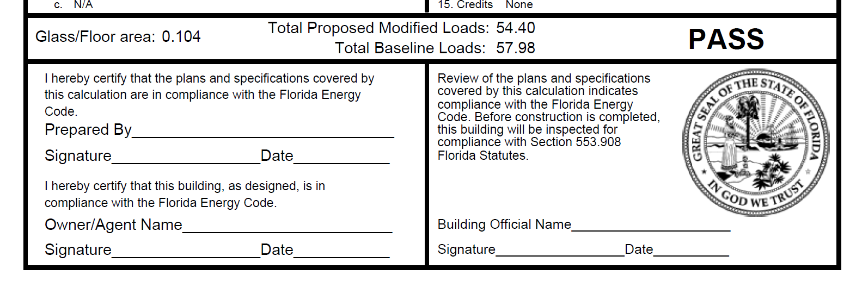

1. The Blower door test report does not select the Performance box when it prints the blower door and duct testing forms.

Some testing companies have taken advantage of this by selecting the prescriptive box when a performance method was used in order to bypass the design rate shown in the box. See code sections below and attached example of the box not checked.

**R405.2.2 Building air leakage testing.**Building or dwelling air leakage testing shall be in accordance with Sections R402.4 through R402.4.1.2. If an air leakage rate below seven air changes per hour at a pressure of 0.2 inch w.g. (50 pascals) is specified for the *proposed design*, testing shall verify the air leakage rate does not exceed the air leakage rate of the *proposed design*instead of seven air changes per hour.

**R405.2.3 Duct air leakage testing.**In cases where duct air leakage lower than the default Qn to outside of 0.080 (where Qn = duct leakage to the outside in cfm per 100 square feet of conditioned floor area tested at 25 Pascals) is specified for the *proposed design*, testing in accordance with Section R403.3.2 shall verify a duct air leakage rate not exceeding the leakage rate of the *proposed design*. Otherwise, in accordance with Section R403.3.3, duct testing is not mandatory for buildings complying by Section R405.

 We fixed this - see screenshot below

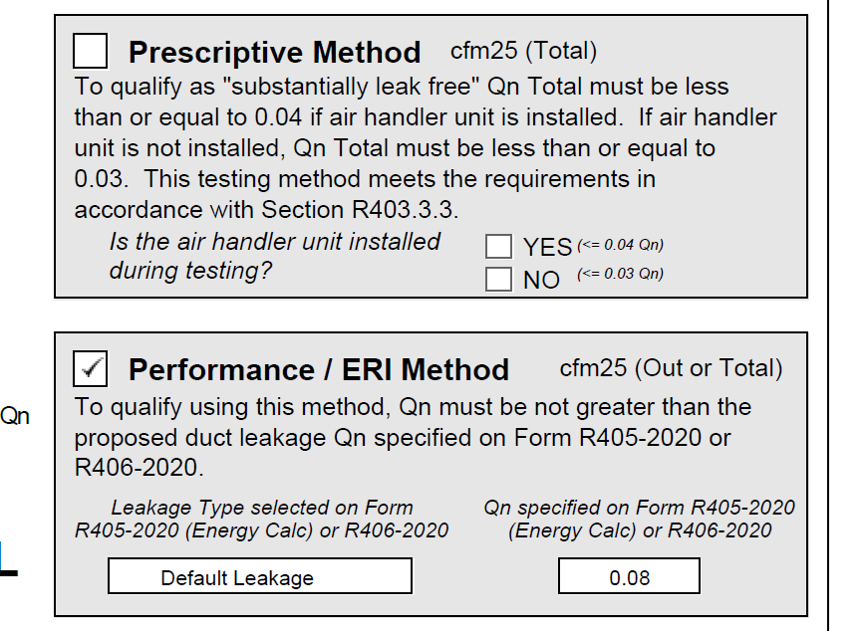

1. The is no place under the credit option screen to add a programmable thermostat. (See attached) If a programmable t-stat is shown on the form as a credit a check box needs to be located with the selected credits. I have not been able to have programmable thermostat credit shown on report.

 There is a place in the program to enter this credit. Go to equipment screen, system tab and select 'Programable thermostat'. Report will change accordingly. See screenshot below

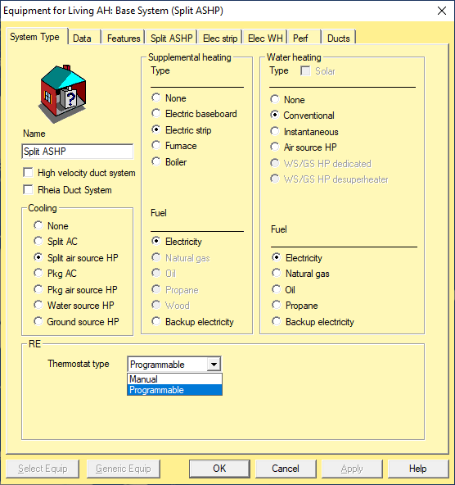

1. Duct location is a significant entry into the program and it needs to be clear on the printout. The form shows “Entire house At” which is not clear. See attached

  We fixed this - see screenshot below

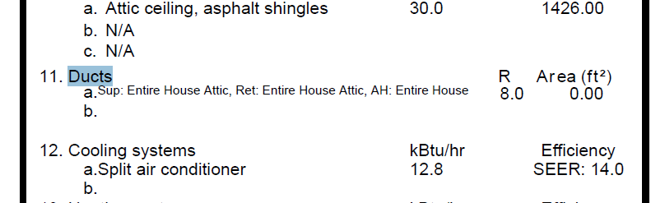

--------------------------------------------------------------------------------------------------------

Thank you,

**Michael Shnitman**

*Director of Software Development – HVAC,*

*Residential North America*

cid:c8b89b97-7e5d-4461-a535-0680a3616623

131 Hartwell Ave, Lexington, MA 02421

O: 781-301-6195

Michael.Shnitman@mii.com **|** www.mii.com **|** [www.](http://www.mii.com)wrightsoft.com