1) Install Right-Suite Universal (RSU) program
Download and run the installer from the following url:
https://www.wrightsoft.com/Support/rsu22.0.04.01/WSF/SetupWWSF2200401.exe

2) Activate the program
-Run Right-Suite Universal
-You will see 'Demo Licensing' screen at startup
- Hit 'Activate' button

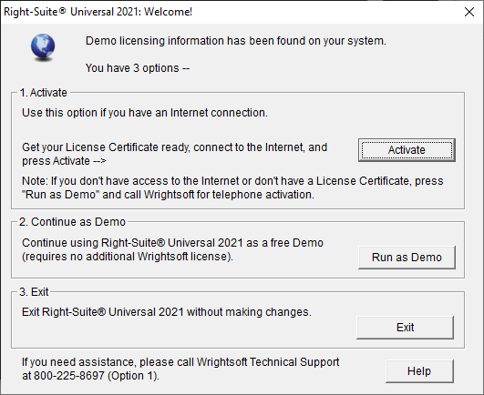

Enter information from attached activation certificate and hit 'submit' button
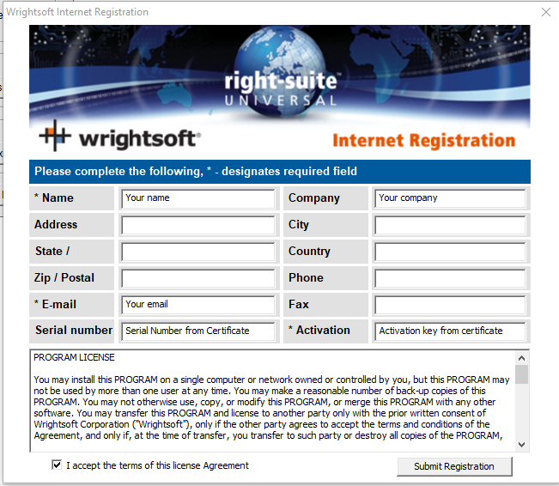

3) 2022 Supplement to the 7th Edition (2020) FBC specific feature

Equipment minimum efficiencies requirement option:
