**From:** Rob Vieira [mailto:robin@fsec.ucf.edu]   
**Sent:** Thursday, August 18, 2022 3:01 PM  
**To:** Madani, Mo  
**Subject:** Approval Request for EnergyGauge USA version 7.5

|  |
| --- |
| **[NOTICE] This message comes from a system outside of DBPR. Please exercise caution when clicking on links and/or providing sensitive information. If you have concerns, please contact your Knowledge Champion or the DBPR Helpdesk.** |

We are seeking approval for EnergyGauge USA 7.5 for the 7th Edition Florida Building Code, Energy Conservation 2020for the methods indicated in the attached memo, as well as the 7th Edition Florida Building Code, Energy Conservation 2020 with 2022 supplement. The feature of entering the efficiency of a central cooling or heating system using SEER2 or HSPF2 has been added. The baseline for the 7th Edition Florida Building Code, Energy Conservation 2020 with 2022 supplement central cooling split systems has been changed to SEER2 of 14.3 or 13.8 based on capacity consistent with the new federal regulation for systems installed in the South after January 1, 2023 and with the 2022 supplement. The minimum SEER2 for those systems is also required for compliance with the prescriptive methods for the 7th Edition Florida Building Code, Energy Conservation 2020 with 2022 supplement.

Direct link to download: <https://www.energygauge.com/downloads/setups/usa7500filing.exe>

Website page to find download: <https://www.energygauge.com/resource/>

Reference: New federal regulation can be found here: <https://www.ecfr.gov/current/title-10/chapter-II/subchapter-D/part-430/subpart-C/section-430.32>

With pertinent parts copied below

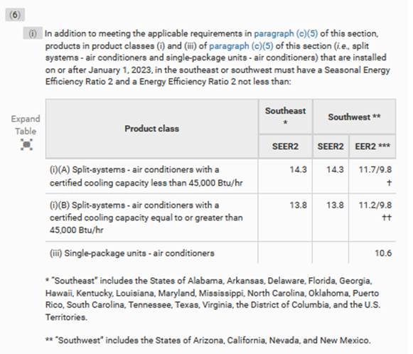

Rob Vieira  
Director, Buildings Research Division  
FSEC Energy Research Center

University of Central Florida

1679 Clearlake Road  
Cocoa, FL 32922  
321-638-1404