2010 Florida Building Code, Building
Glitch Supplement

Chapter 1 - ADMINISTRATION

101.4.7 Accessibility Change to read as shown.

101.4.7 Accessibility. For provisions related to accessibility, refer to Chapter 11 of the Florida Building Code, Building. the Florida Building Code, Accessibility .
[CA4598]

102.2.5 add to read as shown.

102.2.5 (a) Each enforcement district shall be governed by a board, the composition of which shall be determined by the affected localities.
(b)1. At its own option, each enforcement district or
local enforcement agency may adopt promulgate rules granting to
the owner of a single-family residence one or more exemptions
from the Florida Building Code relating to:
a.(a) Addition, alteration, or repairs performed by the
property owner upon his or her own property, provided any
addition or alteration shall not exceed 1,000 square feet or the
square footage of the primary structure, whichever is less.
b.(b) Addition, alteration, or repairs by a nonowner
within a specific cost limitation set by rule, provided the
total cost shall not exceed $5,000 within any 12-month period.
c.(c) Building and inspection fees.
2. However, the exemptions under subparagraph 1. do not
apply to single-family residences that are located in mapped
flood hazard areas, as defined in the code, unless the
enforcement district or local enforcement agency has determined
that the work, which is otherwise exempt, does not constitute a
substantial improvement, including the repair of substantial
damage, of such single-family residences.
3. Each code exemption, as defined in sub-subparagraphs
1.a, b., and c. paragraphs (a), (b), and (c), shall be certified
to the local board 10 days prior to implementation and shall
only be effective in the territorial jurisdiction of the
enforcement district or local enforcement agency implementing
it.

[CA4824]

104.11.3 Accessibility. Revise to read as shown.
104.11.3 Accessibility. Alternative designs and technologies for providing access to and usability of a facility for persons with disabilities shall be in accordance with Section 11.2.2. provisions of the Florida Building Code, Accessibility.
[CA4599]

Chapter 2 – DEFINITIONS

202 – Revise the following definitions to read as shown.
ACCESSIBLE. See Section 11-3.5. theFlorida Building Code, Accessibility.
ACCESSIBLE ROUTE. See Section 11-3.5. theFlorida Building Code, Accessibility
Accessible Unit. Reserved.See the Florida Building Code, Accessibility.
Dwelling unit or sleeping unit, type A. Reserved. See the Florida Building Code, Accessibility.
Dwelling unit or sleeping unit, type B. Reserved. See the Florida Building Code, Accessibility.
EMPLOYEE WORK AREA. Reserved..See theFlorida Building Code, Accessibility.
Wheelchair space. Reserved. ..See theFlorida Building Code, Accessibility.
[S4678]
DESIGN EARTHQUAKE GROUND MOTION. Reserved. See Section 1613.2.
DESIGNATED SEISMIC SYSTEM. Reserved. See Section 1702.1.
DETAILED PLAIN CONCRETE STRUCTURAL WALL. Reserved. See Section 1908.1.1
MAXIMUM CONSIDERED EARTHQUAKE GROUND MOTION. Reserved. See Section 1613.2.
MECHANICAL SYSTEMS. Reserved. See Section 1613.2.
ORTHOGONAL. Reserved. See Section 1613.2.
SEISMIC DESIGN CATEGORY. Reserved. See Section 1613.2.
SEISMIC-FORCE-RESISTING SYSTEM. Reserved. See Section 1613.2.
SPECIAL STRUCTURAL WALL. Reserved. See Section 1908.1.1.
[S4658]

FLOOR FIRE DOOR ASSEMBLY. See Section 702.1. A combination of a fire door, a frame, hardware, and other accessories, installed in a horizontal plane, which together provide a specific degree of fire protection to a through opening in a fire rated floor.
[S4659]

WIND-BORNE DEBRIS IMPACT RESISTANT PRODUCTS – Change to read as shown.
WIND-BORNE DEBRIS IMPACT RESISTANT PRODUCTS. Those products meeting TAS 201, TAS 202 and TAS 203, or ASTM E 1886 or and ASTM E 1996, or AAMA 506, or SSTD 12, or ANSI/DASMA 115.
[S4660]

Chapter 3 – USE & OCCUPANCY CLASSIFICATION

304.1 – 304.3 - Change to read as shown.
SECTION 304
BUSINESS GROUP B

304.1 Business Group B. No change..
304.2 Public and private colleges and universities shall comply with Section 443.

304.3Sections 423(1) and 423(2) are applicable to community Florida colleges shall comply with Section 423.
[SP4764, CA4765]

305 – Change to read as shown.
SECTION 305
EDUCATIONAL GROUP E

305.1 Educational Group E. No change.

305.2 Public and private educational occupancies shall comply with Section 443.

305.3 Public education occupancies shall comply with Section 423.
[SP4764, CA4765]
Chapter 4 – Special Detailed Requirements

403.1.1 Accessibility. Change to read as shown.
403.1.1 Accessibility. For accessibility provisions related to Group B and R occupancies, refer to Sections 11-5, 11-7, 11-9, and 11-11 the applicable sections of the Florida Building Code, Accessibility .
[CA4683]

406.2.2 Clear height. Change to read as shown.
406.2.2 Clear height. The clear height of each floor level in vehicle and pedestrian traffic areas shall not be less than 7 feet (2134 mm). Vehicle and pedestrian areas accommodating van-accessible parking shall be in accordance with Chapter 11. the Florida Building Code, Accessibility .
[CA4684]

412.3.6 Accessibility. Change to read as shown.
412.3.6 Accessibility. Accessibility Sshall be in accordance with the Florida Building Code, Accessibility Chapter 11.
[CA4661]

419.1.2 – Change to read as shown.

419.1.2 A change of ownership of an existing licensed hospital or a change to an existing hospital’s license or a change to a functional use in an existing hospital that does not require new physical plant or design revisions or changes shall not require compliance with this Section.
[SP4822]

419.4.2.2.6 – Change to read as shown.
419.4.2.2.6 New light standards and their foundations used for lighting the on-site emergency access route shall be designed to meet the wind load criteria of the American Society of Civil Engineers (ASCE 7), 50-year recurrence interval of wind velocity with wind speeds determined from Figure 26.5-1B with appropriate exposure category dependent on site location.
[SP4662]

420.4.2.1 Space standards – add to read as follows:

420.4.2.1 Space standards.
420.4.2.1.1 For planning purposes, each new facility shall provide a minimum of 30 net square feet (2.79 m2) per resident served in the occupied resident area(s). The number of residents to be served is to be determined by the facility administration.

420.4.2.1.2 As determined by the facility, space for administrative and support activities shall be provided for use by facility staff to allow for care of residents in the occupied resident area(s).

420.4.2.1.3 As determined by the facility, space shall be provided for all staff and family members of residents and staff.

COMMENT AFTER GLITCH

420.4.2.2.6 – Change to read as shown.
420.4.2.2.6 New light standards and their foundations used for lighting the on-site emergency access route shall be designed to meet the wind load criteria as described in the American Society of Civil Engineers (ASCE 7), 50-year recurrence interval of wind velocity with wind speeds determined from Figure 26.5-1B with appropriate exposure category dependent on site location.
[SP4663]

420.4.2.6.2 - add to read as follows:

All occupied resident areas and resident support areas shall be supplied with sufficient HVAC as determined by the facility to ensure the health, safety and well being of all residents and staff during and immediately following a disaster.

COMMENT AFTER GLITCH

421.3.12 Fire alarm systems. Delete as shown.
421.3.12.1 A fire alarm annunciator panel shall be provided per facility or building at a location that is constantly attended during the facility's hours of operation and shall annunciate a fire alarm from any manual or automatic fire alarm device. The panel shall indicate the zone of actuation of the alarm, and there shall be a trouble signal indicator. Each smoke compartment shall be annunciated as a separate fire alarm zone. A fire alarm system zone shall not include rooms or spaces in other smoke compartments and shall be limited to a maximum area of 22,500 square feet (2090 m²).
[SP4842]

421.3.13 – 421.3.13.7 - delete as shown.
421.3.13 Emergency electric system.
421.3.13.1 A Type 1 essential electrical system shall be provided in ambulatory surgical centers as described in NFPA 99, Health Care Facilities. The emergency power for this system shall meet the requirements of a Level 1, Type 10, Class 8 generator as described in NFPA 110, Emergency Standby Power Systems.
421.3.13.2 In new construction, the normal main service equipment shall be separated from the emergency distribution equipment by locating it in a separate room. Transfer switches shall be considered emergency distribution equipment for this purpose.
421.3.13.3 Switches for critical branch lighting shall be totally separate from normal switching. The devices or cover plates shall be of a distinctive color. Critical branch switches may be adjacent to normal switches. Switches for life safety lighting are not permitted except as required for dusk-to-dawn automatic control of exterior lighting fixtures.
421.3.13.4 There shall be selected life safety lighting provided at a minimum of 1 footcandle (10 lux) and designed for automatic dusk-to-dawn operation along the travel paths from the exits to the public way or to safe areas located a minimum of 30 feet (9.144 m) from the building.
421.3.13.5 A minimum of one elevator serving any patient treatment floor shall be in compliance with Section 421.3.5 of this code and shall be connected to the equipment branch of the essential electric system and arranged for manual or automatic operation during loss of normal power.
421.3.13.6 If a day tank is provided, it shall be equipped with a dedicated low level fuel alarm and a manual pump. The alarm shall be located at the generator derangement panel.
421.3.13.7 Transfer switch contacts shall be of the open type and shall be accessible for inspection and replacement.
[SP4841]

423.10.2.8.7 – Change to read as shown.
423.10.2.8.7 Accessible parking. Parking spaces designated for persons with disabilities shall comply with the ADA,Chapter 11of the Florida Building Code, Accessibility, Building, and Section 316.1955, Florida Statutes.
[SP4687]

423.25.4 Structural standard for wind loads. - Change to read as shown.
423.25.4 Structural standard for wind loads. At a minimum, EHPAs shall be designed for wind loads in accordance with ASCE 7, Minimum Design Loads for Buildings and Other Structures, Category III (Essential Buildings). Openings withstand the impact of wind-borne debris missiles in accordance with the impact and cyclic loading criteria per SBC/SSTD 12. Based on a research document, Emergency Shelter Design Criteria for Educational Facilities, by the University of Florida for the DOE, it is highly recommended by the department that the shelter be designed using the map wind speed plus 40 mph, with an importance factor of 1.0.
423.25.4 Structural standard for wind loads. At a minimum, EHPAs shall be designed for wind loads in accordance with ASCE 7, Minimum Design Loads for Buildings and Other Structures, Risk Category IV III (Essential Buildings). Openings shall withstand the impact of wind-borne debris missiles in accordance with the impact and cyclic loading criteria per ASTM E-1886 and, ASTM E-1996, or SBC/SSTD 12. Based on a research document, Emergency Shelter Design Criteria for Educational Facilities, by the University of Florida for the DOE, it is highly recommended by the department that the shelter be designed using the map wind speed plus 40 mph, with an importance factor of 1.0.
[SP4665]
423.25.4.1 Missile impact criteria – Change to read as shown.
423.25.4.1 Missile impact criteria. The building enclosure, including walls, roofs, glazed openings, louvers and doors, shall not be perforated or penetrated by a flying object. For walls and roofs, the missile criteria are is as provided in ASTM E-1886 and, ASTM E-1996, or SBC/SSTD 12.
[SP4664]
423.27.4 Accessibility. – Change to read as shown.
423.27.4 Accessibility. All relocatables constructed, purchased or otherwise acquired by a board after the effective date of these standards shall comply with the Americans with Disabilities Act as modified by Chapter 553, Florida Statutes, Chapter 11Florida Building Code, Accessibility, Building. Relocatables intended for use at facilities housing up to grades 5 or 6, shall also conform to the federal criteria Accessibility Standards for Children's Environments, which is available from the U.S. Architectural and Transportation Barriers Compliance Board.
[SP4688]

423.1-423.27.20 Change to read as shown.
SECTION 423
STATE REQUIREMENTS FOR EDUCATIONAL FACILITIES

[Note: Section 423 (IBC 09) Storm Shelters was moved to Section 442 of this Chapter to maintain formatting. Enhanced Hurricane Protection Areas (EHPA) requirements for public educational facilities are found in Section 423.25.]

423.1 Scope: Public educational facilities. Public educational facilities shall comply with the Florida Building Code and the Uniform Fire Safety Standards Florida Fire Prevention Code as adopted by the State Fire Marshal. These are minimum standards; boards may impose more restrictive requirements. Additional requirements for public educational facilities in Florida, including public schools and public Florida colleges, are found in these standards.

Note: Other administrative and programmatic provisions may apply. See Department of Education Rule 6-2 and Chapter 1013, Florida Statutes.

423.2 Public schools and Florida colleges general requirements.

423.2.1 Owner. Each school board and Florida college board of trustees is deemed to be the owner of facilities within its respective jurisdiction. Boards shall provide for enforcement of the Florida Building Code and the Uniform Fire Safety Standards Florida Fire Prevention Code as adopted by the State Fire Marshal, including standards for health, sanitation, and others as required by law.

423.2.2 Exemption from local requirements. All public educational and ancillary plants constructed by a school board or a Florida college board are exempt from all other state, county, district, municipal, or local building codes, interpretations, building permits, and assessments of fees for building permits, ordinances, road closures, and impact fees or service availability fees as provided in Section 1013.37(1)(a), Florida Statutes.

423.3 Code enforcement.

423.3.1 School boards and Florida college boards. Section 553.80(6), Florida Statutes, provides options for plan review services and inspections by school boards and Florida college boards.

423.3.2 Owner review and inspection. A school board or Florida college board which undertakes the construction, remodeling, renovation, lease, or lease-purchase of any educational plant or ancillary facility, or day labor project, regardless of cost or fund source, shall review construction documents as required by law in Section 1013.38, Florida Statutes, and Section 553.80(6), Florida Statutes, and shall ensure compliance with requirements of law, rule, and the Florida Building Code and the Uniform Fire Safety Standards Florida Fire Prevention Code as adopted by the State Fire Marshal. Section 553.80(6), Florida Statutes, states that district school boards and Florida college boards shall provide for plan review and inspections for their projects. They shall use personnel certified under Part XII of Chapter 468, Florida Statutes to perform the plan reviews and inspections or use one of the options provided in Section 1013.38, Florida Statutes. Under this arrangement, school boards and Florida college boards are not subject to local government permitting, plan review, and inspection fees.

423.3.3 Local government review and inspection. As an option to the owner providing plan review and inspection services, school boards and Florida college boards may use local government code enforcement offices who will not charge fees more than the actual labor and administrative costs for the plan review and inspections. Local government code enforcement offices shall expedite permitting. Any action by local government not in compliance with Section 553.80(6), Florida Statutes, may be appealed to the Florida Building Commission, which may suspend the authority of that local government to enforce the Florida Building Code and the Uniform Fire Safety Standards Florida Fire Prevention Code as adopted by the State Fire Marshal on the facilities of school boards and Florida college boards.

423.3.4 Other regulatory agencies. Boards shall coordinate the planning of projects with state and regional regulatory and permitting agencies, as applicable. Other state or local agencies may inspect new construction or existing facilities when required by law; however, such inspections shall be in conformance with the code as modified by this section.

423.3.5 Day labor projects. Any one construction project estimated to cost $300,000 or less where bonafide board employees or contracted labor provide the work. Day labor projects are subject to the same Florida Building Code and the Uniform Fire Safety Standards Florida Fire Prevention Code as adopted by the State Fire Marshal as new construction.

423.3.6 Routine maintenance. Maintenance projects are subject to the same Florida Building Code and Uniform Fire Safety Standards Florida Fire Prevention Code as adopted by the State Fire Marshal as new construction. Chapter 489, Florida Statutes, exempts boards from the use of a licensed general contractor for projects up to $300,000 where bonafide board employees provide the work. Maintenance projects estimated to cost more than $300,000 and which include construction, renovation and/or remodeling, shall be reviewed for compliance with the code.

423.3.7 Certificate of occupancy. New buildings, additions, renovations, and remodeling shall not be occupied until the building has received a certificate of occupancy for compliance with codes that were in effect on the date of permit application.

423.3.8 Reuse and prototype plans shall be code updated with each new project.

423.4 Reference documents. School Boards and Florida College Boards of Trustees. In addition to complying with the Florida Building Code and the Uniform Fire Safety Standards Florida Fire Prevention Code as adopted by the State Fire Marshal, and other adopted standards and this section, public educational facilities and sites shall comply with applicable federal and state laws and rules.
423.4.1 Rule 6-2 [State Requirements for Educational Facilities (SREF) ]. A Florida Department of Education document which includes required design standards, standards for rehabilitation of historical resources, capital outlay project process requirements, and various agencies having jurisdiction during project planning and construction.

423.4.2 Flood Resistant Construction. Educational facilities in flood hazard areas shall comply with ASCE 24.

423.4.3 Florida statutes and state rules. Including, but not limited to, Chapters 1013, 240, 255, 468, 471, 481, 489, 553, 633, and Section 287.055, Florida Statutes, and various state rules as applicable to specific projects.

423.4.4 Accessibility requirements for children's environments. U.S. Department of Justice and the U.S. Architectural and Transportation Barriers Compliance Board.

423.4.5 Handbook for public playground safety. Playgrounds and equipment shall be designed and installed using the Handbook for Public Playground Safety by the U. S. Consumer Product Safety Commission, and the ASTM/CPSC Playground Audit Guide as applicable.

423.4.6 ANSI Z53.1. American National Standard Safety Color Code for marking Physical Hazard s, is used in shops where machinery requires marking and safety zones.

423.4.7 ASCE 7. American Society of Civil Engineers.

423.4.8 Life Cycle Cost Guidelines for Materials and Buildings for Florida's Public Educational Facilities, available from the Department of Education, Bureau of Educational Facilities shall be considered.

423.5 Definitions.

423.5.1 "Assembly" occupancies are buildings or portions of buildings used for gatherings of 50 or more persons, such as auditoriums, gymnasiums, multipurpose rooms, classrooms and labs, cafeterias, stadiums, media centers and interior courtyards. Assembly occupancies include adjacent and related spaces to the main seating area, such as stages, dressing rooms, workshops, lobbies, rest rooms, locker rooms, and store rooms. School board and Florida college facilities shall follow the requirements of Uniform Fire Safety Standards Florida Fire Prevention Code as adopted by the State Fire Marshal for assembly spaces.

423.5.2 "Board" means a district school board and a Florida college board of trustees.

423.5.3 "Boiler" is a fuel-fired, heat-producing appliance with a minimum input capacity of (60,000) Btu per hour and intended to supply hot water or steam. Boilers and the inspection of boilers shall comply with the Boiler Safety Act of 1987.

423.5.4 "Certificate of occupancy" is documentation issued by an authority having jurisdiction which indicates inspection and approval of completion of a construction project pursuant to the requirements of Florida law.

423.5.5 "Courtyard" is a court or enclosure adjacent to, or surrounded by, a building(s) and/or walls.

423.5.5.1 "Exterior courtyard" is a courtyard which is not roofed, has a minimum width of 40 feet (1219 mm), and

a. has an opening a minimum width of 40 feet (1219 mm), with no obstructions, on at least one end, or

b. has fences between the buildings for security purposes, and the required exiting capacity of the courtyard is provided for by means of doors or gates from the courtyard.

An exterior courtyard may be considered exterior space and used for exiting of adjacent spaces. For an exterior courtyard with an opening between 40 feet (1219 mm) and 60 feet wide (18 288 mm), the building walls and wall openings must meet the requirements of Florida Building Code, Building Tables 601 and 602 and the maximum travel to the courtyard opening/exit shall not exceed 150 feet (45,720 mm) from any point within the courtyard. If the minimum courtyard width exceeds 60 feet (18 288 mm), the travel distance to a courtyard opening/exit may exceed 150 feet (945 720 mm).

423.5.5.2 "Enclosed courtyard" is a courtyard which is not roofed by more than 50 percent of the courtyard area and which is substantially surrounded by a building(s) on two sides or more and each opening to the exterior is less than 40 feet (1219 mm) in width. The courtyard area shall be calculated for maximum occupancy as an assembly space and the number and size of remotely located exits shall be calculated for the maximum possible load. The maximum possible load is the greater of the calculated capacity of the courtyard or the load imposed by the surrounding spaces. An enclosed courtyard may be used as a component of exit access provided that the walls and wall openings meet the requirements of Florida Building Code, Building Tables 601 and 602 and the maximum travel to the exit discharge does not exceed 150 feet (45 720 mm) from any point within the enclosed courtyard. An enclosed courtyard cannot serve as the exterior for exiting or for emergency rescue openings.

423.5.5.3 "Roofed courtyard" is a courtyard which is roofed by more than 50 percent of the courtyard area in any manner. Courtyards may be used for assembly spaces and may not be used as a component of exiting from adjacent spaces.

423.5.6 "Facility" is additionally defined as follows:

423.5.6.1 "Ancillary facility" is a building or other facility necessary to provide district-wide support services, such as an energy plant, bus garage, warehouse, maintenance building, or administrative building.

423.5.6.2 "Ancillary plant" is buildings, site, and site improvements necessary to provide district-wide vehicle maintenance, storage, building maintenance activities, or administrative functions necessary to provide support services to an educational program.

423.5.6.3 "Auxiliary facility" consists of the support spaces located at educational facilities and plants which do not contain student stations but are used by students, such as libraries, administrative offices, and cafeterias.

423.5.6.4 "Educational facility" consists of buildings and equipment, structures, and special educational use areas that are built, installed, or established to serve primarily the educational purposes and secondarily the social and recreational purposes of the community.

423.5.6.5 "Educational plant" comprises the educational facilities, site, and site improvements necessary to accommodate students, faculty, administrators, staff, and the activities of the educational program.

423.5.6.6 "Existing facility" is a facility owned, rented or leased.

423.5.6.7 "Leased facility" is a facility not owned, but contracted for use.

423.5.6.8 "Permanent facility" is a facility designed for a fixed location.

423.5.6.9 "Relocatable/portable facility" is a building which is designed with the capability of being moved to a new location.

423.5.6.10 "Modular facility" is a structure which, when combined with other modules and/or demountable roof and/or wall sections, forms a complete building. This facility may be relocatable.

423.5.7 "Maintenance and repair" is the upkeep of educational and ancillary plants including, but not limited to, roof or roofing replacement, short of complete replacement of membrane or structure; repainting of interior or exterior surfaces; resurfacing of floors; repair or replacement of glass and hardware; repair or replacement of electrical and plumbing fixtures; repair of furniture and equipment; replacement of system equipment with equivalent items meeting current code requirements providing that the equipment does not place a greater demand on utilities, structural requirements are not increased, and the equipment does not adversely affect the function of life safety systems; traffic control devices and signage; and repair or resurfacing of parking lots, roads, and walkways. Does not include new construction, remodeling, or renovation, except as noted above.

423.5.8 "New construction" is any construction of a building or unit of a building in which the entire work is new. An addition connected to an existing building is considered new construction.

423.5.9 "Open plan building" is any building which does not have corridors defined by permanent walls and is entirely open or divided by partitions which may be easily rearranged.

423.5.10 "Open plan instructional space" is an arrangement of two or more class areas with no permanent partitions or wall separations.

423.5.11 "Owner" of facilities within a repective jurisdiction consists of each school board and Florida college board of trustees is deemed to be the owner of facilities within its respective jurisdiction.

423.5.12 "Permit" for construction is documentation issued by an authority having jurisdiction which indicates approval of construction plans prepared pursuant to the requirements of Florida law.

423.5.13 "Remodeling" is the changing of existing facilities by rearrangement of space and/or change of use. Only that portion of the building being remodeled must be brought into compliance with the Florida Building Code and Uniform Fire Safety Standards Florida Fire Prevention Code as adopted by the State Fire Marshal unless the remodeling adversely impacts the existing life safety systems of the building.

423.5.14 "Renovation" is the rejuvenating or upgrading of existing facilities by installation or replacement of materials and equipment. The use and occupancy of the spaces remain the same. Only that portion of the building being renovated must be brought into compliance with the Florida Building Code and Uniform Fire Safety Standards Florida Fire Prevention Code as adopted by the State Fire Marshal unless the renovation adversely impacts the existing life safety systems of the building.

423.5.15 "Separate atmosphere" is the individual volumes of air in a building which are divided by smoke proof barriers to limit contamination of the air by smoke and fumes during a fire.

423.5.16 "Separate building" for the purpose of separate fire alarm systems or sprinkler systems is a structure separated from other buildings by 60 feet (18 288 mm) or more, or as required by other sections of this code.

423.5.17 Florida college is a public community college, public college, state college, or public junior college.

423.5.18 "Student-occupied space" is any area planned primarily for use by six or more students.

423.6 Administration of public education projects.
423.6.1 Occupancy during construction. School board and Florida college board facilities, or portions of facilities, shall not be occupied during construction unless exits, fire detection and early warning systems, fire protection, and safety barriers are continuously maintained and clearly marked at all times. Construction on an occupied school board site shall be separated from students and staff by secure barriers. Prior to issuance of the notice to proceed, a safety plan shall be provided by the contractor which clearly delineates areas for construction, safety barriers, exits, construction traffic during the various phases of the project and when conditions change. Where heavy machinery, as is used for earth moving or scraping, is required to work on a school board's occupied site, the work shall be separated from occupants by secure double barriers with a distance of 10 feet (3048 mm) in between. New construction, remodeling or renovations in existing facilities shall not reduce the means of egress below the requirements for new buildings; safe means of egress from a student-occupied space may be accomplished as authorized by NFPA 101, Florida edition as adopted by the Florida Fire Prevention Code. New construction (additions) shall not block or reduce safe means of egress.

423.6.2 Contractor toxic substance safety precautions. When hazardous chemicals as defined by 29 CFR 1910.1200, OSHA Hazard Communication Standard are to be used during the maintenance, renovation, remodeling, or addition to an existing facility, the contractor shall notify the administrator in writing at least three working days before any hazardous chemical is used. The notice shall indicate the name of each of the hazardous chemicals to be used, where and when they will be used, and a copy of a Material Safety Data Sheet (MSDS) for each hazardous chemical. The contractor shall comply with the safety precautions and handling instructions set forth in the MSDS. Copies of hazardous waste manifests documenting disposal shall be provided to the facility's administrator who will notify occupants of the anticipated presence of toxic substances during the maintenance, renovation, remodeling, or addition to an existing facility.

423.6.3 Flammable or explosive substances. No flammable or explosive substances or equipment shall be introduced during a remodeling or renovation project in a facility of normally low or ordinary hazard classification while the building is occupied.

423.7 Life safety.

423.7.1 Separate exits. In assembly occupancies, each required exit must exit into a separate atmosphere or to the exterior, to be considered as a separate exit.

423.7.2 Exit access. Exit access shall not be through a toilet room, storage room, or similar space, or any space subject to being locked.

423.7.3 Location of fire extinguishers and blankets. Fire extinguishers may be located inside student-occupied spaces provided they are placed adjacent to the primary exit door, and the room door remains unlocked when the facility is occupied, and a permanently affixed sign, with a red background and white letters, reading "FIRE EXTINGUISHER INSIDE" is placed on the outside adjacent to the door. Fire extinguisher cabinets shall not be locked. Fire blankets shall be located in each laboratory and each shop where a fire hazard may exist. Fire extinguishers and fire blankets shall be readily accessible and suitable for the hazard present and shall not be obstructed or obscured from view. Extinguishers and blankets shall be on hangers or brackets, shelves, or cabinets so that the top of the extinguisher or blanket is not more than 54 inches (1318 mm) above finish floor (AFF) and complies with state and federal accessibility requirements. All extinguishers shall be installed and maintained in accordance with NFPA. Extinguishers shall remain fully charged and operable at all times and have a current tag to indicate compliance.

423.7.4 Common fire alarm. Buildings within 60 feet (18 288 mm) of each other shall have a common fire alarm system. Emergency shelters shall have the fire alarm panel located in the space identified as the shelter manager's office.

423.7.5 Fire alarm sending stations. Sending stations may be located inside student-occupied spaces, adjacent to the primary exit door only if the door to the occupied space is unlocked at all times while the facility is occupied. When located inside a student occupied space, a permanently affixed sign reading "FIRE ALARM PULL STATION INSIDE" shall be placed outside that space adjacent to the door. This sign shall have a red background with white letters. Sending stations shall be mounted to meet accessibility requirements.

423.7.6 Automatic shut off. The fire alarm system shall shut off gas and fuel oil supplies which serve student-occupied spaces or pass through such spaces. The shutoff valve shall be located on the exterior at the service entrance to the building. The shutoff valve shall be of the manual reset type.

423.7.6.1 Kitchen gas supplies. Kitchen gas supplies shall be shut-off by activation of the kitchen hood fire suppression system. The shut-off valve shall be installed in accordance with the manufacturer's instructions and recommendations.

423.7.6.2. Emergency power. The fire alarm system shall not shut off gas supplies which serve emergency power sources.

423.7.7 Unoccupied rooms and concealed spaces. Rooms or spaces for storage, custodial closets, mechanical rooms, spaces under stages with wood structures and other unoccupied or unsupervised spaces in a building shall have automatic fire alarm system detector devices installed. Any concealed space with exposed materials having a flame spread rating greater than Class A, including crawl spaces under floors, interstitial spaces between ceiling and floor or roof above and attic spaces, shall be equipped with heat detector devices. Smoke and heat detector devices shall be installed in accordance with NFPA 72.

423.7.7.1 Fully sprinklered buildings. In fully sprinklered buildings, fire alarm detection devices are not required except where specified in the Florida Fire Prevention Code.

423.7.8 Boiler rooms. Each boiler room shall be separated from the remainder of the building by one hour fire rated construction or shall be separate from other buildings by 60 feet (18 288 mm), and shall have an out-swinging door opening directly to the exterior. A fire door swinging into the boiler room shall also be provided for any opening into the interior of the building. There shall be no opening into any corridor or area designed for use by students.

423.8 General requirements for new construction, additions, renovation, and remodeling.

423.8.1 Codes and standards. Educational facilities owned by school boards and Florida college boards shall meet the construction requirements of the Florida Building Code and the Uniform Fire Safety Standards Florida Fire Prevention Code as adopted by the State Fire Marshal, state and federal laws and rules, and this section for Florida's public educational facilities for new construction, remodeling and renovation of existing facilities. This is a minimum standard; boards may impose more restrictive safety and level of quality standards for educational, auxiliary, and ancillary facilities under their jurisdiction, provided they meet or exceed these minimum requirements.

423.8.1.1 Educational occupancy. School board educational facility projects whether owned, lease-purchased or leased shall comply with the educational occupancy and assembly occupancy portions of the above referenced codes as applicable, except where in conflict with this section. The support spaces such as media centers, administrative offices and cafeterias and kitchens located within educational facilities are not separate occupancies.

423.8.1.2 Business occupancy. Florida college board educational facility projects whether owned, lease-purchased or leased shall comply with the business occupancy and the assembly occupancy of the above referenced codes as applicable, except where in conflict with this section.

423.8.1.3 Ancillary facility. School board and Florida college board ancillary facilities such as warehouses or maintenance buildings, shall use the applicable occupancy section of the Florida Building Code and the Uniform Fire Safety Standards Florida Fire Prevention Code as adopted by the State Fire Marshal. Ancillary facilities on educational plant sites shall be separated from the educational facility as required by code.

423.8.2 Space standards. School board and Florida college board facility sizes shall use standards in the "Size of Space and Occupant Design Criteria Table" found in the Department of Education document, "State Requirements for Educational Facilities (SREF)." Exiting from occupied spaces shall comply with Table 1004.1.2 of the Florida Building Code, Building.

423.8.3 Construction type. School board and Florida college buildings including auxiliary, ancillary and vocational facilities shall comply with the following:

423.8.3.1 Noncombustible Type I, II or IV. The minimum construction type for one- and two-story public educational facilities shall be noncombustible Type I, II or IV construction or better.

423.8.3.1.1 Interior nonload-bearing wood studs or partitions shall not be used in permanent educational and auxiliary facilities or relocatable buildings.

Exception: Historic buildings to maintain the fabric of the historic character of the building.

423.8.3.2 Type I. Facilities three stories or more shall be Type I construction.

423.8.3.3 Type IV. When Type IV construction is used, wood shall be exposed and not covered by ceilings or other construction.

423.8.3.4 Exceptions to types of construction:

1. Covered walkways open on all sides may be Type V construction.

2. Single story dugouts, press boxes, concession stands, related public toilet rooms, detached covered play areas, and nonflammable storage buildings that are detached from the main educational facility by at least 60 feet (1829 mm), may be Type V construction.

423.8.4 Standards for remodeling and/or renovation projects. Portions of buildings being remodeled and/or renovated shall be brought into compliance with current required Florida Building Code and the Uniform Fire Safety Standards Florida Fire Prevention Code as adopted by the State Fire Marshal as required by the plan review authority in its best judgment.

423.8.4.1 An automatic fire sprinkler system is not required in existing educational buildings unless 50 percent of the aggregate area of the building is being remodeled.

423.8.5 Leased facilities. Leased facilities shall be brought into compliance with applicable occupancy requirements of the Florida Building Code and the Uniform Fire Safety Standard s as adopted by the State Fire Marshal prior to occupancy.

423.8.6 Asbestos prohibited. The federal Asbestos Hazard Emergency Response Act, (AHERA) 40 CFR, Part 763, as revised July 1, 1995, prohibits the use of any asbestos containing materials in any public education construction project and requires certification of same by the architect of record.

423.8.7 Life cycle cost guidelines for materials and building systems. An analysis shall be included, as required by Section 1013.37(1), Florida Statutes, which evaluates building materials and systems, life cycle costs for maintenance, custodial, operating, and life expectancy against initial costs, as described in Section 1013(1)(e)4, Florida Statutes. Standards for evaluation of materials are available from the department in a publication entitled Life Cycle Cost Guidelines for materials and Building Systems for Florida's Public Educational Facilities.

423.8.8 Safe school design. School boards should design educational facilities and sites including pre-K through 12, vocational and Florida colleges to enhance security and reduce vandalism through the use of "safe school design" principles. Safe school design strategies are available from DOE/educational facilities and include but are not limited to the following:

423.8.8.1 Natural access and control of schools and campuses.

423.8.8.2 Natural surveillance of schools and campuses both from within the facility and from adjacent streets by removing obstructions or trimming shrubbery.

423.8.8.3 School and campus territorial integrity; securing courtyards, site lighting, building lighting.

423.8.8.4 Audio and motion detection systems covering ground floor doors, stairwells, offices and areas where expensive equipment is stored.

423.8.8.5 Designs which will promote the prevention of school crime and violence. Exterior architectural features which do not allow footholds or handholds on exterior walls, tamperproof doors and locks, nonbreakable glass or shelter window protection system; also landscaping and tree placement should be designed so they do not provide access to roofs by unauthorized persons. Sections of schools commonly used after hours should be separated by doors or other devices from adjacent areas to prevent unauthorized access. Install locks on roof hatches; apply slippery finishes to exterior pipes.

423.8.8.6 Exterior stairs, balconies, ramps, and upper level corridors around the perimeter of buildings should have open-type handrails or other architectural features to allow surveillance.

423.8.8.7 Open areas, such as plazas, the building's main entrance, parking lots, and bicycle compounds should be designed so they are visible by workers at workstations inside the buildings.

423.9 Structural design.

423.9.1 Load importance factor. Structural design shall comply with code requirements and wind loads as stipulated by the Florida Building Code and the Uniform Fire Safety Standards Florida Fire Prevention Code as adopted by the State Fire Marshal. Design shall be based on ASCE 7, with a wind load importance factor for educational facilities of 1.15.

423.10 Site requirements.

423.10.1 Fencing. Fencing for school board educational plants shall be of a material which is nonflammable, safe, durable, and low maintenance, provides structural integrity, strength and aesthetics appropriate for the intended location. Fences shall have no jagged or sharp projections. Fence heights shall be in compliance with local zoning regulations. Access shall be provided for maintenance machinery. Prohibited materials for nonagricultural educational plants include razor wire, barbed wire and electrically charged systems.

423.10.1.1 Required locations. Fencing is required to separate students from potential harm, and shall be provided in the following locations:

423.10.1.1.1 Kindergarten through grade 12. Exposed mechanical, plumbing, gas, or electrical equipment located on ground level.

423.10.1.1.2 Kindergarten through grade 5. Special hazards as identified by the authority having jurisdiction including retention ponds whose permanent water depth or whose water depth over a 24-hour period exceeds 1 foot (305 mm), deep drainage ditches, canals, highways, and play fields adjacent to roadways.

423.10.1.1.3 Kindergarten through grade 12. All child care and kindergarten play areas.

423.10.2 Walks, roads, drives, and parking areas. Walks, roads, drives, and parking areas on educational and ancillary sites shall be paved. Roads, drives, and parking areas shall be in compliance with Department of Transportation (DOT) road specifications and striped in compliance with DOT paint specifications. All paved areas shall have positive drainage.

423.10.2.1 Covered walks. All buildings in K-12 educational facilities shall be connected by paved walks and accessible under continuous roof cover. New relocatable classroom buildings shall be connected to permanent buildings by paved covered walks where applicable. Roofs for covered walks shall extend 1 foot (305 mm) beyond each side of the designated walkway width. Gutters or other water funneling devices shall prevent storm water from pouring onto or draining across walks.
423.10.2.2 Accessible walks and bridges. Accessible walks shall connect building entrance(s) to accessible parking, public transportation stops, public streets, sidewalks, loading and drop-off zones, and other facilities within the site as required by the accessibility standards. School board sites where educational plants are separated by highways shall be connected by overhead pedestrian bridges.

423.10.2.3 Drainage. Soil, grass, and planting beds shall provide positive drainage away from sidewalks, but shall not fall away at more than a 3-percent gradient slope for a minimum distance of 5 feet (1524 mm) from the edge. The location of all drains, grates, drop inlets, catch basins, other drainage elements and curb cuts shall be out of the main flow of pedestrian traffic.
423.10.2.4 Vertical drops. Walls, railings, or other physical barriers which are at least a minimum 12 inches (305 mm) in height, shall define and protect any vertical drop between joining or abutting surfaces of more than 6 inches (152 mm) but less than 18 inches (457 mm) in height. Any vertical drop of 18 inches (457 mm) or more shall be protected by a wall or guardrail a minimum of 42 inches (1067 mm) in height.

423.10.2.5 Roads and streets. Educational and ancillary site access shall consist of a primary road and another means of access to be used in the event the primary road is blocked. Stabilized wide shoulders of the primary road, unobstructed by landscaping, planters, light fixtures, poles, benches, etc., which allow a third lane of traffic, may satisfy the requirement for the other means of access. Driveways shall not completely encircle a school plant, to allow student access to play areas without crossing roads; vehicular and pedestrian traffic shall not cross each other on the site; bus driveways and parent pick-up areas shall be separated.

423.10.2.6 Bus drives. Bus drives on educational sites shall be designed so that buses do not have to back up. The minimum width shall be 24 feet (7315 mm) for two-lane traffic. The turning radius on educational and ancillary sites and for turning off public access streets shall be as follows: one-way traffic, 60 feet (18 288 mm) minimum measured to the outside curb or edge of the traffic lane; two-way traffic, 60 feet (18 288 mm) minimum measured to the centerline of the road.

423.10.2.7 Vehicle parking areas. Vehicle parking areas shall comply with minimum parking space requirements in this section. Except for parking space requirements to meet federal and state accessibility laws, where alternate transportation or parking arrangements are available the parking area requirements may be reduced from these standards if sufficient justification documentation is provided and if the review authority approves the reduction based on the justification. Over- flow parking areas may utilize alternative parking surfaces which facilitate water absorption rather than runoff when approved for use by the review authority. This requirement usually applies to a percentage of the parking spaces, not all of them.

Exception: Accessible parking spaces shall be hard surface.

423.10.2.8 Minimum parking requirements.

423.10.2.8.1 Faculty and staff. One space for each member.

423.10.2.8.2 Visitors. One space for every 100 students.

423.10.2.8.3 Community clinics where provided. Ten spaces, including one accessible space.

423.10.2.8.4 High schools. One space for every 10 students in grades 11 and 12.

423.10.2.8.5 Vocational schools. One space for every two students.

423.10.2.8.6 Florida colleges. One space for every two students.

423.10.2.8.7 Accessible parking. Parking spaces designated for persons with disabilities shall comply with the ADA, Chapter 11 of the Florida Building Code, Accessibility Building, and Section 316.1955, Florida Statutes.

423.10.3 Site lighting required. Design, construction, and installation of exterior security lighting for educational and ancillary facilities shall be provided for:

423.10.3.1 Auto, bus, and service drives and loading areas.

423.10.3.2 Parking areas.

423.10.3.3 Building perimeter.

423.10.3.4 Covered and connector walks between buildings and between buildings and parking.

423.10.3.5 Lighting for parking areas. Parking area lighting standards shall be designed to withstand appropriate wind loads. Parking areas shall be illuminated to an average maintained horizontal footcandle, measured at the surface as follows:

423.10.3.5.1 Parking areas-1 footcandle (10 lux).

423.10.3.5.2 Covered and connector walks-1 footcandle (10 lux).

423.10.3.5.3 Entrances/exits -2 footcandles (20 lux).

423.10.3.6 Building exteriors. Building exteriors, perimeters, and entrances may be illuminated to the minimum number of footcandles, measured at the surface with a suggested uniformity ratio of 2:1 as follows:

423.10.3.6.1 Entrances-5 footcandles (50 lux).

423.10.3.6.2 Building surrounds-1 footcandle (10 lux).

423.10.3.7 Shielding. Exterior lighting shall be shielded from adjacent properties.

423.10.4 Building setbacks. Building setbacks from the property line, including relocatables, shall, at a minimum, be 25 feet (7620 mm) or shall comply with local setback requirements if less than 25 feet (7620 mm).

423.10.5 School board playgrounds, equipment, and athletic fields. Playgrounds, equipment, and athletic fields shall be accessible, compatible with the educational facility served and shall comply with the following:

423.10.5.1 Kindergarten play areas shall be separated from other play areas, fenced, and shall be directly accessed from the kindergarten classrooms.

423.10.5.2 Playgrounds and equipment shall be designed and installed using the Handbook for Public Playground Safety by the U.S. Consumer Product Safety Commission, and the ASTM/CPSC Playground Audit Guide as applicable, resulting in facilities which are safe, structurally sound, verminproof, and do not have jagged or sharp projections.

423.10.5.3 Direct access from the school buildings shall be provided to play areas and athletic fields without crossing public roads, on-site traffic lanes, and parking lots.

423.10.5.4 Related facilities such as toilets, concessions, storage, shower and locker rooms, bleachers, press boxes, observation platforms, scoreboards, and dugouts shall be designed to meet code requirements and the occupant capacity anticipated for the program.

423.10.5.5 Playgrounds shall be evenly graded and sloped to provide surface drainage.

423.10.6 Exterior signage. All permanent and free-standing exterior signs shall be designed to withstand appropriate wind loads. Illuminated signs shall comply with the electrical and installation requirements of the Florida Building Code and Uniform Fire Safety Standards Florida Fire Prevention Code as adopted by the State Fire Marshal.

423.10.6.1 Site signage shall not create visual barriers at entrances, sidewalks, roads or road intersections.

423.10.6.2 Accessible routes, including parking, building directories, building identification, and accessible entrances shall be marked by exterior signage in conformance with federal and state accessibility laws.

423.10.7 Landscaping. Refer to Section 1013.64(5), Florida Statutes, for school board and Florida college requirements. Xeriscape is defined in Section 373.185, Florida Statutes.

423.10.8 Water irrigation systems shall be equipped with soil moisture sensors that will override the irrigation systems cycle when soil contains sufficient moisture.

423.10.9 Transmission line right-of-way. Buildings, play areas, and common use areas shall not be located within a high-voltage power transmission line right-of-way.

423.10.10 School site master plan. New schools planned after the effective date of these standards shall include, as applicable: facility design capacity; floodplain locations; covered accessible walks; infrastructure locations for, and extensions of, technology, telephone, electricity, fire alarm; and, where applicable, water and sewer utilities, and relocatables.

423.11 Wood: fire-retardant treated wood (FRTW). FRTW shall not be used in permanent educational facilities.

Exception: Only FRTW which does not contain ammonium phosphates, sulfates, or halides, may be used in roof structures of noncombustible Type II ancillary facilities as allowed by the Florida Building Code, but only under the following conditions:

423.11.1 Fire-retardant treated wood. All FRTW must meet the requirements of Section 2303.2.

423.11.2 Inspection access panels shall be provided for annual inspection of the condition of the structure and the connectors.

423.11.3 Evidence of compliance shall be provided.

423.12 Roofing.

423.12.1 Class A materials. All roofing materials shall be labeled Class A per ASTM E108 and shall be certified by a nationally recognized independent testing laboratory. All roofing systems shall be installed within the limitations of the test procedure for surfacing, deck cross slope, and combustibility.

423.12.2 Insulation and moisture protection. Insulation, moisture protection, roofing, thermal requirements, fireproofing and firestopping shall be designed and constructed in compliance with the the Florida Building Code and Uniform Fire Safety Standards Florida Fire Prevention Code as adopted by the State Fire Marshal. Cellulose insulation may only be used if it is treated with fire-retardant borate based chemicals; the contractor shall retain bag labels on site for review by building inspector.

423.12.3 Phased installation prohibited. All new installed materials shall be sealed from moisture penetration at the end of each day. The contractor shall provide the architect/engineer (A/E) of record a "final statement of compliance" for the board.

423.12.4 Manufacturer's one-year inspection. The roof shall be inspected by the manufacturer's representative within one year of acceptance by the board.

423.13 Doors and windows.

423.13.1 Doors. All spaces with an occupant load of six or more students, regardless of use, shall have a door opening directly to the exterior, or as required in the Uniform Fire Safety Standards Florida Fire Prevention Code as adopted by the State Fire Marshal, in buildings of three stories or less shall have a rescue window opening directly to the exterior, or shall be fully sprinklered. All doors and gates from spaces with an occupant load of six or more students, regardless of use or location, shall swing in the direction of exit travel, shall be of the side hinged type, and shall always be operable from the inside by a single operation and without a key.

423.13.1.1 Doors for steam rooms, locker rooms, shower rooms and group toilet rooms shall swing in the direction of exit travel, and shall always be operable for exiting from the inside.

423.13.1.2 No mirrors, draperies, curtains, equipment, furnishings, decorations, or other objects which may confuse, obstruct, or conceal the exit or the direction of exit shall be placed to obstruct a means of egress.

423.13.2 Recessed. Doors when fully opened shall not extend into the required exit width of corridors, except for door thickness and required hardware. Doors may either be recessed and hinged to swing 90 degrees, or if flush with corridor wall shall contain a view panel and be hinged to swing 180 degrees.

423.13.3 Special function doors. Special function doors, including balanced doors and overhead doors, shall not be used in a means of egress.

423.13.4 Overhead and sliding security grilles. Security grilles shall have an adjacent side-hinged door swinging in the direction of exit and readily opened from the inside.

423.13.5 Gates. Gates used to secure buildings or used for egress shall be side-hinged and readily opened from the side from which egress is to be made without the use of a key or special tool, or shall have a adjacent side hinged door, or doors as required for occupant load, swinging in the direction of exit and readily opened from the inside without a key.

423.13.6 Hardware. Doors and gates shall be equipped with hardware which will allow egress at all times without assistance. No padlock, chain, hasp, lock, deadbolt, or other device shall be installed at any time on any door used for exiting. Doors which by code require closers and other doors subject to wind exposure shall be equipped with closers to prevent slamming and uncontrolled opening. All doors opening into smoke-tight exit access corridors shall be self-closing or automatic closing. Smoke doors in walls used to divide corridors into separate atmospheres shall be provided with push-pull plates and are not required to have positive latching. As an exception to Section 1008.1.8.6, delayed egress locks may be used in media centers, alternative education centers, and exceptional student education centers. Delayed egress locks are prohibited at time-out rooms at all locations.

423.13.7 Safety glazing: Panels and storefronts. In addition to the requirements of Section 2406.3, the following is considered a hazardous location and requires safety glazing: Glazed panels within 48 inches (1219 mm) of a door, excluding transoms or vertical panels above 6 feet 8 inches (2031 mm).

423.13.7.1 All glazing in hazardous locations shall be safety glazing meeting the requirements of the Florida Building Code, Building, Section 2406.

423.13.7.2 Large glass panels shall be subdivided by a built-in horizontal member or a permanent chair rail not less than 11/2 inches (38 mm) in width, located between 24 and 36 inches (610 and 914 mm) above the floor.

423.13.8 Windows.

423.13.8.1 Natural light and ventilation. Natural light and ventilation requirements for new construction shall be satisfied by windows with operable glazing, providing a net free open area equivalent to 5 percent of the floor area, in all classrooms on the perimeter of buildings, where required by Chapter 1013, Florida Statutes. Auxiliary spaces, music rooms, gyms, locker and shower facilities, laboratories requiring special climate control, and large group instructional spaces having a capacity of more than 100 persons need not have operable windows for the purpose of providing natural light and ventilation. Emergency access, emergency rescue, and secondary means of egress windows may be included in the calculation to comply with this requirement.

423.13.8.2 Projecting and awning windows. Projecting and awning windows shall not be located below door head height if in, or adjacent to, a corridor or walkway.

423.13.8.3 Security/storm screens or grills. If a security/storm screen or grille is installed on the outside of an emergency access, rescue or egress window assembly then that security/storm screen or grille together with the emergency rescue window assembly shall be operable from the inside by a single operation without the use of tools to allow for exit under emergency conditions. The emergency rescue window shall be identified by signage, and the release device shall be readily identifiable.

423.14 Special safety requirements.

423.14.1 Master control switch. In addition to the regular main supply cut-off, each laboratory type space (such as biology, industrial, chemistry, physics, home economics, and electronics labs) equipped with unprotected gas cocks, compressed air valves, water or electric services which are easily accessible to students, shall have master control valves or switches with permanently attached handles, located and accessible within 15 feet (4572 mm) of the instructor's station or adjacent to the door within that space to allow for emergency cut-off of services. The cut-offs shall be in a nonlockable place and the location and operation shall be clearly labeled. Valves shall completely shut off with a one-quarter turn. Computer labs are exempted from this requirement. (Also, see "Emergency shut off switches," and "Emergency disconnects" requirements under "Electrical.")

423.14.2 Interior signage. Signage is required in educational and ancillary facilities. Design, construction, installation, and location of interior signage and graphics shall comply with the Florida Building Code and the Uniform Fire Safety Standards Florida Fire Prevention Code as adopted by the State Fire Marshal and the following:

423.14.2.1 Emergency rescue windows: Windows for emergency rescue shall comply with NFPA 101, Florida Edition, as adopted by the Florida Fire Prevention Code, shall be operable from the inside by a single operation, and shall be labeled "EMERGENCY RESCUE-KEEP AREA CLEAR."

423.14.2.2 Maximum capacity signs in each space with a capacity of 50 or more occupants. The signs shall be mounted adjacent to the main entrance door.

423.14.2.3 Room name, room number and, if different, FISH inventory numbers shall be provided for each space.

423.14.2.4 A graphic diagram of primary and emergency evacuation routes shall be posted adjacent to the primary exit door from each space occupied by six or more students. The diagram shall clearly indicate, by contrasting color and number, each route of evacuation.

423.14.2.5 Signs necessary to meet accessibility requirements shall be provided.

423.14.2.6 Hazardous work and storage areas shall be identified by appropriate caution signs.

423.14.3 Other potential hazards. Pipes, ductwork, fans, light fixtures, window projections, protruding sharp corners, or other potential hazards shall not be installed below 6 feet 8 inches (2031 mm) AFF. Audio/visual aids in classrooms may be mounted below 6 feet 8 inches (2031 mm) provided they are marked and padded in accordance with accepted safety standards or have permanent cabinets installed below them.

423.14.4 Storage shelving. Shelving shall not have sharp corners, splinters, or any construction feature that would be hazardous to the occupants. Shelving shall be constructed to carry the loads imposed. Shelving in science, labs, and shop storage rooms, and other places which may contain hazardous materials shall have a 1/2 inch (12.7 mm) lip on the front edge of each shelf and shall be constructed of noncorrosive material.

423.14.5 Vertical platform lifts and inclined wheelchair lifts. The following standards are in addition to the other requirements of the Florida Building Code, Florida law, and federal requirements:

423.14.5.1 Lifts shall not reduce the width of required means of egress.

423.14.5.2 Lifts shall have shielding devices to protect users from the machinery or other hazards and obstructions.

423.14.5.3 Lifts shall be key operated for attendant operation in all facilities housing kindergarten to grade 8.

423.14.5.4 Inclined wheelchair lifts may be installed in facilities provided:

423.14.5.4.1 The platform is equipped with bidirectional ramp sensing to stop travel if obstructions are encountered.

423.14.5.4.2 Guide rails are smooth and continuous with no sharp edges or obstructions, all drive system components contain safety features for protection of users, and cables and pulling devices are shielded.

423.14.6 Color code machinery. Working machinery with component parts shall be color-coded per ANSI Z53.1, American National Standard Safety Color Code for marking Physical Hazards. Safety zone lines shall be marked on the floor areas surrounding working machinery.

423.14.7 Anchor equipment. All equipment designed to be permanently mounted shall be securely anchored to its supporting surface.

423.14.8 Interior finishes.

423.14.8.1 Floors. Floors in instructional spaces shall be covered with resilient material or carpet. Floors in gymnasium locker rooms, showers, drying areas, toilet rooms, kitchens, scullerys, food storage areas and can wash areas shall be impervious.

423.14.8.2 Walls. Walls in toilet rooms shall be impervious to a height of at least 4 feet (1219 mm) above the floor. Walls in kitchens, scullerys, can wash areas, and shower rooms shall be impervious to a height of at least 6 feet (1829 mm) above the floor. Toilet and shower partitions shall be impervious.

423.14.8.3 Ceilings. Ceilings in group toilet rooms, kitchens, scullerys, can wash areas, showers and locker rooms shall be impervious.

423.15 Mechanical.

423.15.1 Gas and fluid piping.

423.15.1.1 Flammable liquids/gases. Piping systems for flammable liquids or gases shall not be installed in interior corridors or stairwells.

Exception: Piping may be located within corridors provided that they are enclosed in a minimum 1-hour fire-rated enclosure.

423.15.1.2 Piping systems. Piping (fluid system) shall not be run where students can access the pipes, or in areas such as on roofs where they can be damaged by routine or periodic maintenance activities.

423.15.1.3 Main supply valve. The main supply cut-offs for flammable liquids or gases shall shut down upon activation of the fire alarm system. Refer to the automatic shutoff requirements of Section 423.7.6.

423.15.2 Air plenums. Corridors shall not be used as a supply, return, exhaust, relief, or ventilation air plenum. The space between the corridor ceiling and the floor or roof structure above, if used as a plenum, shall be constructed with the ceiling, floor and walls as a minimum 1-hour fire-rated assembly or as a 1-hour fire-rated horizontal wall supported by the corridor walls.

Exception: A smoke-tight corridor with a solid ceiling may be used in a fully sprinklered building.

423.15.3 Residential equipment. In home economics instructional spaces, faculty lounges, and similar areas where small residential-type ranges are installed for staff use or student education, residential-type hoods mechanically exhausted to the outside shall be used. Hood fire suppression systems are not required to be installed.

423.15.4 Toilet rooms shall be continuously ventilated during building occupancy.
Exception: Individual toilet rooms shall be ventilated continuously during building occupancy or ventilation shall turn off with the light switch and run for at least 10 minutes after the light has been turned off.

423.15.5 Reserved Chemistry laboratories and science classrooms. HVAC systems in chemistry labs and science classrooms shall be designed and installed to ensure that chemicals originating from the space are not recirculated.

Exception: A high capacity emergency exhaust system providing twenty (20) air changes per hour may be used in chemistry laboratories and science classrooms with fume hoods. Positive ventilation may be provided via doors or windows opening to the exterior. Signs providing operational instructions shall be permanently installed at the emergency exhaust system fan switch and adjacent to the door(s) or window(s) to be opened.

423.15.6 Ventilation air make-up for HVAC systems. Where peak occupancies of less than 3 hours duration occur, the outdoor air flow may be determined on the basis of average occupancy for school buildings for the duration of operation of the air-conditioning system, provided the average occupancy used is not less than one-half the maximum.

423.16 Plumbing.

423.16.1 Standards. Educational and ancillary facilities shall be provided with toilets, hand washing facilities, and drinking fountains for all occupants, in ratios and accessible as required by the Florida Building Code, Florida law, and federal requirements.

Exception: A single unisex toilet room is allowed where provided in child care, pre-kindergarten through grade 3 and ESE classrooms. Unisex toilets shall not be provided in addition to group toilets in assembly occupancies.

423.16.1.1 Assembly occupancies. Toilet facilities for assembly occupancies (i.e. media centers, gymnasums, cafetoriums, and auditoriums) are not required to be in addition to the overall required plumbing fixture count.

423.16.1.2 Location. Student toilets shall be distributed throughout the facility and located on each floor for convenient access and continuous supervision. The path of travel to the nearest toilet facility shall not exceed a distance of 200 feet.

423.16.2 Teacher toilets. In school board facilities, faculty and staff toilets shall be separate from student toilets.

Exception: Separation of faculty/staff and student toilet facilities is not required for Florida colleges.

423.16.3 Public shelter. Refer to the public shelter design criteria of Section 423.25.

423.16.4 Urinals. Trough urinals shall not be installed in any location.

423.16.5 Floor drains and hose bibbs. All group toilet rooms shall be provided with at least one floor drain and one easily accessible hose bibb. The floor shall be sloped down to the drain. Stall urinals shall not serve as the required floor drains.

423.16.6 Exterior entries. Shielding device. The entry to each group toilet room shall be provided with a door, partition, or other shielding device to block from view the occupants in the toilet room. If a door is provided, it shall have a closer and shall swing out in the direction of exit. Exterior entries to toilet rooms shall have outward swinging doors.

423.16.7 Hot water. When hot water is supplied to showers, handwash sinks, lavatories in toilet rooms, a mixing valve shall be installed to control the temperature which shall not exceed 110°F (43°C).

423.16.8 Delayed closing valves. Water supply at toilet room lavatories shall be controlled by delayed-closing valves.

423.16.9 Shower facilities. Showers shall be provided only where required by the district's educational program and, where provided, shall utilize energy saving concepts for hot water as required by Section 1013.44(2), Florida Statutes . When provided, shower areas shall comply with the following:
423.16.9.1 Floor finish shall be slip resistant.

423.16.9.2 Reserved. Floors shall be drained in such a manner that waste water from any shower head will not pass over areas occupied by other bathers.

423.16.9.3 Reserved. Water shall be heated and the temperature at the shower head shall not exceed 110°F (43°C) nor be less than 95°F (35°C).

423.16.9.4 A master control valve shall be provided to control the shower heads. Showers shall be equipped with flow control devices to limit total flow to a maximum of 3 gpm (-19 L/s) per shower head.

423.16.9.5 Shower heads shall be based on the peak load to be accommodated at one time and provided at the ratio of one shower head for each five students, located a minimum of 30 inches (762 mm) apart.

423.16.10 Kitchens. Kitchens and food service areas shall be provided with toilet and hand washing facilities for employees as required by code, state rule and statute.

423.16.10.1 Toilet rooms shall be completely enclosed, have self-closing doors, and shall open into vestibules with self-closing doors. Toilet rooms shall not open directly into food preparation areas, serving areas, or dining areas. A minimum of one water closet and one lavatory, with hot and cold water, shall be provided in each staff toilet.

423.16.10.2 Floor drains. Floor drains shall be provided in the food serving area, kitchen area, scullery, garbage and rubbish rooms, and can wash area.

423.16.11 Dousing shower and eye wash. Every science room, lab, or shop where instructors and students handle materials or chemicals potentially dangerous to human tissue shall be provided with a dousing shower and eye wash for emergency use, including a floor drain.

423.16.12 Floor drains and plumbing fixtures in equipment rooms. No floor drain or other plumbing fixture shall be installed in a room containing air handling machinery when such room is used as a plenum. When rooms are used as a plenum, equipment drains shall be conveyed through an indirect waste receptor located outside such rooms or other approved point of disposal.

423.17 Electrical.

423.17.1 Emergency lighting. Emergency lighting shall be provided at internal and external means of egress, in student-occupied areas, in group toilets, and main electrical rooms.

423.17.2 Electrical rooms and closets. Main service panels and switches, electrical distribution panels, cabinets, and rooms shall be lockable and not readily accessible to teachers or students.

423.17.3 Spare capacity. Lighting and power panels shall be provided with a minimum of 20-percent spare breakers and a minimum of 10-percent spare capacity in all main panels and switchboards.

423.17.4 Emergency shutoff switches. Every laboratory space which has electrical receptacles at student workstations shall have an emergency shutoff switch within 15 feet (4572 mm) of the instructor's workstation. The emergency shut off switch shall be operable by a single motion and shall interrupt power to all receptacles in the room.

Exception: Emergency shutoff switches are not required in computer laboratories.

423.17.5 Emergency disconnect. Each space equipped with electrically powered machinery accessible to students shall have a minimum of two master emergency disconnect switches at convenient locations within the space to shutoff all power tool outlets, power to student accessible machines and receptacles in the shop. One emergency shutoff or disconnect switch shall be located near the machinery and one emergency shutoff or disconnect switch shall be located in the instructor's office if there is a clear view of the entire shop area, others may be required and located as determined by the authority having jurisdiction. The emergency disconnect or shutoff switch shall be operable by a single motion.

Exception: Ordinary office machines, computers, sewing machines, potter's wheels, residential cooking equipment in home economics labs and other nonhazardous machines do not require emergency disconnect devices.

423.17.6 Sauna and steam rooms. A "panic" switch to deactivate power to heating equipment shall be provided inside sauna and steam rooms. The panic switch shall also be tied into an alarm or other approved warning device in a supervised space in the area of the sauna and/or steam room. The operation of the switch shall be labeled to indicate the intended function.

423.17.7 Lightning. All facilities in high lightning risk areas shall be evaluated using the Risk Assessment Guide in NFPA 780 and other standards which address lightning protection, and shall be protected accordingly.

423.17.8 Ground fault interrupter (GFI) receptacles. GFI receptacles shall be installed as required by NFPA 70 of Chapter 27 and in the following locations:

1. All elementary special needs classroom receptacles.

2. All building entry vestibule receptacles.

3. All mechanical, boiler and electrical rooms receptacles.

423.18 Assembly occupancies in public educational facilities.

423.18.1 Occupant capacity for egress shall be in accordance with Table 1004.1.1 except as follows:

423.18.1.1 Dressing Rooms. Dressing rooms at 20 net square feet (2 m2) per person.

423.18.1.2 Gymnasium. The number of fixed and telescopic bench-type bleacher seats plus the main court area at 15 gross square feet (1.4 m2) per person, plus locker rooms at 5 net square feet (.5 m2) per person.

423.18.1.3 Classrooms and labs.. If spaces are combined through the use of folding partitions, the capacity and exiting shall be based on the capacity of all the spaces joined.

423.18.1.4 Small Group Areas in Media Centers Small group room or area (view and preview) in Media Centers at 5 net square feet (.5 m2) per person.

423.18.1.5 Closed circuit television production, distribution, and control. The main floor area at 15 net square feet (1.4 m2) per person.

423.18.1.6 Interior courtyards. The interior courtyard area at 15 gross square feet (1.4 m2) per person. Raised, dedicated landscape areas may be deducted.

423.19 Shade and green houses.

423.19.1 General. Shade/green houses shall be of Type I or II construction (metal frame) capable of withstanding the appropriate wind load.

423.19.2 Unrestricted exiting. The location of the shade/green house shall not hinder exiting from new and/or existing structures.

423.19.3 Required doors. A minimum of two doors remotely located shall be provided. Doors shall be side hinged and shall swing in the direction of egress.

423.19.4 Accessibility. Green houses shall meet accessibility requirements. The accessible walkway shall be connected to doors leading to an accessible route to the permanent structure.

423.19.5 Shade cloth. Shade cloth shall be tear-away fabric securely fastened to the structural frame.

423.19.6 Fire extinguisher. A minimum of one Type 2A-10B:C fire extinguisher shall be provided per shade/green house.

423.19.7 Fire alarm. Fire alarm pull stations shall be located within 200 feet (60 960 mm) of any shade or green house. Fire alarm horns mounted on a permanent building must be audible inside the shade/green house.

423.19.8 Space heaters. Space heaters, when provided, shall be mounted at least 6 feet 8 inches (2031 mm) AFF.

423.20 Storage.

423.20.1 General storage. Storage rooms and closets shall not be located over or under exit stairs and ramps whether interior or exterior. General storage space(s) shall be included in every educational facility for the bulk storage of materials, supplies, equipment, and books. Storage rooms shall be separated from mechanical and electrical spaces. Storage spaces shall be mechanically ventilated and conditioned as appropriate for the type of materials to be stored. Sinks located in general storage rooms shall not be used for custodial services.

423.20.2 Custodial work areas and storage. Provide custodial work areas with well supported shelving for supplies, cleaning, and sanitation materials and an office area including male/female lockers and toilet facilities.

423.20.3 Custodial closets and storage. Custodial closets shall be provided with storage shelving and a service sink supplied with both hot and cold water. They shall be located to serve each instructional floor and wing regardless of floor area, and other areas such as stage, kitchen, gym, auditorium, clinic, offices and shops. The travel distance to the nearest custodial closet shall not exceed 150 feet.

423.20.4 Chemical and hazardous materials storage. In addition to the requirements of the Florida Building Code and the Uniform Fire Safety Standards Florida Fire Prevention Code as adopted by the State Fire Marshal for separation and protection, chemical and hazardous storage facilities shall also include:

423.20.4.1 Chemical storage. Rooms used for the storage, handling, and disposal of chemicals used in school and community Florida college laboratories shall be vented to the exterior. The ventilation system shall not be connected to the air-conditioning return air system, and the rooms shall be kept at moderate temperatures. Doors shall be lockable from the outside and operable at all times from the inside. Rooms shall be well illuminated. Cabinets shall have shelves with a 1/2 inch (12.7 mm) lip on the front and shall be constructed of noncorrosive material. When vented to the exterior, chemical storage cabinets shall be mechanically vented in accordance with NFPA 30 and NFPA 91.

423.20.4.2 Hazardous materials storage. Buildings and/or rooms used for the storage, handling and disposal of flammable, poisonous, or hazardous materials or liquids, and equipment powered by internal combustion engines and their fuels shall be separated from adjacent spaces by 1-hour fire-rated assemblies. These requirements also apply to completely detached buildings within 60 feet (18 288 mm) of student-occupied facilities. Doors shall have a C Label and open directly to the exterior. Storage buildings and/or rooms shall be mechanically ventilated. Electrical fixtures, switches, heat detectors and outlets installed in flammable storage rooms shall be explosionproof.

423.21 Child care/day care/prekindergarten facilities.

423.21.1 Child care/day care/prekindergarten facilities located on board-owned property shall comply with Florida Building Code and the Uniform Fire Safety Standards Florida Fire Prevention Code as adopted by the State Fire Marshal and the specific criteria in this section. Child care/day care/pre-kindergarten facilities requiring a license from another agency may also be required to comply with additional construction requirements imposed by that agency.

423.21.2 Toilet facilities shall meet accessibility requirements and should open into the instructional space. The toilet may be used by both sexes and shall contain a water closet, lavatory and related accessories.

423.21.3 If child care facilities are provided with a bathing area, it shall be within or adjacent to the child care area and shall contain either a shower with hand-held sprayer or a tub. The water temperature shall be controlled by a mixing valve and shall not exceed 110°F (43°C).

423.21.4 Toilet facilities shall have a non-slip impervious floor and 6-foot (1829 mm) impervious wainscot.

423.21.5 Drinking fountain(s) shall be provided for the children and be within close proximity of the child care facility.

423.21.6 A towel and soap dispenser shall be provided at each sink. Hand wash areas for adults shall be provided with warm water; the water temperature shall be controlled by a mixing valve and shall not exceed 110°F (43°C). All electrical receptacles shall be placed out of reach of the children.

423.21.7 When provided, a residential-type kitchen shall include a nonslip floor, a refrigerator, a residential range, a residential-type range hood mechanically exhausted to the outside, and a fire extinguisher located within 15 feet (457 mm) of the range within the same room.

423.21.8 Areas designated for children's sleeping mats, cots or cribs shall include a clearly marked exit passageway.

423.21.9 The child care facility shall not contain any storage of cleaning agents, chemicals, or other hazardous materials in student accessible areas.

423.21.10 Outdoor play areas shall be provided and shall be protected from access to streets or other dangers. The play area shall be fenced or walled to a minimum height of 4 feet (1219 mm) and any latches on maintenance gates shall be secured or beyond the reach of the children.

423.21.11 Shade shall be provided in the play area (a covered play area may be provided).

423.21.12 Play equipment shall be firmly anchored, free of sharp corners or pointed surfaces, and shall have cushioning surfaces such as mats or sand beneath.

423.21.13 The grounds shall be free of undergrowth or harmful plant material.

423.22 Clinics.

423.22.1 Clinics in kindergarten through grade 12 (K-12), vocational-technical centers (VTC), and full service schools shall comply with the general criteria found in the Florida Building Code and the Uniform Fire Safety Standards Florida Fire Prevention Code as adopted by the State Fire Marshal, as well as the specific criteria found herein. Clinics shall be located and equipped to provide emergency aid to students. Closets and storage cabinets used for medications and bandages shall have locks, and shall be designed to be under constant supervision.

423.22.2 School clinics shall include locked storage, toilet room and shower, and bed space.

423.22.3 Sanitary facilities are required as follows:

423.22.3.1 Elementary school clinics, including kindergarten, shall include at a minimum one accessible toilet room, to serve male and female students, complete with a water closet, lavatory, accessible shower, changing table, and accessories.

423.22.3.2 Secondary and VTC school clinics shall include two accessible toilet rooms complete with water closet, lavatory, accessories and shower.

423.22.3.3 Toilet rooms in clinics shall include both hot and cold water at the showers and all lavatories. The water temperature shall be controlled by a mixing valve and shall not exceed 110°F (43°C).

423.22.3.4 Toilet rooms shall have exhaust fans vented to the exterior.

423.22.3.5 A working counter top with lavatory/sink and hot water shall be provided in each clinic.

423.22.4 The bed area shall be designed to maintain constant visual supervision from the office. Space for student beds shall be provided in each clinic at 50 square feet (5 m2) per bed. Space for beds in secondary and VTC schools shall be equally divided for male and female students. Beds shall be provided based on student capacity in the following ratios:

423.22.4.1 Up to 500 students-three beds.

423.22.4.2 501 to 1,000 students-four beds.

423.22.4.3 1,001 to 2,000 students-five beds.

423.22.4.4 Over 2,000-six beds.

423.22.5 Full-service school health clinics.

423.22.5.1 Location. Clinics shall be located to provide a direct accessible route from the exterior and from the interior or by a connecting covered walk.

423.22.5.2 Parking. Clinics shall be provided with 10 designated parking spaces immediately adjacent to the clinic, one of which shall be accessible to persons with disabilities.

423.22.5.3 Sanitary facilities. Sanitary facilities are required as follows:

423.22.5.3.1 Full-service school clinics shall include one accessible toilet room for males and one for females, complete with water closet, lavatory, accessories, and shower. Additional toilets may be required for a full-service school clinic depending on occupant load and program.

423.22.5.3.2 Hot and cold water shall be provided at the showers and lavatories. The water temperature shall be controlled by a mixing valve and shall not exceed 110°F (43°C).

423.22.5.3.3 Toilet rooms shall have exhaust fans vented to the exterior.

423.22.5.3.4 A nurses' station shall be provided with a working counter with lavatory/sink and be located so as to maintain visual supervision of the bed area.

423.22.5.4 Locked storage rooms shall be provided for a refrigerator, files, equipment, and supplies.

423.22.5.5 Data outlets shall be provided for computer hook-ups and computer networking and additional electric outlets shall be provided for hearing and vision testing machines.

423.23 Kilns. Kiln rooms and areas shall be provided with adequate exhaust to dispel emitted heat to the exterior, and they shall not be connected to any other exhaust system. Kilns shall not be located near or adjacent to paths of egress or exit and shall be placed in separate rooms when serving students through grade 3. Kiln rooms shall be provided with appropriate smoke/heat detectors connected to the fire alarm system.

423.24 Open plan schools. An open plan building or portion of a building may be subdivided into smaller areas by use of low partitions [maximum 5 feet high (1524 mm)], movable partitions, or movable furnishing, which by location and type do not hinder or obstruct the ability of persons in one area of the plan to be immediately aware of an emergency condition in any other area of the plan. Corridors shall be identified with different color or type of flooring materials, by permanent low partitions or by other means to prevent blockage of the path of egress to exits by partitions or furniture. When open plan schools are partitioned, the work shall conform to the code requirements for new construction. Demountable or movable partitions in open plan classroom areas shall be a maximum of 5 feet (1524 mm) in height and shall terminate a minimum of 5 feet (1524 mm) from any permanent wall. All circulation openings in open plan areas shall be a minimum of 5 feet (1524 mm) wide. Movable furnishings shall not exceed 5 feet (1524 mm) in height and shall have a stable base.

423.25 Public shelter design criteria.

423.25.1 New facilities. New educational facilities for school boards and Florida college boards, unless specifically exempted by the board with the written concurrence of the applicable local emergency management agency or the Department of Community Affairs (DCA), shall have appropriate areas designed as enhanced hurricane protection areas (EHPAs) in compliance with this section.

Exception: Facilities located, or proposed to be located, in a Category 1, 2, or 3 evacuation zone shall not be subject to these requirements.

423.25.1.1 Enhanced hurricane protection areas (EHPA). The EHPA areas shall provide emergency shelter and protection for people for a period of up to 8 hours during a hurricane.

423.25.1.1.1 The EHPA criteria apply only to the specific portions of (K-12) and Florida college educational facilities that are designated as EHPAs.

423.25.1.2 The EHPAs and related spaces shall serve the primary educational or auxiliary use during non-shelter occupancy.

423.25.2 Site. Factors such as low evacuation demand, size, location, accessibility and storm surge may be considered by the board, with written concurrence of the local emergency management agency or the DCA, in exempting a particular facility.

423.25.2.1 Emergency access. EHPAs shall have at least one route for emergency vehicle access. The emergency route shall be above the 100-year floodplain. This requirement may be waived by the board, with concurrence of the local emergency management agency or the DCA.

423.25.2.2 Landscaping. Landscaping around the EHPAs shall be designed to preserve safety and emergency access. Trees shall not conflict with the functioning of overhead or underground utility lines, or cause laydown or impact hazard to the building envelope.

423.25.2.3 Parking. During an emergency condition, vehicle parking shall be prohibited within 50 feet (15 240 mm) of an EHPA. Designated EHPA parking areas may be unpaved.

423.25.2.4 Signage. Floor plans of the facility, indicating EHPAs, shall be mounted in the emergency manager's office/area.

423.25.3 Design. EHPAs may be above or below ground and may have more than one story, provided the design satisfies the wind load and missile impact criteria. Modular and open-plan buildings may serve as EHPAs provided the design satisfies the wind load and missile impact criteria.

423.25.3.1 Excluded spaces. Spaces such as mechanical and electrical rooms, storage rooms, open corridors, kitchens, science rooms and labs, vocational shop areas and labs, computer rooms, attic and crawl spaces shall not be used as EHPAs.

423.25.3.2 Capacity. Fifty percent of the net square feet of a designated educational facility shall be constructed as EHPAs. The net square feet shall be determined by subtracting from the gross square feet those spaces, such as mechanical and electrical rooms, storage rooms, open corridors, kitchens, science rooms and labs, vocational shop areas and labs, computer rooms, attic and crawl spaces that shall not be used as EHPAs. The board, with concurrence of the applicable local emergency management agency or DCA, may adjust this requirement if it is determined to be in its best interest. The capacity of an EHPA shall be calculated at 20 square feet (2 m2) per occupant (adults and children five years or older).

423.25.3.3 Toilets. Toilet and hand washing facilities should be located within the EHPAs and provided at one toilet and one sink per 40 occupants. These required toilet and hand-washing facilities are not in addition to those required for normal school occupancy and shall be included in the overall facility fixture count.

423.25.3.3.1 Support systems for the toilets, e.g., bladders, portable toilets, water storage tanks, etc., shall be capable of supplying water and containing waste, for the designed capacity of the EHPAs.

423.25.3.3.2 Plumbing and valve systems of "normal" toilets within the EHPAs may be designed for conversion to emergency operation to meet the required demand.

423.25.3.4 Food service. Where feasible, include counter tops for food distribution functions in the EHPAs.

423.25.3.5 Manager's office. An administration office normally used by a school administrator shall be identified as the EHPA manager's office and shall be located within the EHPA. The office shall have provisions for standby power, lighting, communications, main fire alarm control panel and storage for the manager's equipment.

423.25.4 Structural standard for wind loads. At a minimum, EHPAs shall be designed for wind loads in accordance with ASCE 7, Minimum Design Loads for Buildings and Other Structures, Category III (Essential Buildings) . Openings shall withstand the impact of wind-borne debris missiles in accordance with the impact and cyclic loading criteria per ASTM E-1886, and ASTM E-1996 or SBC/SSTD 12. Based on a research document, Emergency Shelter Design Criteria for Educational Facilities, by the University of Florida for the DOE, it is highly recommended by the department that the shelter be designed using the map wind speed plus 40 mph, with an importance factor of 1.0.

423.25.4.1 Missile impact criteria. The building enclosure, including walls, roofs, glazed openings, louvers and doors, shall not be perforated or penetrated by a flying object. For walls and roofs, the missile criteria is as provided in ASTM E-1886, and ASTM E-1996 or SBC/SSTD 12.

423.25.4.1.1 Materials used for walls, roofs, windows, louvers, and doors shall be certified for resistance to missile impact criteria.

423.25.4.1.2 The glazed openings or permanent protective systems over glazed openings shall be designed for cyclic loading.

423.25.4.2 Roofs. Roof decks shall be cast-in-place 4-inch (102 mm) or more, normal weight concrete. Concrete decks shall be waterproof. Systems other than cast-in-place concrete shall have adequate bearing, anchorage against wind uplift, diaphragm action, and resistance to rain that are equivalent to a cast-in-place system.

Exception: Structural precast concrete roofs, composite metal decks with normal weight concrete roofs, or other systems and materials that meet the wind load and missile impact criteria may be used.

423.25.4.2.1 Light weight concrete or insulating concrete may be used on roof decks of EHPAs provided the roof decks are at least 4-inch (102 mm) cast-in-place normal weight concrete or other structural systems of equivalent strength.

423.25.4.2.2 Roof openings (e.g., HVAC fans, ducts, skylights) shall be designed to meet the wind load and missile impact criteria.

423.25.4.2.3 Roof coverings shall be specified and designed according to the latest ASTM and Factory Mutual Standards for materials and wind uplift forces. Roofs shall be inspected by a licensed engineer/architect and a representative of the roofing manufacturer.

423.25.4.2.4 Roofs shall have adequate slope and drains sized for normal use and shall have emergency overflow scuppers which will accommodate a 2-inch-per-hour (51 mm) rain for 6 hours.

423.25.4.2.5 Parapets shall satisfy the wind load and missile impact criteria; roof overhangs shall resist uplift forces.

423.25.4.3 Windows. All unprotected window assemblies and their anchoring systems shall be designed and installed to meet the wind load and missile impact criteria.

423.25.4.3.1 Windows may be provided with permanent protective systems, provided the protective system is designed and installed to meet the wind load and missile impact criteria and completely covers the window assembly and anchoring system.

423.25.4.3.2 EHPAs shall have mechanical ventilation systems. Ventilation shall be provided at a minimum rate of 2 cfm per square foot of EHPA floor area. The mechanical ventilation system shall be connected to the EHPA's emergency power.

423.25.4.4 Doors. All exterior and interior doors subject to possible wind exposure and/or missile impact shall have doors, frames, anchoring devices, and vision panels designed and installed to resist the wind load and missile impact criteria or such doors, frames, anchoring devices, and vision panels shall be covered with permanent protective systems designed and installed to resist the wind load and missile impact criteria.

423.25.4.5 Exterior envelope. The exterior envelope, louvers over air intakes and vents, and gooseneck type intakes and vents of EHPAs shall be designed and installed to meet the wind load and missile impact criteria.

423.25.4.5.1 HVAC equipment mounted on roofs and anchoring systems shall be designed and installed to meet the wind load criteria.

423.25.4.5.2 Roof mounted HVAC equipment shall have a 12-inch-high (305 mm) curb around the roof opening and be designed to prevent the entry of rain water.

423.25.4.6 Foundations and floor slabs. Foundations shall be designed to resist all appropriate loads and load combinations, including overturning moments due to wind. The floor elevation and necessary life safety and other emergency support systems of EHPAs shall be elevated above the maximum storm surge inundation elevation associated with a Category 4 hurricane event. Storm surge elevations shall be identified by the most current edition of the regional Sea Lake and Overland Surges from Hurricanes (SLOSH) studies and atlases.

423.25.5 Electrical and standby emergency power system. The EHPA shall be provided with a standby emergency electrical power system, per Chapter 27, NFPA 70 Articles 700 and 701, which shall have the capability of being connected to a backup generator or other optional power source. Where economically feasible, an equivalent photovoltaic system may be provided. The EHPA's emergency systems includes, but are not limited to: (1) an emergency lighting system, (2) illuminated exit signs, (3) fire protection system(s), alarm (campus wide) and sprinkler, and (4) minimum ventilation for health/safety purposes. The fire alarm panel shall be located in the EHPA manager's office. A remote annunciator panel shall be located in or adjacent to the school administrator's office. When generators are installed, the facility housing the generator, permanent or portable, shall be an enclosed area designed to protect the generators from wind and missile impact. Air intakes and exhausts shall be designed and installed to meet the wind load and missile impact criteria. Generators hardened by the manufacturer to withstand the area's design wind and missile impact criteria shall be exempt from the enclosed area criteria requirement.

423.25.5.1 EHPA lighting. Emergency lighting shall be provided within the EHPA area, EHPA manager's office, toilet rooms, main electrical room and generator spaces and shall be at least 10 footcandles (100 lux) of general illumination, which can be reduced to 1/2 footcandle (5 lux) in the sleeping areas during the night.

423.25.5.2 Optional standby circuits. Additional nonlife safety systems, as defined by Chapter 27, NFPA 70 Article 702 (optional standby circuits), may be supplied power, if available, by the Standby Emergency Power System. These systems shall be connected to the Standby Emergency Power System via an electrical subpanel to the Standby Electrical Power System's main electrical panel. This will allow selective or total load shedding of power if required. The fire alarm, emergency lighting and illuminated exit signs throughout the entire campus shall receive first priority to power provided by the Standby Emergency Power System per Chapter 27, NFPA 70 Article 700. The systems listed are not all encompassing but are in order of priority. Local officials may request additional non-life safety systems they deem necessary for health, welfare and safety of the public during occupancy:

1. Remainder of the school's campus security lighting (building and site).

2. Additional ventilation systems within the EHPA, including heat.

3. Intercom system.

4. Food storage equipment.

5. Additional electric receptacles, other than those required by Section 423.25.5.3.

423.25.5.3 Receptacle outlets. A minimum of four electrical outlets, served with power from the standby circuits, shall be provided in the EHPA manager's office.

423.25.6 Inspections. EHPAs shall be considered "threshold buildings" in accordance with Section 553.71(7), Florida Statutes, and shall comply with Sections 553.79(5), 553.79(7), and 553.79(8), Florida Statutes.

423.25.6.1 Construction of EHPAs shall be inspected during the construction process by certified building code inspectors or the design architect/engineer(s) certified pursuant to Part XII Chapter 468, Florida Statutes and threshold inspectors for compliance with applicable rules and laws.

423.25.6.2 The emergency electrical systems shall be inspected during the construction process by certified electrical inspector or Florida-registered professional engineers certified pursuant to Part XII Chapter 468, Florida Statutes, skilled in electrical design.

423.25.6.3 EHPAs shall be inspected and recertified for compliance with the structural requirements of this section every five years by a Florida-registered professional engineer skilled in structural design. If any structural system, as specified in this section, is damaged or replaced, the recertification shall be obtained prior to the beginning of the next hurricane season.

423.25.6.4 All shutter systems, roofs, overflow scuppers, and structural systems of EHPAs shall be inspected and maintained annually prior to hurricane season and after a major event. All emergency generators shall be inspected under load conditions including activation of the fire alarms, emergency lights as per applicable equipment codes and NFPA standards, and including mechanical systems and receptacles connected to the emergency power.

423.26 Time-out rooms.

423.26.1 Locking an individual inside a space without a means of opening the door from within that space is contrary to the exiting philosophy of the Florida Building Code and the Uniform Fire Safety Standards Florida Fire Prevention Code as adopted by the State Fire Marshal for educational facilities. The educational program which requires containment of the out-of-control student can be accommodated within this context only if the following are met:

423.26.2 Electromagnetic locking device. When a time-out room is to be locked, an electromagnetic locking device may be used and shall have the following features:

423.26.2.1 The lock shall remain engaged only when a push button mounted outside the time-out room adjacent to the door frame, or other hand held device, is continuously depressed by hand. Upon release of pressure, the door shall unlock. The locking device shall be designed so that it cannot be engaged by leverage of an inanimate object or in any other manner except by constant human contact.

423.26.2.2 The push button, or similar device, shall be recessed from the face of the unit housing, or in some other way designed to prevent taping or wedging the button in the engaged mode.

423.26.2.3 The device shall have an interface relay with the fire alarm system and shall automatically release upon activation of the fire alarm.

423.26.2.4 The locking device shall automatically disengage in the event of a power failure.

423.26.2.5 Timers shall not be used on the locking device.

423.26.3 Door requirements. The door shall have only a push plate exposed on the interior of the room.

423.26.3.1 The door shall swing out of the room and shall be equipped with a fully concealed track type closer.

423.26.3.2 A vision panel shall be provided in the door, and it shall be no larger than 144 square inches (.1 m2). The view panel shall consist of a clear 1/4-inch-thick (6 mm) unbreakable plastic panel flush with the inside face of the door on the inside of the room. The panel shall be positioned in the door so that a staff member may continuously keep the student under surveillance.

423.26.3.3 The door frame and jamb/head reveal on the inside shall be minimal. If provided, a flat metal threshold shall be used.

423.26.4 Finishes. The floor and walls shall be durable, vandal-resistant materials. The ceiling shall be of a solid and moisture-resistant material. There shall be no projections or protrusions from the walls, ceiling, or floor. All surfaces shall be smooth and no electrical outlets, switches, plumbing clean-outs or similar items shall be inside the room. The room shall not contain anything that can be set on fire, torn, shredded or otherwise used for self-harm.

423.26.5 Minimum size. The room shall be designed for a single occupant only and shall be a minimum of 6 feet by 6 feet (1828 mm by 1828 mm).

423.26.6 Lighting. The room shall have a recessed vandalproof light fixture in the ceiling capable of being dimmed. The light switch shall be located outside the room adjacent to the door jamb.

423.26.7 HVAC required. Time-out rooms shall be mechanically heated and cooled. Registers shall be ceiling mounted and vandalproof.

423.27 New relocatable buildings.

423.27.1 Relocatables. The terms "relocatable" and "portable" are interchangeable and both terms are used to describe buildings which are constructed to the same building codes as permanent public school buildings, except they are designed to be moved. These buildings may be manufactured in a plant, constructed on site, may be made of demountable components, and may be combined. All new relocatable or portable classrooms shall be designed and constructed in compliance with the Florida Building Code , the Uniform Fire Safety Standards Florida Fire Prevention Code as adopted by the State Fire Marshal and the Department of Community Affairs rules for factory-built school buildings (see Section 428). The requirements for new relocatables contained herein are in addition to the minimum requirements of the Florida Building Code and the Uniform Fire Safety Standards Florida Fire Prevention Code as adopted by the State Fire Marshal. New relocatables which do not comply with the building codes, fire codes and these standards shall not be used as classrooms or for any other student occupancy. For code requirements and other standards applicable to relocatables constructed prior to this code, which may be Type V (wood) relocatables, see Existing Relocatables, Volume 1, Section 5(2), State Requirements for Educational Facilities as referenced in the Uniform Fire Safety Standards Florida Fire Prevention Code as adopted by the State Fire Marshal.

423.27.1.1 Factory-built school shelter means any site-assembled or factory-built school building that is designed to be portable, relocatable, demountable or reconstructable and that complies with the provisions for enhanced hurricane protection areas, as required by the applicable code (see Section 423.25).

423.27.2 Design, plan approval, construction. Regardless of cost or fund source, whether used for classroom, auxiliary or ancillary space, whether leased, purchased, contracted, or constructed by the school board or Florida college board, plans and documents for relocatables, portables and modular schools shall be prepared by Florida registered design professionals and submitted to the authority having jurisdiction for review and approval for compliance with Florida laws, rules, building and life safety codes. The buildings shall be constructed and inspected by personnel licensed, certified or trained as required by Florida construction industry licensing laws.

423.27.2.1 District-wide foundation plans. District-wide foundation plans for tie down and wind resistance for each type of relocatable and each type of known soil condition in the district, shall be prepared and reviewed at the time of the design and shall be required as a part of the approval of any relocatable. These documents shall be kept on file in the district, with an additional copy in each relocatable filed together with current annual local fire inspection reports, as required by law. The foundation plans shall be reviewed and updated when necessary for compliance with current code for subsequent installations of the relocatable. Relocatables which do not meet the requirements of code for tie down and wind resistance shall not be occupied.

423.27.2.2 DOT Requirements. Relocatable units designed to be moved on state roads shall comply with the maximum unit height, length and width requirements of the DOT.

423.27.2.3 Inventory/construction date signage. A FISH inventory room number and the date of construction shall be noted on an inventory sign permanently affixed outside, beside or above the door, on all relocatables owned or leased by a district.

423.27.3 Construction type. All new relocatables constructed, purchased or otherwise acquired by a board shall be noncombustible Type I, II or IV construction.

423.27.4 Accessibility. All relocatables constructed, purchased or otherwise acquired by a board after the effective date of these standards shall comply with the Americans with Disabilities Act as modified by Chapter 553, Florida Statutes, Chapter 11 of the Florida Building Code, Accessibility Building. Relocatables intended for use at facilities housing up to grades 5 or 6, shall also conform to the federal criteria Accessibility Standards for Children's Environments, which is available from the U.S. Architectural and Transportation Barriers Compliance Board.

423.27.5 Site standards/site plan. Relocatables placed on educational plant sites shall comply with federal and state laws and rules relating to the placement of structures on sites, as well as building code, fire code site requirements.

423.27.5.1 Floodplain. Compliance with floodplain standards is required for the initial and subsequent installation of public educational relocatable units. The finished floor shall be 12 inches (305 mm) above base flood elevation, the structure shall be designed to meet the Florida Building Code and anchored to resist buoyant forces.

423.27.5.2 Covered walks and technology. New relocatables and "modular schools" acquired by a board which are intended for long term use, shall be connected from exit door to the core facilities by accessible covered walkways, and shall contain wiring and computer technologies which connect to the facility's technology, communications and fire alarms infrastructure.

Exceptions:

1. Covered walks and public address systems are not required in Florida college facilities.

2. Temporary relocatables constructed after the date of this standard shall meet all construction requirements of this code, except that covered walks may be installed. The term "temporary relocatable" means relocatables which are used for less than three four years to provide temporary housing while permanent replacement classrooms and related facilities are under construction, renovation or remodeling. The term "temporary relocatable" does not apply to relocatables which have been located on a school site for more than two years and used for classrooms or for student occupancy, where there is no identifiable permanent facility which is under construction, being remodeled, or renovated to house the students.

423.27.5.3 Separation of units. Type I, II or IV, (noncombustible) relocatable units shall be separated as required by the Florida Building Code and the school site plan.

423.27.6 Structure. Relocatable structures shall be positively anchored and designed to comply with Florida Building Code requirements.

423.27.7 Fire-retardant-treated wood (FRTW). Only FRTW which does not contain ammonium phosphates, sulfates, or halides may be used in the roof structure of Type II construction, as authorized by other sections of the Florida Building Code. FRTW shall comply with the specific requirements found elsewhere in these public educational facilities requirements. Contractors shall provide evidence of compliance to inspectors. Inspection access panels shall be provided to facilitate initial and annual inspections for general condition assessment of FRTW and connectors.

423.27.8 Doors. Exit doors shall swing in the direction of exit travel.

423.27.8.1 Classroom locksets. Each door shall be equipped with a lockset, which is readily opened from the side from which egress is to be made at all times, a threshold, heavy duty hinges, and closer to control door closing. Each door shall have a view panel, with minimum dimensions of 8 inches by 42 inches (1067 mm) and a maximum of 1,296 square inches (.84 m2), of ¼ inch (6 mm) tempered or safety glass installed with the bottom edge of the panel at 30 inches (762 mm) AFF. Each exterior door shall be protected from the elements by a roof overhang.

423.27.8.2 Roofed platform. All exterior doors shall open onto a minimum 5 foot by 5 foot (1524 mm by 1524 mm) roofed platform with handrails, which is level with the interior floor.

423.27.9 Operable windows. Classrooms shall have operable windows equal to at least 5 percent of the floor area of the unit where required by Section 1013.44, Florida Statutes. Exterior doors may be included in computing the required 5 percent. Awning, casement, or projecting windows shall not be placed in walls with adjacent walks, ramps, steps or platforms.

423.27.9.1 Rescue. Windows for emergency rescue shall comply with NFPA 101, Florida edition as adopted by the Florida Fire Prevention Code, shall be operable from the inside by a single operation and shall be labeled "EMERGENCY RESCUE-KEEP AREA CLEAR."

423.27.10 Finishes. Finishes in relocatable units shall comply with the following:

423.27.10.1 Interior walls and ceilings. Interior wall and ceiling finishes in classrooms and other student use spaces shall be Class A or B as defined in NFPA 101, Florida edition as adopted by the Florida Fire Prevention Code. Corridor finishes shall be Class A. Formaldehyde levels shall not exceed the minimum HUD standards for manufactured housing.

423.27.10.2 Floors. Floors shall be covered with resilient material, carpet, or other finished product. Carpet in classrooms shall be tested and certified by the manufacturer as passing the Radiant Panel Test Class II. Carpet in corridors shall be tested and certified by the manufacturer as passing the Radiant Panel Test Class I.

423.27.10.3 Toilet rooms, showers and bathing facilities. Partitions and walls separating group toilet rooms shall be extended to the bottom of the roof deck.

423.27.10.3.1 Toilet room floors and base shall be finished with impervious nonslip materials. Toilet room walls shall be finished with impervious materials which shall be extended to a minimum height of 6 feet (1828 mm).

423.27.10.3.2 Ceilings shall be of solid-type moisture- resistant materials.

423.27.11 Fire extinguishers. At least one appropriate fire extinguisher shall be provided in each relocatable classroom unit and in each classroom of a multiclassroom building.

423.27.12 Document storage. Provision shall be made to secure foundation plans and to post the annual fire inspection report within each relocatable unit.

423.27.13 Time-out rooms. Time-out rooms are not recommended but, when provided, shall comply with the specific requirements for time-out rooms found elsewhere in these public educational facilities code requirements.

423.27.14 Child care/day care units. Standard classroom units intended to house birth to age 3 children, including Teenage Parent Programs (TAP), shall meet the additional criteria under the title of Child Care/Day Care/Prekindergarten Facilities for permanent buildings contained in these public educational facilities requirements, as well as the following:

423.27.14.1 All TAP spaces where residential kitchens are provided shall have two doors exiting directly to the outside and remotely located from each other. Areas designated for children's sleeping mats, cots or cribs, shall have a clearly marked exit passageway.

423.27.15 Illumination required. Illumination in classroom units shall be designed to provide an average maintained 50 footcandles (500 lux) at desk top.

423.27.15.1 Emergency lighting. Each classroom unit shall be equipped with emergency lighting.

423.27.15.2 Exterior lighting. Exterior lighting shall be provided as required elsewhere in these public educational facilities code requirements.

423.27.15.3 Exit lighting. Exit lights shall be provided as required by the Uniform Fire Safety Standards Florida Fire Prevention Code adopted by the State Fire Marshal.

423.27.16 Air conditioning, heating and ventilation. Relocatable facilities shall meet Florida Building Code requirements.

423.27.17 Technology. Relocatables shall contain wiring and computer technology appropriate for the programs to be housed.

423.27.18 Fire safety requirements. New relocatables shall be provided with fire alarm devices meeting the code requirements for permanent educational facilities and shall be connected to the facility's main fire alarm system as required by code.

423.27.19 Inspection of units during construction. Boards shall provide for the inspection of relocatables during construction, as required by the Florida Building Code, as authorized by statute.

423.27.20 Inspection of units prior to occupancy. Prior to occupancy new relocatables shall be inspected and approved for compliance to the Florida Building Code. New units shall have foundation plans provided and secured, in the relocatable along with the local fire inspector report. Certification of such inspection shall remain on file with the district. Inventory/date of construction signage shall be affixed to the relocatable. Where FRTW is used inspection access panels shall be provided and within easy reach to facilitate inspection for general condition assessment of FRTW and connectors.
[SP4764]

424.1.6.5.8 – change to read as follows:
424.1.6.5.8 Flow velocity. Pressure piping shall not exceed 8 10 feet per second, except that precoat lines with higher velocities may be used when necessary for agitation purposes. The flow velocity in suction piping shall not exceed 6 feet per second (1829 mm/s) except that flow velocities up to 10 feet per second (3048 mm/s) in filter assembly headers will be acceptable. Main drain systems and surface overflow systems which discharge to collector tanks shall be sized with a maximum flow velocity of 3 feet per second (914 mm/s). The filter and vacuuming system shall have the necessary valves and piping to allow filtering to pool, vacuuming to waste, vacuuming to filter, complete drainage of the filter tank, backwashing for sand and pressure D.E.-type filters and precoat recirculation for D.E.-type filters.

COMMENT AFTER GLITCH

424.1.6.5.9.6 – change to read as follows:

424.1.6.5.9.6 The flow rate through each inlet shall not exceed 15 20 gpm (1 L/s).

COMMENT AFTER GLITCH

427.1.4.1.1 New facility construction – Change to read as shown.
427.1.4.1.1 New facility construction. New facility construction and additions, refurbishing, renovations and alterations to existing facilities shall comply with the following codes and standards:
1. The building codes described in the Florida Building Code.
2. The fire codes contained in Chapter 69A-44, "Minimum Fire Safety Standards for Residential Alcohol and Drug Abuse Treatment and Prevention Programs, Mental Health Residential Treatment Facilities and Crisis Stabilization Units," Florida Administrative Code, as described in the NFPA 101, Chapters 12 and 13, "Special Definitions," as adopted by the Florida Fire Prevention Code, as applicable to limited health care facilities, which is included by reference in Chapter 59A-3, Florida Administrative Code.
3. The accessibility requirements Chapter 11 of the Florida Building Code, Building. Accessibility.
427.1.4.4 Administration and public areas.
[SP4690]

427.1.4.4.1 – 427.1.4.4.2 - change to read as shown.
427.1.4.4.1 Waiting rooms shall have an adjacent rest room which is designed to accommodate persons with physical disabilities in accordance with Chapter 11 of the Florida Building Code, Building. Accessibility.

427.1.4.4.2 The entrance shall be grade level, sheltered from inclement weather and accessible to persons with physical disabilities in accordance with Chapter 11 of the Florida Building Code, Building. Accessibility.
[SP4695]

437.3.2.1 – Change to read as shown.
437.3.2.1 All new facilities and additions and renovations to existing facilities shall be in compliance .
With the Florida Building Code, Accessibility
1. Section 310.1 of this code for Group R-4 occupancy; .
2. The National Fire Protection Association Life Safety Code 101, Chapter 32, Residential Board and Care Occupancy and incorporated by reference in Rule 69A-3.012, F.A.C.,
and
3. The Florida Building Code, Accessibility Chapter 11, Section 11-6.1(1) of the Florida Building Code, Building.
[SP4697]

438.7 Accessibility – Change to read as shown.
438.7 Accessibility. Accessibility shall be designed in accordance with the Florida Building Code, Accessibility Chapter 11.
[SP4699]

443.1 - 443.3.7.5 – add to read as shown.
SECTION 443
Schools, Colleges, and Universities

443.1 Scope: Florida’s public and private schools, colleges, and universities shall comply with all applicable requirements of the code and the following standards. These are minimum standards; boards or owners may impose more restrictive requirements. Additional requirements for public educational facilities in Florida, including public schools and Florida’s colleges, are found in Section 423, State Requirements for Educational Facilities.

443.2 Sites

443.2.1 Drainage. Soil, grass, and planting beds shall provide positive drainage away from sidewalks, but shall not fall away at more than a 3-percent gradient slope for a minimum distance of 5 feet (1524 mm) from the edge.

443.2.2 Playgrounds and Equipment. Playgrounds and equipment shall be safe, structurally sound, verminproof, and shall not have jagged or sharp projections. Playground equipment shall be anchored to suitable foundations to prevent toppling or dislodgement. Cushioning materials such as mats, wood chips, or sand shall be used under climbing equipment, slides, and swings.

443.2.3 Outdoor waste containers. A smooth nonabsorbent surface shall be provided for outdoor waste containers.
443.3 Building Construction

443.3.1 Rodent proofing. Buildings for Group E occupancies shall be rodent proofed per Appendix F, Rodentproofing.

443.3.2 Glare from natural light. Sources of natural light in instructional spaces shall be glazed with glare reducing materials or shall be shielded to prevent glare that can interfere with seeing task within the instructional space.

443.3.3 Automated external defibrillator. Automated external defibrillators shall be provided in public educational facilities that are a member of the Florida High School Athletic Association.

443.3.4 Diaper changing stations. A diaper changing station shall be located in or adjacent to any classroom where children wearing diapers are in attendance. A hand washing lavatory shall be provided within the changing station area. Access shall be provided to the lavatory without opening doors or touching a handle.

443.3.5 Plumbing

443.3.5.1 Standards. Educational and ancillary facilities shall be provided with toilets, hand washing facilities, and drinking fountains for all occupants, in ratios and accessible as required by the Florida Building Code, Florida law, and federal requirements.

Exception: A single unisex toilet room is allowed where provided in child care, pre-kindergarten through grade 3 and ESE classrooms.

443.3.5.2 Teacher toilets. Faculty and staff toilets shall be separate from student toilets.

Exception: Separation of faculty/staff and student toilet facilities is not required for colleges and universities.

443.3.5.3 Toilet room access.

443.3.5.3.1 Toilet facilities for Pre-K through Grade 12 shall be accessible under continuous roof cover from all student occupied spaces.

Exception: Relocatable classrooms installed for temporary use.

443.3.5.3.2 Access to group toilet rooms. Access to student group toilet rooms shall not be through an occupied space, storage space, or equipment space.

443.3.5.4 Shielding device. The entry to each group toilet room shall be provided with a door, partition, or other shielding device to block from view the occupants in the toilet room. If a door is provided, it shall have a closer and shall swing out in the direction of egress.

443.3.5.5 Walls. Walls in toilet rooms shall be impervious to a height of at least 4 feet (1219 mm) above the floor. Walls in kitchens, scullerys, can wash areas, and shower rooms shall be impervious to a height of at least 6 feet (1829 mm) above the floor. Toilet and shower partitions shall be impervious.

443.3.5.6 Floor drains and hose bibbs. All group toilet rooms shall be provided with at least one floor drain and one easily accessible hose bibb. The floor shall be sloped down to the drain.

443.3.5.7 Handwashing facilities.

443.3.5.7.1 Handwashing facilities shall be located within or adjoining each toilet room.

443.3.5.7.2 Soap dispensers for liquid, foam, or powdered soap shall be provided at all handwashing basins.

443.3.5.7.3 Individual towel dispensers or hot-air hand drying devices shall be provided near handwashing basins.

443.3.5.8 Showers

443.3.5.8.1 Shower heads shall be based on the peak load to be accommodated at one time and provided at the ratio of one shower head for each five students, located a minimum of 30 inches (762 mm) apart.

443.3.5.8.2 Floors shall be drained in such a manner that waste water from any shower head will not pass over areas occupied by other bathers.

443.3.5.8.3 Water shall be heated and the temperature at the shower head shall not exceed 110°F (43°C) nor be less than 95°F (35°C).

443.3.6 Mechanical

443.3.6.1 Natural ventilation. Natural ventilation shall not be provided in toilet rooms, shower rooms, lockers rooms, and storage rooms for athletic equipment or soiled clothes.

443.3.6.2 Fans and blowers. Fans and blowers shall be sized and designed to provide the required air movement without excessive or disturbing noise that would interfere with the educational program provided in the space being ventilated.

443.3.6.3 Kilns. Kiln rooms and areas shall be provided with adequate exhaust to dispel emitted heat to the exterior, and they shall not be connected to any other exhaust system.
443.3.6.4 Chemistry laboratories and science classrooms. HVAC systems in chemistry labs and science classrooms shall be designed and installed to ensure that chemicals originating from the space are not recirculated.

Exception: A high capacity emergency exhaust system providing twenty (20) air changes per hour may be used in chemistry laboratories and science classrooms with fume hoods. Positive ventilation may be provided via doors or windows opening to the exterior. Signs providing operational instructions shall be permanently installed at the emergency exhaust system fan switch and adjacent to the door(s) or window(s) to be opened.

443.3.6.5 Chemical storage. Rooms used for the storage, handling, and disposal of chemicals used in school, college, and university laboratories shall be vented to the exterior. The ventilation system shall not be connected to the air-conditioning return air system, and the rooms shall be kept at moderate temperatures. Chemical storage cabinets, when vented to the exterior, shall be mechanically vented in accordance with NFPA 30 and NFPA 91.

443.3.7 Lighting.
443.3.7.1 Illumination level in classrooms/instructional spaces. Illumination at the normal task level for the type of classroom/instruction space shall be a minimum of forty (40) foot-candles (400 Lux).

443.3.7.2 Illumination uniformity in classrooms/instruction spaces. Luminaries shall have a ceiling arrangement or positioned around the walls such that a uniformed illumination level, within ten (10) foot-candles (100 Lux), is maintained at the students required normal task level for the type of classroom/instruction space.

443.3.7.3 Brightness Ratio in classrooms/instructional spaces. The brightness ratio between the student task level and the instruction area or areas or visual display location shall be one (1) to five (5) or less.

443.3.7.4 Illumination failure of general and means of egress luminaries. Illumination systems shall be designed and maintained so that the failure of any single lighting unit, such as an electric luminary, does not leave any occupied space or means of egress in the dark. (See FBC 1006 for additional means of egress requirements.)

443.3.7.5 Glare elimination. Illumination of permanently installed markerboards, chalkboards, and other instruction aids shall be designed to eliminate glare and shadows.
[SP4764]

Chapter 5 – GENERAL BUILDING HEIGHTS AND AREAS

504.1 General – Change to read as shown.
504.1 General Special unlimited height. The building height permitted by Table 503 shall be increased in accordance with this section.
Exceptions:

1. The height of Group B, M and R occupancies of Type I-B construction shall not be limited, provided the fire resistance of all columns shall be not less than 3 hours and the other structural members including floors shall be not less than that shown in Chapter 6, but in no case less than 2 hours except that roofs and their supporting beams, girders, trusses and arches shall be not less than 1½ hours.

2. The building height of one-story aircraft hangars, aircraft paint hangars and buildings used for the manufacturing of aircraft shall not be limited if the building is provided with an automatic fire-extinguishing system in accordance with Chapter 9 and is entirely surrounded by public ways or yards not less in width than one and one-half times the building height.
[F4617]

506.3 Automatic sprinkler system increase. – Change to read as shown.
506.3 Automatic sprinkler system increase. (no change to text).
Exceptions: The building area limitation increases shall not be permitted for the following conditions:
1. (no change)
2. (no change)
3. Reserved. Fire-resistance rating substitution in accordance with Table 601, Note d h.
[F4619]

508.1 General. – Change to read as shown.
508.1 General. Each portion of a building shall be individually classified in accordance with Section 302.1. Where a building contains more than one occupancy group, the building or portion thereof shall comply with the applicable provisions of Section 508.2, 508.3 or 508.4, or a combination of these sections.
Exceptions:
1. Occupancies separated in accordance with Section
509.
2. Where required by Table 415.3.2, areas of Groups
H-1, H-2 and H-3 occupancies shall be located in a separate and detached building or structure.
3. Uses within live/work units, complying with Section 438 419, are not considered separate occupancies.
[F4620]

509.4 Parking beneath Group R – Change to read as shown.

509.4 Parking beneath Group R. Where a maximum one-story above grade plane Group S-2 parking garage, enclosed or open, or combination thereof, of Type I construction or open of Type IV construction, with grade entrance, is provided under a building of Group R, the number of stories to be used in determining the minimum type of construction shall be measured from the floor above such a parking area. The number of stories to be used in determining the height in stories in accordance with Section 903.2.11.3 903.6 shall include the parking garage as a story. The floor assembly between the parking garage and the Group R above shall comply with the type of construction required for the parking garage and shall also provide a fire-resistance rating not less than the mixed occupancy separation required in Section 508.4.
[F4621]

Chapter 6 – TYPES OF CONSTRUCTION

Table 601 fire Resistance Rating Requirements for Building Elements – Change to read as shown.
Table 601 fire Resistance Rating Requirements for Building Elements
Make the following corrections to the table:
1. Under Building Elements revise as follows:
Floor construction and secondary members Including supporting beams and joists (See Section 202)
Roof construction and secondary members Including supporting beams and joists (See Section 202)

2. Revise note supercripts within the table as follows:
Column: Type IIIA Construction
Row: Floor construction and secondary memebers
1^{d}
Column: Type IIIB Construction
Row: Floor construction and secondary memebers
0^{d,i}

3. Revise note a as follows:
a. Fire-resistance ratings of primary structural frame and bearing walls are permitted to be reduced by 1 hour where supporting one floor or one roof only.
4. Change Note “i” to Note “h”.
5. Change Note “j” to Note “i”.
[F4667]

Table 602 – Change to read as shown.
Table 602
Note c:
c. See Section 706.1.1 705.1.1 for party walls.
(no change to remainder of table or notes)
[F4666]

Chapter 7 – FIRE-RESISTANCE-RATED CONSTRUCTION

TABLE 706.4 - Change to read as shown

Delete reference to Note “c” in the table heading.–.

[F4622]

Chapter 9 – FIRE PROTECTION SYSTEMS

901.6.1 Automatic sprinkler systems – Change to read as shown.

901.6.1 Automatic sprinkler systems. Automatic sprinkler systems shall be monitored by an approved supervising station.
Exceptions:
1. A supervising station is not required for automatic
sprinkler systems protecting one- and two-family dwellings.
2. Limited area systems serving fewer than six 20 sprinklers.
[F4623]

903.3.5.2 Secondary water supply – Change to read as shown.
903.3.5.2 Secondary water supply. Reserved.A secondary on-site water supply equal to the hydraulically calculated sprinkler demand, including the hose stream requirement, shall be provided for high-rise buildings assigned to Seismic Design Category C, D, E or F as determined by this code. The secondary water supply shall have a duration of not less than 30 minutes as determined by the occupancy hazard classification in accordance with
NFPA 13.
Exception: Existing buildings.
[F4624]

907.1.4 Accessibility. Change to read as shown.
907.1. 4 Accessibility. Every required fire alarm system shall include a visible alarm indicating appliances in public and common areas. For more specific accessibility requirements related to alarm indicating appliances, refer to Section 11-4.28. applicable sections of the Florida Building Code, Accessibility .
[F4701]
907.9 Accessibility. Change to read as shown.
907.9Accessibility. Alarm systems required to be accessible by Section 11-4.1 shall comply with Section 11-4.28 applicable sections of the Florida Building Code, Accessibility .
[F4712]

909.20.5 Stair pressurization alternative – Change to read as shown.

909.20.5 Stair pressurization alternative. Where the building is equipped throughout with an automatic sprinkler system in accordance with section 903.3.1.1, the vestibule is not required, provided that interior exit stairways are pressurized to a minimum of 0.10.05 inches nches of water (12.3 Pa) and a maximum of 0.35 inches of water (87) Pa) in the shaft relative to the building measured with all stairway doors closed under maximum anticipated conditions of stack effect and wind effect.
[F4763]

Chapter 10 – MEANS OF EGRESS

1003.5.3 Accessibility. Change to read as shown.
1003.5.3 Accessibility. For accessibility provisions related to changes in levels, see Section 11-4.3.8. the Florida Building Code, Accessibility.
[F4713]

1007.1 Accessible means of egress. Change to read as shown.
1007.1 Accessible means of egress. Accessible means of egress shall be provided in accordance with Sections 11-4.1.3(8), 11-4.1.3(9) and 11-4.3.10. with the applicable sections of the Florida Building Code, Accessibility.
[F4714]

Section 1008 Doors, Gates and Turnstiles
1008.1 Doors. Change to read as shown.
1008.1 Doors. Means of egress doors shall meet the requirements of this section. Doors serving a means of egress system shall meet the requirements of this section and Section 1020.2. Doors provided for egress purposes in numbers greater than required by this code shall meet the requirements of this section. For accessibility provisions related to doors,refer to Sections 11-4.1.3, 11-4.3.9 and 11-4.13. or the Florida Building Code, Accessibility.
Means of egress doors shall be readily distinguishable from the adjacent construction and finishes such that the doors are easily recognizable as doors. Mirrors or similar reflecting materials shall not be used on means of egress doors. Means of egress doors shall not be concealed by curtains, drapes, decorations or similar materials.
[F4715]

1008.1.1 Size of doors. Revise to change exception 8 as follows:
Exceptions:
1 – 7 No change.

8. Reserved Buildings that are 400 square feet or less and that are intended for use in conjunction with one‐ and two‐family residences are not subject to the door height and width requirements of this code.
Comment after Glitch
Section 1009.6.1 Stairway walking surface. Change to read as shown.
1009. 6.1 Stairway walking surface. The walking surface of treads and landings of a stairway shall not be sloped steeper than one 1 unit vertical in 50 48 units horizontal (2-percent slope) in any direction. Stairway treads and landings shall have a solid surface. Finish floor surfaces shall be securely attached.
Exceptions:
1-2 No change
3. See also the Florida Building Code, Accessibility.

[F4716]

1009.6.4 Stair identification. Change to read as shown.
1009.6.4 Stair identification. An approved sign shall be located at each floor level landing in all enclosed stairways of buildings four or more stories in height. The sign shall indicate the floor level and the availability of roof access from that stairway and an identification of the stairway. The sign shall also state the floor level of and direction to exit discharge. The sign shall be located approximately 5 feet (1524 mm) above the floor landing in a position which is readily visible when the door is in the open or closed position. The floor level designation shall also be tactile in accordance with Chapter 11or the Florida Building Code, Accessibility.
[F4717]

1010.1 Scope – Change to read as shown.
1010.1 Scope. The provisions of this section shall apply to ramps used as a component of a means of egress.
Exceptions:
1. Other than ramps that are part of the accessible routes providing access in accordance with Sections the provisions of the Florida Building Code, Accessibility 11-4.7 through 11-4.8 , ramped aisles within assembly rooms or spaces shall conform with the provisions in Section 1028.11.
2. Curb ramps shall comply with ICC A117.1.
3. Vehicle ramps in parking garages for pedestrian exit access shall not be required to comply with Sections the provisions of the Florida Building Code, Accessibility 11-4.7 through 11.4-8 when they are not an accessible route serving accessible parking spaces, other required accessible elements or part of an accessible means of egress.
[F4718]

1010.3 Cross slope. Change to read as shown.
1010.3 Cross slope. The slope measured perpendicular to the direction of travel of a ramp shall not be steeper than one unit vertical in 50 48 units horizontal (2-percent slope).
Exception: see also the Florida Building Code, Accessibility.
[F4719]

1010.6 Landings. Change to read as shown.
1010.6 Landings. Ramps shall have landings at the bottom and top of each ramp, points of turning, entrance, exits and at doors and in accordance with the Florida Building Code, Accessibility Section 11- 4.8.4. Landings shall comply with Sections provisions of the 1010.6.1 through 1010.6.5.
Section 1010.6.1 Slope. Change to read as shown.
1010.6.1 Slope. Landings shall have a slope not steeper than one unit vertical in 50 48 units horizontal (2-percent slope) in any direction. Changes in level are not permitted.
Exception: see also the Florida Building Code, Accessibility.
[F4721]

1010.6.3 Length. Change to read as shown.
1010.6.3 Length. The landing length shall be 60 inches (1525 mm) minimum.
Exceptions:
1 – 2 No change.
3. Accessible landings shall comply with section provisions of the Florida Building Code, Accessibility 11-4.8.4.
[F4722]

1010.9 Edge protection. Change to read as shown.
1010.9 Edge protection. Edge protection complying with Sections 1010.9.1 or 1010.9.2 shall be provided on each side of ramp runs and at each side of ramp landings.
Exceptions:
1. Edge protection is not required on ramps not required to have handrails, provided they have flared sides that comply with provisions of the Florida Building Code, Accessibility Section 11-4.8.7, curb ramp.
2 – 4 No change
[F4723]

Section 1012.3 Handrail graspability. Change to read as shown.
1012.3 Handrail graspability. All required handrails shall comply with Section 1012.3.1 or shall provide equivalent graspability.
Exceptions:
1. In Group R-3 occupancies; within dwelling units in Group R-2 occupancies; and in Group U occupancies that are accessory to a Group R-3 occupancy or accessory to individual dwelling units in Group R-2 occupancies; handrails shall be Type I in accordance with Section 1012.3.1, Type II in accordance with Section 1012.3.2 or shall provide equivalent graspability.
2. Accessible handrails shall meet the requirementsof the Florida Building Code, Accessibility of Section 11-4.26.2.
[F4725]

Section 1012.6 Handrail extensions. Change to read as shown.
1012.6 Handrail extensions. Handrails shall return to a wall, guard or the walking surface or shall be continuous to the handrail of an adjacent stair flight or ramp run. Where handrails are
not continuous between flights, the handrails shall extend horizontally at least 12 inches (305 mm) beyond the top riser and continue to slope for the depth of one tread beyond the bottom
riser. At ramps where handrails are not continuous between runs, the handrails shall extend horizontally above the landing 12 18 inches (305 mm) minimum beyond the top and bottom of theramp runs. The extensions of handrails shall be in the same direction of the stair flights at stairways and beyond the top and bottom of ramp runs at ramps.
Exceptions:
1 – 3 No change.
4. Accessible handrail extensions shall be as per Section 11-4.8.5(2).the Florida Building Code, Accessibility.
1012.7 Clearance. Change Exception as shown.
Exception: Accessible handrails shall comply with the provisions of the Florida Building Code, Accessibility Section 11-4.8.5(3).
[F4726]

1003.5.2 delete as shown:
1003.5.2 Where change in elevation of 12 inches (305 mm) or less occurs in exit access corridors, exits and exit discharge, ramps complying with Section 1010 shall be provided.
Exception: Within dwelling level.

[F4626]

Chapter 14 EXTERIOR WALLS
1403.7 Change to read as shown.
1403.7 In order to provide for inspection for termite infestation, clearance between exterior wall coverings and final earth grade on the exterior of a building shall not be less than 6 inches (152 mm).
Exceptions:
1. Paint or decorative cementitious finish less than 5/8 inch (17.1 mm) thick adhered directly to the masonry foundation sidewall.
2. Access or vehicle ramps which rise to the interior finish floor elevation for the width of such ramps only.
3. A 4-inch (102 mm) inspection space above patio and garage slabs and entry areas.
4. If the patio has been soil treated for termites, the finish elevation may match the building interior finish floor elevations on masonry construction only.
5. Masonry veneers constructed in accordance with Section 2114.2.

[S4656]

Revise 1404.5.1 to read as follows:
1404.5.1 Aluminum siding. Aluminum siding shall conform to the requirements of AAMA 1402.
AAMA 1402, shall be modified to read as follows:
Section 1 Standard Specifications for Aluminum Siding, Soffit, and Fascia, 2.0 Siding Specifications, 2.2 Performance Criteria, 2.2.1 Windload Resistance
2.2.1.1 Static Pressure Test
2.2.1.1.1 All siding products shall be capable of resisting the design pressures specified for walls for components and cladding loads in accordance with Section 1609.1.1. To verify that the siding will perform under these conditions, it shall be tested in accordance with Test Method #1, “Standard for Testing of Aluminum Siding/Fastener for Windload Resistance” or in an approved manner. The static test pressure shall be as required to demonstrate compliance with the provisions of 1609.1.
Remainder Unchanged.
Comment after Glitch

Chapter 15 ROOF ASSEMBLIES & STRUCTURES
1507.2.5 Asphalt Shingles. – Change to read as shown.
1507.2.5 Asphalt shingles. Asphalt shingles shall have self-seal strips or be interlocking and comply with ASTM D 225 or ASTM D 3462. Shingles shall also comply with Table 1507.2.7.1. Asphalt shingle packaging shall bear labeling indicating compliance with one of the required classifications as shown in Table 1507.2.7.1 or a listing by an approved testing agency in accordance with the requirements of Section 1609.5.2.
[R4657]

Section 1507.2.7.1, revise as follows:
1507.2.7.1 Wind Resistance of Asphalt Shingles. Asphalt Shingles shall be classified in
accordance with ASTM D3161, TAS 107 or ASTM D7158 in accordance with Table 1507.2.7.1 to resist the basic wind speed per Figure 1609. Shingles classified as ASTM D 3161 Class D or ASTM D 7158 Class G are acceptable for use in the 100‐mph wind zone. Shingles classified as ASTM D3161 Class F, TAS107 or ASTM D 7158 Class H are acceptable for use in all wind zones. Asphalt shingle wrappers shall indicate compliance with one of the required classifications as shown in Table 1507.2.7.1.

Exception: Asphalt shingles not included in the scope of ASTM D 7158 shall be tested and
labeled to indicate compliance with ASTM D 3161 and the required classification in Table
1507.2.7.1(2).

Comment after Glitch

Revise Table 157.2.7 to read as follows:

Table 1507.2.7 Classification of Asphalt Shingles
Maximum Basic Wind Speed From Figure 1609A, B, C or ASCE-7 | Vasd | ASTM D 7158 | ASTM D 3161
130 | 85 | D, G or H | A, D or F
140 | 90 | D, G or H | A, D or F
150 | 100 | G or H | A, D or F
160 | 110 | G or H | F
170 | 120 | G or H | F
180 | 130 | H | F
190 | 140 | H | F
200 | 150 | H | F

Comment after Glitch, R4657

1507.3.2 – 1507.3.9 Change to read as shown.
1507.3.2 Deck slope. Concrete and clay roof tile shall be installed in accordance with the recommendations of FRSA/TRI 07320 where the V_{asd} as determined in accordance with Section 1609.3.1 or the recommendations of RAS 118, 119 or 120.

1507.3.3 Underlayment. Unless otherwise noted, required underlayment shall conform to: ASTM D 226, Type II; ASTM D 2626; ASTM D 1970 or ASTM D 6380 mineral-surfaced roll roofing. Underlayment shall be applied according to the manufacturer’s installation instruction or the recommendations of the FRSA/TRI 07320 where the basic wind speed, V_{asd}, is determined in accordance with Section 1609.3.1 or the recommendations of RAS 118, 119 or 120.

1507.3.3.1 Slope and underlayment requirements. Refer to FRSA/TRI 07320 where the basic wind speed, V_{asd}, is determined in accordance with Section 1609.3.1 for underlayment and slope requirements for specific roof tile systems or the recommendations of RAS 118, 119 or 120.

1507.3.6 Fasteners. Tile fasteners shall be corrosion resistant and not less than 11 gage, 5/16-inch (8.0 mm) head, and of sufficient length to penetrate the deck a minimum of 0.72 inch (19.1 mm) or through the thickness of the deck, which-ever is less or in accordance with the FRSA/TRI 07320 where the basic wind speed, V_{asd}, is determined in accordance with Section 1609.3.1 or in accordance with RAS 118, 119 or 120. Attaching wire for clay or concrete tile shall not be smaller than 0.083 inch (2.1 mm).

1507.3.7 Attachment. Clay and concrete roof tiles shall be fastened in accordance with Section 1609 or in accordance with FRSA/TRI 07320 where the basic wind speed, V_{asd}, is determined in accordance with Section 1609.3.1

1507.3.8 Application. Tile shall be applied according to the manufacturer’s installation instructions or the recommendation of the FRSA/TRI 07320 where the basic wind speed, V_{asd}, is determined in accordance with Section 1609.3.1 or the recommendation of RAS 118, 119 or 120.

1507.3.9 Flashing. At the juncture of the roof vertical surfaces, flashing and counterflashing shall be provided in accordance with the manufacturer’s installation instructions or the recommendation of the FRSA/TRI 07320 where the basic wind speed, V_{asd}, is determined in accordance with Section 1609.3.1 or the recommendation of RAS 118, 119 or 120.
[R4857]

1517.5.2 Change to read as shown.

1517.5.2 Such fasteners shall be applied through"Tin caps" no less than 1_5/8 inches (41 mm) and not more than 2 inches (51 mm) in diameter and of not less than 32 gage (0.010 inch) sheet metal. "Cap nails" or prefabricated fasteners with integral heads complying with this section shall be an acceptable substitute. All "tin caps," "cap nails" or prefabricated fasteners with integral heads shall be tested for corrosion resistance in compliance with TAS 114 Appendix E, Section 2 (ASTM G 85), and shall be product control listed. All of cartons or carton labels "tin caps," "cap nails" or prefabricated fasteners with integral heads shall be labeled to note compliance with the corrosion resistance requirements.

[R4816]

1521.18.1 Change to read as shown.
1521.18.1 No PUF and/or elastomeric coating systems shall be applied over existing composition shingles.
[R4849]

1515.2 – Change to read as shown.
TABLE 1515.2
MINIMUM SLOPE
SYSTEM TYPE | SLOPE
Fibrous Cement Shingles | 4:12
Metal Panels
Architectural | 2:12
Metal Shingles | 4:12
Mortar or Adhesive Tile | 2:12
Mechanically Fastened Tile | 4:12
Asphalt Shingles | 4:12
Laminated | 2:12
3-Tab | 2:12
Quarry Slate | 3-¹/₂:12
Wood
Shakes | 4:12
Shingles | 3-¹/₂:12

[R4789]

Chapter 16 – STRUCTURAL DESIGN

1602 – Change to read as shown.

RISK OCCUPANCY CATEGORY. A categorization category of buildings and other structures for determination used to determine structural requirements based on occupancy of flood and wind loads based on the risk associated with unacceptable performance.

[S4524]

1602 - Change to read as shown.
RISK OCCUPANCY CATEGORY. A categorization category of buildings and other structures for determination used to determine structural requirements based on occupancy of flood and wind loads based on the risk associated with unacceptable performance.
[S4668]

1604.5 – 1604.5.1 – Change to read as shown.
1604.5 Risk Occupancy category. Each building and structure shall be assigned an risk occupancy category in accordance with Table 1604.5.

1604.5.1 Multiple occupancies. Where a building or structure is occupied by two or more occupancies not included in the same risk occupancy category, it shall be assigned the classification of the highest risk occupancy category corresponding to the various occupancies. Where buildings or structures have two or more portions that are structurally separated, each portion shall be separately classified. Where a separated portion of a building or structure provides required access to, required egress from or shares life safety components with another portion having a higher risk occupancy category, both portions shall be assigned to the higher risk occupancy category.

TABLE 1604.5
RISK OCCUPANCY CATEGORY OF BUILDINGS AND OTHER STRUCTURES

Add screen enclosures to Risk Category I:

• Screen enclosures
[S4669]

1604.9 Counteracting structural actions. – Change to read as shown.
1604.9 Counteracting structural actions. Structural members, systems, components and cladding shall be designed to resist forces due to earthquake and wind, with consideration of overturning, sliding and uplift. Continuous load paths shall be provided for transmitting these forces to the foundation. Where sliding is used to isolate the elements, the effects of friction between sliding elements shall be included as a force.
[S4670]

1605.3.1 Basic load combinations. – Change to read as shown.
1605.3.1 Basic load combinations. Where allowable stress design (working stress design), as permitted by this code, is used, structures and portions thereof shall resist the most critical effects resulting from the following combinations of loads:

0.6D+ 0.6W+H (Equation 16-14)
[S4671]

1605.3.1.1 Load reduction. - Change to read as shown.
1605.3.1.1 Load reduction.
1. Increases in allowable stress specified in the materials, sections of this code or a referenced standard shall not be permitted to be used with load combinations of Sections 1605.3.1. Duration of load increase shall be permitted in accordance with Chapter 23.

Exception: Increases in allowable stress shall be permitted in accordance with ACI 530/ASCE 5/TMS 402 provided the load reduction shall not be applied (see s. 1605.3.1) the loads in the load combinations of Equations 16-11 and 16-13 are not reduced.

2. Simultaneous use of both one-third increase in allowable stress and the 25 percent reduction in combined loads shall not be permitted.
[S4672]

Figure 1609 – Change to read as shown.

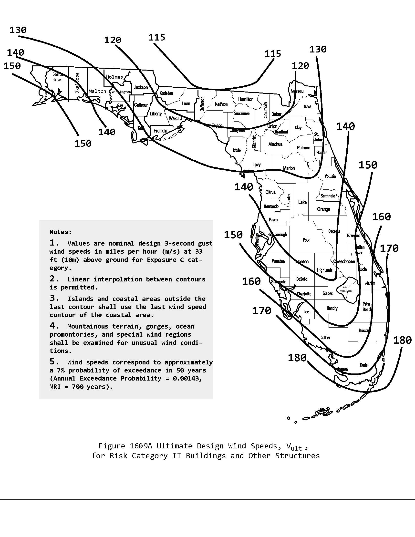

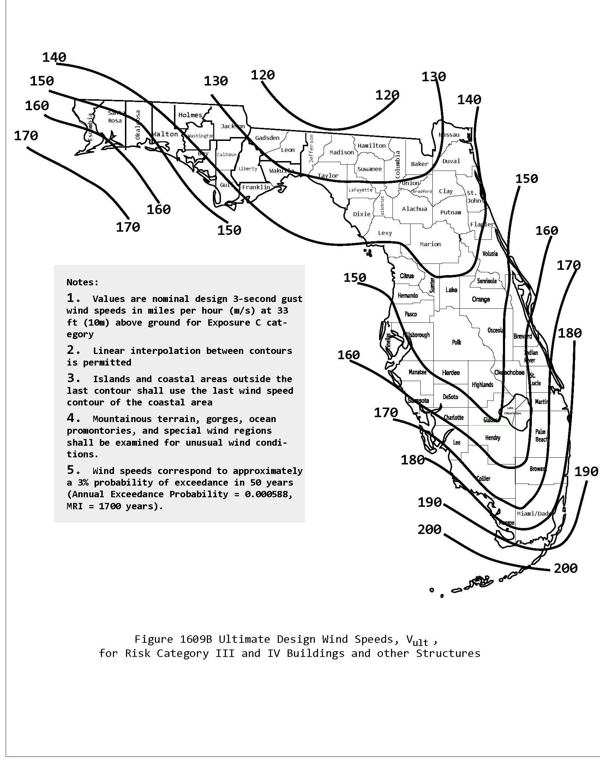

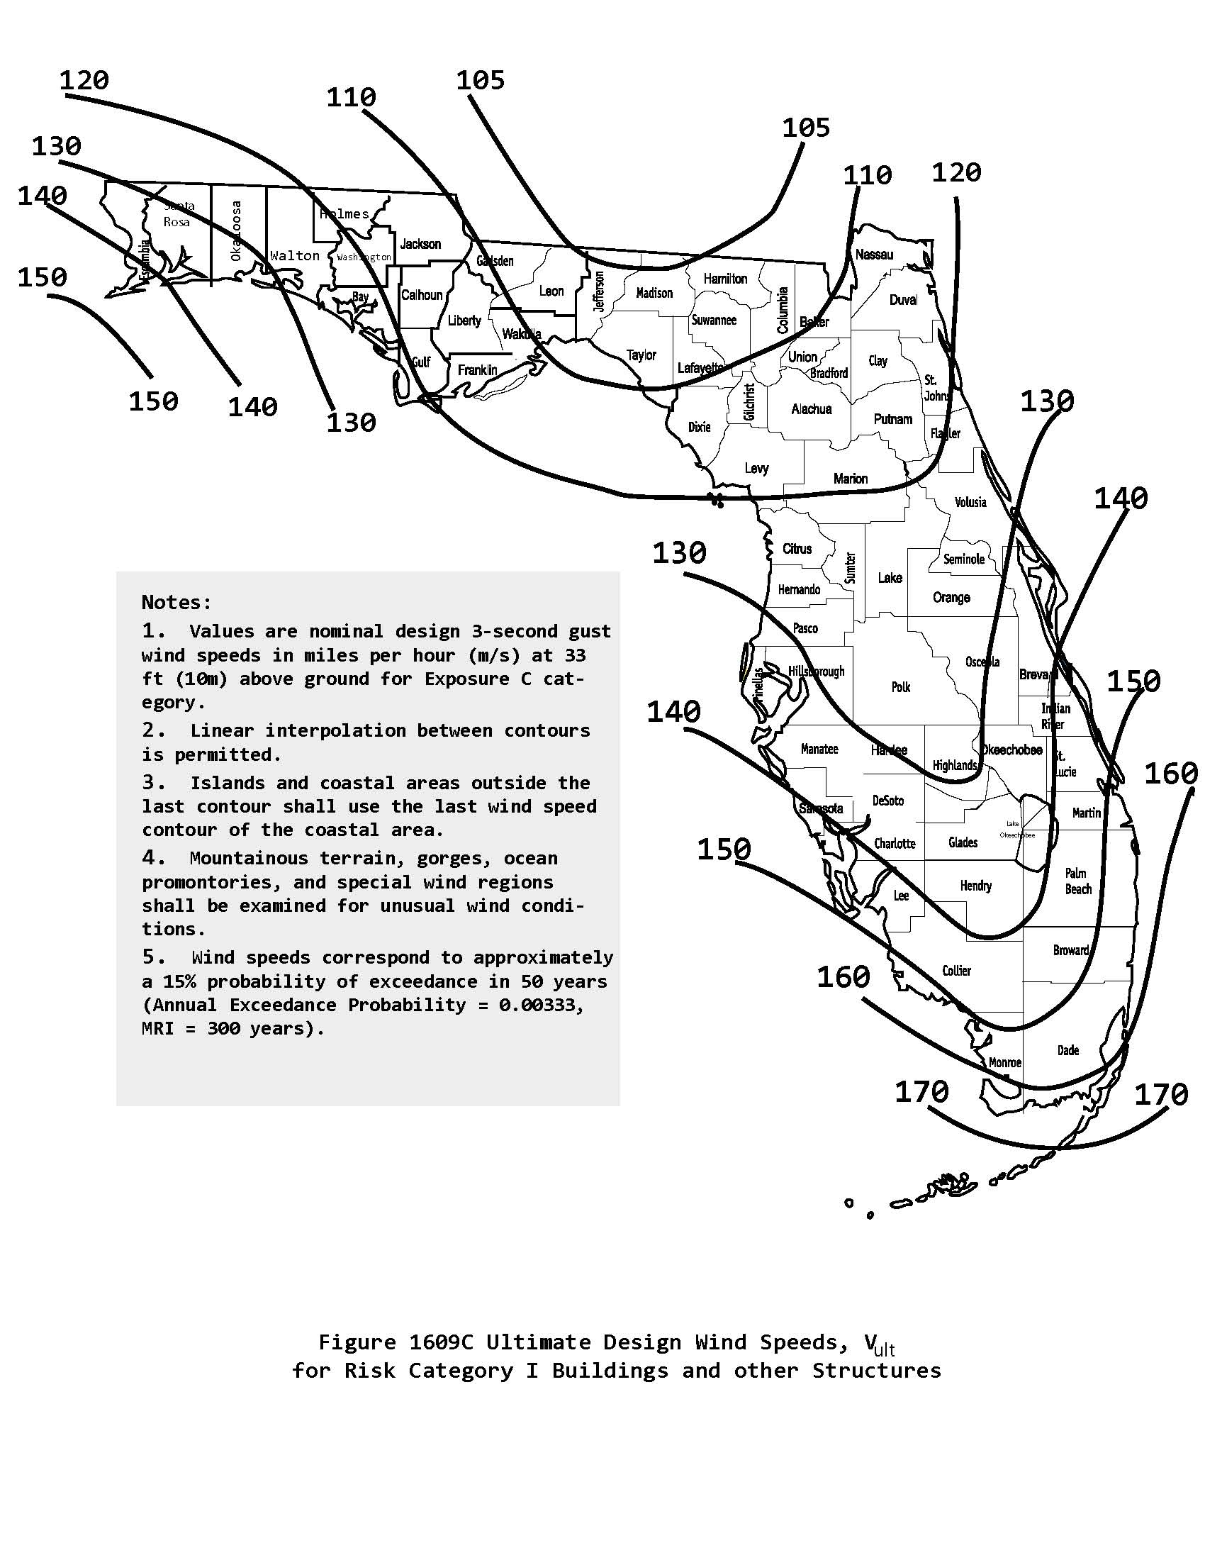
[S4741]
1609.1.1 Determination of wind loads – Change to read as shown.
1609.1.1 Determination of wind loads. Wind loads on every building or structure shall be determined in accordance with Chapters 26 through 30 of ASCE 7 or the provisions of the alternate all-heights method in Section 1609.6. Wind shall be assumed to come from any horizontal direction and wind pressures shall be assumed to act normal to the surface considered.

Exceptions: (no change)

The wind speeds in Figure 1609A, 1609B and 1609C shall be converted to nominal wind speeds, V_{asd}, in accordance with Section 1609.3.1 when the provisions of the standards referenced in Exceptions 1 through 5 and 7 are used unless the wind provisions in the standards are based on Ultimate Wind Speeds as specified in accordance with Figures 1609A, 1609B, or 1609C or Chapter 26 of ASCE 7.
[S4673]

1609.1.1.1 Applicability – Change to read as shown.
1609.1.1.1 Applicability. The provisions of ICC 600 and the AF&PA Wood Frame Construction Manual for One- and Two-Family Dwellings, High Wind Areas are applicable only to buildings located within Exposure B or C as defined in Section 1609.4. The provisions of ICC 600, AF&PA WFCM, and AISI S230 shall not apply to buildings sited on the upper half of an isolated hill, ridge or escarpment meeting the following conditions:

(no change to 1 – 3)

[S4674AM]
1609.1.2 Protection of openings. Change to read as shown.
1609.1.2 Protection of openings. (no change to text)
Exceptions:
1. (no change)
2. Glazing in Risk Occupancy Category I buildings as defined in Section 1604.5 including greenhouses that are occupied for growing plants on a production or research basis, without public access shall be permitted to be unprotected.
3. Glazing in Risk Occupancy Category II, III or IV buildings located over 60 feet (18 288 mm) above the
ground and over 30 feet (9144 mm) above aggregate surface roofs located within 1,500 feet (458 m) of the building shall be permitted to be unprotected.
[S4675]

1609.1.2.3.1 – Change to read as shown.

1609.1.2.3.1 Impact resistant coverings shall be tested at 1.5 times the design pressure (positive or negative) expressed in pounds per square feet as determined by the Florida Building Code, Building Section 1609 or ASCE 7 for which the specimen is to be tested. The design pressures, as determined from ASCE 7, are permitted to be multiplied by 0.6.
[S4677]

1609.1.2.4.1 add to read as follows:

1609.1.2.4.1 Table 1 of ASTM E 1886 and ASTM E 1996 shall be modified to read as follows

Air Pressure Cycles

0.2 to 0.5 P_{pos}¹
0.0 to 0.6 P_{pos}
0.5 to 0.8 P_{pos}
0.3 to 1.0 P_{pos}
0.3 to 1.0 P_{neg}²
0.5 to 0.8 P_{neg}
0.0 to 0.6 P_{neg}
0.2 to 0.5 P_{neg}
Notes:
- P_{pos} = 0.6 x positive ultimate design load in accordance with ASCE 7.
- P_{neg} = 0.6 x negative ultimate design load in accordance with ASCE 7.
[S4679, Comment after Glitch]

1609.2 – Definitions – Change to read as shown.
WIND-BORNE DEBRIS REGION. Areas within hurricane- prone regions located:

- Within 1 mile (1.61 km) of the coastal mean high water line where the ultimate design wind speed V_{ult} is 130 (48 m/s) or greater; or
- In areas where the ultimate design wind speed V_{ult} is 140 mph (53 m/s) or greater

For Risk Category II buildings and structures and Risk occupancy category III buildings and structures, except health care facilities, the windborne debris region shall be based on Figure 1609A. For Risk occupancy category IV buildings and structures and Risk occupancy category III health care facilities, the windborne debris region shall be based on Figure 1609B.
[S4680]

1609.3.1 Wind speed conversion – Change to read as shown.
1609.3.1 Wind speed conversion. (no change to text)

V_{asd} = nominal design wind speed applicable to methods specified in Exceptions 1 through 5 of Section 1609.1.1
[S4681]

1609.6 Alternate all heights method. – 1609.6.4.2 Determination of Kz – Kzt – Change to read as shown.
1609.6 Alternate all heights method. The alternate design provisions in this section are simplifications of Chapter 27 Part 1 – Directional Procedure of the ASCE 7 Method 2 – Analytical Procedure.
1609.6.1 Scope. As an alternate to ASCE 7 Chapter 27 Part 1 and Chapter 30 Part 3 Section 6.5, the following provisions are permitted to be used to determine the wind effects on regularly shaped buildings, or other structures that are regularly shaped, which meet all of the following conditions:

1-3: (no change)
4. The building shall meet the requirements of a simple
diaphragm building as defined in ASCE 7 Section
26.2, where wind loads are only transmitted to the main
wind-force-resisting system (MWFRS) at the diaphragms.
5. (no change)
1609.6.1.1 Modifications. The following modifications shall be made to certain subsections in ASCE 7: in Section 1609.6.2, symbols and notations that are specific to this section are used in conjunction with the symbols and notations in ASCE 7 Section 26.3.
1609.6.2 Symbols and notations. Coefficients and variables used in the alternate all-heights method equations are as follows:

C_{net} = Net-pressure coefficient based on K_{d} [(G) (C_{p}) –
(GC_{pi})], in accordance with Table 1609.6.2(2).

G = Gust effect factor for rigid structures in accordance with ASCE 7 Section 26.9 6.5.8.1.

K_{d} = Wind directionality factor in accordance with
ASCE 7 Table 26.6-1 6-4.

P_{net} = Design wind pressure to be used in determination of wind loads on buildings or other structures or their components and cladding, in psf (kN/m2).

q_{s} = Wind stagnation pressure in psf (kN/m2) in accordance with Table 1609.6.2(1).
1609.6.3 Design equations. When using the alternate all-heights method, the MWFRS and components and cladding of every structure shall be designed to resist the effects of wind pressures on the building envelope in accordance with Equation 16-34.

Pnet = q_{s}K_{z}C_{net} [IK_{zt}] (Equation 16-34)

Design wind forces for the MWFRS shall not be less than 16 10 psf (0.77 0.48 kN/m²) multiplied by the wall area of the building structure and 8 psf (0.38 kN/m²) multiplied by the roof area of the building projected on a plane normal to the assumed wind

direction (see ASCE 7 Section 27.4.7 6.1.4 for criteria). Design net wind pressure for components and cladding shall not be less than 16 10 psf (0.77 0.48 kN/m²) acting in either direction normal to the surface.
1609.6.4.1 Main wind-force-resisting systems. The MWFRS shall be investigated for the torsional effects identified in ASCE 7 Figure 27.4-8 6-9.
1609.6.4.2 Determination of K_{z} and K_{zt}. Velocity pressure exposure coefficient, _{K}z, shall be determined in accordance with ASCE 7 Sections 27.3 and 30.3 6.5.6.6 and the topographic factor, K_{zt}, shall be determined in accordance with ASCE 7 Section 26.8 6.5.7.

1. For the windward side of a structure, K_{zt} and K_{z} shall be based on height z.

2. For leeward and sidewalls, and for windward and leeward roofs, K_{zt} and K_{z} shall be based on mean roof height h.

Replace Table 1609.6.2(1) with the following table:
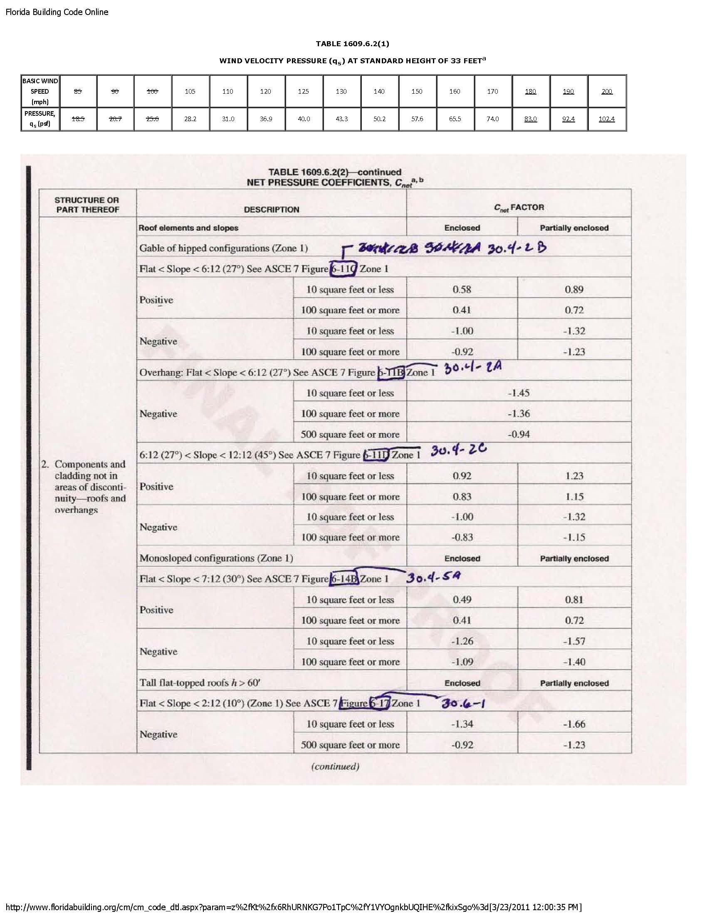

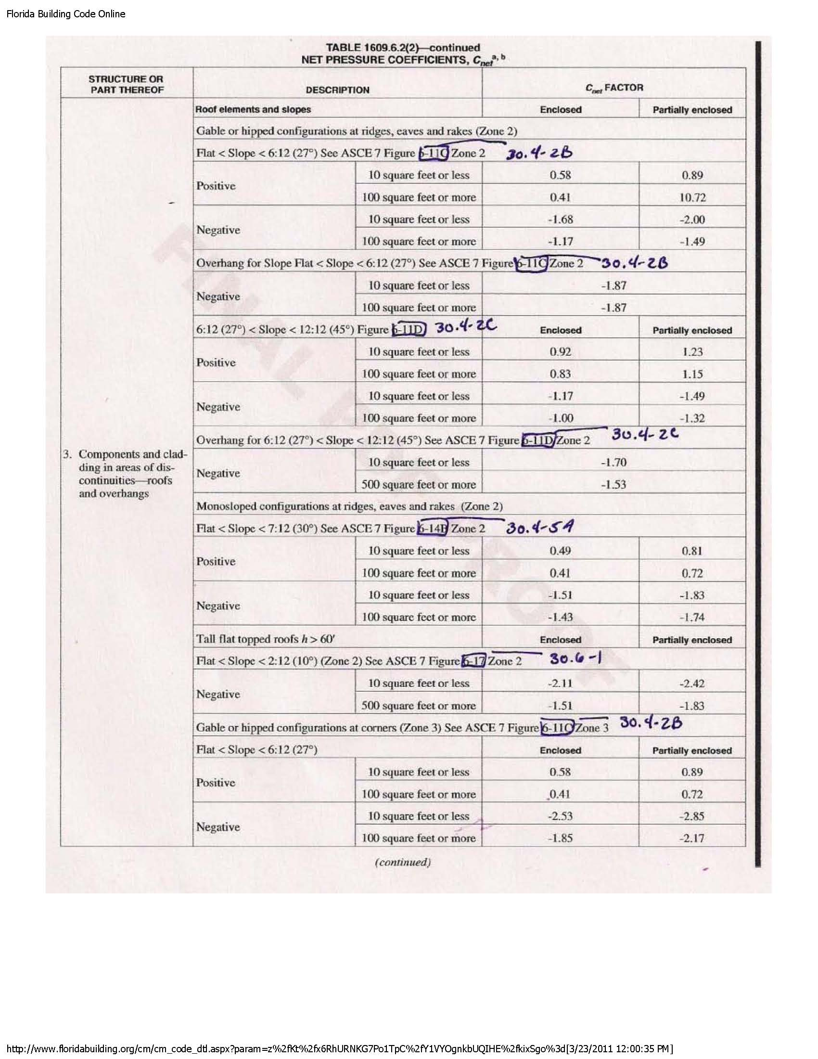

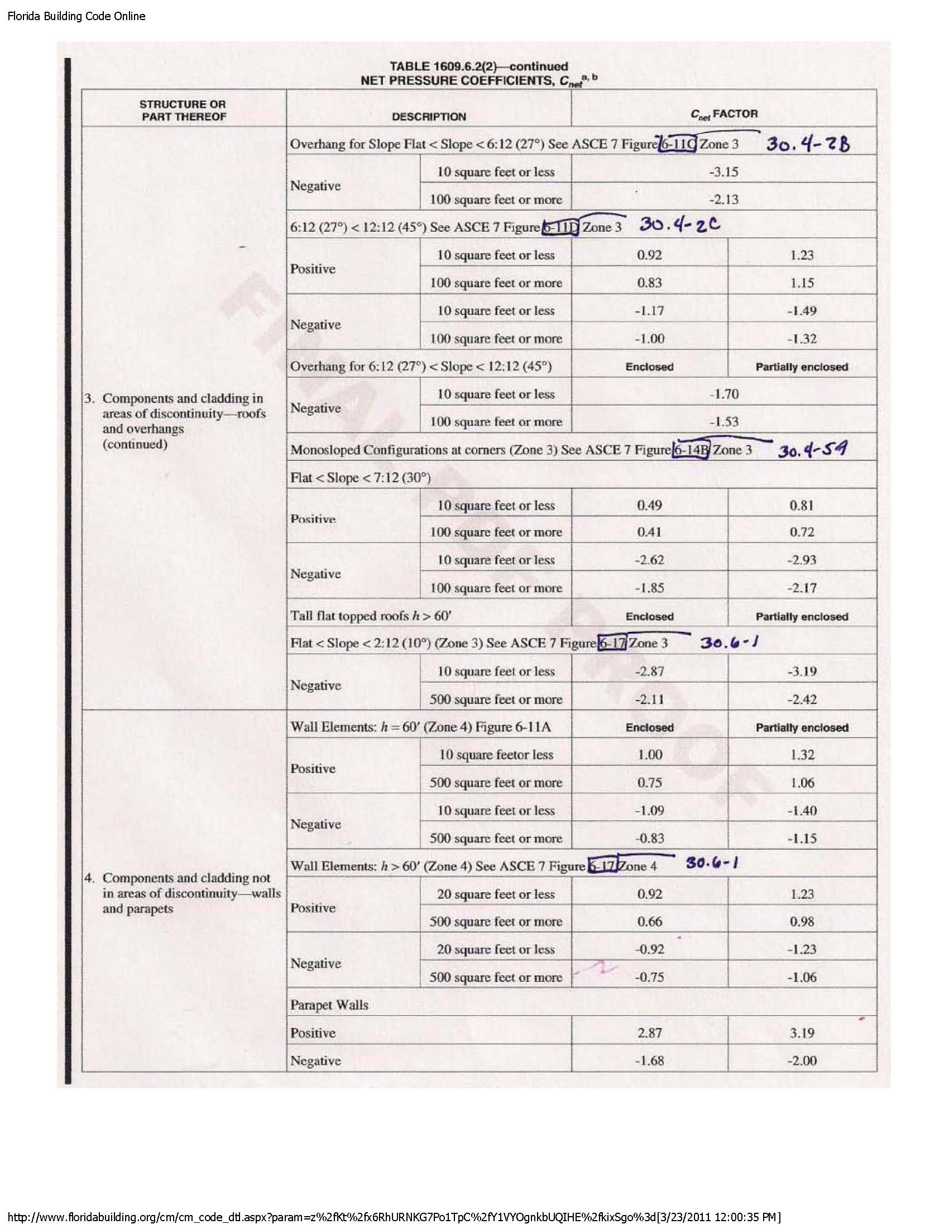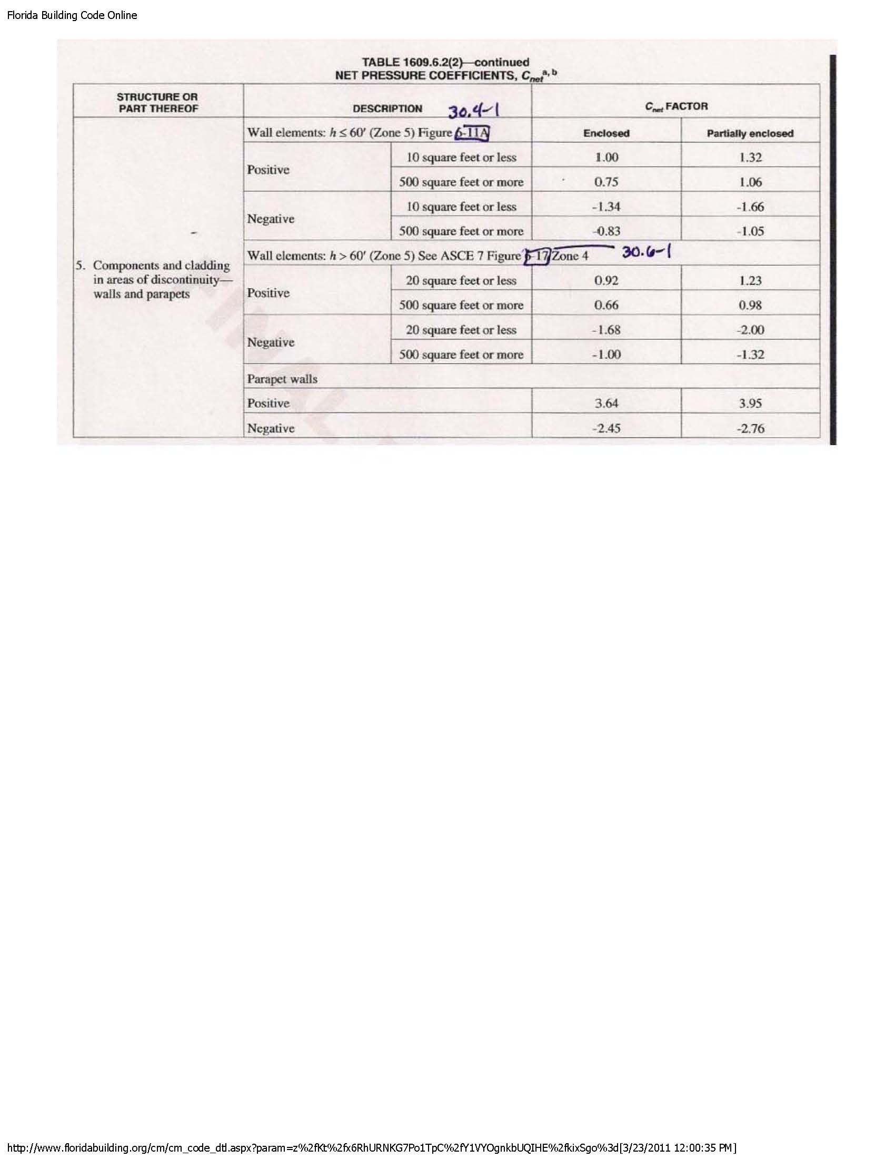
[S4682]
1609.8 change to read as follows:
1609.8 Rooftop structures and equipment. The lateral force on rooftop structures and equipment with A_{f} less than (0.1Bh) located on buildings of all heights shall be determined from Equation 29.5-1 of ASCE 7 Eq. 6-28 in which the value of GC_{f} is shall be taken as 3.1. GC_{f} shall be permitted to be reduced linearly from 3.1 to 1.1 as the value of A_{f} is increased from (0.1Bh) to (Bh). The value of G from Section 26.9 of ASCE 7 6.5.8 shall not be used. Additionally, a simultaneous uplift force shall be applied, given by Equation 29.5-1 of ASCE 7 Eq. 6-28 in which GC_{f} = 1.5 and A_{f} is replaced by the horizontal projected area, A_{r}, of the rooftop structure or equipment. For the uplift force GC_{f} shall be permitted to be reduced linearly from 1.5 to 1.0 as the value of A_{r} is increased from (0.1BL) to (BL).
[S4685]

Table 1612.1 Change to read as shown.
The corrected parts are shown highlighted

Table 1612.1
CROSS REFERENCES DEFINING FLOOD RESISTANT PROVISIONS OF THE FLORIDA BUILDING CODE
Florida Building Code – Building
Section |  | Section
Chapter 1 | Administration | Chapter 14 | Exterior Walls
102 | Applicability | 1403 | Performance Requirements
107 | Construction Documents
110 | Inspections | Chapter 16 | Structural Design
111 | Certificates of Occupancy and Completion | 1601 | General
 |  | 1603 | Construction Documents
Chapter 2 | Definitions | 1605 | Load Combinations
202 | Definitions | 1612 | Flood Loads
Chapter 4 | Special Detailed Requirements Based on Use and Occupancy | Chapter 18 | Soils and Foundations
419 | Hospitals | 1801 | General
420 | Nursing Homes | 1803 1804 | Excavation, Grading and Fill
424 | Swimming Pools and Bathing Places (Public And Private) | 1807 | Dampproofing and Waterproofing
Chapter 8 | Interior Finishes | Chapter 30 | Elevators and Conveying Systems
801 | General | 3001 | General
Chapter 12 | Interior Environment | Chapter 31 | Special Construction
1203 | Ventilation | 3102 | Membrane Structures
Florida Building Code – Residential
Section |  | Section
Chapter 2 | Definitions | Chapter 22 | Special Piping and Storage Systems
202 | Definitions | M2201 | Oil Tanks
Chapter 3 | Building Planning | Chapter 24 | Fuel Gas
R301 | Design Criteria | G2404 (301) | General
R309 | Garages and Carports
R322 | Flood Resistant Construction | Chapter 26 | General Plumbing Requirements
 |  | P2601 | General
Chapter 4 | Foundations
R401 | General | Chapter 27 | Plumbing Fixtures
R408 | Under-Floor Space | P2705 | Installation
Chapter 13 | General Mechanical System Requirements | Chapter 30 | Sanitary Drainage
M1301 | General | P3001 | General
Chapter 14 | Heating and Cooling Equipment | Chapter 31 | Vents
M1401 | General | P3101 | Vent Systems
Chapter 16 | Duct Systems | Chapter 41 | Swimming Pools
M1601 | Duct Construction | R4101 | Private Swimming Pools
Chapter 17 | Combustion Air | Chapter 44 | High-Velocity Hurricane Zones
M1701 | General | R4403 | High-Velocity Hurricane Zones – General
Chapter 20 | Boilers and Water Heaters
M2001 | Boilers
Florida Building Code – Existing
Section |  | Section
Chapter 1 | Administration | Chapter 10 | Additions
101 | General | 1003 | Structural
Chapter 2  202 | Definitions  Definitions
Chapter 3 | Prescriptive Compliance Method | Chapter 11 | Historic Buildings
302  303  304 | Additions  Alterations  Repairs | 1101 | General
Chapter 5 | Repairs | Chapter 12 | Relocated or Moved Buildings
501 | General | 1202 | Requirements
506 | Structural
 |  | Chapter 13 | Performance Compliance Methods
Chapter 6 | Alterations – Level I | 1301 | General
601 | General
Florida Building Code – Mechanical
Section |  | Section
Chapter 3 | General Regulations | Chapter 6 | Duct Systems
M301 | General | M602 | Plenums
 |  | M603 | Duct Construction and Installation
Chapter 4 | Ventilation
M401 | General | Chapter 12 | Hydronic Piping
 |  | M1206 | Piping Installation
Chapter 5 | Exhaust Systems
M501 | General | Chapter 13 | Fuel Oil Piping and Storage
 |  | M1305 | Fuel Oil System Installation
Florida Building Code – Plumbing
Section
Chapter 3 | General Regulations
P309 | Flood Hazard Resistance
Florida Building Code – Fuel Gas
Section
Chapter 3 | General Regulations
FG301 | General
[S4506]

1612.5 Flood hazard documentation. Change to read as shown.
1612.5 Flood hazard documentation. The following documentation shall be prepared and sealed by a registered design professional and shall be submitted to the building official:
1. For construction in flood hazard areas not subject to high-velocity wave action:
1.1. The elevation of the lowest floor, including basement, as required by the foundation inspection and the final inspection in Section 110.3 109.3.
1.2. For fully enclosed areas below the design flood elevation where provisions to allow for the automatic entry and exit of floodwaters do not meet the minimum requirements in Section 2.6.2.1, ASCE 24, construction documents shall include a statement that the design will provide for equalization of hydrostatic flood forces in accordance with Section 2.6.2.2 of ASCE 24.
1.3. For dry floodproofed nonresidential buildings, construction documents shall include a statement that the dry floodproofing is designed in accordance with ASCE 24.
2. For construction in flood hazard areas subject to high-velocity wave action:
2.1. The elevation of the bottom of the lowest horizontal structural member as required by the foundation inspection and the final inspection in Section 110.3 109.3.
remainder not shown
[S4512]

1615.2.1 Fences. – Change to read as shown.
1615.2.1 Fences. Fences not exceeding 6 feet (1829 mm) in height from grade maybe designed for 75 mph(33 m/s) fastest mile wind speed or 115 90 mph (40 m/s) 3-second gust.
[S4686]

1620.2 – Change to read as shown.
1620.2 Wind velocity (3-second gust) used in structural calculations shall be as follows: 140 miles per hour (63 m/s) in Broward County and 146 miles per hour (65 m/s) in Miami-Dade County.
Miami-Dade County
Risk Category I Buildings and Structures: 175 165 mph
Risk Category II Buildings and Structures: 185 175 mph
Risk Category III and IV Buildings and Structures: 195 186 mph
Broward County
Risk Category I Buildings and Structures: 160156 mph
Risk Category II Buildings and Structures: 170 mph
Risk Category III and IV Buildings and Structures: 180 mph
[S4799]
1620.6 Rooftop structures and equipment. – Change to read as shown.
1620.6 Rooftop structures and equipment. The lateral force on rooftop structures and equipment with A_{f} less than (0.1Bh) located on buildings of all heights shall be determined from Equation 29.5-1 of ASCE 7 Eq. 6-28 in which the value of GC_{f} is shall be taken as 3.1. GC_{f} shall be permitted to be reduced linearly from 3.1 to 1.1 as the value of A_{f} is increased from (0.1Bh) to (Bh). The value of G from Section 26.9 of ASCE 7 6.5.8 shall not be used. Additionally, a simultaneous uplift force shall be applied, given by Equation 29.5-1 of ASCE 7 Eq. 6-28 in which GC_{f} = 1.5 and A_{f} is replaced by the horizontal projected area, A_{r}, of the rooftop structure or equipment. For the uplift force GC_{f} shall be permitted to be reduced linearly from 1.5 to 1.0 as the value of A_{r} is increased from (0.1BL) to (BL).
[S4689]
Table 1609.1.2 – Change to read as shown.
(no change to table values)
Note a:
a. This table is based on a V_{asd}, determined in accordance with Section 1609.3.1 of 140 mph wind speeds and a 45-foot mean roof height.
[4676]

TABLE 1625.4 FATIGUE LOADING SEQUENCE – Change to read as shown.
TABLE 1625.4 FATIGUE LOADING SEQUENCE
RANGE OF TEST | NUMBER OF CYCLES¹
0 to 0.5p_{max}² | 600
0 to 0.6p_{max} | 70
0 to 1.3p_{max} | 1

1. Each cycle shall have minimum duration of 1 second and a maximum duration of 3 seconds and must be performed in a continuous manner.
2. p_{max} = 0.6 x ultimate design load in accordance with ASCE7.the design wind load for the height and location, when the assembly will be used. For wall and roof components, shape factors given in ASCE 7 shall be used.
[S4802]

TABLE 1626 CYCLIC WIND PRESSURE LOADING - Change to read as shown.
TABLE 1626 CYCLIC WIND PRESSURE LOADING
INWARD ACTING PRESSURE |  | OUTWARD ACTING PRESSURE
RANGE | NUMBER OF CYCLES¹ | RANGE | NUMBER OF  CYCLES¹
0.2 P_{MAX} to 0.5 P_{MAX}² | 3,500 | 0.3 P_{MAX} to 1.0 P_{MAX} | 50
0.0 P_{MAX} to 0.6 P_{MAX} | 300 | 0.5 P_{MAX} to 0.8 P_{MAX} | 1,050
0.5 P_{MAX} to 0.8 P_{MAX} | 600 | 0.0 P_{MAX} to 0.6 P_{MAX} | 50
0.3 P_{MAX} to 1.0 P_{MAX} | 100 | 0.2 P_{MAX} to 0.5 P_{MAX} | 3,350

NOTES:
1. Each cycle shall have minimum duration of 1 second and a maximum duration of 3 seconds and must be performed in a continuous manner 1.
2. P_{MAX} = 0.6 x ultimate denotes maximum design load in accordance with ASCE 7. The pressure spectrum shall be applied to each test specimen beginning with inward acting pressures followed by the outward acting pressures in the order from the top of each column to the bottom of each column.
[S4803]
Chapter 17 – STRUCTURAL TESTS
1702 – Change to read as shown.
Special Inspection. Reserved.
Special Inspection, Continuous. Reserved.
Special Inspection, Periodic. Reserved.
Structural Observation. Reserved.
[S4693]

1715.5.1 – 1715.9.4 – Change to read as shown.
1715.5.1 The design pressure for window and door assemblies shall be calculated in accordance with component and cladding wind loads in 1609. The design pressures, as determined from ASCE 7, are permitted to be multiplied by 0.6.
1715.5.3 Exterior door assemblies. Exterior door assemblies not covered by Section 1715.5.2or Section 1715.5.3.1 shall be tested for structural integrity in accordance with ASTM E 330 Procedure A, at a load of 1.5 times the required design pressure load. The load shall be sustained for 10 seconds with no permanent deformation of any main frame or panel member in excess of 0.4 percent of its span after the load is removed. The design pressures, as determined from ASCE 7, are permitted to be multiplied by 0.6. High-velocity hurricane zones shall comply with TAS 202. After each specified loading, there shall be no glass breakage, permanent damage to fasteners, hardware parts, or any other damage which causes the door to be inoperable.

(no change to remainder)
1715.5.3.1 Sectional garage doors and rolling doors shall be tested for determination of structural performance under uniform static air pressure difference in accordance with ANSI/DASMA 108, ASTM E 330 Procedure A, or TAS 202. For products tested in accordance with ASTM E 330, testing shall include a load of 1.5 times the required design pressure load sustained for 10 seconds, and acceptance criteria shall be in accordance with ANSI/DASMA 108. (HVHZ shall comply with TAS 202.). The design pressures, as determined from ASCE 7, are permitted to be multiplied by 0.6.
1715.5.5.4 Structural safety factor. Mullions that are tested by an approved testing laboratory shall be capable of resisting a load of 1.5 times the design pressure loads applied by the window and door assemblies to be supported. The design pressures, as determined from ASCE 7, are permitted to be multiplied by 0.6. The 1.5 times the design pressure load shall be sustained for 10 seconds, and the permanent deformation shall not exceed 0.2 percent of the mullion span for assemblies requiring deflection limitations, as defined in AAMA/WDMA/CSA 101/I.S.2/A440 and 0.4 percent of the mullion span for all other assemblies after the 1.5 times design pressure load is removed. Mullions that are qualified by engineering shall be capable of resisting the design pressure loads applied by the window and door assemblies to be supported without exceeding the allowable stress of the mullion elements.
1715.8.2 The following information shall be included on the labels on impact resistant coverings:
1.Product approval holder name and address.
2.All applicable methods of approval. Methods of approval include, but are not limited to Miami-Dade NOA; Florida Building Commission, TDI Product Evaluation; ICC-ES.
3.The test standard or standards specified at Section 1609.1.2 1609.1.4, including standards referenced within the test standards specified at Section 1609.1.2 1609.1.4 used to demonstrate code compliance.
4. For products with a Florida Product Approval Number or a Miami-Dade County Building Code Compliance Office Notice of Acceptance Number (NOA), such numbers shall be included on the label.
1715.9.4 Installation. All manufactured soffit materials shall be installed in accordance with the manufacturer’s installation instructions and in accordance with the product approval. Installation instructions shall be provided and shall be available to inspection personnel on the job site. Soffit pieces, components, fasteners, and other parts evaluated by an approved product evaluation entity, certification agency, testing laboratory, architect, or engineer and approved by the holder of the product approval may be interchangeable in manufactured soffit systems provided that the soffit system component or components provide equal or greater structural performance and durability as demonstrated by testing in accordance with approved test standards.
All exterior wall coverings and soffits shall be capable of resisting the design pressures specified for walls for components and cladding loads in accordance with Section 1609.1. Manufactured soffits shall be tested at 1.5 times the design pressure. The design pressures, as determined from ASCE 7, are permitted to be multiplied by 0.6.
[S4694]
1715.5.2.1.2 Skylights and sloped glazing – Change to read as shown.
1715.5.2.1.2 Skylights and sloped glazing. Unit skylights and tubular daylighting devices (TDDs) shall comply with the requirements of Sections 1715.5.2.1.1 and 2405. All skylights and sloped glazing shall comply with the requirements of Chapter 24.
[S4575]
1715.8.2 – Change to read as shown.
1715.8.2 The following information shall be included on the labels on impact resistant coverings:
1. Product approval holder name and address.
2. All applicable methods of approval. Methods of approval include, but are not limited to Miami-Dade NOA; Florida Building Commission, TDI Product Evaluation; ICC-ES.
3. The test standard or standards specified at Section 1609.1.4, including standards referenced within the test standards specified at Section 1609.1.4 used to demonstrate code compliance.
4. For products with a Florida Product Approval Number or a Miami-Dade County Building and Neighborhood Code Compliance Office Department Notice of Acceptance Number (NOA), such numbers shall be included on the label.
[S4530]

Chapter 18 - Soils and Foundations
1807.2 – 1807.2.4 – Change to read as shown.
1807.2 Retaining walls 1807.1 General. Walls built to retain or support the lateral pressure of earth or water or other superimposed loads shall be designed and constructed of masonry, concrete, steel sheet piling or other approved materials.

1807.2.1 Design. Retaining walls shall be designed to resist the design lateral soil loads in Section 1610, including both dead and live load surcharges to which such walls are subjected, and to ensure stability against overturning, sliding, excessive foundation pressure and water uplift.

1807.2.2 1807.3 Hydrostatic pressure. Unless drainage is provided, the hydrostatic head of the water pressure shall be assumed to be equal to the height of the wall.

1807.2.3 1807.4 Reinforced masonry retaining walls. Vertical reinforcement for masonry retaining walls shall comply with Table 1806.4 or shall be designed in accordance with ACI 530/ASCE 5/TMS 402. Masonry shall be fully grouted with a minimum f’m of 1,500 psi (10 343 kPa). Mortar for masonry shall be Type M or S and laid in running bond. The specified location of the reinforcement shall equal or exceed the effective depth distance, d, noted in Table 1807.2.3 1806.4 and shall be measured from the exposed side of the wall to the center of the vertical reinforcement. Footings for reinforced masonry retaining walls shall be designed in accordance with ACI 318.

1807.2.4 1807.5 Segmental retaining walls. Segmental retaining walls shall be designed in accordance with NCMA Design Manual for Segmental Retaining Walls.

TABLE 1807.2.3 1807.4
REINFORCEMENT FOR MASONRY RETAINING WALLS

(no change to table values
[S4696]

Table 1808.8.1
Change table rows as follows

1. Foundations for structures assigned to Seismic Design Category A, B or C
2a. Reserved Foundations for Group R or U occupancies of light-frame construction, two stories or less in height,
assigned to Seismic Design Category D, E or F 2,500 psi
2b. Reserved Foundations for other structures assigned to Seismic Design Category D, E, or F 3,000 psi
[S4698]

1809.5 Fire Protection – Change to read as shown.
1809.5 Frost protection. Except where otherwise protected from frost, foundations and other permanent supports of buildings and structures shall be protected from frost by one or more of the following methods:
1. Extending below the frost line of the locality;
2. Constructing in accordance with ASCE 32; or
3. Erecting on solid rock.
Exception: Free-standing buildings meeting all of the following
conditions shall not be required to be protected:
1. Assigned to Risk Occupancy Category I, in accordance with Section 1604.5;
2. Area of 600 square feet (56m2) or less for light-frame construction or 400 square feet (37 m2) or less for
other than light-frame construction; and
3. Eave height of 10 feet (3048 mm) or less.
Shallow foundations shall not bear on frozen soil unless such frozen condition is of a permanent character.
[S4700]
1809.10 Pier and curtain wall foundations. – Change to read as shown.
Reserved. Except in Seismic Design Categories D, E and F, pier and curtain wall foundations shall be permitted to be used to support light-frame construction not more than two stories above grade plane, provided the following requirements are met:
1. All load-bearing walls shall be placed on continuous concrete footings bonded integrally with the exterior
wall footings.
2. The minimum actual thickness of a load-bearing masonry wall shall not be less than 4 inches (102 mm)nominal or 35/8 inches (92 mm) actual thickness, and shall be bonded integrally with piers spaced 6 feet (1829
mm) on center (o.c.).
3. Piers shall be constructed in accordance with Chapter 21 and the following:
3.1. The unsupported height of the masonry piers shall not exceed 10 times their least dimension.
3.2. Where structural clay tile or hollow concrete masonry units are used for piers supporting beams and girders, the cellular spaces shall be filled solidly with concrete or Type M or S mortar.
Exception: Unfilled hollow piers shall be permitted where the unsupported height of the pier is not more
than four times its least dimension.
3.3. Hollow piers shall be capped with 4 inches (102 mm) of solid masonry or concrete or the cavities of the top course shall be filled with concrete or
grout.
4. The maximum height of a 4-inch (102 mm) load-bearing masonry foundation wall supporting wood frame walls and floors shall not be more than 4 feet (1219 mm) in height.
5. The unbalanced fill for 4-inch (102 mm) foundation walls shall not exceed 24 inches (610 mm) for solid masonry, nor 12 inches (305 mm) for hollow masonry.
[S4702]

Chapter 19 Concrete

1918.1 and 1918.2, revise as follows:
1918.1 Reinforced concrete components. The design and construction of reinforced concrete
components for buildings sited in areas where the ultimate design wind speed, Vult, is with a basic wind speed greater than 115 100 mph (45 m/s) in accordance with Figure 1609 shall conform to the requirements of ACI 318 or with Section 1609.1.1, Exception 1 3, as applicable, except as modified in this section.
1918.2 Insulated concrete form wall. Insulated concrete form (ICF) wall construction for buildings shall be in accordance with ACI 318 or with Section 1609.1.1, Exception 1 2, as applicable.

Comment after Glitch

Chapter 20 – ALUMINUM

2002.4 – Change to read as shown (below).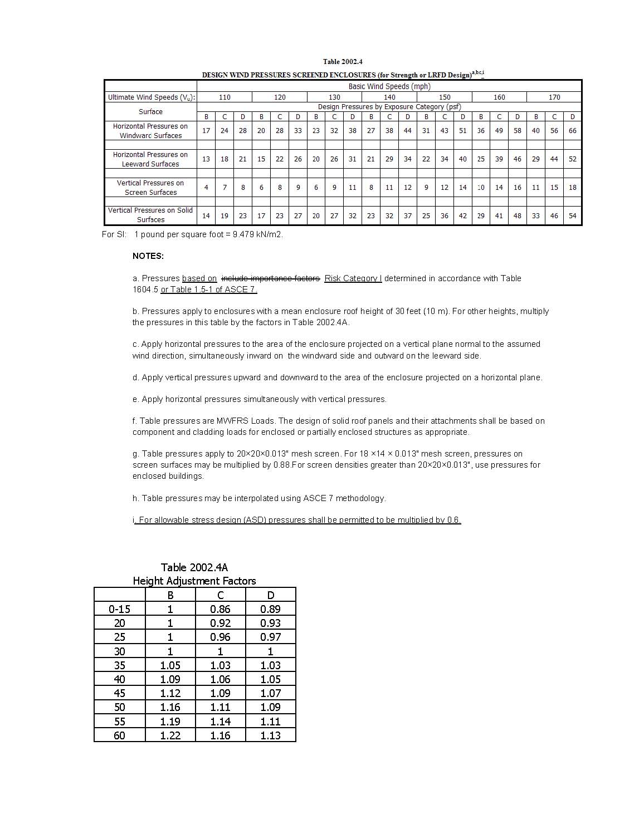
[S4628]

2003.9.2 Sunroom Categories – Change to read as shown.
2003.9.2 Sunroom Categories.Sunroom Categories. For the purpose of applying the criteria of the AAMA Standard for sunrooms based on the intended use, s Sunrooms shall be categorized in one of the following categories by the permit applicant, design professional, or the property owner where the sunroom is being constructed.
[S4629]

Chapter 21 – MASONRY

2102 – revise to add the following definition:
GLASS UNIT MASONRY. Masonry composed of glass units bonded by mortar.
Comment after Glitch
2107.5 TMS 402/ ACI 530/ASCE 5. – Change to read as shown.
2107.5 TMS 402/ ACI 530/ASCE 5. (no change.

y g = 1.0 for No. 3 (M#10) through No. 5 (M#16) bars;

y g = 1.04 for No. 6 (M#19) through No. 7 (M#22) bars; and

y g = 1.2 for No. 8 (M#25) through No. 11 (M#36) bars
The symbol should be a y. The system changes it to a ?
[S4630]

2122.8.2 – Change to read as shown.
2122.8.2 Vertical cells to be grouted shall provided vertical alignment sufficient to maintain clear, unobstructed, continuous, vertical cores measuring not less than 2 ½ inches by 3 inches (51 mm by 76 mm) for fine aggregate grout and 3 inches by 3 inches for coarse aggregate grout as defined by ASTM C 476. The architect or engineer may specify other grout space sizes which shall be permitted provided they comply with TMS 402/ ACI 530/ ASCE 5 Section 1.19 and TMS 602/ ACI 530.1/ ASCE 6 Section 3.5C
[S4631]

Chapter 22 – STEEL
2205.3.1 Seismic Design Categories D, E and F. – Change to read as shown.
2205.3.1 Seismic Design Categories D, E and F. Reserved. Composite structures are permitted in Seismic Design Categories D , E and F, subject to the limitations in Section 12.2.1 of ASCE 7, where substantiating evidence is provided to demonstrate that the proposed system will perform as intended by AISC 341, Part II. The substantiating evidence shall be subject to building official approval. Where composite elements or connections are required to sustain inelastic deformations, the substantiating evidence shall be based on cyclic testing.
[S4703]

2206.5 Certification. – Change to read as shown.
2206.5 Certification. At completion of manufacture, the steel joist manufacturer shall submit a certificate of compliance in accordance with Section 1704.2.2 stating that work was performed in accordance with approved construction documents and with SJI standard specifications.
[S4704]

Chapter 23 – WOOD
2318.1.3.3 – Change to read as shown.
2318.1.3.3 Stud walls framing into base plates of exterior walls and interior bearing walls resting on masonry or concrete shall be anchored past the plate to the masonry or concrete, or shall be anchored to a sill plate which is anchored in accordance with Section 2318.1.4.1 when the net wind uplift is up to 500 300 pounds per foot (4378 N/m).
[S4705]

Chapter 24 – GLASS & GLAZING
2404.1 Vertical glass. - 2404.3.5 Vertical sandblasted glass– Change to read as shown.
2404.1 Vertical glass. Glass sloped 15 degrees (0.26 rad) or less from vertical in windows, curtain and window walls, doors and other exterior applications shall be designed to resist the wind loads for components and cladding. The load resistance of glass under uniform load shall be determined in accordance with ASTM E 1300. Design of exterior windows and glass doors in accordance with Section 2404.1 shall utilize the same edition of ASTM E 1300 used for testing in accordance with Section 1715.5 1714.5. The design of vertical glazing shall be based on the following equation:

Fgw £ Fga (Equation 24-1)
where:

F_{gw} is the wind load on the glass computed in accordance with Section 1609 multiplied by 0.60 and F_{ga} is the short duration load resistance of the glass as determined in accordance with ASTM E 1300.

2404.2 Sloped glass. (no change)

Wi = Inward wind force, psf (kN/m2) as calculated in Section 1609 multiplied by 0.60.
Wo = Outward wind force, psf (kN/m2) as calculated in Section 1609 multiplied by 0.60.

2404.3.1 Vertical wired glass. (no change)

F_{gw} = Is the wind load on the glass computed per Section 1609 multiplied by 0.60.
2404.3.3 Vertical patterned glass. (no change)

F_{gw} = Is the wind load on the glass computed per Section 1609 multiplied by 0.60.
2404.3.5 Vertical sandblasted glass. (no change)

F_{g} = Total Is the wind load on the glass computed per Section 1609 multiplied by 0.60.
[S4706]

2405.5.2 Unit skylights – Change to read as shown.
2405.5.2 Unit skylights rated for separate performance grades for positive and negative design pressure. (no change)

Wo = Outward wind force, psf (kN/m2) as calculated in Section 1609 multiplied by 0.60.

(*2 places*)
[S4707]

2411.3.3.7 – Change to read as shown.
2411.3.3.7 Exterior lite of glass in an insulated glass unit shall be safety glazed.
Exceptions:
1. Large missile impact-resistant glazed assemblies.
2. Non-missile impact units protected with shutters.
[S4818]

Chapter 25 – GYPSUM BOARD & PLASTER
2508.5 Horizontal gypsum board diaphragm ceilings – Change to read as shown.
2508.5 Horizontal gypsum board diaphragm ceilings (Allowable stress design). Gypsum board shall be permitted to be used on wood joists to create a horizontal diaphragm ceiling in accordance with Table 2508.5.

TABLE 2508.5
ALLOWABLE SHEAR CAPACITY FOR HORIZONTAL WOOD FRAMED GYPSUM BOARD DIAPHRAGM CEILING ASSEMBLIES
(no change to table values)
[S4708]

2516.2.4.1 – Change to read as shown.
2516.2.4.1 Stucco applied on metal lath shall be three-coat work applied to a total thickness of not less than1/2 ⁷/₈-inch (12.7 22.2 mm)thickness except as required to meet fire-resistance requirements.
[S4709]

2517.2 Standards – Change to read as shown.
2517.2 Standards. The following standards are adopted as set forth in Chapter 35.
Standard Specification for the Application and Finishing of Gypsum Wallboard, ANSI A97.1.
Application and finishing of gypsum wallboard GA-216-07
Fire resistance Design Manual GA-600-06
[S4757]

Chapter 30 – ELEVATORS & CONVEYING SYSTEMS
3001.3 Accessibility. Change to read as shown.
3001.3 Accessibility. Passenger elevators are required to be accessible by the Florida Building Code, Accessibility by Chapter 11. shall conform to ICC A117.1.
[S4727]

3002.4 Elevator car to accommodate an ambulance stretcher. Change to read as shown.
3002.4 Elevator car to accommodate an ambulance stretcher. Where elevators are provided in buildings four or more stories above, or four or more stories below, grade plane, or where the rise exceeds 25 feet, at least one elevator shall be provided for Any building that is more than three stories high or in which the vertical distance between the bottom terminal landing and the top terminal landing exceeds 25 feet,must be constructed to contain at least one passenger elevator that is operational for building occupants and fire department emergency access to all floors. The elevator car shall be of such a size and arrangement to accommodate an ambulance stretcher 24-inches by 76-inches (610 mm by 1950 mm) with not less than 5-inch radius corners in the horizontal, open position and shall be identified by the international symbol for emergency medical services (star of life). The symbol shall not be less than 3 inches (76 mm) high and shall be placed inside on both sides of the hoistway door frame.
[SP4597]

SECTION 3013
ALTERATIONS TO ELECTRIC AND HYDRAULIC ELEVATORS AND ESCALATORS

REVISE Section 3013.1 and REPLACE Section 3013.1 to read as shown.
3013.1 Alterations to electric and hydraulic elevators and escalators.
Alterations set forth in Part 8, ASME A17.1 to include any change to equipment, including its parts, components, and/or subsystems, other than maintenance, repair, or replacement; require an elevator construction permit, along with documented performance of inspections and tests to determine conformance with ASME A17.1. A repair or replacement of equipment, parts, components or subsystems that requires inspection, tests and independent witnessing in other sections of ASME A17.1, A17.3 and A18.1 shall also require an elevator construction permit. , in accordance with Section 105, Florida Building Code, Building.
[SP4608]

Chapter 31 – SPECIAL CONSTRUCTION
3102.7 Engineering design. – Change to read as shown.
3102.7 Engineering design. The structure shall be designed and constructed to sustain dead loads; loads due to tension or inflation; and live loads including wind loads and flood in accordance with Chapter 16.
[S4513]
3105.4.2.1 revise to read as follows:
3105.4.2.1 The wind design loads for any fabric or membrane-covered structure designed with a quick removal or breakaway membrane or fabric at wind velocities of 75 mph, shall be based on the following criteria:

1. Minimum wind speed velocity of 3-second wind gust 105 90 mph
2. Importance factor based on low hazard to human life of 0.77.
2 3. Exposure Category B, for or C, or D as defined in Chapter 16.

3105.4.2.2 The wind design loads for any fabric or membrane covered structure designed with a permanent or nonremovable fabric or membrane, shall be based on the following criteria:

1. Minimum wind speed velocity as required in Chapter 16 using Figure 1609C..
2. Importance factor based on low hazard to human life of 0
2. Exposure B, C or D as defined in Chapter 16.
3105.5.1 revise to read as follows:
3105.5.1 Loads. Rigid awnings and canopy shutters shall be designed to resist the loads set forth in Chapter 16 of this Code except that structures or parts thereof which are intended to be removed or repositioned during periods of high wind velocity shall be designed in their open or extended position to design pressures based on a basic wind speed of minimum 115 90 mph, 3-second wind gust with applicable shape factors and to resist not less than 10 psf (478 Pa) roof live load.
[S4710]

3109.1.1 Scope. Revise to read as shown.
3109.1.1 Scope. The provisions of Section 3109 shall ensure that structures located seaward of the coastal construction control line are designed to resist the predicted forces associated with a 100-year storm event and shall apply to the following:
1. All habitable structures which extend wholly or partially seaward of a coastal construction control line (CCCL) or 50-foot (15.3 m) setback line.
2. Substantial improvement of or additions to existing habitable structures.
3. Swimming pools that are located in close proximity to a habitable structure or armoring. An environmental permit from the Florida Department of Environmental Protection, requiring special siting considerations to protect the beach-dune system, proposed or existing structures and public beach access, is required prior to the start of construction. The environmental permit may condition the nature, timing and sequence of construction of permitted activities to provide protection to nesting sea turtles and hatchlings and their habitat, including review, submittal and approval of lighting plans.
Exception: The standards for buildings seaward of a CCCL area do not apply to any modification, maintenance or repair of any existing structure within the limits of the existing foundation which does not require, involve or include any additions to, or repair or modification of, the existing foundation of that structure. , except for substantial improvement of or additions to existing habitable structures.
An environmental permit from the Florida Department of Environmental Protection, requiring special siting considerations to protect the beach-dune system, proposed or existing structures and public beach access, is required prior to the start of construction. The environmental permit may condition the nature, timing and sequence of construction of permitted activities to provide protection to nesting sea turtles and hatchlings and their habitat, including review, submittal and approval of lighting plans.
Comment after Glitch

Chapter 35 – REFERENCED STANDARDS

Building Chapter 35 - Referenced Standards – Change to read as shown.
ASME
American Society of Mechanical Engineers
Three Park Avenue
New York, NY 10016-5990
Standard reference number Title Referenced in code section number
REVISE text as shown.
A17.1 - 1990 11-4.10
A17.1/CSA B44-2007 Safety Code for Elevators and Escalators includes A17.1a-- 2008 and A17.1b-2009 Addenda, 1607.8.1, 3001.1, 3001.2, 3001.4, 3001.6, 3002.5, 3002.9, 3003.2, 3007.1, 3008.3, 3008.11.5, 3008.14.1, 3010.1, 3011.1, 3012.1, 3013.1
A17.3—96 Safety Code for Existing Elevators and Escalators 3001.1, 3001.2, 3001.5

A18.1—08 Safety Standard for Platform Lifts and Stairway Chairlifts 3001.1, 3001.2
A90.1 - 03 Safety Standard for Belt Manlifts 3001.2
A120.1—01 Safety Requirements for Powered Platforms for Building Maintenance 3001.6
B20.1 - 2003 Safet Standard for Conveyors and related equipment 3001.2, 3005.3
[SP4724]

AAF – Change to read as shown.
Revisions to the AAF Guide:
General Notes: Chapter 2
Allowable Roof Panel Spans (Table 201) are for industry standard generic panel products, alternate roof panel approved equivalent products may be substituted based upon a Florida Product Approval, in accordance with design pressures specified in Table 201.
General Notes: Chapter 4
Allowable Roof Panel Spans (Table 401) are for industry standard generic panel products, alternate roof panel approved equivalent products may be substituted based upon a Florida Product Approval, in accordance with design pressures specified in Table 401.
General Notes: Chapter 5
Allowable Roof Panel Spans (Table 501) are for industry standard generic panel products, alternate roof panel approved equivalent products may be substituted based upon a Florida Product Approval, in accordance with design pressures specified in Table 501.
General Notes: Chapter 6
4) Allowable Roof Panel Spans (Table 601) are for industry standard generic panel products, alternate roof panel approved equivalent products may be substituted based upon a Florida Product Approval, in accordance with design pressures specified in Table 601.
General Notes: Chapter 8
Allowable Roof Panel Spans (Table 801) are for industry standard generic panel products, alternate roof panel approved equivalent products may be substituted based upon a Florida Product Approval, in accordance with design pressures specified in Table 801.
[S4632]
AAMA –– Change to read as shown.
AAMA
American Architectural Manufacturers Association
1827 Waldon Walden Office Square, Suite 104 550
Schaumburg, IL 60173-4268
[CA4589]

ANSI – Change to read as shown.
ANSI
American National Standards Institute
25 West 43rd Street, Fourth Floor
New York, NY 10036
A 97.1
Specification for the Application and Finishing of Gypsum Wallboard
2517.2
[S4759]

ASCE/SEI – Change to read as shown.
ASCE/SEI
American Society of Civil Engineers
Structural Engineering Institute
1801 Alexander Bell Drive
Reston, VA 20191-4400

7-10 Minimum Design Loads for Buildings and Other Structures (with Errata dated January 11, 2011)
[S4711]

ASTM – Change to read as shown.
ASTM
ASTM International
100 Barr Harbor Drive
West Conshohocken, PA 19428-2959
Standard reference number Title Referenced in code section number
…
C 509-00 Elastomeric Cellular Preformed Gaskets and Sealing Material 2411.3.4
…
C 864-05 Dense Elastomeric Compression Seal Gaskets, Setting Blocks, and Spacers ________________________________________ 2411.3.4
…
C 1115-00 Dense Elastomeric Silicone Rubber Gaskets and Accessories 2411.3.4
…
E 2203-02 Dense Thermoplastic Elastomers Used for Compression Seals, Gaskets, Setting Blocks, Spacers and Accessories 2411.3.4
[S4806]

Florida Building Code, Accessibility – Change to read as shown.
Florida Building Code, Accessibility Ch. 11 FBC-B—2012 Ch. 11, Florida Building Code, Building (Florida Accessible Code for Building Construction) 101.4.8, 104.11.3, 201.5, 403.1.1, 406.2.2, 412.1.6, 423.10.2.8.7, 423.27.4, 423.28.2.4, 427.1.4.1.1.3, 427.1.4.4.1, 427.1.4.4.2, 1003.3.4, 1003.5.3, 1007.1, 1008.1, 1009.5.3, 1009.11.8, 1009.14, 1010.1, 1010.8, 1010.9, 1208.2, 3001.3
[SP4731]
Appendix F – Change to read as shown.
APPENDIX F
Rodent Proofing

The provisions contained in this appendix are not mandatory unless specifically referenced in the adopting ordinance.

SECTION F101

GENERAL

F101.1 General. Buildings or structures and the walls enclosing habitable or occupiable rooms and spaces in which persons live, sleep or work, or in which feed, food or foodstuffs are stored, prepared, processed, served or sold, shall be constructed in accordance with the provisions of this section.

F101.2 Foundation wall ventilation openings. Foundation wall ventilator openings shall be covered for their height and width with perforated sheet metal plates no less than 0.070 inch (1.8 mm) thick, expanded sheet metal plates not less than 0.047 inch (1.2 mm) thick, cast iron grills or grating, extruded aluminum load-bearing vents or with hardware cloth of 0.035 inch (0.89 mm) wire or heavier. The openings therein shall not exceed 1/4 inch (6.4 mm).

F101.3 Foundation and exterior wall sealing. Annular spaces around pipes, electric cables, conduits, or other openings in the walls shall be protected against the passage of rodents by closing such openings with cement mortar, concrete masonry or noncorrosive metal.

F101.4 Doors. Doors on which metal protection has been applied shall be hinged so as to be free swinging. When closed, the maximum clearance between any door, door jambs and sills shall not be greater than 3/8 inch (9.5 mm).

F101.5 Windows and other openings. Windows and other openings for the purpose of light or ventilation located in exterior walls within 2 feet (610 mm) above the existing ground level immediately below such opening shall be covered for their entire height and width, including frame, with hardware cloth of at least 0.035 inch (0.89 mm) wire or heavier.

F101.5.1 Rodent-accessible openings. Windows and other openings for the purpose of light and ventilation in the exterior walls not covered in this chapter, accessible to rodents by way of exposed pipes, wires, conduits and other appurtenances, shall be covered with wire cloth of at least 0.035 inch (0.89 mm) wire. In lieu of wire cloth covering, said pipes, wires, conduits and other appurtenances shall be blocked from rodent usage by installing solid sheet metal guards 0.024 inch (0.61 mm) thick or heavier. Guards shall be fitted around pipes, wires, conduits or other appurtenances. In addition, they shall be fastened securely to and shall extend perpendicularly from the exterior wall for a minimum distance of 12 inches (305 mm) beyond and on either side of pipes, wires, conduits or appurtenances.

F101.6 Pier and wood construction.

F101.6.1 Sill less than 12 inches above ground. Buildings not provided with a continuous foundation shall be provided with protection against rodents at grade by providing either an apron in accordance with Section F101.6.1.1 or a floor slab in accordance with Section F101.6.1.2.

F101.6.1.1 Apron. Where an apron is provided, the apron shall not be less than 8 inches (203 mm) above, nor less than 24 inches (610 mm) below, grade. The apron shall not terminate below the lower edge of the siding material. The apron shall be constructed of an approved nondecayable, water-resistant rodentproofing material of required strength and shall be installed around the entire perimeter of the building. Where constructed of masonry or concrete materials, the apron shall not be less than 4 inches (102 mm) in thickness.
F101.6.1.2 Grade floors. Where continuous concrete grade floor slabs are provided, open spaces shall not be left between the slab and walls, and openings in the slab shall be protected.

F101.6.2 Sill at or above 12 inches above ground. Buildings not provided with a continuous foundation and which have sills 12 or more inches (305 mm) above the ground level shall be provide with protection against rodents at grade in accordance with any of the following:

1. Section F101.6.1.1 or F101.6.1.2;

2. By installing solid sheet metal collars at least 0.024 inch (0.6 mm) thick at the top of each pier or pile and around each pipe, cable, conduit, wire or other item which provides a continuous pathway from the ground to the floor; or

3. By encasing the pipes, cables, conduits or wires in an enclosure constructed in accordance with Section F101.6.1.1.
[SP4764]

