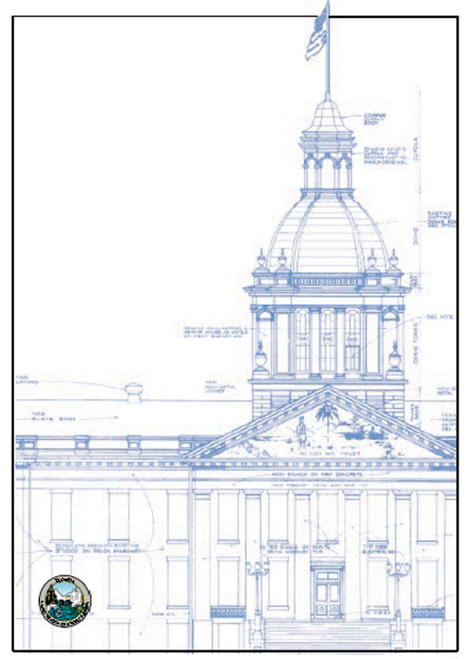

Florida
Building
Commission

Annual
Report
FY 2021 - 2022

Ron DeSantis, Governor
Jim Schock, Chair
Melanie Griffin, DBPR Secretary

Prepared by Thomas Campbell, Executive Director, Florida Building Commission
June 2022
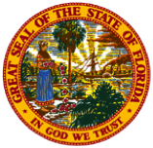

Florida Building Commission
Report to the 2022 Florida Legislature
for the Reporting Period of July 1, 2021 – June 30, 2022

Table of Contents

Table of Contents 1
Table of Appendices 1

I. Issues and Recommendations 2

Table of Appendices

II. Appendices 8 - 13

A. Development of the Florida Building Code Overview 8
B. Commission Representation and Process 9
C. Key to Common Acronyms 11
D. Commission Milestone and Plenary Session Summaries for FY 2021 - 2022 12

d
a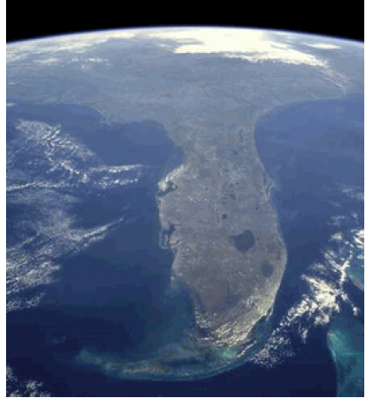 Building Commission
Report to the 2022 Florida Legislature

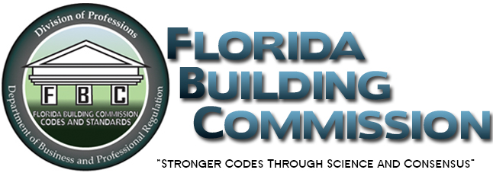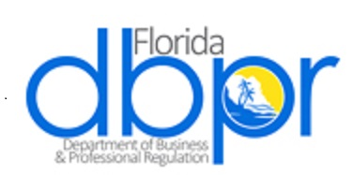

I. Issues and Recommendations

Meetings. During the reporting period of July 1, 2021 – June 30, 2022 (fiscal year 2021 – 2022) the Commission conducted three virtual meetings and three in-person meetings.

Overview. The primary focus of the Florida Building Commission during the reporting period was the development of the Florida Building Code, 8th Edition (2023), and the implementation of legislation from the 2021 and 2022 legislative sessions.

In addition, the Commission, pursuant to Section 553.73(8)(b), Florida Statutes, approved errata to the Florida Building Code, 7th Edition, (2020), and completed the first step of updating the Florida Building Code, 7th Edition, (2020), to the Florida Building Code, 8th Edition, (2023). During the initial step of the update process the Commission reviewed 1,318 changes from 2021 international model codes and approved 657 changes.

Entering its twenty-fourth year, the Commission is focused primarily on the maintenance of existing processes and programs, while continuing to work with stakeholders to enhance the effectiveness of the Florida Building Code System by continuously monitoring, evaluating, and refining the System using their facilitated stakeholder driven consensus-building process.

Process. During the reporting period the Commission continued its focus on consensus-building efforts regarding the implementation of Commission policy, with extensive input from building construction industry stakeholders, and interests affected by Commission policy. Commission Chair Jim Schock encouraged and led the Commission’s consensus-building efforts supported by DBPR Commission staff.

Research—Science Based Hurricane and Code Protections. The Florida Building Commission has continuously assessed building systems and component failures identified after major storms since its inception in 1998, and in response has funded research to strengthen the Code’s effectiveness against wind and water intrusion based on these assessments. Assessments subsequent to the implementation of the Florida Building Code indicate that the research based design wind speeds required by the Code’s enhancements were adequate, and buildings built to the new Florida Building Code experienced less severe damage than did older buildings not built to the Florida Building Code. Although the Code is by law a minimum building code, the Florida Building Code is the strongest consensus and science based building code in the country. The Insurance Institute for Business and Home Safety (IBHS) ranked the Florida Building Code as number one in their 2021 assessment of residential building code enforcement systems for life safety and property protection in hurricane prone regions.

The Commission has been funding hurricane resistance research based on legislatively approved spending authority since the formation of the Commission’s HRAC in 2005. In addition to hurricane resistance, the Commission expanded the funding of research projects in August of 2013 to include other Code related topical areas to ensure the development of Code amendments that make Florida’s structures, and the products that comprise them, more resilient. Starting in 2019 the Commission voted to again restrict the funding of research projects to hurricane resistance research as a result of the frequency and severity of the impacts of recent hurricanes to Florida.

During the reporting period—based on recommendations from the HRAC and DBPR technical staff—the Commission approved the funding of research projects for fiscal year 2022 – 2023. As a result of evaluating proposed research projects in the context of the evaluation criteria, the Commission sponsored the following research projects:
Wind-Inducted Loads on Ground-Mounted and Ground Ballasted Systems, Ioannis Zisis, FIU; Assessing the need to Modernize water Penetration Resistance Test Procedures, Forrest Masters, UF; Assessment of Durability Requirements for Concrete Structures in Florida, Chris Ferraro, UF; Assessment of Inspection Reporting and Building Conditions in South Florida, Jennifer Bridge, UF; and An Investigation of the Factors leading to Ridge Vent Failure and Possible Mitigation Solutions, Cigdem Akan, UNF.

In addition, during the reporting period the Commission continued its commitment to evaluating and amending the Code as needed based on storm damage investigations, through periodic updates and reviews of research projects and investigations. The Structural Technical Advisory Committee, and the Hurricane Research Advisory Committee have been reviewing interim research project reports, and providing feedback to the principal investigators for revisions prior to submittal for final reports and approval by the Commission.

As previously reported, investigations and analysis of the impacts of Hurricane Michael conducted by the University of Florida demonstrated that houses built to the Florida Building Code (FBC) performed better than those that were not built to the FBC. The Commission maintains their commitment to ensuring that the FBC remains the strongest consensus and science based building code in the country.

New HRAC Assignment. In August 2021, Commission Chairman Jim Shock tasked the HRAC with the following assignment:

- To gather and review all guidelines, statutes, ordinances, standards, and model codes related to building recertification requirements, inspection schedules for existing buildings, and procedures for inspecting unsafe buildings.

- To discuss what role the Florida Building Code could or should have regarding inspections of maintenance of existing high-rise residential buildings and other structures.

- To track and compile findings from investigations of Champlain Towers.

The HRAC completed the first two tasks over the course of several meetings held during September 2022 and October 2022. Commission staff is continuing to monitor all investigations of Champlain Towers and will report any new findings to the Commission and the HRAC. Additionally, the Department of Business and Professional Regulation contracted with the University of Florida for a research project to investigate existing recertification/building safety inspections in Broward and Miami-Dade counties. The final report is due in June 2022.

2023 Code Update. Florida law requires the Commission to update the Florida Building Code every three years. The development of the 8th Edition (2023), Florida Building Code will be conducted to ensure that Florida’s Energy Code efficiencies are maintained as required, and that the requirements related to wind resistance or prevention of water intrusion contained in the Code or its referenced standards and criteria are maintained or enhanced. The 2023 Code Update process began on February 9, 2021 when the Commission voted to select the 2021 International Codes (I-Code), and 2020 National Electrical Code (NEC) for review in the development of the 8th Edition (2023), Florida Building Code.

In late September 2021, the Commission’s TACs reviewed and provided recommendations to the Commission regarding the inclusion of I-Code changes in the 8th Edition (2023), Florida Building Code. The Florida Building Commission met in December 2021 and approved 657 of the 1318 I-Code changes. The Commission’s TACs are set to take up code modifications developed by the public at the end of June 2022.

Following is a table reflecting the key tasks and associated Workplan schedule for the 2023 Code Update Process:
8th Edition (2023), Florida Building Code Development Schedule
Key Tasks | Schedule
Commission selects 2021 I Codes “model codes” and 2020 NEC to conduct its review. | February 9, 2021
TACs review the changes to the I Codes and make recommendations to the Commission. | September 24-29, 2021
Commission considers TACs’ recommendations regarding the latest changes to the model codes. | December 14-15, 2021
TACs consider proposed amendments (1st 45 day comment period) | June 20-24, 2022
TACs consider public comments on their actions on the proposed amendments. | October 11-14, 2022
Commission considers TAC’s recommendations (2nd 45 day comment period) in a Rule Development Workshop. | December 13-14, 2022
TACs consider public comments on Rule Development Workshop comments on Commission’s Adopted Draft Code and provide recommendations to the Commission | February 22-23, 2023
Commission conducts rule development workshop on the Commission’s package of approved Code amendments for the Florida Building Code, 8th Edition (2023) | March 13, 2023
Commission conducts hearing on the Commission’s package of approved Code amendments for the Florida Building Code, 8th Edition (2023). | TBD
Final rule adoption hearing on Florida Building Code, 8th Edition (2023)—Commission approves final version of the Code. | TBD
Florida Building Code, 8th Edition (2023) Effective Date. | December 31, 2023

Energy Code Initiatives. During the reporting period, the Commission voted to approve software for demonstrating compliance with the requirements of the 7th Edition (2020), Florida Building Code, Energy Conservation. Specific actions included approving Right Suite Universal 2021 using Right Energy Florida’s 2020 Module. Additionally, the Commission voted to approve enhancements and bug fixes for Energy Gauge Summit 7.0. Furthermore, the Commission voted to initiate rulemaking to update the Florida Building Code to meet the U.S. Department of Energy’s new HVAC energy efficiency requirements.

Product Approval. The product approval system is an internet-based system operated and administered by the Department of Business and Professional Regulation. Since January 1, 2014 DBPR staff has been administering the Product Approval System, and stakeholders continue to report a high level of satisfaction with DBPR staff’s administration of the System.

The Product Approval system efficiently processes hundreds of applications monthly. The Commission’s Product Approval Program Oversight Committee (POC) convenes prior to every Commission meeting to review product and entity applications, address petitions for declaratory statements and consider enhancements to the product approval system. Since the system went into effect in October of 2003, the Commission has approved 38,026 product applications, and 166,330 products for statewide use within limitations established by the approvals. In addition, the total number of product approval applications approved to the 2020 Code is 6,081 (6,791 total in the System), the total number of products approved to the 2020 Code is 24,085 (26,911 total in the System), and the total number of entities approved to the 2020 Code is 122 (429 total in the System).

In response to a letter from The Florida Legislature Joint Administrative Procedure Committee (JAPC) the Commission completed rulemaking to implement specified changes to various sections of Rule Chapter 61G20-3, F.A.C., and repealed Rule 61G20-3.010. The Commission also completed rulemaking for Rules 61G20-3.008, F.A.C., 61G20-3.011, F.A.C., 61G20-3.013, F.A.C., and 61G20-3.016, F.A.C., which implemented legislative assignments from the 2021 Legislature regarding required revisions to the Product Approval System.

Education. Education is one of the cornerstones of the Building Code System, and the effectiveness of the Building Code depends on the knowledge of professionals who design and construct buildings. The Commission continues to work with the Department of Business and Professional Regulation and representatives of the licensing boards to establish a cooperative system for approving building code courses and integrating building code continuing education into licensing requirements. In collaboration with the System Administrator and stakeholders, the Commission is working to ensure the accountability and efficacy of the Education System. During the reporting period the Commission continued to efficiently review and approve course and accreditor applications. In addition, the Commission completed rulemaking for Rule 61G20-6.002, F.A.C., which streamlined and clarified the advanced code course application process.

Binding Interpretation Process. The Commission coordinates with the Building Officials Association of Florida (BOAF) on appointments to the Binding Interpretation Panel. The Panel consists of seven members charged with hearing requests to review decisions of local building officials. The Panel has heard 38 binding interpretations regarding the Florida Building Code to date.

Florida Accessibility Code for Building Construction (FACBC) Declaratory Statements. In 2014, the Florida Building Commission was granted authority by the Florida Legislature to interpret the Florida Accessibility Code for Building Construction (FACBC). There were no interpretations issued during the reporting period, and to date the Commission has issued five interpretations regarding petitions for declaratory statements on the FACBC.

Legislative Assignments. The Florida Building Commission provides a forum for stakeholders representing key interests to participate in a consensus-building process where issues affecting the construction industry are discussed and evaluated on their technical merits and cost-benefits to the citizens of the State of Florida. In addition, as a result of the Commission’s proven consensus-building process and success in developing consensus on complex and controversial issues, the Florida Legislature frequently assigns policy issues to the Commission for evaluation and implementation.

The 2021 Florida Legislature passed HB 401 amending: 1.) Section 553.73(4)(k)(11), F.S. creating a nonbinding advisory opinion process for the Florida Building Commission to consider petitions from individuals who believe a local regulation is a local technical amendment to the Florida Building Code, and requiring the Commission to adopt a form for the petition and directions for filing; 2.) Amending Section 553.73(8)(b), F.S. creating a process which would allow the Florida Building Commission to correct demonstrated errors in the Florida Building Code by issuing errata; 3.) Amending Section 553.791 (4), F.S. requiring the Commission to adopt a form for notification to local building officials that a private provider has been contracted to perform the required inspections of construction; and, 4.) Amending Section 553.842 (8)(a), F.S. granting the Florida Building Commission authority to develop by rule criteria for the approval of evaluation entities for the Commission’s statewide product approval program, and requiring the Commission to establish criteria for suspension of approvals of product evaluation entities.

The 2021 Florida Legislature passed SB 804 amending: Section 553.80(9), F.S. by preventing reclassification (Use and Occupancy) of a single family or two-family dwelling for the enforcement of the Florida Building Code because it is being used as a recovery residence, and requiring the Commission to amend the Code to reflect the requirement.

Finally, the 2021 Florida Legislature passed SB 286 amending: Section 633.102 F.S. by changing requirements for what license is necessary to design certain types of fire protection systems, and requiring the Commission to amend the Code to reflect the new requirement.

In response to the assignments from the 2021 Florida Legislature, the Commission completed rulemaking for the relevant rules. Additionally, at its August 2021 meeting, the Commission approved errata pursuant to the newly created Section 553.73(8)(b), F.S., and approved code amendments as required for the implementation of SB 804 and SB 286.

The 2022 Florida Legislature passed HB 423. HB 423 sets limits on the ability of local governments to request more information from building permit applicants and requires local governments to approve permit applications within certain time constraints once the permit applicant has supplied the local government with the requested information.

The 2022 Florida Legislature passed SB 1140 which creates a streamlined permitting process for certain types of smaller fire alarm system projects. The bill also amends the definition of “Low voltage alarm system project” to include video cameras and closed circuit television systems used to detect a burglary, fire, robbery, or medical emergency and clarifies that it only applies to low voltage electric fences.

The 2022 Florida Legislature passed SB 4-D. The bill permits 25% or more of a roofing system or section to be repaired, replaced, or recovered when the existing roof system or roof section was built, repaired, or replaced in compliance with the requirements of the 2007 Florida Building Code, or any subsequent edition of the Florida Building Code. The repaired, replaced, or recovered roof system or roof section must comply with the requirements of the current edition of the Florida Building Code. The bill also creates structural inspection requirements for condominiums and cooperative building ownership associations. The bill tasks the Florida Building Commission with two specific assignments. The first assignment is to review the structural inspection requirements in the bill and provide recommendations to the legislature to ensure the structural inspections required by the bill are sufficient to determine the structural integrity of a building. This set of recommendations is due December 31, 2022. The second assignment is for the Commission to develop recommendations for the adoption of comprehensive structural and life safety standards for maintaining and inspecting all types of buildings and structures in this state that are three stories or more in height. This set of recommendations is due December 31, 2023.

In response to the assignments from the 2022 Florida Legislature, the Commission has initiated rulemaking to incorporate the statutory changes into the Florida Building Code and will be forming a workgroup to develop the recommendations required by SB4-D. The required rulemaking is set to be completed during the first quarter of FY 2022-2023.

Recommendations. Monitoring the building code system and determining refinements that will make it function better is a primary responsibility of the Commission, and consequently the Commission is continually effecting refinements to the building code system by administrative rule amendments where the statutes provide authority. However, the building code system is established in law, requiring that some refinements must be implemented through changes to law.

As a general approach, the Commission works with building construction industry stakeholders to build consensus on legislative assignments and on amendments to the Florida Building Code implemented through rulemaking, and relies on industry groups to take the lead in proposing specific legislation to implement proposed changes to statute.

The Commission’s consensus developed recommendations for statutory changes designed to improve the system’s effectiveness are developed in collaboration with industry stakeholders, who generally take the lead on initiating any specific legislative proposals. The Commission has no specific recommendations for 2022 Legislative actions deriving from Commission activities during the reporting period of July 1, 2021 – June 30, 2022.

II. Appendices

Appendix A

Development of the Florida Building Code Overview

In 1974, Florida adopted a state minimum building code law requiring all local governments to adopt and enforce a building code. The system provided four separate model codes that local governments could consider and adopt to establish minimum standards of health and life safety for the public. In that system, the state’s role was limited to adopting all or relevant parts of new editions of the four model codes. Local governments could amend and enforce their local codes as they saw fit.
Hurricane Andrew demonstrated in 1992 that this system of local codes did not provide the level of public protection that was necessary. The South Florida Building Code, which was the local code universally acknowledged to set the strongest standard for hurricane protection, essentially failed. The resulting problems had impacts well beyond southern Miami-Dade County. The state filled the property insurer void left by failed and fleeing private insurance companies, and the federal government poured billions of dollars of aid into the disaster area. It became starkly apparent the state had a significant interest in the effectiveness of building codes.
After Hurricane Andrew, Miami-Dade County conducted an exhaustive review of its building code and made significant changes to both the code and support systems for code enforcement. In other areas of the state the Florida Board of Building Codes and Standards (the predecessor to the Florida Building Commission) adopted significant upgrades to the wind resistance standards of the model state minimum code that was used by the majority of other local governments. The state also began licensing local governments’ building code enforcement personnel. These steps proved critical in leading to the building codes that produced improved building performance in the 2004 - 2005 hurricane seasons.
Like Miami-Dade County, the State went beyond modernizing the minimum building codes. In 1996 a study commission was appointed to review the system of local codes created by the 1974 law and to make recommendations for modernizing the entire system. The 1998 Legislature adopted the study commission’s recommendations for a single state building code and an enhanced oversight role for the state in local code enforcement. The same legislation created the Florida Building Commission to develop and maintain the Florida Building Code and related programs and processes. The 2000 Legislature authorized implementation of the Florida Building Code, and the first edition replaced all local codes on March 1, 2002. There have been seven Code editions to date, and the Commission initiated the development of the Florida Building Code, 8th Edition (2023) in August of 2019.
Although the Code is by law a minimum building code, the Florida Building Code is the strongest consensus and science based building code in the country. The Insurance Institute for Business and Home Safety (IBHS) ranked the Florida Building Code as number one in its 2018 assessment of residential building code enforcement systems for life safety and property protection in hurricane prone regions.

Appendix B

Commission Representation and Process

Commission Representation. The Florida Building Commission is an appointed stakeholder representative group that successfully created, implemented, and maintains and updates the statewide Florida Building Code. The 2020 Florida Legislature reduced the number of Commissioners from 27 to 19 effective January 1, 2021. The Commission is currently comprised of 19 members appointed to represent specific building construction industry stakeholder interests. They are as follows: three municipal, county, or district code enforcement officials, a persons with disabilities representative, a building owners and managers industry representative, an insurance industry representative, a certified general or building contractor, a certified residential contractor, an architect, a structural engineer, an air-conditioning contractor or a mechanical contractor or engineer, an electrical contractor or electrical engineer, a plumbing contractor, a roofing or sheet metal contractor, a manufactured buildings industry representative, a building products manufacturing industry representative, a swimming pool contractor, a natural gas distribution system representative, and the chief resilience officer or their designee.

Consensus Process. The Florida Building Commission (Commission) seeks to develop consensus decisions on its recommendations and policy decisions. General consensus is a participatory process whereby, on matters of substance, the members strive for agreements which all of the members can accept, support, live with or agree not to oppose. In instances where, after vigorously exploring possible ways to enhance the members’ support for the final decision on substantive decisions, and the Commission finds that 100 percent acceptance or support is not achievable, final decisions require at least a 75 percent favorable vote of all members present and voting. This super majority decision rule underscores the importance of actively developing consensus throughout the process on substantive issues with the participation of all members and which all can live with and support.

The Commission’s consensus process is conducted as an open public process with multiple opportunities for the public to provide input to the Commission on substantive issues. At each Commission meeting, the public is welcome to speak during the public comment opportunity provided for each substantive issue under consideration, as well as during general public comment periods provided at the end of each meeting. In addition, most substantive issues before the Commission go through a technical advisory committee review or workgroup process where consensus recommendations are developed by appointed representative stakeholder interests, providing extensive opportunities for public input. In addition many of the Commission’s decisions require rule development to implement, affording additional entry points for public input.

Since its formation in July of 1998, the Commission has demonstrated a commitment to working with affected interests to build consensus on complex issues. The adoption of the first edition of the Florida Building Code (2001 Edition), developed from September 1998 through January of 2001, involved 27 Commission meetings, dozens of facilitated public workshops and hundreds of TAC meetings. The Commission has consistently worked with all affected interests to build the best possible consensus-based Building Code for the citizens of Florida. Through its committees and workgroups comprised of experts, the Commission has always developed its decisions based on analysis of the results of the best engineering and science available. Since 1999 the Commission has convened 68 special issue stakeholder workgroups to develop broad based consensus recommendations on issues of concern to building construction industry stakeholders.

Appendix C

Key to Common Acronyms

Acronym | Definition
ADA | Americans With Disabilities Act
ADAAG | ADA Accessibility Guidelines for Buildings and Facilities
BCSA | Florida Building Code System Assessment
BOAF | Building Officials Association of Florida
DACS or FDACS | Florida Department of Agriculture and Consumer Services
DBPR | Department of Business and Professional Regulations
DCA | Department of Community Affairs (Abolished 2011)
DEP or FDEP | Florida Department of Environmental Protection
DOH or FDOH | Florida Department of Health
EPA | U.S. Environmental Protection Agency
FACBC | Florida Accessibility Code for Building Construction
FAR | Florida Administrative Register (previously FAW)
FBC | Florida Building Code
FBC | Florida Building Commission
FECC | Florida Energy and Conservation Code
IBC | International Building Code
ICC | International Code Council
POC | Program Oversight Committee (Education and Product Approval)
SAD | ADA Standards for Accessibility Design
TAC | Technical Advisory Committee

Appendix D

Commission Milestones and Plenary Session Meeting Summaries

for the Period of July 2020 – June 2021

August 2021 The Commission conducts their 10 August 2021 meeting in Sarasota, the first in-person meeting since February of 2020. The Commission votes to approve the updated Workplan and Schedule for development of the 8th Edition (2023), Florida Building Code. The Commission votes to proceed with rule adoption, unless a hearing is requested, for Rule 61G20-1.001—Florida Building Code Adopted, incorporating the Commission’s approved errata and changes in response to legislative action to the 7th Edition (2020), FBC, and to delegate authority to Thomas Campbell to sign rulemaking documents on behalf of the Commission. The Commission votes to approve the 2021 - 2022 Annual Regulatory Plan as presented, and to authorize publication of the Plan by DBPR.

October 2021 The Commission conducts their 12 October 2021 meeting as a virtual meeting via webinar and teleconference. The Commission votes to reverse the Binding Interpretation Panel’s interpretation of the Florida Building Code regarding an appeal of Binding Interpretation #217 as outside the scope of the Binding Interpretation process. The Commission votes to approve the updated Workplan and Schedule for development of the 8th Edition (2023), Florida Building Code.

December 2021 The Commission conducts their 14 December 2021 meeting in Gainesville, Florida. The Commission votes to approve rulemaking for Rule 61G20-2.003 and votes to approve the corresponding nonbinding advisory opinion petition form. The Commission votes to approve an energy compliance software submittal for Right-Suite Universal 2021 using Right Energy Florida’s 2020 Module. The Commission also votes to approve enhancements and bug fixes for Energy Gauge Summit 7.0. The Commission votes to adopt the package of approved 2021 I-Code changes for inclusion into the Florida Building Code, 8th Edition (2023). Additionally, Chairman Shock makes two appointments to the Structural Technical Advisory Committee and one appointment to the Accessibility Advisory Committee.

February 2022 The Commission conducts their 8 February 2022 meeting virtually. The Commission votes to approve the updated Workplan and Schedule for development of the Florida Building Code, 8th Edition, (2023). The Commission receives a briefing on Binding Interpretation #233. Additionally, Chairman Shock makes one appointment to the Structural Technical Advisory Committee and one appointment to the Fire Technical Advisory Committee.

April 2022 The Commission conducts their 12 April 2022 meeting in Jacksonville. The Commission votes to approve the updated Workplan and Schedule for development of the Florida Building Code, 8th Edition, (2023). The Commission authorizes staff to initiate the rulemaking process for Rule 61G20-1.001 to address potential changes to state law and to update the minimum energy efficiency requirements in the Florida Building Code to match federal standards that will become effective 1 January 2023. The Florida Building Commission considers a complaint filed by Silvia Lino against Soft-Lite LLC., and dismisses the complaint. The Commission receives a briefing on Binding Interpretation #231. Chairman Shock makes one appointment to the Structural TAC and two appointments to the Special Occupancy TAC.

June 2022

