HUMIDITY AND MOISTURE CONTROLWORKGROUP

REPORT TO THE FLORIDA BUILDING COMMISSION

June 13, 2008

Tampa, Florida

Meeting Design & Facilitation By



Report By Jeff A. Blair
Florida Conflict Resolution Consortium
Florida State University



jblair@fsu.edu
http:// consensus.fsu.edu

This document is available in alternate formats upon request to Dept. of Community Affairs, Codes & Standards, 2555 Shumard Oak Blvd., Tallahassee, FL 32399, (850) 487-1824.
FLORIDA BUILDING COMMISSION
HUMIDITY AND MOISTURE CONTROL WORKGROUP REPORT

JUNE 13, 2008

OVERVIEW
Chairman Rodriguez announced that at the recommendation of the Energy TAC the Commission is convening a Regional AC Efficiency Workgroup. The Workgroup will develop recommendations on whether the Commission and DCA should recommend to the United States Department of Energy (USDOE) regional AC efficiency standards for the hot and humid climate. The USDOE now has authority to develop and adopt regional AC efficiency standards. The Workgroup will work with affected stakeholder interests in a facilitated workgroup process.
The Workgroup shall investigate the feasibility of a hot-and-humid climate regional efficiency rating for air-conditioner and heat-pump systems and if determined a regional standard is a good strategy, then to develop recommendations for the technical requirements.

Following the first meeting, the scope of the Workgroup was changed to develop recommendations regarding AC equipments’ role in controlling humidity and moisture in buildings in a hot and humid climate. The Workgroup is tasked with considering a range of issues and options regarding the manufacturing, design and installation of AC equipment in controlling moisture and preventing mold and mildew in the hot and humid Florida climate.

Humidity and Moisture Control Workgroup Members

Ron Bailey

Oscar Calleja
Bob Cochell

Roy Crawford
Philip Fairey
Dale Greiner
Gary Griffin
Pete Quintela
Dutch Uselton

REPORT OF THE JUNE 13, 2008 MEETING

Opening and Meeting Attendance
The meeting started at 9:10 AM, and the following Workgroup members were present:
Oscar Calleja, Paul Stehle for Bob Cochell, Ron Bailey, Philip Fairey, Dale Greiner,
Gary Griffin, Pete Quintela, and Larry Straub for Dutch Uselton.

DCA Staff Present
Rick Dixon and Mo Madani.

FSEC Staff Present
Rob Vierra

Meeting Facilitation
The meeting was facilitated by Jeff Blair from the Florida Conflict Resolution Consortium at Florida State University. Information at: http://consensus.fsu.edu/

Project Webpage
Information on the project, including agenda packets, meeting reports, and related documents may be found in downloadable formats at the project webpage below: http://consensus.fsu.edu/FBC/hmcw.html

Meeting Objectives
- To Approve Regular Procedural Topics (Agenda and Summary Report from Last Meeting)
- To Review Revised Workgroup Scope
- To Discuss Building Construction and Operation Characteristics and Climate Control System Characteristics that Contribute to Problems Controlling Moisture in Buildings in Hot and Humid Climates
- To Identify Options for Addressing Construction Characteristics Contributing to Moisture Control in Buildings in Hot and Humid Climates
- To Discuss and Prioritize Near-Term Options for Addressing Moisture Control in Buildings in Hot and Humid Climates
- To Identify and Discuss Long-Term Needed Actions
- To Consider Public Comment
- To Identify Needed Next Steps and Agenda Items for Next Meeting

Agenda Review
Following a review of the agenda, the Workgroup voted unanimously, 6 – 0 in favor, to approve the agenda as presented.

Approval of May 9, 2008 Meeting Summary Report
Following a review of the May Report, the Workgroup voted unanimously, 6 – 0 in favor, to approve
the May 9, 2008 Meeting Summary Report as presented.

Overview of Revised Workgroup Scope
Jeff Blair, Commission Facilitator, explained that the Workgroup’s scope had been revised by the
Commission Chair to developing recommendations regarding AC equipments’ role in controlling humidity and moisture in buildings in a hot and humid climate. The Workgroup is tasked with considering a range of issues and options regarding the manufacturing, design and installation of AC equipment in controlling moisture and preventing mold and mildew in the hot and humid Florida climate.

Update on USDOE Regional AC Efficiency Standards Rulemaking Process
The Workgroup received an update from Don Brundage, Southern Company, regarding the United States Department of Energy (USDOE) Framework Document public meeting on Energy Conservation Standards for Residential Air Conditioners and Heat Pumps. Don reported that DOE took public input regarding the Framework Document on June 12, 2008 in Washington D.C., and that rulemaking milestones were reviewed. Following are the USDOE Milestones for Rulemaking:

Framework comment period: July 31, 2008
ANOPR published in Federal Register: Fall of 2009
NOPR published in Federal Register: Fall of 2010
Final Rule published in Federal Register: June 2011
Effective date of Standard (5 years after F.R.): June 2016 or January 2017

Discussion of Building Construction and Operation Characteristics and Climate Control System
Characteristics that Contribute to Problems Controlling Moisture in Buildings in Hot and Humid
Climates
The Workgroup heard a presentation from Rob Vierra, Florida Solar Energy Center, regarding
controlling moisture in buildings in a hot and humid climate. Following the presentation questions and
answers were considered.

Summary of Presentation:
Following are the seven options reviewed by Rob with the Workgroup:

- Select AC systems with lower sensible heat ratio
- Configure the AC system fan to operate at a lower air flow rate
- Disable supply air fan overrun
- Operate the supply air fan in AUTO mode
- Install airtight ductwork
- Proper AC equipment sizing
- Install thermostatic expansion valves (TXV)

The full Report titled: Investigate the Feasibility of a Hot-and-Humid Climate Regional Efficiency Rating
For AC and Heat Pump Systems, is on the project webpage. In addition, Rob’s full presentation is available
as an attachment to this Report.
(Attachment 3—PowerPoint of Presentation)

Dehumidification Performance
The Workgroup heard a presentation from Armin Rudd, Building Science Corporation, regarding
dehumidification performance. Following the presentation questions and answers were considered.

Summary of Presentation:
- Armin Rudd presented some of the work that DOE’s Building America teams have done with high performance homes and equipment options.
- DOE has tasked them with how to evaluate for dehumidification performance.
- What information should be divulged to help create information for evaluation?
- Current goal chosen is limit duration of RH > 60% to 4 hours or less, while meeting dehumidification efficiency requirements.
- Current dehumidifiers are rated in two ranges, small ones are energy star if they are 1.25 liters per kW, or larger ones at 2.5 liters per kW. AHAM criteria is 80 F and 60% RH.
- They want to test in the lab and field.
- He presented tests they are attempting in the field.
- Research is ongoing.
- Will have an expert meeting, web-based in June or July.
- Email Armin to participate.
- Also an expert meeting at ASHRAE winter meeting.
- An industry test procedure, test standard by 2010.
- Will keep humidity control separate form incorporation with SEER.
(Attachment 4—PowerPoint of Presentation)

Identification and Discussion in Turn of Near-Term Options Regarding Addressing Construction
Characteristics Contributing to Moisture Control Problems
Members were asked to identify options that could be implemented in the short-term for controlling indoor humidity and moisture in the hot and humid climate. Members identified options, discussed pros and cons of each, and then prioritized each in terms of importance for achieving the control of indoor humidity and moisture.

Summary of Discussion and Member’s Questions and Comments:
Following are the Options identified by Workgroup members and the public:
- Air Distribution Systems
- Fan Settings –auto vs. continuous, fan speed, overrun
- Code should mandate that equipment should be able to maintain humidity level based on design conditions
- High performance buildings and need for auxiliary dehumidification equipment
- Source Control
- A humidity control device, thermostats -programmable
- Make sure equipment is based on the space of the building, envelope performance
- Outside air ventilation
- Testing at alternative indoor and outdoor humidity with dehumidification performance – perhaps the liters/kWh
- Start-up Commissioning
- Maintenance
- Roger Sanders – Location of ductwork trying to locate it inside conditioned space
- Larry Nelson – Use of ECMs and TXVs in order to control humidity

Following is a summary of the discussion regarding each of the Options:

Air distribution systems and location of ductwork trying to locate it inside conditioned space:
- Better efficiency from such systems
- There needs to be some incentive and emphasis on installing ducts in conditioned space
- Location and tightness
- Inner-core of the duct connection inspection issues
- Testing should be mandatory for new construction

Fan Settings:
- Set system to Auto
- Eliminate fan overrun
- Incorporate humidity control into things like fan overrun so that machine can operate in best mode for the load at that time
- Return outdoor air ventilation systems

Code mandated design criteria:
- Code should mandate that equipment should be able to maintain humidity level based on code mandated design criteria.
- Sizing unit, sizing plus dehumidifier, many options by designer, we need to set the criteria, set desired humidity level or range.
- Set criteria for the equipment that must be able to maintain the criteria that we set during a specific period of the year.
- Unrealistic to do this year round without auxiliary equipment so period of year is important.
- 50% RH in winter is too high for surface temperature sin locations that have winters.
- Need to have temperature and humidity for outside.
- Discussion should be limited to summertime and not deal with the wintertime issue in this discussion.

High performance buildings and need for auxiliary dehumidification equipment
- Need to control humidity during the periods when the air conditioning equipment is not running.
- With improved codes this can apply to most new buildings.
- ASHRAE ventilation requirements –how will code officials look at it, how will Florida look at the increased humidity load and related microbials.
- High relative humidity when, April at 7 am in the morning when much of Florida has windows open?
- We must know when hours are occurring before making rules that are not appropriate.
- Don’t think that the code should require humidity control for times when AC is not running.

Source Control
- Bathroom and kitchen control.
- Winter time concerns.
- Humidity control in attics and how it may migrate into conditioned space.
- Source control with respect with contaminants found in homes.
- Why are we ventilating? We are trying to dilute interior pollutants. Cleaning product VOC’s, building material and finishing products are some of the sources.
- Solution to pollution is not necessarily dilution, at times outdoor air may be worse for allergies.

A humidity control device, thermostats –programmable
- Setting design criteria as mentioned, will depend on the control device. There are some low cost thermostats that now have humidity control.
- Need to have a humidity control device and system.
- Problem may be cost for standard homes.
- When a humidity device is installed the control must be there.
- Want to control dew point.
- Armin – Industry uses internal software to control on dew point using words like Dry or less dry as opposed to letting consumers control directly on dew point.
- Practicality of humidity devices with human behavior.
- Could put in a more advanced thermostat for $150 to $200.
- Houses have significant moisture capacitance –they can store it in materials and furnishings, door openings will not change it drastically hour to hour.
- Outside air is the source of significant moisture so we know if there is a large exchange there can be humidity issues, leaky ducts also can lead to greater infiltration.
- If we bring in outside air than conventional equipment has trouble keeping up, particularly in envelopes that are highly efficient.
- Cranking AC to lower settings causes more moisture to be removed but usually raises RH.
- When we reach the Governor’s goals of 50% more efficiency by 2019, we have to solve this issue
- Armin – By making the homes more efficient we are saving energy even when using dehumidifiers based on our measured results.
- With TXV my system can handle 68 cfm coming in, equipment.
- Humidity sensors are not consistently accurate.
- If AC systems will run on humidity sensors there needs to be a low temperature cutoff to prevent overcooling.
- Location of control is important, some are on walls exposed to attic air.

Make sure equipment is based on the space of the building, envelope performance
- If there are changes in the envelope the equipment must be adjusted accordingly.
- Understand that you have to make a correlation between the equipment and the building, don’t think our code does that correlation for humidity.

Outside air ventilation
- Addressed it above with discussion of other options.
- Do we have to have mechanically forced outside air ventilation and are the ASHRAE 62.2 standards appropriate for Florida? Requires 0.2 ACH whether continuous or intermittent strategy – total must still be 0.2 ACH.
- Some new efforts to push the number higher, to perhaps twice as much.
- We need data to see what the differences are; not sure we have good hot humid data on the chemical soup problem that they focus on.
- For a lot of things we might consider pollutants, VOCs, mold spores, etc. there is no standard exposure – but there is for formaldehyde.
- We are on verge of being able to tell the dilution ability of various flow rates, vent strategies and housing types, but can not tell you what level of dilution is needed.
- We need to mandate some level of mechanical ventilation. Occupants are buying air fresheners that pollute their homes more.
- In addition to dilution, by using positive pressure we can reduce uncontrolled airflow.
- It is a good thing to recommend ventilation but not sure it needs to be required.
- We need to have data before we impose it.
- Affordable housing issues of requiring additional requirements.

Testing at alternative indoor and outdoor humidity with dehumidification performance – perhaps the liters/kWh
- Dehumidifiers are being tested but the air conditioning systems are not being tested in the same manner. We need to know how they perform in terms of energy and dehumidification removal.
- Manufacturers indicate that the information is available, but not necessarily to the public. Make information at multiple test points available.
- The information they publish is from models.
- SEER is from models.
- It may need to become a requirement later.

Start-up Commissioning
- We select the equipment but if installer does not charge the equipment correctly, how do we know what we are getting? Very few installers measure pressures and leave the information there.
- Third party confirmation is needed.
- Only some problems will show-up on a start-up sheet. How do you legislate proper start-up?
- May have been addressed by IECC at Palm Springs for commercial buildings.
- Will have to be per manufacturers recommendations.
- Don’t think 3rd party is much benefit.
- Contractors are not following proper procedures.
- Well trained technicians may be difficult to keep.
- Contractors that do the job right get penalized by not enforcing requirements on those that are not following the code – LA contractors sued.
- The best contractors lose.
- We have trouble just getting contractors to pull permits for change-outs.

Maintenance
- Once it is installed how do you know that it still performing?
- Will a maintenance contract be beneficial?
- Different contractors may change system parameters.
- Should be education of consumers.
- Prefer education to code requirement.
- Roger – changeout of mismatched equipment.
- Warranties are void if equipment is mismatched.
- Contractors believe they will lose the job if they don’t do it.
- Code has clarified that systems can not be mismatched.

Use of ECMs and TXVs in order to control humidity
- Requiring variable speed air handler units
- ECMs were a 5% increase when I priced them for my home
- Cost another $150 incremental for the thermostat.

- Want to make sure that any system set to run for dehumidification does not do so during the utility’s peak load times –they already provide incentives for high SEER to keep peaks lower
ECMs must be part of the strategy to obtain the dehumidification performance criteria – must be linked to the humidity control device.
- Lennox is doing this now.
- Contractor must program the complicated thermostats.

Prioritization of Near-Term Options
Members were asked to rank each of the short-term options for controlling indoor moisture and humidity on their importance for achieving control of indoor humidity and moisture on a five-point scale, where 5 is the highest level of importance and 1 the lowest level of importance.
Following are the results of the prioritization exercise regarding level of importance for controlling
indoor humidity and moisture control:

TOPIC | RANK
Airtight air distribution system | 1
Use of ECM’s/TXV | 2
Location of ductwork-encourage conditioned space | 3
Outside air ventilation | 4
Humidity control devices | 4
Envelope performance | 6
Fan overrun/settings | 7
Aux. dehumidification equipment in high performance buildings | 7
Startup commissioning of equipment | 9
Source control | 10
Maintenance of equipment | 10
Code mandated design criteria | 10
Power consumption/testing at multiple points/dehumidification performance | 13

(Attachment 5—Options Prioritization Exercise Results)

Identification and Discussion of Long-Term Issues and Action Plan

Members were asked to identify options that should be evaluated in the long-term regarding controlling indoor building humidity and moisture in a hot and humid climate.

Following are the issues/options identified during the meeting:

- Commercial building moisture control should be evaluated.
- Have the ARI directories list the moisture removal of equipment.
- Incorporate humidity removal in regional methodology for efficiency of AC.
- Consider a regional AC efficiency rating for the hot-and-humid climate.
- Come up with a humidity removal number label or rating as it relates to energy consumption.
- Proper enforcement of energy code could eliminate many of the problems.
- Review whether humidity control features are better located in mechanical code or energy code, or both.

Have trained and certified system designers.

General Public Comment
Members of the public were provided with an opportunity to speak on each of the Workgroup’s substantive issue discussion throughout the course of the meeting.

Jeff Blair, invited members of the public to address the Workgroup on any general issue within the Workgroup’s purview.

Review of Workgroup Delivery and Meeting Schedule

Next Steps and Agenda Items for Next Meeting

Jeff Blair explained that the Workgroup’s recommendations would be reported to the Commission during the June 2008 meeting, and that the Commission would determine when the Workgroup would meet next based on a Workplan Prioritization Exercise and factoring in availability of resources. All relevant documents are posted to the project webpage, and member’s will be notified when the next meeting will be held.

Adjourn
The Workgroup voted unanimously, 8 – 0 in favor, to adjourn at 2:00 PM.
ATTACHMENT 1
MEETING EVALUATION RESULTS

June 13, 2008—Tampa, Florida
Average rank using a 0 to 10 scale, where 0 means totally disagree and 10 means totally agree.

1. Please assess the overall meeting.
9.8 The background information was very useful.
9.6 The agenda packet was very useful.
9.8 The objectives for the meeting were stated at the outset.
9.2 Overall, the objectives of the meeting were fully achieved.
9.2 Overview of the Workgroup’s Revised Scope and Charge.
9.6 Discussion of Building Construction Characteristics and Climate Control System Characteristics that Contribute to Problems Controlling Moisture in Buildings in Hot and Humid Climates.
9.2 Identification of Options for Addressing Characteristics Contributing to Moisture Control.
9.2 Discussion and Prioritization of Near-Term Options for Addressing Moisture Control in Buildings in Hot and Humid Climates.
8.4 Identification and Discussion of Long-Term Needed Actions.
8.7 Identification of Next Steps.

2. Please tell us how well the Facilitator helped the participants engage in the meeting.
10 The members followed the direction of the Facilitator.
10 The Facilitator made sure the concerns of all members were heard.
10 The Facilitator helped us arrange our time well.
9.6 Participant input was documented accurately.

3. What is your level of satisfaction with the meeting?
8.8 Overall, I am very satisfied with the meeting.
9.8 I was very satisfied with the services provided by the Facilitator.
8.6 I am satisfied with the outcome of the meeting.

- What progress did you make?
9.0 I know what the next steps following this meeting will be.
9.0 I know who is responsible for the next steps.

- Written Member Comments.
None were offered.
ATTACHMENT 2
MEETING ATTENDANCE

NAME | AFFILIATION
Larry Nelson | FPL
Jonathon Curd | Lennox
Pat McLaughlin | AHRI
Jennifer Valentine | Lennox
Larry Straub | Lennox
Roger Sanders | Nova Engineering
Chris Gray | Southern Company
Armin Rudd | Building Science Corporation
Don Brundage | Southern Company
ATTACHMENT 3
CONTROLLING MOISTURE IN BUILDINGS
IN HOT AND HUMID CLIMATES
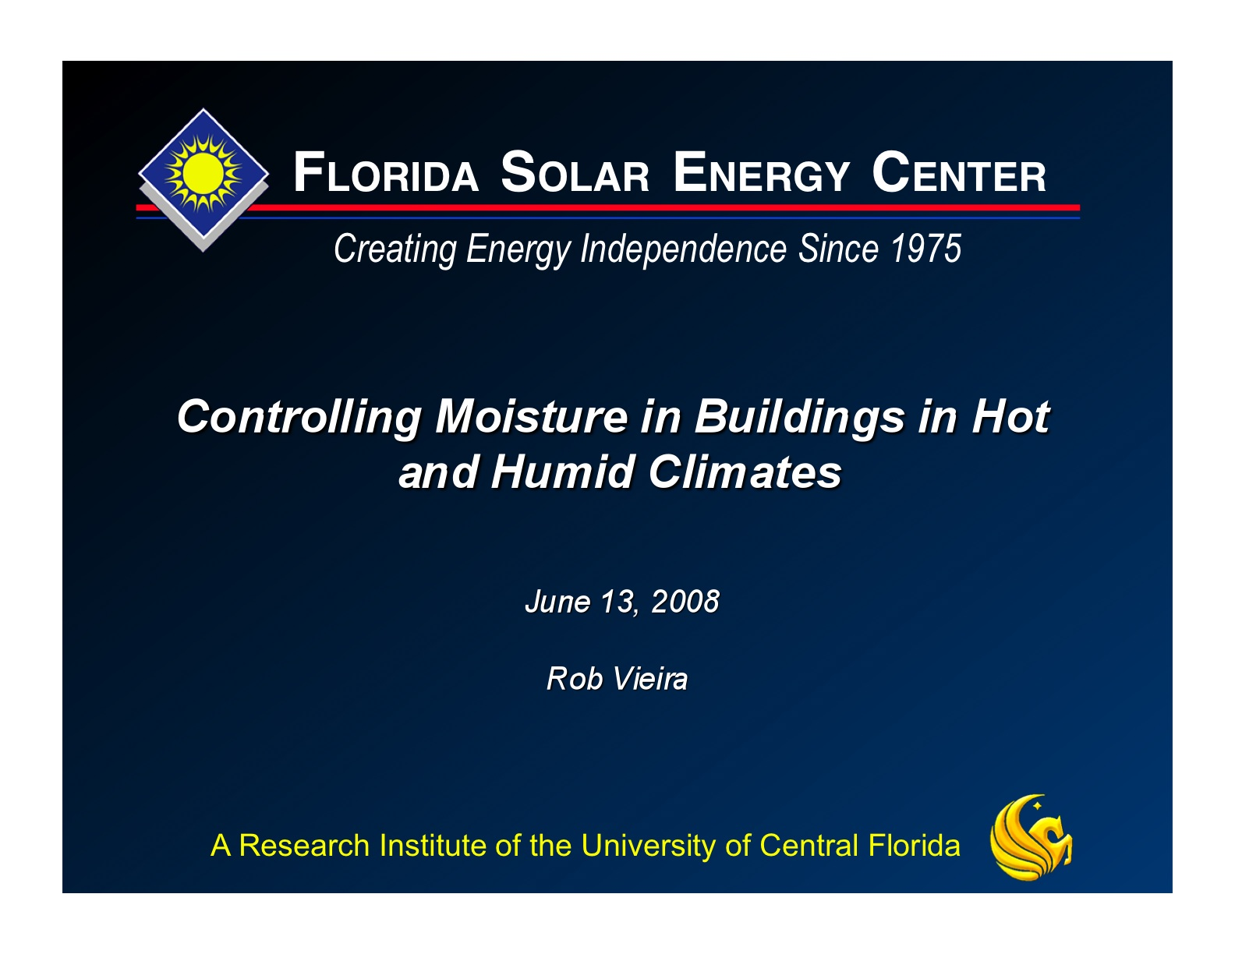
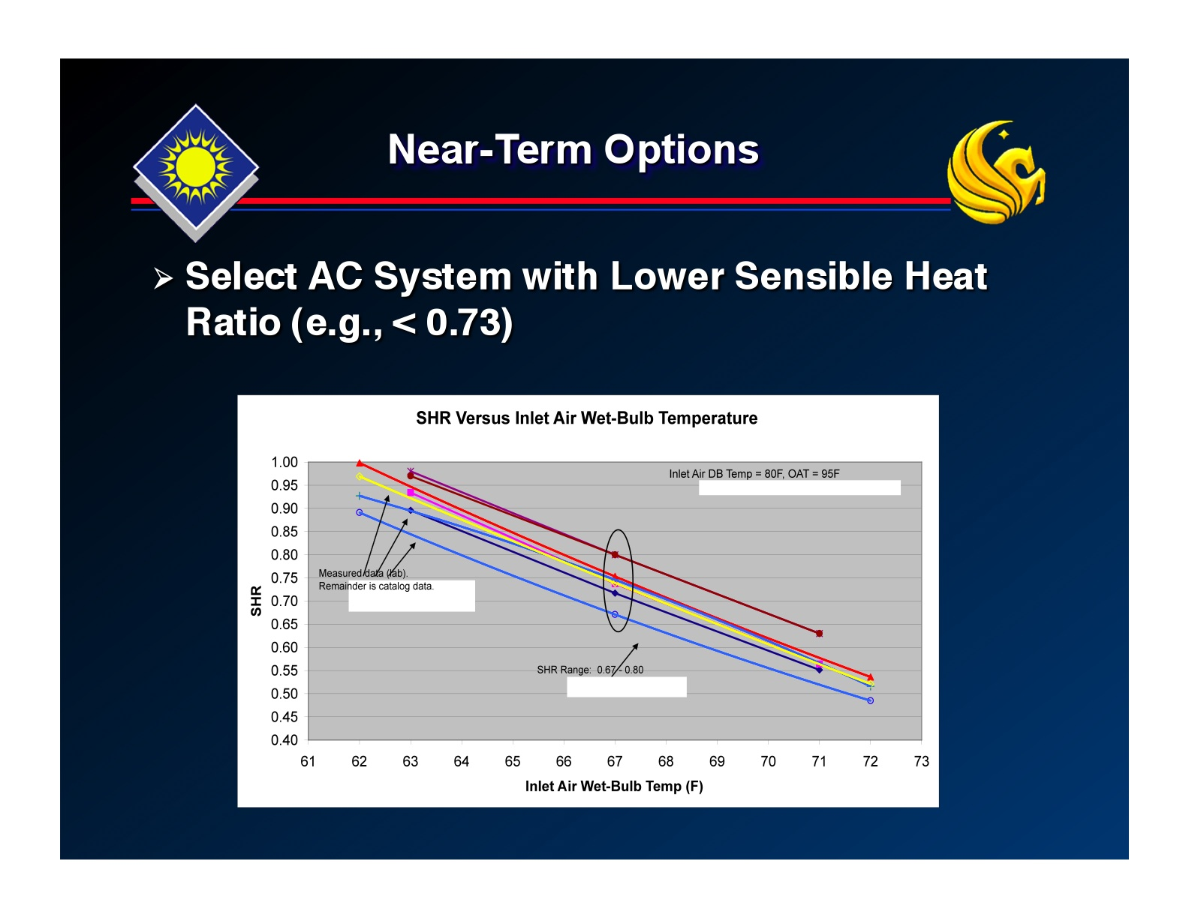
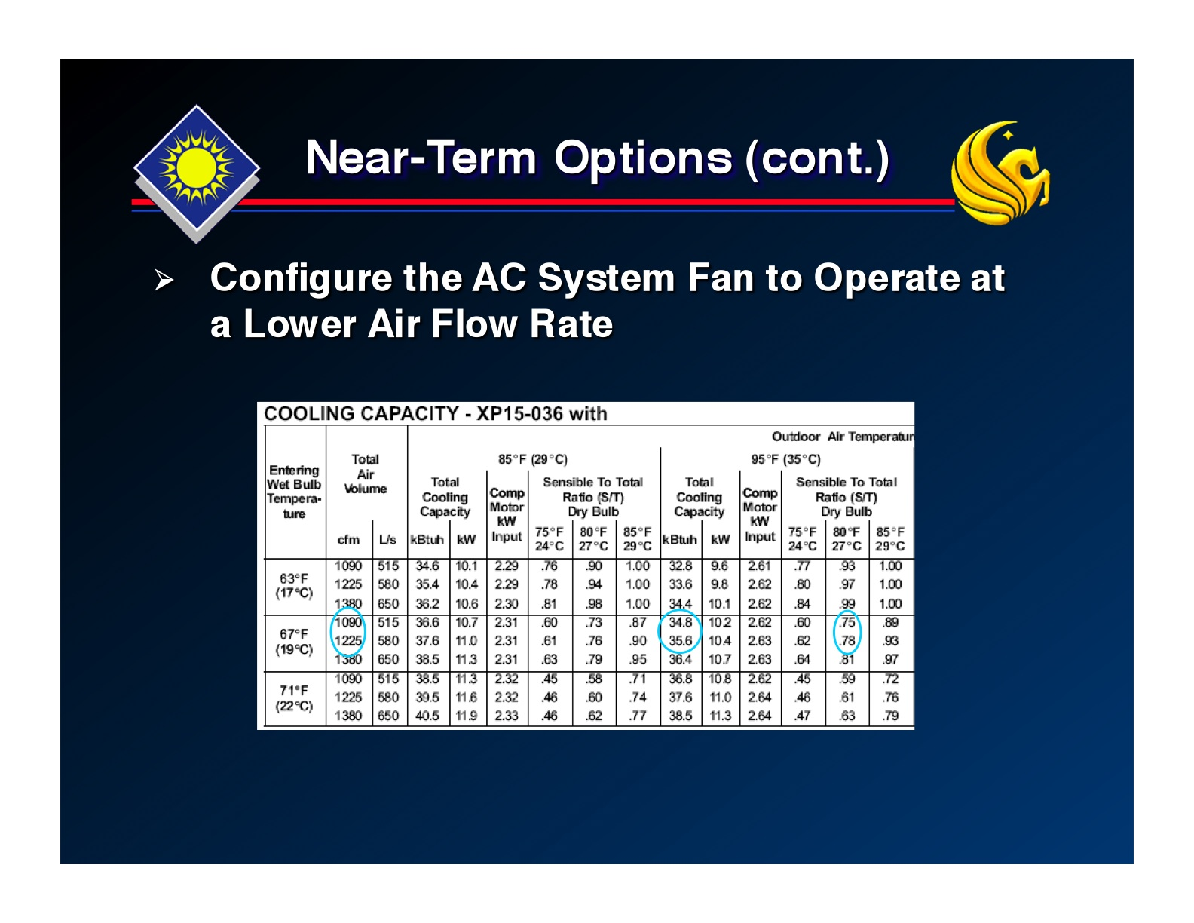
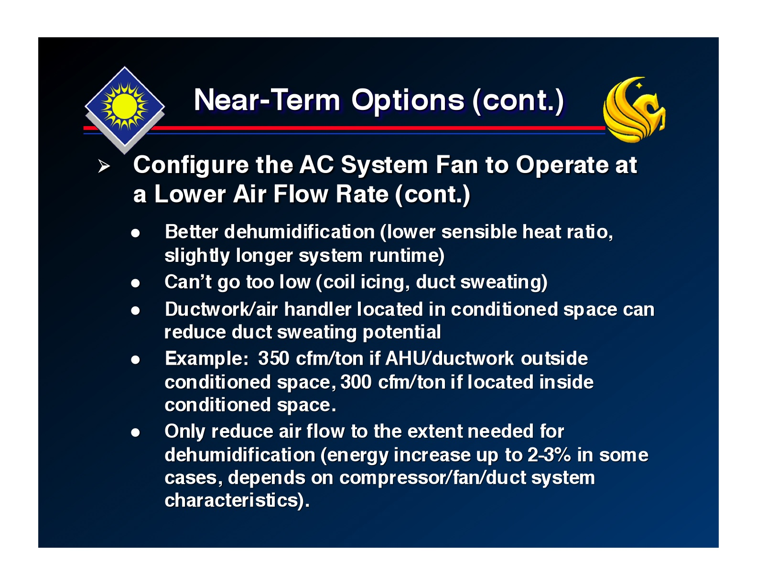
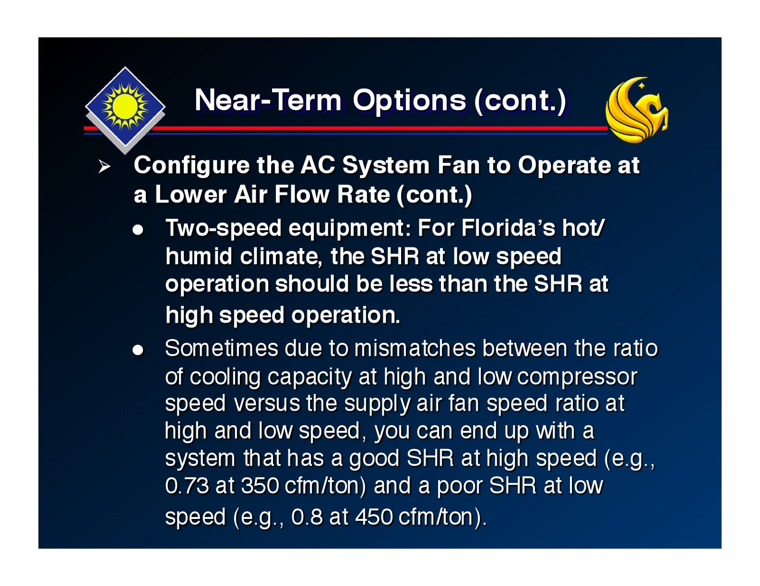
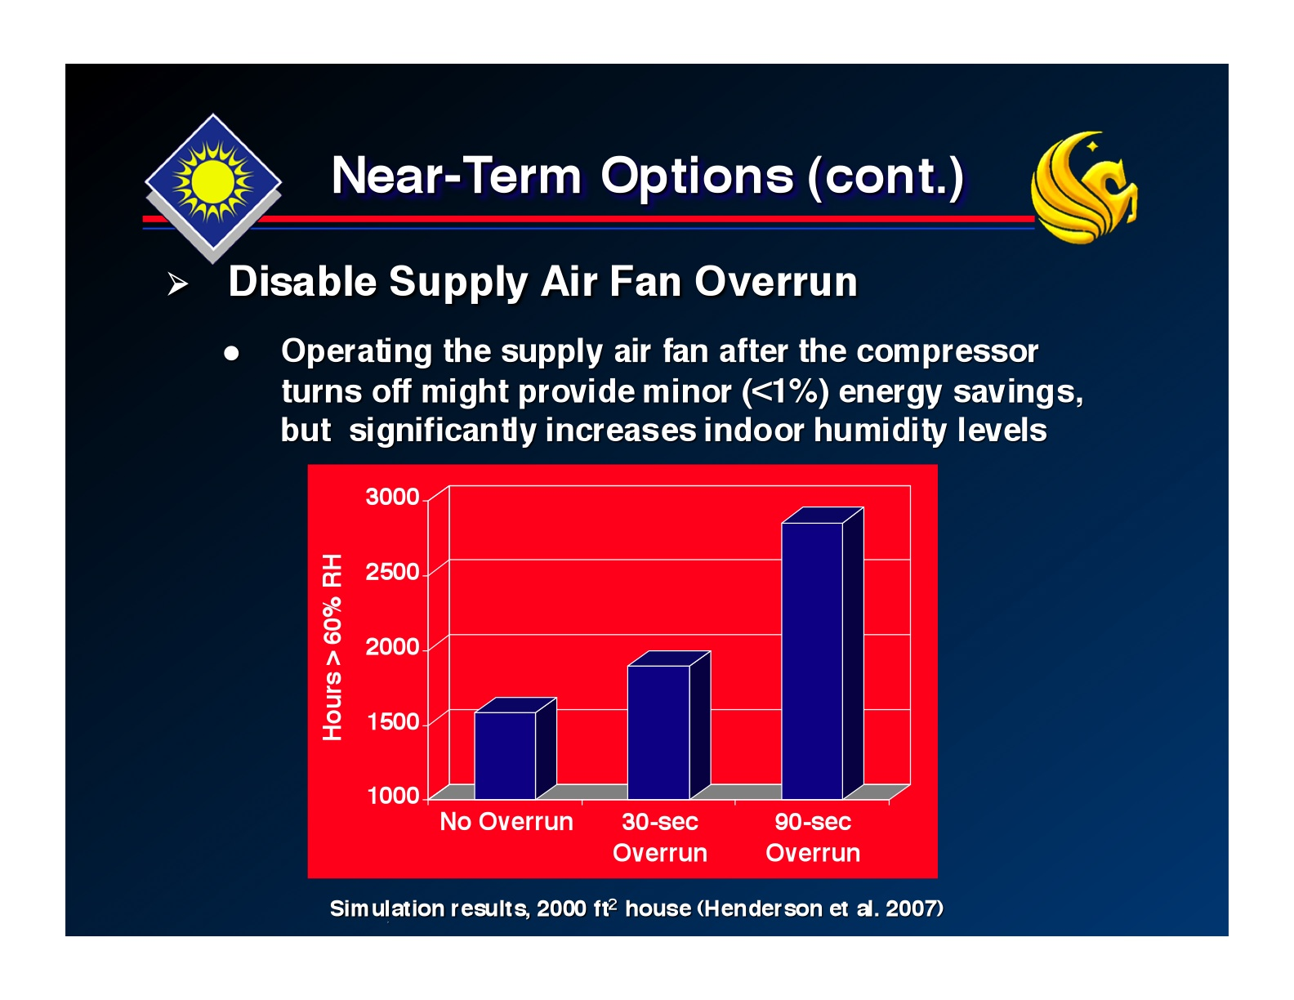
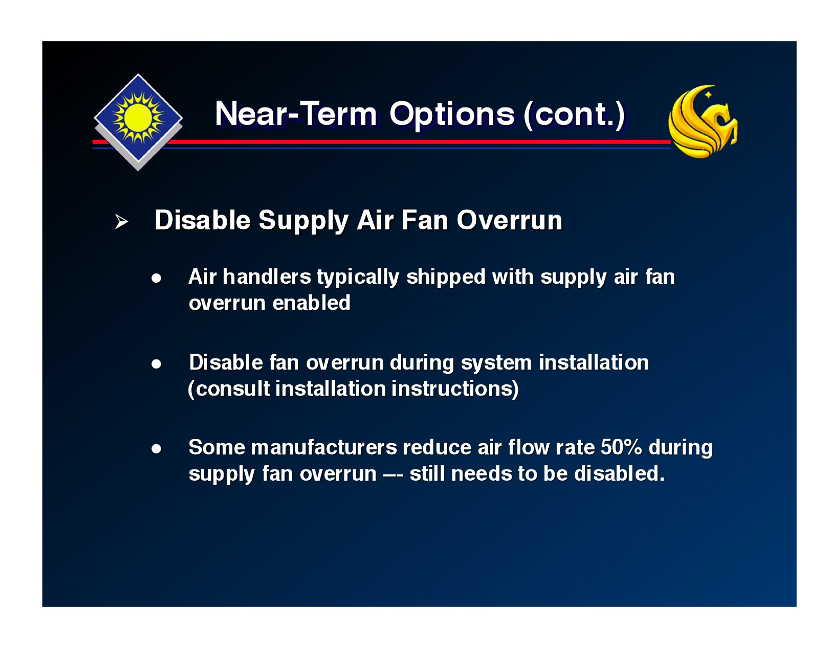
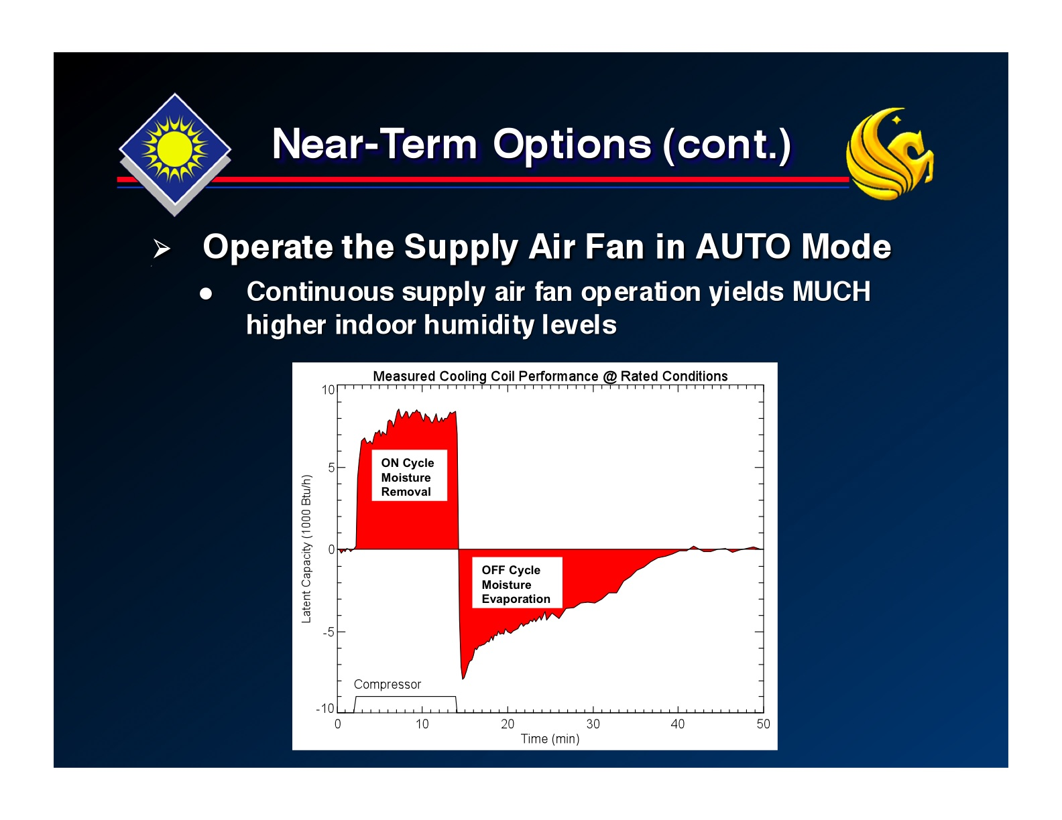
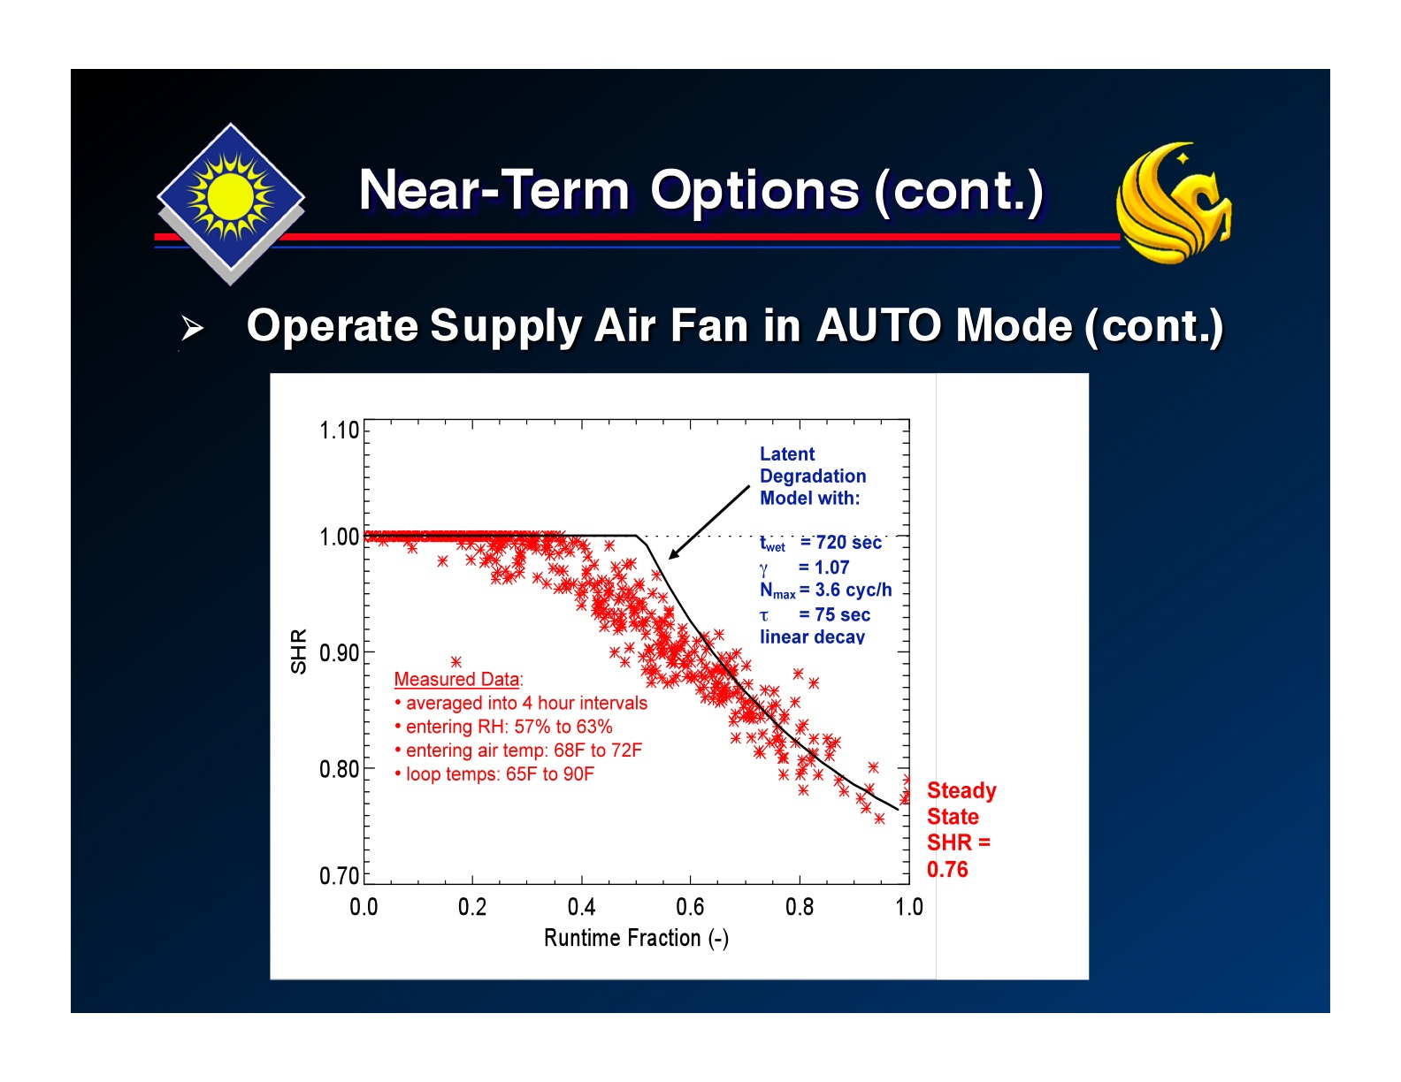
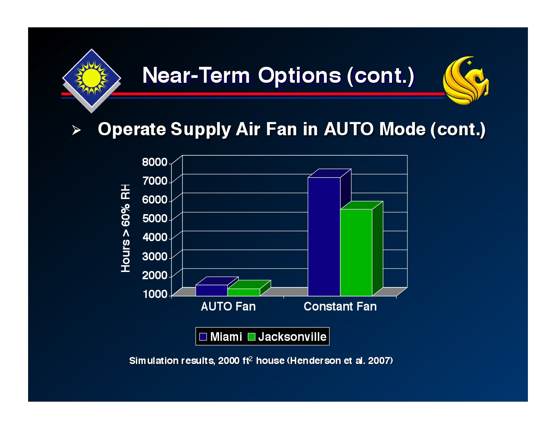
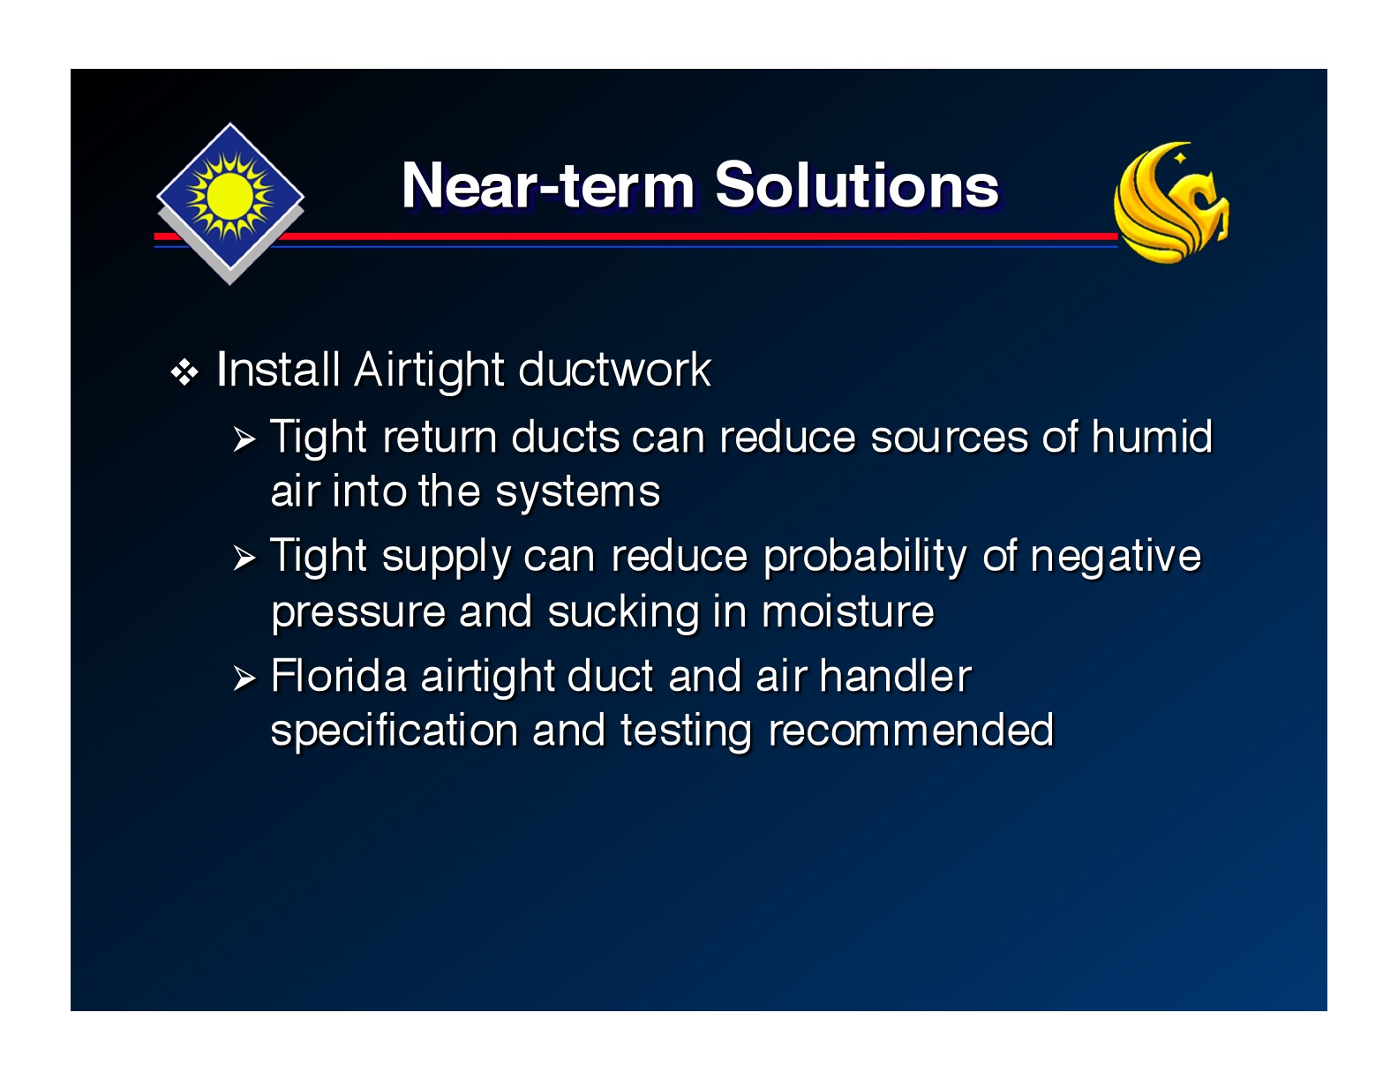
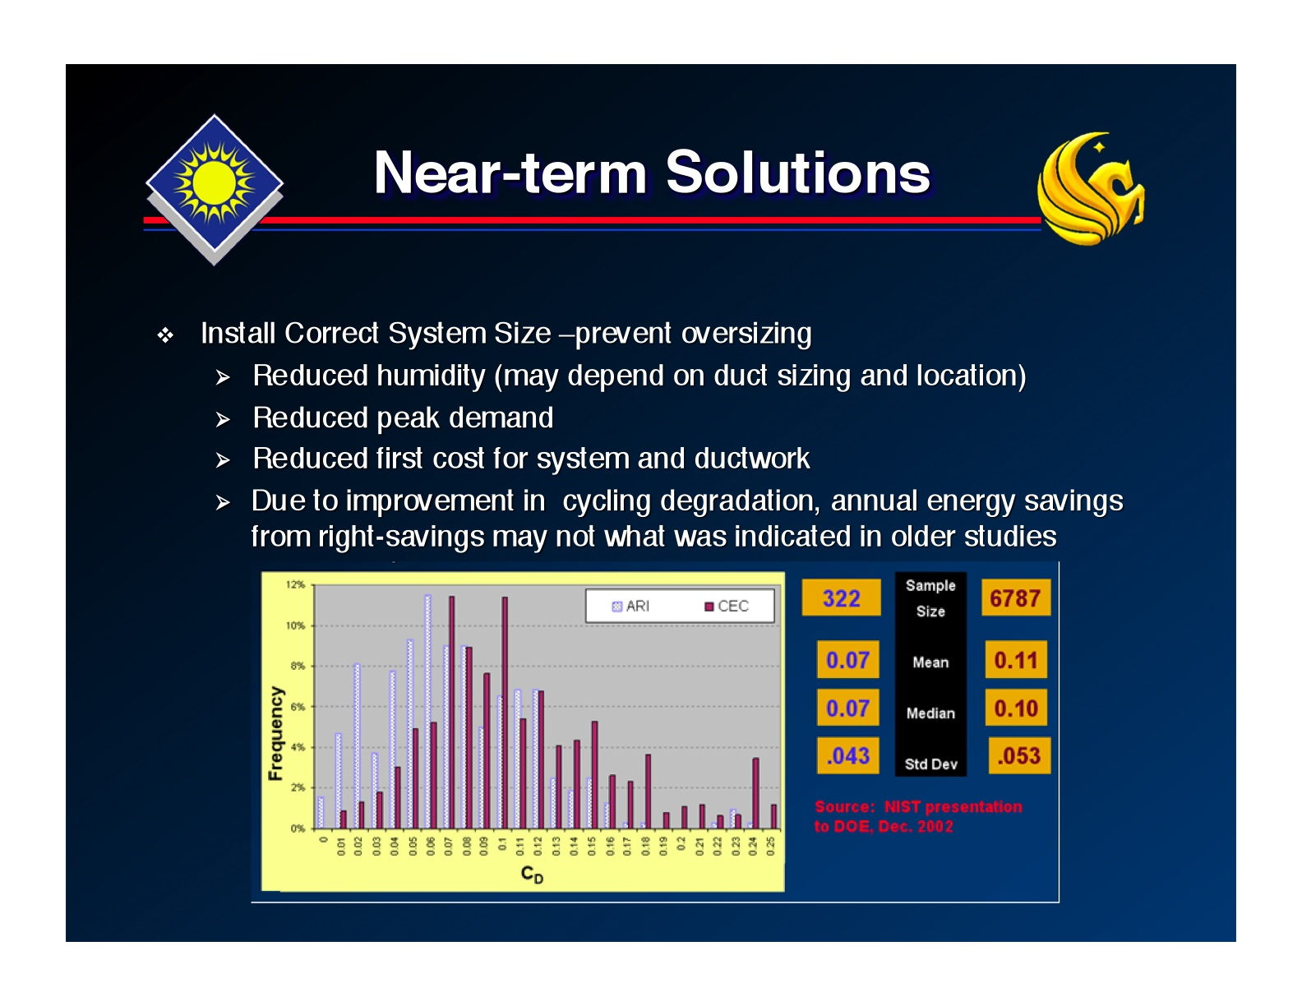
ATTACHMENT 4
DEHUMIDIFICATION PERFORMANCE

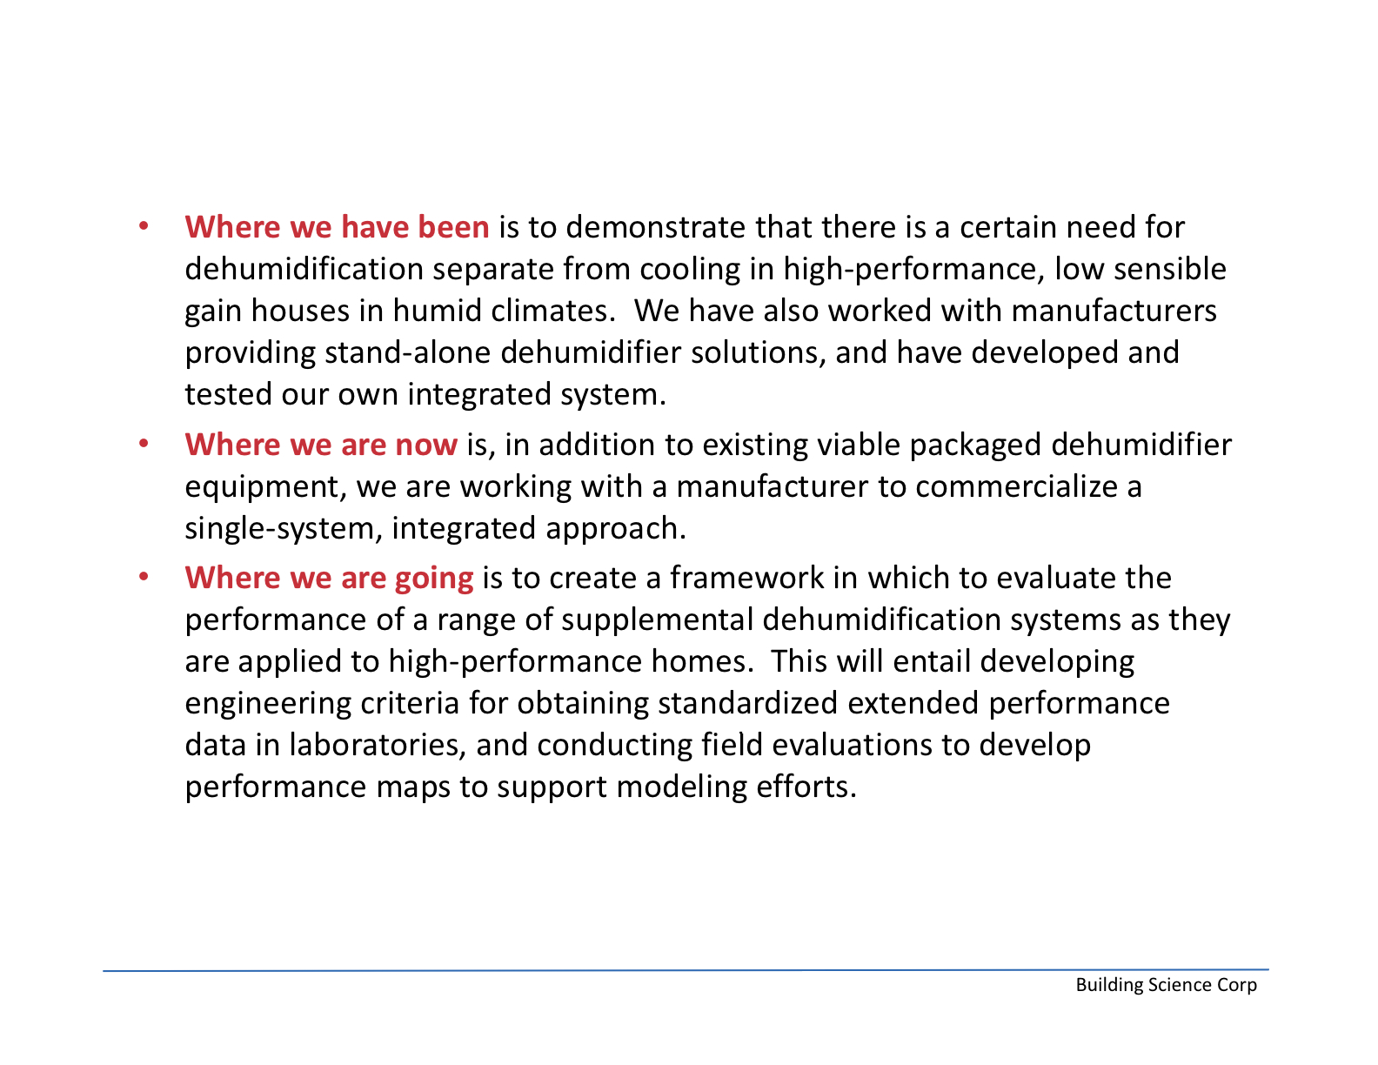
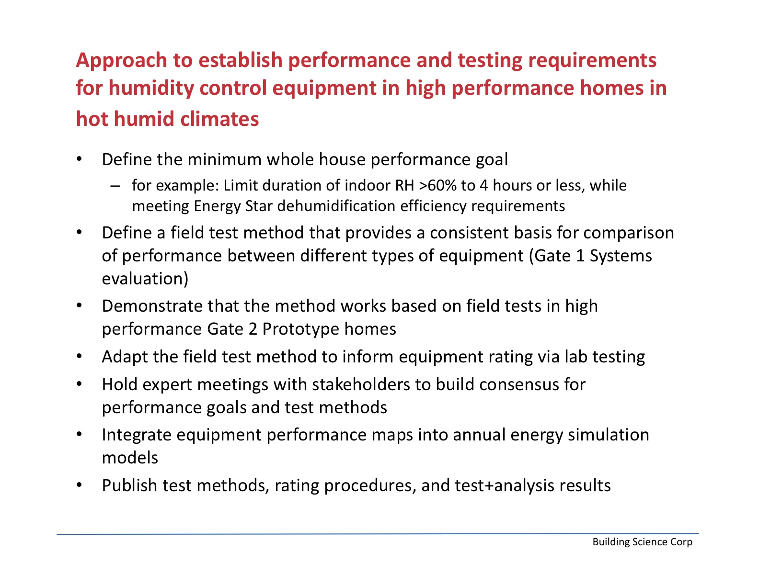
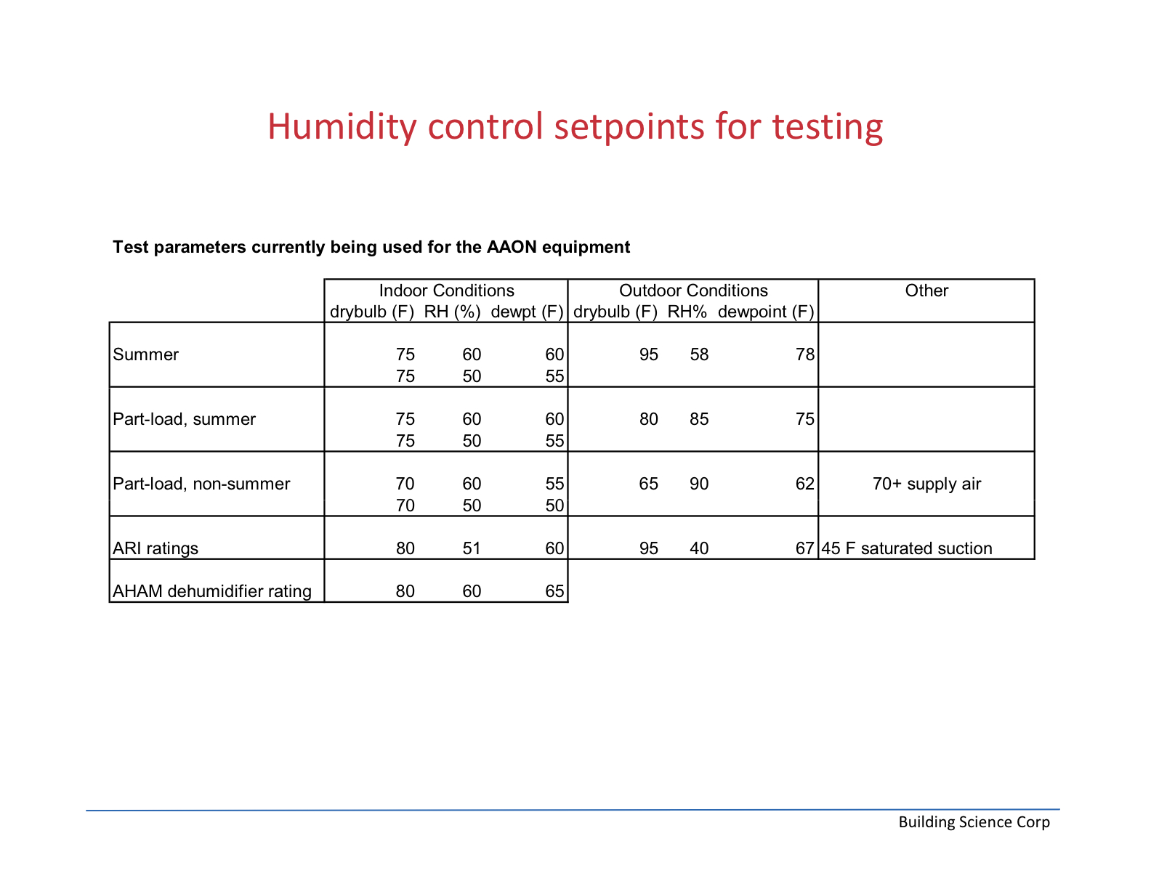
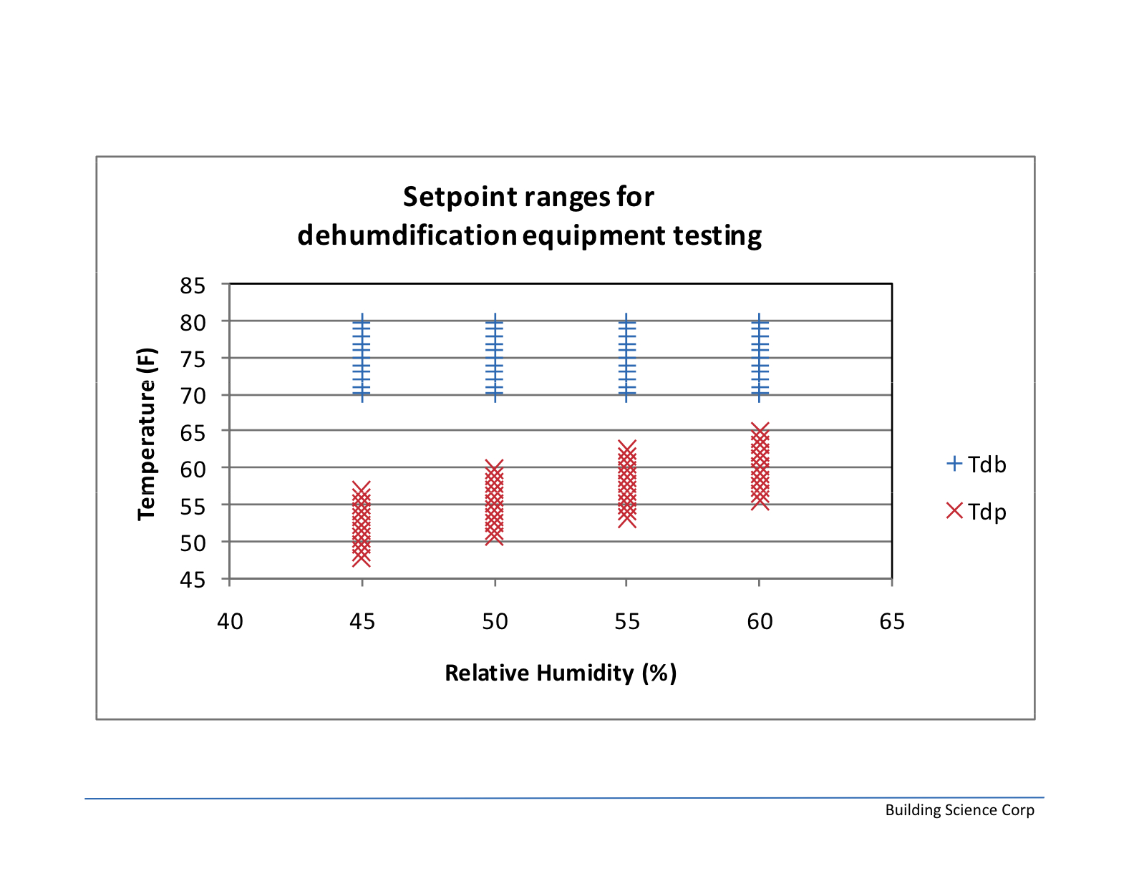
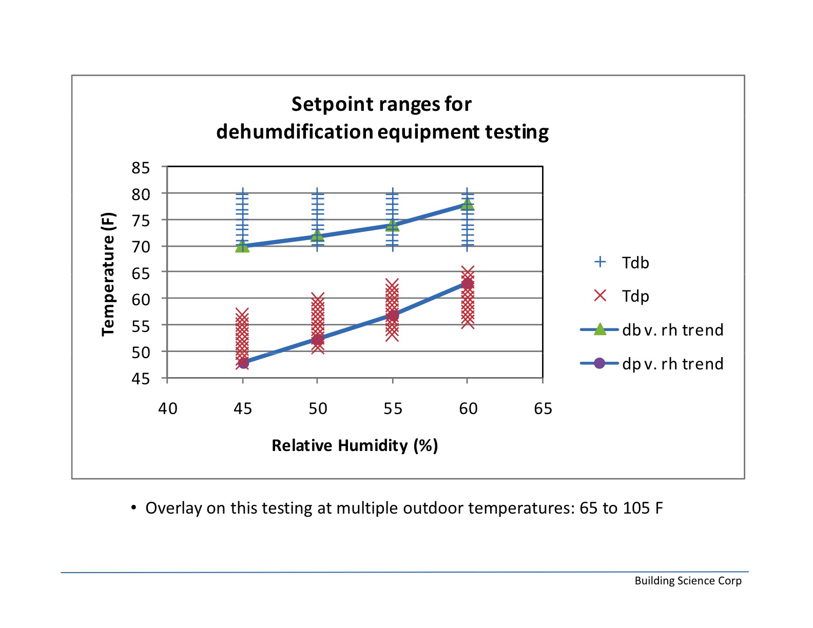
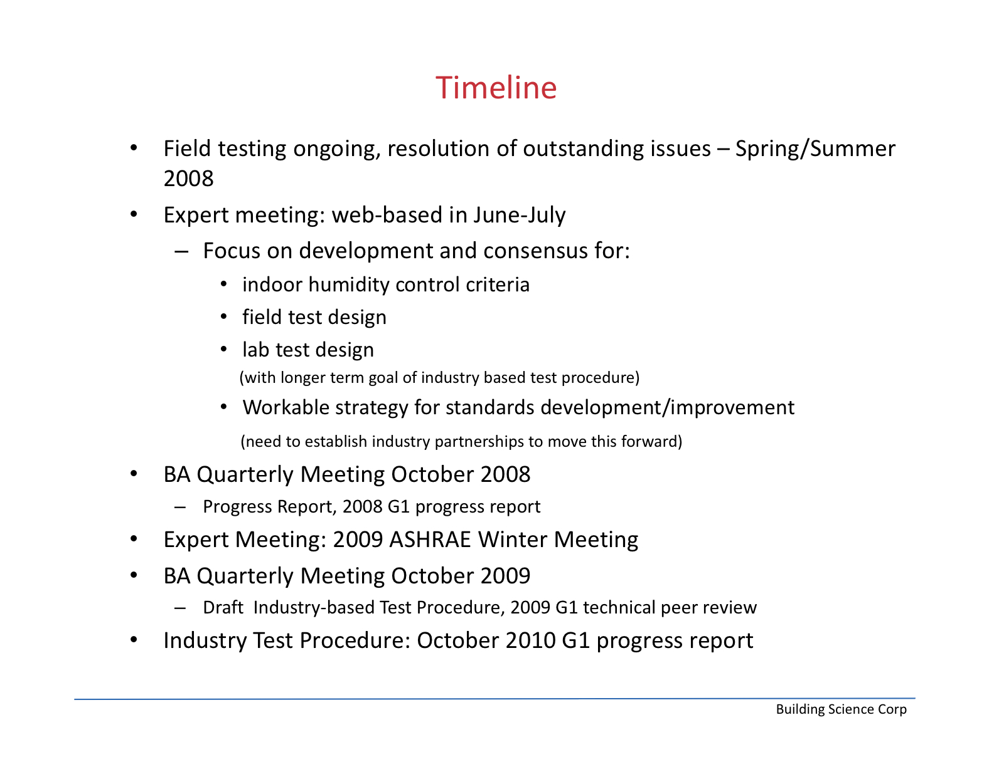
ATTACHMENT 5

HUMIDITY AND MOISTURE CONTROL PRIORITIZATION EXERCISE
IMPORTANCE FOR PROVIDING MOISTURE CONTROL
RANKING SCALE
5 Highest Level of Importance—Urgent
4 High Importance
3 Moderate Level of Importance
2 Low Level of Importance
1 Lowest Possible Importance —Group Should not Pursue

TOPIC | RANK | 5 | 4 | 3 | 2 | 1 | RAW  SCORE
Airtight air distribution system | 1 | 7 | 1 | 0 | 0 | 0 | 39
Use of ECM’s/TXV | 2 | 6 | 2 | 0 | 0 | 0 | 38
Location of ductwork-encourage conditioned space | 3 | 4 | 4 | 0 | 0 | 0 | 36
Outside air ventilation | 4 | 4 | 3 | 1 | 0 | 0 | 35
Humidity control devices | 4 | 4 | 3 | 1 | 0 | 0 | 35
Envelope performance | 6 | 3 | 4 | 1 | 0 | 0 | 34
Fan overrun/settings | 7 | 4 | 3 | 0 | 0 | 1 | 33
Auxiliary dehumidification equipment in high performance buildings | 7 | 2 | 5 | 1 | 0 | 0 | 33
Startup commissioning of equipment | 9 | 3 | 1 | 3 | 1 | 0 | 30
Source control | 10 | 2 | 1 | 5 | 0 | 0 | 29
Maintenance of equipment | 10 | 2 | 1 | 5 | 0 | 0 | 29
Code mandated design criteria | 10 | 2 | 1 | 5 | 0 | 0 | 29
Power consumption/testing at multiple points/dehumidification performance | 13 | 0 | 3 | 4 | 0 | 1 | 25

