Summary

The information and exhibits provided in the Petition #239 do not offer any evidence that would warrant overturning the building official’s interpretation. In fact, the applicable codes and standards are quite clear regarding the intent of the 10’ separation and the manner in which the distance should be measured.

The horizontal distance shall be measured from a point determined by projecting the outside edge of the overhanging structure vertically downward to grade or other level upon which the container is installed. ⁽¹⁾

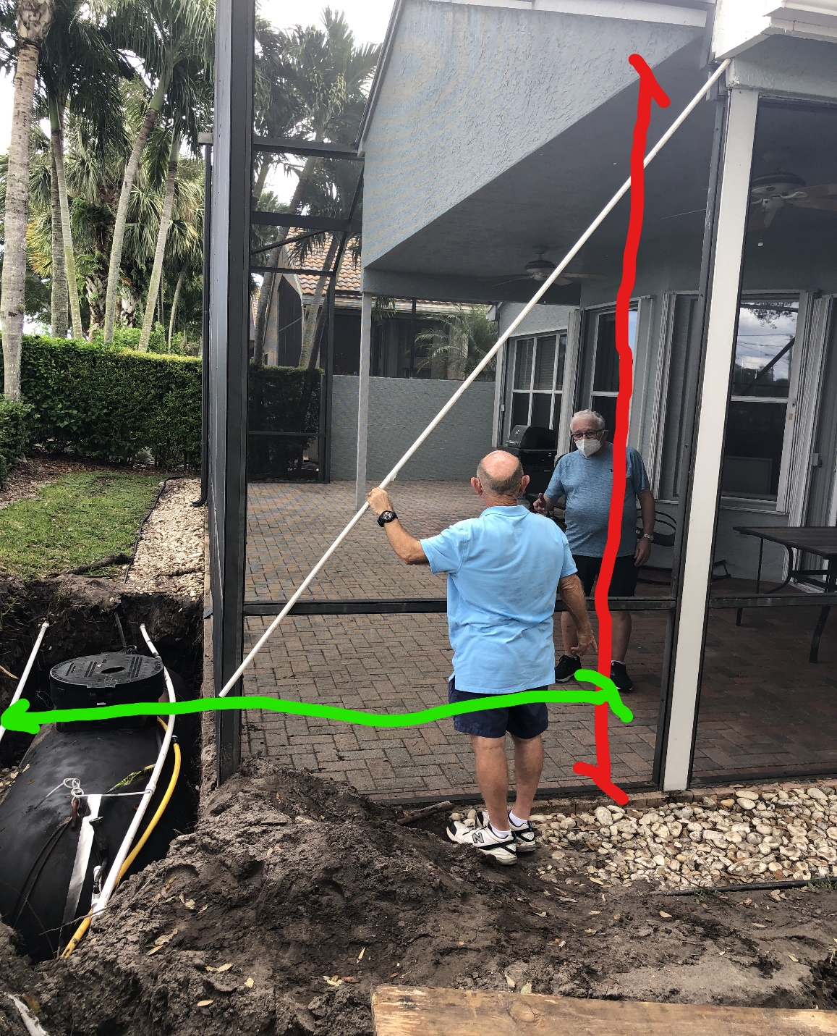

It is clear from this picture that the 10’ minimum required separation distance has been encroached. The white ten foot PVC conduit should be laid flat on the ground to obtain the distance from the vertical projection line.
Detailed Response

Line by Line response to each file and exhibit in the Petition (#239):
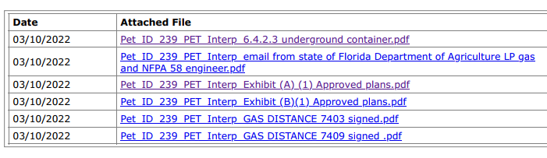

I. 6.4.2.3 Underground Container – 2020 LP Gas Handbook excerpts

The information submitted from the Handbook (below) supports the intent and importance of maintaining the minimum 10’ separation distance.

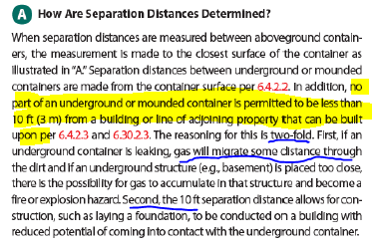
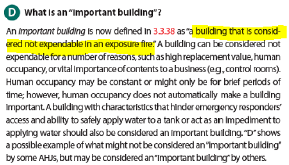

II. Interpretation Email NFPA/FDACS - Technical Question Response/Interpretation

The answer/response/interpretations provided from NFPA and FDACS clarify the intent and importance of maintaining the 10’ separation distance, but do not provide evidence that would overturn the BO interpretation of how to make the measurement.

NFPA Technical Question Response (NFPA 58 LP-Gas Code 2020 Edition)
The intention of requiring 10 ft of separation from a building is twofold.
First to prevent gas from migrating into the building in the event of a gas leak, and secondly, enable the tank to be recovered without damage to the building (or in the event of new construction, the construction damaging the new building).
Simply provides explanation for the intent of the 10’ separation distance.

What is considered to be a building or part of a building is up to the local building code. In the context of the code if gas cannot migrate into the part of the building being measured then that should not be considered part of the building.
The Code provides several definitions to base this determination on:

AREA, BUILDING. The area included within surrounding exterior walls exclusive of vent shafts and courts. Areas of the building not provided with surrounding walls shall be included in the building area if such areas are included within the horizontal projection of the roof or floor above.
FIRE AREA. The aggregate floor area enclosed and bounded by fire walls, fire barriers, exterior walls or horizontal assemblies of a building. Areas of the building not provided with surrounding walls shall be included in the fire area if such areas are included within the horizontal projection of the roof or floor next above.
FIRE SEPARATION DISTANCE. The distance measured from the building face to one of the following:
1. The closest interior lot line.
2. To the centerline of a street, an alley or public way.
3. To an imaginary line between two buildings on the lot.
The distance shall be measured at right angles from the face of the wall.

FDACS Re: NFPA Technical Question Response

Good morning Mr. Cramer, thanks for sharing NFPA answer with me. It shows from NPFA 58 this installation has no problem meeting distance to building requirements.
We don’t see how the NFPA response supports this statement.

I hope local building officials take this in consideration but it really is up them since they are the local Authority Having Jurisdiction; we don't know what local ordinances may direct their decision if any.
The intent, purpose, and scope of all applicable codes and standards have been considered.

III. Exhibit (A)(1) – M-2021-020026-0001 (7409 Cortes Lake Dr)

The Original House plans show the existence of a monolithic thickened edge and primary roof structure with drop fascia that could easily be enclosed.

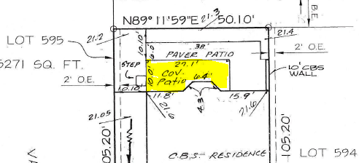

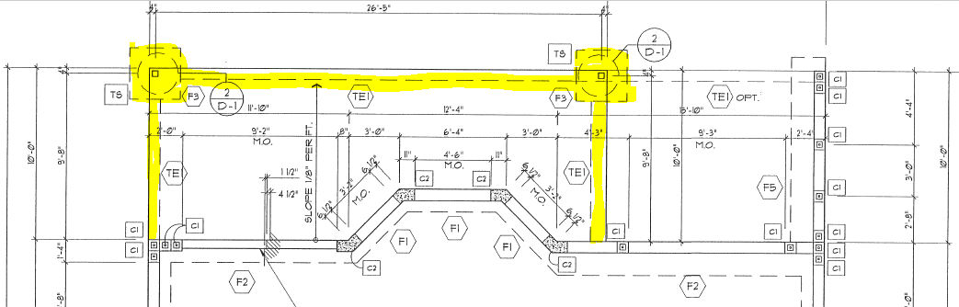
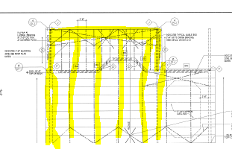
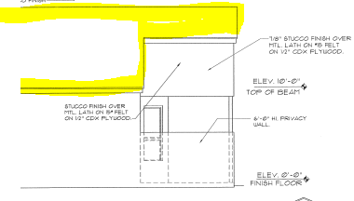
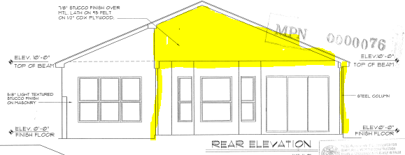
IV. Exhibit (B)(1) – M-2020-018252-0001 (9907 Chantilly Point Ln)

The Original House plans were not available for this home, however, it is a similar GL Homes design that exhibits the same characteristics as 7409/7403 Cortes Lake Dr.

The issued Plan was identified as “Reviewed for Compliance”, and it is unfortunate the Inspector did not catch the encroachment; however, it is still the Contractor License holder’s professional responsibility to provide a code-compliant installation.

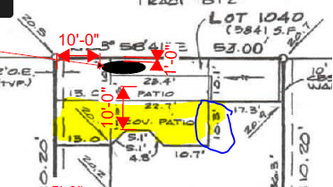

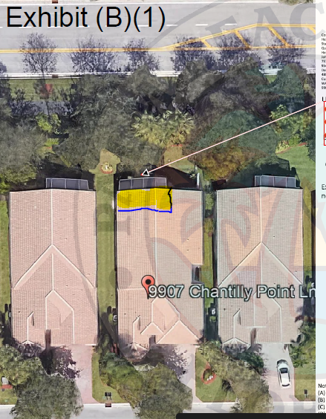
V. Engineer Certification Letters

After researching the distance from underground tank to important building, I found the reason for the code is to prevent gas from entering an enclosed important building thru the soil between the tank and the important building.
Correct
A structure that is 50% open to outdoors is considered ventilated and does not constitute an important building.
Previous versions of NFPA 58 along with Building Code definitions for “Building Area”,“Fire Area” and “Fire Separation Distance”, make it clear the intent is to measure from the face of the primary roof projection over an area that could be enclosed in the future.
FLORIDA BUILDING CODE
AREA, BUILDING. The area included within surrounding exterior walls exclusive of vent shafts and courts. Areas of the building not provided with surrounding walls shall be included in the building area if such areas are included within the horizontal projection of the roof or floor above.
FIRE AREA. The aggregate floor area enclosed and bounded by fire walls, fire barriers, exterior walls or horizontal assemblies of a building. Areas of the building not provided with surrounding walls shall be included in the fire area if such areas are included within the horizontal projection of the roof or floor next above.
FIRE SEPARATION DISTANCE. The distance measured from the building face to one of the following:
1. The closest interior lot line.
2. To the centerline of a street, an alley or public way.
3. To an imaginary line between two buildings on the lot.
The distance shall be measured at right angles from the face of the wall.
INTERNATIONAL FIRE CODE
AREA, BUILDING. The area included within surrounding exterior walls exclusive of vent shafts and courts. Areas of the building not provided with surrounding walls shall be included in the building area if such areas are included within the horizontal projection of the roof or floor above.
Table 6104.3 Note b
The tank has to be 10’ from the enclosed important building, and the liquid gas escaping from a tank, in NFPA-58 has to be 10’ away from the wall that has to touch the ground where liquid gas can travel in the ground and get inside the important building through cracks and other openings.
Correct. The intent of the code is to provide a safe distance to mitigate hazards and provide for emergency response.

Fire Safety Analysis Manual For LP-Gas Storage Facilities Based on the 2014 Edition of NFPA 58 Liquefied Petroleum Gas Code
6.3 Separation Distances - The separation distance provisions in NFPA 58 are minimum requirements and are intended to buy time in an emergency and to implement appropriate response.

FLORIDA FIRE PREVENTION CODE
1.2* Purpose. The purpose of this Code is to prescribe minimum requirements necessary to establish a reasonable level of fire and life safety and property protection from the hazards created by fire, explosion, and dangerous conditions.
The gas that escapes in the air is not considered for the distance clearances required.
Liquid Petroleum Gas is heavier than air and will spread out low before dissipating in the air.

Therefore if there is an overhang and column less than 10’ from the tank, NFPA-58 allows the tank to be less than 10’ away, because the gas or liquid gas will not enter the important building thru the column or the overhang and will dissipate in the air and will not become a fire or explosion hazard.

NFPA 58 expressly states “No part of an underground or mounded ASME container shall be less than 10 ft (3 m) from a building or line of adjoining property that can be built upon”
This requirement is restated in many codes including the FFPC, IFC, and NFPA 58 LP Gas Handbook

CODE HISTORY – prior to the NFPA 58 2014 Edition and FFPC 2017 Edition, there was specific language specifying how the distance to the building should be measured:

NFPA 58 (2011) Section 6.3.11(1) - The horizontal distance shall be measured from a point determined by projecting the outside edge of the overhanging structure vertically downward to grade or other level upon which the container is installed.

FFPC (2014) Section 69.3.3.11 The horizontal distance between the portion of a building that overhangs out of the building wall and an ASME container of 125 gal (0.5 m3) or more water capacity shall comply with the following:
(1) The horizontal distance shall be measured from a point determined by projecting the outside edge of the overhanging structure vertically downward to grade or other level upon which the container is installed.

The 2021 International Fire Code Table 6104.3 Note b - still includes this language.

(1) NFPA 58 (2014) Section 6.3.11(1); FFPC (2014) Section 69.3.3.11(1): IFC (2021) Table 6104.3(note b)

