**JDB Code Services, Inc.**

**Date: October 27, 2023**

**To: James Schock, P.E, Chairman, Florida Building Commission**

**From:** **Joe Belcher,FHBA Code Consultant**

**IN RE: Change to Wind-Borne Debris Definition Florida Building Code 8th Edition (2023)**

While we are not sure the requested change by FHBA strictly meets the criteria for a Glitch Change,FHBA believes the Florida Building Commission has the authority to make this change due to the unintended consequences and the deleterious effect on the home buying public. FHBA strongly believes the change generates severe unintended consequences by significantly expanding the wind-borne debris region in Florida with no justification or discussion of the far reaching impact or cost. There was no discussion at the Structural TAC or Commission meetings regardingf this change's extensive and costly impact.

The graphic below depicts the magnitude of the change on a single lake with 5,000 feet of fetch.

The state of Florida has many such lakes. The FEMA MAT Reports for Hurricanes Katrina, Charley, Irma and Michael were reviewed, and there is no reporting of wind-borne debris damage due to the failure of glazed openings caused by wind-borne debris a mile from the shoreline of an inland lake of any size.

The Florida modification (Mod S9473) and the I-Code change (G12-19) indicate the change is a clarification to eliminate confusion.The cost impact statements for both say it will not increase or decrease the construction cost. (See Code Change G12-19 Part II at the end of this document.)

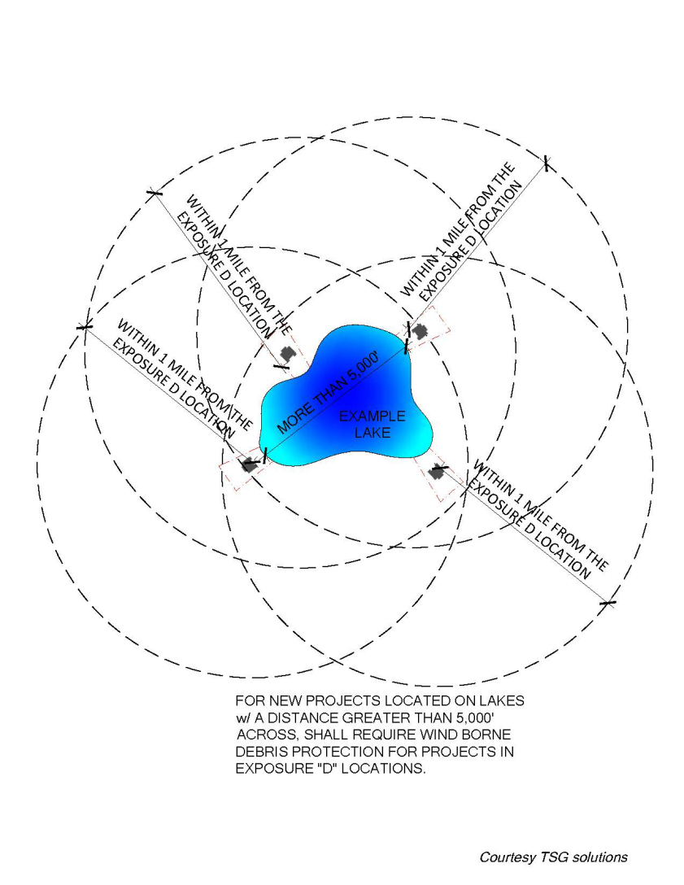

A builder in Lake County provided a cost estimate to upgrade to impact-resistant windows and sliding glass doors in a house he is currently designing. The upgrades almost doubled the window and door costs from $12,361 to $24,874, an increase of $12,513.00,.The NAHB reports a **$1,000 increase in the price of of a new home will further price 140,436 U.S. household s out of the marke**t. The builder's estimate is not an isolated instance in Lake County. Following is a list of lakes in the Central Florida region, including their fetch in feet, that will be affected by this change**:**

**Lake County**

* **Lake Apopka, one side is Lake County; the other is Orange County, 39,311 feet**
* **John's Lake, 8,530 feet**
* **Clermont Chain of Lakes (largest listed below)**
* **Lake Louisa 14,488 feet**
* **Lake Minnehaha 17,057 feet**
* **Lake Minneola 11,482 feet**
* **Lake Harris Chain of Lakes (largest listed below)**
* **Big Lake Harris 27,814 feet**
* **Little Lake Harris 28,497 feet**
* **Lake Eustis 25,387 feet**
* **Lake Dora 28,592 feet**

**Lake Griffin 2,316 feet**

* **St. Johns River (Astor area)**
* **Sumter County**
* **Lake Panasoffkee 42,637 feet**
* **Marion County**
* **Lake Weir     18,648 feet**
* **Volusia**
* **Lake George 62,247 feet**
* **Polk County**
* **Arbuckle**
* **Lake Alfred 7309 feet**
* **Lake Ariana 56,492 feet**
* **Seminole County**
* **Lake Monroe (and Volusia County)**
* **Lake Jesup/Lake Harney 14,658 feet**
* **Orange County**
* **Lake Conway 5944 feet**
* **Butler Chain of Lakes**
* **Lake Butler 7,769 feet**
* **Lake Down7893 feet**
* **Lake Tibet 10,790 feet**
* **Lake Louisa 14,488 feet**
* **Osceola County**
* **Lake Kissimmee 61,062 feet**
* **Lake Tohopekaliga 43,270 feet**

“NAHB recently released its 2023 priced out [estimates](https://www.nahb.org/News-and-Economics/Housing-Economics/Housings-Economic-Impact/Households-Priced-Out-by-Higher-House-Prices-and-Interest-Rates), showing how higher prices and interest rates affect housing affordability. The new estimates show that 96.5 million households are already not able to afford a median priced new home in 2023 due to the fact that their incomes are insufficient to qualify for the required mortgage under standard underwriting criteria. If the median new home price goes up by $1,000, an additional 140,436 households would be priced out of the market. These 140,436 households would qualify for the mortgage before the price increase, but not afterward.”(Source: https://eyeonhousing.org/2023/03/nahb-2023-priced-out-estimates-state-and-local-estimates/

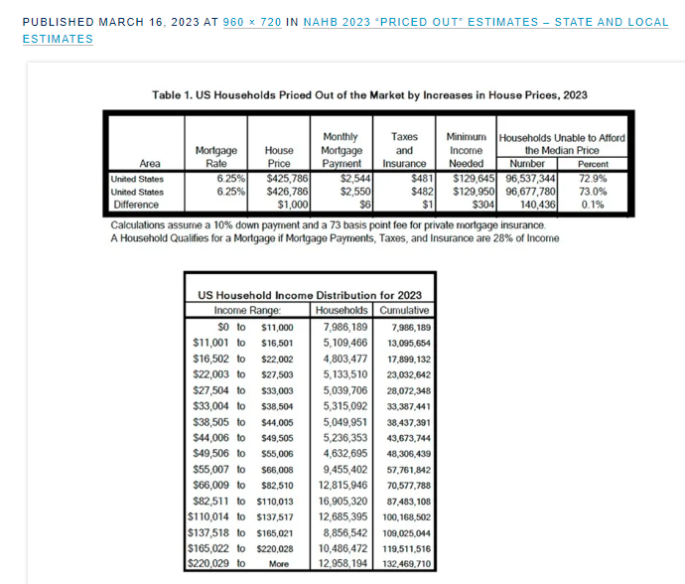  
[“](https://eyeonhousing.org/2023/03/nahb-2023-priced-out-estimates-state-and-local-estimates/slide1-243/)The underwriting criterion used to determine affordability is that the sum of mortgage payments, property taxes, homeowners and private mortgage insurance premiums (PITI) during the first year is no more than 28 percent of the household’s income. Key assumptions include a 10% down payment, a 30-year fixed rate mortgage at an interest rate of 3.5%, and an annual premium starting at 73 basis points for private mortgage insurance”.Recent reports indicate that mortgage rates are increasing and will soon be at 8 percent.

As usual, NAHB’s latest update includes priced out estimates for all states and metropolitan areas. The priced out numbers vary with both the sizes of the local population and the affordability of its new homes. **Among all the states, Florida registered the largest number of households priced out of the market by a $1,000 increase in the median-priced home in the state (9,573)**, followed by Texas (9,151), and California (7,243), largely because these three states are the top three populous states”.S[*ource:* https://eyeonhousing.org/2023/03/nahb-2023-priced-out-estimates-state-and-local-estimates/slide1-243/s://eyeonhousing.org/2023/03/nahb-2023-priced-out-estimates-state-and-local-estimates/slide1-243/](https://eyeonhousing.org/2023/03/nahb-2023-priced-out-estimates-state-and-local-estimates/slide1-243/)

FHBA is aware that the code provides alternatives to impact-resistant glazing for opening protection that may be cheaper than impact-resistant windows. However, the alternates present other insurmountable issues, such as storing wood structural panels or removable manufactured panels and installation hardware. The hassle of installing the removable panels and removing them after the storm could delay citizens starting the installation, which could result in injuries to citizens installing them in inclement weather or on elevated openings. Such systems are also not suitable for elderly citizens.

Accordingly, the FHBA requests the following changes in the FBC-R and the FBC-B 8th Edition (2023):

**Delete as follows**

**From FBC-B-Section 202**

**~~WINDBORNE DEBRIS REGION.~~** ~~Areas within~~ *~~hurricane-prone regions~~* ~~located in accordance with one of the following:~~

# ~~Within 1 mile (1.61 km) of the coastal mean high-water line where an Exposure D condition exists upwind at the ultimate design wind speed, V~~ *~~ult~~* ~~, is 130 mph (58 m/s) or greater.~~

# ~~In areas where the ultimate design wind speed, V~~ *~~ult~~* ~~, is 140 mph (63.6 m/s) or greater; or Hawaii.~~

**Add as follows to FBC-Bsection 202**

**202[WIND-BORNE DEBRIS REGION.** Areas within hurricane-

prone regions located:

1. Within 1 mile (1.61 km) of the coastal mean high water

line where the ultimate design wind speed, *Vult*, is 130

mph (58 m/s) or greater; or

2. In areas where the ultimate design wind speed, *Vult*, is

140 mph (63.6 m/s) or greater.

For *Risk Category* II buildings and other structures and

*Risk Category* III buildings and other structures, except

health care facilities, the wind-borne debris region shall be

based on Figure 1609.3(1). For *Risk Category* III health care

facilities, the wind-borne debris region shall be based on Figure

1609.3(2). For Risk Category IV buildings and other

structures, the wind-borne debris region shall be based on

Figure 1609.3(3).

Delete as follows from the FBC-Rsection R202

**Delete as follows**

**From FBC-B-Section 202**

**~~WINDBORNE DEBRIS REGION.~~** ~~Areas within~~ *~~hurricane-prone regions~~* ~~located in accordance with one of the following:~~

# ~~Within 1 mile (1.61 km) of the coastal mean high-water line where an Exposure D condition exists upwind at the ultimate design wind speed, V~~ *~~ult~~* ~~, is 130 mph (58 m/s) or greater.~~

# ~~In areas where the ultimate design wind speed, V~~ *~~ult~~* ~~, is 140 mph (63.6 m/s) or greater; or Hawaii.~~

Add as follows FBC-R

R202**WINDBORNE DEBRIS REGION.** Areas within *hurricane-*

*prone regions* located in accordance with one of the

following:

1. Within 1 mile (1.61 km) of the coastal mean high water

line where the ultimate design wind speed, Vult, is 130

mph (58 m/s) or greater.

2. In areas where the ultimate design wind speed, Vult, is

140 mph (63.6 m/s) or greater; or Hawaii.

**Fiscal Impact Statement [Provide documentation of the costs and benefits of the proposed modifications to the code for each of the following entities. Cost data should be accompanied by a list of assumptions and supporting documentation. Explain expected benefits.]:**

**A.          Impact to local entity relative to enforcement of code:** No impact the current definition will be retained.

**B.          Impact to building and property owners relative to cost of compliance with code:** The change will decrease the cost for property owners as the cost of providing impact resistant windows and glass doors is at least double the cost standard windows and glass doors.

**C.          Impact to industry relative to cost of compliance with code:**The change will reduce the constructioncost to the industry, which will be passed on to the homebuyer and will therefore avoid decreasing those in the market able to purchase a home.

**Rationale [Provide an explanation of why you would like this Proposed Modification to the Florida Building Code.]: There is a Florida specific need for the requested changes due to the great number of large inland lakes in the state. The change will avoid adopting a costly provision for which there is no justification and no proven need. The changes will eliminate the decrease in the ability of a large number of members of the public to qualify for a home mortgage.**

**Please explain how the proposed modification meets the following requirements:**

**1.          Has a reasonable and substantial connection with the health, safety, and welfare of the general public:**The changes have a reasonable and substantial connection with the health safety and welfare of the general public by decreasing the cost of construction and eliminating a provision for which there is no justification and no proven need.

**2.          Strengthens or improves the code, and provides equivalent or better products, methods, or systems of construction:**The changes Improve the code by decreasing the cost of construction and eliminating a provision for which there is no justification and no proven need, which will decrease the number of members of the public able to qualify for the purchase of a home.

**3.          Does not discriminate against materials, products, methods, or systems of construction of demonstrated capabilities:**The change does not discriminate against materials products method sources of the construction of demonstrated capabilities

**4. Does not degrade the effectiveness of the code:** The changes do not degrade the effectiveness of the code.

**Code Change No:G12-19 Part II**

**Original Proposal**

**Section(s): IRC: [RB]202**

**Proponent:** Don Scott, Representing National Council of Structural Engineers Association, representing National Council of Structural Engineers Association (dscott@pcs-structural.com)

**THIS IS A TWO PART PROPOSAL. PART I WILL BE HEARD BY THE IBC-STRUCTURAL COMMITTEE. PART II WILL BE HEARD BY THE IRC-BUILDING COMMITTEE. PLEASE CHECK THE RESPECTIVE HEARING AGENDAS.**

**2018 International Residential Code**

**[RB] WINDBORNE DEBRIS REGION.** Areas within *hurricane-prone regions* located in accordance with one of the following:

# Within 1 mile (1.61 km) of the ~~coastal~~ mean high-water line where an Exposure D condition exists upwind at the waterline and the ultimate design wind speed, V *ult* , is 130 mph (58 m/s) or greater.

# In areas where the ultimate design wind speed, V *ult* , is 140 mph (63.6 m/s) or greater; or Hawaii.

**Reason:** Significant confusion has arisen in hurricane-prone regions in trying to determine wind-borne debris regions because the term "coastal mean high waterline" in not a mapped or defined term. Due to this lack of definition, some jurisdictions have incorrectly interpreted areas within one mile of the mean high waterline along narrow inland tidal waterways to be in wind-borne debris regions. The primary intent behind paragraph No. 1, is that within one mile of the coast, hurricane wind speeds will be governed by the wind speed over the open water, i.e. an Exposure Category D rather than an inland Exposure Category C situation on which the basic wind speed and paragraph No. 2 are based. This CCP clarifies that the waterline has to be classified as an Exposure D in order for paragraph No. 1 to apply. It also deletes the word "coastal" since wind speed increases could occur at large inland waterways in hurricane-prone regions as well. Also, NOAA maintains a database of the "mean high waterline" values in the US, which can be used in conjunction with this definition.

**Cost Impact:** The code change proposal will not increase or decrease the cost of construction

This code change proposal is location dependent on its impact on construction costs, however by providing a definition of the wind-borne debris zone, it will eliminate confusion as to where to apply the wind-borne debris protection requirements.