Dear Florida Building Commission Staff:

Please find enclosed our Request for approval by the Florida Building Commission as a Compliance Software, IESVE.

We are submitting an update of our software for use in 2020 Performance Method, New Construction, Commercial. This update incudes changes to support 2022 Supplement to the 7th Edition Florida Building Code (FBC).

We are including the following submittals in support of our application:
- Cover sheet “Request for Approval” with certification that the software meets the requirements of the Florida Building Code, Energy Conservation 2020, 02_Approval_Request_Letter_FBC_Supplement.
- Instructions to install and activate the program including link to download and example project file, 03_Software_Download_ Intructions.
To summarize the changes in the software to meet the requirements of the supplement, the IESVE Florida Compliance report directs to the supplement table C403.2.3(1) as shown in the following image.
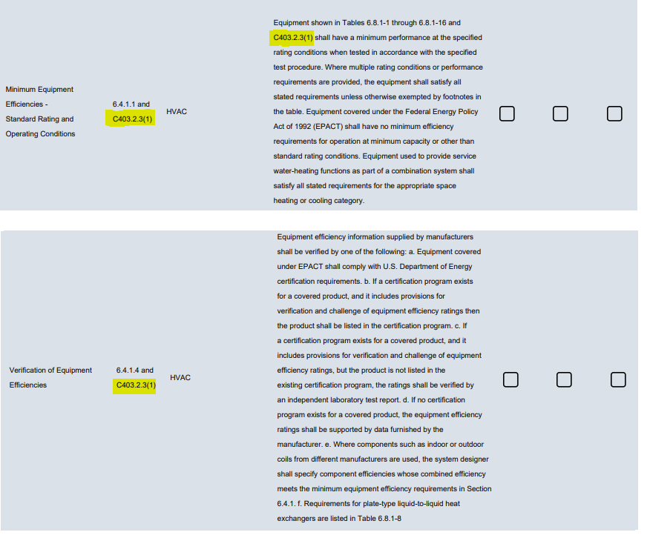

We look forward to continuing our participation with the Florida Building Commission to meet the testing requirements and any additional requirements moving forward. Please contact me at matthew.duffy@iesve.com or by calling or texting 415.420.9314 if you have any questions while reviewing our application submission.

Sincerely,
Matthew Duffy

 | Matthew Duffy (he/him/his)  VP IESVE Sales North America East | C: +1 415 420 9314  E: matthew.duffy@iesve.com  http://www.iesve.com

