Proposed Code Modifications Quick Reference Guide

Florida Department of Community Affairs – Codes and Standards
Definitions | Mod – short for proposed code Modification  The Code – The Florida Building Code  Staff – Department of Community Affairs , Codes and Standards Staff
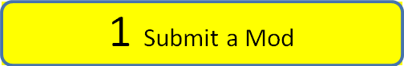 | This section describes the steps to create a new Proposed Code Modification.  To submit a Proposed Code Modification, navigate your browser to www.floridabuilding.org. You should see a page with 6 large multicolored buttons.  - To submit a Mod you will need to be logged in as a BCIS user. (See User Registration section for information on how to register) See Item 4 Below  Note: Before starting the proposed Code Modification application online it is recommended to have your mod “preassembled” in a word processing program.  Note: Proposed Code Modifications submitted after the deadline will go into an on hold status until a new cycle opens.
Page 1 – Code Criteria |  | The system automatically selects the latest Code Version.  * Required fields  - All required fields are marked in blue with asterisks  For the Related Modifications box, provide Sub Code and section(s) for other code modifications that you are proposing that are related to this mod. Add mod number if known.  - For further information see the “Needs Help” link for a .pdf describing the section  Note: Save in Progress saves your information if you feel you may timeout your session. It is a good rule of thumb to click this if you are going to be working on a page for a while. Clicking “Next” will also save the page in progress and advance to the next page of the mod.
Page 2 – Text and Rationale |  | This page is where the text for the mod is entered. Here there is a link that will take you to the required documents to be used as guidelines for your mod.  - Click on Required documents to be used as the basis for proposed code modification for 2010 FBC.  In the middle of the page is the ‘Text of Modification’ box. It does contain many word processor functions but it is recommended to formulate your mod in a word processor on your machine. Be sure to save your mod in your word processor to ensure you have a backup in case the BCIS produces an error. For further help click on the “Needs Help” file  Note: The pages of the application are on a timer. You may lose your material if you don’t save in progress often or work locally on a word processor.
Page 3 – Impact Statement |  | For the Impact Statement boxes, answer all questions regarding the impact of your code change proposal.  For further information see the “Needs Help” link for a .pdf describing the section  Note: You can also upload a Support File for this section.
Page 4 - Requirements |  | Answer all questions regarding the specific requirements of submitted mods.  For further information see the “Needs Help” link for a .pdf describing the section  Note: You can also upload a Support File for this section.
Page 5 - Summary |  | This is the final page just before submitting the mod. Ensure that everything is correct. If you see a section that needs work, just click on the ‘Edit’ link next to the section to return to the sect. You may have to step through a few pages to get back to the summary.  Once you feel it is complete it is a good rule of thumb to print this page.
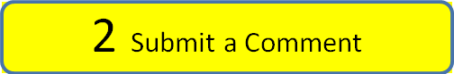 |  |  | You may wish to submit a comment on a proposed code mod. If the comment period is open you can submit a comment, either a general comment or an alternate language to the proposed code modification:  Note: You may receive periodic emails to inform you of the status of your mods so it is a good practice to look for these emails from DCA staff and the automated website emails.
General Comment |  | General comments are for any comment that doesn’t include alternate language. This section is limited to one Text box for users to either cut and paste into or type live.  There is also a Needs Help file here with information in case you get stuck.
Alternate Language Comment |  | If you find a mod that you feel would be improved if it had different language you can submit an alternate language mod. Once you click on “submit a Comment on a Code Modification” select the Alternate language radio button. You will be taken to a search screen. Search for the Mod you wish to comment on and scroll to the bottom and click on “Submit Comment”  Here add the text of the Modification as the text of the Comment
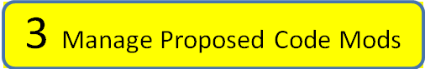 |  |  | Once you have submitted a Mod you will want to track its progress throughout the Code Change Cycle. The following steps will help you monitor your mod:  Note: You may receive periodic emails to inform you of the status of your mods so it is a good practice to look for these emails from DCA staff and the automated website emails.  Note: If you submit a mod outside of a cycle your mod may go into an “On-Hold” status. This is a temporary holding bin where there is little access to your mod once it is submitted. You can keep track of this on-hold mod by following the notices in your inbox.
Notices |  |  | Depending upon the mods you have submitted you will see various types of notices. The notices tab is split into two different sections. The top section visible is the “Action Required” This will give you information on mods that need the most immediate attention.  In the bottom pane, is the “Information Only” area. These are just informational and do not require your immediate involvement. These are good to follow just to keep track of where your mod is in the cycle and how many days it has been there.  Note: You can remove notices by checking them and clicking the remove button
Saved In Progress |  | These are your mods that you have saved in progress and have not completed.  - To access a Saved in Progress Mod Click the saved in progress tab and then click on a mod proposal number. Here you can continue through the mod to do a final “Submit”
Need More Information |  |  | This is a holding status that DCA staff can issue to a mod. These notifications come up under “Action required” notices. Until the changes are submitted the application will remain in this status.  Note : It is recommended to check periodically the status of your mod. It may have been put in a temporary status
Pending DCA Review |  | If the mod is submitted during a cycle it is automatically set to this status.
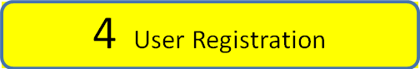 |  |  | Registration on the BCIS is crucial for submitting and participating in the 2010 Code development cycle. In addition to Mod submittal and code development, notices and meeting information is periodically sent to those registered with the BCIS at www.floridabuilding.org
New Users |  | - If you intend to submit proposed code modifications it is recommended to register if you haven’t already. The process is easy and the next few steps will guide you through the process  - You can register by clicking at the top of the BCIS page “User Registration” Here you will enter all of your contact information including a email address that you check often.
Returning Users |  | - Returning users only need to click on login and enter their login and password. There is a forgot password feature if you have forgotten you password. Contact us if you have forgotten your user login. We can be reached at 850-487-1824
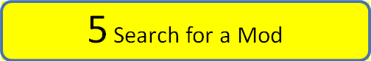 |  |  | To search for a Proposed Code Modification navigate your browser to www.floridabuilding.org. You should see a page with 6 large multicolored buttons.  Do the following steps:  - Click or hover over “Proposed Code Modifications” This should pull up a dropdown menu or take you to a new menu screen. To find a Mod, select Find a Proposed Code Modification.  - Here a search screen should load and near the top of the page it should say in the “breadcrumbs” Proposed Code Modifications Menu > Modification Search. You can enter in the 4 digit mod number and click search, or you can enter in some of the variables to search for a specific Mod.  Note: No need to login to search  Note: Looking for a Mod that you have previously submitted, but it doesn’t come up? it may be in a temporary “holding bin” for DCA staff to review. In that temporary status the mod is un-viewable by the general search. Check your “Manage Proposed Code Modifications inbox for its status. For more information see “Manage Proposed Code Modifications” below  Note: If you don’t receive any results try broadening your search by removing some of the search variables by making them (Select All)
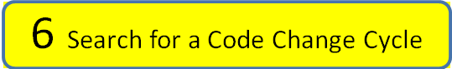 |  |  | To search for a Code Cycle navigate your browser to www.floridabuilding.org. You should see a page with 6 large multicolored buttons.  Do the following steps:  - Click or hover over “Proposed Code Modifications” This should pull up a dropdown menu or take you to a new menu screen. To search a cycle, select Find a Code Change Cycle  - The default is the latest Code Version  Note: No need to login to search  Note: If you don’t receive any results try broadening your search by removing some of the search variables by making them (Select All)  Note: You can submit a Mod at any time. Mods submitted between Code development cycles will go in the “On Hold” status until a cycle opens. Once opened these “On Hold” Mods will be assigned for the earliest cycle available.
Reports |  |  | To print a report of your mods or other mods select “Find a Proposed code Modification” and select the radio button at the top of the screen that says “Crystal Report” now everything that you search for will be output into a report format.  - There are three report styles to choose from: TAC and Commission Tracking Chart, Proposed Code Modification Detail, Proposed Code Modification Supplement
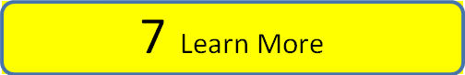 |  |  | There is much more to use to learn about how to use the Proposed Code Modification Module and the Code development process.
Code Development |  | For information on code development go to www.floridabuilding.org, click on Hot Topics and then click on Code development
Proposed Code Modifications |  | For information on proposed code modifications go to www.floridabuilding.org, click on Proposed Code Modifications and then click on FAQ (Getting Started)
BCIS |  | There is a lot of Code related and Florida Building Commission material on www.floridabuilding.org. A good place to start is by clicking on “Hot Topics” at the top menubar of the homepage. You can also click on “Publications” to view some of the reports and periodicals that have been produced.
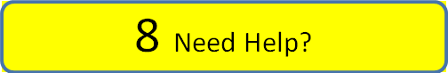 |  |  | There are many good resources on www.floridabuilding.org. For information specific to Proposed Code Modifications you can easily search up a list of Frequently asked questions. To find these do the following: Here you should have a screen with 6 large multicolored buttons.  - Click or hover over “Proposed Code Modifications” This should pull up a dropdown menu or take you to a new menu screen. Then click on “FAQ (Getting Started).  - Here you will find the latest information on Proposed Code Changes, calendars, and Frequently asked questions.  Note: If you are unable to find the answer to your question please contact DCA staff at 850-487-1824 and we will be happy to assist you.

