Florida Building Code, Residential

CHAPTER 9 ROOF ASSEMBLIES

R905.1.1.2 Underlayment for concrete and clay tile. Underlayment for concrete and clay tile shall comply with 905.3.3 one of the following methods:

- The entire roof deck shall be covered with an approved self-adhering polymer modified bitumen underlayment complying with ASTM D1970 installed in accordance with both the underlayment manufacturer’s and roof covering manufacturer’s installation instructions for the deck material, roof ventilation configuration and climate exposure for the roof covering to be installed.

- A minimum 4-inch-wide (102 mm) strip of self-adhering polymer-modified bitumen membrane complying with ASTM D1970, installed in accordance with the manufacturer’s instructions for the deck material, shall be applied over all joints in the roof decking. An underlayment complying with Section R905.3.3 shall be applied over the entire roof over the 4-inch-wide (102 mm) membrane strips.

- A minimum 3 ¾-inch wide (96 mm) strip of self-adhering flexible flashing tape complying with AAMA 711-13, Level 3 (for exposure up to 176° F (80° C), installed in accordance with the manufacturer’s instructions for the deck material, shall be applied over all joints in the roof decking. An underlayment complying with Section R905.3.3 shall be applied over the entire roof over the 4-inch-wide (102 mm) flashing strips.

4. Two layers of ASTM D226 Type II or ASTM D4869 Type III or Type IV underlayment shall be installed as follows: Apply a 19-inch (483 mm) strip of underlayment felt parallel to and starting at the eaves, fastened sufficiently to hold in place. Starting at the eave, apply 36-inchwide (914 mm) sheets of underlayment, overlapping successive sheets 19 inches (483 mm), end laps shall be 6 inches and shall be offset by 6 feet. The underlayment shall be attached to a nailable deck with corrosion-resistant fasteners with one row centered in the field of the sheet with a maximum fastener spacing of 12 inches (305 mm) o.c., and one row at the end and side laps fastened 6 inches (152 mm) o.c. Underlayment shall be attached using annular ring or deformed shank nails with metal or plastic caps with a nominal cap diameter of not less than 1 inch. Metal caps are required where the ultimate design wind speed, V_{ult}, equals or exceeds 170 mph. Metal caps shall have a thickness of not less than 32-gage sheet metal. Power-driven metal caps shall have a minimum thickness of 0.010 inch. Minimum thickness of the outside edge of plastic caps shall be 0.035 inch. The cap nail shank shall be not less than 0.083 inch for ring shank cap nails. Cap nail shank shall have a length sufficient to penetrate through the roof sheathing or not less than 3/4 inch into the roof sheathing.

Exception: Compliance with Section R905.1.1.2 is not required where a fully adhered underlayment is applied in accordance with Section R905.3.3.

(R- Ch. 9- Comment #1)

Appendix Q
APPENDIX Q TINY HOUSES

SECTION AQ101 GENERAL
AQ101.1 Scope. This appendix shall be applicable to tiny houses used as single dwelling units. Tiny houses shall com-ply with this code except as otherwise stated in this appendix.
SECTION AQ102 DEFINITIONS
AQ102.1 General. The following words and terms shall, for the purposes of this appendix, have the meanings shown herein. Refer to Chapter 2 of this code for general definitions.
EGRESS ROOF ACCESS WINDOW. A skylight or roof window designed and installed to satisfy the emergency escape and rescue opening requirements of Section R310.2.
LANDING PLATFORM. A landing provided as the top step of a stairway accessing a loft.
LOFT. A floor level located more than 30 inches (762 mm) above the main floor, open to the main floor on one or more sides with a ceiling height of less than 6 feet 8 inches (2032mm) and used as a living or sleeping space.
TINY HOUSE. A dwelling that is 400 square feet (37 m2) or less in floor area excluding lofts.
SECTION AQ103 CEILING HEIGHT
AQ103.1 Minimum ceiling height. Habitable space and hallways in tiny houses shall have a ceiling height of not less than 6 feet 8 inches (2032 mm). Bathrooms, toilet rooms and kitchens shall have a ceiling height of not less than 6 feet 4 inches (1930 mm). Obstructions including, but not limited to, beams, girders, ducts and lighting, shall not extend below these minimum ceiling heights.
Exception: Ceiling heights in lofts are permitted to be less than 6 feet 8 inches (2032 mm).
SECTION AQ104 LOFTS
AQ104.1 Minimum loft area and dimensions. Lofts used as a sleeping or living space shall meet the minimum area and dimension requirements of Sections AQ104.1.1 through AQ104.1.3.
AQ104.1.1 Minimum area. Lofts shall have a floor area of not less than 35 square feet (3.25 m2).
AQ104.1.2 Minimum horizontal dimensions. Lofts shall be not less than 5 feet (1524 mm) in any horizontal dimension.
AQ104.1.3 Height effect on loft area. Portions of a loft with a sloped ceiling measuring less than 3 feet (914 mm) from the finished floor to the finished ceiling shall not be considered as contributing to the minimum required area for the loft. See Figure AQ104.1.3.
Exception: Under gable roofs with a minimum slope of 6 units vertical in 12 units horizontal (50-percent slope), portions of a loft with a sloped ceiling measuring less than 16 inches (406 mm) from the finished floor to the finished ceiling shall not be considered as contributing to the minimum required area for the loft.

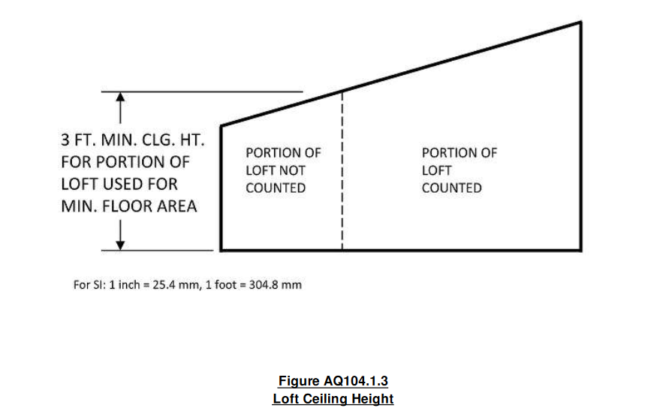

AQ104.2 Loft access and egress. The access to and primary egress from lofts shall be of any type described in Sections AQ104.2.1 through AQ104.2.4. The loft access and egress element along its required minimum width, shall meet the loft where its ceiling height is not less than 3 feet (914 mm).
AQ104.2.1 Stairways. Stairways accessing lofts shall comply with this code or with Sections AQ104.2.1.1 through AQ104.2.1.5. AQ104.2.1.7.
AQ104.2.1.1 Width. Stairways accessing a loft shall not be less than 17 inches (432 mm) in clear width at or above the handrail. The width below the handrail shall be not less than 20 inches (508 mm).
AQ104.2.1.2 Headroom. The headroom in above stairways accessing a loft shall be not less than 6 feet 2 inches (1880 mm), as measured vertically, from a sloped line connecting the tread, landing or landing platform nosings in the middle center of their width. width, and vertically from the landing platform along the center of its width.
AQ104.2.1.3 Treads and risers. Risers for stairs accessing a loft shall be not less than 7 inches (178 mm) and not more than 12 inches (305 mm) in height. Tread depth and riser height shall be calculated in accordance with one of the following formulas:
- The tread depth shall be 20 inches (508 mm) minus four-thirds of the riser height.
- The riser height shall be 15 inches (381 mm) minus three-fourths of the tread depth.
AQ104.2.1.4 Landings. Intermediate landings and landings at the bottom of stairways shall comply with Section R311.7.6, except that the depth in the direction of travel shall be not less than 24 inches (610 mm).

AQ104.2.1.4 AQ104.2.1.5 Landing platforms. The top tread and riser of stairways accessing lofts shall be constructed as a landing platform where the loft ceiling height is less than 6 feet 2 inches (1880 mm) where the stairway meets the loft. The landing platform shall be 18 inches to 22 inches (457 to 559 not less than 201 inches (508 mm) in width and in depth measured horizontally from and perpendicular to the nosing of the landing platform. The landing platform riser height to the edge of the loft, and 16 to floor shall be not less than 16 inches (406 mm) and not greater than 18 inches (406 to 457 mm) in height measured from the landing platform to the loft floor.
AQ104.2.1.5 AQ104.2.1.6 Handrails. Handrails shall comply with Section R311.7.8.
AQ104.2.1.6 AQ104.2.1.7 Stairway guards. Guards at open sides of stairways, landings and landing platforms shall comply with Section R312.1.
AQ104.2.2 Ladders. Ladders accessing lofts shall comply with Sections AQ104.2.1 and AQ104.2.2.
AQ104.2.2.1 Size and capacity. Ladders accessing lofts shall have a rung width of not less than 12 inches (305 mm), and 10-inch (254 mm) to 14-inch (356 mm) spacing between rungs. Ladders shall be capable of supporting a 200 300-pound (75 136 kg) load on any rung. Rung spacing shall be uniform within 3/8 inch (9.5 mm).
AQ104.2.2.2 Incline. Ladders shall be installed at 70 to 80 degrees from horizontal.
AQ104.2.3 Alternating tread devices. Alternating tread devices accessing lofts shall comply with Sections R311.7.11.1 and R311.7.11.2. The clear width at and below the handrails shall be not less than 20 inches (508mm).
AQ104.2.4 Ships ladders. Ships ladders accessing lofts shall comply with Sections R311.7.12.1 and R311.7.12.2. The clear width at and below handrails shall be not less than 20 inches (508 mm).
AQ104.2.5 Loft Guards. Loft guards shall be located along the open side(s) of lofts. Loft guards shall be not less than 36 inches (914 mm) in height or one-half of the clear height to the ceiling, whichever is less. Loft guards shall comply with Section R312.1.3 and Table R301.5 for their components.
SECTION AQ105 EMERGENCY ESCAPE AND RESCUE OPENINGS
AQ105.1 General. Tiny houses shall meet the requirements of Section R310 for emergency escape and rescue openings.
Exception: Egress roof access windows in lofts used as sleeping rooms shall be deemed to meet the requirements of Section R310 where installed such that the bottom of the opening is not more than 44 inches (1118 mm) above the loft floor, provided the egress roof access window complies with the minimum opening area requirements of Section R310.2.1.

(F-R-Appendix Q – Comment #1)

