Florida Building Commission
Product Approval / Manufactured Buildings Program Oversight Committee (POC)
AGENDA
Feb 2nd 2008 - 9.00 a.m.
Crowne Plaza Melbourne Oceanfront Hotel
2605 N AIA Highway, Melbourne FL, 1-800-980-6429 or 321-777-4100
Meeting Objectives:
- To Consider/Discuss Product Approval Program Issues
- To Consider/Decide on Declaratory Statements
- To Consider Consider/Decide on Approval of Products and Product Approval Entities
- Provide Comments to the Product Approval Hearings on the February 17th.
POC: Ed Carson -Chair, Chris Schulte, Paul Kidwell, Herminio Gonzalez, and Jeffrey Stone.
1. Call to Order -review/approve agenda and December 8th Minutes.
2. Product Approval Program Issues
A. Product Approval and Entities Statistics Report
B. Product Approval Administrator’s Performance survey
C. Provide Comments to the Rule Adoption Hearing for Rule 9B-72.090 and Rule 9B-72.180 on Feb 17th. (See attached notices Appendix A on page 24).
D. Consider Revocations for the following products:
FL | Mfg Name
3941-R1 6331 9945 9946 9947 | Uroll Shutters
5486, 5497 | TNT Roofing Manufacturer
7140, 7617, 7618 | Atlantic Windows and Doors, Inc.

E. Petition by Powers Steel Corporation to revoke FL 158.

3. Declaratory Statements
DCA08-DEC-339 by Jose Sanchez, Fenestration Testing Laboratory, Inc
DCA08-DEC-345 by James Reed, Southwest Progressive Enterprises, Inc
DCA08-DEC-359 by Michael J. Wolfe, Advanced Shelter Solutions, Inc

4. Ted Berman & Associates Report
A. Review product approval and entity applications.
B. Product Approval Applications with Comments.

5. Adjourn
This document is available in alternate format upon request.
Florida Building Commission
Product Approval / Manufactured Buildings
Program Oversight Committee (POC)
MINUTES
December 8th 2008 – 3.00 pm to 5:23 pm

Embassy Suites Tampa
3705 Spectrum Blvd | Tampa, Florida 33612-9412 | Tel: 1-813-977-7066
Product Approval POC Attendees: Ed Carson- Chair, Herminio Gonzalez, Paul Kidwell, and Jeffrey Stone. Staff present: Azhar Khan, Mo Madani, Jeff Blair Rick Dixon and Jim Richmond. Ted Berman, Product Approval Administrator was also present.
There was a quorum.
1. Agenda and minutes from October 6th were approved as presented.

2. Manufactured Buildings Program Issues
A. Manufactured Buildings Program Budget
Staff presented to the Committee the Manufactured Buildings Program Budget illustrating the drop in revenue and the fees spent on the contract for monitoring.

B. The POC discussed the need for legislative authority for establishing Manufactured (Modular) Building Program Administrator. Staff presented the case for the Manufactured Building Program Administrator due to possible staff reduction and budget cuts which will impact the Department’s ability to continue the current management structure of the Manufactured Building Program. The intent is to contract out the manufactured buildings program similar to the state product approval program. Staff requested that the Commission support such legislative authority.

POC Action: The POC recommends that the Commission support the Department’s initiatives to request legislative authority for the following:

1: Contract the manufactures building administrator responsibilities;
2: Manufacturers pay the vendor directly for plans review and inspection services via the Building Code Information System;
3: Department will establish plan review and inspection fees.

3. Product Approval Program Issues
A. Product Approval and Entities Statistics Report
Staff presented the current entities and product statistics from inception of the program.
B. Product Approval Administrator’s Performance survey
Staff presented to the Committee the Survey Results.

C. Statutory authority for manufacturers / entities to pay the Product Approval Administrator directly via the BCIS.

POC Action:
The Committee moved to approve Staff request for specific authority for manufacturer / entities to pay vendor directly via BCIS.

D. Revocations for the following products:
The Committee voted to defer the item to the next meeting directing staff to conduct more research on the subject.

FL | Mfg Name
3941-R1 6331 9945 9946 9947 | Uroll Shutters
5486, 5497 | TNT Roofing Manufacturer
7140, 7617, 7618 | Atlantic Windows and Doors, Inc.

E. Standard Equivalency between ASTM 1300-2 to ASTM E 1300-04 with limitations as applied to laminated glass as identified in the engineering report

Staff informed the committee of the report from the Structural TAC.

The Structural TAC recognized equivalency of ASTM E 1300-02 to ASTM E 1300-04C with limitations as applied to laminated glass as identified in the engineering report.

F. Complaint filed against FL 5343 by Michael J. Wolfe of Advanced Shelter Solutions

Michael J Wolfe of Advanced Shelter Solutions was present at the meeting to present his case.
The committee voted to dismiss the complaint due to lack of substantive material evidence necessary to conduct an investigation.

G. Complaint filed against FL 7350 and FL 9328 by Steve Sincere, PE.

POC Action:
The Committee voted to dismiss the complaint due to the fact the Florida Board of Engineers voted to dismiss the case.

H. Deadlines for Product Approval Applications for 2009.

The Committee made changes to the deadlines for the Feb meeting. The deadlines were adjusted forward 4 days to allow for more review time due the holidays.

I. Develop criteria for evaluation entity approval and adopt by Rule or develop recommendation for 2009 legislature for entities to be recognized by law.

The Committee agreed with the staff recommendations below:

- IAPMO Evaluation Service (ES) is accredited by ANSI as a certification agency meeting ISO 65. (Please see the attached accreditation certificate on page 24) Therefore, it is the staff recommendation that IAPMO by recommended by the Commission for inclusion in the law as an approved evaluation entity.

- Change the law to read as follows:
(a) Evaluation entities that meet the criteria for approval adopted by the commission by rule. The commission shall specifically approve the, the International Association of Plumbing and Mechanical Officials Evaluation Service, the International Code Council Evaluation Services, the Miami-Dade County Building Code Compliance Office Product Control and National Evaluation Service, the international Conference of Building Officials Evaluation Services, the Building Officials and Code Administrators International Evaluation Services, the Southern Building Code Congress International Evaluation Services. Architects and engineers licensed in this state are also approved to conduct product evaluations as provided in subsection (5).
Note: Staff will organize the entities listed above alphabetically.
J. Height of Rollup Shutters.

Structural TAC made the following recommendation to the Committee

One cannot assume that larger height of roll-up shutters other than tested will perform as the tested size. Engineering is required to substantiate the increase in height beyond the tested size.
Note: Under the High Velocity Hurricane Zone because of the deflection limit required by the code, roll-up shutters approved by Miami-Dade Code Compliance Office are not allowed to exceed three times the tested height.

The POC directed the Administrator to contact the affected manufacturers to advise them to make changes to their applications necessary to comply with the above findings. This would exclude product approvals that are based on certification through Miami Dade NOA.

K. Update on Investigation of FL 8843

Ted Berman, Product Approval Administrator, informed the Committee of his findings.

POC Action:
Based on the administrator’s findings that the issue in question is outside the scope of Rule 9B-72 and the lack of substantive material evidence, the Committee voted to dismiss the investigation.

L. Discuss and provide comments to the rule development workshop on December 15th 2008 for Rule 9B-72.090 and 9B-72.180

POC Action:
The committee voted in favor of the staff recommendation to provide comment at the workshop to allow the upload of an attachment for the self-affirmation method in the Building Code Information System.

The committee also voted to provide comments at the workshop to allow the standard equivalencies to the following standards:
DASMO108-02 to DASMA 108-05
TPI 1-02 to TPI 1-07
ASTM E 1300-02 to ASTME E 1300-04

M. Investigation of Improper Validations

Validations for FL1865 and FL2617 were performed on an incorrect checklist. The Committee asked the Administrator to send the validator a warning letter to avoid this from happening again.

4. Declaratory Statements:
DCA08-DEC-339 by Jose Sanchez, Fenestration Testing Laboratory, Inc

More information is required.
The committee deferred action on this Dec Statement to the February meeting requesting the presence of the petitioner to provide more information.

5. Review product approval applications: FL 11095 and FL 11561

The Committee made the following recommendations:
FL 11095 – recommend conditional approval
FL 11561 – recommend approval

6. Adjourn
The Committee adjourned at 5.23 pm.

Actions needed by the Commission:
Product Approval POC:
1. The Committee recommends the products and entities listed in Administrator's report be approved, deferred, conditionally approved or denied as per voted on by the Committee.

2. The POC recommends that the Commission support the Department’s initiatives to request legislative authority for the following:

1: Contract the manufactured building administrator responsibilities;
2: Manufacturers pay the vendor directly for plans review and inspection services via the Building Code Information System;
3: Department will establish plan review and inspection fees.
3. The POC recommends that the following entities be recognized by law:

(a) Recommend that IAPMO be recommended by the Commission for inclusion in the law as an approved evaluation entity.
(b) Change the law 553.842 Product Evaluation and Approval to read as follows:
(a) Evaluation entities that meet the criteria for approval adopted by the commission by rule. The commission shall specifically approve the, the International Association of Plumbing and Mechanical Officials Evaluation Service, the International Code Council Evaluation Services, the Miami-Dade County Building Code Compliance Office Product Control and National Evaluation Service, the international Conference of Building Officials Evaluation Services, the Building Officials and Code Administrators International Evaluation Services, the Southern Building Code Congress International Evaluation Services. Architects and engineers licensed in this state are also approved to conduct product evaluations as provided in subsection (5).
Note: Staff will organize the entities listed above alphabetically.
4. The POC recommends that the Commission approve Staff request for specific authority for manufacturer / entities to pay vendor directly via BCIS.

5. Complaint filed against FL 5343 by Michael J. Wolfe of Advanced Shelter Solutions

The committee recommends that the Commission dismiss the complaint due to lack of substantive material evidence necessary to conduct an investigation.

6. Complaint filed against FL 7350 and FL 9328 by Steve Sincere, PE.

The Committee recommends the Commission dismiss the complaint due to the fact the Florida Board of Engineers voted to dismiss the case.

7. Update on Investigation of FL 8843

Ted Berman, Product Approval Administrator, informed the Committee of his findings.
Based on the administrator’s findings that the issue in question is outside the scope of Rule 9B-72 and the lack of substantive material evidence, the Committee recommends that the Commission dismiss the investigation.

____________________________________________

2. Product Approval Program Issues
A. Product Approval and Entities Statistics Report

Entities | Accreditation Body | Certification Agency | Evaluation Entity | Quality Assurance Entity | Testing Laboratory | Validation Entity | Totals
Approved | 6 | 14 | 6 | 28 | 49 | 14 | 117
Pending | 0 | 0 | 0 | 0 | 0 | 0 | 0
Pending Accreditation | 0 | 0 | 0 | 0 | 2 | 0 | 2
Denied | 0 | 0 | 0 | 0 | 0 | 0 | 0
Suspended | 0 | 0 | 0 | 0 | 0 | 1 | 1
Expired | 1 | 4 | 0 | 8 | 25 | 14 | 52
Renewed / Revised | 0 | 15 | 0 | 26 | 59 | 19 | 119
Totals | 7 | 33 | 6 | 62 | 135 | 48 | 291

CODE VERSION | 2004 |  | 2007
 | Applications | Products | Applications | Products
Approved | 5,593 | 22,575 | 1411 | 7310
Applied For | 31 | 39 | 158 | 868
Denied | 154 | 482 | 1 | 1
Validated | 15 | 28 | 187 | 514
Suspended | 0 | 0 | 0 | 0
Re-Apply | 3 | 3 | 24 | 88
Pending FBC Approval | 1 | 1 | 15 | 682
Revoked | 6 | 17 | 0 | 0
Archived | 528 | 1828 | 156 | 654
Over 180 Days Old and Not Approved, Denied, Validated, or Pending Status | 3 | 7 | 11 | 20
Totals | 6334 | 24,980 | 1963 | 10,137

B. Product Approval Administrator’s Performance survey

Survey Results
1) Select a rating: Excellent, Good, Fair, or Poor. REPLY: Good
2) Comment on TB&A performance (including telephone support, application review and support, emails describing the results of application review, recommendation to the Product Approval Oversight Committee (POC) and timely carrying out of the final Commission Vote on your application) REPLY: excellent

Ted seems to have done an outstanding job this round. I do not know how he made it with all the time the website was down. Top ratings for phone and processing as well.

C. Provide Comments to the Rule Adoption Hearing for Rule 9B-72.090 and Rule 9B-72.180 on Feb 17th.

The Committee can provide Comments to the Commission for the Rule Adoption Hearing scheduled for February 17th. The notices and the proposed language are attached. See Appendix A page 24.See also the copy of the matrix in the handout attached.

Randy Shackelford of Simpson Strong-Tie submitted the following comment:

January 22, 2009

Mr. Azhar Khan
Florida Department of Community Affairs
2555 Shumard Oak Blvd
Tallahassee, Fl 32399-2100

RE: Proposed revision to Rule 9B-72.090

Dear Mr. Khan:

I am writing to offer a suggested improvement to the proposed revision to Rule 9B-72.090, regarding self-affirmation of State Product Approvals when the evaluation report refers to the previous edition of the Florida Building Code.

I believe only permitting uploading of additional documentation from the original evaluating entity is overly restrictive. Evaluation entities may not want to provide this service or may not provide it at an affordable cost. I suggest that, in addition to allowing the original evaluation entity, that the original validation entity can also provide the documentation. The original validator should be familiar with the product being evaluated, and of the code requirements for that product, so should be able to tell if the new code contains provisions that would limit the applicability of that product. I also propose deleting the words “necessary to certify” because it is not clear who is certifying. The uploaded document should just be a statement that the product complies with the new code.

So what I propose is this (new wording in blue):
(e) When a new edition of the Code does not require a material or substantive change for an approved product, the manufacturer of the approved product shall affirm that his or her approved product meets the new edition of the Code. As part of application for self-affirmation, if the evaluation report refers to the previous edition of the Code, the manufacturer of the approved product shall submit a statement from the original evaluation entity or original validation entity necessary to certify that the product complies with the subsequent code version via an attachment uploaded and submitted through the BCIS. Self-affirmation is subject to review and verification by the Program Administrator.

Thank you for your consideration.

Sincerely,

Simpson Strong-Tie Co.
Randall Shackelford, P.E.
Branch Engineer

Dick Wilhelm of FMA submitted the following two comments.

Mo:

Thank you for the opportunity to respond to the proposed language in Chapter 9B-72, sections .090 and .180.

After much discussion between the Florida Building Materials Association representative the FMA, WDMA members and numerous individual window manufacturers, it was concluded that our industry would like to request time before the Florida Product Approval POC on Monday, Feb. 2 to explain why our industry cannot accept the proposed language as advertised in the Florida Administrative Weekly.

We will be more than happy to provide proposed compromise language prior to the hearing scheduled for Feb. 17, 2009. However, it is imperative to resolve these differences before the teleconference. As you are painfully aware, to take the time to flesh out these issues on a Commission conference call is not practical nor fair to other folks with a different set of issues.

Specifically, we oppose the requirement to have the "engineer of record" (evaluation entity) be the only party to sign -off on the affirmation and would like to add the validation entity to the list of certifiers.

Regards:

Dick

Please note in proposed rule Ch 9B-72.180, FAC, Equivalency of Accreditation Standards, cites the entity as NWWDA in subparagraph (5)(e).

Please consider changing NWWDA to read WDMA (Window and Door Manufacturers Association) as that is the current designation of that association.

Thank you.

Dick Wilhelm
representing the WDMA in the southeast U.S. and Gulf coast.

Kari Hebrank made the following comment:

Also, there is an extra E in the ASTM E 1300-04 standard.

D. Revocations for the following products:

FL | Mfg Name
3941-R1 6331 9945 9946 9947 | Uroll Shutters
5486, 5497 | TNT Roofing Manufacturer
7140, 7617, 7618 | Atlantic Windows and Doors, Inc.

UROLL Shutters
FL | Notifying Agency | TB&A Date Notified | Call Mfg Date | Email Mfg Date | Reg Letter Date | Issue Status | Testlab/ Evaluator | QA | Validator
3941-R1 | ATI | 7/10/2008 | 7/10/2008 | 7/10/2008 | 8/6/2008 | No longer a participant in ATI program | Architectural Testing | Architectural Testing | Architectural Testing
6331 | ATI | 7/10/2008 | 7/10/2008 | 7/10/2008 | 8/6/2008 | No longer a participant in ATI program | Architectural Testing | Architectural Testing | Architectural Testing
9945 | ATI | 7/10/2008 | 7/10/2008 | 7/10/2008 | 8/6/2008 | No longer a participant in ATI program | Luis Lomas | Architectural Testing | Jefferey Friant
9946 | ATI | 7/10/2008 | 7/10/2008 | 7/10/2008 | 8/6/2008 | No longer a participant in ATI program | Luis Lomas | Architectural Testing | Jefferey Friant
9947 | ATI | 7/10/2008 | 7/10/2008 | 7/10/2008 | 8/6/2008 | No longer a participant in ATI program | Luis Lomas | Architectural Testing | Jefferey Friant
The company is believed to be out of business. The company was non-responsive to calls by the certification agency, NAMI, by Ted Berman and Associates and by DCA staff. They have failed to maintain their Quality Assurance in good standing. Staff Recommendation : REVOCATION

TNT ROOFING
FL | Notifying Agency | TB&A Date Notified | Call Mfg Date | Email Mfg Date | Reg Letter Date | Issue Status | Testlab/ Evaluator | QA | Validator
5486 | Keystone | 5/19/2008 | 7/23/2008 & 08/21/08 (813-818-4422) | 5/29/2008 & 7/23/08 | 8/6/2008 Registered Letter Returned undelivered | Mfg does not respond to Keystone emails | UL | Keystone | Locke Bowden
5497 | Keystone | 5/20/2008 | 7/23/2008 & 08/21/08 (813-818-4422) | 5/29/2008 & 7/23/09 | 8/6/2008 Registered Letter Returned undelivered | Mfg does not respond to Keystone emails | Farabaugh | Keystone | Locke Bowden
The company was non-responsive to calls by the QA agency Keystone, by Ted Berman and Associates and by DCA staff. They have failed to maintain their Quality Assurance in good standing. Staff Recommendation: REVOCATION

Atlantic Windows and Doors
FL | Mfg Name | Notifying Agency | TB&A Date Notified | Call Mfg Date | Email Mfg Date | Reg Letter Date | Issue Status | Certification agency
7140 | Atlantic Windows and Doors, Inc. | NAMI | 1/31/2008 | 7/23/08 Phone Disconnected | 02/04/08 Email bounced | 7/23/2008 Registered Letter Returned undelivered | NAMI QA dropped mfg due to non-compliance issues | NAMI
7617 | Atlantic Windows and Doors, Inc. | NAMI | 2/1/2008 | 7/23/08 Phone Disconnected | 02/04/08 Email bounced | 7/23/2008 Registered Letter Returned undelivered | NAMI QA dropped mfg due to non-compliance issues | NAMI
7618 | Atlantic Windows and Doors, Inc. | NAMI | 2/2/2008 | 7/23/08 Phone Disconnected | 02/04/08 Email bounced | 7/23/2008 Registered Letter Returned undelivered | NAMI QA dropped mfg due to non-compliance issues | NAMI
The company was non-responsive to calls by the certification agency, NAMI, by Ted Berman and Associates and by DCA staff. They have failed to maintain their certification in good standing. The company is believed to be out of business by all parties involved. Staff Recommendation: REVOCATION

E. Petition by Powers Steel Corporation to revoke FL 158.

Please see handout attached.

____________________________________________

3. Declaratory Statements
DCA08-DEC-339 by Jose Sanchez, Fenestration Testing Laboratory, Inc
Deferred from last meeting due to lack of information:
Staff sent the petitioner the following email. However, there has been no contact from the petitioner:

Jose,

The Committee wanted more information from you as to the setup of the company.

Excerpt from the minutes of the meeting:

Declaratory Statements:
DCA08-DEC-339 by Jose Sanchez, Fenestration Testing Laboratory, Inc

More information is required.
The committee deferred action on this Dec Statement to the February meeting requesting the presence of the petitioner to provide more information.

The minutes of the meeting can be found at:
http://www.dca.state.fl.us/fbc/commission/FBC_1208/Committee_Reports/PA_POC_MIN_1208.htm

The committee requested your presence so that their questions can be answered.
Please let me know if you have any inquiries to that effect.

Thanks.

Azhar Khan

Building Code and Standards
Florida Department of Community Affairs
2555 Shumard Oak Blvd | Tallahassee, Fl 32399-2100
850.922.1870(o) | 850.414.8436(f) | www.floridabuilding.org

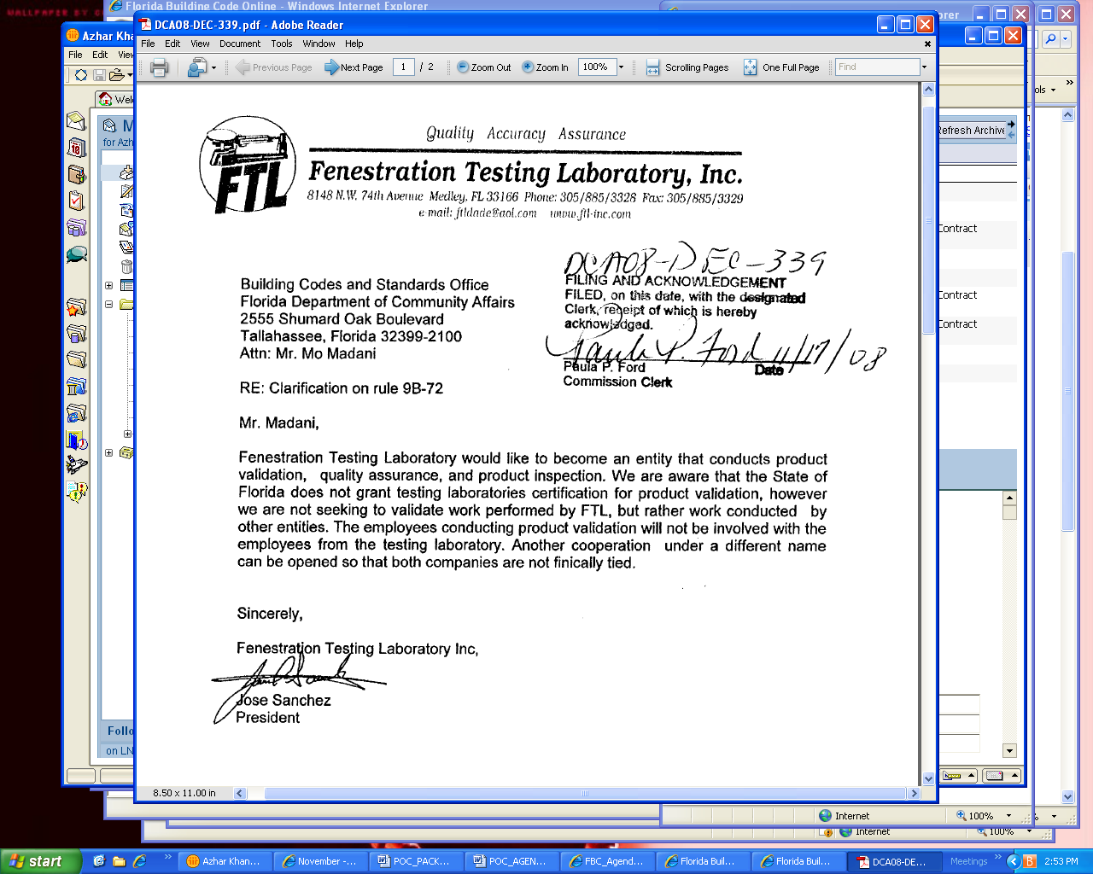

And Amendment:
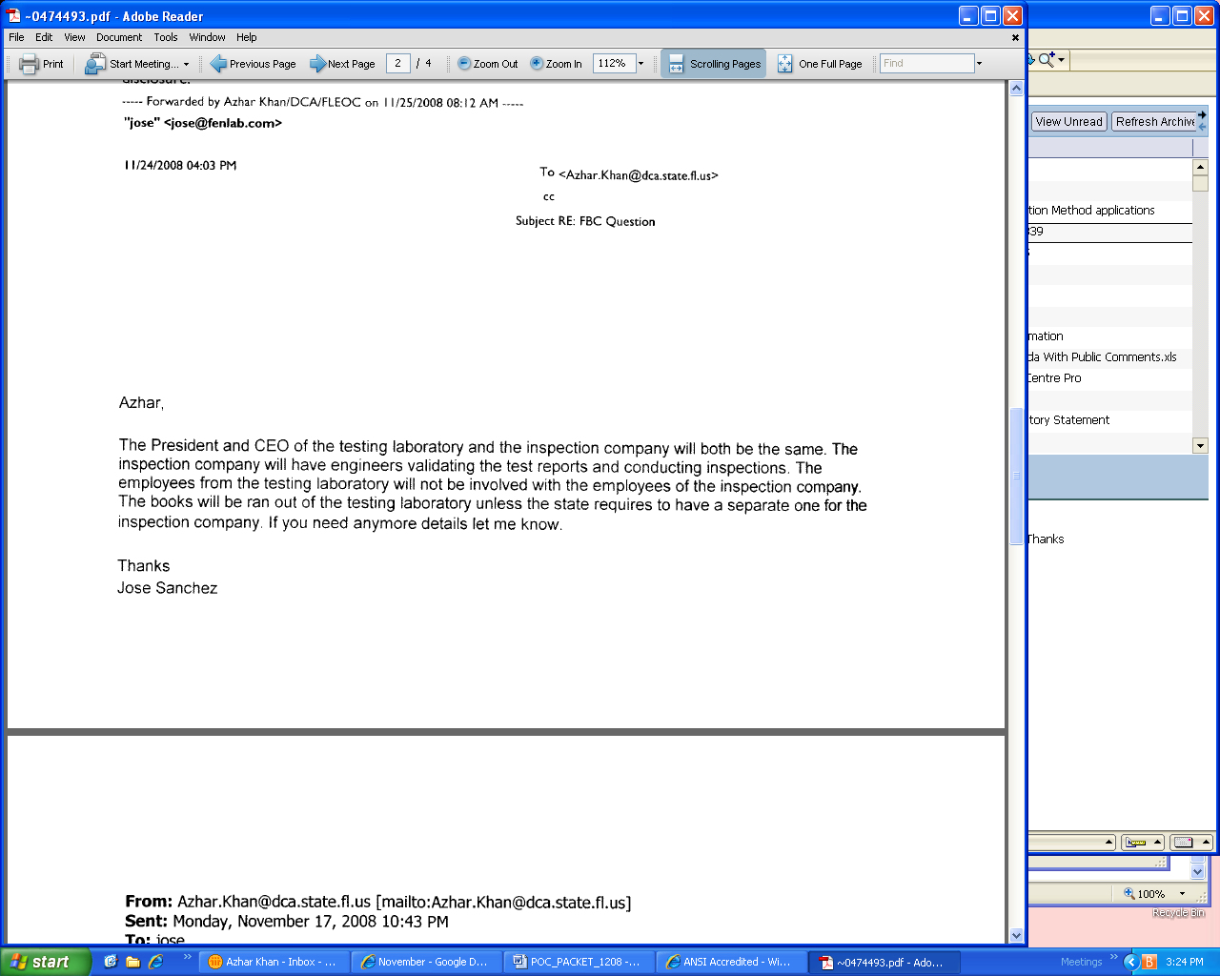

ISSUE: DCA08-DEC-339

The petitioner, Jose Sanchez, President Fenestration Testing Laboratory, Inc. requests a declaratory statement inquiring into the role of an independent corporation being able to perform validation and quality assurance inspection functions.

Mr. Sanchez would like to set up another corporation that performs validations and quality assurance functions, that is not financially linked to Fenestration Testing Laboratory, Inc and whose employees that perform validations will not have professional involvement with employees of the Fenestration Testing Laboratory, Inc.

He further clarifies stating, “The President and CEO of the testing laboratory and the inspection company will both be the same. The inspection company will have engineers validating the test reports and conducting inspections. The employees from the testing laboratory will not be involved with the employees of the inspection company. The books will be ran out of the testing laboratory unless the state requires to have a separate one for the inspection company. If you need anymore details let me know.”

QUESTION:
Under the circumstance described above, is another entity that performs validations permissible under Rule 9B-72?

BACKGROUND

Fenestration Testing Laboratory is an approved Testing Lab under Rule 9b-72,190 (5) International Organization for Standardization/International Electrotechnical Commission (ISO/IEC) Guide 17025: 1999, General Requirements for the Competence of Testing and Calibration Laboratories. Certificate attached on page 40. Fenestration is also accredited by Miami Dade; certificate is attached on page 41.

Rule 9B-72.100 Approval of Product Evaluation Entities, Product Validation Entities, Testing Laboratories, Certification Agencies, Quality Assurance Agencies and Accreditation Bodies.

(2) Approved Validation Entities.
An entity shall be approved by the Commission as a validation entity if it is a Commission approved evaluation entity, testing laboratory or certification agency, and it certifies to the Commission compliance with standards established by the Code or intent of the Code. Architects and engineers licensed in this Sstate are also approved to conduct validation for the state approval. Testing Laboratories are not allowed to conduct validations. Validation by an approved testing laboratory acting as a validation entity shall be limited to the scope for which they are accredited.

(b) An entity may be approved as a validation entity after applying to the Commission for approval. Applications must be submitted in accordance with subsections 9B-72.130(1) and 9B-72.090(3), F.A.C., including a Certificate of Independence in accordance with Rule 9B-72.110, F.A.C., and fees submitted pursuant to subsection 9B-72.090(2), F.A.C. Application shall be made through the Building Codes Information System on the Internet, www.floridabuilding.org, and payment shall be by credit card or electronic check.

Rule 9B-72.190 Reference Standards
(1) International Organization for Standardization/International Electrotechnical Commission ISO/IEC Guide 61, General Requirements for Assessment and Accreditation of Certification/Registration Bodies.

(2) International Organization for Standardization/International Electrotechnical Commission (ISO/IEC) Guide 65: 1996, General Requirements for Bodies Operating Product Certification Systems.

(3) International Organization for Standardization/International Electrotechnical Commission ISO/IEC Guide TR 17010: 1998, General Requirements for Bodies Providing Accreditation of Inspection Bodies.

(4) International Organization for Standardization/International Electrotechnical Commission ISO/IEC Guide TR 17020: 1998, General Criteria for the Operation of Various Types of Bodies Performing Inspection.

(5) International Organization for Standardization/International Electrotechnical Commission (ISO/IEC) Guide 17025: 1999, General Requirements for the Competence of Testing and Calibration Laboratories.

(6) International Organization for Standardization/International Electrotechnical Commission ISO/IEC Guide 58, Calibration and Testing Laboratory Accreditation Systems – General Requirements for Operation and Recognition.

9B-72.110 Criteria for Certification of Independence.
A certification of independence shall be provided by a Florida registered architect or licensed professional engineer as applicable or by an officer of the entity, agency or laboratory who is responsible for operation of said entity, agency or laboratory that attests to the following:
(1) The entity, agency or laboratory does not have, nor does it intend to acquire or will it acquire, a financial interest in any company manufacturing or distributing products tested or labeled by the agency.
(2) The entity, agency or laboratory is not owned, operated or controlled by any company manufacturing or distributing products it tests or labels.
(3) The Florida registered architect or licensed professional engineer performing an evaluation does not have nor will acquire, a financial interest in any company manufacturing or distributing products for which the reports are being issued.
(4) The Florida registered architect or licensed professional engineer performing an evaluation does not have, nor will acquire, a financial interest in any other entity involved in the approval process of the product.

Currently on the system, certification agencies and evaluation entities accredited under “Rule 9B-72.190 (2) ) International Organization for Standardization/International Electrotechnical Commission (ISO/IEC) Guide 65: 1996, General Requirements for Bodies Operating Product Certification Systems” are allowed to perform validations in addition to certification services.

STAFF RECOMMENDATION

Mr. Sanchez would like to set up another corporation that performs validations and quality assurance functions, that is not financially linked to Fenestration Testing Laboratory, Inc and whose employees that perform validations will not have professional involvement with employees of the Fenestration Testing Laboratory, Inc.

He further clarifies stating, “The President and CEO of the testing laboratory and the inspection company will both be the same. The inspection company will have engineers validating the test reports and conducting inspections. The employees from the testing laboratory will not be involved with the employees of the inspection company. The books will be ran out of the testing laboratory unless the state requires to have a separate one for the inspection company. If you need anymore details let me know.”

QUESTION:
Under the circumstance described above, is another entity that performs validations permissible under Rule 9B-72?

ANSWER:
Since the engineer working for the second entity is financially tied to the Fenestration Testing Lab, Inc, a validation evaluation performed by the said engineer would violate Rule 9B-72.110 and is therefore not permissable.

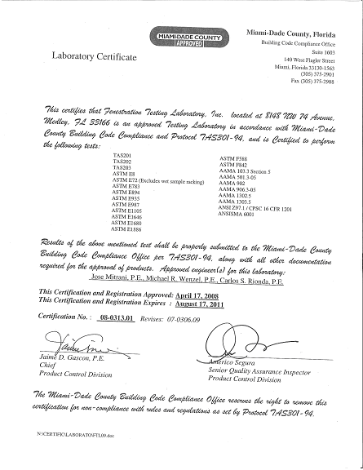

DCA08-DEC-345 by James Reed, Southwest Progressive Enterprises, Inc

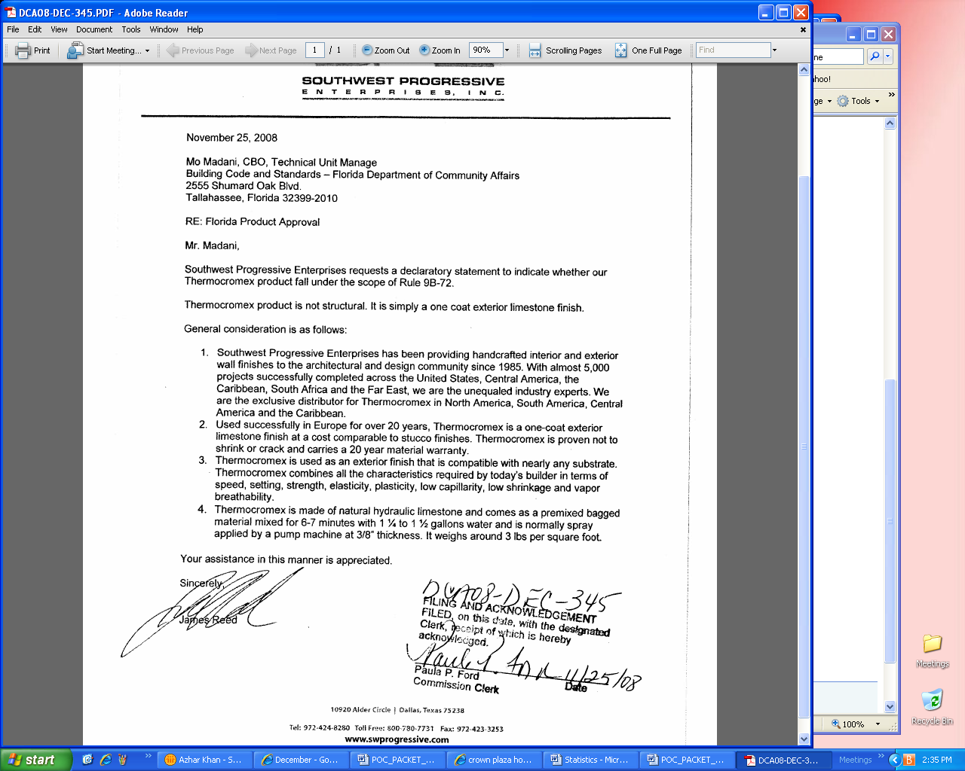

ISSUE: DCA08-DEC-345

The petitioner, James Reed of Southwest Progressive Enterprises, Inc. seeks a Declaratory Statement on Rule 9B-72 as it pertains to his product

BACKGROUND

9B-72.005 Scope (1) Products in the following categories as defined by subcategories of subsection 9B-72.010(31), F.A.C., shall be available for approval by the Commission pursuant to Rule 9B-72.090, F.A.C., for use in the state:
(a) Panel Walls;
(b) Exterior Doors;
(c) Roofing Products;
(d) Skylights;
(e) Windows;
(f) Shutters; and
(g) Structural Components.

9B-72.005 Scope (2) This rule applies to approval of products and systems, which comprise the building envelope and structural frame, for compliance with the structural requirements of the Florida Building Code.

From the declaratory statement request:

USES: Thermocromex is a one-coat exterior limestone finish on many substrates. It is made of natural hydraulic limestone and comes as a premixed bagged material that is mixed for 6-7 minutes and is spray applied by a pump machine at 3/8 inches thickness. It weighs around 3 lbs/ft sq.

Technical Data:

St. Astier One Coat Exterior Limestone Finish - Thermocromex
~Based on St. Astier natural hydraulic lime, this product is visually pleasant, durable, water resistant and cost effective.
~ A one coat easy and economical application, ready mixed product based on Natural Hydraulic lime specially formulated to work on all substrates, including light weight cement blocks, clay blocks, bricks, and stone to achieve excellent waterproofing, low capillarity, high breathability, elasticity, and vibrant colored finishes. Thermocromex is available in a variety of colors. Our color chart is by no means exhaustive and can be supplied to a custom color with substantial savings in cost of painting and maintenance.

Technical Data |  | Test std. CSTB & EN/BS 998.1
Dry Density (hardened product) | 1450 g.1 +/100g/1 | EN 459-2
Thermal conductivity | 0.54 W/m.K | EN 1745
Granulometry | 0.8 - 4.0 mm | C 136
Compressive strength 28 days | Between 4 and 6 N/mm² | C 109
Flexural strength 28 days | Between 2 and 2.5 N/mm² | C 348
Water retention (on paste) | 94% (± 2%) | C 1506
Vapour permeability | 1.61.10-9 kg/m²sPa (0.772 g x m² x h x mmHg) | EN 1015-19
Capillarity | Between 1 and 2.5 g/dm².min1/2 | EN 1015-18
Fire & Smoke | Class A (all uses)
Elasticity moduli 28 days | Between 4000 and 6000 MPa

The manufacturer has stated it to be a stucco substitute. We have approved stucco products in both the 2004 code and the 2007 as products with structural properties. The manufacturer has not as yet submitted final testing and evaluation data that determines the structural properties of this product and its compliance with the Florida Building Code. Subsequently it is difficult to say at this stage whether it falls within the scope of Rule 9B-72.

STAFF RECOMMENDATION

Staff recommends dismissal of the Declaratory Statement DCA08-DEC-345 as not enough information is provided to correctly determine the products structural properties.

DCA08-DEC-359 by Michael J. Wolfe, Advanced Shelter Solutions, Inc
Staff recommends dismissal – does not meet the Declaratory Statement criteria

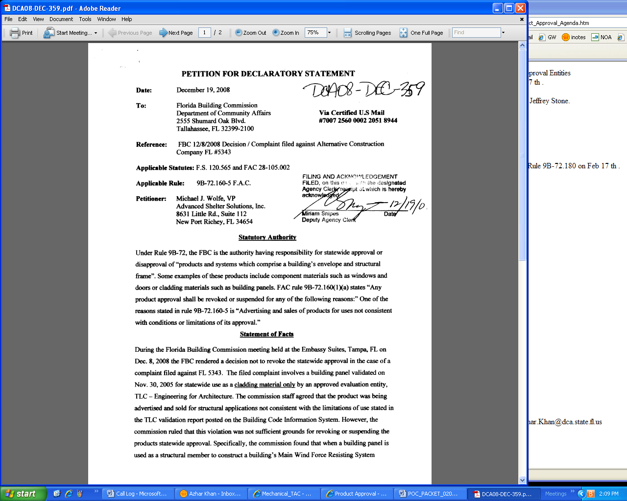
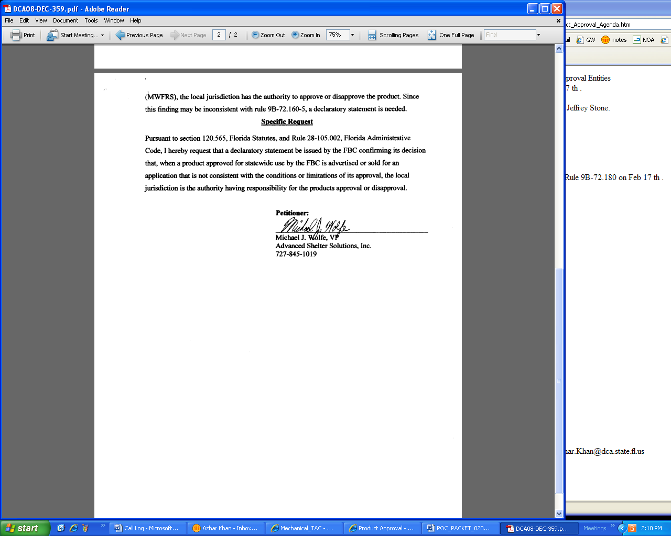

____________________________________________

4. Ted Berman & Associates Report
A. Review product approval and entity applications.
B. Product Approval Applications with Comments.

____________________________________________

5. Adjourn

APPENDIX A

Notice of Proposed Rule

DEPARTMENT OF COMMUNITY AFFAIRS
Division of Housing and Community Development
RULE NO: RULE TITLE
9B-72.090: Product Approval by the Commission
PURPOSE AND EFFECT: To address the availability and conditions of self certification of compliance with an updated version of the Florida Building Code when documentation supporting a product approval to a preceding edition of the Code specifically refers to that earlier edition.
SUMMARY: The Commission previously provided a means by which a manufacturer could self-affirm compliance with a new edition of the building code for purposes of renewing an approval by the Commission in the event that there were no changes from the previous edition that impacted the substance of the approval. In many circumstances, however, the evaluation submitted in support of the initial approval generally referred to the preceding code edition rather than a particular provision or standard. The rule is amended to insure that there is adequate review of the information to assure accuracy of the affirmation and to address the potential for violation of law pertaining to licensure of those performing engineering services in the State.
SUMMARY OF STATEMENT OF ESTIMATED REGULATORY COSTS: No Statement of Estimated Regulatory Cost was prepared.
Any person who wishes to provide information regarding a statement of estimated regulatory costs, or provide a proposal for a lower cost regulatory alternative must do so in writing within 21 days of this notice.
SPECIFIC AUTHORITY: 553.77(1)(i), 553.842(1) FS.
LAW IMPLEMENTED: 553.942(1), (2) FS.
A HEARING WILL BE HELD AT THE DATE, TIME AND PLACE SHOWN BELOW:
DATE AND TIME: February 17, 2009; 10:00 a.m. to 1:00 p.m.
PLACE: Room 250L, Sadowski Building, 2555 Shumard Oak Boulevard, Tallahassee, Florida 32399 AND via communications media technology, specifically a telephone conference call. Please refer to the meeting notice for the Florida Building Commission for call-in information.
Pursuant to the provisions of the Americans with Disabilities Act, any person requiring special accommodations to participate in this workshop/meeting is asked to advise the agency at least 7 days before the workshop/meeting by contacting: Ila Jones, Community Program Administrator, Department of Community Affairs, 2555 Shumard Oak Boulevard, Sadowski Building, Tallahassee, Florida 32399-2100, (850) 487-1824 If you are hearing or speech impaired, please contact the agency using the Florida Relay Service, 1(800)955-8771 (TDD) or 1(800)955-8770 (Voice).
THE PERSON TO BE CONTACTED REGARDING THE PROPOSED RULE IS: Ila Jones, Community Program Administrator, Department of Community Affairs, 2555 Shumard Oak Boulevard, Sadowski Building, Tallahassee, Florida 32399-2100, (850) 487-1824
THE FULL TEXT OF THE PROPOSED RULE IS:
(1)(a) through (d) No change.
(e) When a new edition of the Code does not require a material or substantive change for an approved product, the manufacturer of the approved product shall affirm that his or her approved product meets the new edition of the Code. As part of application for self-affirmation, if the evaluation report refers to the previous edition of the Code, the manufacturer of the approved product shall submit a statement from the original evaluation entity necessary to certify that the product complies with the subsequent code version via an attachment uploaded and submitted through the BCIS. Self-affirmation is subject to review and verification by the Program Administrator.
(f) and (g) No change.
(2) and (3) No change.
Specific Authority 553.77(1)(i), 553.842(1) FS. Law Implemented 553.842(1) FS. History –New 5-5-02, Amended 9-4-03, 11-22-06, _________.
NAME OF PERSON ORIGINATING PROPOSED RULE: Ila Jones, Community Program Administrator, Department of Community Affairs, 2555 Shumard Oak Boulevard, Sadowski Building, Tallahassee, Florida 32399-2100, (850) 487-1824
NAME OF AGENCY HEAD WHO APPROVED THE PROPOSED RULE: Florida Building Commission
DATE PROPOSED RULE APPROVED BY AGENCY HEAD: December 15, 2008
DATE NOTICE OF PROPOSED RULE DEVELOPMENT PUBLISHED IN FAW: November 26, 2008

__________________________________________________________________________

Notice of Proposed Rule

DEPARTMENT OF COMMUNITY AFFAIRS
Division of Housing and Community Development
RULE NO: RULE TITLE
9B-72.180: Equivalence of Standards
PURPOSE AND EFFECT: To review standards for equivalence to those referenced in the Florida Building Code and, if appropriate, authorize the use of analysis performed in accordance with the alternative standards for Florida Product Approval.
SUMMARY: Statute permits the Commission to determine the equivalency of standards not specifically adopted within the Building Code for purposes of state product approval. This practice allows avoidance of unnecessary expense and delay imposed by testing to a new edition of a standard despite the fact that the existing data indicates that the product meets or exceeds the requirements thereof. The rule is amended to recognize the equivalency of the standards identified.
SUMMARY OF STATEMENT OF ESTIMATED REGULATORY COSTS: No Statement of Estimated Regulatory Cost was prepared.
Any person who wishes to provide information regarding a statement of estimated regulatory costs, or provide a proposal for a lower cost regulatory alternative must do so in writing within 21 days of this notice.
SPECIFIC AUTHORITY: 553.77(1)(i), 553.842(1), (16) FS.
LAW IMPLEMENTED: 553.842(1), (2), (16) FS.
A HEARING WILL BE HELD AT THE DATE, TIME AND PLACE SHOWN BELOW:
DATE AND TIME: February 17, 2009; 10:00 a.m. to 1:00 p.m.
PLACE: Room 250L, Sadowski Building, 2555 Shumard Oak Boulevard, Tallahassee, Florida 32399 AND via communications media technology, specifically a telephone conference call. Please refer to the meeting notice for the Florida Building Commission for call-in information.
Pursuant to the provisions of the Americans with Disabilities Act, any person requiring special accommodations to participate in this workshop/meeting is asked to advise the agency at least 7 days before the workshop/meeting by contacting: Ila Jones, Community Program Administrator, Department of Community Affairs, 2555 Shumard Oak Boulevard, Sadowski Building, Tallahassee, Florida 32399-2100, (850) 487-1824 If you are hearing or speech impaired, please contact the agency using the Florida Relay Service, 1(800)955-8771 (TDD) or 1(800)955-8770 (Voice).
THE PERSON TO BE CONTACTED REGARDING THE PROPOSED RULE IS: Ila Jones, Community Program Administrator, Department of Community Affairs, 2555 Shumard Oak Boulevard, Sadowski Building, Tallahassee, Florida 32399-2100, (850) 487-1824
THE FULL TEXT OF THE PROPOSED RULE IS:
(1) and (2) No change.
(3) Standard which meet or exceeds standards referenced by 2007 edition of the Code and recognized as equivalent for determining Code Compliance are:
(a) ANSI/DASMA108-02 Standard Method for Testing Sectional Garage Doors and Rolling Doors: Determination of Structural Performance under Uniform Static Air Pressure Difference equivalent to ANSI/DASMA 108-05;
(b) TPI 1-02 National Design Standards for Metal-Plate-Connected Wood Truss Construction equivalent to TPI 1-07; and
(c) ASTM E 1300-02 Practice for Determining Load Resistance of Glass in Buildings equivalent to ASTME E 1300-04.
(4)(3) Equivalence of product standards for specific product application. Standards which meet or exceed standards referenced by the Code and certified as equivalent for determining code compliance by one of the following entities shall be considered as equivalent by the Commission:
(a) An approved certification agency;
(b) An approved test lab;
(c) An approved evaluation entity;
(d) Florida licensed professional engineer or architect; or
(e) A nationally recognized standard writing organization.
(5)(4) Equivalence of accreditation standards. Where approved evaluation entities and accreditation bodies accredit testing laboratories, certification agencies and quality assurance agencies to standards other than the referenced ISO standards in Rule 9B-72.100, F.A.C., the accrediting body shall certify to the Commission that its standard is equivalent to the ISO standard. Such certification shall contain:
(a) A sworn statement by the officer of the accrediting body; and
(b) A comparison of the accrediting body’s standard to each criteria of the ISO reference standard with an explanation of why it is considered equivalent.
(6)(5) Organizations:
(a) ANSI – American National Standards Institute;
(b) AAMA – American Architectural Manufacturers Association;
(c) ASTM – American Society of Testing and Materials;
(d) DASMA – Door Access Systems Manufacturers Association; and
(e) NWWDA – National Wood Window and Door Association.
Specific Authority 553.842(1), (16) FS. Law Implemented 553.842(2), (16) FS. History – New 5-5-02, Amended 3-9-04, 11-22-06, .
NAME OF PERSON ORIGINATING PROPOSED RULE: Ila Jones, Community Program Administrator, Department of Community Affairs, 2555 Shumard Oak Boulevard, Sadowski Building, Tallahassee, Florida 32399-2100, (850) 487-1824
NAME OF AGENCY HEAD WHO APPROVED THE PROPOSED RULE: Florida Building Commission
DATE PROPOSED RULE APPROVED BY AGENCY HEAD: December 15, 2008
DATE NOTICE OF PROPOSED RULE DEVELOPMENT PUBLISHED IN FAW: November 26, 2008

