Preface

Preface, add text after the section, Adoption and Maintenance, to read as follows:

Letter Designations in Front of Section Numbers
In each code development cycle, proposed changes to the code are considered at the Code Development Hearings by the ICC Fire Code Development Committee, whose action constitutes a recommendation to the voting membership for final action on the proposed change. Proposed changes to a code section that has a number beginning with a letter in brackets are considered by a different code development committee. For example, proposed changes to code sections that have [F] in front of them (e.g. [F] 903.1.1.1) are considered by the ICC Fire Code Development Committee at the code development hearings.

The content of sections in this code that begin with a letter designation are maintained by another code development committee in accordance with the following:
[E] = International Energy Conservation Code Development Committee;
[EB] = International Existing Building Code Development Committee;
[EL] = ICC Electrical Code Development Committee;
[F] = International Fire Code Development Committee;
[FG] = International Fuel Gas Code Development Committee;
[M] = International Mechanical Code Development Committee; and
[P] = International Plumbing Code Development Committee.

[Mod 2862]

Chapter 2 Definitions

Section R201.5 is added to read as follows:

R201.5 Terms relevant to the energy provisions of Chapter 11 shall be as defined in Section N1100.7.3.

[Mod 3000 revised]

Section R202 Definitions, add text to read as follows:
CARBON MONOXIDE ALARM. A device for the purpose of detecting carbon monoxide, that produces a distinct audible alarm, and is listed or labeled with the appropriate standard, either ANSI/UL 2034 - 96, Standard for Single and Multiple Station CO Alarms, or UL 2075 - 04, Gas and Vapor Detector Sensor, in accordance with its application.

[Mod 2897]

Revise text to read as follows:

CONDITIONED SPACE. For energy purposes: See Space (a) conditioned space, Chapter 11, Section N1100.7.3. space within a building that is provided with heating and/or cooling equipment or systems capable of maintaining, through design or heat loss/gain, 50°F (10°C) during the heating season and 85°F (29°C) during the cooling season, or communicates directly with a conditioned space. For mechanical purposes, an area, room or space being heated or cooled by any equipment or appliance.

[Mod 3000, Comment 1]

Add text to read as follows:

FOSSIL FUEL. Coal, kerosene, oil, fuel gases, or other petroleum or hydrocarbon product that emits carbon monoxide as a by-product of combustion.

[Mod 2897]

Chapter 3 Building Planning

Section R301.1 Application, revise to read as follows:

R301.1 Application. Buildings and structures, and all parts thereof, shall be constructed to safely support all loads, including dead loads, live loads, roof loads, flood loads and wind loads as prescribed by this code. The construction of buildings and structures in accordance with the provisions of this code shall result in a system that provides a complete load path that meets all requirements for the transfer of all loads from their point of origin through the load-resisting elements to the foundation. Buildings and structures constructed as prescribed by this code are deemed to comply with the requirements of this section.

Exception: Buildings and structures located within the High-Velocity Hurricane Zone shall comply only with Sections R302 to R3265, inclusive and the provisions of Chapter R44.

[Staff after]

Figure R301.2(4) Basic Wind Design Speeds, add the missing figure title:

Figure R301.2(4) Basic Wind Design Speeds.

[Mod 2858]

Section R301.2.1.1.2 Sunrooms, revise text to read as follows:

R301.2.1.1.2 Sunrooms. Sunrooms shall comply with AAMA/NPEA/NSA 2100 with the structural requirements and testing provisions of Chapter 5 modified to incorporate ASCE 7. Sunrooms shall be categorized in one of the following categories by the permit applicant, design professional or the property owner where the sunroom is being constructed.

Categories I to IV, no change to text.

Category V: A roof or a covering of an outdoor space with enclosed walls. The sunroom is designed to be heated and/or cooled and is open to the main structure. The sunroom complies with additional requirements for forced-entry resistance, water-penetration resistance, air-leakage resistance, and thermal performance. The space is defined defines as habitable and conditioned.

[Mod 3241]

Section R301.2.1.4 Exposure category, revise text to read as follows:

R301.2.1.4 Exposure category. For each wind direction considered, an exposure category that adequately reflects the characteristics of ground surface irregularities shall be determined for the site at which the building or structure is to be constructed. For a site located in the transition zone between categories, the category resulting in the largest wind forces shall apply. Account shall be taken of variations in ground surface roughness that arise from natural topography and vegetation as well as from constructed features. For any given wind direction, the exposure in which a specific building or other structure is sited shall be assessed as being one of the following categories:
Exception: An intermediate exposure between the exposure categories defined is permitted in a transition zone provided that it is determined by a rational analysis method.

Section R301.2.1.4.1 Wind directions and sectors, add text to read as follows:

R301.2.1.4.1 Wind directions and sectors. For each selected wind direction at which the wind loads are to be evaluated, the exposure of the building or structure shall be determined for the two upwind sectors extending 45 degrees (0.79 rad) either side of the selected wind direction. The exposures in these two sectors shall be determined in accordance with Sections R301.2.4.2 and R301.2.1.4.3 and the exposure resulting in the highest wind loads shall be used to represent winds from that direction.

Section R301.2.1.4.2 Surface roughness categories, add text to read as follows:

R301.2.1.4.2 Surface roughness categories. A ground surface roughness within each 45-degree (0.79 rad) sector shall be determined for a distance upwind of the site as defined in Section R301.2.1.4.3 from the categories defined below, for the purpose of assigning an exposure category as defined in Section R301.2.1.4.3.

Surface Roughness B. Urban and suburban areas, wooded areas or other terrain with numerous closely spaced obstructions having the size of single-family dwellings or larger.

Surface Roughness C. Open terrain with scattered obstructions having heights generally less than 30 feet (9144 mm). This category includes flat open country, grasslands, and all water surfaces in hurricane-prone regions. This surface roughness shall also apply to any building located within surface roughness B-type terrain where the building is within 100 feet horizontally in any direction of open areas of surface roughness C-type terrain that extends more than 600 feet (182.9 m) and width greater than 150 ft. in the upwind direction. Short-term (less than two year) changes in the pre-existing terrain exposure, for the purposes of development, shall not be considered surface roughness C. Where development buildout will occur within three years and the resultant condition will meet the definition of surface roughness B, surface roughness B shall be regulating for the purpose of permitting. This category includes flat open country, grasslands and ocean or gulf shorelines and shall extend downwind for a distance of 1500 feet.

[Mod 3164 revised]

Surface Roughness D. Reserved.

Section R301.2.1.4.3 Exposure categories, revise text to read as follows:

R301.2.1.4.3 Exposure categories. An exposure category shall be determined in accordance with the following:

1. Exposure A. This exposure category is not applicable in Florida.

1 2. Exposure B. Exposure B shall apply where the ground surface roughness condition, as defined by Surface Roughness B, prevails in the upwind direction for a distance of at least 2,600 feet (792 m) or 20 times the height of the building, whichever is greater.
Exception: For buildings whose mean roof height is less than or equal to 30 feet (9144 mm), the upwind distance is permitted to be reduced to 1,500 feet (457 m).
Urban and suburban areas, wooded areas or other terrain with numerous closely spaced obstructions having the size of single-family dwellings or larger. Exposure B shall be assumed unless the site meets the definition of another type exposure.

2 3. Exposure C. No change.
Exposure C. Exposure C shall apply for all cases where Exposure B does not apply. Open terrain with scattered obstructions, including surface undulations or other irregularities, having heights generally less than 30 feet (9144 mm) extending more than 1,500 feet (457.2 m) from the building site in any quadrant. This exposure shall also apply to any building located within Exposure B-type terrain where the building is within 100 feet horizontally in any direction of open areas of Exposure C-type terrain that extends more than 600 feet (182.9 m) and width greater than 150 ft. in the upwind direction. Short-term (less than two year) changes in the pre-existing terrain exposure, for the purposes of development, shall not be considered open fields. Where development buildout will occur within three years and the resultant condition will meet the definition of Exposure B, Exposure B shall be regulating for the purpose of permitting. This category includes flat open country, grasslands and ocean or gulf shorelines and shall extend downwind for a distance of 1500 feet. For bBuildings located within a distance of 600 feet of inland bodies of water that present a fetch of 1 mile (1.61 km) or more or inland waterways or rivers with a width of 1 mile (1.61 km) or more shall be classified as Exposure C and roof sheathing uplift and roof-to-wall uplift loads shall be increased by 20 percent.

3 4. Exposure D. No change.

[Mod 3164]

Figure R301.3, correct the figure and add the resource.

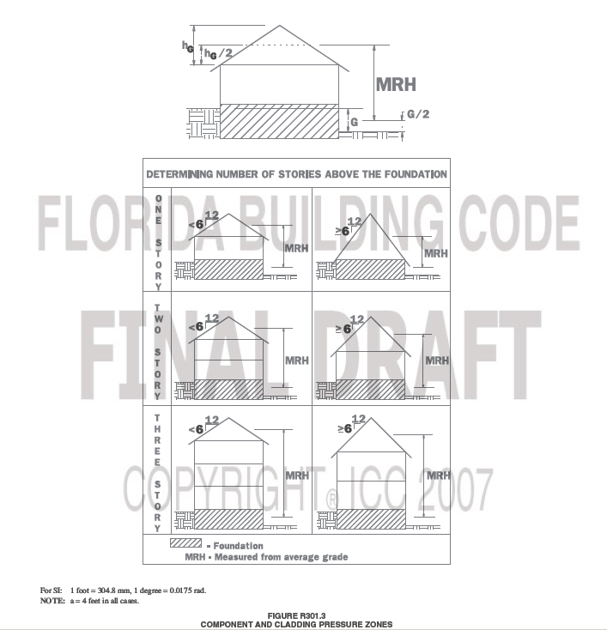
Courtesy, American Forest and Paper Association, Washington, D.C.

Table R302.1 Exterior Walls, revise text to read as follows:

Table R302.1
EXTERIOR WALLS
EXTERIOR WALL ELEMENT |  | MINIMUM  FIRE-RESISTANCE RATING | MINIMUM  FIRE  SEPARATION DISTANCE
Walls | (Fire-Resistance Rated) | 1 hour with exposure  from both sides | 0 feet
Walls | ( Not Fire-Resistance Rated) | 0 Hours | 3 feet
Projections | (Fire-Resistance Rated) | 1 hour on the  underside | 42 feet
Projections | Not (Fire-Resistance Rated) | 0 Hours | 3 feet
Openings | Not Allowed | N/A | N/A
Openings | 25% Maximum Wall Area | 0 Hours | <3 feet
Openings | Unlimited | 0 Hours | 3 feet
Penetrations | All | Comply with Section R317.3 | <3 feet
Penetrations | All | None Required | 3 feet

Section R302.1 Exterior walls, add text to read as follows:

R302.1 Exterior walls. No change.
Exceptions:
1-3 No change.
4. Openings and roof overhang projections shall be permitted on the exterior wall of a building located on a zero lot line when the building exterior wall is separated from an adjacent building exterior wall by a distance of 6 feet or more, and the roof overhang projection is separated from an adjacent building projection by a distance of 4 feet or more, with 1 hour fire resistive construction on the underside of the overhang required, unless the separation between projections is 6 feet or more.

[Mod 2844 revision]

Section R306.3 Sewage disposal, revise text to read as follows:

R306.3 Sewage disposal. All plumbing fixtures shall be connected to a sanitary sewer or to an approved private sewage disposal system in accordance with Chapter 64E-6, Florida Administrative Code, Standards for Onsite Sewage Treatment and Disposal Systems.

[Mod 3065]

Section R308.1 Identification, revise text to read as follows:

R308.1 Identification. Each pane shall bear the manufacturer’s label designating the type and thickness of glass or glazing material. Except as indicated in Section R308.1.1, each pane of glazing installed in hazardous locations as defined in Section R308.4 shall be provided with a manufacturer’s or installer’s label, designating the type and thickness of glass and the safety glazing standard with which it complies, which is visible in the final installation. The safety glazing label shall be acid etched, sandblasted, ceramic-fired, embossed mark, or shall be of a type which once applied cannot be removed without being destroyed. Laminated glass, other than as used for safety glazing, shall be permanently identified as per this section, designating laminator, overall glass thickness and trade name of interlayer.
Exceptions:
1. For other than tempered glass, labels may be omitted provided the building official approves the use of a certificate, affidavit or other evidence furnished by the glazing contractor certifying that each light is glazed in accordance with approved construction documents that comply with the provisions of this chapter confirming compliance with this code.
2. Tempered spandrel glass may be identified by the manufacturer with a removable paper label.

[Mod 3303]

Section R313 Smoke and Carbon Monoxide Alarms, revise text to read as follows:

Section R313 SMOKE and CARBON MONOXIDE ALARMS

Section R313.4 Carbon monoxide protection, add text to read as follows:

R313.4 Carbon monoxide protection. Every building for which a permit for new construction is issued having a fossil-fuel-burning heater or appliance, a fireplace, or an attached garage shall have an operational carbon monoxide alarm installed within 10 feet of each room used for sleeping purposes.

[Mod 2897revised]
R313.4.1 Power Source. In new construction, alarms shall receive their primary power from the building wiring when such wiring is served from the local power utility. Such alarms shall have battery back up.
R313.4.2 Combination alarms. Combination smoke/carbon monoxide alarms shall be listed or labeled by a Nationally Recognized Testing Laboratory.

[Mod 2897]

Section R317.1 Two-family dwellings, revise text to read as follows:

R317.1, Two-family dwellings. No change.
Exceptions:
1. No change.
2. Wall assemblies need not extend through attic spaces when the ceiling is protected by not less than 5/8-inch (15.9 mm) Type X gypsum board and an attic draft stop constructed as specified in Section R502.12.1 Section R502.1.2.1 is provided above and along the wall assembly separating the dwellings. The structural framing supporting the ceiling shall also be protected by not less than 1/2-inch (12.7 mm) gypsum board or equivalent.

[Mod 3282]

Section R317.3.2 is revised to read as follows:

R317.3.2 Membrane penetrations. Membrane penetrations shall comply with Section R317.3.1. Where walls are required to have a minimum fire-resistance rating, recessed fixtures shall be so installed that the required fire resistance will not be reduced.

Exceptions:

1. Membrane penetrations of maximum 2-hour fire-resistance-rated walls and partitions by steel electrical boxes that do not exceed 16 square inches (0.0103 m2) in area provided the aggregate area of the openings through the membrane does not exceed 100 square inches (0.0645 m2) in any 100 square feet (9.29 m2) of wall area. The annular space between the wall membrane and the box shall not exceed 1/8 inch (3.1 mm). Such boxes on opposite sides of the wall shall be separated as follows:

1.1. to 1.5. No change.

2. Membrane

2. Membrane penetrations by listed electrical boxes of any materials provided the boxes have been tested for use in fire-resistance-rated assemblies and are installed in accordance with the instructions included in the listing. The annular space between the wall membrane and the box shall not exceed 1/8 inch (3.1 mm) unless listed otherwise.

Such boxes on opposite sides of the wall shall be separated as follows:

No change to remaining text.

[Staff after]

Section R320.2 Penetration, revise text to read as follows:

R320.2 Penetration. Protective sleeves around metallic piping penetrating concrete slab-on-grade floors shall not be of cellulose-containing materials. and, If soil treatment is used for subterranean termite protection, shall receive application of a termiticide in annular space between sleeve and pipe. the sleeve shall have a maximum wall thickness of 0.010 inch, and be sealed within the slab using a non-corrosive clamping device to eliminate the annular space between the pipe and the sleeve. No termiticides shall be applied inside the sleeve.

[Mod 2840]

Section R320.7 Protection against decay and termites, revise text to read as follows:

R320.7 Protection against decay and termites. Condensate Lines, irrigation/sprinkler system risers for spray heads, and roof downspouts shall discharge at least 1 foot (305 mm) away from the structure sidewall, whether by underground piping, tail extensions or splash blocks. Gutters with downspouts are required on all buildings with eaves of less than 6 inches (152 mm) horizontal projection except for gable end rakes or on a roof above another roof.

[Mod 2986]

Section R326 Elevators and Platform Lifts, revise text to read as follows:

SECTION R326 R323
ELEVATORS AND PLATFORM LIFTS

Section R326.1 Elevators, revise text to read as follows:

R3263.1 Elevators. Where provided, passenger elevators, limited-use/limited-application elevators or private residence elevators shall comply with ASME A17.1.

Section R326.2 Platform Lifts, revise text to read as follows:

R3263.2 Platform lifts. Where provided, platform lifts shall comply with ASME A18.1.

Section R326.3 Accessibility, revise text to read as follows:

R3263.3 Accessibility. Reserved. Elevators or platform lifts that are part of an accessible route required by Chapter 11 of the International Building Code, shall comply with ICC A117.1.

[Mod 3069]

Chapter 4 Foundations

Section R401.1 Application, revise text to read as follows:

R401.1 Application. The provisions of this chapter shall control the design and construction of the foundation and foundation spaces for all buildings. In addition to the provisions of this chapter, the design and construction of foundations in areas prone to flooding as established by Table R301.2(1) shall meet the provisions of Section R323. Wood foundations shall be designed and installed in accordance with AF&PA Report No. 7 (see Section R301.2.1.1).

[Mod 2880]

Table R402.2 Minimum Specified Compressive Strength of Concrete, revise text to read as follows:

Note b. See Table R301.2(1) R301.2(3) for weathering potential.

[Mod 3255]

Section R404.3 Wood sill plates, revise to read as follows:

R404.3 Wood sill plates. Wood sill plates shall be a minimum of 2-inch by 4-inch (51 mm by 102 mm) nominal lumber. Sill plate anchorage shall be in accordance with Sections R403.1.6 and R602.11.

[Staff Comment]

Section R408.3 Unvented crawl space, revise text to read as follows:

R408.3 Unvented crawl space. Ventilation openings in under-floor spaces specified in Sections R408.1 and R408.2 shall not be required where:
1. Exposed earth is covered with a continuous vapor retarder. Joints of the vapor retarder shall overlap by 6 inches (152 mm) and shall be sealed or taped. The edges of the vapor retarder shall extend at least 6 inches (152 mm) up the stem wall and shall be attached and sealed to the stem wall; and
2. One of the following is provided for the under-floor space:
2.1. Continuously operated mechanical exhaust ventilation at a rate equal to 1 cfm (0.47 L/s) for each 50 ft² (4.7m²) of crawlspace floor area, including an air pathway to the common area (such as a duct or transfer grille), and perimeter walls insulated in accordance with Section B2.5.6 of Appendix G N1102.2.8;
2.2. Conditioned air supply sized to deliver at a rate equal to 1 cfm (0.47 L/s) for each 50 ft² (4.7 m²) of under-floor area, including a return air pathway to the common area (such as a duct or transfer grille), and perimeter walls insulated in accordance with Section B2.5.6 of Appendix G N1102.2.8;
2.3. Plenum complying with Section M1601.4, if under-floor space is used as a plenum.

[Mod 3085]

Chapter 6 Wall Construction

Table R609.3.3A-4 Grade 40 Single Story and Top Story Walls Parallel to Ridge Vertical Reinforcement Spacing No. 4 Bars (1/2”) is revised to read as follows:

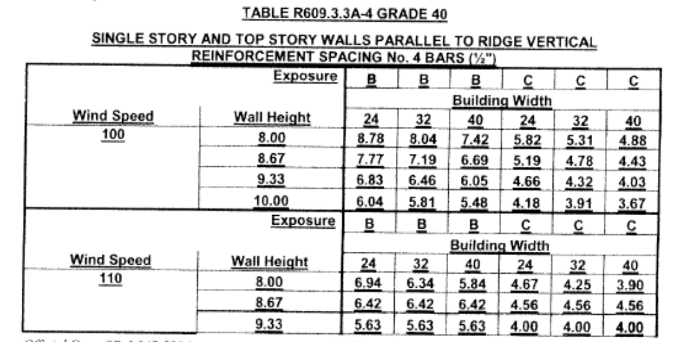
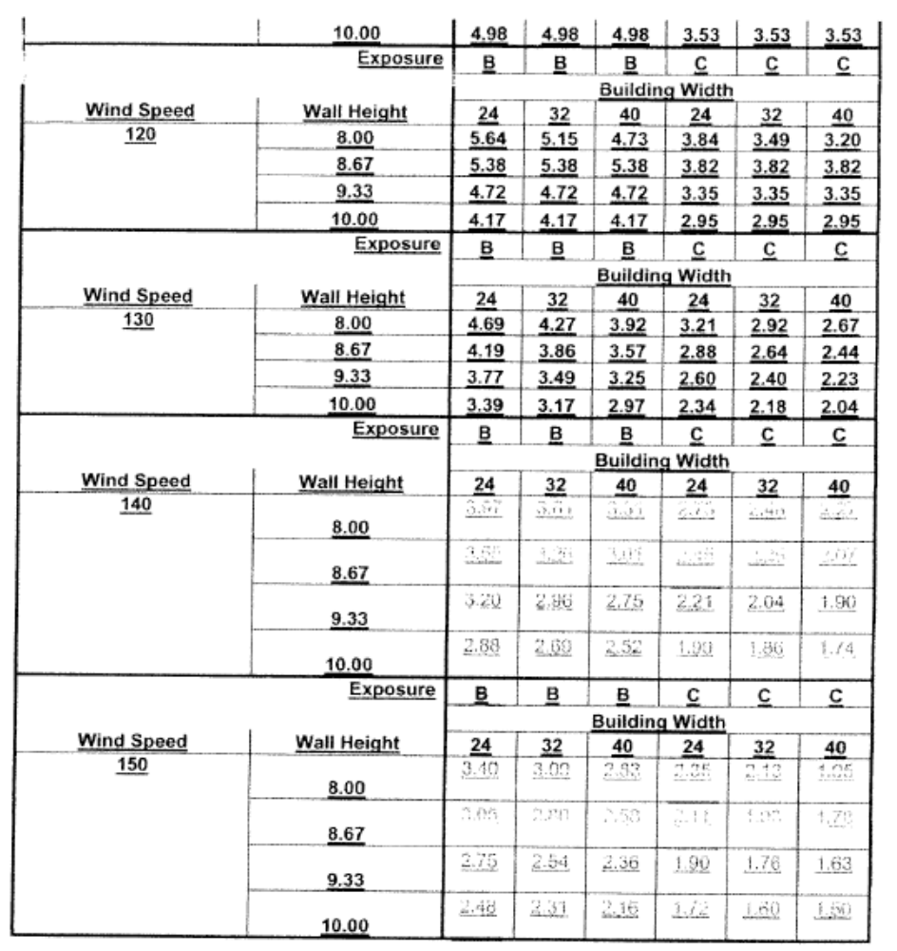

Table R609.3.3A-2 Grade 60 Single Story and Top Story Walls Parallel to Ridge Vertical Reinforcement Spacing No. 4 Bars (1/2”) is revised to read as follows:

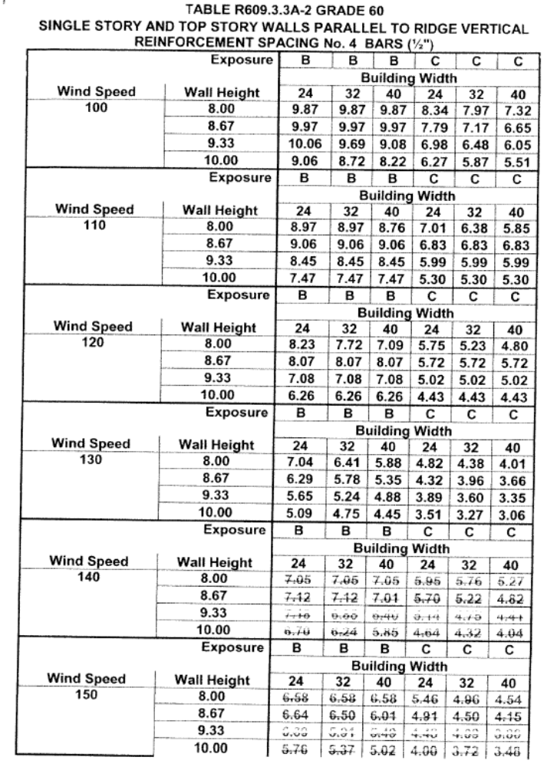
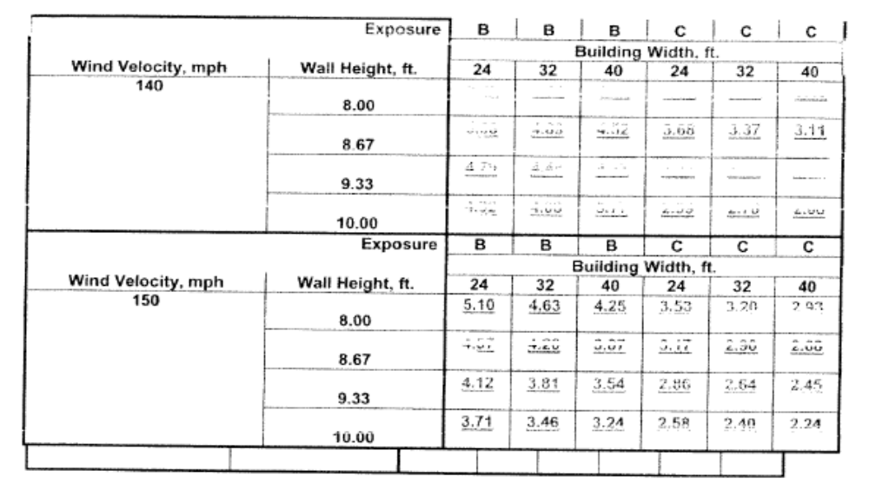
[Mod 3355revised]

Table R609.5.1.A Grade 60, revise text to read as follows:

TABLE R609.5.1A Grade 60
REQUIRED SHEARWALL LENGTH PARALLEL TO RIDGE NO. 4 REINFORCEMENT^{1,2,3,5}
 |  | ROOF ANGLE ≤23°
TOP STORY |  |  |  |  | 1ST STORY OF 2 STORY OR 2ND STORY OF 3 STORY |  |  | 1ST STORY OF 3 STORY
Exp-osure | Wind Speed | BUILDING WIDTH |  |  | BUILDING WIDTH |  |  | BUILDING WIDTH
Exp-osure | Wind Speed | 24 | 32 | 40 | 24 | 32 | 40 | 24 | 32 | 40
B | 100 | 1.62 | 2.31 | 3.14 | 3.68 | 4.98 | 6.49 | 5.41 | 7.28 | 9.43
B | 110 | 1.96 | 2.79 | 3.80 | 4.45 | 6.03 | 7.85 | 6.55 | 8.81 | 11.42
B | 120 | 2.33 | 3.32 | 4.52 | 5.30 | 7.17 | 9.34 | 7.79 | 10.48 | 13.58
B | 130 | 2.73 | 3.90 | 5.31 | 6.22 | 8.42 | 10.96 | 9.14 | 12.30 | 15.94
B | 140 | 3.17 | 4.52 | 6.16 | 7.22 | 9.76 | 12.71 | 10.60 | 14.27 | 18.49
B | 150 | 3.64 | 5.19 | 7.07 | 8.28 | 11.21 | 14.59 | 12.17 | 16.38 | 21.23
C | 100 | 1.92 | 2.77 | 3.82 | 4.86 | 6.63 | 8.69 | 7.56 | 10.15 | 13.13
C | 110 | 2.32 | 3.35 | 4.62 | 5.88 | 8.02 | 10.52 | 9.14 | 12.28 | 15.88
C | 120 | 2.76 | 3.99 | 5.50 | 7.00 | 9.54 | 12.52 | 10.88 | 14.61 | 18.90
C | 130 | 3.24 | 4.68 | 6.46 | 8.21 | 11.20 | 14.69 | 12.77 | 17.15 | 22.18
C | 140 | 3.76 | 5.43 | 7.49 | 9.53 | 12.99 | 17.04 | 14.81 | 19.89 | 25.73
C | 150 | 4.32 | 6.23 | 8.59 | 10.94 | 14.91 | 19.56 | 17.00 | 22.83 | 29.53
REQUIRED SHEARWALL LENGTH PARALLEL TO RIDGE NO. 5 REINFORCEMENT^{1,2,3,6}
 |  | ROOF ANGLE ≤23°
TOP STORY |  |  |  |  | 1ST STORY OF 2 STORY OR 2ND STORY OF 3 STORY |  |  | 1ST STORY OF 3 STORY
Exp-osure | Wind Speed | BUILDING WIDTH |  |  | BUILDING WIDTH |  |  | BUILDING WIDTH
Exp-osure | Wind Speed | 24 | 32 | 40 | 24 | 32 | 40 | 24 | 32 | 40
B | 100 | 1.09 | 1.55 | 2.12 | 2.48 | 3.35 | 4.37 | 3.64 | 4.90 | 6.35
B | 110 | 1.32 | 1.88 | 2.56 | 3.00 | 4.06 | 5.28 | 4.41 | 5.93 | 7.68
B | 120 | 1.57 | 2.23 | 3.05 | 3.57 | 4.83 | 6.29 | 5.24 | 7.06 | 9.14
B | 130 | 1.84 | 2.62 | 3.57 | 4.19 | 5.67 | 7.38 | 6.16 | 8.28 | 10.73
B | 140 | 2.13 | 3.04 | 4.15 | 4.86 | 6.57 | 8.56 | 7.14 | 9.60 | 12.45
B | 150 | 2.45 | 3.49 | 4.76 | 5.58 | 7.54 | 9.82 | 8.19 | 11.02 | 14.29
C | 100 | 1.29 | 1.86 | 2.57 | 3.27 | 4.46 | 5.85 | 5.09 | 6.83 | 8.84
C | 110 | 1.56 | 2.26 | 3.11 | 3.96 | 5.40 | 7.08 | 6.16 | 8.26 | 10.69
C | 120 | 1.86 | 2.68 | 3.70 | 4.71 | 6.42 | 8.43 | 7.33 | 9.84 | 12.72
C | 130 | 2.18 | 3.15 | 4.35 | 5.53 | 7.54 | 9.89 | 8.60 | 11.54 | 14.93
C | 140 | 2.53 | 3.65 | 5.04 | 6.41 | 8.74 | 11.47 | 9.97 | 13.39 | 17.32
C | 150 | 2.91 | 4.19 | 5.79 | 7.36 | 10.04 | 13.17 | 11.45 | 15.37 | 19.88
Notes:

1. The cumulative shear wall segment length for each side of the building shall be equal to or greater than the tabular shear wall length required. If the required shear wall segment length provided is not one continuous shear wall segment, the total shear wall length required shall be increased by 0.67 feet (8 inches) for each additional shear wall segment making up the total shear wall length on a side.
2. The mMinimum shear wall segment length shall be 2 feet-0 inches. Values less than 2 feet-0 inches (610 mm) are shown only for summation of shear wall segments and for interpolation purposes. FilledA grouted cell with vertical reinforcement of the size indicated is reinforcing steel bar required at each end of every shear wall segment.
3. Portions of walls with openings shall not be considered part of the shear wall length. Other than incidental utility penetrations, shearwall piers and shearwall segments shall not contain openings with a maximum horizontal or vertical dimension of 5 inches for piers and 12 inches for portions of shearwall segments above and below piers. The total area of openings in any one segment of shearwall shall not exceed 144 square inches.
4. Required shearwall lengths normal (perpendicular) to the ridge are per lineal foot of building length. Multiply tabular values by building length (distance between adjacent shear walls perpendicular to the ridge if interior shear walls are used for total shear wall length required.
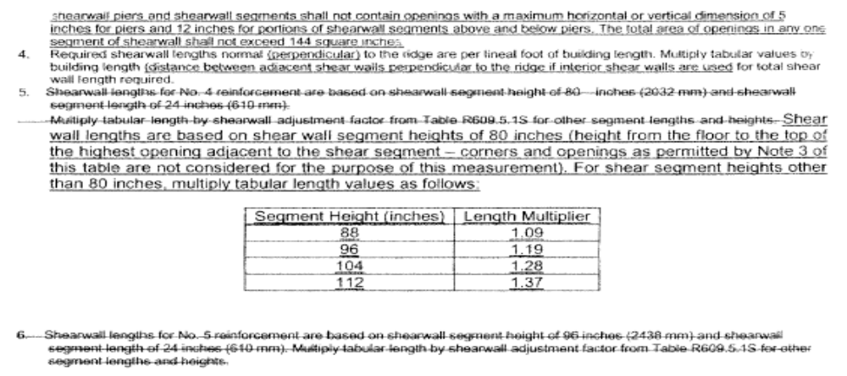
[Mod 3355 revised]

Table R609.5.1B Grade 60, revise text to read as follows:

TABLE R609.5.1B Grade 60
REQUIRED SHEARWALL LENGTH PARALLEL TO RIDGE NO. 4 REINFORCEMENT^{1,2,3,5}
 |  | ROOF ANGLE 30°
TOP STORY |  |  |  |  | 1ST STORY OF 2 STORY OR 2ND STORY OF 3 STORY |  |  | 1ST STORY OF 3 STORY
Exp-osure | Wind Speed | BUILDING WIDTH |  |  | BUILDING WIDTH |  |  | BUILDING WIDTH
Exp-osure | Wind Speed | 24 | 32 | 40 | 24 | 32 | 40 | 24 | 32 | 40
B | 100 | 1.66 | 2.45 | 3.40 | 3.55 | 4.92 | 6.49 | 5.18 | 7.13 | 9.36
B | 110 | 2.01 | 2.96 | 4.11 | 4.30 | 5.96 | 7.86 | 6.27 | 8.63 | 11.32
B | 120 | 2.39 | 3.52 | 4.89 | 5.12 | 7.09 | 9.35 | 7.46 | 10.27 | 13.47
B | 130 | 2.81 | 4.13 | 5.74 | 6.00 | 8.32 | 10.97 | 8.76 | 12.05 | 15.81
B | 140 | 3.26 | 4.79 | 6.66 | 6.96 | 9.65 | 12.73 | 10.15 | 13.98 | 18.34
B | 150 | 3.74 | 5.50 | 7.64 | 7.99 | 11.08 | 14.61 | 11.66 | 16.05 | 21.05
C | 100 | 2.00 | 2.99 | 4.21 | 4.73 | 6.62 | 8.82 | 7.22 | 9.92 | 12.97
C | 110 | 2.42 | 3.62 | 5.10 | 5.72 | 8.01 | 10.67 | 8.74 | 12.00 | 15.70
C | 120 | 2.88 | 4.30 | 6.07 | 6.81 | 9.53 | 12.70 | 10.40 | 14.28 | 18.68
C | 130 | 3.37 | 5.05 | 7.12 | 7.99 | 11.19 | 14.90 | 12.20 | 16.76 | 21.92
C | 140 | 3.91 | 5.86 | 8.26 | 9.27 | 12.98 | 17.28 | 14.15 | 19.43 | 25.43
C | 150 | 4.49 | 6.73 | 9.48 | 10.64 | 14.90 | 19.84 | 16.25 | 22.31 | 29.19
REQUIRED SHEARWALL LENGTH PARALLEL TO RIDGE NO. 5 REINFORCEMENT^{1,2,3,6}
 |  | ROOF ANGLE 30°
TOP STORY |  |  |  |  | 1ST STORY OF 2 STORY OR 2ND STORY OF 3 STORY |  |  | 1ST STORY OF 3 STORY
Exp-osure | Wind Speed | BUILDING WIDTH |  |  | BUILDING WIDTH |  |  | BUILDING WIDTH
Exp-osure | Wind Speed | 24 | 32 | 40 | 24 | 32 | 40 | 24 | 32 | 40
B | 100 | 1.12 | 1.65 | 2.29 | 2.39 | 3.31 | 4.37 | 3.49 | 4.80 | 6.30
B | 110 | 1.35 | 1.99 | 2.77 | 2.89 | 4.01 | 5.29 | 4.22 | 5.81 | 7.62
B | 120 | 1.61 | 2.37 | 3.29 | 3.44 | 4.77 | 6.29 | 5.02 | 6.91 | 9.07
B | 130 | 1.89 | 2.78 | 3.86 | 4.04 | 5.60 | 7.39 | 5.89 | 8.11 | 10.64
B | 140 | 2.19 | 3.23 | 4.48 | 4.69 | 6.50 | 8.57 | 6.84 | 9.41 | 12.34
B | 150 | 2.52 | 3.71 | 5.14 | 5.38 | 7.46 | 9.83 | 7.85 | 10.80 | 14.17
C | 100 | 1.34 | 2.01 | 2.84 | 3.18 | 4.46 | 5.93 | 4.86 | 6.67 | 8.73
C | 110 | 1.63 | 2.44 | 3.43 | 3.85 | 5.39 | 7.18 | 5.88 | 8.08 | 10.57
C | 120 | 1.94 | 2.90 | 4.08 | 4.58 | 6.42 | 8.55 | 7.00 | 9.61 | 12.57
C | 130 | 2.27 | 3.40 | 4.79 | 5.38 | 7.53 | 10.03 | 8.21 | 11.28 | 14.76
C | 140 | 2.63 | 3.94 | 5.56 | 6.24 | 8.74 | 11.63 | 9.53 | 13.08 | 17.12
C | 150 | 3.02 | 4.53 | 6.38 | 7.16 | 10.03 | 13.35 | 10.94 | 15.02 | 19.65
Notes:

1. The cumulative shear wall segment length for each side of the building shall be equal to or greater than the tabular shear wall length required. If the required shear wall segment length provided is not one continuous shear wall segment, the total shear wall length required shall be increased by 0.67 feet (8 inches) for each additional shear wall segment making up the total shear wall length on a side.
2. The mMinimum shear wall segment length shall be 2 feet-0 inches. Values less than 2 feet-0 inches (610 mm) are shown only for summation of shear wall segments and for interpolation purposes. FilledA grouted cell with vertical reinforcement of the size indicated is reinforcing steel bar required at each end of every shear wall segment.
3. Portions of walls with openings shall not be considered part of the shear wall length. Other than incidental utility penetrations, shearwall piers and shearwall segments shall not contain openings with a maximum horizontal or vertical dimension of 5 inches for piers and 12 inches for portions of shearwall segments above and below piers. The total area of openings in any one segment of shearwall shall not exceed 144 square inches.
4. Required shearwall lengths normal (perpendicular) to the ridge are per lineal foot of building length. Multiply tabular values by building length (distance between adjacent shear walls perpendicular to the ridge if interior shear walls are used for total shear wall length required.
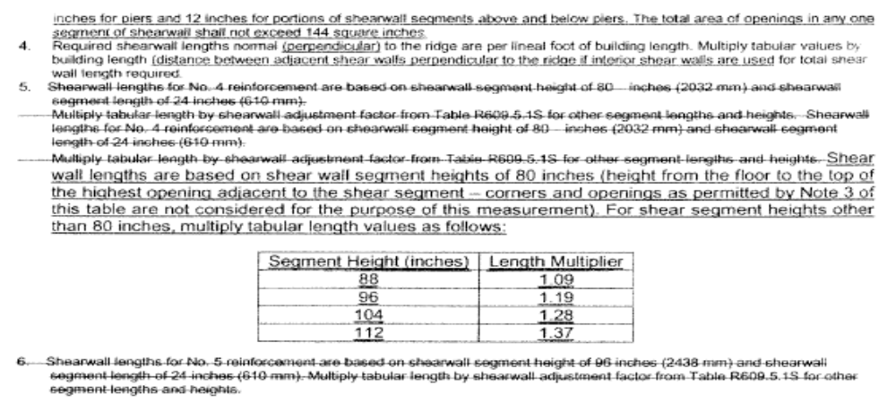
[Mod 3355revised]

Table R609.5.1C Grade 60, revise text to read as follows:

TABLE R609.1.5C Grade 60
REQUIRED SHEARWALL LENGTH PARALLEL TO RIDGE NO. 4 REINFORCEMENT^{1,2,3,5}
 |  | ROOF ANGLE 45°
TOP STORY |  |  |  |  | 1ST STORY OF 2 STORY OR 2ND STORY OF 3 STORY |  |  | 1ST STORY OF 3 STORY
Exp-osure | Wind Speed | BUILDING WIDTH |  |  | BUILDING WIDTH |  |  | BUILDING WIDTH
Exp-osure | Wind Speed | 24 | 32 | 40 | 24 | 32 | 40 | 24 | 32 | 40
B | 100 | 2.11 | 3.24 | 4.64 | 2.11 | 5.72 | 7.73 | 5.77 | 8.17 | 11.00
B | 110 | 2.56 | 3.92 | 5.61 | 4.85 | 6.92 | 9.36 | 6.98 | 9.89 | 13.31
B | 120 | 3.05 | 4.67 | 6.68 | 5.77 | 8.23 | 11.13 | 8.31 | 11.77 | 15.85
B | 130 | 3.57 | 5.48 | 7.84 | 6.77 | 9.66 | 13.07 | 9.75 | 13.81 | 18.60
B | 140 | 4.15 | 6.35 | 9.09 | 7.85 | 11.20 | 15.16 | 11.31 | 16.02 | 21.57
B | 150 | 4.76 | 7.29 | 10.43 | 9.01 | 12.86 | 17.40 | 12.98 | 18.39 | 24.76
C | 100 | 2.63 | 4.13 | 6.03 | 5.45 | 7.90 | 10.84 | 7.22 | 9.92 | 12.97
C | 110 | 3.18 | 4.99 | 7.30 | 6.60 | 9.56 | 13.12 | 8.74 | 12.00 | 15.70
C | 120 | 3.79 | 5.94 | 8.68 | 7.85 | 11.38 | 15.61 | 10.40 | 14.28 | 18.68
C | 130 | 4.45 | 6.97 | 10.19 | 9.21 | 13.35 | 18.32 | 12.20 | 16.76 | 21.92
C | 140 | 5.16 | 8.09 | 11.82 | 10.68 | 15.48 | 21.25 | 14.15 | 19.43 | 25.43
C | 150 | 5.92 | 9.28 | 13.57 | 12.26 | 17.77 | 24.39 | 16.25 | 22.31 | 29.19
REQUIRED SHEARWALL LENGTH PARALLEL TO RIDGE NO. 5 REINFORCEMENT^{1,2,3,6}
 |  | ROOF ANGLE 45°
TOP STORY |  |  |  |  | 1ST STORY OF 2 STORY OR 2ND STORY OF 3 STORY |  |  | 1ST STORY OF 3 STORY
Exp-osure | Wind Speed | BUILDING WIDTH |  |  | BUILDING WIDTH |  |  | BUILDING WIDTH
Exp-osure | Wind Speed | 24 | 32 | 40 | 24 | 32 | 40 | 24 | 32 | 40
B | 100 | 1.42 | 2.18 | 3.12 | 2.70 | 3.85 | 5.21 | 3.88 | 5.50 | 7.41
B | 110 | 1.72 | 2.64 | 3.78 | 3.26 | 4.66 | 6.30 | 4.70 | 6.66 | 8.96
B | 120 | 2.05 | 3.14 | 4.49 | 3.88 | 5.54 | 7.50 | 5.59 | 7.92 | 10.67
B | 130 | 2.41 | 3.69 | 5.27 | 4.56 | 6.50 | 8.80 | 6.56 | 9.30 | 12.52
B | 140 | 2.79 | 4.27 | 6.12 | 5.29 | 7.54 | 10.20 | 7.61 | 10.78 | 14.52
B | 150 | 3.20 | 4.91 | 7.02 | 6.07 | 8.66 | 11.71 | 8.74 | 12.38 | 16.67
C | 100 | 1.77 | 2.78 | 4.06 | 3.67 | 5.32 | 7.30 | 5.38 | 7.59 | 10.18
C | 110 | 2.14 | 3.36 | 4.91 | 4.44 | 6.43 | 8.83 | 6.51 | 9.19 | 12.32
C | 120 | 2.55 | 4.00 | 5.85 | 5.28 | 7.66 | 10.51 | 7.75 | 10.93 | 14.66
C | 130 | 2.99 | 4.69 | 6.86 | 6.20 | 8.99 | 12.33 | 9.09 | 12.83 | 17.21
C | 140 | 3.47 | 5.44 | 7.96 | 7.19 | 10.42 | 14.30 | 10.55 | 14.88 | 19.96
C | 150 | 3.98 | 6.25 | 9.13 | 8.26 | 11.96 | 16.42 | 12.11 | 17.09 | 22.91
Notes:

1. The cumulative shear wall segment length for each side of the building shall be equal to or greater than the tabular shear wall length required. If the required shear wall segment length provided is not one continuous shear wall segment, the total shear wall length required shall be increased by 0.67 feet (8 inches) for each additional shear wall segment making up the total shear wall length on a side.
2. The mMinimum shear wall segment length shall be 2 feet-0 inches. Values less than 2 feet-0 inches (610 mm) are shown only for summation of shear wall segments and for interpolation purposes. FilledA grouted cell with vertical reinforcement of the size indicated is reinforcing steel bar required at each end of every shear wall segment.
3. Portions of walls with openings shall not be considered part of the shear wall length. Other than incidental utility penetrations, shearwall piers and shearwall segments shall not contain openings with a maximum horizontal or vertical dimension of 5 inches for piers and 12 inches for portions of shearwall segments above and below piers. The total area of openings in any one segment of shearwall shall not exceed 144 square inches.
4. Required shearwall lengths normal (perpendicular) to the ridge are per lineal foot of building length. Multiply tabular values by building length (distance between adjacent shear walls perpendicular to the ridge if interior shear walls are used for total shear wall length required.
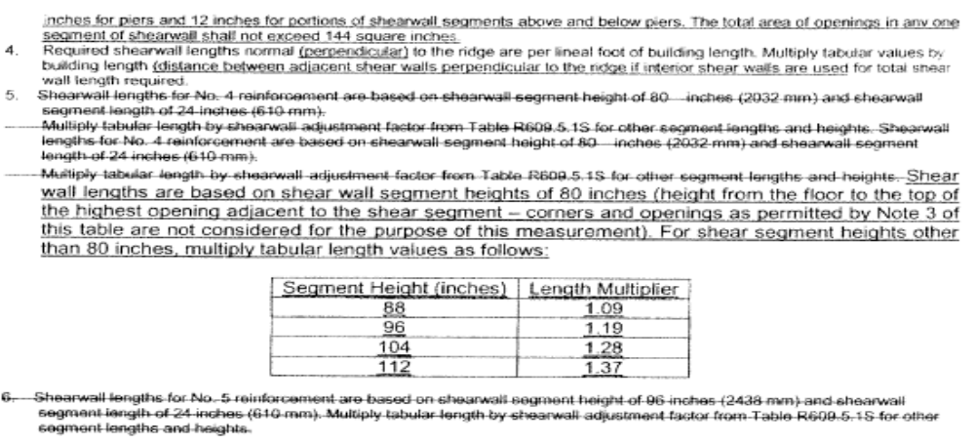

[Mod 3355revised]

Table R609.5.1D Grade 60, revise text to read as follows:

TABLE R609.5.1D Grade 60
REQUIRED SHEARWALL LENGTH PERPENDICULAR TO RIDGE - NO. 4 REINFORCEMENT
PER FOOT OF BUILDING LENGTH^{1,2,3,4,5}
ROOF ANGLE 23°
TOP STORY |  |  |  |  | 1ST STORY OF 2 STORY OR 2ND STORY OF 3 STORY |  |  | 1ST STORY OF 3 STORY
Exp-osure | Wind Speed | BUILDING WIDTH |  |  | BUILDING WIDTH |  |  | BUILDING WIDTH
Exp-osure | Wind Speed | 24 | 32 | 40 | 24 | 32 | 40 | 24 | 32 | 40
B | 100 | 0.054 | 0.053 | 0.053 | 0.142 | 0.142 | 0.141 | 0.231 | 0.231 | 0.230
B | 110 | 0.065 | 0.065 | 0.064 | 0.172 | 0.172 | 0.171 | 0.279 | 0.279 | 0.278
B | 120 | 0.077 | 0.077 | 0.076 | 0.205 | 0.204 | 0.204 | 0.333 | 0.332 | 0.331
B | 130 | 0.091 | 0.090 | 0.089 | 0.240 | 0.240 | 0.239 | 0.390 | 0.390 | 0.389
B | 140 | 0.105 | 0.104 | 0.103 | 0.279 | 0.278 | 0.277 | 0.453 | 0.452 | 0.451
B | 150 | 0.121 | 0.120 | 0.119 | 0.320 | 0.319 | 0.318 | 0.520 | 0.519 | 0.518
C | 100 | 0.075 | 0.075 | 0.074 | 0.199 | 0.199 | 0.198 | 0.324 | 0.323 | 0.322
C | 110 | 0.091 | 0.090 | 0.089 | 0.241 | 0.241 | 0.240 | 0.392 | 0.391 | 0.390
C | 120 | 0.108 | 0.108 | 0.106 | 0.287 | 0.287 | 0.285 | 0.466 | 0.466 | 0.464
C | 130 | 0.127 | 0.126 | 0.125 | 0.337 | 0.336 | 0.335 | 0.547 | 0.546 | 0.545
C | 140 | 0.147 | 0.147 | 0.145 | 0.391 | 0.390 | 0.388 | 0.635 | 0.634 | 0.632
C | 150 | 0.169 | 0.168 | 0.166 | 0.449 | 0.448 | 0.446 | 0.729 | 0.728 | 0.726
REQUIRED SHEARWALL LENGTH PERPENDICULAR TO RIDGE - NO. 5 REINFORCEMENT
PER FOOT OF BUILDING LENGTH^{1,2,3,4,6}
ROOF ANGLE 23°
TOP STORY |  |  |  |  | 1ST STORY OF 2 STORY OR 2ND STORY OF 3 STORY |  |  | 1ST STORY OF 3 STORY
Exp-osure | Wind Speed | BUILDING WIDTH |  |  | BUILDING WIDTH |  |  | BUILDING WIDTH
Exp-osure | Wind Speed | 24 | 32 | 40 | 24 | 32 | 40 | 24 | 32 | 40
B | 100 | 0.036 | 0.036 | 0.035 | 0.096 | 0.096 | 0.095 | 0.155 | 0.155 | 0.155
B | 110 | 0.044 | 0.043 | 0.043 | 0.116 | 0.116 | 0.115 | 0.188 | 0.188 | 0.187
B | 120 | 0.052 | 0.052 | 0.051 | 0.138 | 0.138 | 0.137 | 0.224 | 0.224 | 0.223
B | 130 | 0.061 | 0.061 | 0.060 | 0.162 | 0.162 | 0.161 | 0.263 | 0.262 | 0.262
B | 140 | 0.071 | 0.070 | 0.070 | 0.188 | 0.187 | 0.186 | 0.305 | 0.304 | 0.303
B | 150 | 0.081 | 0.081 | 0.080 | 0.215 | 0.215 | 0.214 | 0.350 | 0.349 | 0.348
C | 100 | 0.051 | 0.050 | 0.050 | 0.134 | 0.134 | 0.133 | 0.218 | 0.218 | 0.217
C | 110 | 0.061 | 0.061 | 0.060 | 0.162 | 0.162 | 0.161 | 0.264 | 0.263 | 0.263
C | 120 | 0.073 | 0.072 | 0.072 | 0.193 | 0.193 | 0.192 | 0.314 | 0.313 | 0.313
C | 130 | 0.086 | 0.085 | 0.084 | 0.227 | 0.226 | 0.225 | 0.368 | 0.368 | 0.367
C | 140 | 0.099 | 0.099 | 0.097 | 0.263 | 0.263 | 0.261 | 0.427 | 0.427 | 0.425
C | 150 | 0.114 | 0.113 | 0.112 | 0.302 | 0.301 | 0.300 | 0.490 | 0.490 | 0.488
Notes:

1. The cumulative shear wall segment length for each side of the building shall be equal to or greater than the tabular shear wall length required. If the required shear wall segment length provided is not one continuous shear wall segment, the total shear wall length required shall be increased by 0.67 feet (8 inches) for each additional shear wall segment making up the total shear wall length on a side.
2. The mMinimum shear wall segment length shall be 2 feet-0 inches. Values less than 2 feet-0 inches (610 mm) are shown only for summation of shear wall segments and for interpolation purposes. FilledA grouted cell with vertical reinforcement of the size indicated is reinforcing steel bar required at each end of every shear wall segment.
3. Portions of walls with openings shall not be considered part of the shear wall length. Other than incidental utility penetrations, shearwall piers and shearwall segments shall not contain openings with a maximum horizontal or vertical dimension of 5 inches for piers and 12 inches for portions of shearwall segments above and below piers. The total area of openings in any one segment of shearwall shall not exceed 144 square inches.
4. Required shearwall lengths normal (perpendicular) to the ridge are per lineal foot of building length. Multiply tabular values by building length (distance between adjacent shear walls perpendicular to the ridge if interior shear walls are used for total shear wall length required.
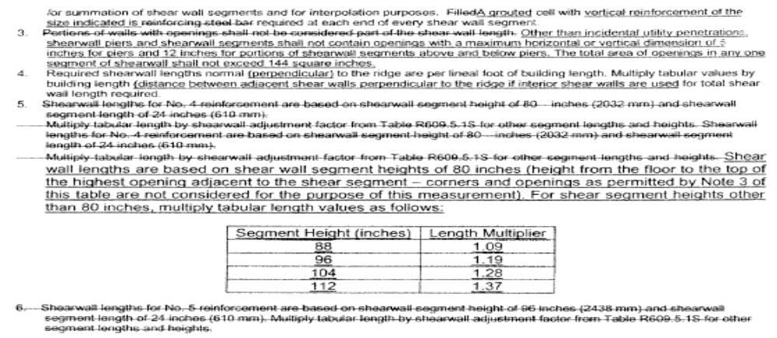
[Mod 3355revised]

Table R609.5.1E Grade 60, revise text to read as follows:

TABLE R609.5.1E Grade 60
REQUIRED SHEARWALL LENGTH PERPENDICULAR TO RIDGE - NO. 4 REINFORCEMENT
PER FOOT OF BUILDING LENGTH^{1,2,3,4,5}
ROOF ANGLE 30°
TOP STORY |  |  |  |  | 1ST STORY OF 2 STORY OR 2ND STORY OF 3 STORY |  |  | 1ST STORY OF 3 STORY
Exp-osure | Wind Speed | BUILDING WIDTH |  |  | BUILDING WIDTH |  |  | BUILDING WIDTH
Exp-osure | Wind Speed | 24 | 32 | 40 | 24 | 32 | 40 | 24 | 32 | 40
B | 100 | 0.088 | 0.102 | 0.117 | 0.166 | 0.180 | 0.195 | 0.243 | 0.257 | 0.272
B | 110 | 0.107 | 0.124 | 0.142 | 0.201 | 0.217 | 0.236 | 0.294 | 0.311 | 0.329
B | 120 | 0.127 | 0.147 | 0.169 | 0.239 | 0.259 | 0.280 | 0.350 | 0.371 | 0.392
B | 130 | 0.149 | 0.173 | 0.198 | 0.280 | 0.304 | 0.329 | 0.411 | 0.435 | 0.460
B | 140 | 0.173 | 0.200 | 0.230 | 0.325 | 0.352 | 0.382 | 0.477 | 0.504 | 0.534
B | 150 | 0.199 | 0.230 | 0.264 | 0.373 | 0.404 | 0.438 | 0.548 | 0.579 | 0.613
C | 100 | 0.124 | 0.143 | 0.164 | 0.232 | 0.252 | 0.273 | 0.341 | 0.361 | 0.382
C | 110 | 0.150 | 0.173 | 0.199 | 0.281 | 0.305 | 0.330 | 0.413 | 0.437 | 0.462
C | 120 | 0.178 | 0.206 | 0.237 | 0.335 | 0.363 | 0.393 | 0.491 | 0.519 | 0.550
C | 130 | 0.209 | 0.242 | 0.278 | 0.393 | 0.426 | 0.461 | 0.577 | 0.610 | 0.645
C | 140 | 0.242 | 0.281 | 0.322 | 0.456 | 0.494 | 0.535 | 0.669 | 0.707 | 0.748
C | 150 | 0.278 | 0.322 | 0.370 | 0.523 | 0.567 | 0.614 | 0.768 | 0.812 | 0.859
REQUIRED SHEARWALL LENGTH PERPENDICULAR TO RIDGE - NO. 5 REINFORCEMENT
PER FOOT OF BUILDING LENGTH^{1,2,3,4,6}
ROOF ANGLE 30°
TOP STORY |  |  |  |  | 1ST STORY OF 2 STORY OR 2ND STORY OF 3 STORY |  |  | 1ST STORY OF 3 STORY
Exp-osure | Wind Speed | BUILDING WIDTH |  |  | BUILDING WIDTH |  |  | BUILDING WIDTH
Exp-osure | Wind Speed | 24 | 32 | 40 | 24 | 32 | 40 | 24 | 32 | 40
B | 100 | 0.059 | 0.069 | 0.079 | 0.112 | 0.121 | 0.131 | 0.164 | 0.173 | 0.183
B | 110 | 0.072 | 0.083 | 0.095 | 0.135 | 0.146 | 0.159 | 0.198 | 0.210 | 0.222
B | 120 | 0.086 | 0.099 | 0.114 | 0.161 | 0.174 | 0.189 | 0.236 | 0.249 | 0.264
B | 130 | 0.100 | 0.116 | 0.133 | 0.189 | 0.204 | 0.222 | 0.277 | 0.293 | 0.310
B | 140 | 0.116 | 0.135 | 0.155 | 0.219 | 0.237 | 0.257 | 0.321 | 0.339 | 0.359
B | 150 | 0.134 | 0.155 | 0.177 | 0.251 | 0.272 | 0.295 | 0.369 | 0.390 | 0.412
C | 100 | 0.083 | 0.096 | 0.111 | 0.156 | 0.170 | 0.184 | 0.230 | 0.243 | 0.257
C | 110 | 0.101 | 0.117 | 0.134 | 0.189 | 0.205 | 0.222 | 0.278 | 0.294 | 0.311
C | 120 | 0.120 | 0.139 | 0.159 | 0.225 | 0.244 | 0.265 | 0.331 | 0.350 | 0.370
C | 130 | 0.141 | 0.163 | 0.187 | 0.264 | 0.287 | 0.311 | 0.388 | 0.410 | 0.434
C | 140 | 0.163 | 0.189 | 0.217 | 0.307 | 0.333 | 0.360 | 0.450 | 0.476 | 0.504
C | 150 | 0.187 | 0.217 | 0.249 | 0.352 | 0.382 | 0.413 | 0.517 | 0.546 | 0.578
Notes:

1. The cumulative shear wall segment length for each side of the building shall be equal to or greater than the tabular shear wall length required. If the required shear wall segment length provided is not one continuous shear wall segment, the total shear wall length required shall be increased by 0.67 feet (8 inches) for each additional shear wall segment making up the total shear wall length on a side.
2. The mMinimum shear wall segment length shall be 2 feet-0 inches. Values less than 2 feet-0 inches (610 mm) are shown only for summation of shear wall segments and for interpolation purposes. FilledA grouted cell with vertical reinforcement of the size indicated is reinforcing steel bar required at each end of every shear wall segment.
3. Portions of walls with openings shall not be considered part of the shear wall length. Other than incidental utility penetrations, shearwall piers and shearwall segments shall not contain openings with a maximum horizontal or vertical dimension of 5 inches for piers and 12 inches for portions of shearwall segments above and below piers. The total area of openings in any one segment of shearwall shall not exceed 144 square inches.
4. Required shearwall lengths normal (perpendicular) to the ridge are per lineal foot of building length. Multiply tabular values by building length (distance between adjacent shear walls perpendicular to the ridge if interior shear walls are used for total shear wall length required.

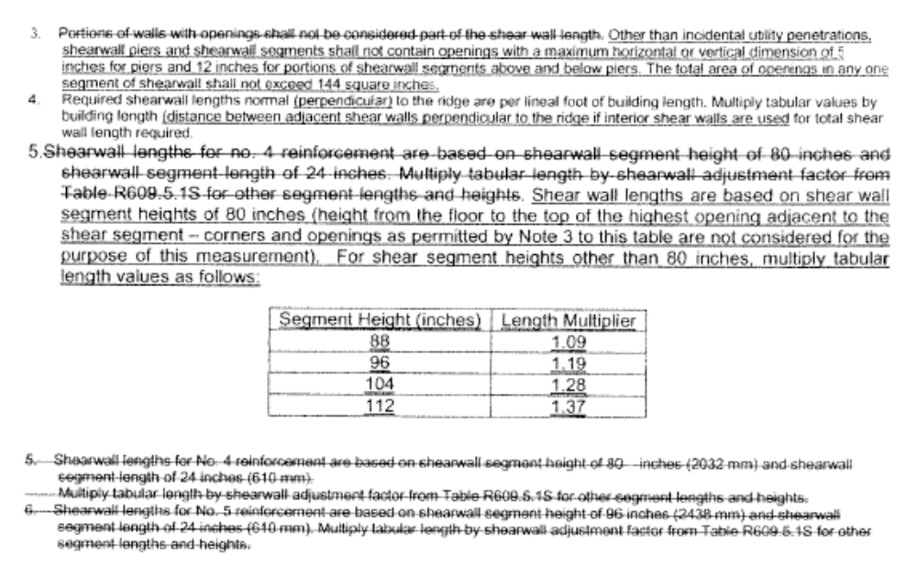
[Mod 3355revised]

Table R609.5.1F Grade 60, revise text to read as follows:

TABLE R609.5.1F Grade 60
REQUIRED SHEARWALL LENGTH PERPENDICULAR TO RIDGE - NO. 4 REINFORCEMENT
PER FOOT OF BUILDING LENGTH^{1,2,3,4,5}
ROOF ANGLE 45°
TOP STORY |  |  |  |  | 1ST STORY OF 2 STORY OR 2ND STORY OF 3 STORY |  |  | 1ST STORY OF 3 STORY
Exp-osure | Wind Speed | BUILDING WIDTH |  |  | BUILDING WIDTH |  |  | BUILDING WIDTH
Exp-osure | Wind Speed | 24 | 32 | 40 | 24 | 32 | 40 | 24 | 32 | 40
B | 100 | 0.118 | 0.142 | 0.168 | 0.196 | 0.220 | 0.246 | 0.273 | 0.297 | 0.323
B | 110 | 0.143 | 0.172 | 0.204 | 0.237 | 0.266 | 0.297 | 0.331 | 0.360 | 0.391
B | 120 | 0.170 | 0.205 | 0.242 | 0.282 | 0.317 | 0.354 | 0.393 | 0.428 | 0.466
B | 130 | 0.200 | 0.241 | 0.284 | 0.331 | 0.372 | 0.415 | 0.462 | 0.503 | 0.546
B | 140 | 0.232 | 0.279 | 0.330 | 0.384 | 0.431 | 0.482 | 0.536 | 0.583 | 0.634
B | 150 | 0.266 | 0.320 | 0.378 | 0.440 | 0.495 | 0.553 | 0.615 | 0.669 | 0.727
C | 100 | 0.166 | 0.200 | 0.236 | 0.274 | 0.308 | 0.345 | 0.383 | 0.417 | 0.453
C | 110 | 0.200 | 0.241 | 0.285 | 0.332 | 0.373 | 0.417 | 0.464 | 0.505 | 0.549
C | 120 | 0.239 | 0.287 | 0.340 | 0.395 | 0.444 | 0.496 | 0.552 | 0.600 | 0.653
C | 130 | 0.280 | 0.337 | 0.399 | 0.464 | 0.521 | 0.582 | 0.647 | 0.705 | 0.766
C | 140 | 0.325 | 0.391 | 0.462 | 0.538 | 0.604 | 0.675 | 0.751 | 0.817 | 0.888
C | 150 | 0.373 | 0.449 | 0.531 | 0.617 | 0.694 | 0.775 | 0.862 | 0.938 | 1.020
REQUIRED SHEARWALL LENGTH PERPENDICULAR TO RIDGE - NO. 5 REINFORCEMENT
PER FOOT OF BUILDING LENGTH^{1,2,3,4,6}
ROOF ANGLE 45°
TOP STORY |  |  |  |  | 1ST STORY OF 2 STORY OR 2ND STORY OF 3 STORY |  |  | 1ST STORY OF 3 STORY
Exp-osure | Wind Speed | BUILDING WIDTH |  |  | BUILDING WIDTH |  |  | BUILDING WIDTH
Exp-osure | Wind Speed | 24 | 32 | 40 | 24 | 32 | 40 | 24 | 32 | 40
B | 100 | 0.080 | 0.096 | 0.113 | 0.132 | 0.148 | 0.165 | 0.184 | 0.200 | 0.218
B | 110 | 0.096 | 0.116 | 0.137 | 0.159 | 0.179 | 0.200 | 0.223 | 0.242 | 0.263
B | 120 | 0.115 | 0.138 | 0.163 | 0.190 | 0.213 | 0.238 | 0.265 | 0.288 | 0.313
B | 130 | 0.134 | 0.162 | 0.191 | 0.223 | 0.250 | 0.280 | 0.311 | 0.338 | 0.368
B | 140 | 0.156 | 0.188 | 0.222 | 0.258 | 0.290 | 0.324 | 0.361 | 0.392 | 0.427
B | 150 | 0.179 | 0.216 | 0.255 | 0.296 | 0.333 | 0.372 | 0.414 | 0.450 | 0.490
C | 100 | 0.111 | 0.134 | 0.159 | 0.185 | 0.208 | 0.232 | 0.258 | 0.281 | 0.305
C | 110 | 0.135 | 0.163 | 0.192 | 0.223 | 0.251 | 0.281 | 0.312 | 0.340 | 0.369
C | 120 | 0.161 | 0.193 | 0.229 | 0.266 | 0.299 | 0.334 | 0.371 | 0.404 | 0.439
C | 130 | 0.188 | 0.227 | 0.268 | 0.312 | 0.351 | 0.392 | 0.436 | 0.474 | 0.516
C | 140 | 0.219 | 0.263 | 0.311 | 0.362 | 0.407 | 0.455 | 0.505 | 0.550 | 0.598
C | 150 | 0.251 | 0.302 | 0.357 | 0.416 | 0.467 | 0.522 | 0.580 | 0.632 | 0.687
Notes:

1. The cumulative shear wall segment length for each side of the building shall be equal to or greater than the tabular shear wall length required. If the required shear wall segment length provided is not one continuous shear wall segment, the total shear wall length required shall be increased by 0.67 feet (8 inches) for each additional shear wall segment making up the total shear wall length on a side.
2. The mMinimum shear wall segment length shall be 2 feet-0 inches. Values less than 2 feet-0 inches (610 mm) are shown only for summation of shear wall segments and for interpolation purposes. FilledA grouted cell with vertical reinforcement of the size indicated is reinforcing steel bar required at each end of every shear wall segment.
3. Portions of walls with openings shall not be considered part of the shear wall length. Other than incidental utility penetrations, shearwall piers and shearwall segments shall not contain openings with a maximum horizontal or vertical dimension of 5 inches for piers and 12 inches for portions of shearwall segments above and below piers. The total area of openings in any one segment of shearwall shall not exceed 144 square inches.
4. Required shearwall lengths normal (perpendicular) to the ridge are per lineal foot of building length. Multiply tabular values by building length (distance between adjacent shear walls perpendicular to the ridge if interior shear walls are used for total shear wall length required.
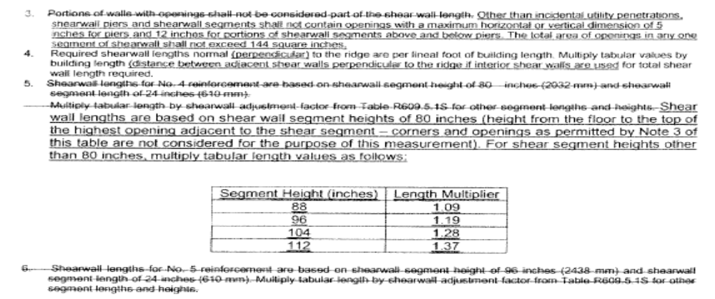
[Mod 3355 and Mod 3355revised]

Table R609.5.1G Grade 40, revise text to read as follows:

TABLE R609.5.1G GRADE 40
REQUIRED SHEARWALL LENGTH PARALLEL TO RIDGE NO. 4 REINFORCEMENT^{1,2,3,5}
 |  | ROOF ANGLE ≤ 23⁰
 |  | TOP STORY |  |  | 1ST STORY OF 2 STORY OR 2ND STORY OF 3 STORY |  |  | 1ST STORY OF 3 STORY
Exp | Wind Speed | BUILDING WIDTH |  |  | BUILDING WIDTH |  |  | BUILDING WIDTH
Exp | Wind Speed | 24 | 32 | 40 | 24 | 32 | 40 | 24 | 32 | 40
B | 100 | 2.32 | 3.31 | 4.51 | 5.29 | 7.15 | 9.31 | 7.77 | 10.45 | 13.55
B | 110 | 2.81 | 4.01 | 5.46 | 6.40 | 8.65 | 11.27 | 9.40 | 12.65 | 16.39
B | 120 | 3.35 | 4.77 | 6.50 | 7.61 | 10.30 | 13.41 | 11.19 | 15.05 | 19.51
B | 130 | 3.93 | 5.59 | 7.63 | 8.94 | 12.09 | 15.74 | 13.13 | 17.67 | 22.90
B | 140 | 4.55 | 6.49 | 8.84 | 10.36 | 14.02 | 18.26 | 15.23 | 20.49 | 26.56
B | 150 | 5.23 | 7.45 | 10.15 | 11.90 | 16.09 | 20.96 | 17.48 | 23.52 | 30.48
C | 100 | 2.75 | 3.98 | 5.49 | 6.98 | 9.52 | 12.49 | 10.85 | 14.57 | 18.85
C | 110 | 3.33 | 4.81 | 6.64 | 8.45 | 11.52 | 15.11 | 13.13 | 17.63 | 22.81
C | 120 | 3.97 | 5.73 | 7.90 | 10.05 | 13.70 | 17.98 | 15.63 | 20.98 | 27.14
C | 130 | 4.66 | 6.72 | 9.27 | 11.80 | 16.08 | 21.10 | 18.34 | 24.63 | 31.86
C | 140 | 5.40 | 7.79 | 10.75 | 13.68 | 18.65 | 24.47 | 21.27 | 28.56 | 36.95
C | 150 | 6.20 | 8.95 | 12.34 | 15.71 | 21.41 | 28.10 | 24.42 | 32.79 | 42.41
Notes :
1. The cumulative shear wall segment length for each side of the building shall be equal to or greater than the tabular shear wall length required. If the required shear wall segment length provided is not continuous the total shear wall length required shall be increased by 8" for each additional shear wall segment on a side.
2. Minimum shear wall segment length shall be 2'-0". A grouted cell with reinforcing steel shall be provided at each end of every shear wall segment. A minimum length of 24 inches (610 mm) of solid wall segment, extending the full height of each wall, shall be provided at exterior corners of exterior walls. A fully grouted cell with reinforcing steel shall be provided at each end of every shear wall segment.
3. Portions of walls with openings shall not be considered part of the shear wall length.
4. Required shearwall lengths perpendicular to the ridge are per lineal foot of building length. Multiply tabular values by building length for total shear wall length required.
5. Shearwall lengths for no. 4 reinforcement are based on shearwall segment height of 80 inches and shearwall segment length of 24 inches. Multiply tabular length by shearwall adjustment factor from Table R609.5.1S for other segment lengths and heights.
6. Shearwall lengths for no. 5 reinforcement are based on shearwall segment height of 96 inches and shearwall segment length of 24 inches. Multiply tabular length by shearwall adjustment factor from Table R609.5.1S for other segment height lengths and heights.

Table R609.5.1H Grade 40, revise text to read as follows:

TABLE R609.5.1H GRADE 40
REQUIRED SHEARWALL LENGTH PARALLEL TO RIDGE NO. 5 REINFORCEMENT^{1,2,3,6}
 |  | ROOF ANGLE ≤ 23⁰
 |  | TOP STORY |  |  | 1ST STORY OF 2 STORY OR 2ND STORY OF 3 STORY |  |  | 1ST STORY OF 3 STORY
Exp | Wind Speed | BUILDING WIDTH |  |  | BUILDING WIDTH |  |  | BUILDING WIDTH
Exp | Wind Speed | 24 | 32 | 40 | 24 | 32 | 40 | 24 | 32 | 40
B | 100 | 1.59 | 2.26 | 3.08 | 3.61 | 4.88 | 6.36 | 5.30 | 7.14 | 9.25
B | 110 | 1.92 | 2.73 | 3.73 | 4.37 | 5.91 | 7.69 | 6.42 | 8.63 | 11.19
B | 120 | 2.28 | 3.25 | 4.44 | 5.20 | 7.03 | 9.16 | 7.64 | 10.28 | 13.32
B | 130 | 2.68 | 3.82 | 5.21 | 6.10 | 8.25 | 10.75 | 8.96 | 12.06 | 15.63
B | 140 | 3.11 | 4.43 | 6.04 | 7.07 | 9.57 | 12.46 | 10.40 | 13.99 | 18.13
B | 150 | 3.57 | 5.08 | 6.93 | 8.12 | 10.99 | 14.31 | 11.93 | 16.06 | 20.81
C | 100 | 1.88 | 2.71 | 3.75 | 4.77 | 6.50 | 8.52 | 7.41 | 9.95 | 12.87
C | 110 | 2.28 | 3.28 | 4.53 | 5.77 | 7.86 | 10.31 | 8.96 | 12.04 | 15.57
C | 120 | 2.71 | 3.91 | 5.39 | 6.86 | 9.36 | 12.28 | 10.67 | 14.32 | 18.53
C | 130 | 3.18 | 4.59 | 6.33 | 8.05 | 10.98 | 14.41 | 12.52 | 16.81 | 21.75
C | 140 | 3.69 | 5.32 | 7.34 | 9.34 | 12.73 | 16.71 | 14.52 | 19.50 | 25.22
C | 150 | 4.23 | 6.11 | 8.43 | 10.72 | 14.62 | 19.18 | 16.67 | 22.38 | 28.95
Notes :
1. The cumulative shear wall segment length for each side of the building shall be equal to or greater than the tabular shear wall length required. If the required shear wall segment length provided is not continuous the total shear wall length required shall be increased by 8" for each additional shear wall segment on a side.
2. Minimum shear wall segment length shall be 2'-0". A grouted cell with reinforcing steel shall be provided at each end of every shear wall segment. A minimum length of 24 inches (610 mm) of solid wall segment, extending the full height of each wall, shall be provided at exterior corners of exterior walls. A fully grouted cell with reinforcing steel shall be provided at each end of every shear wall segment.
3. Portions of walls with openings shall not be considered part of the shear wall length.
4. Required shearwall lengths perpendicular to the ridge are per lineal foot of building length. Multiply tabular values by building length for total shear wall length required.
5. Shearwall lengths for no. 4 reinforcement are based on shearwall segment height of 80 inches and shearwall segment length of 24 inches. Multiply tabular length by shearwall adjustment factor from Table R609.5.1S for other segment lengths and heights.
6. Shearwall lengths for no. 5 reinforcement are based on shearwall segment height of 96 inches and shearwall segment length of 24 inches. Multiply tabular length by shearwall adjustment factor from Table R609.5.1S for other segment height lengths and heights.

Table R609.5.1I Grade 40, revise text to read as follows:

TABLE R609.5.1I GRADE 40
REQUIRED SHEARWALL LENGTH PARALLEL TO RIDGE NO. 4 REINFORCEMENT^{1,2,3,5}
 |  | ROOF ANGLE 30⁰
 |  | TOP STORY |  |  | 1ST STORY OF 2 STORY OR 2ND STORY OF 3 STORY |  |  | 1ST STORY OF 3 STORY
Exp | Wind Speed | BUILDING WIDTH |  |  | BUILDING WIDTH |  |  | BUILDING WIDTH
Exp | Wind Speed | 24 | 32 | 40 | 24 | 32 | 40 | 24 | 32 | 40
B | 100 | 2.39 | 3.51 | 4.88 | 5.10 | 7.07 | 9.32 | 7.44 | 10.24 | 13.44
B | 110 | 2.89 | 4.25 | 5.90 | 6.17 | 8.55 | 11.28 | 9.00 | 12.39 | 16.26
B | 120 | 3.43 | 5.06 | 7.02 | 7.35 | 10.18 | 13.43 | 10.71 | 14.75 | 19.35
B | 130 | 4.03 | 5.94 | 8.24 | 8.62 | 11.95 | 15.76 | 12.57 | 17.31 | 22.71
B | 140 | 4.67 | 6.89 | 9.56 | 10.00 | 13.86 | 18.28 | 14.58 | 20.08 | 26.34
B | 150 | 5.37 | 7.90 | 10.98 | 11.48 | 15.91 | 20.98 | 16.74 | 23.05 | 30.23
C | 100 | 2.87 | 4.29 | 6.05 | 6.79 | 9.51 | 12.66 | 10.37 | 14.24 | 18.63
C | 110 | 3.47 | 5.19 | 7.32 | 8.22 | 11.51 | 15.32 | 12.55 | 17.23 | 22.54
C | 120 | 4.13 | 6.18 | 8.71 | 9.78 | 13.69 | 18.23 | 14.93 | 20.51 | 26.83
C | 130 | 4.85 | 7.26 | 10.23 | 11.48 | 16.07 | 21.40 | 17.53 | 24.06 | 31.49
C | 140 | 5.62 | 8.41 | 11.86 | 13.31 | 18.64 | 24.82 | 20.33 | 27.91 | 36.52
C | 150 | 6.45 | 9.66 | 13.62 | 15.28 | 21.39 | 28.49 | 23.33 | 32.04 | 41.92
Notes :
1. The cumulative shear wall segment length for each side of the building shall be equal to or greater than the tabular shear wall length required. If the required shear wall segment length provided is not continuous the total shear wall length required shall be increased by 8" for each additional shear wall segment on a side.
2. Minimum shear wall segment length shall be 2'-0". A grouted cell with reinforcing steel shall be provided at each end of every shear wall segment. A minimum length of 24 inches (610 mm) of solid wall segment, extending the full height of each wall, shall be provided at exterior corners of exterior walls. A fully grouted cell with reinforcing steel shall be provided at each end of every shear wall segment.
3. Portions of walls with openings shall not be considered part of the shear wall length.
4. Required shearwall lengths perpendicular to the ridge are per lineal foot of building length. Multiply tabular values by building length for total shear wall length required.
5. Shearwall lengths for no. 4 reinforcement are based on shearwall segment height of 80 inches and shearwall segment length of 24 inches. Multiply tabular length by shearwall adjustment factor from Table R609.5.1S for other segment lengths and heights.
6. Shearwall lengths for no. 5 reinforcement are based on shearwall segment height of 96 inches and shearwall segment length of 24 inches. Multiply tabular length by shearwall adjustment factor from Table R609.5.1S for other segment height lengths and heights.

Table R609.5.1J Grade 40, revise text to read as follows:

TABLE R609.5.1J GRADE 40
REQUIRED SHEARWALL LENGTH PARALLEL TO RIDGE NO. 5 REINFORCEMENT^{1,2,3,6}
 |  | ROOF ANGLE 30⁰
 |  | TOP STORY |  |  | 1ST STORY OF 2 STORY OR 2ND STORY OF 3 STORY |  |  | 1ST STORY OF 3 STORY
Exp | Wind Speed | BUILDING WIDTH |  |  | BUILDING WIDTH |  |  | BUILDING WIDTH
Exp | Wind Speed | 24 | 32 | 40 | 24 | 32 | 40 | 24 | 32 | 40
B | 100 | 1.63 | 2.40 | 3.33 | 3.48 | 4.83 | 6.37 | 5.08 | 6.99 | 9.17
B | 110 | 1.97 | 2.90 | 4.03 | 4.21 | 5.84 | 7.70 | 6.15 | 8.46 | 11.10
B | 120 | 2.34 | 3.45 | 4.80 | 5.02 | 6.95 | 9.17 | 7.31 | 10.07 | 13.21
B | 130 | 2.75 | 4.05 | 5.63 | 5.89 | 8.16 | 10.76 | 8.58 | 11.82 | 15.50
B | 140 | 3.19 | 4.70 | 6.53 | 6.83 | 9.46 | 12.48 | 9.96 | 13.71 | 17.98
B | 150 | 3.66 | 5.40 | 7.49 | 7.84 | 10.86 | 14.32 | 11.43 | 15.73 | 20.64
C | 100 | 1.96 | 2.93 | 4.13 | 4.64 | 6.49 | 8.64 | 7.08 | 9.72 | 12.72
C | 110 | 2.37 | 3.55 | 5.00 | 5.61 | 7.85 | 10.46 | 8.57 | 11.76 | 15.39
C | 120 | 2.82 | 4.22 | 5.95 | 6.68 | 9.35 | 12.45 | 10.19 | 14.00 | 18.31
C | 130 | 3.31 | 4.95 | 6.98 | 7.84 | 10.97 | 14.61 | 11.96 | 16.43 | 21.49
C | 140 | 3.84 | 5.74 | 8.10 | 9.09 | 12.72 | 16.94 | 13.88 | 19.05 | 24.93
C | 150 | 4.41 | 6.59 | 9.29 | 10.43 | 14.61 | 19.45 | 15.93 | 21.87 | 28.62
Notes:
1. The cumulative shear wall segment length for each side of the building shall be equal to or greater than the tabular shear wall length required. If the required shear wall segment length provided is not continuous the total shear wall length required shall be increased by 8" for each additional shear wall segment on a side.
2. Minimum shear wall segment length shall be 2'-0". A grouted cell with reinforcing steel shall be provided at each end of every shear wall segment. A minimum length of 24 inches (610 mm) of solid wall segment, extending the full height of each wall, shall be provided at exterior corners of exterior walls. A fully grouted cell with reinforcing steel shall be provided at each end of every shear wall segment.
3. Portions of walls with openings shall not be considered part of the shear wall length.
4. Required shearwall lengths perpendicular to the ridge are per lineal foot of building length. Multiply tabular values by building length for total shear wall length required.
5. Shearwall lengths for no. 4 reinforcement are based on shearwall segment height of 80 inches and shearwall segment length of 24 inches. Multiply tabular length by shearwall adjustment factor from Table R609.5.1S for other segment lengths and heights.
6. Shearwall lengths for no. 5 reinforcement are based on shearwall segment height of 96 inches and shearwall segment length of 24 inches. Multiply tabular length by shearwall adjustment factor from Table R609.5.1S for other segment height lengths and heights.

Table R609.5.1K Grade 40, revise text to read as follows:

TABLE R609.5.1K GRADE 40
REQUIRED SHEARWALL LENGTH PARALLEL TO RIDGE NO. 4 REINFORCEMENT^{1,2,3,5}
 |  | ROOF ANGLE 45⁰
 |  | TOP STORY |  |  | 1ST STORY OF 2 STORY OR 2ND STORY OF 3 STORY |  |  | 1ST STORY OF 3 STORY
Exp | Wind Speed | BUILDING WIDTH |  |  | BUILDING WIDTH |  |  | BUILDING WIDTH
Exp | Wind Speed | 24 | 32 | 40 | 24 | 32 | 40 | 24 | 32 | 40
B | 100 | 3.04 | 4.65 | 6.66 | 3.04 | 8.21 | 11.11 | 8.28 | 11.74 | 15.80
B | 110 | 3.68 | 5.63 | 8.06 | 6.96 | 9.93 | 13.44 | 10.02 | 14.20 | 19.12
B | 120 | 4.37 | 6.70 | 9.59 | 8.29 | 11.82 | 15.99 | 11.93 | 16.90 | 22.76
B | 130 | 5.13 | 7.86 | 11.25 | 9.72 | 13.87 | 18.77 | 14.00 | 19.84 | 26.71
B | 140 | 5.95 | 9.12 | 13.05 | 11.28 | 16.09 | 21.77 | 16.24 | 23.01 | 30.97
B | 150 | 6.83 | 10.47 | 14.98 | 12.95 | 18.47 | 24.99 | 18.64 | 26.41 | 35.56
C | 100 | 3.78 | 5.93 | 8.66 | 7.83 | 11.34 | 15.57 | 10.37 | 14.24 | 18.63
C | 110 | 4.57 | 7.17 | 10.48 | 9.47 | 13.73 | 18.84 | 12.55 | 17.23 | 22.54
C | 120 | 5.44 | 8.53 | 12.47 | 11.27 | 16.34 | 22.42 | 14.93 | 20.51 | 26.83
C | 130 | 6.39 | 10.01 | 14.64 | 13.23 | 19.17 | 26.31 | 17.53 | 24.06 | 31.49
C | 140 | 7.41 | 11.61 | 16.98 | 15.34 | 22.24 | 30.52 | 20.33 | 27.91 | 36.52
C | 150 | 8.50 | 13.33 | 19.49 | 17.61 | 25.53 | 35.03 | 23.33 | 32.04 | 41.92
Notes:
1. The cumulative shear wall segment length for each side of the building shall be equal to or greater than the tabular shear wall length required. If the required shear wall segment length provided is not continuous the total shear wall length required shall be increased by 8" for each additional shear wall segment on a side.
2. Minimum shear wall segment length shall be 2'-0". A grouted cell with reinforcing steel shall be provided at each end of every shear wall segment. A minimum length of 24 inches (610 mm) of solid wall segment, extending the full height of each wall, shall be provided at exterior corners of exterior walls. A fully grouted cell with reinforcing steel shall be provided at each end of every shear wall segment.
3. Portions of walls with openings shall not be considered part of the shear wall length.
4. Required shearwall lengths perpendicular to the ridge are per lineal foot of building length. Multiply tabular values by building length for total shear wall required.
5. Shearwall lengths for no. 4 reinforcement are based on shearwall segment height of 80 inches and shearwall segment length of 24 inches. Multiply tabular length by shearwall adjustment factor from Table R609.5.1S for other segment lengths and heights.
6. Shearwall lengths for no. 5 reinforcement are based on shearwall segment height of 96 inches and shearwall segment length of 24 inches. Multiply tabular length by shearwall adjustment factor from Table R609.5.1S for other segment height lengths and heights.

Table R609.5.1L Grade 40, revise text to read as follows:

TABLE R609.5.1L GRADE 40
REQUIRED SHEARWALL LENGTH PARALLEL TO RIDGE NO. 5 REINFORCEMENT^{1,2,3,6}
 |  | ROOF ANGLE 45⁰
 |  | TOP STORY |  |  | 1ST STORY OF 2 STORY OR 2ND STORY OF 3 STORY |  |  | 1ST STORY OF 3 STORY
Exp | Wind Speed | BUILDING WIDTH |  |  | BUILDING WIDTH |  |  | BUILDING WIDTH
Exp | Wind Speed | 24 | 32 | 40 | 24 | 32 | 40 | 24 | 32 | 40
B | 100 | 2.07 | 3.18 | 4.55 | 3.93 | 5.60 | 7.58 | 5.66 | 8.01 | 10.79
B | 110 | 2.51 | 3.84 | 5.50 | 4.75 | 6.78 | 9.17 | 6.84 | 9.70 | 13.05
B | 120 | 2.99 | 4.57 | 6.55 | 5.66 | 8.07 | 10.92 | 8.14 | 11.54 | 15.54
B | 130 | 3.50 | 5.37 | 7.68 | 6.64 | 9.47 | 12.81 | 9.56 | 13.54 | 18.23
B | 140 | 4.06 | 6.23 | 8.91 | 7.70 | 10.99 | 14.86 | 11.08 | 15.71 | 21.15
B | 150 | 4.67 | 7.15 | 10.23 | 8.84 | 12.61 | 17.06 | 12.72 | 18.03 | 24.27
C | 100 | 2.58 | 4.05 | 5.91 | 5.34 | 7.74 | 10.63 | 7.84 | 11.06 | 14.83
C | 110 | 3.12 | 4.89 | 7.15 | 6.47 | 9.37 | 12.86 | 9.48 | 13.38 | 17.94
C | 120 | 3.71 | 5.83 | 8.51 | 7.69 | 11.15 | 15.31 | 11.29 | 15.93 | 21.36
C | 130 | 4.36 | 6.84 | 9.99 | 9.03 | 13.09 | 17.96 | 13.25 | 18.69 | 25.06
C | 140 | 5.06 | 7.93 | 11.59 | 10.47 | 15.18 | 20.83 | 15.36 | 21.68 | 29.07
C | 150 | 5.80 | 9.10 | 13.30 | 12.02 | 17.43 | 23.92 | 17.63 | 24.88 | 33.37
Notes:
1. The cumulative shear wall segment length for each side of the building shall be equal to or greater than the tabular shear wall length required. If the required shear wall segment length provided is not continuous the total shear wall length required shall be increased by 8" for each additional shear wall segment on a side.
2. Minimum shear wall segment length shall be 2'-0". A grouted cell with reinforcing steel shall be provided at each end of every shear wall segment. A minimum length of 24 inches (610 mm) of solid wall segment, extending the full height of each wall, shall be provided at exterior corners of exterior walls. A fully grouted cell with reinforcing steel shall be provided at each end of every shear wall segment.
3. Portions of walls with openings shall not be considered part of the shear wall length.
4. Required shearwall lengths perpendicular to the ridge are per lineal foot of building length. Multiply tabular values by building length for total shear wall length.
5. Shearwall lengths for no. 4 reinforcement are based on shearwall segment height of 80 inches and shearwall segment length of 24 inches. Multiply tabular length by shearwall adjustment factor from Table R609.5.1S for other segment lengths and heights.
6. Shearwall lengths for no. 5 reinforcement are based on shearwall segment height of 96 inches and shearwall segment length of 24 inches. Multiply tabular length by shearwall adjustment factor from Table R609.5.1S for other segment height lengths and heights.

Table R609.5.1M Grade 40, revise text to read as follows:

TABLE R609.5.1M GRADE 40
REQUIRED SHEARWALL LENGTH PERPENDICULAR TO RIDGE NO. 4 REINFORCEMENT PER FOOT OF BUILDING LENGTH^{1,2,3,4,5}
ROOF ANGLE ≤ 23⁰
 |  | TOP STORY |  |  | 1ST STORY OF 2 STORY OR 2ND STORY OF 3 STORY |  |  | 1ST STORY OF 3 STORY
Exp | Wind Speed | BUILDING WIDTH |  |  | BUILDING WIDTH |  |  | BUILDING WIDTH
Exp | Wind Speed | 24 | 32 | 40 | 24 | 32 | 40 | 24 | 32 | 40
B | 100 | 0.077 | 0.077 | 0.076 | 0.204 | 0.204 | 0.203 | 0.332 | 0.331 | 0.330
B | 110 | 0.093 | 0.093 | 0.092 | 0.247 | 0.247 | 0.246 | 0.401 | 0.401 | 0.400
B | 120 | 0.111 | 0.110 | 0.109 | 0.294 | 0.294 | 0.292 | 0.478 | 0.477 | 0.476
B | 130 | 0.130 | 0.129 | 0.128 | 0.345 | 0.345 | 0.343 | 0.561 | 0.560 | 0.558
B | 140 | 0.151 | 0.150 | 0.148 | 0.400 | 0.400 | 0.398 | 0.650 | 0.649 | 0.647
B | 150 | 0.173 | 0.172 | 0.170 | 0.460 | 0.459 | 0.457 | 0.746 | 0.745 | 0.743
C | 100 | 0.108 | 0.107 | 0.106 | 0.286 | 0.286 | 0.285 | 0.465 | 0.464 | 0.463
C | 110 | 0.131 | 0.130 | 0.128 | 0.347 | 0.346 | 0.344 | 0.563 | 0.562 | 0.560
C | 120 | 0.155 | 0.155 | 0.153 | 0.413 | 0.412 | 0.410 | 0.670 | 0.669 | 0.667
C | 130 | 0.182 | 0.181 | 0.179 | 0.484 | 0.483 | 0.481 | 0.786 | 0.785 | 0.783
C | 140 | 0.212 | 0.210 | 0.208 | 0.562 | 0.560 | 0.558 | 0.911 | 0.910 | 0.908
C | 150 | 0.243 | 0.242 | 0.239 | 0.645 | 0.643 | 0.640 | 1.046 | 1.045 | 1.042
Notes:
1. The cumulative shear wall segment length for each side of the building shall be equal to or greater than the tabular shear wall length required. If the required shear wall segment length provided is not continuous the total shear wall length required shall be increased by 8" for each additional shear wall segment on a side.
2. Minimum shear wall segment length shall be 2'-0". A grouted cell with reinforcing steel shall be provided at each end of every shear wall segment. A minimum length of 24 inches (610 mm) of solid wall segment, extending the full height of each wall, shall be provided at exterior corners of exterior walls. A fully grouted cell with reinforcing steel shall be provided at each end of every shear wall segment.
3. Portions of walls with openings shall not be considered part of the shear wall length.
4. Required shearwall lengths perpendicular to the ridge are per lineal foot of building length. Multiply tabular values by building length for total shear wall length.
5. Shearwall lengths for no. 4 reinforcement are based on shearwall segment height of 80 inches and shearwall segment length of 24 inches. Multiply tabular length by shearwall adjustment factor from Table R609.5.1S for other segment lengths and heights.
6. Shearwall lengths for no. 5 reinforcement are based on shearwall segment height of 96 inches and shearwall segment length of 24 inches. Multiply tabular length by shearwall adjustment factor from Table R609.5.1S for other segment height lengths and heights.

Table R609.5.1N Grade 40, revise text to read as follows:

TABLE R609.5.1N GRADE 40
REQUIRED SHEARWALL LENGTH PERPENDICULAR TO RIDGE NO. 5 REINFORCEMENT PER FOOT OF BUILDING LENGTH^{1,2,3,4,6}
ROOF ANGLE ≤ 23⁰
 |  | TOP STORY |  |  | 1ST STORY OF 2 STORY OR 2ND STORY OF 3 STORY |  |  | 1ST STORY OF 3 STORY
Exp | Wind Speed | BUILDING WIDTH |  |  | BUILDING WIDTH |  |  | BUILDING WIDTH
Exp | Wind Speed | 24 | 32 | 40 | 24 | 32 | 40 | 24 | 32 | 40
B | 100 | 0.053 | 0.052 | 0.052 | 0.139 | 0.139 | 0.139 | 0.226 | 0.226 | 0.226
B | 110 | 0.064 | 0.063 | 0.063 | 0.169 | 0.168 | 0.168 | 0.274 | 0.274 | 0.273
B | 120 | 0.076 | 0.075 | 0.074 | 0.201 | 0.200 | 0.200 | 0.326 | 0.326 | 0.325
B | 130 | 0.089 | 0.088 | 0.087 | 0.236 | 0.235 | 0.234 | 0.383 | 0.382 | 0.381
B | 140 | 0.103 | 0.102 | 0.101 | 0.273 | 0.273 | 0.272 | 0.444 | 0.443 | 0.442
B | 150 | 0.118 | 0.118 | 0.116 | 0.314 | 0.313 | 0.312 | 0.509 | 0.509 | 0.507
C | 100 | 0.074 | 0.073 | 0.072 | 0.196 | 0.195 | 0.194 | 0.317 | 0.317 | 0.316
C | 110 | 0.089 | 0.089 | 0.088 | 0.237 | 0.236 | 0.235 | 0.384 | 0.384 | 0.383
C | 120 | 0.106 | 0.106 | 0.104 | 0.282 | 0.281 | 0.280 | 0.457 | 0.457 | 0.455
C | 130 | 0.125 | 0.124 | 0.122 | 0.331 | 0.330 | 0.328 | 0.536 | 0.536 | 0.534
C | 140 | 0.144 | 0.144 | 0.142 | 0.383 | 0.383 | 0.381 | 0.622 | 0.621 | 0.620
C | 150 | 0.166 | 0.165 | 0.163 | 0.440 | 0.439 | 0.437 | 0.714 | 0.713 | 0.711
Notes:
1. The cumulative shear wall segment length for each side of the building shall be equal to or greater than the tabular shear wall length required. If the required shear wall segment length provided is not continuous the total shear wall length required shall be increased by 8" for each additional shear wall segment on a side.
2. Minimum shear wall segment length shall be 2'-0". A grouted cell with reinforcing steel shall be provided at each end of every shear wall segment. A minimum length of 24 inches (610 mm) of solid wall segment, extending the full height of each wall, shall be provided at exterior corners of exterior walls. A fully grouted cell with reinforcing steel shall be provided at each end of every shear wall segment.
3. Portions of walls with openings shall not be considered part of the shear wall length.
4. Required shearwall lengths perpendicular to the ridge are per lineal foot of building length. Multiply tabular values by building length for total shear wall length.
5. Shearwall lengths for no. 4 reinforcement are based on shearwall segment height of 80 inches and shearwall segment length of 24 inches. Multiply tabular length by shearwall adjustment factor from Table R609.5.1S for other segment lengths and heights.
6. Shearwall lengths for no. 5 reinforcement are based on shearwall segment height of 96 inches and shearwall segment length of 24 inches. Multiply tabular length by shearwall adjustment factor from Table R609.5.1S for other segment height lengths and heights.

Table R609.5.1O Grade 40, revise text to read as follows:

TABLE R609.5.1O GRADE 40
REQUIRED SHEARWALL LENGTH PERPENDICULAR TO RIDGE NO. 4 REINFORCEMENT PER FOOT OF BUILDING LENGTH^{1,2,3,4,5}
ROOF ANGLE 30º
 |  | TOP STORY |  |  | 1ST STORY OF 2 STORY OR 2ND STORY OF 3 STORY |  |  | 1ST STORY OF 3 STORY
Exp | Wind Speed | BUILDING WIDTH |  |  | BUILDING WIDTH |  |  | BUILDING WIDTH
Exp | Wind Speed | 24 | 32 | 40 | 24 | 32 | 40 | 24 | 32 | 40
B | 100 | 0.127 | 0.147 | 0.168 | 0.238 | 0.258 | 0.280 | 0.349 | 0.370 | 0.391
B | 110 | 0.153 | 0.178 | 0.204 | 0.288 | 0.312 | 0.338 | 0.423 | 0.447 | 0.473
B | 120 | 0.182 | 0.211 | 0.242 | 0.343 | 0.372 | 0.403 | 0.503 | 0.532 | 0.563
B | 130 | 0.214 | 0.248 | 0.284 | 0.402 | 0.436 | 0.473 | 0.591 | 0.624 | 0.661
B | 140 | 0.248 | 0.288 | 0.330 | 0.467 | 0.506 | 0.548 | 0.685 | 0.724 | 0.766
B | 150 | 0.285 | 0.330 | 0.379 | 0.536 | 0.581 | 0.629 | 0.786 | 0.831 | 0.880
C | 100 | 0.178 | 0.206 | 0.236 | 0.334 | 0.362 | 0.392 | 0.490 | 0.518 | 0.548
C | 110 | 0.215 | 0.249 | 0.285 | 0.404 | 0.438 | 0.474 | 0.593 | 0.627 | 0.663
C | 120 | 0.256 | 0.296 | 0.340 | 0.481 | 0.521 | 0.565 | 0.706 | 0.746 | 0.789
C | 130 | 0.300 | 0.348 | 0.399 | 0.564 | 0.612 | 0.663 | 0.828 | 0.876 | 0.926
C | 140 | 0.348 | 0.403 | 0.462 | 0.654 | 0.709 | 0.768 | 0.960 | 1.015 | 1.074
C | 150 | 0.400 | 0.463 | 0.531 | 0.751 | 0.814 | 0.882 | 1.102 | 1.166 | 1.233
Notes:
1. The cumulative shear wall segment length for each side of the building shall be equal to or greater than the tabular shear wall length required. If the required shear wall segment length provided is not continuous the total shear wall length required shall be increased by 8" for each additional shear wall segment on a side.
2. Minimum shear wall segment length shall be 2'-0". A grouted cell with reinforcing steel shall be provided at each end of every shear wall segment. A minimum length of 24 inches (610 mm) of solid wall segment, extending the full height of each wall, shall be provided at exterior corners of exterior walls. A fully grouted cell with reinforcing steel shall be provided at each end of every shear wall segment.
3. Portions of walls with openings shall not be considered part of the shear wall length.
4. Required shearwall lengths perpendicular to the ridge are per lineal foot of building length. Multiply tabular values by building length for total shear wall length.
5. Shearwall lengths for no. 4 reinforcement are based on shearwall segment height of 80 inches and shearwall segment length of 24 inches. Multiply tabular length by shearwall adjustment factor from Table R609.5.1S for other segment lengths and heights.
6. Shearwall lengths for no. 5 reinforcement are based on shearwall segment height of 96 inches and shearwall segment length of 24 inches. Multiply tabular length by shearwall adjustment factor from Table R609.5.1S for other segment height lengths and heights.

Table R609.5.1P Grade 40, revise text to read as follows:

TABLE R609.5.1P GRADE 40
REQUIRED SHEARWALL LENGTH PERPENDICULAR TO RIDGE NO. 5 REINFORCEMENT PER FOOT OF BUILDING LENGTH^{1,2,3,4,6}
ROOF ANGLE 30º
 |  | TOP STORY |  |  | 1ST STORY OF 2 STORY OR 2ND STORY OF 3 STORY |  |  | 1ST STORY OF 3 STORY
Exp | Wind Speed | BUILDING WIDTH |  |  | BUILDING WIDTH |  |  | BUILDING WIDTH
Exp | Wind Speed | 24 | 32 | 40 | 24 | 32 | 40 | 24 | 32 | 40
B | 100 | 0.087 | 0.100 | 0.115 | 0.163 | 0.176 | 0.191 | 0.239 | 0.252 | 0.267
B | 110 | 0.105 | 0.121 | 0.139 | 0.197 | 0.213 | 0.231 | 0.289 | 0.305 | 0.323
B | 120 | 0.125 | 0.144 | 0.165 | 0.234 | 0.254 | 0.275 | 0.344 | 0.363 | 0.384
B | 130 | 0.146 | 0.169 | 0.194 | 0.275 | 0.298 | 0.323 | 0.403 | 0.426 | 0.451
B | 140 | 0.170 | 0.196 | 0.225 | 0.319 | 0.345 | 0.374 | 0.468 | 0.494 | 0.523
B | 150 | 0.195 | 0.225 | 0.258 | 0.366 | 0.397 | 0.430 | 0.537 | 0.568 | 0.601
C | 100 | 0.121 | 0.140 | 0.161 | 0.228 | 0.247 | 0.268 | 0.334 | 0.354 | 0.374
C | 110 | 0.147 | 0.170 | 0.195 | 0.276 | 0.299 | 0.324 | 0.405 | 0.428 | 0.453
C | 120 | 0.175 | 0.202 | 0.232 | 0.328 | 0.356 | 0.385 | 0.482 | 0.509 | 0.539
C | 130 | 0.205 | 0.237 | 0.272 | 0.385 | 0.418 | 0.452 | 0.565 | 0.598 | 0.632
C | 140 | 0.238 | 0.275 | 0.316 | 0.447 | 0.484 | 0.525 | 0.656 | 0.693 | 0.734
C | 150 | 0.273 | 0.316 | 0.362 | 0.513 | 0.556 | 0.602 | 0.753 | 0.796 | 0.842
Notes:
1. The cumulative shear wall segment length for each side of the building shall be equal to or greater than the tabular shear wall length required. If the required shear wall segment length provided is not continuous the total shear wall length required shall be increased by 8" for each additional shear wall segment on a side.
2. Minimum shear wall segment length shall be 2'-0". A grouted cell with reinforcing steel shall be provided at each end of every shear wall segment. A minimum length of 24 inches (610 mm) of solid wall segment, extending the full height of each wall, shall be provided at exterior corners of exterior walls. A fully grouted cell with reinforcing steel shall be provided at each end of every shear wall segment.
3. Portions of walls with openings shall not be considered part of the shear wall length.
4. Required shearwall lengths perpendicular to the ridge are per lineal foot of building length. Multiply tabular values by building length for total shear wall length.
5. Shearwall lengths for no. 4 reinforcement are based on shearwall segment height of 80 inches and shearwall segment length of 24 inches. Multiply tabular length by shearwall adjustment factor from Table R609.5.1S for other segment lengths and heights.
6. Shearwall lengths for no. 5 reinforcement are based on shearwall segment height of 96 inches and shearwall segment length of 24 inches. Multiply tabular length by shearwall adjustment factor from Table R609.5.1S for other segment height lengths and heights.

Table R609.5.1Q Grade 40, revise text to read as follows:

TABLE R609.5.1Q GRADE 40
REQUIRED SHEARWALL LENGTH PERPENDICULAR TO RIDGE NO. 4 REINFORCEMENT PER FOOT OF BUILDING LENGTH^{1,2,3,4,5}
ROOF ANGLE 45⁰
 |  | TOP STORY |  |  | 1ST STORY OF 2 STORY OR 2ND STORY OF 3 STORY |  |  | 1ST STORY OF 3 STORY
Exp | Wind Speed | BUILDING WIDTH |  |  | BUILDING WIDTH |  |  | BUILDING WIDTH
Exp | Wind Speed | 24 | 32 | 40 | 24 | 32 | 40 | 24 | 32 | 40
B | 100 | 0.170 | 0.204 | 0.242 | 0.281 | 0.316 | 0.353 | 0.392 | 0.427 | 0.464
B | 110 | 0.205 | 0.247 | 0.292 | 0.340 | 0.382 | 0.427 | 0.475 | 0.517 | 0.562
B | 120 | 0.244 | 0.294 | 0.348 | 0.405 | 0.455 | 0.508 | 0.565 | 0.615 | 0.669
B | 130 | 0.287 | 0.345 | 0.408 | 0.475 | 0.534 | 0.597 | 0.663 | 0.722 | 0.785
B | 140 | 0.333 | 0.401 | 0.474 | 0.551 | 0.619 | 0.692 | 0.769 | 0.837 | 0.910
B | 150 | 0.382 | 0.460 | 0.544 | 0.632 | 0.710 | 0.794 | 0.883 | 0.961 | 1.045
C | 100 | 0.238 | 0.287 | 0.339 | 0.394 | 0.443 | 0.495 | 0.550 | 0.599 | 0.651
C | 110 | 0.288 | 0.347 | 0.410 | 0.477 | 0.536 | 0.599 | 0.666 | 0.725 | 0.788
C | 120 | 0.343 | 0.413 | 0.488 | 0.567 | 0.637 | 0.713 | 0.792 | 0.862 | 0.937
C | 130 | 0.402 | 0.484 | 0.572 | 0.666 | 0.748 | 0.836 | 0.930 | 1.012 | 1.100
C | 140 | 0.466 | 0.562 | 0.664 | 0.772 | 0.868 | 0.970 | 1.078 | 1.174 | 1.276
C | 150 | 0.535 | 0.645 | 0.762 | 0.887 | 0.996 | 1.113 | 1.238 | 1.347 | 1.465
Notes:
1. The cumulative shear wall segment length for each side of the building shall be equal to or greater than the tabular shear wall length required. If the required shear wall segment length provided is not continuous the total shear wall length required shall be increased by 8" for each additional shear wall segment on a side.
2. Minimum shear wall segment length shall be 2'-0". A grouted cell with reinforcing steel shall be provided at each end of every shear wall segment. A minimum length of 24 inches (610 mm) of solid wall segment, extending the full height of each wall, shall be provided at exterior corners of exterior walls. A fully grouted cell with reinforcing steel shall be provided at each end of every shear wall segment.
3. Portions of walls with openings shall not be considered part of the shear wall length.
4. Required shearwall lengths perpendicular to the ridge are per lineal foot of building length. Multiply tabular values by building length for total shear wall length.
5. Shearwall lengths for no. 4 reinforcement are based on shearwall segment height of 80 inches and shearwall segment length of 24 inches. Multiply tabular length by shearwall adjustment factor from Table R609.5.1S for other segment lengths and heights.
6. Shearwall lengths for no. 5 reinforcement are based on shearwall segment height of 96 inches and shearwall segment length of 24 inches. Multiply tabular length by shearwall adjustment factor from Table R609.5.1S for other segment height lengths and heights.

Table R609.5.1R Grade 40, revise text to read as follows:

TABLE R609.5.1R GRADE 40
REQUIRED SHEARWALL LENGTH PERPENDICULAR TO RIDGE NO. 5 REINFORCEMENT PER FOOT OF BUILDING LENGTH^{1,2,3,4,6}
ROOF ANGLE 45⁰
 |  | TOP STORY |  |  | 1ST STORY OF 2 STORY OR 2ND STORY OF 3 STORY |  |  | 1ST STORY OF 3 STORY
Exp | Wind Speed | BUILDING WIDTH |  |  | BUILDING WIDTH |  |  | BUILDING WIDTH
Exp | Wind Speed | 24 | 32 | 40 | 24 | 32 | 40 | 24 | 32 | 40
B | 100 | 0.116 | 0.140 | 0.165 | 0.192 | 0.216 | 0.241 | 0.268 | 0.292 | 0.317
B | 110 | 0.140 | 0.169 | 0.200 | 0.232 | 0.261 | 0.292 | 0.324 | 0.353 | 0.384
B | 120 | 0.167 | 0.201 | 0.237 | 0.276 | 0.310 | 0.347 | 0.386 | 0.420 | 0.456
B | 130 | 0.196 | 0.236 | 0.279 | 0.324 | 0.364 | 0.407 | 0.453 | 0.493 | 0.536
B | 140 | 0.227 | 0.273 | 0.323 | 0.376 | 0.422 | 0.472 | 0.525 | 0.572 | 0.621
B | 150 | 0.261 | 0.314 | 0.371 | 0.432 | 0.485 | 0.542 | 0.603 | 0.656 | 0.713
C | 100 | 0.162 | 0.196 | 0.231 | 0.269 | 0.302 | 0.338 | 0.376 | 0.409 | 0.444
C | 110 | 0.196 | 0.237 | 0.280 | 0.325 | 0.366 | 0.409 | 0.454 | 0.495 | 0.538
C | 120 | 0.234 | 0.282 | 0.333 | 0.387 | 0.435 | 0.486 | 0.541 | 0.589 | 0.640
C | 130 | 0.274 | 0.331 | 0.391 | 0.455 | 0.511 | 0.571 | 0.635 | 0.691 | 0.751
C | 140 | 0.318 | 0.383 | 0.453 | 0.527 | 0.592 | 0.662 | 0.736 | 0.801 | 0.871
C | 150 | 0.365 | 0.440 | 0.520 | 0.605 | 0.680 | 0.760 | 0.845 | 0.920 | 1.000
Notes:
1. The cumulative shear wall segment length for each side of the building shall be equal to or greater than the tabular shear wall length required. If the required shear wall segment length provided is not continuous the total shear wall length required shall be increased by 8" for each additional shear wall segment on a side.
2. Minimum shear wall segment length shall be 2'-0". A grouted cell with reinforcing steel shall be provided at each end of every shear wall segment. A minimum length of 24 inches (610 mm) of solid wall segment, extending the full height of each wall, shall be provided at exterior corners of exterior walls. A fully grouted cell with reinforcing steel shall be provided at each end of every shear wall segment.
3. Portions of walls with openings shall not be considered part of the shear wall length.
4. Required shearwall lengths perpendicular to the ridge are per lineal foot of building length. Multiply tabular values by building length for total shear wall length.
5. Shearwall lengths for no. 4 reinforcement are based on shearwall segment height of 80 inches and shearwall segment length of 24 inches. Multiply tabular length by shearwall adjustment factor from Table R609.5.1S for other segment lengths and heights.
6. Shearwall lengths for no. 5 reinforcement are based on shearwall segment height of 96 inches and shearwall segment length of 24 inches. Multiply tabular length by shearwall adjustment factor from Table R609.5.1S for other segment height lengths and heights.

[Mod 3319]

Table R609.5.1S Shearwall Length Adjustment Factor Grade 40 Steel, revise to read as follows:
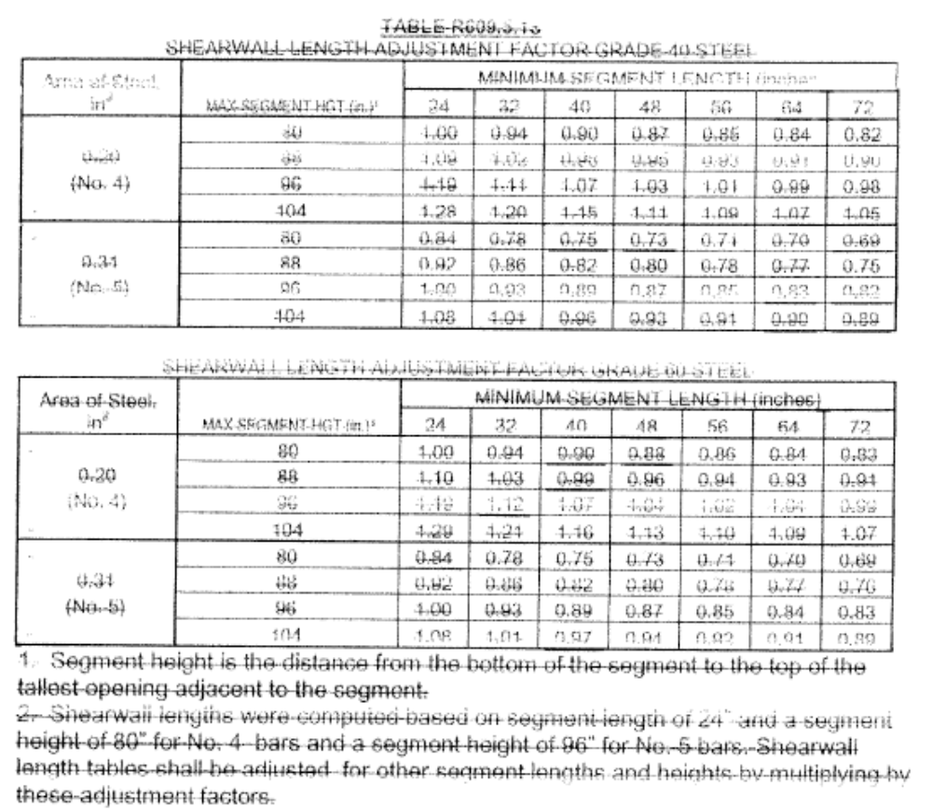

[Mod 3355revised]

Section R613.3.1 Testing and labeling revise text to read as follows:

R613.3.1 Testing and labeling. Exterior windows and glass doors shall be tested by an approved independent testing laboratory, and shall be labeled with an approved permanent label identifying the manufacturer, the products model/series number, performance characteristics and approved product certification agency, testing laboratory, evaluation entity or Miami-Dade Product Approval to indicate compliance with the requirements of one of the following specifications:
ANSI/AAMA/NWWDA101/I.S.2 or ANSI/AAMA/WDMA 101/I.S.2/NAFS or AAMA/WDMA/CSA 101/I.S.2/A440 or TAS 202 (HVHZ shall comply with TAS 202 utilizing ASTM E 1300-98 or ASTM E 1300-04 02).
Exterior windows and sliding glass doors shall be labeled with a permanent label, marking, or etching providing traceability to the manufacturer and product. The following shall also be required either on a permanent label or on a temporary supplemental label applied by the manufacturer: information identifying the manufacturer, the product model/series number, positive and negative design pressure rating, product maximum size, glazing thickness, impact-resistance rating if applicable, Florida Product Approval number or Miami-Dade Product Approval number, applicable test standard(s), and approved product certification agency, testing laboratory, evaluation entity or Miami-Dade Product Approval.

The labels are limited to one design pressure rating per reference standard. The temporary supplemental label shall remain on the window or door until final approval by the building official.

Exceptions:
1. Door assemblies installed in nonhabitable areas where the door assembly and area are designed to accept water infiltration need not be tested for water infiltration.
2. Door assemblies installed where the overhang (OH) ratio is equal to or more than 1 need not be tested for water infiltration. The overhang ratio shall be calculated by the following equation:
OH ratio = OH length/OH height
Where:
OH length = The horizontal measure of how far an overhang over a door projects out from door's surface.
OH height = The vertical measure of the distance from the door's sill to the bottom of the overhang over a door.
3. Pass-through windows for serving from a single-family kitchen, where protected by a roof overhang of 5 feet (1.5 m) or more shall be exempted from the requirements of the water infiltration test.
4. Decorative glazed openings.

The permanent label is limited to only one design pressure rating per reference standard per label. Exterior windows and glass doors shall be labeled with a temporary supplemental label printed and applied by the manufacturer. The label shall identify the manufacturer, products model/series number, positive and negative design pressure rating, products maximum size, glazing thickness, indicate impact rated if applicable, Florida Product Approval or Miami-Dade Product Approval number if applicable, and applicable test standard. The supplemental label is limited to only one design pressure rating per reference standard per label. This supplemental label shall remain on the window until final approval by the building official.

The permanent label is always the default label in case the temporary label is missing or no longer legible for final approval by the building official.

Glass Strength: Products tested and labeled as conforming to ANSI/AAMA/NWWDA 101/I.S.2 or ANSI/AAMA/WDMA 101/I.S.2/NAFS or AAMA/WDMA/CSA 101/I.S.2/A440 or TAS 202 shall not be subject to the requirements of the Florida Building Code, Building. Determination of load resistance of glass for specific loads of products not tested and certified in accordance with Section R613.3.1 shall be designed and labeled to comply with ASTM E 1300. The temporary supplemental label shall designate the type and thickness of glass or glazing material.

[Mod 3041, Mod 3201 and Mod 3192]

Section R613.3.1.1 Testing and labeling of skylights revise text to read as follows:

R613.3.1.1 R308.6.9 Testing and labeling of skylights. Exterior skylights shall be tested by an approved independent testing laboratory, and shall be labeled with an approved permanent label identifying the manufacturer, the products model/series number, performance characteristics and approved product evaluation entity to indicate compliance with the requirements of one of the following specification:
ANSI/AAMA/WDMA 101/I.S.2/NAFS or AAMA/WDMA/CSA 101/I.S.2/A440, Voluntary Performance Specification for Windows, Skylights and Glass Doors, or TAS 202 (HVHZ shall comply with TAS 202).

Exterior skylights shall be labeled with a permanent label, marking, or etching providing traceability to the manufacturer and product. The following shall also be required either on a permanent label or on a temporary supplemental label applied by the manufacturer: information identifying the manufacturer, the product model/series number, positive and negative design pressure rating, product maximum size, type and thickness of glass or glazing material, impact-resistance rating if applicable, Florida Product Approval number or Miami-Dade Product Approval number, applicable test standard(s), and approved product certification agency, testing laboratory, evaluation entity or Miami-Dade Product Approval.

Labels are limited to one design pressure rating per reference standard. The temporary supplemental label shall remain on the skylight until final approval by the building official.

The permanent label is limited to only one design pressure rating per reference standard per label.

Exterior skylights shall be labeled with a temporary supplemental label printed and applied by the manufacturer. The label shall identify the manufacturer, products model/series number, positive and negative design pressure rating, products maximum size, glazing thickness, indicate impact rated if applicable, Florida Product Approval or Miami-Dade Product Approval number if applicable, and applicable test standard. The supplemental label is limited to only one design pressure rating per reference standard per label. This supplemental label shall remain on the window until final approval by the building official. The permanent label is always the default label in case the temporary label is missing or no longer legible for final approval by the building official.

[Mod 3200 and Mod 3194]

Section R613.3.2 Supplemental label revise text to read as follows:

R613.3.2 Supplemental label. Comparative Analysis Label. A temporary supplemental label conforming to AAMA 203, Procedural Guide for the Window Inspection and Notification System, shall be acceptable for establishing and communicating the calculated allowable design pressures higher than indicated on the label required by Section R613.3.1 for window or door sizes smaller than that required by the ANSI/AAMA/NWWDA 101/I.S.2 or ANSI/AAMA/WDMA 101/I.S.2/NAFS or AAMA/WDMA/CSA 101/I.S.2/A440 test requirements. This temporary supplemental label shall be applied by the manufacturer and remain on the window or door until final approval by the building official.

[Mod 3198]

Section R613.8.1, revise text to read as follows:

R613.8.1 All exterior fenestration products shall be sealed at the juncture with the building wall with a sealant complying with AAMA 800 or and ASTM C 920 Class 25 Grade NS or greater for proper joint expansion and contraction, ASTM C 1281, AAMA 812, or other approved standard as appropriate for the type of sealant.

[Staff Comment]

Section R613.8.2 Masonry rough openings revise text to read as follows:

R613.8.2 Masonry rough openings. Masonry rough opening dimensions shall be within the tolerances specified at Section R606.13 R606.12 and in addition shall provide for a window perimeter sealant joint a maximum of 1/4 inches in width.

[Mod 2876]

Chapter 8 Roof-Ceiling Construction

Table R802.2.9.1 Roof Bearing Uplift at Top of Wall in Exposure B PLF, revise text to read as follows:

 | TABLE R802.2.9.1
 | ROOF BEARING UPLIFT AT TOP OF WALL IN EXPOSURE B, PLF^{1,2,4}
Roof Angle | Wind Speed, mph | Roof Span (feet) |  |  |  |  |  |  | Over-hangs³
Roof Angle | Wind Speed, mph | 12 | 20 | 24 | 28 | 32 | 36 | 40 | Over-hangs³
End zone load for all roof angles | 85 | -39.50 | -65.83 | -79.00 | -92.16 | -105.33 | -118.49 | -131.66 | -19.3
End zone load for all roof angles | 90 | -48.64 | -81.07 | -97.28 | -113.50 | -129.71 | -145.92 | -162.14 | -21.6
End zone load for all roof angles | 100 | -68.50 | -114.16 | -136.99 | -159.82 | -182.66 | -205.49 | -228.32 | -26.7
End zone load for all roof angles | 110 | -90.44 | -150.73 | -180.88 | -211.03 | -241.17 | -271.32 | -301.47 | -32.3
End zone load for all roof angles | 120 | -114.47 | -190.79 | -228.95 | -267.11 | -305.26 | -343.42 | -381.58 | -38.4
End zone load for all roof angles | 130 | -140.60 | -234.33 | -281.20 | -328.06 | -374.93 | -421.79 | -468.66 | -45.1
End zone load for all roof angles | 140 | -168.81 | -281.35 | -337.62 | -393.89 | -450.16 | -506.44 | -562.71 | -52.3
End zone load for all roof angles | 150 | -199.12 | -331.86 | -398.23 | -464.60 | -530.97 | -597.35 | -663.72 | -60.0
Interior zone load for all roof angles | 85 | -17.57 | -29.28 | -35.13 | -40.99 | -46.84 | -52.70 | -58.55 | -15.1
Interior zone load for all roof angles | 90 | -24.05 | -40.09 | -48.11 | -56.12 | -64.14 | -72.16 | -80.18 | -16.9
Interior zone load for all roof angles | 100 | -38.14 | -63.57 | -76.28 | -88.99 | -101.71 | -114.42 | -127.13 | -20.9
Interior zone load for all roof angles | 110 | -53.71 | -89.52 | -107.42 | -125.32 | -143.22 | -161.13 | -179.03 | -25.3
Interior zone load for all roof angles | 120 | -70.76 | -117.94 | -141.52 | -165.11 | -188.70 | -212.28 | -235.87 | -30.1
Interior zone load for all roof angles | 130 | -89.30 | -148.83 | -178.59 | -208.36 | -238.12 | -267.89 | -297.65 | -35.3
Interior zone load for all roof angles | 140 | -109.31 | -182.19 | -218.63 | -255.07 | -291.50 | -327.94 | -364.38 | -40.9
Interior zone load for all roof angles | 150 | -130.81 | -218.02 | -261.63 | -305.23 | -348.84 | -392.44 | -436.05 | -47.0
Interior zone uplift for 30⁰ roof angle
Interior zone uplift for 30⁰ roof angle |  |  | All values deleted

 | TABLE R802.2.9.1 (cont.)
 | ROOF BEARING UPLIFT AT TOP OF WALL IN EXPOSURE C, PLF^{1,2,4}
Roof Angle | Wind Speed, mph | Roof Span (feet) |  |  |  |  |  |  | Over-hangs³
Roof Angle | Wind Speed, mph | 12 | 20 | 24 | 28 | 32 | 36 | 40 | Over-hangs³
End zone load for all roof angles | 85 | -69.85 | -116.42 | -139.70 | -162.99 | -186.27 | -209.55 | -232.84 | -27.0
End zone load for all roof angles | 90 | -82.67 | -137.78 | -165.34 | -192.90 | -220.45 | -248.01 | -275.57 | -30.3
End zone load for all roof angles | 100 | -110.51 | -184.18 | -221.01 | -257.85 | -294.68 | -331.52 | -368.36 | -37.4
End zone load for all roof angles | 110 | -141.27 | -235.45 | -282.55 | -329.64 | -376.73 | -423.82 | -470.91 | -45.3
End zone load for all roof angles | 120 | -174.97 | -291.62 | -349.94 | -408.26 | -466.59 | -524.91 | -583.23 | -53.9
End zone load for all roof angles | 130 | -211.60 | -352.66 | -423.19 | -493.72 | -564.26 | -634.79 | -705.32 | -63.2
End zone load for all roof angles | 140 | -251.15 | -418.59 | -502.31 | -586.02 | -669.74 | -753.46 | -837.18 | -73.3
End zone load for all roof angles | 150 | -293.64 | -489.40 | -587.28 | -685.16 | -783.04 | -880.92 | -978.80 | -84.2
Interior zone load for all roof angles | 85 | -39.10 | -65.17 | -78.20 | -91.24 | -104.27 | -117.30 | -130.34 | -21.2
Interior zone load for all roof angles | 90 | -48.20 | -80.33 | -96.39 | -112.46 | -128.52 | -144.59 | -160.66 | -23.7
Interior zone load for all roof angles | 100 | -67.95 | -113.24 | -135.89 | -158.54 | -181.19 | -203.84 | -226.49 | -29.3
Interior zone load for all roof angles | 110 | -89.78 | -149.63 | -179.55 | -209.48 | -239.40 | -269.33 | -299.25 | -35.4
Interior zone load for all roof angles | 120 | -113.68 | -189.47 | -227.37 | -265.26 | -303.16 | -341.05 | -378.94 | -42.2
Interior zone load for all roof angles | 130 | -139.67 | -232.78 | -279.34 | -325.90 | -372.45 | -419.01 | -465.57 | -49.5
Interior zone load for all roof angles | 140 | -167.74 | -279.56 | -335.47 | -391.38 | -447.29 | -503.21 | -559.12 | -57.4
Interior zone load for all roof angles | 150 | -197.88 | -329.80 | -395.76 | -461.72 | -527.68 | -593.64 | -659.60 | -65.9
Interior zone uplift for 30⁰ roof angle
Interior zone uplift for 30⁰ roof angle |  |  | All values deleted.
Notes:
a. The uplift loads are pounds per lineal foot of building length. For roof uplift connections use the tables for 20 degrees and multiply by 1.33 for framing spaced 16 inches on center and multiply by 2 for framing spaced 24 inches on center.
b. The uplift loads include an allowance for 10 pounds of dead load.
c. The uplift loads do not account for the effects of overhangs. The magnitude of the above loads shall be increased by adding the overhang loads found in the table. The overhang loads are also based on framing spaced 12 inches on center. The overhang loads given shall be multiplied by the overhang projection and added to the roof uplift value in the table.
d. End zones extend 8 feet from building corners. Values may be interpolated between 20_ and 30_.
e. For buildings with a roof slope of 5:12 or greater, tabulated uplift loads shall be permitted to be multiplied by 0.87. Use value for 30_ for slopes up to 45_.
f. Negative values indicate uplift.
g.Use valve for 20_ for slopes of 20_ or less

[Mod 3354 and Mod 3356]

Chapter 9 Roof Assemblies

Section R905.2.4.1 Wind resistance of asphalt shingles revise text to read as follows:

R905.2.4.1 Wind resistance of asphalt shingles. Asphalt shingles shall be installed in accordance with Section R905.2.6. and R905.2.6.1. Shingles classified using ASTM D 3161 are acceptable for use in wind zones less than 110 mph (49 m/s). Shingles classified using ASTM D 3161, Class F, are acceptable for use in all cases where special fastening is required.

[Mod 3209]

Section R905.3.3.3 Underlayment and high wind revise text to read as follows:

R905.3.3.3 Underlayment and high wind. Reserved Underlayment applied in areas subject to high wind [over 110 miles per hour (49 m/s) per Figure R301.2(4)] shall be applied with corrosion-resistant fasteners in accordance with manufacturer’s installation instructions. Fasteners are to be applied along the overlap not farther apart than 36 inches (914 mm) on center.

[Mod 2922]

Section R905.7.8 Flashing revise text to read as follows:

R905.7.8 Flashing. At the juncture of the roof and vertical surfaces, flashing and counterflashing shall be provided in accordance with the manufacturer’s installation instructions, and where of metal, shall not be less than 0.0179-inch (0.48 mm) (No. 26 galvanized sheet gage) corrosion-resistant metal

[Mod 2924]

Section R905.7.8.1 Valley flashing revise text to read as follows:

R905.7.8.1 Valley flashing. Roof flashing shall be not less than No. 26 gage [0.0179 inches (0.48 mm)] corrosion-resistant sheet metal and shall extend 10 inches (254 mm) from the centerline each way for roofs having slopes less than 12 units vertical in 12 units horizontal
(100-percent slope), and 7 inches (178 mm) from the centerline each way for slopes of 12 units vertical in 12 units horizontal and greater. Sections of flashing shall have an end lap of not less than 4 inches (102 mm).

[Mod 2925]

Section R905.8.10 Flashing, revise text to read as follows:

R905.8.10 Flashing At the juncture of the roof and vertical surfaces, flashing and counter flashing shall be provided in accordance with the manufacturer’s installation instructions, and where of metal, shall not be less than 0.0179-inch (0.48 mm) (No. 26 galvanized sheet gage) corrosion-resistant metal.

[Mod 2926]

Section R905.10.4 Attachment revise text to read as follows:

R905.10.4 Attachment. Metal roof panels shall be secured to the supports in accordance with this chapter and the manufacturer’s installation instructions. Metal roofing fastened directly to steel framing shall be attached by approved fasteners. The following fasteners shall be used:
1. Galvanized fasteners shall be used for galvanized roofs.
2. Hard copper or copper alloy or 300 series stainless steel fasteners shall be used for copper roofs.
3. Stainless steel fasteners are acceptable for all types of metal roofs.
4. Aluminum-zinc coated fasteners are acceptable for aluminum-zinc coated roofs.

[Mod 2927]

Table R905.11.2 Modified Bitumen Roofing Material Standards, revise text to read as follows:

TABLE R905.11.2
MODIFIED BITUMEN ROOFING MATERIAL STANDARDS

Modified bitumen roof membrane | ASTM D 6162; D 6163; D 6164;  D 6222; D 6223; D 6298; D 6509  CGSB 37–56M;

No change to remainder of the table.

[Mod 3210]

Chapter M14 Heating and Cooling Equipment

Section M1411.3.1 Auxiliary and secondary drain systems revise text to read as follows:

M1411.3.1 Auxiliary and secondary drain systems. In addition to the requirements of Section M1411.3, a secondary drain or auxiliary drain pan shall be required for each cooling or evaporator coil where damage to any building components will occur as a result of overflow from the equipment drain pan or stoppage in the condensate drain piping. Such piping shall maintain a minimum horizontal slope in the direction of discharge of not less than 1/8 unit vertical in 12 units horizontal (1-percent slope). Drain piping shall be a minimum of 3/4-inch (19 mm) nominal pipe size. One of the following methods shall be used:
1. An auxiliary drain pan with a separate drain shall be installed under the coils on which condensation will occur. The auxiliary pan drain shall discharge to a conspicuous point of disposal to alert occupants in the event of a stoppage of the primary drain. The pan shall have a minimum depth of 1.5 inches (38 mm), shall not be less than 3 inches (76 mm) larger than the unit or the coil dimensions in width and length and shall be constructed of corrosion-resistant material. Metallic pans shall have a minimum thickness of not less than 0.0276-inch (0.7 mm) galvanized sheet metal. Nonmetallic pans shall have a minimum thickness of not less than 0.0625 inch (1.6 mm).
2. A separate overflow drain line shall be connected to the drain pan provided with the equipment. This overflow drain shall discharge to a conspicuous point of disposal to alert occupants in the event of a stoppage of the primary drain. The overflow drain line shall connect to the drain pan at a higher level than the primary drain connection. As an alternative to a separate drain line, a water-level detection device that will shut off the equipment served prior to overflow of the pan shall be provided. The water-level detection device shall connect to the drain pan at a higher level than the primary drain connection.
3. An auxiliary drain pan without a separate drain line shall be installed under the coils on which condensate will occur. This pan shall be equipped with a water level detection device conforming to UL 508 that will shut off the equipment served prior to overflow of the pan. The auxiliary drain pan shall be constructed in accordance with Item 1 of this section.
4. A water level detection device conforming to UL 508 shall be provided that will shut off the equipment served in the event that the primary drain is blocked. The device shall be installed in the primary drain line, the overflow drain line or the equipment-supplied drain pan, located at a point higher than the primary drain line connection and below the overflow rim of such pan.

[Mod 2831]

Chapter M15 Exhaust Systems

Section M1502.6 Duct length revise text to read as follows:

M1502.6 Duct length. The maximum length of a clothes dryer exhaust duct shall not exceed 25 feet (7620 mm) from the dryer location to the wall or roof termination. The maximum length of the duct shall be reduced 2.5 feet (762 mm) for each 45-degree (0.8 rad) bend and 5 feet (1524 mm) for each 90-degree (1.6 rad) bend. The maximum length of the exhaust duct does not include the transition duct.

Exceptions:

1. Where a clothes dryer booster fan is installed and listed and labeled for the application, the maximum length of the exhaust duct, including any transition duct, shall be permitted to be in accordance with the booster fan manufacturer’s installation instructions. Where a clothes dryer booster fan is installed and not readily accessible from the room in which the dryer is located, a permanent identifying label shall be placed adjacent to where the exhaust duct enters the wall. The label shall bear the words “This dryer exhaust system is equipped with a remotely located booster fan.”

12. Where the make and model of the clothes dryer to be installed is known and the manufacturer’s installation instructions for the dryer are provided to the building official, the maximum length of the exhaust duct, including any transition duct, shall be permitted to be in accordance with the dryer manufacturer’s installation instructions.

23. Where large-radius 45-degree (0.8 rad) and 90-degree (1.6 rad) bends are installed, determination of the equivalent length of clothes dryer exhaust duct for each bend by engineering calculation in accordance with the ASHRAE
Fundamentals Handbook shall be permitted.

[Mod 3267]

Chapter M16 Duct Systems

Section M1601.1.2 Underground ducts revise text to read as follows:

M1601.1.2 Underground ducts. Ducts shall be approved for underground installation. Metallic ducts not having an approved protective coating shall be completely encased in a minimum of 2 inches (51 mm) of concrete.
M1601.1.2.1 Slope. Ducts shall slope to allow drainage to a point provided with access.
M1601.1.2.2 Sealing. Ducts shall be sealed and secured prior to pouring the concrete encasement.
M1601.1.2.3 Plastic ducts and fittings. Plastic ducts shall be constructed of PVC having a minimum pipe stiffness of 8 psi (55 kPa) at 5-percent deflection when tested in accordance with ASTM D 2412. Plastic duct fittings shall be constructed of either PVC or high-density polyethylene. Plastic duct and fittings shall be utilized in underground installations only. The maximum design temperature for systems utilizing plastic duct and fittings shall be 150°F (66°C).
Underground duct systems shall be constructed of approved concrete, clay, metal or plastic. The maximum duct temperature for plastic ducts shall not be greater than 150°F (66°C). Metal ducts shall be protected from corrosion in an approved manner or shall be completely encased in concrete not less than 2 inches (51 mm) thick. Nonmetallic ducts shall be installed in accordance with the manufacturer’s installation instructions. Plastic pipe and fitting materials shall conform to cell classification 12454-B of ASTM D 1248 or ASTM D 1784 and external loading properties of ASTM D 2412. All ducts shall slope to an accessible point for drainage. Where encased in concrete, ducts shall be sealed and secured prior to any concrete being poured. Metallic ducts having an approved protective coating and nonmetallic ducts shall be installed in accordance with the manufacturer’s installation instructions.

[Mod 2948rev]

Chapter P26 General Plumbing Requirements

Section P2603.3 Breakage and corrosion revise text to read as follows:

P2603.3 Breakage and corrosion. Pipes passing through concrete or cinder walls and floors or other corrosive material shall be protected against external corrosion by a protective sheathing or wrapping or other means that will withstand any reaction from lime and acid of concrete, cinder or other corrosive material. Sheathing or wrapping shall allow for expansion and contraction of piping to prevent any rubbing action. Minimum wall thickness of material shall be 0.025 0.010 inch (0.64 mm).
Exception: Sleeving is not required for installation of CPVC into concrete or similar material

Section P2603.3.1 Penetration add text to read as follows:

P2603.3.1 Penetration. Protective sleeves around piping penetrating concrete slab-on-grade floors shall not be of cellulose-containing materials. If soil treatment is used for subterranean termite protection, the sleeve shall have a maximum wall thickness of 0.010 inch, and be sealed within the slab using a non-corrosive clamping device to eliminate the annular space between the pipe and the sleeve. No termiticides shall be applied inside the sleeve.

[Mod 2841]

Chapter P27 Plumbing Fixtures

Table P2701.1 Plumbing Fixtures, Faucets and Fixture Fittings, revise text to read as follows:

TABLE P2701.1
PLUMBING FIXTURES, FAUCETS AND FIXTURE FITTINGS
(Only relevant section of table shown below)
Material | Standard
Suction fittings for use in swimming pools, wading pools, spas, hot tubs and whirlpool bathtub appliances | ASME A112.19.8M

[Mod 3183]

Chapter P28 Water Heaters

Section P2803.6.1.2 Requirements for discharge piping add text to read as follows:

P2803.6.1.2 Requirements for discharge piping. The discharge piping serving a pressure relief valve, temperature relief valve or combination thereof shall:
1. Not be directly connected to the drainage system.
2. Discharge through an air gap located in the same room as the water heater.
3. Not be smaller than the diameter of the outlet of the valve served and shall discharge full size to the air gap.
4. Serve a single relief device and shall not connect to piping serving any other relief device or equipment.
5. Discharge to the floor, to the water heater pan, to an indirect waste receptor or to the outdoors. Where discharging to the outdoors in areas subject to freezing, discharge piping shall be first piped to an indirect waste receptor through an air gap located in a conditioned area.
6. Discharge in a manner that does not cause personal injury or structural damage.
7. Discharge to a termination point that is readily observable by the building occupants.
8. Not be trapped.
9. Be installed so as to flow by gravity.
10. Not terminate more than 6 inches (152 mm) above the floor or waste receptor.
11. Not have a threaded connection at the end of such piping.
12. Not have valves or tee fittings.
13. Be constructed of those materials listed in Section P2904.5 or materials tested, rated and approved for such use in accordance with ASME A112.4.1

[Mod 3066]

Chapter P29 Water Supply and Distribution

Table P2903.2b Minimum Water Service Size, revise text to read as follows:

Table P2903.2b Minimum Water Service Size
Replace 56-58 with 56-85.

[Mod 2829rev]

Table P2903.2b, Minimum Water Service Size, revise text to read as follows:

TABLE P2903.2b
MINIMUM WATER SERVICE SIZEª
No change to table.
a. Table is applicable for both copper and plastic water piping.
b. See Table P3004.1 P2903.6 for fixture unit values.
c. Minimum water service shall be ¾” to control valve.
d. All secondary submeters and backflow assemblies shall be at least the same size as the line in which they are installed.
e. Table based on minimum water main pressure of 50 psi.

[Mod 2894 and Mod 3347]

Chapter E33 General Requirements

Section E3304 Equipotential Bonding, revise text to read as follows:

Section E3304 Equipotential Bonding

E3304.1 NFPA 70A - 05: National Electric Code, Article 680 (Swimming Pools, Fountains, and Similar Installation), Section 680.26, Equipotential Bonding is amended to read as follows:

680.26 Equipotential Bonding.
(A) Performance. The equipotential bonding required by this section shall be installed to reduce eliminate voltage gradients in the pool area as prescribed.

FPN: The 8 AWG or larger solid copper bonding conductor shall not be required to be extended or attached to any remote panelboard, service equipment, or any electrode.

(B) Bonded Parts. The parts specified in 680.26(B)(1) through (B)(57) shall be bonded together using solid copper conductors, insulated covered, or bare, not smaller than 8 AWG or with rigid metal conduit of brass or other identified corrosion-resistant metal. Connections to bonded parts shall be made in accordance with 250.8. An 8 AWG or larger solid copper bonding conductor provided to reduce voltage gradients in the pool area shall not be required to be extended or attached to remote panelboards, service equipment, or electrodes.

(1) Conductive Pool Shells. Bonding to conductive pool shells shall be provided as specified in 680.26(B)(1)(a) or (B)(1)(b). Poured concrete, pneumatically applied or sprayed concrete, and concrete block with painted or plastered coatings shall all be considered conductive materials due to water permeability and porosity. Vinyl liners and fiberglass composite shells shall be considered to be non-conductive materials.

(a). Structural Reinforcing Steel. Unencapsulated structural reinforcing steel shall be bonded together by steel tie wires or the equivalent. Where structural reinforcing steel is encapsulated in a nonconductive compound, a copper conductor grid shall be installed in accordance with 680.26(B)(1)(b).

(b). Copper Conductor Grid. A copper conductor grid shall be provided and shall comply with (b)(1) through (b)(4):

(1) Be constructed of minimum 8 AWG bare solid copper conductors bonded to each other at all points of crossing.

(2) Conform to the contour of the pool and the pool deck.

(3) Be arranged in a 300 mm (12 in.) by 300 mm (12 in.) network of conductors in a uniformly spaced perpendicular grid pattern with a tolerance of 100 mm (4 in.).

(4) Be secured within or under the pool no more than 150 mm (6 in.) from the outer contour of the pool shell.

(2) Perimeter Surfaces. The perimeter surface shall extends for 1 m (3 ft) horizontally beyond the inside walls of the pool and shall includes unpaved surfaces as well as poured concrete and other types of paving. Bonding to perimeter surfaces shall be provided as specified in 680.26(B)(2)(a) or (2)(b), and shall be attached to the pool reinforcing steel or copper conductor grid at a minimum of four (4) points uniformly spaced around the perimeter of the pool. For non-conductive pool shells, bonding at four points shall not be required.

(C) Equipotential Bonding Grid. The parts specified in 680.26(B) shall be connected to an equipotential bonding grid with a solid copper conductor, insulated, covered, or bare, not smaller than 8 AWG or rigid metal conduit of brass or other identified corrosion-resistant metal conduit. Connection shall be made by exothermic welding or by listed pressure connector or clamps that are labeled as being suitable for the purpose and are of stainless steel, brass, copper, or copper alloy. The equipotential common bonding grid shall extend under paved walking surfaces for 1 m (3 ft) horizontally beyond the inside walls of the pool and shall be permitted to be any of the following:

(1)(a) Structural Reinforcing Steel. Structural reinforcing steel of a concrete pool where the reinforcing rods are bonded together by the usual steel tie wires or the equivalent shall be bonded In accordance with 680.26 (B)(1)(a).

(2) Bolted or Welded Metal Pools. The wall of a bolted or welded metal pool.

(3) (b) Alternate Means. Where structural reinforcing steel is not available or is encapsulated in a nonconductive compound, a copper conductor(s) shall be utilized where the following requirements are met:

(1) At least one minimum 8 AWG bare solid copper conductor shall be provided.
(2) The conductor(s) shall follow the contour of the perimeter surface.
(3) Only listed splices shall be permitted.
(4) The required conductor shall be 450 to 600 mm (18 to 24 in.) from the inside walls of the pool.
(5) The required conductor shall be secured within or under the perimeter surface 100 to 150 mm (4 to 6 in.) below the subgrade.
This system shall be permitted to be constructed as specified in (a) through (c):
a. Materials and Connections. The grid shall be constructed of minimum 8 AWG bare solid copper conductors. Conductors shall be bonded to each other at all points of crossing. Connection shall be made as required by 680.26(D).
b. Grid Structure. The equipotential bonding grid shall cover the contour of the pool and the pool deck extending 1 m (3 ft) horizontally from the inside walls of the pool. The equipotential bonding grid shall be arranged in a 300 mm (12 in) by 300 mm (12 in) network of conductors in a uniformly spaced perpendicular grid pattern with tolerance of 100 mm (4 in).
c. Securing. The below-grade grid shall be secured within or under the pool and deck media.

(D) Connections. Where structural reinforcing steel or the walls of bolted or welded metal pool structures are used as an equipotential bonding grid for nonelectrical parts, the connections shall be made in accordance with 250.8.

(13) Metallic Structural Components. All metallic parts of the pool structure, including reinforcing metal of the pool shell, coping stones, and deck, shall be bonded. The usual steel tie wires shall be considered suitable for bonding the reinforcing steel together, and welding or special clamping shall not be required. These tie wires shall be made tight. If reinforcing steel is affectively insulated by an encapsulating nonconductive compound at the time of manufacture and installation, it shall not be required to be bonded. Where reinforcing steel of the pool shell or the reinforcing steel of coping stones and deck is encapsulated with a nonconductive compound or another conductive material is not available, provisions shall be made for an alternative means to eliminate voltage gradients that would otherwise be provided by an encapsulated, bonding reinforcing steel. not addressed in 680.26(B)(1)(a), shall be bonded. Where reinforcing steel is encapsulated with a nonconductive compound, the reinforcing steel shall not be required to be bonded.

(24) Underwater Lighting. All metal forming shells and mounting brackets of no-niche luminaires (fixtures) shall be bonded unless a.
Exception: Listed low-voltage lighting systems with nonmetallic forming shells shall not requireing bonding.

(35) Metal Fittings. All metal fittings within or attached to the pool structure shall be bonded. Isolated parts that are not over 100 mm (4 in.) in any dimension and do not penetrate into the pool structure more than 25 mm (1 in.) shall not require bonding.

(46) Electrical Equipment. Metal parts of electrical equipment associated with the pool water circulating system, including pump motors and metal parts of equipment associated with pool covers, including electric motors, shall be bonded. Accessible metal parts of listed equipment incorporating an approved system of double insulation and providing a means for grounding internal nonaccessible, non-current-carrying metal parts shall not be bonded by a direct connection to the equipotential bonding grid. The means for grounding internal nonaccessible, non-current-carrying metal parts shall be an equipment grounding conductor run with the power-supply conductors in the case of motors supplied with a flexible cord, or a grounding terminal in the case of motors intended for permanent connection.

Where a double-insulated water-pump motor is installed under the provisions of this rule, a solid 8 AWG copper conductor that is of sufficient length to make a bonding connection to a replacement motor shall be extended from the bonding grid to an accessible point in the motor vicinity. Where there is no connection between the swimming pool bonding grid and the equipment grounding conductor of the motor circuit.
Exception: Metal parts of listed equipment incorporating an approved system of double insulation shall not be bonded.

(a) Double-Insulated Water Pump Motors. Where a double-insulated water-pump motor is installed under the provisions of this rule, a solid 8 AWG copper conductor that is of sufficient length to make a bonding connection to a replacement motor shall be extended from the bonding grid to an accessible point in the motor vicinity of the pool pump motor. Where there is no connection between the swimming pool bonding grid and the equipment grounding system for the premises, this bonding conductor shall be connected to the equipment grounding conductor of the motor circuit.

(bE) Pool Water Heaters. For pool water heaters rated at more than 50 amperes and having specific instructions regarding bonding and grounding, only those parts designated to be bonded shall be bonded and only those parts designated to be grounded shall be grounded.

(57) Metal Wiring Methods and Equipment. Metal-sheathed cables and raceways, metal piping, and all fixed metal parts that are within the following distances of the pool, except those separated from the pool by a permanent barrier, shall be bonded.
(1) Within 1.5 m (5 ft) horizontally of the inside walls of the pool
(2) Within 3.7 m (12 ft) measured vertically above the maximum water level of the pool, or any observation stands, towers, or platforms, or any diving structures.
Exception No. 1: Those separated from the pool by a permanent barrier shall not be required to be bonded.
Exception No. 2: (1) Within Those greater than 1.5 m (5 ft) horizontally of the inside walls of the pool shall not be required to be bonded.
Exception No. 3: (2) Within Those greater than 3.7 m (12 ft) measured vertically above the maximum water level of the pool, or as measured vertically above any observation stands, towers, or platforms, or any diving structures shall not be required to be bonded.

(C) Pool Water. An intentional bond of a minimum conductive surface area of 5806 mm 2 (9 in 2 ) shall be installed in contact with the pool water. This bond shall be permitted to consist of parts that are required to be bonded in 680.26(B).

Section E3305 Connection of Grounding and Bonding Equipment add text to read as follows:

E3305 Connection of Grounding and Bonding Equipment.

E3305.1 NFPA 70A-05 National Electric Code, Article 250 (Grounding and Bonding), Section 250.8 Connection of Grounding and Bonding Equipment is amended to read as follows:

250.8 Connection of Grounding and Bonding Equipment.
A. Permitted Methods. Grounding conductors and bonding jumpers shall be connected by one of the following means:
(1) Llisted pressure connectors, listed clamps, or
(2) Terminal bars
(3) Pressure connectors listed as grounding and bonding equipment
(4) Eexothermic welding process
(5) Machine screw-type fasteners that engage not less than two threads or are secured with a nut
(6) Thread-forming machine screws that engage not less than two threads in the enclosure
(7) Connections that are part of a listed assembly
(8) Oother listed means
B. Methods not permitted. Connection devices or fittings that depend solely on solder shall not be used. Sheet metal screws shall not be used to connect grounding conductors to enclosures.

[Mod 3015rev]

Chapter 43 Reference Standards

Revise text to read as follows:

AAF Aluminum Association of Florida, Inc.
1650 S Dixie Hwy, Ste 500 3165 McCrory Place, Suite 185
Boca Raton, FL 33432 Orlando, FL 32803

AAF—07 07-1 Guide to Aluminum Construction in High Wind Areas 2003 2007-1 R301.2.1.1

[Mod 2988]

ACCA
ACCA Manual D-1995 Residential Duct Systems N1110.ABC.1

ACCA Manual J-2003 Residential Load Calculation, Eighth Edition with posted updates/errata N1107.ABC.1

301 Specifications for Structural Concrete for Buildings R4405.2.2

[Staff]

ACI
318-05 Building Code Requirements for Structural Concrete. . . . . . . . . . . . . R402.2, R404.1, Table R404.1.1(5), R404.4, R404.4.6.1, Table R404.4(1), Table R404.4(2), Table R404.4(3), Table R404.4(4), Table R404.4(5), R611.1, Table R611.3(1), Table R611.7(1), Table R611.7(2), Table R611.7(3), Table R611.7(4), Table R611.7(5), Table R611.7(6), Table R611.7(7), Table R611.7(9), Table R611.7(10), R611.7.1.1, Table R611.7.4, R612.1, R4405.8.5.5

[Mod 2893]

ADC
ADC 2003 Flexible Duct Performance & Installation Standards, Fourth Edition N1110.ABC.2.2

AHAM
ANSI/AHAM RAC1-03 Room Air Conditioners Table 1107.ABC.3.2D

AHRI (Formerly ARI)
Air-Conditioning Heating and Refrigeration Institute
Suite 5200
2111 Wilson Boulevard 4100 North Fairfax Drive
Arlington, VA 222013

Standard reference number Title Referenced in code section number
ARI Std. 210/240-2006 Unitary Air-Conditioning and Air-Source Heat Pump Equipment
Tables N1107.ABC.3.2A, N1107.ABC.3.2B
ARI Std. 310/380-2004 Packaged Terminal Air-Conditioners and Heat Pumps
Tables N1107.ABC.3.2D
ARI Std. 340/360-2004 Commercial and Industrial Unitary Air-Conditioning and Heat Pump Equipment Tables N1107.ABC.3.2A, N1107.ABC.3.2B
ARI Std. 365-2002 Commercial and Industrial Unitary Air-Conditioning Condensing Units
Table N1107.ABC.3.2A
ARI Std. 390-2003 Single Packaged Vertical Air Conditioners and Heat Pumps
Table N1107.ABC.3.2D
ARI Std. 1160-2004 Performance Rating of Heat Pump Pool Heaters N1112.ABC.2.3.4

ANSI
A112.18.1M-99 Finished and Rough Brass Plumbing Fixture Fittings N1108.A.3.5, N1112.ABC.2.4

Z21.47a-04 Gas-Fired Central Furnaces Table N1108.ABC.3.2E

Z21.56-2006 Gas-Fired Pool Heaters N1112.ABC.2.3.1

Z83.8/CGA 2.6-06 Gas Unit Heaters and Gas-Fired Duct Furnaces Table N1108.ABC.3.2E

[Staff]

Delete text to read as follows:

ANSI
Z21.10.3 Gas Water Heater, Volume 3, Storage, with Input Ratings above 75,000 Btu/h, Circulating and Instantaneous Water Heaters. . .Appendix G C4.3.1.3

[Mod 2893]

Revise text to read as follows:

APSP NSPI
Association of Pool and Spa Professionals
National Spa and Pool Institute
ANSI/NSPI 3—99 American National Standard for Permanently Installed Residential Spas……………………………………………………………R4101.6.1

ANSI/NSPI 4—99 American National Standard for Aboveground/Onground Residential Swimming Pools……………………………………………..R4101.6.1

ANSI/NSPI 5—03 American National Standard for Residential Inground Swimming Pools…………………………………………………………….R4101.6.1

ANSI/NSPI 6—99 American National Standard for Residential Portable Spas…………………………………………………………………………...R4101.6.1

ANSI/APSP 7—06 American National Standard for Suction Entrapment Avoidance in Swimming Pools, Wading Pools, Spas, Hot Tubs, and Catch Basins…………….……………………………….R4101.6.1, R4101.6.3, R4101.6.6

[Mod 3180]

ASHRAE
ANSI/ASHRAE Std. 93-1986 (RA91) Methods of Testing to Determine the Thermal Performance of Solar Collectors N1112.ABC.3.4

ASHRAE, 1998 Cooling and Heating Load Calculation Principles N1107.ABC.1

ASME
BPVC-20041 ASME Boiler and Pressure Vessel Code (2001 Edition) (Sections I,II, IV, V, VI & IX) M2001.1.1, G2452.1

[Staff]

Delete text to read as follows:

ASME
A112.18.19.8M—1987(R1996) Suction Fittings for Use in Swimming Pools, Wading Pools, Spas, Hot Tubs and Whirlpool Bathtub Appliances. Table P2701.1

Add text to read as follows:

ASTM
ASTM D 6509-00 Specification for Atactic Polypropylene (APP) Modified Bituminous Base Sheet Materials Using Glass Fiber Reinforcements ……………………….Table R905.11.2

[Mod 3210]

Revise text to read as follows:

ASTM
A924 /A924M—04 Standard Specification for General Requirements for Steel Sheet, Metallic-coated by the Hot-dip Process . . . . . . . . . . . 4409.6.17.2.2.7.

E 1300—04e01 or 98 (02 or 98 HVHZ) Practice for Determining Load Resistance of Glass in Buildings . . . . . . . . . . . . . . . . . . . R613.3.1, R4410.2.2

[Mod 2983, and Mod 3068]

ASTM
C 177-04 Test Method for Steady-State Heat Flux Measurements and Thermal Transmission Properties by Means of the Guarded-Hot-Plate Apparatus N1110.ABC.2.2

C 518-04 Test Method for Steady-State Thermal Transmission Properties by Means of the Heat Flow Meter Apparatus N1110.ABC.2.2

E 84-06a Test Method for Surface Burning Characteristics of Building Materials R202, R314.3, R314.5.8, R314.5.10, R315.3 R315.4, R316.1, R316.2, R802.1.4, M1601.11, M1601.3.7, M1601.3.13 M1601.16, R4409.1.4.4, R4409.14.1, R4412.1.2, R4412.1.3.1.1, R4412.1.3.1.4, R4412.1.3.2.4.5, N1110.ABC.3.0.7

E 283-04 Standard Test Method for Determining the Rate of Air Leakage through Exterior Windows, Curtain Walls and Doors Under Specified Pressure Differences Across the Specimen
N1106.ABC.1.1, N1106.ABC.2.4, R4409.13.3.2.5, Appendix G B3.4

CSA
101/I.S.2/A440-05 Specifications for Windows, Doors and Unit Skylights R308.6.9, R613.4, N1106.ABC.1.1

[Staff]

DASMA
ANSI/DASMA 108-02 05 Standard Method for Testing Sectional Garage Doors and Rolling Doors: Determination of Structural Performance Under Uniform Static Air Pressure Difference R613.4.1, R613.4.2

[Mod 3239]

DOE
DOE, 10 CFR, Part 430 Subpart B, App. E-1998 Uniform Test Method for Measuring the Energy Consumption of Water Heaters Table N1108.ABC.3.2F, Subpart B, App. E-1998, N1112.ABC.3.1.1, N1112.ABC.3.2.1

DOE, 10 CFR, Part 430 Subpart B, App. M Uniform Test Method for Measuring the Energy Consumption of Central Air Conditioners N1107.ABC.3.1

DOE, 10 CFR, Part 430 Subpart B, App N-1998 Uniform Test Method for Measuring the Energy Consumption of Furnaces Table N1108.ABC.3.2E

EPACT, 1992 42 USC 6831 Energy Policy Act of 1992 et seq. Public Law 102-486 N1107.ABC.3.2

NAECA, 1987 National Appliance Energy Conservation Act of 1987 Tables N1107.ABC.3.2A, N1107.ABC.3.2B, N1108.ABC.3.2E

GAMA
GAMA Consumer's Directory of Certified Efficiency Ratings for Water Heating Equipment Table N1112.ABC.3.5, Appendix G C4.3.1.3

HI
H.I., HBS 86-1989 Testing and Rating Standard for Heating Boilers Tables N1108.ABC.3.2F

ISO
ISO 9806 (1994, 1995) Test Methods for Solar Collectors
Part 1: December 1, 1994 Thermal Performance of glazed liquid heating collectors including pressure drop
Part 2: Qualification test procedures, August 15, 1995.
Part 3: Thermal performance of unglazed liquid heating collectors (sensible heat transfer only) including pressure drop, December 15, 1995. N1112.ABC.3.4

ISO 13256-1 (1998) Part 1 Water-Source Heat Pumps-Testing and Rating for Performance-
Water-to-Air and Brine-to-Air Heat Pumps Table N1107.ABC.3.2B

NAIMA
NAIMA 2002 Fibrous Glass Duct Construction Standards, Fifth Edition N1110.ABC.3.2
NAIMA 2002 Fibrous Glass Duct Liner Standard, Third edition N1110.ABC.2.4, N1110.ABC.3

[Staff]

NFPA
259—03 04Test Method for Potential Heat of Building Materials. . . . . 2603.4.1.10, 2603.5.3, 2612.3.2.4.4

NFPA
501—05 03 Standard on Manufactured Housing . . . . . . . . . . . . . . . . . . .R202

[Mod 3013 and Mod 3052]

Revise text to read as follows:

SRCC
FSEC Directory of Certified Solar Systems N1112.ABC.3.4
SRCC TM-1 Solar Domestic Hot Water System and Component Test Protocol, December 6, 2002 N1112.ABC.3.4

UL

181-05 Standard for Factory-made Air Ducts and Air Connectors N1110.ABC.3.0.7, N1110.ABC.3.7.1

181A-05 Closure Systems for Use with Rigid Air Ducts and Air Connectors N1110.ABC.3.0.7

181B-05 Closure Systems for Use with Flexible Air Ducts and Air Connectors N1110.ABC.3.0.7

723-03 Standard for Test for Surface Burning Characteristics of Building Materials N1110.ABC.3.0.7

727-06 Standard for Oil-Fired Central Furnaces, with Revisions through January 1999 Table N1108.ABC.3.2E

731-95 Standard for Oil-Fired Unit Heaters, with revisions through January 1999 Table N1108.ABC.3.2E

[Staff]

Add text to read as follows:

ANSI/UL 2034 - 96, Standard for Single and Multiple Station CO Alarms……R202

UL 2075 - 04, Gas and Vapor Detector Sensor………R202

[Mod 2897]

WDMA
101/I.S.2/NAFS-02 Specifications for Windows, Doors and Unit Skylights N1106.ABC.1.1

[Staff]

Chapter 44 High Velocity Hurricane Zone

Section R4402.14 High-Velocity Hurricane Zones — Uniform Permit Application, revise text to read as follows:

SECTION R4402.14
HIGH-VELOCITY HURRICANE ZONES — UNIFORM PERMIT APPLICATION

Florida Building Code Edition 2004 2007
High-Velocity Hurricane Zone Uniform Permit Application Form.
Instruction Page

Florida Building Code Edition 2004 2007
High-Velocity Hurricane Zone Uniform Permit Application Form.
Section A (General Information)

Florida Building Code Edition 2004 2007
High-Velocity Hurricane Zone Uniform Permit Application Form.
Section B (Roof Plan)

Florida Building Code Edition 2004 2007
High-Velocity Hurricane Zone Uniform Permit Application Form.
Section C (Low Slope Application)

Florida Building Code Edition 2004 2007
High-Velocity Hurricane Zone Uniform Permit Application Form.
Section D (Steep Sloped Roof System)

Florida Building Code Edition 2004 2007
High-Velocity Hurricane Zone Uniform Permit Application Form.
Section E (Tile Calculations)

[Mod 3281]

Section R44003.2.1 Fences revise text to read as follows:

R44003.2.1 Fences. Fences not exceeding 6 inches feet (52 1829 mm) in height from grade may be designed for 75 mph (33 m/s) fastest mile wind speed or 90 mph (40 m/s) 3-second gust.

[Mod 3242]

Section R4403.14.2 Wind effects delete text to read as follows:

R4403.14.2 Wind effects. Where the pressure on the foundation from wind is less than 25 percent of that resulting from dead or other live loads, wind pressure may be neglected in the footing design.
R4403.14.2.1 Where this percentage exceeds 25 percent, foundations shall be so designed that the pressure resulting from combined dead, live and wind loads shall not exceed the allowable soil bearing values or allowable loads per pile by more than 25 percent.

[Mod 2859]

Section R4403.16.1, revise to read as follows:

R4403.16.1 All parts or systems of a building or structure envelope such as, but not limited, to exterior walls, roof, outside doors, skylights, glazing and glass block shall meet impact test criteria or be protected with an external protection device that meets the impact test criteria. Test procedures to determine resistance to wind-borne debris of wall cladding, outside doors, skylights, glazing, glass block, shutters and any other external protection devices shall be performed in accordance with this section.

Exception: The following structures or portion of structures shall not be required to meet the provisions of this section:

a. Roof assemblies for screen rooms, porches, canopies, etc., attached to a building that do not breach the exterior wall or building envelope and have no enclosed sides other than screen.
b. Soffits, soffit vents and ridge vents. Size and location of such vents shall be detailed by the designer and shall not compromise the integrity of the diaphragm boundary.
c. Vents in a garage with four or fewer cars. Size and location of such vents shall be detailed by the designer and shall not exceed the minimum required area by more than 25 percent.
d. Exterior wall or roof openings for wall or roof mounted HVAC equipment.
e. Openings for roof-mounted personnel access roof hatches.
f. Storage sheds that are not designed for human habitation and that have a floor area of 720 square feet (67 m2) or less are not required to comply with the mandatory windborne debris impact standards of this code.
g. Louvers as long as they properly considered ASCE 7 in the design of the building.
h. Buildings and structures for marinas, cabanas, swimming pools, solariums and greenhouses.

[Mod 3233]

Section R4404.7.1.3 is revised to read as follows:

R4404.7.1.3 Preservative and minimum final retention shall be in accordance with AWPB AWPA Use Category Systems Standard U1, Commodity Specification A and E Use Category 4C Standard C3.

[Mod 2941]

Section R4404.7.1.4 is revised to read as follows:

R4404.7.1.4 When timber piles are used in salt water, the treatment shall conform to AWPB AWPA Use Category Systems Standard U1, Commodity Specification G Use Category 5C Standard MP-1, MP-2 or MP-4. Pile cutoffs shall be treated in accordance with AWPA AWPB Standard M-4.

[Mod 2866]

Section R4407.4.1.6 revise text to read as follows:

R4407.4.1.6 Minimum No. 9 gauge horizontal joint reinforcing at every alternate course (16 inches spacing), ladder type for reinforced masonry and truss type for all others shall be provided. This reinforcement shall extend 4 inches (102 mm) into tie columns or be tied to structural columns with approved methods where structural columns replace the tie columns.

[Mod 2860]

Section R4407.4.2.3.2, revise text to read as follows:

R4407.4.2.3.2 Unless otherwise………….. except that a tie beam using “U” type block may be used with the following limitations:
1. Limited to one-story Group R3 occupancy.
2. Limited to unsupported spans of 7 feet (2.1m)
3. Beam block shall be reinforced with one # 7 bar in the top and one # 7 bar in the top bottom of the pour.
4-5. No change.
`
[Mod 2861]

Section R4409.1.4.5 is revised to read as follows:

R4409.1.4.5
American Wood Preservers Association P.O. Box 361784, Birmingham, AL 35236-1784 5283, Springfield, VA 22150 AWPA
1. AWPA Use Category Systems Standard U1 All Timber Products - Pressure Treatment (General Requirements) C1
2. Lumber, Timbers, Bridge Ties & Mine Ties Pressure Requirements C2 AWPA Standard M4 Care of Pressure Treated Wood Products
3. Piles - Pressure Treatment C3
4. Poles - Pressure Treatment C4
5. Care of Pressure Treated Wood Products M4
6. Posts - Pressure Treatment C5
7. Crossties and Switch Ties -Pressure Treatment C6
8. Incised (Red, White & Alaska Yellow Cedar) Poles Butts Thermal Treatment C7
9. Poles (Western Red & Alaska Yellow Cedar) Full Length Thermal Treatment C8
10. Plywood - Pressure Treatment C9
11. Poles (Lodgepole Pine) Full Length Thermal Treatment C10
12. Wood Blocks for Floors & Platforms Pressure Treatment C11
13. Wood for Highway Construction Pressure Treatment C14
14. Wood used on Farms - Pressure Treatment C16
15. Piles and Timbers in Marine Construction Pressure Treatment C18
16. Structural Lumber - Fire Retardant -Pressure Treatment C20
17. Lumber and Plywood for Permanent Wood Foundations C22
18. Pole building Construction - Pressure Treatment C23
19. Crossarms - Pressure Treatment C25
20. Crossarms - Non-Pressure Treatment C26
21. Structural Glued Laminated Members & Laminations Before Gluing Pressure Treatment C28
22. Lumber to be used for the Harvesting, Storage and Transportation of Food Stuffs - Pressure Treatment C29

[Mod 2868]

R4409.2.1.9 Pressure-treated poles shall be treated in accordance with AWPA U1 for sawn timber posts (Commodity Specification A, Use Category 4B) and for round timber posts (Commodity Specification B, Use Category 4B) branded in accordance with AWPA Standard M6 at the treating facility.

[Mod 2869]

R4409.12.3 Plywood decking and approved wood panels, wood joists and wood studs supporting such wood joists may be used to support reinforced concrete slabs, concrete-base tile and terrazzo floors and lightweight concrete toppings as follows:
1. There shall be an approved moisture vapor barrier between the concrete or other cementitious materials and the wood.
2. Wood members supporting concrete shall be preservative treated in compliance with the standards of AWPA Use Category Systems Standard U1, Commodity Specification A Use Category 4B and AWPB set forth in Sections R4409.1.4 and R4409.13.
3. Approved wood-based structural-use panel decking shall be rated for Exposure 1.
4. Wood rafters may support concrete roof tile.

[Mod 2870]

Appendix O

APPENDIX O
GRAY WATER RECYCLING SYSTEMS

Note: Section P2601.2 of the Florida Building Code, Residential requires all plumbing fixtures that receive water or waste to discharge to the sanitary drainage system of the structure. To allow for the use of a gray water recycling system, Section P2601.2 of the Florida Building Code, Residential should be revised to read as follows:

P2601.2 Connections. Plumbing fixtures, drains and appliances used to receive or discharge liquid wastes or sewage shall be directly connected to the sanitary drainage system of the building or premises, in accordance with the requirements of this code. This section shall not be construed to prevent indirect waste systems.

Exception: Bathtubs, showers, lavatories, clothes washers and laundry trays are not required to discharge to the sanitary drainage system where those fixtures discharge to an approved gray water recycling system. Any sewage that discharges from the building must be connected to a sanitary drainage system of the building or premises. The sanitary drainage system shall discharge either to public sewer or to an onsite sewage treatment and disposal system in accordance with the State of Florida Standards for Onsite Sewage Treatment and Disposal Systems, Chapter 64E-6, Florida Administrative Code.

SECTION AO101 GENERAL

Section AO101.1 Scope, revise text to read as follows:

AO101.1 Scope. The provisions of this appendix shall govern the materials, design, construction and installation of gray water systems for flushing of water closets and urinals and for subsurface landscape irrigation (see Figures AO101.1(1) and AO101.1(2)).

Section AO101.2 Definition, revise text to read as follows:

AO101.2 Definition. The following term shall have the meaning shown herein.
GRAYWATER. As defined by 381.0065(2)(b) and (d) Florida Statutes, “Graywater” means that part of domestic sewage that is not blackwater, including waste from the bath, lavatory, laundry, and sink, except kitchen sink waste. “Blackwater” means that part of domestic sewage carried off by toilets, urinals, and kitchen drains Waste discharged from lavatories, bathtubs, showers, clothes washers and laundry trays.

AO101.3 Permits. Permits shall be required in accordance with Section R105 of the Florida Building Code, Residential.

Section AO101.4 Installation, revise text to read as follows:

AO101.4 Installation. In addition to the provisions of Section AO101, systems for flushing of water closets and urinals shall comply with Section AO102 and systems for subsurface landscape irrigation shall comply with Section AO103. Except as provided for in Appendix O, all systems shall comply with the provisions of the Florida Building Code, Residential.

AO101.5 Materials. Above-ground drain, waste and vent piping for gray water systems shall conform to one of the standards listed in P3002.1(1) of the Florida Building Code, Residential. Gray water underground building drainage and vent pipe shall conform to one of the standards listed in P3002.1(2) of the International Residential Code.

AO101.6 Tests. Drain, waste and vent piping for gray water systems shall be tested in accordance with Section P2503 of the Florida Building Code, Residential.

AO101.7 Inspections. Gray water systems shall be inspected in accordance with Section P2503 of the Florida Building Code, Residential.

AO101.8 Potable water connections. Only connections in accordance with Section AO102.3 shall be made between a gray water recycling system and a potable water system.

AO101.9 Waste water connections. Gray water recycling systems shall receive only the waste discharge of bathtubs, showers, lavatories, clothes washers or laundry trays.

AO101.10 Filtration. Gray water entering the reservoir shall pass through an approved filter such as a media, sand or diatomaceous earth filter.

AO101.10.1 Required valve. A full-open valve shall be installed downstream of the last fixture connection to the gray water discharge pipe before entering the required filter.

AO101.11 Collection reservoir. Gray water shall be collected in an approved reservoir constructed of durable, nonabsorbent and corrosion-resistant materials. The reservoir shall be a closed and gas-tight vessel. Access openings shall be provided to allow inspection and cleaning of the reservoir interior.

AO101.12 Overflow. The collection reservoir shall be equipped with an overflow pipe having the same or larger diameter as the influent pipe for the gray water. The overflow pipe shall be indirectly connected to the sanitary drainage system.

AO101.13 Drain. A drain shall be located at the lowest point of the collection reservoir and shall be indirectly connected to the sanitary drainage system. The drain shall be the same diameter as the overflow pipe required in Section AO101.12.

AO101.14Vent required. The reservoir shall be provided with a vent sized in accordance with Chapter 31 of the Florida Building Code, Residential and based on the diameter of the reservoir influent pipe.

SECTION AO102 SYSTEMS FOR FLUSHING WATER CLOSETS AND URINALS

AO102.1 Collection reservoir. The holding capacity of the reservoir shall be a minimum of twice the volume of water required to meet the daily flushing requirements of the fixtures supplied with gray water, but not less than 50 gallons (189 L). The reservoir shall be sized to limit the retention time of gray water to a maximum of 72 hours.

AO102.2 Disinfection. Gray water shall be disinfected by an approved method that employs one or more disinfectants such as chlorine, iodine or ozone.

AO102.3 Makeup water. Potable water shall be supplied as a source of makeup water for the gray water system. The potable water supply shall be protected against backflow in accordance with Section 608. There shall be a full-open valve located on the makeup water supply line to the collection reservoir.

AO102.4 Coloring. The gray water shall be dyed blue or green with a food grade vegetable dye before such water is supplied to the fixtures.

AO102.5 Materials. Distribution piping shall conform to one of the standards listed in Table 605.4.

AO102.6 Identification. Distribution piping and reservoirs shall be identified as containing nonpotable water. Piping identification shall be in accordance with Section 608.8.

Section AO103 Subsurface Landscape Irrigation Systems, delete text to read as follows:

SECTION AO103
SUBSURFACE LANDSCAPE IRRIGATION SYSTEMS
AO103.1 Collection reservoir. Reservoirs shall be sized to limit the retention time of gray water to a maximum of 24 hours.
AO103.1.1 Identification. The reservoir shall be identified as containing nonpotable water.
AO103.2 Valves required. Acheck valve and a full-open valve located on the discharge side of the check valve shall be installed on the effluent pipe of the collection reservoir.
AO103.3 Makeup water. Makeup water shall not be required for subsurface landscape irrigation systems. Where makeup water is provided, the installation shall be in accordance with Section AO102.3.
AO103.4 Disinfection. Disinfection shall not be required for gray water used for subsurface landscape irrigation systems.
AO103.5 Coloring. Gray water used for subsurface landscape irrigation systems shall not be required to be dyed.
AO103.6 Estimating gray water discharge. The system shall be sized in accordance with the gallons-per-day-per-occupant number based on the type of fixtures connected to the gray water system. The discharge shall be calculated by the following equation:
C = A _ B
A = Number of occupants:
Residential–Number of occupants shall be determined by the actual number of occupants, but not less than two occupants for one bedroom and one occupant for each additional bedroom.
Commercial–Number of occupants shall be determined by the Florida Building Code, Building.
B = Estimated flow demands for each occupant:
Residential–25 gallons per day (94.6 lpd) per occupant for showers, bathtubs and lavatories and 15 gallons per day (56.7 lpd) per occupant for clothes washers or laundry trays.
Commercial–Based on type of fixture or water use records minus the discharge of fixtures other than those
discharging gray water.
C = Estimated gray water discharge based on the total number of occupants.
AO103.7 Percolation tests. The permeability of the soil in the proposed absorption system shall be determined by percolation tests or permeability evaluation.
AO103.7.1 Percolation tests and procedures. At least three percolation tests in each system area shall be conducted. The holes shall be spaced uniformly in relation to the bottom depth of the proposed absorption system. More percolation tests shall be made where necessary, depending on system design.
AO103.7.1.1 Percolation test hole. The test hole shall be dug or bored. The test hole shall have vertical sides and a horizontal dimension of 4 inches to 8 inches (102 mm to 203 mm). The bottom and sides of the hole shall be scratched with a sharp-pointed instrument to expose the natural soil. All loose material shall be removed from the hole and the bottom shall be covered with 2 inches (51 mm) of gravel or coarse sand.
AO103.7.1.2 Test procedure, sandy soils. The hole shall be filled with clear water to a minimum of 12 inches (305 mm)above the bottom of the hole for tests in sandy soils. The time for this amount of water to seep away shall be determined, and this procedure shall be repeated if the water from the second filling of the hole seeps away in 10 minutes or less. The test shall proceed as follows: Water shall be added to a point not more than 6 inches (152 mm) above the gravel or coarse sand. Thereupon, from a fixed reference point, water levels shall be measured at 10-minute intervals for a period of 1 hour. Where 6 inches (152 mm)of water seeps away in less than 10 minutes, a shorter interval between measurements shall be used, but in no case shall the water depth exceed 6 inches (152 mm). Where 6 inches (152 mm) of water seeps away in less than 2 minutes, the test shall be stopped and a rate of less than 3 minutes per inch (7.2 s/mm) shall be reported. The final water level drop shall be used to calculate the percolation rate. Soils not meeting the above requirements shall be tested in accordance with Section AO103.7.1.3.
AO103.7.1.3 Test procedure, other soils. The hole shall be filled with clear water, and a minimum water depth of
12 inches (305 mm) shall be maintained above the bottom of the hole for a 4-hour period by refilling whenever necessary or by use of an automatic siphon. Water remaining in the hole after 4 hours shall not be removed.
Thereafter, the soil shall be allowed to swell not less than 16 hours or more than 30 hours. Immediately after the soil swelling period, the measurements for determining the percolation rate shall be made as follows: Any soil sloughed into the hole shall be removed and the water level shall be adjusted to 6 inches (152 mm) above the gravel or coarse sand. Thereupon, from a fixed reference point, the water level shall be measured at 30-minute intervals for a period of 4 hours, unless two successive water level drops do not vary by more than 11/16 inch (1.59 mm). At least three water level drops shall be observed and recorded. The hole shall be filled with clear water to a point not more than 6 inches (152 mm) above the gravel or coarse sand whenever it becomes nearly empty. Adjustments of the water level shall not be made during the three measurement periods except to the limits of the last measured water level drop. When the first 6 inches (152 mm)of water seeps away in less than 30 minutes, the time interval between measurements shall be 10 minutes and the test run for 1 hour. The water depth shall not exceed 5 inches (127 mm) at any time during the measurement period. The drop that occurs during the final measurement period shall be used in calculating the percolation rate.
AO103.7.1.4 Mechanical test equipment. Mechanical percolation test equipment shall be of an approved type.
AO103.7.2 Permeability evaluation. Soil shall be evaluated for estimated percolation based on structure and texture in accordance with accepted soil evaluation practices. Borings shall be made in accordance with Section AO103.7.1 for evaluating the soil.
AO103.8 Subsurface landscape irrigation site location. The surface grade of all soil absorption systems shall be located at a point lower than the surface grade of any water well or reservoir on the same or adjoining property. Where this is not possible, the site shall be located so surface water drainage from the site is not directed toward a well or reservoir. The soil absorption system shall be located with a minimum horizontal distance between various elements as indicated in Table AO103.8. Private sewage disposal systems in compacted areas, such as parking lots and driveways, are prohibited. Surface water shall be diverted away from any soil absorption site on the same or neighboring lots.

TABLE AO103.8
LOCATION OF GRAY WATER SYSTEM
ELEMENT
MINIMUM HORIZONTAL DISTANCE
HOLDING TANK
(feet)
IRRIGATION
DISPOSAL FIELD
(feet)
Buildings 5 2
Property line adjoining
private property
5 5
Water wells 50 100
Streams and lakes 50 50
Seepage pits 5 5
Septic tanks 0 5
Water service 5 5
Public water main 10 10
For SI: 1 foot = 304.8 mm.
AO103.9 Installation. Absorption systems shall be installed in accordance with Sections AO103.9.1 through AO103.9.5 to provide landscape irrigation without surfacing of gray water.
AO103.9.1 Absorption area. The total absorption area required shall be computed from the estimated daily gray water discharge and the design-loading rate based on the percolation rate for the site. The required absorption area equals the estimated gray water discharge divided by the design-loading rate from Table AO103.9.1.

TABLE C 103.9.1
DESIGN LOADING RATE
PERCOLATION RATE
(minutes per inch)
DESIGN LOADING FACTOR
(gallons per square foot per day)
0 to less than 10 1.2
10 to less than 30 0.8
30 to less than 45 0.72
45 to 60 0.4
For SI: 1 minute per inch = min/25.4 mm,
1 gallon per square foot = 40.7 L/m
2
.
AO103.9.2 Seepage trench excavations. Seepage trench excavations shall be a minimum of 1 foot (304 mm) to a maximum of 5 feet (1524 mm) wide. Trench excavations shall be spaced a minimum of 2 feet (610 mm) apart. The soil absorption area of a seepage trench shall be computed by using the bottom of the trench area (width) multiplied by the length of pipe. Individual seepage trenches shall be a maximum of 100 feet (30 480 mm) in developed length.
AO103.9.3 Seepage bed excavations. Seepage bed excavations shall be a minimum of 5 feet (1524 mm)wide and have more than one distribution pipe. The absorption area of a seepage bed shall be computed by using the bottom of the trench area. Distribution piping in a seepage bed shall be uniformly spaced a maximum of 5 feet (1524 mm) and a minimum of 3 feet (914 mm)apart, and a maximum of 3 feet (914 mm) and a minimum of 1 foot (305 mm) from the sidewall or headwall.
AO103.9.4 Excavation and construction. The bottom of a trench or bed excavation shall be level. Seepage trenches or beds shall not be excavated where the soil is so wet that such material rolled between the hands forms a soil wire. All smeared or compacted soil surfaces in the sidewalls or bottom of seepage trench or bed excavations shall be scarified to the depth of smearing or compaction and the loose material removed. Where rain falls on an open excavation, the soil shall be left until sufficiently dry so a soil wire will not form when soil from the excavation bottom is rolled between the hands. The bottom area shall then be scarified and loose material removed.
AO103.9.5 Aggregate and backfill. A minimum of 6 inches of aggregate ranging in size from ½ to 2½ inches (12.7 mm to 64 mm) shall be laid into the trench below the distribution piping elevation. The aggregate shall be evenly distributed a minimum of 2 inches (51 mm) over the top of the distribution pipe. The aggregate shall be covered with approved synthetic materials or 9 inches (229 mm) of uncompacted marsh hay or straw. Building paper shall not be used to cover the aggregate. A minimum of 9 inches (229 mm) of soil backfill shall be provided above the covering.
AO103.10 Distribution piping. Distribution piping shall be not less than 3 inches (76 mm) in diameter. Materials shall comply with Table AO103.10. The top of the distribution pipe shall be not less than 8 inches (203 mm)below the original surface. The slope of the distribution pipes shall be a minimum of 2 inches (51 mm)and a maximum of 4 inches (102 mm)per 100 feet (30 480 mm).
TABLE AO103.10
DISTRIBUTION PIPE
MATERIAL STANDARD
Polyethylene (PE) plastic pipe ASTM F 405
Polyvinyl chloride (PVC) plastic pipe ASTM D 2729
Polyvinyl chloride (PVC) plastic pipe
with pipe stiffness of PS 35 and PS 50
ASTM F 1488
AO103.11 Joints. Joints in distribution pipe shall be made in accordance with Section 705 of this code.

Delete figure AO101.1(1) and rename figure AO101.1(2) to figure AO101.1(1)

[Mod 3061]

