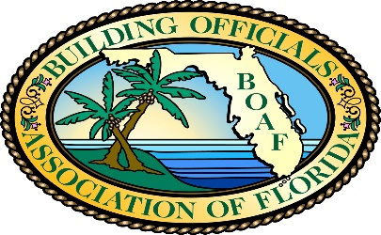
Florida Building Code Binding Interpretation Report Number 169
Date: September 17, 2019
Report: 169
Edition: 2010
Sections: see below
Question 1: Can an existing 2-story office building Type IIA construction be reclassified from Group B to Mixed (Group B on the 2nd floor and Group A-3 on the 1st floor) without installing an automatic fire sprinkler system or an alternative automatic fire-extinguishing system if the fire area on each floor does not exceed 12,000 square feet (1115 m2), has an occupant load of 300 or less; and Groups B and A-3 are fully separated by fire barriers and horizontal assemblies? (Note: the entire building does not exceed 12,000 square feet [1115 m2] and has an occupant load of 300 or less)
Question 2: If the fire area is defined as the aggregate floor area enclosed and bounded by fire walls, fire barriers, exterior walls, or horizontal assemblies of a building, wouldn’t the 2nd floor (aggregate floor) level of exit discharge be met by the stairways enclosed by fire barriers which leads directly to exit discharge. Since only the first floor is assembly occupancy (A-3) and is fully separated from Group B on the 2nd floor, would it be true that fire sprinklers are not required throughout the building?
Question 3: Could a business occupant form an assembly space with a maximum of 49 persons only loading (defined by fixed seating, barriers, and/or corridor roping) within an area larger than 750 sq. ft without a sprinkler system and retain its Group B status in accordance with 303.1.2.1 small assembly spaces?
Answer:
The Panel declined to answer these generic Building Code questions because they are too general in nature and do not address a specific interpretation by the building official and the jurisdiction, which is the intent of the binding interpretation process. Recommendation is made that the applicant go back to the local building official to obtain and clarify the building code interpretation in order to obtain resolution of this issue or pursue other means to resolve this matter.

NOTICE:
The Building Officials Association of Florida, in cooperation with the Florida Building Commission, and the Florida Department of Business & Professional Regulation, provides this interpretation of the Florida Building Code in the interest of consistency and application of the Building Code statewide. This interpretation is binding and not subject to acceptance and approval by the local building official.

