July 30, 2019
Mo Madani
Program Manager
Building Codes and Standards
Florida Department of Business and Professional Regulation
2601 Blair Stone Road
Tallahassee, Florida 32399

Dear Mr. Madani:
On behalf of the Window and Door Manufacturers Association and our members, thank you for allowing us the opportunity to provide feedback on the proposed “Wind Driven Rain Tests of Building Envelope Systems up to Hurricane-Strength Wind-Driven Rain Intensity” research study that will be conducted under the supervision of the University of Florida. WDMA is readily available to assist Dr. Prevatt and the Engineering School of Sustainable Infrastructure and Environment (ESSIE) in investigating water intrusion into high-rise buildings during hurricanes through the building envelope. After our initial review, WDMA would like to suggest the following objectives be added to the project’s scope of work to focus on the entire building envelope and for the project team to expand the goal of the project as they move forward.
- The testing protocol and the goal of the research project appear to be misaligned. The stated goal is to study the effect of hurricane strength wind-driven rain intensity on the building envelope, yet the testing methods outlined in the project are not reflective of wind-driven rain conditions. WDMA suggests that testing conditions be created that will simulate conditions the buildings experienced during Hurricane Irma (based on the weather data recorded during the event). It should not come as a surprise to anyone that incrementally increasing the test pressure beyond a product’s design limit will result in a failure of the individual product.
- Each building envelope product currently used in the construction of high-rise buildings is required to be tested in accordance to the 2017 Florida Building Code in accordance with TAS 202-94 for the HVHZ. As part of the research project, the project team should conduct a literary review of all consensus based standards and test method used to determine the water penetration testing requirements for other building envelope materials and components required to meet TAS 202 provisions (I.E. wall cladding, glass block, storm shutters, and any other similar materials). Based on the goals/outcomes of the research, it would be extremely beneficially to know what the testing criteria is for all building envelope components permitted to be used in high-rise building within the state of Florida. This information is necessary to determine if industry standards for fenestration products are below, equal to or exceeding other recognized water penetration industry standards.
- Currently, the building envelope research proposed is limiting the observation and testing to testing of the wall. Consider expanding the research to including testing the entire building envelope from the peak of the roof to foundation. Include in the mock-up all the typical openings and their water protection methods within the entire envelope (electrical outlets, fenestrations, exhaust vents, soffits, crawl space ventilation openings, etc.). In addition, during the testing establish a baseline by isolating and sealing all openings. After the baseline is established, continue to expose each protective opening individually to the water test and resealing the opening before exposing another. Once all opening protective measures have been tested individually, expose all protective openings and test the entire mock up as a whole and record the findings.
As stated at the beginning, the window and door industry is readily available to assist the University of Florida in conducting this research. Our hope is that the information from the study can be used to develop educational resources for Floridians to better understand how fenestration will perform during these extreme events.
Moving forward, please let the project team know that WDMA and our members are here to support the University of Florida and willing to participate in the research project in whatever manner they feel is appropriate.
Sincerely,
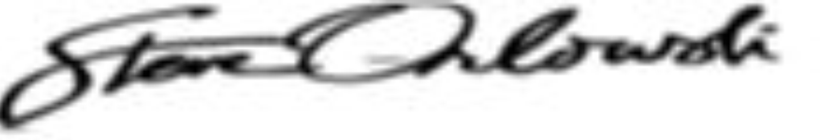
Steve Orlowski
Sr. Director, Standards & Technical Activities
Window & Door Manufacturers Association
2025 M St, NW, Ste 800 | Washington, DC 20036
Tel 202.367.1235 | Mobile 301.514.1124
Email: sorlowski@wdma.com
Web: www.wdma.com

