Florida Supplement to the 2012 IEBC
PRE-GLITCH CORRECTION VERSION

Note 1: Throughout the document, change International Building Code to Florida Building Code, Building; change the ICC Electrical Code to Chapter 27 of the Florida Building Code, Building; change the International Energy Conservation Code to the Florida Building Code, Energy Conservation; change the International Existing Building Code to Florida Building Code, Existing Building; change the International Fire code to Florida Fire Prevention Code; change International Fuel Gas Code to Florida Building Code, Fuel Gas; change the International Mechanical Code to Florida Building Code, Mechanical; change the International Plumbing Code to Florida Building Code, Plumbing; change the International Residential Code to Florida Building Code, Residential.

Note 2: Criteria blocked in yellow indicate Florida specific language from the 2010 FBC.

Chapter 1, Scope and Administration

Section 101.1. Add a section to read as follows:

Section 101.1 Title. These regulations shall be known as the Florida Building Code, Existing Building, hereinafter referred to as “this code”. In addition to the provisions of this chapter, the provisions of Chapter 1, Florida Building Code, Building, shall govern the administration and enforcement of this code.

Section 101.2 Scope. Change to read as follows:

101.2 Scope. The provisions of the Florida Building Code, Existing Building, shall apply to the repair, alteration, change of occupancy, addition, and relocation of existing buildings.
Exception: For the purpose of public educational facilities and state licensed facilities, see Chapter 4, Special Occupancy, of the Florida Building Code, Building.

Section 101.6 Appendices. Change to read as follows:

101.6 Appendices. The code official is authorized to require rehabilitation and retrofit of buildings, structures or individual structural members in accordance with the appendices of this code if such appendices have been individually adopted. Reserved.

Section 101.8. Add to read as follows:

101.8 Existing mechanical equipment. An agency or local government may not require that existing mechanical equipment on the surface of a roof be installed in compliance with the requirements of the Florida Building Code until the equipment is required to be removed or replaced.

(R5140 AS)

SECTION 102
APPLICABILITY
RESERVED
[A] 102.1 General. Where there is a conflict between a general requirement and a specific requirement, the specific requirement shall be applicable. Where in any specific case different sections of this code specify different materials, methods of construction or other requirements, the most restrictive shall govern.
[A] 102.2 Other laws. The provisions of this code shall not be deemed to nullify any provisions of local, state, or federal law.
[A] 102.3 Application of references. References to chapter or section numbers or to provisions not specifically identified by number shall be construed to refer to such chapter, section, or provision of this code.
[A] 102.4 Referenced codes and standards. The codes and standards referenced in this code shall be considered part of the requirements of this code to the prescribed extent of each such reference and as further regulated in Sections 102.4.1 and 102.4.2.
Exception: Where enforcement of a code provision would violate the conditions of the listing of the equipment or appliance, the conditions of the listing shall govern.
[A] 102.4.1 Conflicts. Where conflicts occur between provisions of this code and referenced codes and standards, the provisions of this code shall apply.
[A] 102.4.2 Conflicting provisions. Where the extent of the reference to a referenced code or standard includes subject matter that is within the scope of this code, the provisions of this code as applicable, shall take precedence over the provisions in the referenced code or standard.
[A] 102.5 Partial invalidity. In the event that any part or provision of this code is held to be illegal or void, this shall not have the effect of making void or illegal any of the other parts or provisions.

SECTION 103
DEPARTMENT OF BUILDING SAFETY
RESERVED

[A] 103.1 Creation of enforcement agency. The Department of Building Safety is hereby created, and the official in charge thereof shall be known as the code official.
[A] 103.2 Appointment. The code official shall be appointed by the chief appointing authority of the jurisdiction.
[A] 103.3 Deputies. In accordance with the prescribed procedures of this jurisdiction and with the concurrence of the appointing authority, the code official shall have the authority to appoint a deputy code official, the related technical officers, inspectors, plan examiners, and other employees. Such employees shall have powers as delegated by the code official.

SECTION 104
DUTIES AND POWERS OF CODE OFFICIAL
RESERVED
[A] 104.1 General. The code official is hereby authorized and directed to enforce the provisions of this code. The code official shall have the authority to render interpretations of this code and to adopt policies and procedures in order to clarify the application of its provisions. Such interpretations, policies, and procedures shall be in compliance with the intent and purpose of this code. Such policies and procedures shall not have the effect of waiving requirements specifically provided for in this code.
[A] 104.2 Applications and permits. The code official shall receive applications, review construction documents, and issue permits for the repair, alteration, addition, demolition, change of occupancy, and relocation of buildings; inspect the premises for which such permits have been issued; and enforce compliance with the provisions of this code.
[A] 104.2.1 Preliminary meeting. When requested by the permit applicant or the code official, the code official shall meet with the permit applicant prior to the application for a construction permit to discuss plans for the proposed work or change of occupancy in order to establish the specific applicability of the provisions of this code.
Exception: Repairs and Level 1 alterations.
[A] 104.2.1.1 Building evaluation. The code official is authorized to require an existing building to be investigated and evaluated by a registered design professional based on the circumstances agreed upon at the preliminary meeting. The design professional shall notify the code official if any potential nonconformance with the provisions of this code is identified.
[A] 104.3 Notices and orders. The code official shall issue all necessary notices or orders to ensure compliance with this code.
[A] 104.4 Inspections. The code official shall make all of the required inspections, or the code official shall have the authority to accept reports of inspection by approved agencies or individuals. Reports of such inspections shall be in writing and be certified by a responsible officer of such approved agency or by the responsible individual. The code official is authorized to engage such expert opinion as deemed necessary to report upon unusual technical issues that arise, subject to the approval of the appointing authority.
[A] 104.5 Identification. The code official shall carry proper identification when inspecting structures or premises in the performance of duties under this code.
[A] 104.6 Right of entry. Where it is necessary to make an inspection to enforce the provisions of this code, or where the code official has reasonable cause to believe that there exists in a structure or upon a premises a condition which is contrary to or in violation of this code which makes the structure or premises unsafe, dangerous, or hazardous, the code official is authorized to enter the structure or premises at reasonable times to inspect or to perform the duties imposed by this code, provided that if such structure or premises be occupied that credentials be presented to the occupant and entry requested. If such structure or premises be unoccupied, the code official shall first make a reasonable effort to locate the owner or other person having charge or control of the structure or premises and request entry. If entry is refused, the code official shall have recourse to the remedies provided by law to secure entry.
[A] 104.7 Department records. The code official shall keep official records of applications received, permits and certificates issued, fees collected, reports of inspections, and notices and orders issued. Such records shall be retained in the official records for the period required for retention of public records.
[A] 104.8 Liability. The code official, member of the Board of Appeals, or employee charged with the enforcement of this code, while acting for the jurisdiction in good faith and without malice in the discharge of the duties required by this code or other pertinent law or ordinance, shall not thereby be rendered liable personally and is hereby relieved from personal liability for any damage accruing to persons or property as a result of any act or by reason of an act or omission in the discharge of official duties. Any suit instituted against an officer or employee because of an act performed by that officer or employee in the lawful discharge of duties and under the provisions of this code shall be defended by legal representative of the jurisdiction until the final termination of the proceedings. The code official or any subordinate shall not be liable for cost in any action, suit, or proceeding that is instituted in pursuance of the provisions of this code.
[A] 104.9 Approved materials and equipment. Materials, equipment, and devices approved by the code official shall be constructed and installed in accordance with such approval.
[A] 104.9.1 Used materials and equipment. The use of used materials that meet the requirements of this code for new materials is permitted. Used equipment and devices shall be permitted to be reused subject to the approval of the code official.
[A] 104.10 Modifications. Wherever there are practical difficulties involved in carrying out the provisions of this code, the code official shall have the authority to grant modifications for individual cases upon application of the owner or owner’s representative, provided the code official shall first find that special individual reason makes the strict letter of this code impractical and the modification is in compliance with the intent and purpose of this code, and that such modification does not lessen health, accessibility, life and fire safety, or structural requirements. The details of action granting modifications shall be recorded and entered in the files of the Department of Building Safety.
[A] 104.10.1 Flood hazard areas. For existing buildings located in flood hazard areas for which repairs, alterations and additions constitute substantial improvement, the code official shall not grant modifications to provisions related to flood resistance unless a determination is made that:
1. The applicant has presented good and sufficient cause that the unique characteristics of the size, configuration or topography of the site render compliance with the flood-resistant construction provisions inappropriate.
2. Failure to grant the modification would result in exceptional hardship.
3. The granting of the modification will not result in increased flood heights, additional threats to public safety, extraordinary public expense nor create nuisances, cause fraud on or victimization of the public or conflict with existing laws or ordinances.
4. The modification is the minimum necessary to afford relief, considering the flood hazard.
5. A written notice will be provided to the applicant specifying, if applicable, the difference between the design flood elevation and the elevation to which the building is to be built, stating that the cost of flood insurance will be commensurate with the increased risk resulting from the reduced floor elevation and that construction below the design flood elevation increases risks to life and property.
[A] 104.11 Alternative materials, design and methods of construction, and equipment. The provisions of this code are not intended to prevent the installation of any material or to prohibit any design or method of construction not specifically prescribed by this code, provided that any such alternative has been approved. An alternative material, design, or method of construction shall be approved where the code official finds that the proposed design is satisfactory and complies with the intent of the provisions of this code, and that the material, method, or work offered is, for the purpose intended, at least the equivalent of that prescribed in this code in quality, strength, effectiveness, fire resistance, durability, and safety.
[A] 104.11.1 Research reports. Supporting data, where necessary to assist in the approval of materials or assemblies not specifically provided for in this code, shall consist of valid research reports from approved sources.
[A] 104.11.2 Tests. Whenever there is insufficient evidence of compliance with the provisions of this code or evidence that a material or method does not conform to the requirements of this code, or in order to substantiate claims for alternative materials or methods, the code official shall have the authority to require tests as evidence of compliance to be made at no expense to the jurisdiction. Test methods shall be as specified in this code or by other recognized test standards. In the absence of recognized and accepted test methods, the code official shall approve the testing procedures. Tests shall be performed by an approved agency. Reports of such tests shall be retained by the code official for the period required for retention.

SECTION 105
PERMITS
RESERVED
[A] 105.1 Required. Any owner or authorized agent who intends to repair, add to, alter, relocate, demolish, or change the occupancy of a building or to repair, install, add, alter, remove, convert, or replace any electrical, gas, mechanical, or plumbing system, the installation of which is regulated by this code, or to cause any such work to be done, shall first make application to the code official and obtain the required permit.
[A] 105.1.1 Annual permit. In lieu of an individual permit for each alteration to an already approved electrical, gas, mechanical, or plumbing installation, the code official is authorized to issue an annual permit upon application therefor to any person, firm, or corporation regularly employing one or more qualified trade persons in the building, structure, or on the premises owned or operated by the applicant for the permit.
[A] 105.1.2 Annual permit records. The person to whom an annual permit is issued shall keep a detailed record of alterations made under such annual permit. The code official shall have access to such records at all times, or such records shall be filed with the code official as designated.
[A] 105.2 Work exempt from permit. Exemptions from permit requirements of this code shall not be deemed to grant authorization for any work to be done in any manner in violation of the provisions of this code or any other laws or ordinances of this jurisdiction. Permits shall not be required for the following:
Building:
1. Sidewalks and driveways not more than 30 inches (762 mm) above grade and not over any basement or story below and that are not part of an accessible route.
2. Painting, papering, tiling, carpeting, cabinets, counter tops, and similar finish work.
3. Temporary motion picture, television, and theater stage sets and scenery.
4. Shade cloth structures constructed for nursery or agricultural purposes, and not including service systems.
5. Window awnings supported by an exterior wall of Group R-3 or Group U occupancies.
6. Movable cases, counters, and partitions not over 69 inches (1753 mm) in height.
Electrical:
Repairs and maintenance: Minor repair work, including the replacement of lamps or the connection of approved portable electrical equipment to approved permanently installed receptacles.
Radio and television transmitting stations: The provisions of this code shall not apply to electrical equipment used for radio and television transmissions, but do apply to equipment and wiring for power supply, the installations of towers, and antennas.
Temporary testing systems: A permit shall not be required for the installation of any temporary system required for the testing or servicing of electrical equipment or apparatus.
Gas:
1. Portable heating appliance.
2. Replacement of any minor part that does not alter approval of equipment or make such equipment unsafe.
Mechanical:
1. Portable heating appliance.
2. Portable ventilation equipment.
3. Portable cooling unit.
4. Steam, hot, or chilled water piping within any heating or cooling equipment regulated by this code.
5. Replacement of any part that does not alter its approval or make it unsafe.
6. Portable evaporative cooler.
7. Self-contained refrigeration system containing 10 pounds (4.54 kg) or less of refrigerant and actuated by motors of 1 horsepower (746 W) or less.
Plumbing:
1. The stopping of leaks in drains, water, soil, waste, or vent pipe; provided, however, that if any concealed trap, drainpipe, water, soil, waste, or vent pipe becomes defective and it becomes necessary to remove and replace the same with new material, such work shall be considered as new work, and a permit shall be obtained and inspection made as provided in this code.
2. The clearing of stoppages or the repairing of leaks in pipes, valves, or fixtures, and the removal and reinstallation of water closets, provided such repairs do not involve or require the replacement or rearrangement of valves, pipes, or fixtures.
[A] 105.2.1 Emergency repairs. Where equipment replacements and repairs must be performed in an emergency situation, the permit application shall be submitted within the next working business day to the code official.
[A] 105.2.2 Repairs. Application or notice to the code official is not required for ordinary repairs to structures and items listed in Section 105.2. Such repairs shall not include the cutting away of any wall, partition, or portion thereof, the removal or cutting of any structural beam or load-bearing support, or the removal or change of any required means of egress or rearrangement of parts of a structure affecting the egress requirements; nor shall ordinary repairs include addition to, alteration of, replacement, or relocation of any standpipe, water supply, sewer, drainage, drain leader, gas, soil, waste, vent, or similar piping, electric wiring, or mechanical or other work affecting public health or general safety.
[A] 105.2.3 Public service agencies. A permit shall not be required for the installation, alteration, or repair of generation, transmission, distribution, or metering or other related equipment that is under the ownership and control of public service agencies by established right.
[A] 105.3 Application for permit. To obtain a permit, the applicant shall first file an application therefor in writing on a form furnished by the Department of Building Safety for that purpose. Such application shall:
1. Identify and describe the work in accordance with Chapter 3 to be covered by the permit for which application is made.
2. Describe the land on which the proposed work is to be done by legal description, street address, or similar description that will readily identify and definitely locate the proposed building or work.
3. Indicate the use and occupancy for which the proposed work is intended.
4. Be accompanied by construction documents and other information as required in Section 106.3.
5. State the valuation of the proposed work.
6. Be signed by the applicant or the applicant’s authorized agent.
7. Give such other data and information as required by the code official.
[A] 105.3.1 Action on application. The code official shall examine or cause to be examined applications for permits and amendments thereto within a reasonable time after filing. If the application or the construction documents do not conform to the requirements of pertinent laws, the code official shall reject such application in writing, stating the reasons therefor. If the code official is satisfied that the proposed work conforms to the requirements of this code and laws and ordinances applicable thereto, the code official shall issue a permit therefor as soon as practicable.
[A] 105.3.2 Time limitation of application. An application for a permit for any proposed work shall be deemed to have been abandoned 180 days after the date of filing, unless such application has been pursued in good faith or a permit has been issued; except that the code official is authorized to grant one or more extensions of time for additional periods not exceeding 90 days each. The extension shall be requested in writing and justifiable cause demonstrated.
[A] 105.4 Validity of permit. The issuance or granting of a permit shall not be construed to be a permit for, or an approval of, any violation of any of the provisions of this code or of any other ordinance of the jurisdiction. Permits presuming to give authority to violate or cancel the provisions of this code or other ordinances of the jurisdiction shall not be valid. The issuance of a permit based on construction documents and other data shall not prevent the code official from requiring the correction of errors in the construction documents and other data. The code official is also authorized to prevent occupancy or use of a structure where in violation of this code or of any other ordinances of this jurisdiction.
[A] 105.5 Expiration. Every permit issued shall become invalid unless the work on the site authorized by such permit is commenced within 180 days after its issuance, or if the work authorized on the site by such permit is suspended or abandoned for a period of 180 days after the time the work is commenced. The code official is authorized to grant, in writing, one or more extensions of time for periods not more than 180 days each. The extension shall be requested in writing and justifiable cause demonstrated.
[A] 105.6 Suspension or revocation. The code official is authorized to suspend or revoke a permit issued under the provisions of this code wherever the permit is issued in error or on the basis of incorrect, inaccurate, or incomplete information or in violation of any ordinance or regulation or any of the provisions of this code.
[A] 105.7 Placement of permit. The building permit or copy shall be kept on the site of the work until the completion of the project.

SECTION 106
CONSTRUCTION DOCUMENTS
RESERVED
[A] 106.1 General. Submittal documents consisting of construction documents, special inspection and structural observation programs, investigation and evaluation reports, and other data shall be submitted in two or more sets with each application for a permit. The construction documents shall be prepared by a registered design professional where required by the statutes of the jurisdiction in which the project is to be constructed. Where special conditions exist, the code official is authorized to require additional construction documents to be prepared by a registered design professional.
Exception: The code official is authorized to waive the submission of construction documents and other data not required to be prepared by a registered design professional if it is found that the nature of the work applied for is such that reviewing of construction documents is not necessary to obtain compliance with this code.
[A] 106.2 Construction documents. Construction documents shall be in accordance with Sections 106.2.1 through 106.2.5.
[A] 106.2.1 Construction documents. Construction documents shall be dimensioned and drawn upon suitable material. Electronic media documents are permitted to be submitted when approved by the code official. Construction documents shall be of sufficient clarity to indicate the location, nature and extent of the work proposed and show in detail that it will conform to the provisions of this code and relevant laws, ordinances, rules and regulations, as determined by the code official. The work areas shall be shown.
[A] 106.2.2 Fire protection system(s) shop drawings. Shop drawings for the fire protection system(s) shall be submitted to indicate conformance with this code and the construction documents and shall be approved prior to the start of system installation. Shop drawings shall contain all information as required by the referenced installation standards in Chapter 9 of the International Building Code.
[A] 106.2.3 Means of egress. The construction documents for Alterations—Level 2, Alterations—Level 3, additions and changes of occupancy shall show in sufficient detail the location, construction, size and character of all portions of the means of egress in compliance with the provisions of this code. The construction documents shall designate the number of occupants to be accommodated in every work area of every floor and in all affected rooms and spaces.
[A] 106.2.4 Exterior wall envelope. Construction documents for all work affecting the exterior wall envelope shall describe the exterior wall envelope in sufficient detail to determine compliance with this code. The construction documents shall provide details of the exterior wall envelope as required, including windows, doors, flashing, intersections with dissimilar materials, corners, end details, control joints, intersections at roof, eaves, or parapets, means of drainage, water-resistive membrane, and details around openings.
The construction documents shall include manufacturer’s installation instructions that provide supporting documentation that the proposed penetration and opening details described in the construction documents maintain the wind and weather resistance of the exterior wall envelope. The supporting documentation shall fully describe the exterior wall system which was tested, where applicable, as well as the test procedure used.
[A] 106.2.5 Site plan. The construction documents submitted with the application for permit shall be accompanied by a site plan showing to scale the size and location of new construction and existing structures on the site, distances from lot lines, the established street grades, and the proposed finished grades; and it shall be drawn in accordance with an accurate boundary line survey. In the case of demolition, the site plan shall show construction to be demolished and the location and size of existing structures and construction that are to remain on the site or plot. The code official is authorized to waive or modify the requirement for a site plan when the application for permit is for alteration, repair or change of occupancy.
[A] 106.3 Examination of documents. The code official shall examine or cause to be examined the submittal documents and shall ascertain by such examinations whether the construction or occupancy indicated and described is in accordance with the requirements of this code and other pertinent laws or ordinances.
[A] 106.3.1 Approval of construction documents. When the code official issues a permit, the construction documents shall be approved in writing or by stamp as "Reviewed for Code Compliance.” One set of construction documents so reviewed shall be retained by the code official. The other set shall be returned to the applicant, shall be kept at the site of work, and shall be open to inspection by the code official or a duly authorized representative.
[A] 106.3.2 Previous approval. This code shall not require changes in the construction documents, construction or designated occupancy of a structure for which a lawful permit has been issued and the construction of which has been pursued in good faith within 180 days after the effective date of this code and has not been abandoned.
[A] 106.3.3 Phased approval. The code official is authorized to issue a permit for the construction of foundations or any other part of a building before the construction documents for the whole building or structure have been submitted, provided that adequate information and detailed statements have been filed complying with pertinent requirements of this code. The holder of such permit for the foundation or other parts of a building shall proceed at the holder's own risk with the building operation and without assurance that a permit for the entire structure will be granted.
[A] 106.3.4 Deferred submittals. For the purposes of this section, deferred submittals are defined as those portions of the design that are not submitted at the time of the application and that are to be submitted to the code official within a specified period.
Deferral of any submittal items shall have the prior approval of the code official. The registered design professional in responsible charge shall list the deferred submittals on the construction documents for review by the code official.
Submittal documents for deferred submittal items shall be submitted to the registered design professional in responsible charge who shall review them and forward them to the code official with a notation indicating that the deferred submittal documents have been reviewed and that they have been found to be in general conformance to the design of the building. The deferred submittal items shall not be installed until their deferred submittal documents have been approved by the code official.
[A] 106.4 Amended construction documents. Work shall be installed in accordance with the reviewed construction documents, and any changes made during construction that are not in compliance with the approved construction documents shall be resubmitted for approval as an amended set of construction documents.
[A] 106.5 Retention of construction documents. One set of approved construction documents shall be retained by the code official for a period of not less than the period required for retention of public records.
[A] 106.6 Design professional in responsible charge. When it is required that documents be prepared by a registered design professional, the code official shall be authorized to require the owner to engage and designate on the building permit application a registered design professional who shall act as the registered design professional in responsible charge. If the circumstances require, the owner shall designate a substitute registered design professional in responsible charge who shall perform the duties required of the original registered design professional in responsible charge. The code official shall be notified in writing by the owner if the registered design professional in responsible charge is changed or is unable to continue to perform the duties. The registered design professional in responsible charge shall be responsible for reviewing and coordinating submittal documents prepared by others, including phased and deferred submittal items, for compatibility with the design of the building. Where structural observation is required, the inspection program shall name the individual or firms who are to perform structural observation and describe the stages of construction at which structural observation is to occur.

SECTION 107
TEMPORARY STRUCTURES AND USES
RESERVED
[A] 107.1 General. The code official is authorized to issue a permit for temporary uses. Such permits shall be limited as to time of service but shall not be permitted for more than 180 days. The code official is authorized to grant extensions for demonstrated cause.
[A] 107.2 Conformance. Temporary uses shall conform to the structural strength, fire safety, means of egress, accessibility, light, ventilation and sanitary requirements of this code as necessary to ensure the public health, safety and general welfare.
[A] 107.3 Temporary power. The code official is authorized to give permission to temporarily supply and use power in part of an electric installation before such installation has been fully completed and the final certificate of completion has been issued. The part covered by the temporary certificate shall comply with the requirements specified for temporary lighting, heat or power in NFPA 70.
[A] 107.4 Termination of approval. The code official is authorized to terminate such permit for a temporary use and to order the temporary use to be discontinued.

SECTION 108
FEES
RESERVED
[A] 108.1 Payment of fees. A permit shall not be valid until the fees prescribed by law have been paid. Nor shall an amendment to a permit be released until the additional fee, if any, has been paid.
[A] 108.2 Schedule of permit fees. On buildings, electrical, gas, mechanical, and plumbing systems or alterations requiring a permit, a fee for each permit shall be paid as required in accordance with the schedule as established by the applicable governing authority.
[A] 108.3 Building permit valuations. The applicant for a permit shall provide an estimated permit value at time of application. Permit valuations shall include total value of work including materials and labor for which the permit is being issued, such as electrical, gas, mechanical, plumbing equipment, and permanent systems. If, in the opinion of the code official, the valuation is underestimated on the application, the permit shall be denied unless the applicant can show detailed estimates to meet the approval of the code official. Final building permit valuation shall be set by the code official.
[A] 108.4 Work commencing before permit issuance. Any person who commences any work before obtaining the necessary permits shall be subject to an additional fee established by the code official that shall be in addition to the required permit fees.
[A] 108.5 Related fees. The payment of the fee for the construction, alteration, removal, or demolition of work done in connection to or concurrently with the work authorized by a building permit shall not relieve the applicant or holder of the permit from the payment of other fees that are prescribed by law.
[A] 108.6 Refunds. The code official is authorized to establish a refund policy.

SECTION 109
INSPECTIONS
RESERVED
[A] 109.1 General. Construction or work for which a permit is required shall be subject to inspection by the code official, and such construction or work shall remain accessible and exposed for inspection purposes until approved. Approval as a result of an inspection shall not be construed to be an approval of a violation of the provisions of this code or of other ordinances of the jurisdiction. Inspections presuming to give authority to violate or cancel the provisions of this code or of other ordinances of the jurisdiction shall not be valid. It shall be the duty of the permit applicant to cause the work to remain accessible and exposed for inspection purposes. Neither the code official nor the jurisdiction shall be liable for expense entailed in the removal or replacement of any material required to allow inspection.
[A] 109.2 Preliminary inspection. Before issuing a permit, the code official is authorized to examine or cause to be examined buildings and sites for which an application has been filed.
[A] 109.3 Required inspections. The code official, upon notification, shall make the inspections set forth in Sections 109.3.1 through 109.3.9.
[A] 109.3.1 Footing or foundation inspection. Footing and foundation inspections shall be made after excavations for footings are complete and any required reinforcing steel is in place. For concrete foundations, any required forms shall be in place prior to inspection. Materials for the foundation shall be on the job, except where concrete is ready-mixed in accordance with ASTM C 94, the concrete need not be on the job.
[A] 109.3.2 Concrete slab or under-floor inspection. Concrete slab and under-floor inspections shall be made after in-slab or under-floor reinforcing steel and building service equipment, conduit, piping accessories, and other ancillary equipment items are in place but before any concrete is placed or floor sheathing installed, including the sub floor.
[A] 109.3.3 Lowest floor elevation. For additions and substantial improvements to existing buildings in flood hazard areas, upon placement of the lowest floor, including basement, and prior to further vertical construction, the elevation documentation required in the International Building Code shall be submitted to the code official.
[A] 109.3.4 Frame inspection. Framing inspections shall be made after the roof deck or sheathing, all framing, fire blocking, and bracing are in place and pipes, chimneys, and vents to be concealed are complete and the rough electrical, plumbing, heating wires, pipes, and ducts are approved.
[A] 109.3.5 Lath or gypsum board inspection. Lath and gypsum board inspections shall be made after lathing and gypsum board, interior and exterior, is in place but before any plastering is applied or before gypsum board joints and fasteners are taped and finished.
Exception: Gypsum board that is not part of a fire-resistance-rated assembly or a shear assembly.
[A] 109.3.6 Fire and smoke-resistant penetrations. Protection of joints and penetrations in fire-resistance-rated assemblies, smoke barriers and smoke partitions shall not be concealed from view until inspected and approved.
[A] 109.3.7 Other inspections. In addition to the inspections specified above, the code official is authorized to make or require other inspections of any construction work to ascertain compliance with the provisions of this code and other laws that are enforced by the Department of Building Safety.
[A] 109.3.8 Special inspections. Special inspections shall be required in accordance with the International Building Code.
[A] 109.3.9 Final inspection. The final inspection shall be made after all work required by the building permit is completed.
[A] 109.4 Inspection agencies. The code official is authorized to accept reports of approved inspection agencies, provided such agencies satisfy the requirements as to qualifications and reliability.
[A] 109.5 Inspection requests. It shall be the duty of the holder of the building permit or their duly authorized agent to notify the code official when work is ready for inspection. It shall be the duty of the permit holder to provide access to and means for any inspections of such work that are required by this code.
[A] 109.6 Approval required. Work shall not be done beyond the point indicated in each successive inspection without first obtaining the approval of the code official. The code official, upon notification, shall make the requested inspections and shall either indicate the portion of the construction that is satisfactory as completed or shall notify the permit holder or an agent of the permit holder wherein the same fails to comply with this code. Any portions that do not comply shall be corrected and such portion shall not be covered or concealed until authorized by the code official.

SECTION 110
CERTIFICATE OF OCCUPANCY
RESERVED
[A] 110.1 Altered area use and occupancy classification change. No altered area of a building and no relocated building shall be used or occupied, and no change in the existing occupancy classification of a building or portion thereof shall be made until the code official has issued a certificate of occupancy therefor as provided herein. Issuance of a certificate of occupancy shall not be construed as an approval of a violation of the provisions of this code or of other ordinances of the jurisdiction.
[A] 110.2 Certificate issued. After the code official inspects the building and finds no violations of the provisions of this code or other laws that are enforced by the Department of Building Safety, the code official shall issue a certificate of occupancy that shall contain the following:
1. The building permit number.
2. The address of the structure.
3. The name and address of the owner.
4. A description of that portion of the structure for which the certificate is issued.
5. A statement that the described portion of the structure has been inspected for compliance with the requirements of this code for the occupancy and division of occupancy and the use for which the proposed occupancy is classified.
6. The name of the code official.
7. The edition of the code under which the permit was issued.
8. The use and occupancy in accordance with the provisions of the International Building Code.
9. The type of construction as defined in the International Building Code.
10. The design occupant load and any impact the alteration has on the design occupant load of the area not within the scope of the work.
11. If fire protection systems are provided, whether the fire protection systems are required.
12. Any special stipulations and conditions of the building permit.
[A] 110.3 Temporary occupancy. The code official is authorized to issue a temporary certificate of occupancy before the completion of the entire work covered by the permit, provided that such portion or portions shall be occupied safely. The code official shall set a time period during which the temporary certificate of occupancy is valid.
[A] 110.4 Revocation. The code official is authorized to, in writing, suspend or revoke a certificate of occupancy or completion issued under the provisions of this code wherever the certificate is issued in error or on the basis of incorrect information supplied, or where it is determined that the building or structure or portion thereof is in violation of any ordinance or regulation or any of the provisions of this code.

SECTION 111
SERVICE UTILITIES
RESERVED
[A] 111.1 Connection of service utilities. No person shall make connections from a utility, source of energy, fuel, or power to any building or system that is regulated by this code for which a permit is required, until approved by the code official.
[A] 111.2 Temporary connection. The code official shall have the authority to authorize the temporary connection of the building or system to the utility source of energy, fuel, or power.
[A] 111.3 Authority to disconnect service utilities. The code official shall have the authority to authorize disconnection of utility service to the building, structure or system regulated by this code and the referenced codes and standards in case of emergency where necessary to eliminate an immediate hazard to life or property or when such utility connection has been made without the approval required by Section 111.1 or 111.2. The code official shall notify the serving utility and, wherever possible, the owner and occupant of the building, structure or service system of the decision to disconnect prior to taking such action. If not notified prior to disconnecting, the owner or occupant of the building, structure or service system shall be notified in writing, as soon as practical thereafter.

SECTION 112
BOARD OF APPEALS
RESERVED
[A] 112.1 General. In order to hear and decide appeals of orders, decisions, or determinations made by the code official relative to the application and interpretation of this code, there shall be and is hereby created a board of appeals. The board of appeals shall be appointed by the governing body and shall hold office at its pleasure. The board shall adopt rules of procedure for conducting its business.
[A] 112.2 Limitations on authority. An application for appeal shall be based on a claim that the true intent of this code or the rules legally adopted thereunder have been incorrectly interpreted, the provisions of this code do not fully apply, or an equally good or better form of construction is proposed. The board shall have no authority to waive requirements of this code.
[A] 112.3 Qualifications. The board of appeals shall consist of members who are qualified by experience and training to pass on matters pertaining to building construction and are not employees of the jurisdiction.
SECTION 113
VIOLATIONS
RESERVED
[A] 113.1 Unlawful acts. It shall be unlawful for any person, firm, or corporation to repair, alter, extend, add, move, remove, demolish, or change the occupancy of any building or equipment regulated by this code or cause same to be done in conflict with or in violation of any of the provisions of this code.
[A] 113.2 Notice of violation. The code official is authorized to serve a notice of violation or order on the person responsible for the repair, alteration, extension, addition, moving, removal, demolition, or change in the occupancy of a building in violation of the provisions of this code or in violation of a permit or certificate issued under the provisions of this code. Such order shall direct the discontinuance of the illegal action or condition and the abatement of the violation.
[A] 113.3 Prosecution of violation. If the notice of violation is not complied with promptly, the code official is authorized to request the legal counsel of the jurisdiction to institute the appropriate proceeding at law or in equity to restrain, correct, or abate such violation or to require the removal or termination of the unlawful occupancy of the building or structure in violation of the provisions of this code or of the order or direction made pursuant thereto.
[A] 113.4 Violation penalties. Any person who violates a provision of this code or fails to comply with any of the requirements thereof or who repairs or alters or changes the occupancy of a building or structure in violation of the approved construction documents or directive of the code official or of a permit or certificate issued under the provisions of this code shall be subject to penalties as prescribed by law.

SECTION 114
STOP WORK ORDER
RESERVED
[A] 114.1 Authority. Whenever the code official finds any work regulated by this code being performed in a manner contrary to the provisions of this code or in a dangerous or unsafe manner, the code official is authorized to issue a stop work order.
[A] 114.2 Issuance. The stop work order shall be in writing and shall be given to the owner of the property involved or to the owner’s agent, or to the person doing the work. Upon issuance of a stop work order, the cited work shall immediately cease. The stop work order shall state the reason for the order and the conditions under which the cited work will be permitted to resume.
[A] 114.3 Unlawful continuance. Any person who shall continue any work after having been served with a stop work order, except such work as that person is directed to perform to remove a violation or unsafe condition, shall be subject to penalties as prescribed by law.

SECTION 115
UNSAFE BUILDINGS AND EQUIPMENT
RESERVED
[A] 115.1 Conditions. Buildings, structures or equipment that are or hereafter become unsafe, shall be taken down, removed or made safe as the code official deems necessary and as provided for in this code.
[A] 115.2 Record. The code official shall cause a report to be filed on an unsafe condition. The report shall state the occupancy of the structure and the nature of the unsafe condition.
[A] 115.3 Notice. If an unsafe condition is found, the code official shall serve on the owner, agent, or person in control of the structure a written notice that describes the condition deemed unsafe and specifies the required repairs or improvements to be made to abate the unsafe condition, or that requires the unsafe building to be demolished within a stipulated time. Such notice shall require the person thus notified to declare immediately to the code official acceptance or rejection of the terms of the order.
[A] 115.4 Method of service. Such notice shall be deemed properly served if a copy thereof is delivered to the owner personally; sent by certified or registered mail addressed to the owner at the last known address with the return receipt requested; or delivered in any other manner as prescribed by local law. If the certified or registered letter is returned showing that the letter was not delivered, a copy thereof shall be posted in a conspicuous place in or about the structure affected by such notice. Service of such notice in the foregoing manner upon the owner’s agent or upon the person responsible for the structure shall constitute service of notice upon the owner.
[A] 115.5 Restoration. The building or equipment determined to be unsafe by the code official is permitted to be restored to a safe condition. To the extent that repairs, alterations, or additions are made or a change of occupancy occurs during the restoration of the building, such repairs, alterations, additions, or change of occupancy shall comply with the requirements of this code.

SECTION 116
EMERGENCY MEASURES
RESERVED
[A] 116.1 Imminent danger. When, in the opinion of the code official, there is imminent danger of failure or collapse of a building that endangers life, or when any building or part of a building has fallen and life is endangered by the occupation of the building, or when there is actual or potential danger to the building occupants or those in the proximity of any structure because of explosives, explosive fumes or vapors, or the presence of toxic fumes, gases, or materials, or operation of defective or dangerous equipment, the code official is hereby authorized and empowered to order and require the occupants to vacate the premises forthwith. The code official shall cause to be posted at each entrance to such structure a notice reading as follows: "This Structure Is Unsafe and Its Occupancy Has Been Prohibited by the Code Official.” It shall be unlawful for any person to enter such structure except for the purpose of securing the structure, making the required repairs, removing the hazardous condition, or of demolishing the same.
[A] 116.2 Temporary safeguards. Notwithstanding other provisions of this code, whenever, in the opinion of the code official, there is imminent danger due to an unsafe condition, the code official shall order the necessary work to be done, including the boarding up of openings, to render such structure temporarily safe whether or not the legal procedure herein described has been instituted; and shall cause such other action to be taken as the code official deems necessary to meet such emergency.
[A] 116.3 Closing streets. When necessary for public safety, the code official shall temporarily close structures and close or order the authority having jurisdiction to close sidewalks, streets, public ways, and places adjacent to unsafe structures, and prohibit the same from being utilized.
[A] 116.4 Emergency repairs. For the purposes of this section, the code official shall employ the necessary labor and materials to perform the required work as expeditiously as possible.
[A] 116.5 Costs of emergency repairs. Costs incurred in the performance of emergency work shall be paid by the jurisdiction. The legal counsel of the jurisdiction shall institute appropriate action against the owner of the premises where the unsafe structure is or was located for the recovery of such costs.
[A] 116.6 Hearing. Any person ordered to take emergency measures shall comply with such order forthwith. Any affected person shall thereafter, upon petition directed to the appeals board, be afforded a hearing as described in this code.

SECTION 117
DEMOLITION
RESERVED
[A] 117.1 General. The code official shall order the owner of any premises upon which is located any structure that in the code official’s judgment is so old, dilapidated, or has become so out of repair as to be dangerous, unsafe, insanitary, or otherwise unfit for human habitation or occupancy, and such that it is unreasonable to repair the structure, to demolish and remove such structure; or if such structure is capable of being made safe by repairs, to repair and make safe and sanitary or to demolish and remove at the owner’s option; or where there has been a cessation of normal construction of any structure for a period of more than two years, to demolish and remove such structure.
[A] 117.2 Notices and orders. All notices and orders shall comply with Section 113.
[A] 117.3 Failure to comply. If the owner of a premises fails to comply with a demolition order within the time prescribed, the code official shall cause the structure to be demolished and removed, either through an available public agency or by contract or arrangement with private persons, and the cost of such demolition and removal shall be charged against the real estate upon which the structure is located and shall be a lien upon such real estate.
[A] 117.4 Salvage materials. When any structure has been ordered demolished and removed, the governing body or other designated officer under said contract or arrangement aforesaid shall have the right to sell the salvage and valuable materials at the highest price obtainable. The net proceeds of such sale, after deducting the expenses of such demolition and removal, shall be promptly remitted with a report of such sale or transaction, including the items of expense and the amounts deducted, for the person who is entitled thereto, subject to any order of a court. If such a surplus does not remain to be turned over, the report shall so state.

(CA5141 – R1 / AM)

Chapter 2, Definitions

Section 202 General Definitions. Add or modify to read as follows:
EXISTING STRUCTURES (for flood hazard areas). See Section 1612.2 of the Florida Building Code, Building.
(SP5277 AS)

HISTORIC BUILDING. See Section 12002.

RETROFIT. The voluntary process of strengthening or improving buildings or structures, or individual components of buildings or structures, for the purpose of making existing conditions better serve the purpose for which they were originally intended or the purpose that current building codes intend.
(R5889 AM)(S5889 AM R1)
ROOF SECTION. A separating or division of a roof area by existing expansion joints, parapet walls, flashing (excluding valley), difference of elevation (excluding hips and ridges), roof type or legal description; not including the roof area required for a proper tie-off with an existing system.
(R5937 AM)(S5889 AM R1)
SITE BUILT SINGLE-FAMILY RESIDENTIAL STRUCTURES. This term shall mean site built single family detached residential structures.
(R5937 AM)
SUBSTANTIAL IMPROVEMENT. Any repair, reconstruction, rehabilitation, alteration, addition or other improvement of a building or structure, the cost of which equals or exceeds 50 percent of the market value of the structure before the improvement or repair is started. If the structure has sustained substantial damage, any repairs are considered substantial improvement regardless of the actual repair work performed. The term does not, however, include either:
1. Any project for improvement of a building required to correct existing health, sanitary or safety code violations identified by the building official and that are is the minimum necessary to assure safe living conditions.
2. Any alteration of a historic structure provided that the alteration will not preclude the structure’s continued designation as a historic structure.

(SP5277 AS)
SUNROOM.
1. A room with roof panels that include sloped glazing that in a one-story structure added to an existing dwelling with an open or glazed area in excess of 40 percent of the gross area of the sunroom structure's exterior walls and roof.
2. A one-story structure added to a dwelling with solid roof panels without sloped glazing. The sunroom walls may have any configuration, provided the open areas with operable of fixed glass or windows or side hinged or sliding glass doors of the longer wall and one additional wall is equal to at least 65 percent of the area below 6 foot 8 inches of each wall, measured from the floor. For the purpose of this code the term sunroom as used herein shall include conservatories, sunspaces, solariums and porch or patio covers or enclosures.
(S5854 AS) (S5961 AS)
VALUE. The estimated current replacement cost of the building in kind.
(CA5938 AS)

Chapter 3 Compliance Methods
Section 301 Compliance Methods
Add Section 301.1.5 to read as follows:
301.1.5 Existing mechanical equipment. An agency or local government may not require that existing mechanical equipment on the surface of a roof be installed in compliance with the requirements of the Florida Building Code until the equipment is required to be removed or replaced.
(CA 4997 – R1 / AM)
Chapter 4 Prescriptive Compliance Method

Section 402.2 Flood hazard areas. Modify to read as follows:
402.2 [Additions] Flood hazard areas. For buildings and structures in flood hazard areas established in Section 1612.3 of the International Building Code ,Florida Building Code, Building or Section R322 of the International Residential Code, Florida Building Code, Residential as applicable, any addition that constitutes substantial improvement of the existing structure, as defined in Section 202, shall comply with the flood design requirements for new construction and all aspects of the existing structure shall be brought into compliance with the requirements for new construction for flood design.
For buildings and structures in flood hazard areas established in Section 1612.3 of the International Building Code, Florida Building Code, Building or Section R322 of the International Residential Code, Florida Building Code, Residential, as applicable, any additions that do not constitute substantial improvement of the existing structure, as defined in Section 202, are not required to comply with the flood design requirements for new construction.
(SP5573 AM)

Section 402.4, Existing structural elements carrying lateral load. Change to read as follows:
[B] 402.4 Existing structural elements carrying lateral load. Where the addition is structurally independent of the existing structure, existing lateral load-carrying structural elements shall be permitted to remain unaltered. Where the addition is not structurally independent of the existing structure, the existing structure and its addition acting together as a single structure shall be shown to meet the requirements of Sections1609 and 1613 (the HVHZ shall comply with Section 1620) of the Florida Building Code, Building International Building Code.
Exception: Any existing lateral load-carrying structural element whose demand-capacity ratio with the addition considered is no more than 10 percent greater than its demand-capacity ratio with the addition ignored shall be permitted to remain unaltered. For purposes of calculating demand-capacity ratios, the demand shall consider applicable load combinations with design lateral loads or forces in accordance with Sections 1609 and 1613 of the International Building Code. For purposes of this exception, comparisons of demand-capacity ratios and calculation of design lateral loads, forces and capacities shall account for the cumulative effects of additions and alterations since original construction.
(S4962 AS)

Section 403.2 Flood hazard areas. Change to read as follows:
403.2 [Alterations] Flood hazard areas. For buildings and structures in flood hazard areas established in Section 1612.3 of the International Building Code, Florida Building Code, Building or Section R322 of the International Residential Code, Florida Building Code, Residential, as applicable, any alteration that constitutes substantial Improvement of the existing structure, as defined in Section 202, shall comply with the flood design requirements for new construction, and all aspects of the existing structure shall be brought into compliance with the requirements for new construction for flood design.
For buildings and structures in flood hazard areas established in Section 1612.3 of the International Building Code, Florida Building Code, Building or Section R322 of the International Residential Code, Florida Building Code, Residential, as applicable, any alterations that do not constitute substantial improvement of the existing structure, as defined in Section 202, are not required to comply with the flood design requirements for new construction.
(SP5573 AM)

Section 403.4 Existing structural elements carrying lateral load. Change to read as follows:
[B] 403.4 Existing structural elements carrying lateral load. Except as permitted by Section 403.5, with the alteration increases design lateral loads in accordance with Section1609 or 1613 (the HVHZ shall comply with Section 1620) of the Florida Building Code, Building International Building Code, or where the alteration results in a structural irregularity as defined in ASCE 7, or where the alteration decreases the capacity of any existing lateral load-carrying structural element, the structure of the altered building or structure shall be shown to meet the requirements of Sections 1609 and 1613 (the HVHZ shall comply with Section 1620) of the Florida Building Code, Building International Building Code.
Exception: Any existing lateral load-carrying structural element whose demand-capacity ratio with the alteration considered is no more than 10 percent greater than its demand-capacity ratio with the alteration ignored shall be permitted to remain unaltered. For purposes of calculating demand-capacity ratios, the demand shall consider applicable load combinations with design lateral loads or forces in accordance with Sections 1609 and 1613 (the HVHZ shall comply with Section 1620) of the Florida Building Code, Building International Building Code. For purposes of this exception, comparisons of demand-capacity ratios and calculation of design lateral loads, forces and capacities shall account for the cumulative effects of additions and alterations since original construction.
(S4963 AS)
Section 404.2.1 Evaluation. Change to read as follows:
[B] 404.2.1 Evaluation. The building shall be evaluated by a registered design professional, and the evaluation findings shall be submitted to the building official. The evaluation shall establish whether the damaged building, if repaired to its predamage state, would comply with the provisions of the Florida Building Code, Building International Building Code for wind and earthquake loads.
Wind loads for this evaluation shall be those prescribed in Section 1609 (the HVHZ shall comply with Section 1620) of the Florida Building Code, Building International Building Code. Earthquake loads for this evaluation, if required, shall be permitted to be 75 percent of those prescribed in Section 1613 of the Florida Building Code, Building International Building Code.
(S4965 AS)

Section 404.5 Flood hazard areas. Change to read as follows:
404.5 [Repairs] Flood hazard areas. For buildings and structures in flood hazard areas established in Section 1612.3 of the International Building Code, Florida Building Code, Building or Section R322 of the International Residential Code, Florida Building Code, Residential, as applicable, any repair that constitutes substantial improvement of the existing structure, as defined in Section 202, shall comply with the flood design requirements for new construction, and all aspects of the existing structure shall be brought into compliance with the requirements for new construction for flood design.
For buildings and structures in flood hazard areas established in Section 1612.3 of the International Building Code, Florida Building Code, Building, or Section R322 of the International Residential Code, Florida Building Code, Residential, as applicable, any repairs that do not constitute substantial improvement or repair of substantial damage of the existing structure, as defined in Section 202, are not required to comply with the flood design requirements for new construction.
(SP5573 AM)

Section 408 Historic buildings. Change to read as follows:
[B] SECTION 408
HISTORIC BUILDINGS
SEE CHAPTER 12

Section 408.2 Flood hazard areas. Change to read as follows:
408.2 [Historic Buildings] Flood hazard areas. Within flood hazard areas established in accordance with Section 1612.3 of the International Building Code,Florida Building Code, Building or Section R322 of the International Residential Code, Florida Building Code, Residential, as applicable, where the work proposed constitutes substantial improvement as defined in Section 202, the building shall be brought into conformance with Section 1612 of the International Building Code,Florida Building Code, Building or Section R322 of the International Residential Code, Florida Building Code, Residential, as applicable,
[No change to rest of text]
(SP5573 AM)

SECTION 409
MOVED STRUCTURES
Section 409.1 Conformance. Change to read as follows:
409.1 Conformance. Structures moved into or within the jurisdiction shall comply with the provisions of this code for new structures. See Chapter 13.

Section 410 Accessibility for Existing Buildings. Change to read as follows:
410.1 Scope. See the provisions of the Florida Building Code, Accessibility. The provisions of Sections 410.1 through 410.9 apply to maintenance, change of occupancy, additions and alterations to existing buildings, including those identified as historic buildings.
410.2 Maintenance of facilities. Reserved. A facility that is constructed or altered to be accessible shall be maintained accessible during occupancy.
410.3 Extent of application. Reserved. An alteration of an existing facility shall not impose a requirement for greater accessibility than that which would be required for new construction. Alterations shall not reduce or have the effect of reducing accessibility of a facility or portion of a facility.
410.4 Change of occupancy. Reserved. Existing buildings that undergo a change of group or occupancy shall comply with this section.
Exception: Type B dwelling or sleeping units required by Section 1107 of the International Building Code are not required to be provided in existing buildings and facilities undergoing a change of occupancy in conjunction with alterations where the work area is 50 percent or less of the aggregate area of the building.
410.4.1 Partial change in occupancy. Reserved. Where a portion of the building is changed to a new occupancy classification, any alterations shall comply with Sections 410.6, 410.7 and 410.8.
410.4.2 Complete change of occupancy. Reserved. Where an entire building undergoes a change of occupancy, it shall comply with Section 410.4.1 and shall have all of the following accessible features:
1. At least one accessible building entrance.
2. At least one accessible route from an accessible building entrance to primary function areas.
3. Signage complying with Section 1110 of the International Building Code.
4. Accessible parking, where parking is being provided.
5. At least one accessible passenger loading zone, when loading zones are provided.
6. At least one accessible route connecting accessible parking and accessible passenger loading zones to an accessible entrance.
Where it is technically infeasible to comply with the new construction standards for any of these requirements for a change of group or occupancy, the above items shall conform to the requirements to the maximum extent technically feasible.
Exception: The accessible features listed in Items 1 through 6 are not required for an accessible route to Type B units.
410.5 Additions. Reserved. Provisions for new construction shall apply to additions. An addition that affects the accessibility to, or contains an area of, a primary function shall comply with the requirements in Section 410.7.
410.6 Alterations. Reserved. A facility that is altered shall comply with the applicable provisions in Chapter 11 of the International Building Code, unless technically infeasible. Where compliance with this section is technically infeasible, the alteration shall provide access to the maximum extent technically feasible.
Exceptions:
1. The altered element or space is not required to be on an accessible route, unless required by Section 410.7.
2. Accessible means of egress required by Chapter 10 of the International Building Code are not required to be provided in existing facilities.
3. The alteration to Type A individually owned dwelling units within a Group R-2 occupancy shall be permitted to meet the provision for a Type B dwelling unit.
4. Type B dwelling or sleeping units required by Section 1107 of the International Building Code are not required to be provided in existing buildings and facilities undergoing a change of occupancy in conjunction with alterations where the work area is 50 percent or less of the aggregate area of the building.

410.7 Alterations affecting an area containing a primary function. Reserved. Where an alteration affects the accessibility to, or contains an area of primary function, the route to the primary function area shall be accessible. The accessible route to the primary function area shall include toilet facilities or drinking fountains serving the area of primary function.
Exceptions:
1. The costs of providing the accessible route are not required to exceed 20 percent of the costs of the alterations affecting the area of primary function.
2. This provision does not apply to alterations limited solely to windows, hardware, operating controls, electrical outlets and signs.
3. This provision does not apply to alterations limited solely to mechanical systems, electrical systems, installation or alteration of fire protection systems and abatement of hazardous materials.
4. This provision does not apply to alterations undertaken for the primary purpose of increasing the accessibility of a facility.
5. This provision does not apply to altered areas limited to Type B dwelling and sleeping units.

410.8 Scoping for alterations. Reserved.The provisions of Sections 410.8.1 through 410.8.14 shall apply to alterations to existing buildings and facilities.
410.8.1 Entrances. Reserved. Accessible entrances shall be provided in accordance with Section 1105.
Exception: Where an alteration includes alterations to an entrance, and the facility has an accessible entrance, the altered entrance is not required to be accessible, unless required by Section 410.7. Signs complying with Section 1110 of the International Building Code shall be provided.
410.8.2 Elevators. Reserved.Altered elements of existing elevators shall comply with ASME A17.1 and ICC A117.1. Such elements shall also be altered in elevators programmed to respond to the same hall call control as the altered elevator.
410.8.3 Platform lifts. Reserved. Platform (wheelchair) lifts complying with ICC A117.1 and installed in accordance with ASME A18.1 shall be permitted as a component of an accessible route.
410.8.4 Stairs and escalators in existing buildings. Reserved. In alterations, change of occupancy or additions where an escalator or stair is added where none existed previously and major structural modifications are necessary for installation, an accessible route shall be provided between the levels served by the escalator or stairs in accordance with Sections 1104.4 and 1104.5 of the International Building Code.
410.8.5 Ramps. Reserved. Where slopes steeper than allowed by Section 1010.3 of the International Building Code are necessitated by space limitations, the slope of ramps in or providing access to existing facilities shall comply with Table 410.8.5.
TABLE 410.8.5 RAMPS
Reserved.

SLOPE | MAXIMUM RISE
Steeper than 1:10 but not steeper than 1:8 | 3 inches
Steeper than 1:12 but not steeper than 1:10 | 6 inches
For SI: 1 inch = 25.4 mm.
410.8.6 Performance areas. Reserved. Where it is technically infeasible to alter performance areas to be on an accessible route, at least one of each type of performance area shall be made accessible.

410.8.7 Accessible dwelling or sleeping units. Reserved.Where Group I-1, I-2, I-3, R-1, R-2 or R-4 dwelling or sleeping units are being altered or added, the requirements of Section 1107 of the International Building Code for Accessible units apply only to the quantity of spaces being altered or added.
410.8.8 Type A dwelling or sleeping units. Reserved.Where more than 20 Group R-2 dwelling or sleeping units are being altered or added, the requirements of Section 1107 of the International Building Code for Type A units apply only to the quantity of the spaces being altered or added.
410.8.9 Type B dwelling or sleeping units. Reserved. Where four or more Group I-1, I-2, R-1, R-2, R-3 or R-4 dwelling or sleeping units are being added, the requirements of Section 1107 of the International Building Code for Type B units apply only to the quantity of the spaces being added. Where Group I-1, I-2, R-1, R-2, R-3 or R-4 dwelling or sleeping units are being altered and where the work area is greater than 50 percent of the aggregate area of the building, the requirements of Section 1107 of the International Building Code for Type B units apply only to the quantity of the spaces being altered.
410.8.10 Jury boxes and witness stands. Reserved. In alterations, accessible wheelchair spaces are not required to be located within the defined area of raised jury boxes or witness stands and shall be permitted to be located outside these spaces where the ramp or lift access restricts or projects into the means of egress.
410.8.11 Toilet rooms. Reserved.Where it is technically infeasible to alter existing toilet and bathing rooms to be accessible, an accessible family or assisted-use toilet or bathing room constructed in accordance with Section 1109.2.1 of the International Building Code is permitted. The family or assisted-use toilet or bathing room shall be located on the same floor and in the same area as the existing toilet or bathing rooms.
410.8.12 Dressing, fitting and locker rooms. Reserved.Where it is technically infeasible to provide accessible dressing, fitting or locker rooms at the same location as similar types of rooms, one accessible room on the same level shall be provided. Where separate-sex facilities are provided, accessible rooms for each sex shall be provided. Separate-sex facilities are not required where only unisex rooms are provided.
410.8.13 Fuel dispensers. Reserved. Operable parts of replacement fuel dispensers shall be permitted to be 54 inches (1370 mm) maximum, measuring from the surface of the vehicular way where fuel dispensers are installed on existing curbs.
410.8.14 Thresholds. Reserved. The maximum height of thresholds at doorways shall be ³/₄ inch (19.1 mm). Such thresholds shall have beveled edges on each side.
410.9 Historic buildings. Reserved. These provisions shall apply to facilities designated as historic structures that undergo alterations or a change of occupancy, unless technically infeasible. Where compliance with the requirements for accessible routes, entrances or toilet rooms would threaten or destroy the historic significance of the facility, as determined by the applicable governing authority, the alternative requirements of Sections 410.9.1 through 410.9.4 for that element shall be permitted.
Exception: Type B dwelling or sleeping units required by Section 1107 of the International Building Code are not required to be provided in historical buildings.
410.9.1 Site arrival points. Reserved.At least one accessible route from a site arrival point to an accessible entrance shall be provided.
410.9.2 Multilevel buildings and facilities. Reserved.An accessible route from an accessible entrance to public spaces on the level of the accessible entrance shall be provided.

410.9.3 Entrances. Reserved.At least one main entrance shall be accessible.
Exceptions:
1. If a main entrance cannot be made accessible, an accessible nonpublic entrance that is unlocked while the building is occupied shall be provided; or
2. If a main entrance cannot be made accessible, a locked accessible entrance with a notification system or remote monitoring shall be provided.
Signs complying with Section 1110 of the International Building Code shall be provided at the primary entrance and the accessible entrance.
410.9.4 Toilet and bathing facilities. Reserved. Where toilet rooms are provided, at least one accessible family or assisted-use toilet room complying with Section 1109.2.1 of the International Building Code shall be provided.
(CA5143 AS)

ADD - SECTION 41112 - RE-ROOFING as follows:
SECTION 41112
REROOFING

411.1 General. The provisions of Section 70811 – Reroofing of this code, shall govern requirements of all reroofing work performed under this code.
(R5940 AM)

Chapter 5 Classification of Work

Section 501.3.1 Add to read as shown:

501.3.1 Structure seaward of a coastal construction line. Structures located seaward of the coastal construction line shall be designed to resist the predicted forces of a 100-year storm event in accordance with Section 3109 of the Florida Building Code, Building.

Section 501.4 Add to read as shown:

501.4 Dangerous buildings. When an historic building is determined as dangerous, no work shall be required except as necessary to correct identified dangerous conditions.

SECTION 508
HISTORIC BUILDINGS

Section 508, Historic buildings. Change to read as shown:

508.1 Scope. Historic buildings provisions shall apply to buildings classified as historic as defined in Chapter 12.
508.2 Application. Except as specifically provided for in Chapter 12, history buildings shall comply with applicable provisions of this code for the type of work performed.

Add a new section as shown:
SECTION 510
RETROFITTING
510.1 Scope. Retrofitting of buildings, as defined in Chapter 2, includes work of a voluntary nature for the purposes of improving the ability of the building or building elements or building components to better serve the purpose for which they were originally intended or the purpose that current building codes intend. Retrofit work shall not include repair work as defined in Chapter 2 and described in Section 502.1.
510.2 Application. Retrofitting of existing buildings shall comply with the provisions of Chapter 17 of this code. (S5890 AM R1)

Chapter 6 Repairs
Section 601.3 Flood hazard areas. Change to read as follows:
601.3 Flood hazard areas. In flood hazard areas, repairs that constitute substantial improvement shall require that the building comply with Chapter 1612 of the International Building Code,Florida Building Code, Building or Section R322 of the International Residential Code, Florida Building Code, Residential, as applicable. (SP5573 AM)
Section 601.3.1. Add to read as follows:

601.3.1 Structure seaward of a coastal construction line. Structures located seaward of the coastal construction line shall be designed to resist the predicted forces of a 100-year storm event in accordance with Section 3109 of the Florida Building Code, Building.

Section 601.4. Add to read as follows:

601.4 Dangerous buildings. When an historic building is determined as dangerous, no work shall be required except as necessary to correct identified dangerous conditions.

Section 602.2 New and replacement materials. Change to read as follows:

602.2 New and replacement materials. Except as otherwise required or permitted by this code, materials permitted by the applicable code for new construction shall be used. Like materials shall be permitted for repairs and alterations, provided no dangerous or unsafe condition, as defined in Chapter 2, is created. Hazardous materials, such as asbestos and lead-based paint, shall not be used where the code for new construction would not permit their use in buildings of similar occupancy, purpose and location.
Exception: Repairs to a historic building shall be permitted using original or like materials. Materials shall comply with Sections 602.2, 602.3 and 602.4.

Section 602.4. Add to read as follows:

602.4 Replacement. For repairs in an historic building, replacement or partial replacement of existing or missing features that match the original in configuration, height, size and original methods of construction shall be permitted.
Exception: Glazing in hazardous locations shall comply with Section 602.3.

Section 604.1 General. Change to read as follows:

604.1 General. Repairs shall be done in a manner that maintains the level of protection provided for the means of egress. Means of egress for buildings undergoing alteration shall comply with the requirements of Section 601.1 and the scoping provisions of Chapter 1 where applicable.
Exception: Door and window dimensions. In residential dwellings and dwelling units, a maximum of 5 percent reduction in the clear opening dimensions of replacement doors and windows shall be allowed.

(F5771 AS)
Section 606.2.4 Flood hazard areas. Change to read as follows:
606.2.4 [Structural] Flood hazard areas. In flood hazard areas, buildings that have sustained substantial damage shall be brought into compliance with Section 1612 of the International Building Code,Florida Building Code, Building or Section R322 of the International Residential Code, Florida Building Code, Residential, as applicable.
(SP5573 AM)
Chapter 7 ALTERATIONS - - LEVEL 1
Section 701.3 Flood hazard areas. Change to read as follows:
701.3 Flood hazard areas. In flood hazard areas, alterations that constitute substantial improvement shall require that the building comply with Section 1612 of the International Building Code,Florida Building Code, Building or Section R322 of the International Residential Code, Florida Building Code, Residential, as applicable..
(SP5573 AM)

Section 705.1 General. Change to read as follows:
705.1 General. Accessibility shall be in accordance with the provisions of the Florida Building Code, Accessibility. A facility that is altered shall comply with the applicable provisions in Sections 705.1.1 through 705.1.14, and Chapter 11 of the International Building Code unless it is technically infeasible. Where compliance with this section is technically infeasible, the alteration shall provide access to the maximum extent that is technically feasible.
A facility that is constructed or altered to be accessible shall be maintained accessible during occupancy.
Exceptions:
1. The altered element or space is not required to be on an accessible route unless required by Section 705.2.
2. Accessible means of egress required by Chapter 10 of the International Building Code are not required to be provided in existing facilities.
3. Type B dwelling or sleeping units required by Section 1107 of the International Building Code are not required to be provided in existing facilities undergoing less than a Level 3 alteration.
4. The alteration to Type A individually owned dwelling units within a Group R-2 occupancy shall meet the provisions for Type B dwelling units.
705.1.1 Entrances. Reserved. Where an alteration includes alterations to an entrance, and the facility has an accessible entrance on an accessible route, the altered entrance is not required to be accessible unless required by Section 705.2. Signs complying with Section 1110 of the International Building Code shall be provided.
705.1.2 Elevators. Reserved. Altered elements of existing elevators shall comply with ASME A17.1/CSA B44 and ICC A117.1. Such elements shall also be altered in elevators programmed to respond to the same hall call control as the altered elevator.
705.1.3 Platform lifts. Reserved. Platform (wheelchair) lifts complying with ICC A117.1 and installed in accordance with ASME A18.1 shall be permitted as a component of an accessible route.
705.1.4 Ramps. Reserved. Where steeper slopes than allowed by Section 1010.3 of the International Building Code are necessitated by space limitations, the slope of ramps in or providing access to existing facilities shall comply with Table 705.1.4.

TABLE 705.1.4 RAMPS
Reserved
SLOPE | MAXIMUM RISE
Steeper than 1:10 but not steeper than 1:8 | 3 inches
Steeper than 1:12 but not steeper than 1:10 | 6 inches
For SI: 1 inch = 25.4 mm.
705.1.5 Dining areas. Reserved. An accessible route to raised or sunken dining areas or to outdoor seating areas is not required provided that the same services and decor are provided in an accessible space usable by any occupant and not restricted to use by people with a disability.
705.1.6 Performance areas. Reserved. Where it is technically infeasible to alter performance areas to be on an accessible route, at least one of each type of performance area shall be made accessible.
705.1.7 Jury boxes and witness stands. Reserved. In alterations, accessible wheelchair spaces are not required to be located within the defined area of raised jury boxes or witness stands and shall be permitted to be located outside these spaces where ramp or lift access poses a hazard by restricting or projecting into a required means of egress.
705.1.8 Accessible dwelling or sleeping units. Reserved. Where Group I-1, I-2, I-3, R-1, R-2 or R-4 dwelling or sleeping units are being altered, the requirements of Section 1107 of the International Building Code for accessible units and Chapter 9 of the International Building Code for visible alarms apply only to the quantity of the spaces being altered.
705.1.9 Type A dwelling or sleeping units. Reserved. Where more than 20 Group R-2 dwelling or sleeping units are being altered, the requirements of Section 1107 of the International Building Code for Type A units and Chapter 9 of the International Building Code for visible alarms apply only to the quantity of the spaces being altered.
705.1.10 Toilet rooms. Reserved. Where it is technically infeasible to alter existing toilet and bathing rooms to be accessible, an accessible family or assisted-use toilet or bathing room constructed in accordance with Section 1109.2.1 of the International Building Code is permitted. The family or assisted-use toilet or bathing room shall be located on the same floor and in the same area as the existing toilet or bathing rooms.
705.1.11 Dressing, fitting and locker rooms. Reserved. Where it is technically infeasible to provide accessible dressing, fitting, or locker rooms at the same location as similar types of rooms, one accessible room on the same level shall be provided. Where separate sex facilities are provided, accessible rooms for each sex shall be provided. Separate sex facilities are not required where only unisex rooms are provided.
705.1.12 Fuel dispensers. Reserved. Operable parts of replacement fuel dispensers shall be permitted to be 54 inches (1370 mm) maximum measured from the surface of the vehicular way where fuel dispensers are installed on existing curbs.
705.1.13 Thresholds. Reserved. The maximum height of thresholds at doorways shall be ³/₄ inch (19.1 mm). Such thresholds shall have beveled edges on each side.
705.1.14 Extent of application. Reserved. An alteration of an existing element, space, or area of a facility shall not impose a requirement for greater accessibility than that which would be required for new construction. Alterations shall not reduce or have the effect of reducing accessibility of a facility or portion of a facility. (A5146 AS)
Section 705.2 Alterations affecting an area containing a primary function. Change to read as follows:
705.2 Alterations affecting an area containing a primary function. Reserved. Where an alteration affects the accessibility to a, or contains an area of, primary function, the route to the primary function area shall be accessible. The accessible route to the primary function area shall include toilet facilities or drinking fountains serving the area of primary function.
Exceptions:
1. The costs of providing the accessible route are not required to exceed 20 percent of the costs of the alterations affecting the area of primary function.
2. This provision does not apply to alterations limited solely to windows, hardware, operating controls, electrical outlets and signs.
3. This provision does not apply to alterations limited solely to mechanical systems, electrical systems, installation or alteration of fire protection systems and abatement of hazardous materials.
4. This provision does not apply to alterations undertaken for the primary purpose of increasing the accessibility of a facility.
5. This provision does not apply to altered areas limited to Type B dwelling and sleeping units.

(A5146 AS)
Section 706.1 General. Change to read as follows:
[B] 706.1 General. Where alteration work includes replacement of equipment that is supported by the building or where a reroofing permit is required, the provisions of this section shall apply.
Exception: Buildings and structures located within the High Velocity Hurricane Zone shall comply with Sections 1512-1525 of the Florida Building Code, Building.

(R4967 AS)
Section 706.1.1. Add to read as follows:
Section 706.1.1 Nonstructural alteration. Nonstructural alterations exclusive of fixtures and furniture, the cost of which does not exceed 25 percent of the replacement value of the existing building or structure, with the approval of the building official may be made of the same material of which the building or structure is constructed.
(S5147 AS)
Section 706.3.2 Roof diaphragms resisting wind loads in high-wind regions. Change to read as follows:
[B] 706.3.2 Roof diaphragms resisting wind loads in high-wind regions. Where roofing materials are removed from more than 50 percent of the roof diaphragm or section of a building located where the basic wind speed is greater than 90 mph or in a special wind region, as defined in Section 1609 (the HVHZ shall comply with Section 1620) of the Florida Building Code, Building, International Building Code, roof diaphragms, connections of the roof diaphragm to roof framing members, and roof-to-wall connections shall be evaluated for the wind loads specified in the Florida Building Code, Building, International Building Code, including wind uplift. If the diaphragms and connections in their current condition are not capable of resisting at least 75 percent of those wind loads, they shall be replaced or strengthened in accordance with the loads specified in the Florida Building Code, Building International Building Code,.(S4966 AS)

Section 706.4. Add to read as follows:

706.4 Replacement of windows and doors. The replacement of garage doors, exterior doors, skylight, operative and inoperative windows shall be designed and constructed to comply with Chapter 16 of the Florida Building Code, Building.
Exceptions:
1. Opening protection exception: For one- and two-family dwellings constructed under codes other than the Florida Building Code and located in windborne debris regions, the replacement of garage doors and exterior doors with glazing, sliding glass doors, glass patio doors, skylights, and operable and inoperable windows within any 12-month period shall not be required to have opening protection but shall be designed for wind pressures for enclosed buildings, provided the aggregate area of the glazing in the replaced components does not exceed 25 percent of the aggregate area of the glazed openings in the dwelling or dwelling unit.
2. Opening protection exception for High Velocity Hurricane Zones: For one-and two-family dwellings constructed under codes prior to September 1, 1994 the replacement of exterior doors with glazing, sliding glass doors, glass patio doors, skylights, and operable and inoperable windows within any 12 month period shall not be required to have opening protection provided the aggregate area of the glazing in the replaced components does not exceed 25 percent of the aggregate area of the glazed openings in the dwelling or dwelling unit.
Section 706.5. Add to read as follows:
706.5 Openings in sunrooms, enclosed balconies and enclosed porches constructed under existing roofs or decks are not required to be protected, provided the space is separated from the building interior by a wall and all openings in the separating wall are protected in accordance with Section 1609.1.2 of the Florida Building Code, Building. Such spaces shall be permitted to be designed as enclosed or partially enclosed. (High Velocity Hurricane Zones must comply with Chapter 16 of the Florida Building Code, Building.)
Exceptions:
1. Exterior balconies or porches under existing roofs or decks enclosed with screen or removable vinyl and acrylic panels complying with the Florida Building Code, Building, Section 2002.3.3 shall not be required to be protected and openings in the wall separating the unit from the balcony or porch shall not be required to be protected unless required by other provisions of this code
2. High Velocity Hurricane Zones must comply with Chapter 16 of the Florida Building Code, Building.

(S5147 AS)

Section 708. Add a new section as follows:

SECTION 708
REROOFING

708.1 General. Materials and methods of application used for recovering or replacing an existing roof covering shall comply with the requirements of Chapter 15 of the Florida Building Code, Building or Chapter 9 of the Florida Building Code, Residential. Roof repairs to existing roofs and roof coverings shall comply with the provisions of this code.

Exception: Reroofing shall not be required to meet the minimum design slope requirement of ¼:12 in Section 1507 of the Florida Building Code, Building for roofs that provide positive roof drainage (high-velocity hurricane zones shall comply with Sections 1515.2.2.1 and 1515.2.2.2 of the Florida Building Code, Building).
708.1.1 Not more than 25 percent of the total roof area or roof section of any existing building or structure shall be repaired, replaced or recovered in any 12 month period unless the entire roofing system or roof section conforms to requirements of this code.
708.2 Structural and construction loads. The structural roof components shall be capable of supporting the roof covering system and the material and equipment loads that will be encountered during installation of the roof covering system.
708.3 Recovering versus replacement. New roof coverings shall not be installed without first removing all existing layers of roof coverings where any of the following conditions occur:
1. Where the existing roof or roof covering is water soaked or has deteriorated to the point that the existing roof or roof covering is not adequate as a base for additional roofing.
2. Where the existing roof covering is wood shake, slate, clay, cement or asbestos-cement tile.
3. Where the existing roof has two or more applications of any type of roof covering.
4. When blisters exist in any roofing, unless blisters are cut or scraped open and remaining materials secured down before applying additional roofing.
5. Where the existing roof is to be used for attachment for a new roof system and compliance with the securement provisions of Section 1504.1 cannot be met.

Exceptions:
1. Building and structures located within the High-Velocity Hurricane Zone shall comply with the provisions of Sections 1512 through 1525 of the Florida Building Code, Building.
2. Complete and separate roofing systems, such as standing-seam metal roof systems, that are designed to transmit the roof loads directly to the building’s structural system and that do not rely on existing roofs and roof coverings for support, shall not require the removal of existing roof coverings.
3. Reserved.
4. The application of a new protective coating over an existing spray polyurethane foam roofing system shall be permitted without tear-off of existing roof coverings.
5. Roof Coating. Application of elastomeric and or maintenance coating systems over existing asphalt shingles shall be in accordance with the shingle manufacturer’s approved installation instructions.
708.4 Roof recovering. Where the application of a new roof covering over wood shingle or shake roofs creates a combustible concealed space, the entire existing surface shall be covered with gypsum board, mineral fiber, glass fiber or other approved materials securely fastened in place.
708.5 Reinstallation of materials. Existing slate, clay or cement tile shall be permitted for reinstallation, except that damaged, cracked or broken slate or tile shall not be reinstalled. Existing vent flashing, metal edgings, drain outlets, collars and metal counter flashings shall not be reinstalled where rusted, damaged or deteriorated. Aggregate surfacing materials shall not be reinstalled (high-velocity hurricane zones shall comply with Sections 1512 through 1525 of the Florida Building Code, Building).
708.6 Flashings. Flashings shall be reconstructed in accordance with roof covering manufacturer’s installation instructions. Metal flashing to which bituminous materials are to be adhered shall be primed prior to installation (high-velocity hurricane zones shall comply with Sections 1512 through 1525 of the Florida Building Code, Building).
708.7 When a roof covering on an existing site-built single- family residential structure is removed and replaced, the following procedures shall be permitted to be performed by the roofing contractor:
(a) Roof-decking attachment shall be as required by Section 708.7.1.
(b) A secondary water barrier shall be provided as required by Section 708.7.2.
Exception: Single family residential structures permitted subject to the Florida Building Code are not required to comply with this section.
708.7.1 Roof decking attachment for site-built single- family residential structures. For site-built single-family residential structures the fastening shall be in accordance with Section 708.7.1.1 or 708.7.1.2 as appropriate for the existing construction. 8d nails shall be a minimum of 0.113 inch (2.9 mm) in diameter and shall be a minimum of 2 ¼ inch (57 mm) long to qualify for the provisions of this section for existing nails regardless of head shape or head diameter.
708.7.1.1 Roof decking consisting of sawn lumber or wood planks up to 12” wide and secured with at least two nails (minimum size 8d) to each roof framing member it crosses shall be deemed to be sufficiently connected. Sawn lumber or wood plank decking secured with smaller fasteners than 8d nails or with fewer than two nails (minimum size 8d) to each framing member it crosses shall be deemed sufficiently connected if fasteners are added such that two clipped head, round head, or ring shank nails (minimum size 8d) are in place on each framing member it crosses.
708.7.1.2 For roof decking consisting of wood structural panels, fasteners and spacing required in columns 3 and 4 of Table 708.7.1.2 are deemed to comply with the requirements of Section 706.3, Florida Building Code, Existing Building for the indicated design wind speed range. Wood structural panel connections retrofitted with a two part urethane based closed cell adhesive sprayed onto the joint between the sheathing and framing members are deemed to comply with the requirements of Section 706.3, Florida Building Code, Existing Building, provided testing using the manufacturer’s recommended application on panels connected with 6d smooth shank nails at no more than a 6-inch edge and 12-inch field spacing demonstrate an uplift resistance of a minimum of 200 psf.
Supplemental fasteners as required by Table 708.7.1.2 shall be 8d ring shank nails with round heads and the following minimum dimensions:
1. 0.113-inch nominal shank diameter.
2. Ring diameter a minimum of 0.012-inch greater than shank diameter.
3. 16 to 20 rings per inch.
4. A minimum 0.280-inch full round head diameter.
5. Ring shank to extend a minimum of 1 ½ inches from the tip of the nail.
6. Minimum 2 ¼ inch nail length.

TABLE 708.7.1.2
SUPPLEMENT FASTENERS AT PANEL EDGES AND INTERMEDIATE FRAMING

EXISTING FASTENERS | EXISTING SPACING | V_{asd} 110 MPH OR LESS SUPPLEMENTAL FASTENER SPACING SHALL BE NO GREATER THAN | V_{asd} GREATER THAN 110 MPH SUPPLEMENTAL FASTENER SPACING SHALL BE NO GREATER THAN
Staples or 6d | Any | 6" o.c.^{b} | 6" o.c.^{b}
8d clipped head, round head, smooth or ring shank | 6” o.c. or less | None necessary | None necessary
8d clipped head, round head, smooth or ring shank | Greater than 6” o.c. | 6" o.c.ª | 6" o.c.ª
For SI: 1 inch = 25.4 mm.
a. Maximum spacing determined based on existing fasteners and supplemental fasteners.
b. Maximum spacing determined based on supplemental fasteners only.
c. V_{asd} shall be determined in accordance with Section 1609.3.1 of the Florida Building Code, Building or Section R301.2.1.3 of the Florida Building Code, Residential.
(R5241 AS)
708.7.2 Roof secondary water barrier for site-built single family residential structures. A secondary water barrier shall be installed using one of the following methods when roof covering is removed and replaced:
1. In either HVHZ or Non-HVHZ regions:
a) All joints in structural panel roof sheathing or decking shall be covered with a minimum 4 inch (102 mm) wide strip of self-adhering polymer modified bitumen tape applied directly to the sheathing or decking. The deck and self adhering polymer modified bitumen tape shall be covered with one of the underlayment systems approved for the particular roof covering to be applied to the roof.
b) The entire roof deck shall be covered with an approved asphalt impregnated 30# felt underlayment or approved synthetic underlayment installed with nails and tin-tabs in accordance with Sections R4402.7.2, R4402.7.3, or R4402.7.4 of the Florida Building Code, Residential. (No additional underlayment shall be required over the top of this sheet.) The synthetic underlayment shall be fastened in accordance with the manufacturer’s recommendations.
2. Outside the High Velocity Hurricane Zone:
a) The entire roof deck shall be covered with an approved self-adhering polymer modified bitumen sheet meeting ASTM D 1970 or an approved self-adhering synthetic underlayment installed in accordance with the manufacturer’s installation instructions. No additional underlayment shall be required on top of this sheet for new installations.
b) An underlayment system approved for the particular roof covering shall be applied with the following modification:

(1) For roof slopes that require one layer of underlayment, a layer of approved asphalt impregnated ASTM D 226 Type I or Type II, ASTM D 4869, Type II or Type IV underlayment or approved synthetic underlayment shall be installed. The felt is to be fastened with 1 inch (25 mm) round plastic cap, metal cap nails or nails and tin-tabs attached to a nailable deck with two staggered rows in the field of the sheet with a maximum fastener spacing of 12 in. o.c. (305 mm), and one row at the overlaps fastened 6 in. o.c. (152 mm). Synthetic underlayment shall be fastened in accordance with this section and the manufacturer’s recommendations.
(2) For roof slopes that require two layers of underlayment, an approved asphalt impregnated ASTM D 226 Type I or Type II, ASTM D 4869, Type II or Type IV underlayment shall be installed in a shingle–fashion and lapped 19 inch (483 mm) and fastened with 1 inch (25 mm) round plastic cap, metal cap nails or nails and tin-tabs, attached to a nailable deck with one row in the field of the sheet with a maximum fastener spacing of 12 in. o.c. (305 mm), and one row at the overlaps fastened 6 in. o.c. (152 mm). An approved synthetic underlayment shall be installed in accordance with this section and the manufacturer’s installation instruction. (No additional underlayment shall be required over the top of this sheet.)
Exceptions:
1. Roof slopes < 2:12 having a continuous roof system shall be deemed to comply with Section 708.7.2 requirements for a secondary water barrier.
2. Clay and concrete tile roof systems installed as required by the Florida Building Code are deemed to comply with the requirements of Section 708.7.2 for Secondary Water Barriers.
(R5244 AS)

708.8 When a roof covering on an existing site-built-single-family residential structure is removed and replaced on a building that is located in the wind-borne debris region as defined in the Florida Building Code, Building and that has an insured value of $300,000 or more or, if the building is uninsured or for which documentation of insured value is not presented, has a just valuation for the structure for purposes of ad valorem taxation of $300,000 or more:
(a) Roof to wall connections shall be improved as required by Section 708.8.1
(b) Mandated retrofits of the roof-to-wall connection shall not be required beyond a 15 percent increase in the cost of re-roofing.
Exception: Single-family residential structures permitted subject to the Florida Building Code are not required to comply with this section.
708.8.1 Roof-to-wall connections for site-built single-family residential structures. Where required by Section 708.8, the intersection of roof framing with the wall below shall provide sufficient resistance to meet the uplift loads specified in Table 708.8.1 either because of existing conditions or through retrofit measures. As an alternative to an engineered design, the prescriptive retrofit solutions provided in Sections 708.8.1.1 through 708.8.1.7 shall be accepted as meeting the mandated roof-to-wall retrofit requirements.
Exceptions:
1. Where it can be demonstrated (by code adoption date documentation and permit issuance date) that roof-to-wall connections and/or roof-to-foundation continuous load path requirements were required at the time of original construction.
2. Roof-to-wall connections shall not be required unless evaluation and installation of connections at gable ends or all corners can be completed for 15 percent of the cost of roof replacement.
TABLE 708.8.1
REQUIRED UPLIFT CAPACITIES FOR ROOF-TO-WALL CONNECTIONS^{a, b}
(POUNDS PER LINEAR FOOT)

ULTIMATE DESIGN WIND SPEED, V_{ult} | ROOF SPAN (feet) |  |  |  |  |  |  | OVERHANGS
ULTIMATE DESIGN WIND SPEED, V_{ult} | 12 | 20 | 24 | 28 | 32 | 36 | 40 | OVERHANGS
Within 6 feet of building corner | 85 | -69.85 | -116.42 | -139.70 | -162.99 | -186.27 | -209.55 | -232.84 | -27
Within 6 feet of building corner | 90 | -82.67 | -137.78 | -165.34 | -192.90 | -220.45 | -248.01 | -275.57 | -30.3
Within 6 feet of building corner | 100 | -110.51 | -184.18 | -221.01 | -257.85 | -294.68 | -331.52 | -368.36 | -37.4
Within 6 feet of building corner | 110 | -141.27 | -235.45 | -282.55 | -329.64 | -376.73 | -423.82 | -470.91 | -45.3
Within 6 feet of building corner | 120 | -174.97 | -291.62 | -349.94 | -408.26 | -466.59 | -524.91 | -583.23 | -53.9
Within 6 feet of building corner | 130 | -211.60 | -352.66 | -423.19 | -493.72 | -564.26 | -634.79 | -705.32 | -63.2
Within 6 feet of building corner | 140 | -251.15 | -418.59 | -502.31 | -586.02 | -669.74 | -753.46 | -837.18 | -73.3
Within 6 feet of building corner | 150 | 293.64 | 489.40 | -587.28 | 685.16 | 783.04 | 880.92 | 978.80 | -84.2
Within 6 feet of building corner | 170 | -387.40 | -645.67 | -774.81 | -903.94 | -1033.08 | -1162.21 | -1291.35 | -108
Greater than 6 feet from building corner | 85 | -39.10 | -65.17 | -78.20 | -91.24 | -104.27 | -117.30 | -130.34 | -27
Greater than 6 feet from building corner | 90 | -48.20 | -80.33 | -96.39 | -112.46 | -128.52 | -144.59 | -160.66 | -30.3
Greater than 6 feet from building corner | 100 | -67.95 | -113.24 | -135.89 | -158.54 | -181.19 | -203.84 | -226.49 | -37.4
Greater than 6 feet from building corner | 110 | -89.78 | -149.63 | -179.55 | -209.48 | -239.40 | -269.33 | -299.25 | -45.3
Greater than 6 feet from building corner | 120 | -113.68 | -189.47 | -227.37 | -265.26 | -303.16 | -341.05 | -378.94 | -53.9
Greater than 6 feet from building corner | 130 | -139.67 | -232.78 | -279.34 | -325.90 | -372.45 | -419.01 | -465.57 | -63.2
Greater than 6 feet from building corner | 140 | -167.74 | -279.56 | -335.47 | -391.38 | -447.29 | -503.21 | -559.12 | -73.3
Greater than 6 feet from building corner | 150 | -197.88 | -329.80 | -395.76 | -461.72 | -527.68 | -593.64 | -659.60 | -84.2
Greater than 6 feet from building corner | 170 | -264.41 | -440.68 | -528.81 | -616.95 | -705.08 | -793.22 | -881.35 | -108
For SI: 1 foot = 304.8 mm; 1 pound per linear foot = 1.488 kg/m; 1 mile per hour = 0.305 m/s.
a. The uplift loads are pounds per lineal foot of building length. For roof uplift connections multiply by 1.33 for framing spaced 16 inches on center and multiply by 2 for framing spaced 24 inches on center.
b. The uplift loads do not account for the effects of overhangs. The magnitude of the above loads shall be increased by adding the overhang loads found in the table. The overhang loads are also based on framing spaced 12 inches on center. The overhang loads given shall be multiplied by the overhang projection and added to the roof uplift value in the table.
c. For Ultimate design wind speeds, V_{ult}, greater than 170 mph, wind uplift forces shall be determined in accordance with Florida Building Code, Residential, Section R802.3 or ASCE 7.
d. Ultimate Design Wind Speeds determined from Figure 1609A in the Florida Building Code, Building or Figure R301.2(4) in the Florida Building Code, Residential.
708.8.1.1 Access for Retrofitting Roof to Wall Connections. These provisions are not intended to limit the means for gaining access to the structural elements of the roof and wall for the purposes of retrofitting the connection. The retrofit of roof to wall connections can be made by access through the area under the eave, from above through the roof, or from the interior of the house. Methods for above access include removal of roof panels or sections thereof or removal of portions of roof paneling at selected locations large enough for access, viewing, and installing the retrofit connectors and fasteners.
Where panels or sections are removed, the removed portions shall not be reused. New paneling shall be used and fastened as in new construction.
Holes shall be deemed adequately repaired if a patch of paneling is installed with no gap greater than 1/2 inch (13 mm) between the patch and the existing sheathing and if the patch is supported using one of the following methods.
a) Solid 1 ½ inch lumber shall fully support the patch and shall be secured to the existing sheathing with #8 by 1 ¼ inch screws spaced a minimum of 3 inches (76 mm) around the perimeter with screws a minimum of ¾ inch from the near edge of the hole. The patch shall be secured to the lumber with #8 × 1 ¼ inch screws spaced on a grid no greater than 6 inches by 6 inches (152 mm × 152 mm) with no fewer than 2 screws.
b) Holes that extend horizontally from roof framing member to adjacent roofing framing member that are less than or equal to 7 inches (178 mm) wide along the slope of the roof shall be supported by minimum of 2 × 4 lumber whose face is attached to each roofing framing members using a minimum of 2 each 3-inch (76 mm) long fasteners (#8 screws or 10d common nails) connecting the two. The patch shall have attached to its bottom, running horizontally, a minimum 2 × 4 either flat wise or on edge secured with #8 × 1 ¼ inch screws a maximum of 4 inches (102 mm) on center and no more distant from the end of the added lumber than 3 inches (76 mm). The patch shall be secured with two #8 × 1 ¼ inch screws to each support member.
708.8.1.2 Partially inaccessible straps. Where part of a strap is inaccessible, if the portion of the strap that is observed is fastened in compliance with these requirements, the inaccessible portion of the strap shall be presumed to comply with these requirements.
708.8.1.3 Prescriptive method for gable roofs on a wood frame wall. The anchorage of each of the exposed rafters or truss within 6 feet (1829 mm) of the corner along the exterior wall on each side of each gable end shall be inspected. Wherever a strap is missing or an existing strap has fewer than four fasteners on each end, approved straps, ties or right angle brackets with a minimum uplift capacity of 500 lbs (740 kg) shall be installed that connect each rafter or truss to the top plate below. Adding fasteners to existing straps shall be allowed in lieu of adding a new strap provided the strap is manufactured to accommodate at least 4 fasteners at each end. Wherever access makes it possible (without damage of the wall or soffit finishes), both top plate members shall be connected to the stud below using a stud to plate connector with a minimum uplift capacity of 500 lbs (740 kg). Use of straps that connect directly from the rafter or truss to the wall stud below shall be allowed as an alternate provided the two members align with no more than 1 ½ inches (38 mm) offset.
708.8.1.4 Prescriptive method for gable roofs on a masonry wall. The anchorage of each of the exposed rafters or truss within 6 feet (1829 mm) of the corner along the exterior wall on each side of each gable end shall be inspected. Wherever a strap is missing or an existing strap has fewer than four fasteners on each end, approved straps, ties or right angle gusset brackets with a minimum uplift capacity of 500 lbs (740 kg) shall be installed that connect each rafter or truss to the top plate below or directly to the masonry wall using approved masonry screws of a length and diameter recommended by the manufacturer. In the absence of manufacturer’s recommendations, screws shall provide at least a 2 ½ inch (64 mm) embedment into the concrete or masonry. When the straps or right angle gusset brackets are attached to a wood sill plate, the sill plate shall be anchored to the concrete masonry wall below. This anchorage shall be accomplished by installing ¼ -inch diameter masonry screws, each with supplementary ¼ -inch washer, having sufficient length to develop a 2 ½ inch (64 mm) embedment into the concrete and masonry. These screws shall be installed within 4 inches (102 mm) of the truss or rafter on both sides of each interior rafter or truss and on the accessible wall side of the gable end truss or rafter.
708.8.1.5 Prescriptive method for hip roofs on a wood frame wall. Unless it is possible to verify through non-destructive inspection or from plans prepared by a design professional that the roof structure is anchored at least as well as outlined below, access shall be provided at a minimum to the hip rafter (commonly known as a "king jack”), to the hip girder and at each corner of the hip roof. The hip rafter (commonly known as a "king jack”), the hip girder and the rafters/trusses adjacent to the hip girder that are not anchored with a strap having at least four fasteners on each end, shall be connected to the top plate below using a strap or a right angle gusset bracket having a minimum uplift capacity of 500 lbs (740 kg). Adding fasteners to existing straps shall be allowed in lieu of adding a new strap provided the strap is manufactured to accommodate at least 4 fasteners at each end. Wherever access makes it possible (without damage of the wall or soffit finishes), both top plate members shall be connected to the stud below using a stud to plate connector with a minimum uplift capacity of 500 lbs (740 kg). Use of straps that connect directly from the hip rafter, hip girder or adjacent rafters/trusses to the wall stud below shall be allowed as an alternate provided the two members align with no more than 11/2 inch (38 mm) offset.
708.8.1.6 Prescriptive method for hip roofs on a masonry wall. Unless it is possible to verify through non-destructive inspection or from plans prepared by a design professional that the roof structure is anchored at least as well as outlined below, access shall be provided at a minimum to the hip rafter (commonly known as a "king jack”), to the hip girder and at each corner of the hip roof. The hip rafter (commonly known as a "king jack”), the hip girder and the rafters/trusses adjacent to the hip girder that are not anchored with a strap having at least four fasteners on each end, shall be connected to the concrete masonry wall below using approved straps or right angle gusset brackets with a minimum uplift capacity of 500 lbs (740 kg). Adding fasteners to existing straps shall be allowed in lieu of adding a new strap provided the strap is manufactured to accommodate at least 4 fasteners at each end. The straps or right angle gusset brackets shall be installed such that they connect each rafter or truss to the top plate below or directly to the masonry wall using approved masonry screws of a length and diameter recommended by the manufacturer. In the absence of manufacturer’s recommendations, screws shall provide at least 21/2 inches (64 mm) embedment into the concrete or masonry. When the straps or right angle gusset brackets are attached to a wood sill plate, the sill plate shall be anchored to the concrete masonry wall below. This anchorage shall be accomplished by installing ¼ -inch (6 mm) diameter masonry screws, each with supplementary ¼ -inch (6 mm) washer, with sufficient length to develop a 2 ½ inch (64 mm) embedment into the concrete and masonry. These screws shall be installed within 4 inches (102 mm) of the truss or rafter on both sides of each interior rafter or truss and on the accessible wall side of the gable end truss or rafter.
708.8.1.7 Priorities for mandated roof-to-wall retrofit expenditures. Priority shall be given to connecting the exterior corners of roofs to walls where the spans of the roofing members are greatest. For houses with both hip and gable roof ends, the priority shall be to retrofit the gable end roof-to-wall connections unless the width of the hip end is more than 1.5 times greater than the width of the gable end. When considering priorities for houses with both hip and gable roof ends, and the fifteen percent of the cost of roof replacement is sufficient to complete all of the prioritized elements pursuant to this section, but is not sufficient to complete all of the non-prioritized elements, then no portion of complete retrofit of the non-prioritized element is required.
(R5241 AS)

Chapter 8 – Alterations – Level 2

Section 806.1 General. Change to read as follows:
806.1 General. A building, facility, or element that is altered shall comply with this section and Section 705. the provisions of the Florida Building Code, Accessibility.

Section 806.2 Stairs and escalators in existing buildings. Change to read as follows:
806.2 Stairs and escalators in existing buildings Reserved. In alterations where an escalator or stair is added where none existed previously, an accessible route shall be provided in accordance with Sections 1104.4 and 1104.5 of the International Building Code.

Section 806.3 Accessible dwelling units and sleeping units. Change to read as follows:
806.3 Accessible dwelling units and sleeping units. Reserved. Where Group I-1, I-2, I-3, R-1, R-2 or R-4 dwelling or sleeping units are being added, the requirements of Section 1107 of the International Building Code for accessible units and Chapter 9 of the International Building Code for visible alarms apply only to the quantity of spaces being added.

Section 806.4 Type A dwelling or sleeping units. Change to read as follows:
806.4 Type A dwelling or sleeping units. Reserved. Where more than 20 Group R-2 dwelling or sleeping units are being added, the requirements of Section 1107 of the International Building Code for Type A units and Chapter 9 of the International Building Code for visible alarms apply only to the quantity of the spaces being added.

Section 806.5 Type B dwelling or sleeping units. Change to read as follows:
806.5 Type B dwelling or sleeping units. Reserved. Where four or more Group I-1, I-2, R-1, R-2, R-3 or R-4 dwelling or sleeping units are being added, the requirements of Section 1107 of the International Building Code for Type B units and Chapter 9 of the International Building Code for visible alarms apply only to the quantity of the spaces being added.
(A5151 AS)

Chapter 9 – Alterations-- Level 3
Section 906.1 General. Change to read as follows:
906.1 General. A building, facility, or element that is altered shall comply with this section and Sections 705 and 806. the provision of the Florida Building Code, Accessibility.
(A5156 AS)

Chapter 10 Change of Occupancy

SECTION 1006
ACCESSIBILITY
Section 1006.1 General. Change to read as follows:
1006.1 General. Accessibility in portions of buildings undergoing a change of occupancy classification shall comply with Section 1012.8. the provisions of the Florida Building Code, Accessibility.
(A5157 AS)

SECTION 1007
STRUCTURAL
Section 1007.1 Gravity loads. Change to read as follows:
1007.1 Gravity loads. Buildings or portions thereof subject to a change of occupancy where such change in the nature of occupancy results in higher uniform or concentrated loads based on Table 1607.1 of the International Building Code the Florida Building Code, Building Tables 1607.1 and 1607.6 (high-velocity hurricane zones shall comply with Table 1615.2) shall comply with the gravity load provisions of the International Building Code. Florida Building Code, Building.
Exception: Structural elements whose stress is not increased by more than 5 percent.

(S5875AS)

Section 1007.2 Snow and wind loads. Change to read as follows:
1007.2 Snow and Wind loads. Buildings and structures subject to a change of occupancy where such change in the nature of occupancy results in higher wind or snow risk categories based on Table 1604.5 of the International Building Code the Florida Building Code, Building Table 1604.5, (high -velocity hurricane zones shall comply with Section 1620.1 Table 1615.2) shall be analyzed and shall comply with the applicable wind load or snow provisions of the International Building Code. Florida Building Code, Building.
Exception: Where the new occupancy with a higher importance factor is less than or equal to 10 percent of the total building floor area. The cumulative effect of the area of occupancy changes shall be considered for the purposes of this exception.
(S5878AM R1)

SECTION 1012
CHANGE OF OCCUPANCY CLASSIFICATION

Section 1012.8 Accessibility. Change to read as follows:
1012.8 Accessibility. Existing buildings or portions thereof that undergo a change of group or occupancy classification shall comply with this section. the provisions of the Florida Building Code, Accessibility.
Exception: Type B dwelling or sleeping units required by Section 1107 of the International Building Code are not required to be provided in existing buildings and facilities undergoing a change of occupancy in conjunction with less than a Level 3 alteration.

1012.8.1 – 1012.8.2 Reserved.

(A5879 AS)

Chapter 11 – Additions

SECTION 1102
HEIGHTS AND AREAS

Section 1102.3 Fire protection systems. Change to read as follows:
1102.3 Fire protection systems. Existing fire allowable areas increased by the addition shall comply with Chapter 9 of the International Building Code. Florida Building Code, Building.
Exception: If an existing warehouse is expanded, the addition must comply with the requirements in Chapter 9 of the Florida Building Code, Building; however, the existing warehouse need not be updated to meet those requirements so long as it is in compliance with the Florida Building Code, 2001 edition, and with requirements concerning automatic sprinkler systems in Section 903 of the Florida Building Code, Building.
(F5158 AM)

SECTION 1103
STRUCTURAL
Section 1103.5 Flood hazard areas. Change to read as follows:
1103.5 Flood Hazard Areas. Additions and foundations in flood hazard areas shall comply with the following requirements:
1. For horizontal additions that are structurally interconnected to the existing building:
1.1 If the addition and all other proposed work, when combined, constitute substantial improvement, the existing building and the addition shall comply with Section 1612 of the Florida Building Code, Building International Building Code or Section R322 of the International Residential Code Florida Building Code, Residential as applicable.
1.2 If the addition constitutes substantial improvement, the existing building and the addition shall comply with Section 1612 of the Florida Building Code, Building International Building Code. or Section R322 of the International Residential Code Florida Building Code, Residential as applicable.

2. For horizontal additions that are not structurally interconnected to the existing building:
2.1 The addition shall comply with Section 1612 of the Florida Building Code, Building International Building Code. or Section R322 of the International Residential Code Florida Building Code, Residential as applicable.

2.2 If the addition and all other proposed work, when combined, constitute substantial improvement, the existing building and the addition shall comply with Section 1612 of the Florida Building Code, Building International Building Code. or Section R322 of the International Residential Code Florida Building Code, Residential as applicable.

3. For vertical additions and all other proposed work, when combined, that constitute substantial improvement, the existing building shall comply with Section 1612 of the Florida Building Code, Building International Building Code. or Section R322 of the International Residential Code Florida Building Code, Residential as applicable.

4. For a new, replacement, raised, or extended foundation, if the foundation work and all other proposed work, when combined, constitute substantial improvement, the existing building shall comply with Section 1612 of the Florida Building Code, Building International Building Code.
5. For a new foundation or replacement foundation, the foundation shall comply with Section 1612 of the Florida Building Code, Building International Building Code. or Section R322 of the International Residential Code Florida Building Code, Residential as applicable.

(SP5279 AM) (SP5573 AM)

Section 1105 Accessibility. Change to read as shown:

SECTION 1105
ACCESSIBILITY
1105.1 Minimum Requirements. Accessibility provisions for new construction shall apply to additions. An addition that affects the accessibility to, or contains an area of, primary function, shall comply with the requirements of 706, 806 and 906 as applicable the Florida Building Code, Accessibility. Alterations within existing building footprints proposed in conjunction with an addition shall comply with the alterations provision of the Florida Building Code, Accessibility.
(A5870 AM)

SECTION 1106
ENERGY CONSERVATION

Section 1106.1 Minimum requirements. Change to read as follows:
1106.1 Minimum requirements. Additions to existing buildings or structures shall conform to the energy comply with the requirements of the International Energy Conservation Code or International Residential Code as they relate to new construction. Florida Building Code, Energy Conservation.
(EN5871 AS)

Chapter 12 Historic Buildings

Replace Chapter 12 in its entirety with Florida-specific language to read as follows:

SECTION 1201
GENERAL
1201.1 Intent and purpose. It is the intent of this chapter to provide means for occupant safety, property conservation and use of designated historic buildings while protecting those elements, spaces and features that make these buildings historically or architecturally significant.
1201.2 Scope. The provisions of this code acknowledge the need to preserve the character of historic buildings and shall apply to the repair, alteration, restoration, change of occupancy, addition and relocation of historic buildings.
1201.3 Flood hazard areas. In flood hazard areas, if all proposed work, including repairs, work required because of a change of occupancy, and alterations, constitutes substantial improvement, then the building shall comply with Section 1612 of the Florida Building Code, Building, or Section R322 of the Florida Building Code, Residential as applicable. (SP5573 AM)
Exception: If the program that designated the building as historic determines that it will continue to be an historic building after the proposed work is completed, then the proposed work is not considered to be substantial improvement. For the purposes of this exception, an historic building is:
1. Individually listed in the National Register of Historic Places; or
2. A contributing resource within a National Register of Historic Places listed district; or
3. Designated as historic property under an official municipal, county, special district or state designation, law, ordinance or resolution either individually or as a contributing property in a district, provided the local program making the designation is approved by the Department of the Interior (the Florida state historic preservation officer maintains a list of approved local programs); or
4. Determined eligible by the Florida State Historic Preservation Officer for listing in the National Register of Historic Places, either individually or as a contributing property in a district.

1201.4 Accessibility requirements. For accessibility requirements, see the Florida Building Code, Accessibility.
SECTION 1202
DEFINITIONS
ADAPTIVE REUSE. The conversion of functional change of a building from the purpose or use for which it was originally constructed or designed.
ADAPTIVE USE. A use for a building other than that for which it was originally designed or intended.
HISTORIC BUILDING. For the purposes of this code and the referenced documents, an historic building is defined as a building or structure that is:
1. Individually listed in the National Register of Historic Places; or
2. A contributing property in a National Register of Historic Places listed district; or
3. Designated as historic property under an official municipal, county, special district or state designation, law, ordinance or resolution either individually or as a contributing property in a district; or
4. Determined eligible by the Florida State Historic Preservation Officer for listing in the National Register of Historic Places, either individually or as a contributing property in a district.
HISTORIC CHARACTER. The essential quality of an historic building or space that provides its significance. The character might be determined by the historic background, including association with a significant event or person, the architecture of design, or the contents or elements and finishes of the building or space.
HISTORIC FABRIC. Original or added building or construction materials, features and finishes that existed during the period that is deemed to be most architecturally or historically significant or both.
HISTORIC PRESERVATION. A generic term that encompasses all aspects of the professional and public concern related to the maintenance of an historic structure, site or element in its current condition, as originally constructed, or with the additions and alterations determined to have acquired significance over time.
HISTORIC SITE. A place, often with associated structures, having historic significance.
HISTORIC STRUCTURE. A building, bridge, lighthouse, monument, pier, vessel or other construction that is designated or that is deemed eligible for such designation by a local, regional or national jurisdiction as having historical, architectural or cultural significance.
PRESERVATION. The act or process of applying measures necessary to sustain the existing form, integrity and materials of an historic building or structure.
REHABILITATION, HISTORIC BUILDING. The act or process of making possible a compatible use of a property through repair, alterations and additions while preserving those portions or features which convey its historical, cultural or architectural values.
RESTORATION. The act or process of accurately depicting the form, features and character of a property as it appeared at a particular period of time by means of the removal of features, and repair or replacement of damaged or altered features from the restoration period.

SECTION 1203
STANDARDS AND GUIDELINES FOR
REHABILITATING HISTORIC BUILDINGS

1203.1 Historic preservation goal. The historic preservation goal of this code shall be to minimize damage to and loss of historic structures, their unique characteristics and their contents as follows:
1 Maintain and preserve original space configurations of historic buildings.
2. Minimize alteration, destruction or loss of historic fabric or design.

1203.2 Historic preservation objectives.
1. Preservation of the original qualities or character of a building, structure, site or environment shall be encouraged.
2. Removal or alteration of any historic material or distinctive architectural features shall be minimized.
3. Distinctive stylistic features or examples of skilled craftsmanship that characterize a building, structure or site shall be treated with sensitivity.
4. A compatible use for a property that requires minimal alteration of the building, structure or site and its environment shall be encouraged.
5. New additions or alterations shall be designed and constructed in such a manner that if such additions or alterations were to be removed in the future, the essential form and integrity of the structure would be unimpaired to the greatest degree possible.
6. Repairs, alterations, restorations, changes of occupancy, additions and relocations shall be guided by the recommended approaches in rehabilitation set forth in the Secretary of the Interior’s Standards for Rehabilitation and Guidelines for Rehabilitating Historic Buildings (Appendix B).

SECTION 1204
EQUIVALENCY
1204.1 Equivalency. Nothing in this code shall be intended to prevent the use of systems, methods or devices of equivalent or superior quality, strength, fire resistance or effectiveness, provided that the following conditions are met:
1. Technical documentation is submitted to the building official to document equivalency.
2. The system, method or device is acceptable to the building official.

SECTION 1205
COMPLIANCE
1205.1 Strict compliance. Historic structures or portions of such structures that do not strictly comply with this code shall be considered to be in compliance if it can be shown to the satisfaction of the building code official that equivalent protection has been provided or that no hazard will be created or continued through noncompliance.
1205.2 Compliance option. Life safety and property conservation shall be provided in accordance with one of the following options:
1. Prescriptive-based provisions of this code.
2. Compliance alternative-based provisions of this code.
3. Performance-based provisions of NFPA 914, Code for Fire Protection of Historic Structures, Chapter 6, along with a structural evaluation as specified in Section 1401.4.1 of this code.

1205.3 Conditions specific to Compliance Options 2 and 3.
1. Architect or engineer required. The evaluation of historic structures utilizing Compliance Options 2 or 3 shall be completed by a Florida-registered architect or engineer and submitted to the building code official for review.
2. Documentation. Historic buildings that are determined to be code compliant through the use of Compliance Option 2 or 3 shall have copies of the architect or engineer’s report kept on site and available for review by the building official.
3. Change of report assumptions. Any remodeling, modification, renovation, change of use or change in the established assumptions of the report shall require a reevaluation and reapproval by the building code official.
4. Construction safeguards. Construction safeguards consistent with Chapter 13 and NFPA 914, Code for Fire Protection of Historic Structures, shall be maintained during periods of repair, alteration, change of occupancy, addition and relocation of historic buildings.
5. Maintenance. In addition to the requirements of Section 1004, historic buildings shall be maintained in accordance with Chapters 1, 2, 8, 9, 10 and 11 of NFPA 914, Code for Fire Protection of Historic Structures.
SECTION 1206
INVESTIGATION AND EVALUATION
1206.1 Investigation and evaluation report. An historic building undergoing alteration or change of occupancy shall be investigated and evaluated. If it is intended that the building meet the requirements of this chapter, a written report shall be prepared and filed with the building official by a Florida-registered architect or engineer. Such report shall be in accordance with the provisions of Sections 4.3.1.2 through 4.3.2 of NFPA 914, Code for Fire Protection of Historic Structures and shall identify each required safety feature that is in compliance with this chapter and where compliance with this or other chapters would be damaging to the contributing historic features. In addition, the report shall describe each feature that is not in compliance and demonstrate how the intent of the provisions of this or other chapters are complied with in providing an equivalent level of safety.

SECTION 1207
HISTORIC CUBAN TILE
1207.1 Historic Cuban tile is a material with distinct architectural features and unity and with examples of skilled craftsmanship. In order to preserve its use and in accordance with Section 1003.2, Historic preservation objectives, its use shall be preserved for both existing and new construction with the following requirements.
1207.2 Handmade or hand process made barrel (“C”-shaped) natural clay tile, often variegated in color, either manufactured in the Republic of Cuba prior to the imposition of the U.S. Embargo, or, in the case of antique tile, manufactured in 18th century Spain, salvaged from buildings in Cuba and imported to the United States during the 1920s and 1930s.
1. Identification. Final responsibility for the identification of historic Cuban tile shall rest with the building official, subject to the appeals process established by the authority having jurisdiction. Historic Cuban tile is generally identified in the following manner:
1.1 Tile bearing an embossed identification mark usually located on the convex side at the wide taper end of the tile, the most common of which are: “C.E. SAÑUDO MADE IN CUBA”; “JAIME MADE IN CUBA”; “FLORIDO”; “st ANA R.S.”; “St. FELIPE”; “MIA”; “CPS”; “C”; “D”; “DD”; “DDD”; “M”; [script] “M”; [script] “JS”; “S”; “SS”; “TZ”; “Z”; “ZZ”; “*”, a nonalphabetical symbol (such as the “delta” figure created by three finger-tip impressions in a triangular position), or a distinctive physical characteristic (such as a burlap material impression over the convex surface of the tile or finger-made impression band(s) located across the end lap of the convex surface); and
1.2 Tile not bearing an embossed identification mark, a nonalphabetical symbol or a distinctive physical characteristic(s) listed in Item 1 above but determined by official action of the legally constituted historic preservation board or historic preservation officer of the jurisdiction to be antique Cuban tile of Spanish origin or tile manufactured in preembargo Cuba.
2. Reapplication of historic Cuban tile-method. When a structure which bore historic Cuban tile when originally constructed is reroofed, reapplication of historic Cuban tile, rather than replacement with new contemporary tile, is preferred and shall be encouraged by the building official. When historic Cuban tile is reapplied under the circumstances described above, except as otherwise provided herein, all of the requirements of this code, especially Chapter 15 of the Florida Building Code, Building relating to roof covering and application, shall apply. In addition, the following reapplication methods shall be observed:
2.1 Attachment. Historic Cuban tile shall be mortar set or adhesive set to the deck in the same manner as other product approved handmade clay barrel tile, in accordance with RAS 120.
2.2 Use with contemporary tile. Where, during removal, the salvage ratio of the historic Cuban tile is less than 100 percent, it is preferred that the replacement cap tile also be historic Cuban tile. Where this is not practical or possible, during reapplication, the salvaged historic Cuban tile shall be used only as cap tile, and not as pan tile. The historic Cuban tile should always be reapplied to distinctive architectural elements such as walls, parapets and chimneys. Where contemporary barrel tile is used to supplement salvaged historic Cuban tile, the contemporary barrel tile shall be Product Approved and otherwise comply with all the requirements of this code. It is preferred that the contemporary barrel tile, when used as cap tile, be handmade natural clay tile, but, in any event, it shall be the same shape, color and texture as the existing historic Cuban tile. Because the salvage ratio of pan tile is low and because pan tile is much less visible, reapplication of historic Cuban tile as a pan tile is discouraged. Rather, it is preferred that pan tile be contemporary barrel tile of either handmade clay, vitrified clay or cement.
2.3 Mixing dissimilar tiles. Mixing dissimilar tile styles or shapes, such as an “S”-shaped tile with the “C”-shaped historic Cuban barrel tile, even on separate roofing surfaces of the same structure, shall be avoided. In no case shall dissimilar tile styles or shapes be permitted on the same roofing surface.
2.4 Double caps and/or pans on the eave roof line. For reinforcement during routine maintenance and for aesthetic purposes, double caps, double pans or both shall be encouraged on the eave roof line, especially where extant or historical evidence of the original installation indicates the use of this historic technique.
2.5 Inspection and testing of the installation. Installations of salvaged and reapplied historic Cuban tile, as are specifically permitted in this section, shall be subject to each and every inspection and test otherwise required in this code for a barrel tile mortar set or adhesive set installation.
3. Exemption from product control and testing requirements. Historic Cuban tile, when salvaged and reapplied, as otherwise provided in this section, to a roof that historically bore such material, is exempt from the Product Approval and preinstallation physical testing requirements of this code. However, the completed installation shall be subject to each and every inspection and test otherwise required of a barrel tile mortar set or adhesive set installation, and, further, if contemporary barrel tile is used to supplement historic Cuban tile, the contemporary tile shall be product approved and comply with all requirements of this code.

Chapter 13 Relocated or Moved Buildings

SECTION 1301
GENERAL
Section 1301.2 Conformance. Change to read as follows:
1301.2 Conformance. The building shall be safe for human occupancy as determined by the International Fire Code Florida Fire Prevention Code and the International Property Maintenance Code. Florida Building Code, Building. Any repair, alteration, or change of occupancy undertaken within the moved structure shall comply with the requirements of this code applicable to the work being performed. Any field-fabricated elements shall comply with the requirements of the International Building Code or the International Residential Code as applicable. Florida Building Code, Building.

SECTION 1302
REQUIREMENTS

Section 1302.0. Add section to read as follow:
1302.0 Residential buildings or structures moved into or within a county or municipality shall not be required to be brought into compliance with the state minimum building code in force at the time the building or structure is moved, provided:
1. The building or structure is structurally sound and in occupiable condition for its intended use;
2. The occupancy use classification for the building or structure is not changed as a result of the move;
3. The building is not substantially remodeled;
4. Current fire code requirements for ingress and egress are met;
5. Electrical, gas and plumbing systems meet the code in force at the time of construction and are operational and safe for reconnection; and
6. Foundation plans are sealed by a professional engineer or architect licensed to practice in this state, if required by the Florida Building Code, Building for all residential buildings or structures of the same occupancy class.
7. Moving of buildings shall be in accordance with the Florida Building Code, Building.

(CA5159 AS) (CA5159 AS)

1302.2.1 Connection to the foundation. Add a new section to read as follows:

1302.2.1.1 Historic buildings. Foundations of relocated historic buildings and structures shall comply with the Florida Building Code, Building. Relocated historic buildings shall otherwise be considered historic buildings for the purpose of this code. Relocated historic buildings and structures shall be so sited that exterior wall and opening requirements comply with the Florida Building Code, Building or the compliance alternatives of this code.

1302.3 Wind loads. Change to read as follows:

1302.3 Wind loads. Buildings shall comply with the Florida Building Code, Building.
Exceptions:
1 – 2 [No change]
3. Manufactured buildings as approved by the Manufactured Buildings Program, Florida Department of Business and Professional Regulation.

1302.6 Flood hazard areas. Change to read as follows:
1302.6 Flood hazard areas. If relocated or moved into a flood hazard area, structures shall comply with Section 1612 of the International Building Code,Florida Building Code, Building or Section R322 of the International Residential Code, Florida Building Code, Residential, as applicable.
(SP5573 AM)

Chapter 14, Performance Compliance Methods

SECTION 1401
GENERAL

Section 1401 .2 Applicability. Change to read as follows:
1401.2 Applicability. Existing structures Structures existing prior to [DATE TO BE INSERTED BY THE JURISDICTION. NOTE: IT IS RECOMMENDED THAT THIS DATE COINCIDE WITH THE EFFECTIVE DATE OF BUILDING CODES WITHIN THE JURISDICTION], in which there is work involving additions, alterations or changes of occupancy shall be made to conform to the requirements of this chapter or the provisions of Chapters 5 through 13. The provisions of Sections 1401.2.1 through 1401.2.5 shall apply to existing occupancies that will continue to be, or are proposed to be, in Groups A, B, E, F, M, R and S. These provisions shall not apply to buildings with occupancies in Group H or I.
(CA 5160-R1 / AM)

Section 1401.3.3 Compliance with flood hazard provisions. Change to read as follows:
1401.3.3 Compliance with flood hazard provisions. In flood hazard areas, buildings that are evaluated in accordance with this section shall comply with Section 1612 of the International Building Code Florida Building Code, Building, or Section R322 of the Florida Building Code, Residential, as applicable, if the work covered by this section constitutes substantial improvement.
(SP5573 AM)

Section 1401.4 Investigation and evaluation. Change to read as follows:

1401.4 Investigation and evaluation. For proposed work covered by this chapter, the building owner shall cause the existing building to be investigated and evaluated by a registered architect or engineer in accordance with the provisions of Sections 1401.4 through 1401.9. Historic buildings shall be investigated and evaluated in accordance with Chapter 12.

Chapter 16 Referenced Standards

ASME American Society of Mechanical Engineers
Three Park Avenue
New York, NY 10016-5990

Standard reference number Title Referenced in code section number
A17.1/CSA B44-2007 Safety Code for Elevators and Escalators includes A17.1a-2008
and A17.1b-2009 Addenda 310.8.2, 605.1.2, 802.1.2
A17.3-2008 Safety Code for Existing Elevators and Escalators 802.1.2

CSSB Cedar Shake and Shingle Bureau
PO Box 1178
Shumas, WA 98295-1178

Standard reference number Title Referenced in code section number
Recommendations 711.3

Florida Codes Florida Building Commission
c/o Florida Department of Business and Professional Regulation
Building Codes and Standards
1940 North Monroe Street
Tallahassee, Florida 32399 - 2100

Standard reference number Title Referenced in code section number
FBC–2013 Florida Building Code, Building® 101, 106, 109, 110, 202, 301, 402, 403, 404, 407, 408, 410, 501, 601, 602, 606, 701, 702, 705, 706, 708, 801, 802, 803, 804, 805,
806, 807, 904, 905, 907, 1001, 1002, 1007, 1011, 1012, 1102,
1103, 1104, 1201, 1202, 1203, 1204, 1205, 1301, 1302, 1201,
1401, 1501, 1506, 1701, 1703

Ch. 27–Electrical 408.1, 508.1.2, 508.1.3, 608.1, 608.2, 808.1, 808.2, 808.3, 808.4

FBC, Accessibility 2012 410.6, 410.1, 410.8.2, 705.1, 705.1.2, 705.1.3, 806.1, 906.1, 1006.1, 1012.8, 1105.1, 1201.4
FBC, Energy Conservation 2013 702.4, 707.1, 811.1, 908.1, 1106.1
FFPC–2013 Florida Fire Prevention Code 101.4.2, 301.1.1, 803.2.1, 803.2.3, 804.4.1.1, 804.4.1.2,
804.4.1.3, 804.4.1.4, 804.4.1.5, 804.4.1.6, 804.4.1.7, 804.4.3,
1301.2, 1401.3.2, 1401.6.8.1, 1401.6.14, 1401.6.14.1, 1504.1, 1504.2

FBC, Mechanical–2013 Florida Building Code, Mechanical 407.8, 702.4, 809.1, 902.1.1, 1002.2., 11009.1
FBC, Plumbing–2013 Florida Building Code, Plumbing 407.9, 609.1, 702.4, 810.1, 1010.2, 1010.3, 1010.5, 1501.5

FBC, Residential–2013 Florida Building Code, Residential 101.4.1, 402.2, 403.2, 404.5, 408.2, 601.3, 602.3, 606, 701.3, 706.2.1, 707.1, 708.1, 708.7.1.2, 708.7.2, Table 708.8.1,
807.4, 808.3, 811.1, 907.4, 907.4.2, 908.1, 1103.2, 1103.3, 1103.4, 1103.5
1104.1, 1201.3 1302.1, 1302.2, 1302.6 1302.2.1, 1302.3, 1302.4, 1302.5, 1401.2.2, 1401.2.3, 1401.3.3

(CA5161 AS)

NFPA
914–01 Code for Fire Protection of Historic Structures 1205.2, 1205.3, 1206.1
Chapter 17, Retrofitting

Add a new Chapter 17 to read as follows:

SECTION 1701
GENERAL

1701.1 Purpose. This chapter provides prescriptive methods for partial structural retrofit of an existing building to increase the resistance of gable end walls to out-of-plane wind loads. It is intended for voluntary use and for reference by mitigation programs. The provisions of this chapter do not necessarily satisfy requirements for new construction. Unless specifically cited, the provisions of this chapter do not necessarily satisfy requirements for structural improvements triggered by addition, alteration, repair, change of occupancy, building relocation or other circumstances.

1701.2 Eligible condition. The provisions of this chapter are applicable to buildings that meet all of the following eligibility requirements:
- The building is Occupancy R3 (1-2 family dwellings)
- The building includes one or more wood-framed gable end walls constructed using platform framing techniques.
- The building shall have a mean roof height of 35’ or less.
- The building includes attic-framing members in the area where retrofit members will be installed shall be made of conventional lumber assembled with nails or the like or with truss plates.
- The wall below a gable end wall being retrofitted shall be made of conventional lumber assembled with nails or the like or with truss plates or the wall shall be made of concrete or masonry.
- Each gable end wall being retrofitted has or will be provided with studs or vertical webs spaced 24 inches on center maximum.
- Each gable end wall being retrofitted has a maximum height of 16 ft.
- The building is or would be assigned to risk category I or II per Florida Building Code Table 1604.5.
- The ceiling diaphragm of the retrofitted building in the area of the retrofit shall be comprised of minimum ½ inch gypsum board, minimum nominal 3/8 inch wood structural panels, or plaster.
- The roof diaphragm of the building in the area of the retrofit shall be of minimum nominal 4’x8’ paneling made of plywood, oriented strand board, or similar, or boards butted to each other along their long edges and ends.

1701.3 Compliance. All modifications required for conformance with this chapter shall be designed and constructed in accordance with the Florida Building Code or Florida Residential Code provisions for new construction except as specifically modified by this chapter.

SECTION 1702
DEFINITIONS

ADDED STUD. Studs installed in a gable end wall to provide the required minimum spacing between existing wall studs prior to adding any retrofit studs needed to brace or stiffen the gable end wall.

ATTIC-FRAMING MEMBERS. Structural members such as ceiling joists, rafters, and roof trusses that support ceiling diaphragms or roof decking.

BALLOON FRAMING. A type of wall framing where vertical wall framing members of the gable end wall and the rectangular wall below are continuous from the top of the gable end wall to the bottom of the rectangular wall below.

COMPRESSION BLOCK. A piece of lumber used to restrain an existing or retrofit stud against movement or deflection toward the interior of the building, attached to a lateral brace and bearing directly against the primary or retrofit stud.

EXISTING STUD. A stud in a gable end wall that already exists before the installation of added studs or conducting gable end bracing and stiffening using lateral braces or retrofit studs.

GABLE END WALL. The triangular wall segment at a gable end whose framing members may be conventionally framed, balloon framed, or framed with a truss.

GABLE END TRUSS. A roof truss at an exterior wall with lumber members oriented with their wide faces parallel to the plane of the wall.

GUSSET ANGLE BRACKET. Metal connectors intended by the manufacturer to be connect materials at right angles to each other supplied by the manufacturer with fasteners.

LATERAL BRACE. A lumber member typically installed horizontally on the top of attic floor framing members or on the bottom of pitched roof framing members used to transfer both compression and tension loads applied by a gable wall existing, added or retrofit stud into either the ceiling or roof diaphragm.

NAIL PLATE. A manufactured metal plate made of galvanized steel with factory punched holes for fasteners. A nail plate may have the geometry of a strap.

PLATFORM FRAMING. A type of wall framing where vertical framing members of the gable end wall terminate at or above the top plate on the rectangular wall below the gable end wall.

PRIMARY STUD. An existing or added stud as defined above. A vertical member installed against the gable end wall sheathing and connected to the top and bottom chords of the gable end framing that provides the required minimum spacing of structural members supporting the wall sheathing.

RETROFIT. The process of strengthening or improving buildings or structures, or individual components of buildings or structures for the purpose of making existing conditions better serve the purpose for which they were originally intended or the purpose that current building codes intend.

RETROFIT STUD. A vertical lumber member used to supplement the strength or stiffness of an existing or added (primary) stud.

STUD-TO-PLATE CONNECTOR. A manufactured metal connector designed to connect studs to lumber plates.

SECTION 1703
MATERIALS

1703.1 Existing materials. All existing lumber framing members to which retrofit components will be attached shall be in sound condition suitable for their purpose. Ceiling and roof diaphragms in the area of lateral braces shall be in sound condition suitable for their purpose.

1703.2 New and replacement materials. All new and replacement materials shall comply with the requirements of the Florida Building Code or the Florida Residential Code as applicable.

1703.3 Material specifications for retrofits. Materials for retrofitting gable end walls shall comply with Table 1703.3.

TABLE 1703.3
MATERIAL SPECIFICATIONS FOR RETROFITS
Component | Minimum Size  or Thickness | Minimum Material Grade or Type | Minimum Capacity
All lumber | 2 inch nominal thickness  Minimum depth will vary according to application | #2 Spruce-Pine-Fir (S) or better | Not applicable
Gusset angle bracket | 14 gage thickness | Galvanized sheet steel  approved for connecting wood-to-wood, wood-to-CMU, or wood-to-concrete. | 350 pounds uplift and lateral load
Stud-to-plate connector | 14 gage thickness | Galvanized sheet steel approved for connecting wood-to-wood | 500 pounds uplift
Metal connectors | 20 gage thickness | Galvanized sheet steel approved for connecting wood-to-wood, wood-to-CMU, or wood-to-concrete. | Not applicable
Nail plates and straps | 20 gage thickness | Galvanized sheet steel  approved for connecting wood-to-wood. | Not applicable

1703.4 Nominal sizes. For the purposes of this code, where dimensions of lumber are specified, they shall be deemed to be nominal dimensions.

1703.5 Fasteners. Fasteners shall meet the requirements of Table 1703.6, Sections 1703.6.1, and Section 1703.6.2, and shall be permitted to be screws or nails meeting the minimum length requirement shown in the figures and specified in the tables of this chapter. Fasteners used to secure connectors shall be those approved by the manufacturer.

1703.5.1 Screws. Unless otherwise indicated in this Appendix, screw sizes and lengths shall be in accordance with Table 1703.5. Permissible screws include deck screws and wood screws. Fine threaded screws, finish screws, or drywall screws shall not be permitted.

1703.5.2 Nails. Unless otherwise indicated in this Chapter, nail sizes and lengths shall be in accordance with Table 1703.5.

TABLE 1703.5
NAIL AND SCREW REQUIREMENTS
Minimum Fastener Length | Fastener Type | Shank Diameter  (Neglecting galvanizing)  Minimum and maximum | Minimum  Length of thread | Minimum Head Diameter
1-1/2 inches | #9 screws | 0.177 inches | 1-1/4” | 0.28 inches
1-1/2 inches | 8d common nails | 0.131 inches | Not applicable | 0.28 inches
3 inches | #9 screws | 0.177 inches | 1-1/2” | 0.28 inches
3 inches | 10d common nails | 0.148 inches | Not applicable | 0.28 inches
For SI: 1 inch = 25.4 mm

1703.6. Metal connectors and nail plates. Metal plate connectors, nail plates, stud-to-plate connectors, straps and anchors shall be manufactured from galvanized steel and be products approved for connecting wood-to-wood or wood-to-concrete as appropriate for the application. Nail plates shall have holes sized for a minimum of 8d or 10d nails or #9 screws.

SECTION 1704
GENERAL REQUIREMENTS AND MEANS OF RETROFIT

1704.1 General requirements. The strengthening scheme provided by this chapter requires the installation of lateral braces, retrofit studs, and other load path components to supplement existing framing. Figure 1704.1 shows the general schematic arrangement of the various elements. Lateral braces and retrofit studs shall be installed at each primary stud as specified in Section 1706 and Section 1707. At each primary stud subject to strengthening, the retrofit configuration shall be determined in accordance with Table 1704.1. Retrofitting shall be in accordance with Section 1705 for installation of added studs where existing ones are too far apart, Section 1706 for the establishment of locations for retrofits and the installation of retrofit studs that strengthen primary studs, Section 1707 for the installation of lateral braces that connect ceiling and roof diaphragms via attic-framing members, Section 1708 for the two methods for the installation of straps that connect the ends of retrofit studs to lateral braces, and Section 1709 for connection of a gable end wall to the wall below.

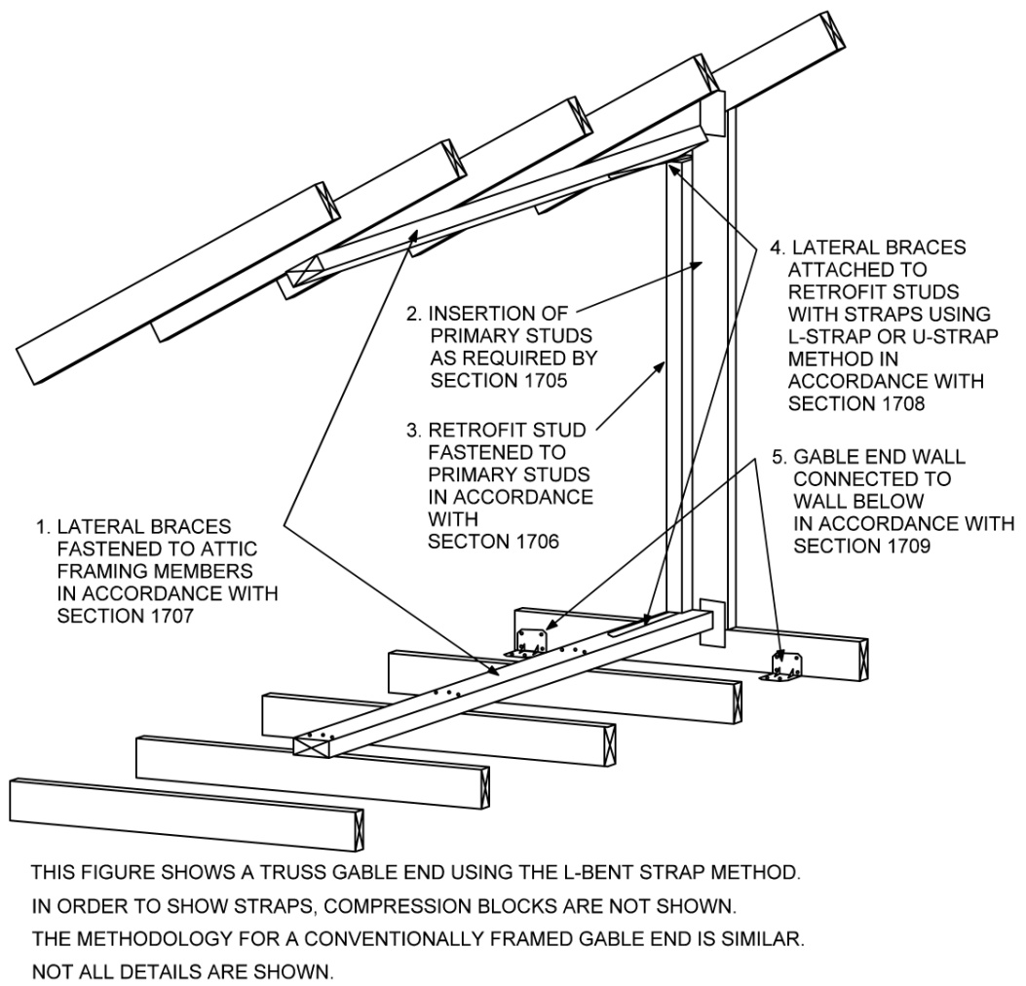

FIGURE 1704.1
GENERAL MEANS OF GABLE END RETROFIT

TABLE 1704.1
RETROFIT CONFIGURATION AS A FUNCTION OF EXPOSURE CATEGORY,
DESIGN WIND SPEED, AND STUD HEIGHT
RETROFIT ELEMENTS |  |  |  |  | SIZE AND NUMBER OF RETROFIT ELEMENTS  Stud length limitations based on Exposure, Basic Wind Speed, and Configuration
Exposure  Category | Max 3-sec gust  Basic Wind Speed  (Interpolation is not permitted) | Connections of gable end wall to wall below.  On center spacing  (Section 1708) |  |  | Configurations A, B, C, or D
Exposure  Category |  | Gusset angle  bracket | Fasteners to secure  sill plate to wall |  | A | B | C |  | D
D | < or =130 mph | 39” | 14” |  | 6’-11” | 10’-11” | 14’-3” |  | 16’-0”
D | >130 - 140 mph | 34” | 12” |  | 6’-7” | 10’-5” | 13’-7” |  | 16’-0”
D | >140 - 150 mph | 29” | 10” |  | 6’-2” | 9’-9” | 12’-10” |  | 16’-0”
D | >150 - 160 mph | 26” | 9” |  | 5’-11” | 9’-1” | 12’-0” |  | 15’-4”
D | .>160 - 170 mph | 23” | 8” |  | 5’-6” | 8’-7” | 11’-4” |  | 14’-9”
D | >170 - 180 mph | 20” | 7” |  | 5’-2” | 8’-1” | 10’-8” |  | 14’-2”
C | < or =130 mph | 46” | 16” |  | 7‘-4“ | 11’-6” | 15’-1” |  | 16’-0”
C | >130 - 140 mph | 39” | 14” |  | 7‘-0” | 10’-11” | 14’-5” |  | 16’-0”
C | >140 - 150 mph | 34” | 12” |  | 6’-8” | 10’-5 | 13’-8” |  | 16’-0”
C | >150 - 160 mph | 30” | 11” |  | 6’-4” | 9’-10” | 13’-0” |  | 16’-0”
C | .>160 - 170 mph | 27” | 9” |  | 5’-11” | 9’-3” | 12’-3” |  | 15’-6”
C | >170 - 180 mph | 24” | 8” |  | 5’-7” | 8’-9” | 11’-7” |  | 15’-0”
B | < or =130 mph | 63” | 22” |  | 8’-2” | 12’-10” | 16’-0” |  | (a)
B | >130 - 140 mph | 54” | 19” |  | 7’-9” | 12’-2” | 15’-0” |  | (a)
B | >140 - 150 mph | 47” | 17” |  | 7’-5” | 11’-8” | 15’-3” |  | 16’-0”
B | >150 - 160 mph | 42” | 15” |  | 7’-1” | 11’-2” | 14’-7” |  | 16’-0”
B | .>160 - 170 mph | 37” | 13” |  | 6’-10” | 10’-8” | 14’-0” |  | 16’-0”
B | >170 - 180 mph | 33” | 12” |  | 6’-7” | 10’-4” | 13’-6” |  | 16’-0”
Retrofit studs Minimum size and number  (Section 1706) |  |  |  |  | 2x4 | 2x6 | 2x8 |  | 2 each 2x8
Lateral brace above and below (top and bottom)  Minimum size and number  (Section 1707) |  |  |  |  | 2x4 | 2x4 | 2x4 |  | 2 each 2x8
Retrofit Elements for L-bent strap applications
(Section 1708.1)
Fasteners at each end for strap connecting Retrofit studs to Lateral braces using 1-1/2 inch long fasteners complying with Table 1703.6 Minimum number |  |  |  | 3 |  | 5 | 6 | 5 at each end of each strap
Fasteners to connected Compression blocks to Lateral braces using 3-inch long fasteners complying with  Table 1703.6 Minimum number |  |  |  | 4 |  | 6 | 7 | 5
Retrofit Elements for U-bent strap applications
(Section 1708.2)
Fasteners to connect straps to each edge of Lateral braces using 1-1/2 inch long fasteners complying with Table 1703.6 Minimum number |  |  |  | 3 |  | 4 | 4 | 4 at each end of each strap

For SI: 1 inch =25.4 mm, 1 Foot = 304.8 mm, 1 mile per hour = 0.447 m/s.
- Configuration C is allowable.

SECTION 1705
ADDED STUDS

1705.1 Requirements for added studs. Along a platform framed gable end wall where an existing stud is longer than 3 feet and the distance (centerline to centerline) between that stud and an adjacent stud that is also longer than 3 feet is greater than 22 ½ inches, an added stud shall be installed. This requirement also applies to the top truss of a piggyback truss assembly. The length of the stud shall be the maximum length of the stud itself exclusive of the depth of the top chord and bottom chord members. If an existing stud is interrupted by other members, such as by a diagonal in a gable end truss, it shall include pieces above and below the interrupting member to provide continuity from the top of the bottom chord to the bottom of the top chord of the gable end framing, or wood structural members shall be added to provide this continuity. If a lateral brace is being omitted as allowed in Section 1707.4.1, then the existing or added stud shall not be required to be continuous from an interruption to the location of the omitted lateral brace. Added studs shall have at minimum the same narrow and wide face dimensions as the existing studs.

1705.2 Placement of added studs. Added studs shall be installed with the same orientation as existing studs. Added studs of piggyback trusses shall align with required primary studs in the truss below.

1705.3 Attachment of added studs. In the case of conventional framing, each end of each required added stud shall be attached to the top and bottom plates. In the case of truss construction, each end of each required added stud shall be attached to the top and bottom chord of the truss. Attachments shall be made using a stud-to-plate metal connector with minimum uplift capacity of 175 pounds fastened with 1-1/2 inch long fasteners complying with Table 1703.5.

1705.4 Interrupted or short existing studs. Existing studs longer than 3 feet that extend to only one end of attic-framing members shall be retrofitted using the methods of Section 1706.6. Existing studs that are interrupted shall be retrofitted using the methods of Section 1706.7.

SECTION 1706
RETROFIT STUDS

1706.1 Requirements for retrofit studs. Except as allowed by Section 1706.5, a retrofit stud shall be installed at each primary stud longer than 3 feet where lateral braces can be installed using the methods of Section 1707. The size of retrofit studs shall be as required by Table 1704.1 for the appropriate retrofit configuration. Where straps are installed using the L-bent strap method of Section 1708.1.1, retrofit studs shall extend from the top of the lower lateral brace up to the bottom of the upper lateral brace except that a maximum gap of 1/8 inch is allowed at the bottom and ½ inch at the top. Where straps are installed using the U-bent method of Section 1708.1.2, retrofit studs shall extend beyond the ends of lateral braces such that lateral braces can fully butt against the retrofit studs.
Exception: A retrofit stud need not be added where the distance between it and an adjacent retrofit, primary stud would be less than 14 ½ inches.

1706.2 Piggyback trusses. Primary studs of piggyback truss assemblies shall have retrofit studs sized and placed such that a single continuous retrofit stud is installed and fastened to the primary stud of both the lower and upper truss. Added studs shall be placed and fastened in accordance with Section 1705. The bottom chord of the upper truss shall be connected to the retrofit stud using an approved connector with minimum tension capacity of 175 pounds.

1706.3 Placement of retrofit studs. Retrofit studs and nailers can be placed on either side of primary studs. Retrofit studs shall be installed in accordance with one of the following methods.

1706.3.1 Method (a): Face to edge or to face method. Retrofit studs shall be placed immediately adjacent to primary studs as indicated in Figure 1706.3(a) such that retrofit studs overlap the edge or side of the primary stud by a minimum of 1 ¼ inches. Fasteners shall be placed in accordance with Section 1706.4.1.

1706.3.2 Method (b): Butted retrofit stud method. Retrofit studs shall be placed such that the narrow face of retrofit studs butt against primary studs as indicated in Figure 1706.3(b). Retrofit studs shall be attached to primary studs with nail plates as indicated in Figure 1706.3(b). Nail plates shall be spaced and attached in accordance with Section 1706.4.2.

1706.3.3 Method (c): Offset retrofit stud method. Retrofit studs shall be placed such that the retrofit stud is offset from the primary stud by use of nail plates such that the nail plate can be affixed as indicated in Figure 1706.3(c) and Figure 1706.4.2 provided the fastening conditions of Section 1706.4.2 are met.

1706.3.4 Method (d): Nailer with retrofit stud method. Retrofit studs and existing studs shall be connected using minimum 2x4 nailers as indicated in Figure 1706.3(d) provided the following conditions are met. Nailers may be comprised of multiple members lengthwise.
- Both the primary stud and the retrofit stud shall be butted to nailers and both shall be fastened to the nailer with 3-inch fasteners. Fasteners connecting each stud to the nailer shall be spaced 6 inches on center.
- Fasteners into nailers through the face of either member shall be offset vertically by a minimum of 2-3/4 inches.
- Fasteners into nailers shall be a minimum of 2 ¾ inches but not more than 6 inches from the end of the shorter of the primary stud or retrofit stud to which they are fastened.
- Fasteners shall be placed minimum ½ inch from the edges of studs.

1706.4 Attachment of retrofit studs to primary studs. Retrofit studs, nail plates, and nailers shall be fastened in accordance with the following.

1706.4.1. Fastener attachments. Where retrofit studs are placed using the methods of Section 1706.3.1 or Section 1706.3.4, retrofit studs shall be attached to primary studs and nailers shall be attached to primary studs and retrofit studs using minimum 3-inch long fasteners. Fastener penetration into each member shall be a minimum 1 ½ inch. Fasteners can be installed from either face of studs or nailers. Fasteners shall be a minimum of 2 ¾ inches on center along through the face of either member along the length of studs and from ends of studs, and a maximum of 6 inches on center, minimum ½ inch to edges of studs, and minimum 1 inch across studs. Fasteners into nailers from any direction shall be offset vertically a minimum of 2 ¾ inches. Fasteners shall be a minimum 2 ¾ inches from ends of lumber.

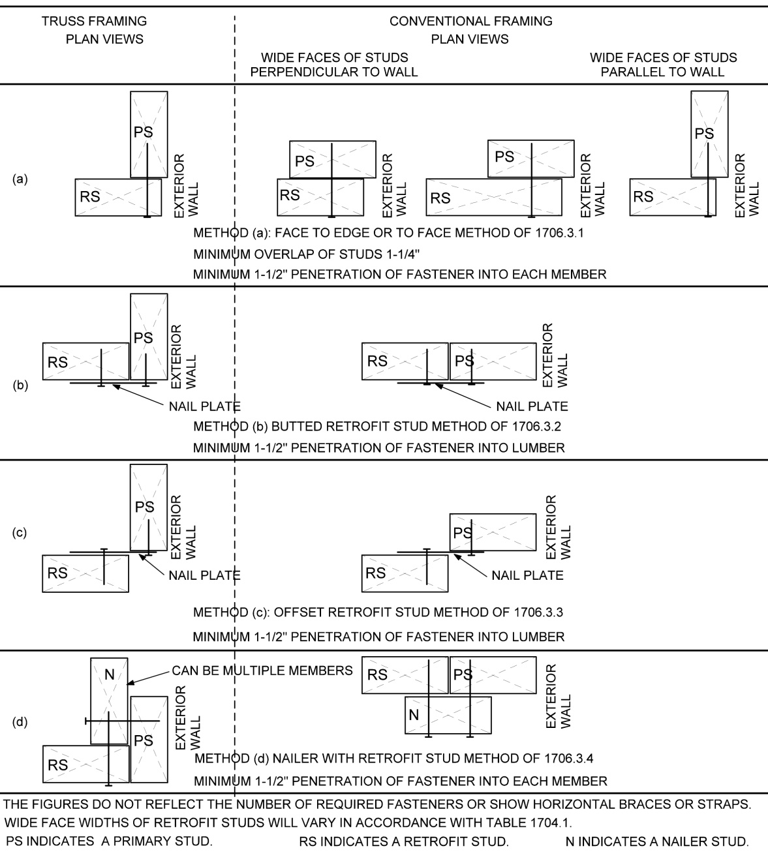
For SI: 1 inch = 25.4 mm
FIGURE 1706.3
PLACEMENT OF RETROFIT STUDS

1706.4.2. Nail plate attachments. Where retrofit studs are placed using the methods of Section 1706.3.2 or Section 1706.3.3, nail plates shall be spaced and attached in accordance with all of the following requirements.
- Nail plates shall be spaced such that vertical spacing between plates shall be a maximum of 20 inches.
- There shall be at least 3 fasteners through each nail plate into both the primary and retrofit studs.
- Fasteners used to secure nail plates to studs shall be a minimum 1½ inch long and fasteners shall be a minimum of 2-3/4 inches and a maximum of 6 inches from the ends of retrofit studs.
- Fasteners placed in nail plates shall be spaced a minimum of 2-3/4 inches along the length of lumber and 2 ¾ inch from ends of lumber.
- Fasteners shall be placed a minimum of a ½ inch from the edges of the studs and a maximum of 1-1/2 inches from the abutting vertical edges of primary and retrofit studs.
- Staggered fasteners used to secure nail plates shall be spaced horizontally a minimum of ½ inches.
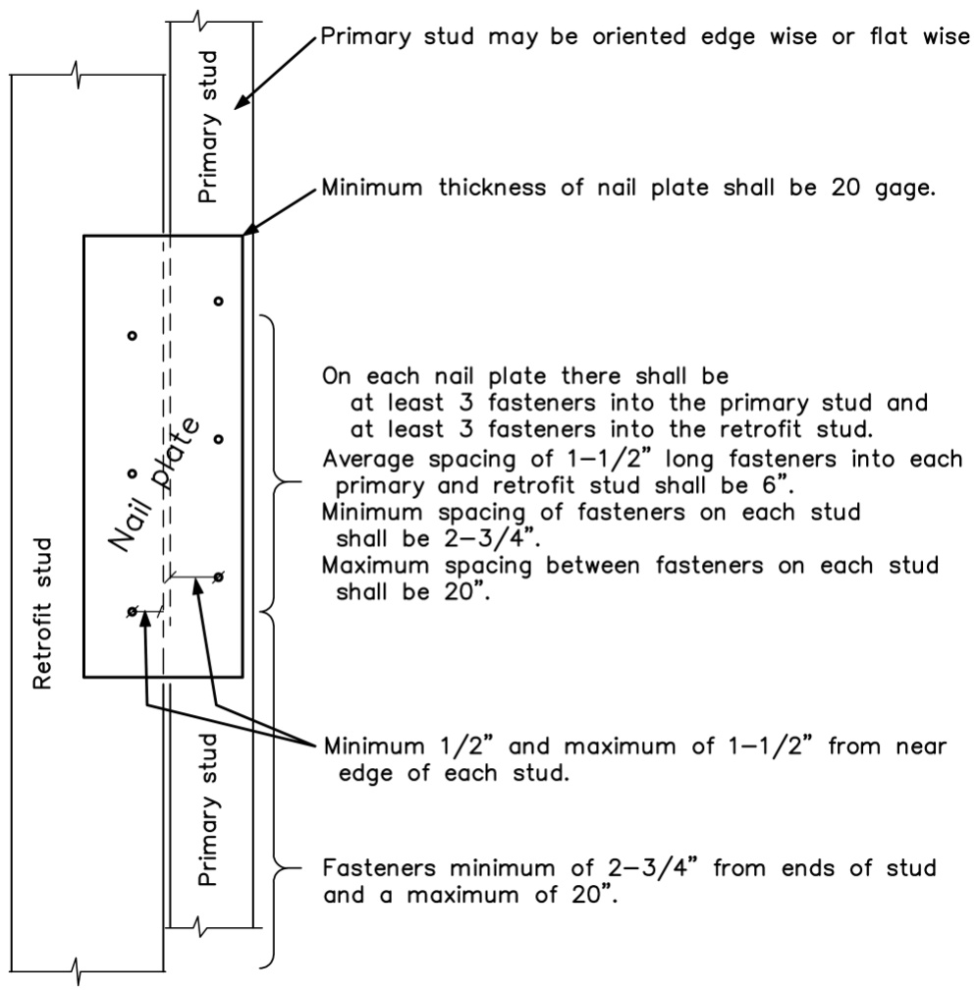
For SI: 1 inch = 25.4 mm
FIGURE 1706.4.2
NAIL PLATE FASTENING

1706.5 Reduced width of retrofit studs. The broad face of retrofit studs may be reduced in width by methods of cutting, boring, or notching at any number of locations along their length provided that all of the following conditions are met.
- The wide face of retrofit studs shall be sized such that the remaining minimum width of the member at each location of reduced width shall not be less than that required by Table 1704.1.
- The distance between segments of reduced width shall be a minimum of 8 inches and shall be allowable at the ends of retrofit studs.
- The average spacing of fasteners connecting retrofit studs to existing studs shall be maximum 6 inches on center.
- The minimum vertical distance between fasteners on studs shall be a minimum of 2-3/4 inches.
- Retrofit studs reduced in width shall not be spliced within 12 inches of the location of reduced width. Splice members shall not be notched.

1706.6 Omitted retrofit stud – Ladder assembly. Where existing conditions prevent installation of a full length retrofit stud in accordance with Section 1706.1 or Section 1707.4, the retrofit stud and its associated two lateral braces shall be permitted to be wholly or partially omitted from that location by installation of a ladder assembly for Retrofit Configurations A and B as defined in Table 1704.1 provided all of the following conditions are met. This method is not allowed for Retrofit Configurations C or D.
- No more than two ladder assemblies are permitted on a single gable end.

- There shall be at least two retrofit studs and lateral brace assemblies on each side of the location where a retrofit stud is omitted.
- Where both of the retrofit studs on each side an omitted retrofit stud would be required by Table 1704.1 to be 2x4, they shall both be 2x6. Where either retrofit stud on the side of an omitted stud would be required by Table 1704.1 to be 2x6, they both shall be 2x8. Where either retrofit stud on the side of an omitted stud would be required by Table 1704.1 to be 2x8, they both shall be 2x10.
- Lateral braces adjacent to the omitted lateral brace shall be minimum 2x6 lumber extend over four roof framing members and be fastened to each of the four attic-framing member crossed using minimum four (4) 3-inch long fasteners. Fasteners shall be installed in accordance with Section 1706.4.
- Ladder rungs shall be of minimum 2x4 lumber installed horizontally with their wide face oriented horizontally and installed to span between the retrofit studs on either side of the omitted retrofit stud. The edge of the ladder rung shall bear against the primary stud at the location of the omitted retrofit stud. Ladder rungs shall be vertically spaced a maximum of 16 inches on center.
- Where ladder rungs cross and bear against the primary stud at the location of the omitted retrofit stud, they shall be attached to the primary stud using a stud-to-plate connector with a minimum capacity of 175 pounds in the direction perpendicular to the gable end wall. Ladder rungs shall be attached to the retrofit studs on both sides of the location where the retrofit stud is omitted using two 3-inch long fasteners driven through the retrofit stud and into the end of the ladder rung.
- Notching of the ladder rungs shall not be permitted unless the net depth of the ladder rung is a minimum of 3-1/2 inches in the area of the notch.

1706.7 Interrupted primary studs. Where primary studs are interrupted because of existing conditions and where existing conditions permit, a retrofit stud shall be installed that bridges the interruption. It shall be attached to the primary stud both below and above the interruption, sized in accordance with Table 1704.1 for the total length, placed in accordance with Section 1706.3, and attached in accordance with Section 1706.4 along the portion of its length that is in contact with the primary stud.

1706.8 Short retrofit studs. Where existing conditions are such that a lateral brace installed in accordance with Section 1707 can only be installed at one end of a primary stud extends to a lateral brace at only a ceiling or a roof diaphragm such that a lateral brace can be installed in accordance with Section 1707, the method of retrofit shall comply with Section 1706.7.

1706.9 Spliced retrofit studs. Retrofit studs shall be permitted to be spliced provided all of the following conditions are met.
- Retrofit studs shall be butted to one another at the splice joint and a minimum 4 foot length of splice member shall be centered at the butt joint.
- Lumber splice members shall be nominal 2 inch lumber with the wide face width equal to or wider than the face width of the spliced retrofit studs.
- Splice members shall be attached to each of the retrofit stud members on each side of the splice with minimum 7 rows of 3 fasteners for a total of 21 fasteners. Rows of fasteners shall be minimum 2 ¾ inches from the end of the splice member, minimum 2 ¾ inches from the splice joint and ends of members, and spaced evenly along the 18 inch splice overlap between these two limits.

SECTION 1707
LATERAL BRACES

1707.1 Requirements for lateral braces. At each end of a retrofit stud, a lateral brace shall be installed as indicated in Figure 1707.1(1) or Figure 1707.1(3) for trusses and Figure 1707.1(2) or Figure 1707.1(4) for conventionally framed gable end walls. Lateral braces shall be allowed to be omitted in accordance with Section 1706.6 or Section 1707.3. Alternative methods for providing lateral bracing are allowable in accordance with Sections 1707.4.1. Lateral braces shall be minimum 2x4 lumber except as required by Section 1707.4.1 or Section 1706.6.

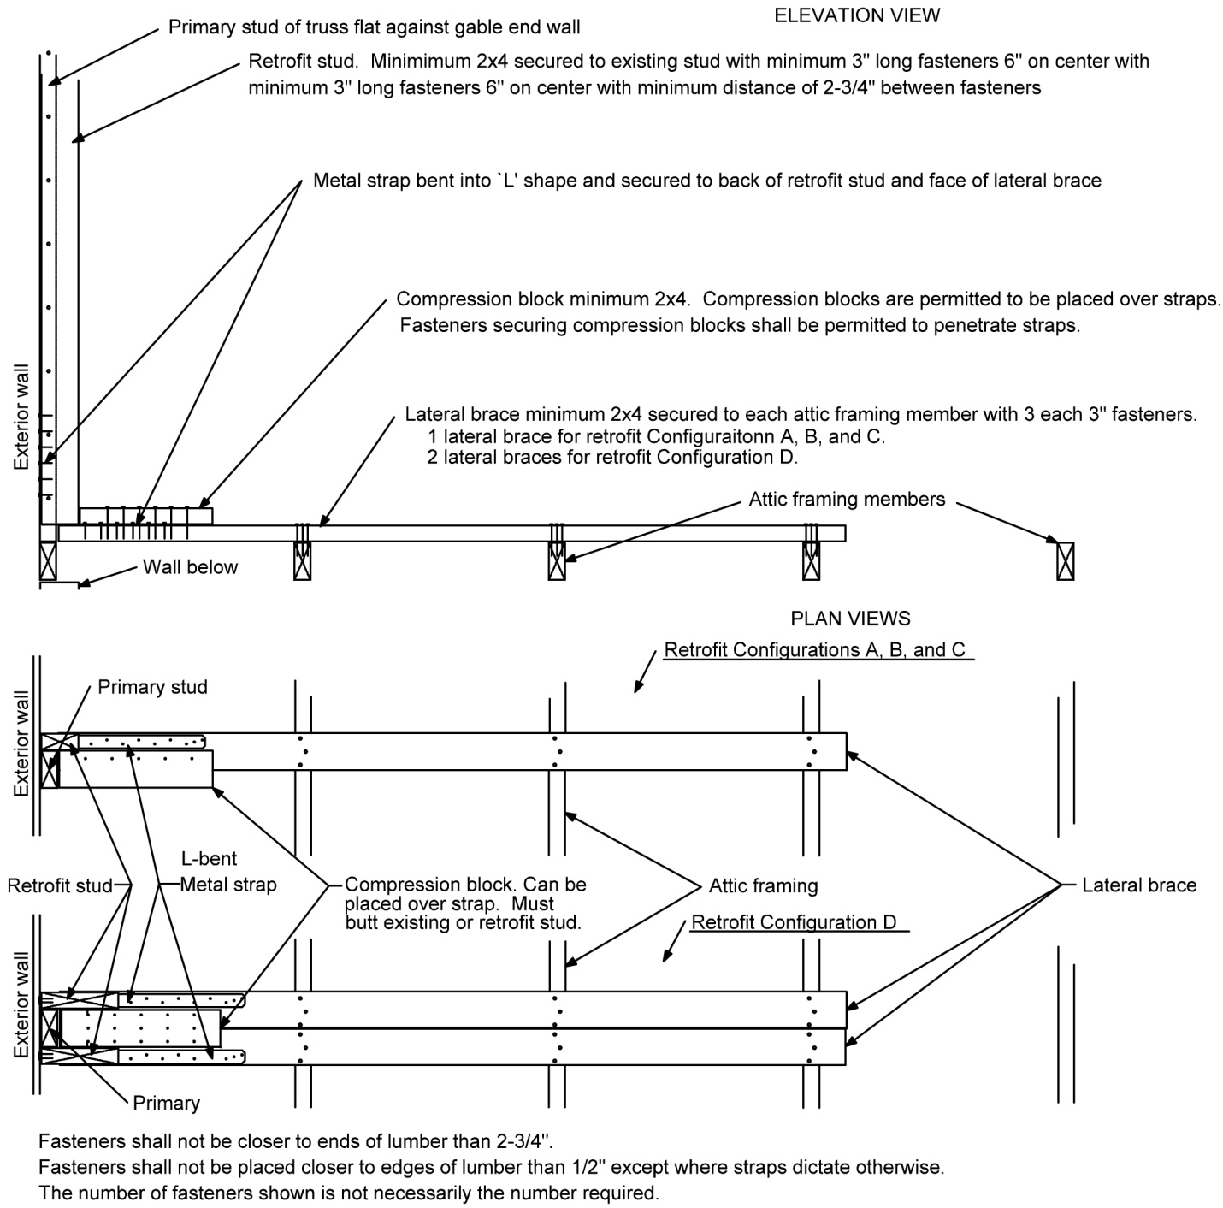

FIGURE 1707.1(1)
TRUSS GABLE END WALL WITH L-BENT STRAPS

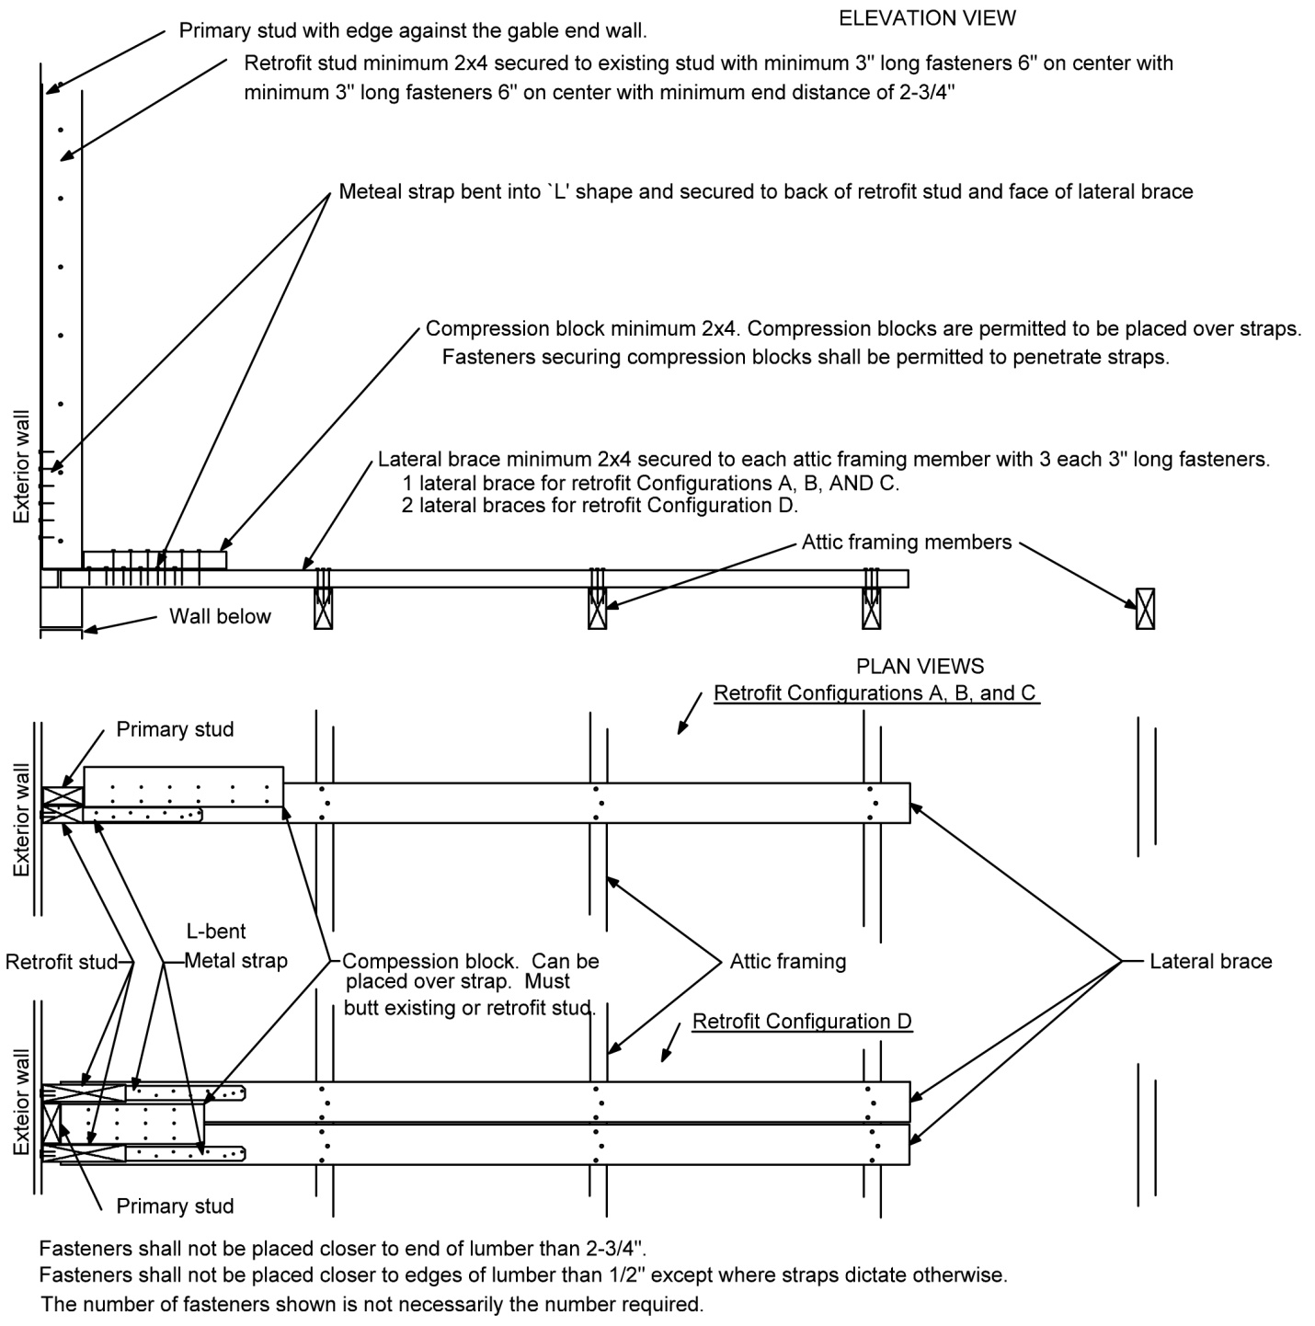

FIGURE 1707.1(2)
CONVENTIONALLY FRAME GABLE END WALL WITH L-BENT STRAPS

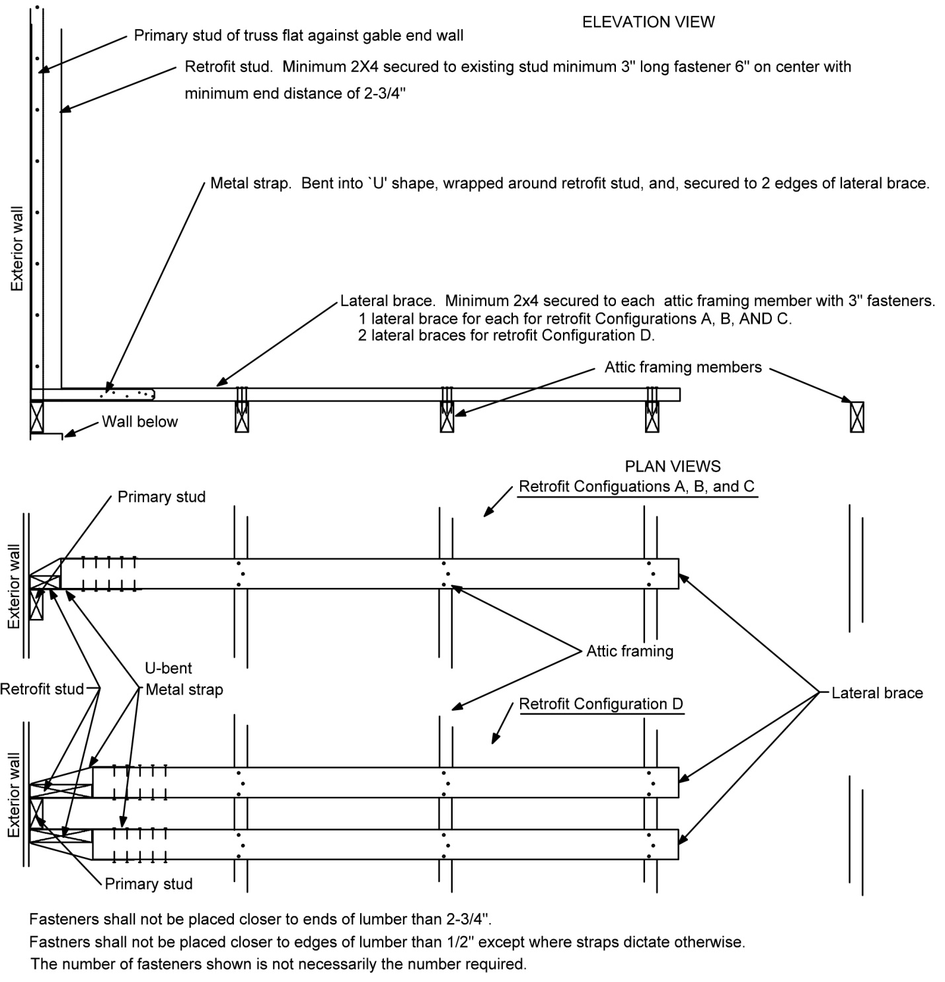

FIGURE 1707.1(3)
TRUSS GABLE END WALL WITH U-BENT STRAPS

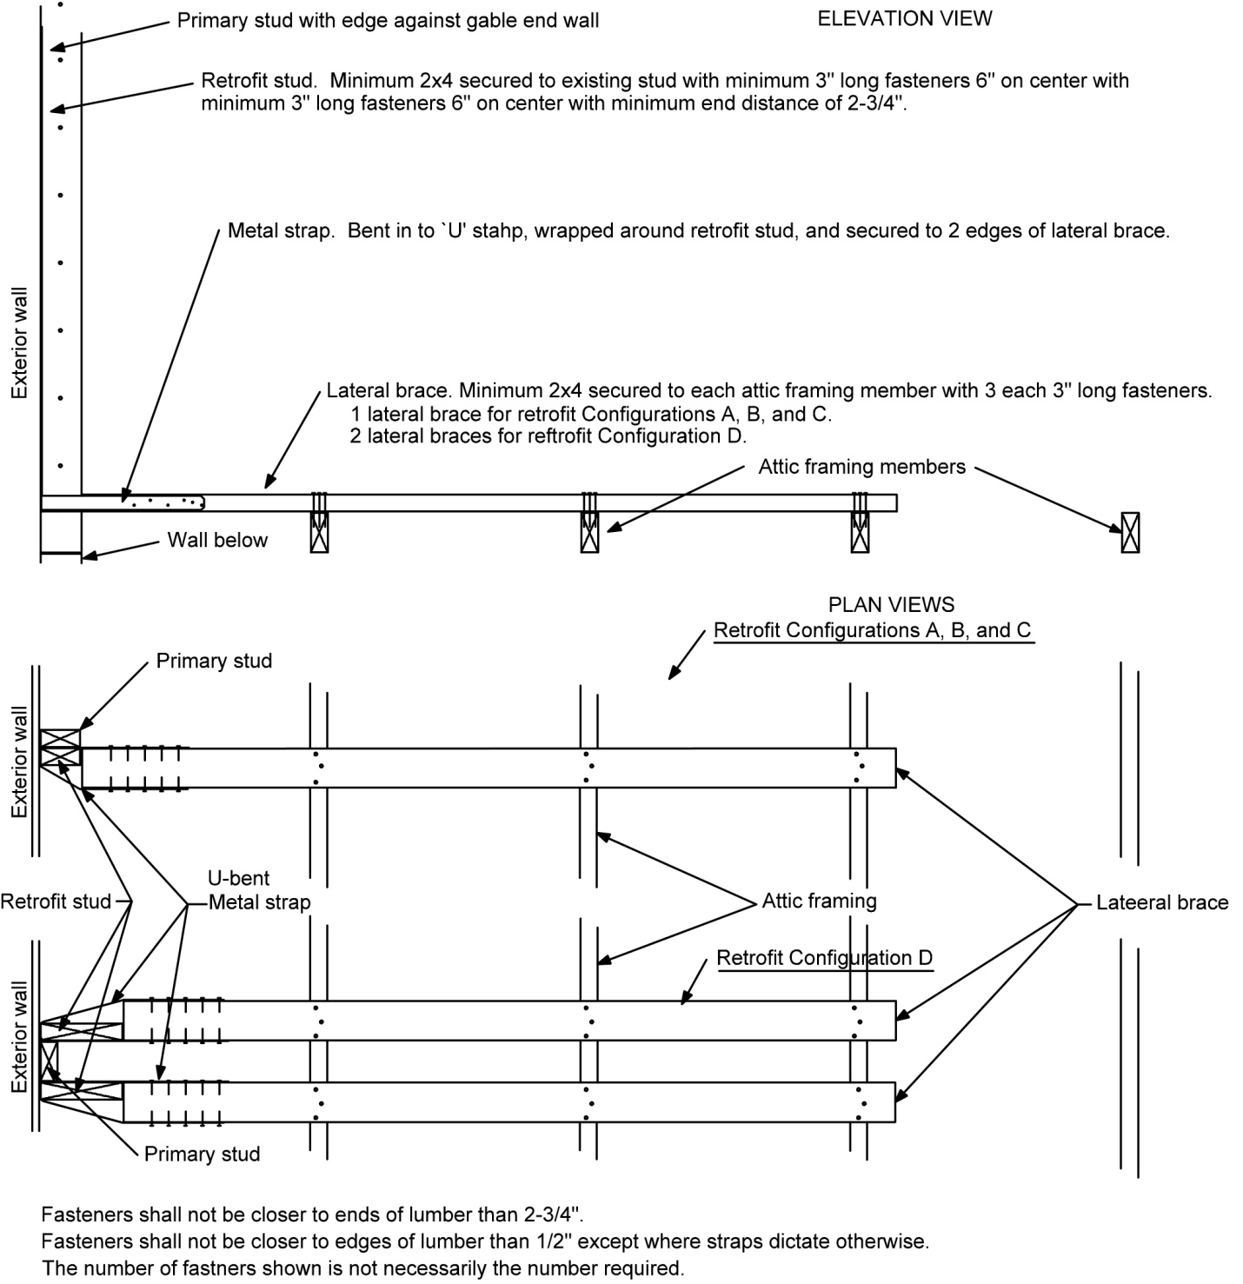
FIGURE 1707.1(4)
CONVENTIONALLY FRAME GABLE END WALL WITH U-BENT STRAPS

1707.2 Placement. Lateral braces shall be placed approximately perpendicular to the attic-framing members and extend so they are attached to a minimum of three attic-framing members. The attic-framing member farthest from the gable end wall shall be a minimum of 6 feet from the exterior sheathing or siding on the gable end wall. Lateral braces shall be installed with their wide faces across attic-framing members. Where the method of Section 1708.1 is used, lateral braces shall butt against the sheathing or siding of the wall. Where the method of Section 1708.2 is used, lateral braces shall butt against the retrofit studs.
Exception: Where existing conditions prevent placement of continuous lateral braces on attic-framing members, installation shall be in accordance with Section 1707.4.

1707.3 Attachment of lateral braces. Lateral braces shall be attached to attic-framing members and attached to retrofit studs in accordance with this section.

1707.3.1 Attachment of lateral braces to attic framing or ridge ties. Lateral braces shall be attached to each of the attic-framing members or ridge ties that they cross with a minimum of three (3) 3-inch long fasteners. Fasteners shall be installed at least ½ inch from any edge of either the lateral brace or the attic frame member and spaced at least 1 inch apart across the width of the lateral brace as shown in Figure 1707.3.1. Lateral braces shall extend a minimum of 2 ¾ inches beyond the edge of the last attic-framing member to which they are attached.

1707.3.2 Attachment of lateral braces to retrofit studs. Attachment of lateral braces to retrofit studs shall be in accordance with Section 1708.
1707.3.3 Bocking attachment to lateral braces. Where ceiling joists or truss bottom chords are deeper than 6 inches, an anchor block shall be installed in each space between ceiling members along the length of the lateral brace except for the space next to the gable end wall.
1. An anchor block shall be installed in each space between attic-framing members along the length of the lateral brace except for the space next to the gable end wall.
2. Anchor blocks shall be minimum 15/32 inch plywood, 7/16 inch OSB, or nominal 2 inch thick lumber #2 spruce-pine-fir or better.
3. Anchor blocks shall have minimum wide face dimension equal to the attic-framing members at the location where the anchor block is installed. Anchor blocks shall extend between attic-framing members and butt against them or their truss plates with a maximum gap of 1/8 inch.
4. Anchor blocks shall be installed on lateral braces with their wide face on the narrow face of lateral braces. Anchor blocks shall be placed on lateral braces with their attic interior edge flash with the attic interior face of lateral braces. They are permitted to be placed on different edges of lateral braces.
Anchor blocks shall be fastened to lateral braces with a single row of 8d common nail, 10d common nails or #9 screws with minimum penetration into lateral braces equal to the thickness of the anchor block or 1 inch whichever is greater. The minimum number of fastener shall be the maximum that can be placed in a single row with minimum 2 ¾ inch distance between fasteners and 2 ¾ inch distance to ends of anchor blocks except that the number of fasteners need not exceed three per anchor block made of nominal 2 inch thick lumber. For nominal 2 inch thick lumber anchor blocks, the number of fasteners need not exceed three fasteners per anchor block.
(S5888 AM A2)
1707.4 Alternative installation. Where existing conditions prevent the placement of lateral braces as specified in 1707.2, the alternative installation methods of Section 1707.4.1, Section 1707.4.2, and Section 1707.4.3 shall be allowable.

1707.4.1 Omitted lateral brace. Where existing conditions prevent installation of lateral braces in accordance with Section 1707.2, lateral braces shall be permitted to be omitted for Retrofit Configurations A and B as defined in Table 1704.1 provided all of the following conditions are met. This method is not allowed for Retrofit Configurations C or D.

- Lateral braces on each side of omitted lateral braces shall be 2x4 lumber placed approximately perpendicular to the attic-framing members and installed with their wide faces across attic-framing members. They shall be attached to a minimum of four (4) attic-framing members with attachment to the attic-framing member farthest from the gable end wall a minimum of 8 feet from the exterior sheathing or siding on the gable end wall.

- The lateral brace on each side of an omitted lateral brace shall be fastened to each attic-framing member that they cross using three (3) 3-inch long fasteners. Fasteners shall be spaced a minimum of ½ inch from the edges of the lateral braces, a minimum of 2 ¾ inches from ends of lateral braces, and a minimum of 1 inch from adjacent fasteners.

- A retrofit stud shall be installed in accordance with Section 1706.4 at the location of the omitted lateral brace. This retrofit stud and both of the retrofit studs on either side of the omitted lateral brace shall be sized in accordance with Table 1704.1 for the largest of the retrofit studs required at any of the three locations.

- All three retrofit studs shall have their attic interior edges aligned such that they snuggly butt the strong back to be installed between the two lateral braces on either side of the omitted lateral brace.

- Retrofit studs adjacent to the omitted lateral brace shall be fastened to their corresponding lateral brace using straps in accordance with the L-bent strap method of Section 1708.1.1 except that a compression block is not required. The U-bent strap method of Section 1708.1.2 is not allowed unless U-bent straps are routed around the exterior face of primary studs.

- A strong back of minimum 2x6 lumber shall be installed parallel to the gable end and shall be located on and span between the lateral braces on the two sides of the omitted lateral brace. The strong back shall extend a minimum of 2 ¾ inches beyond the outer edges of the lateral braces and be snuggly butted against each of the three retrofit studs. The strong back shall be attached to each of the lateral braces on which it rests with four (4) 3-inch fasteners. The fasteners shall be placed a minimum ½ inch from all edges, a minimum of 2 inch spacing between fasteners, and a minimum of 2 ¾ inches from ends of the lumber members.

- The retrofit stud at the location of the omitted lateral braces shall be fastened to the strong back using a connector with minimum uplift capacity of 800 pounds as specified by the manufacturer for use with spruce-pine-fir or hem-fir lumber and installed such that this capacity is oriented in the direction perpendicular to the gable end wall.

- Lateral braces at ends of strong backs shall be permitted to be interrupted in accordance with Section 1707.4.2; but shall not be permitted to be shortened using the alternative method of Section 1707.4.3.

1707.4.2 Interrupted lateral braces. Where existing conditions prevent the installation of lateral braces of required length in accordance with Section 1707.1, a splice member shall be permitted to be installed to bridge interruptions. Splice members shall be at minimum the same size lumber as the lateral braces they bridge. Although Figure 1707.4.2 illustrates the general methods that can be used where attic-framing members are spaced 24” o.c., the methods apply to other on center spacings. Splice members may extend beyond those shown and are allowed to be fastened to the main lateral brace segments farther than shown. Splice members shall be fastened at each end using the number of fasteners equal to the total number that would be required to be placed in total in that part of lateral braces more distant from the gable end wall. For a lateral brace that requires 3 fasteners at each roof framing members and installation across three roof framing members, the number of fasteners in the splice need not be more than nine fasteners if the interruption is between the gable end wall and the first attic-framing member; six fasteners if between the first and second framing members, and three fasteners if between subsequent interruptions. Fasteners shall be spaced ½ inch from the edges of lateral braces, 1 inch from each other, ½ inch from the edge of attic members, and minimum 2 ¾ inch from the ends of lateral braces and from the ends of splice members.

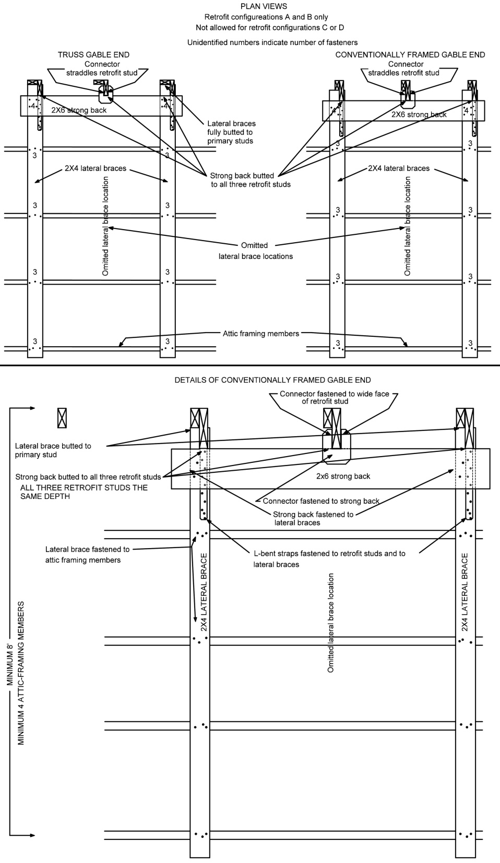
FIGURE 1707.4.1
OMITTED LATERAL BRACE

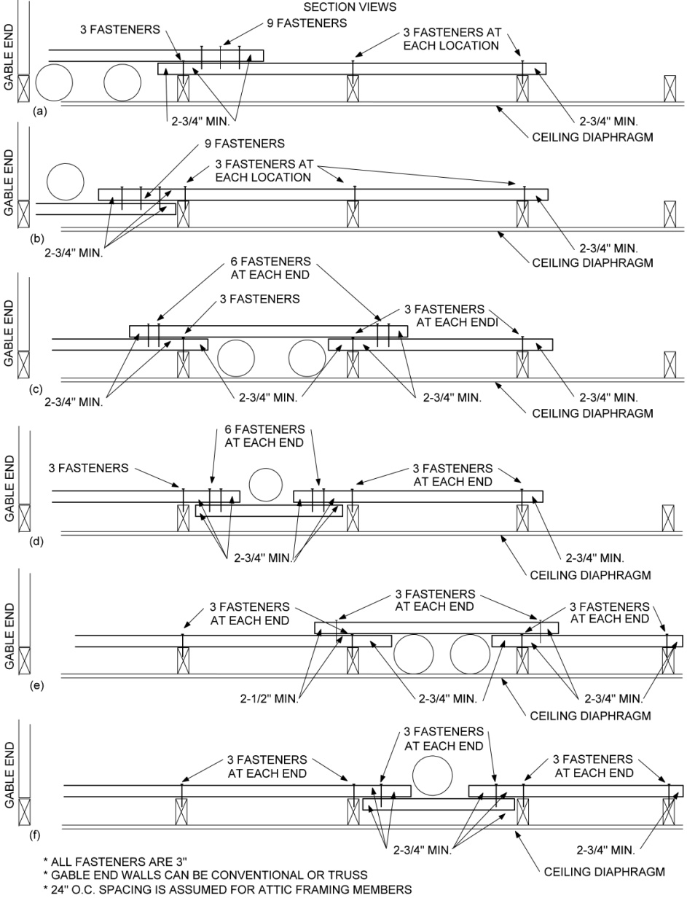
For SI: 1 inch = 25.4 mm
FIGURE 1707.4.2
INTERRUPTED LATERAL BRACES

1707.4.3 Short lateral brace. Where conditions exist that prevent installation of lateral braces in accordance with Section 1707.4.1 or Section 1707.4.2, lateral braces shall be permitted to be shortened, except where the brace is adjacent to an omitted lateral brace of Section 1707.4.1, provided all of the following conditions are met.

- The short lateral brace shall be installed across a minimum of two attic-framing members, be attached to an attic-framing member a minimum of 4 feet from the gable end wall. Where lateral braces are 2x4 they shall be fastened to each attic-framing member over which they cross with three (3) 3-inch fasteners. Where lateral braces are 2 x 6 or wider they shall be fastened to each attic-framing member over which they cross with four (4) 3-inch fasteners.

- An anchor block shall be installed in each space between attic-framing members along the length of the lateral brace except for the space next to the gable end wall.

- Anchor blocks shall be minimum 15/32 inch plywood, 7/16 inch OSB, or nominal 2 inch thick lumber #2 spruce-pine-fir or better.

- Anchor blocks shall have minimum wide face dimension equal to the attic-framing members at the location where the anchor block is installed. Anchor blocks shall extend between attic-framing members and butt against them or their truss plates with a maximum gap of 1/8 inch.

- Anchor blocks shall be installed on lateral braces with their wide face on the narrow face of lateral braces. Anchor blocks shall be placed on lateral braces with their attic interior edge flash with the attic interior face of lateral braces. They are permitted to be placed on different edges of lateral braces.

- Anchor blocks shall be fastened to lateral braces with a single row of 8d common nail, 10d common nails or #9 screws with minimum penetration into lateral braces equal to the thickness of the anchor block or 1 inch whichever is greater. The minimum number of fastener shall be the maximum that can be placed in a single row with minimum 2 ¾ inch distance between fasteners and 2 ¾ inch distance to ends of anchor blocks except that the number of fasteners need not exceed seven per anchor block. For nominal 2 inch thick lumber anchor blocks, the number of fasteners need not exceed three fasteners per anchor block.

1707.5 Lateral brace connections to webs of trusses. Where existing conditions prevent installation of lateral braces on top or bottom chords of trusses, they shall be permitted to be installed on diagonal webs or vertical members of trusses provided all of the following conditions are met.

- Lateral braces shall be positioned as close to the ceiling or roof diaphragms as existing conditions permit without altering trusses or any of their components.

- Anchor blocks shall be installed between each pair of attic-framing members along the length of the lateral brace except for the framing member space next to the gable end wall. Anchor blocks can be installed on the narrow or wide face of lateral braces.

- Anchor blocks shall be minimum 15/32 inch plywood, 7/16 inch OSB, or nominal 2 inch thick #2 spruce-pine-fir lumber or better.

- Anchor blocks shall be sized to extend towards the nearby ceiling or roof diaphragm to within 3 ½ inches of the diaphragm. Anchor blocks shall butt against chords or diagonals or vertical webs of trusses or truss plates with a maximum gap of 1/8 inch.

- Anchor blocks shall be fastened to lateral braces with 8d common or 10d common nails or #9 screws with minimum penetration into lateral braces equal to the thickness of the anchor blocks or 1 inch whichever is greater. The minimum number of fastener shall be the maximum that can be placed in a row with a minimum 2 ¾ inch distance between fasteners and 2 ¾ inch distance to ends of anchor blocks except that the number need not exceed three fasteners for nominal 2 inch thick lumber anchor blocks.

1707.6 Installation at truss ridges. Where existing conditions prevent installation of lateral braces near the peak of roofs, ridge ties made of minimum 2x4 members shall be installed horizontally on faces of trusses to provide anchorage for a required lateral brace. The bottom surfaces of added ridge tie members shall be aligned so that they will support a continuous lateral brace and be installed a maximum of 4 inches below limiting existing conditions for any of the trusses used to support the lateral brace. Ridge ties shall be installed on a minimum of three trusses and on every truss member over which lateral braces pass and be attached to an attic-framing member at least 6 feet from the exterior sheathing or siding on the gable end wall. Ridge ties shall be placed on alternate sides of trusses. Ridge ties used to support lateral braces shall be fastened to each top chord member of each truss using two (2) 3-inch long fasteners and to any other truss members they cross using three (3) 3-inch long fasteners. Fasteners shall be spaced a minimum ½ inch from edges of all members and minimum of 1 inch from each other. Lateral braces shall be attached to ridge ties as required by Section 1707.3.1.

1707.7 Piggyback trusses. Piggyback truss assemblies, trusses composed of two trusses one above the other, shall be retrofitted such that a single continuous retrofit stud is installed and fastened to the primary studs of both the lower and upper truss. Primary studs shall be placed and fastened in accordance with Section 1705. The bottom chord of the upper truss shall be connected to the retrofit stud using a connector with minimum 175 pound uplift capacity.

1707.8 Outlookers. Where outlookers exist to support a gable roof overhang, the out lookers shall be attached to the gable end truss or rafter using a connector with a minimum 175 pound uplift capacity. Where the end of the out looker butts against an interior truss or rafter, the end shall be connected to the truss or rafter using a joist hanger or U shaped metal connector with a minimum capacity of 175 pounds.

SECTION 1708
ATTACHMENT OF LATERAL BRACES TO RETROFIT STUDS

1708.1 Attachment of lateral braces to retrofit studs. The top and bottom of each retrofit stud shall be attached to a lateral brace with a minimum 1 ¼ inch wide approved flat or coil metal straps with pre-punched holes for 10d common or 16d common nails or #9 screws. No attachment is required for the retrofit stud located at an omitted lateral brace location where connectors are in place in accordance with Section 1707.4.1. Straps shall be fastened using the size and number of fasteners in accordance with Table 1704.1. For use of L-bent straps, attachment shall comply with the method of Section 1708.1.1 and for use of U-bent straps with the method of Section 1708.1.2. Either method is allowable at either end of a retrofit stud.

1708.1.1 L-bent strap method. For Configurations A, B, and C, retrofit studs shall be attached to lateral braces in accordance with Figure 1708.1.1 and Figure 1707.1(1) or 1707.1(2). For Configuration D, retrofit studs shall be attached to lateral braces in accordance with Figure 1708.1.2 and Figure 1707.1(1) or Figure 1707.1(2). Attachments shall comply with the following conditions except where attachments of retrofit studs at omitted lateral braces are in conformance with Section 1707.4.1.
1. A strap of the gage specified in Table 1704.1 shall be installed to the retrofit stud and lateral brace such that one end of the strap is applied vertically to the retrofit stud on its vertical narrow face nearest the exterior of the gable end wall, bent 90 degrees, and applied horizontally to the wide horizontal face of the lateral brace.
2. Straps shall be long enough and bent appropriately so that the number of fasteners required by Table 1704.1 can be installed while maintaining a minimum distance of 2 ¾ inches from fasteners to the end of retrofit studs and long enough to clear the retrofit stud end butting the lateral brace.
3. Straps shall be permitted to be twisted or bent where they transition between the tops of retrofit studs and lateral braces to follow roof pitch. Straps shall be bent only once at a given location though it is permissible that they be bent or twisted at multiple locations along their length. The bends of straps over the ends of retrofit studs shall be right angles.
4. Compression blocks shall be placed on the lateral braces and butted directly against the primary stud or the retrofit stud. Figure 1706.2.1(1) (trusses) and Figure 1706.2.1(2) (conventionally framed) show the placement of a compression block against the existing stud. The minimum contact area between compression blocks and primary or retrofit studs shall be an area equivalent to 1 ½ inches by 1 ½ inches (2.25 square inches). Angled contact is permissible. Compression blocks shall be allowed to be placed over straps or beside straps.
5. Compression blocks shall be fastened to lateral braces using the number of 3-inch fasteners required by Table 1704.1. Fasteners shall be placed such they are a minimum 2 ¾ inches from the ends of compression blocks, a minimum 2 ¾ inches from each other along the length of compression blocks, and a minimum ½ inch from edges of both compression blocks and lateral braces. Fasteners securing compression blocks are allowed to penetrate straps.
(S5888 AM A2)
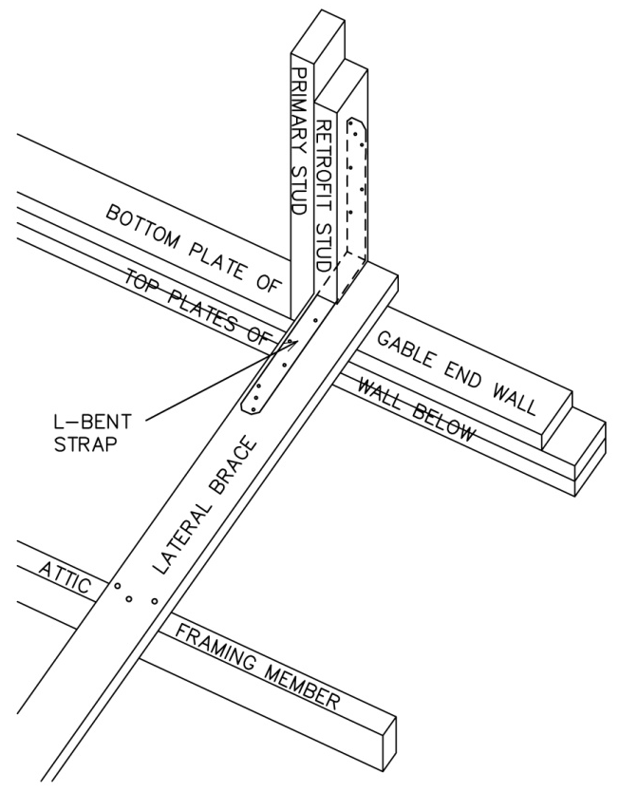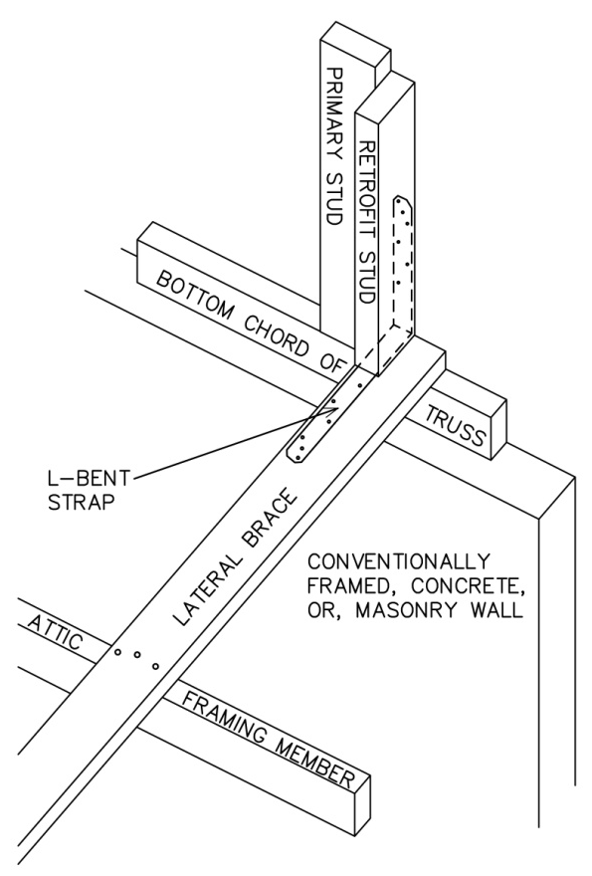
Conventionally framed gable end wall Truss framed gabled end wall
Compression blocks are not shown for clarity. Views are from within the attic.
FIGURE 1708.1.1(1)
L-BENT STRAP METHOD FOR CONFIGURATIONS A, B, AND C

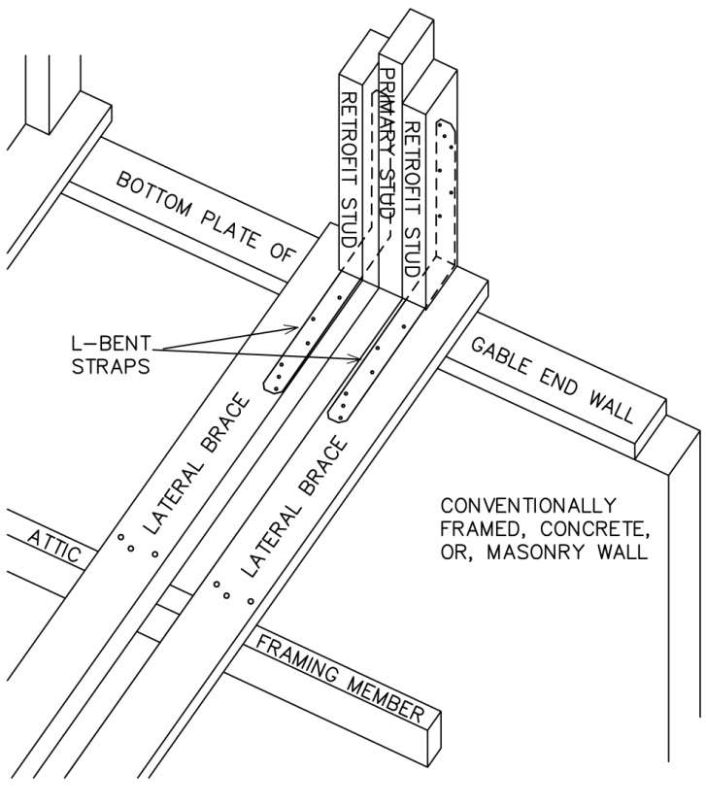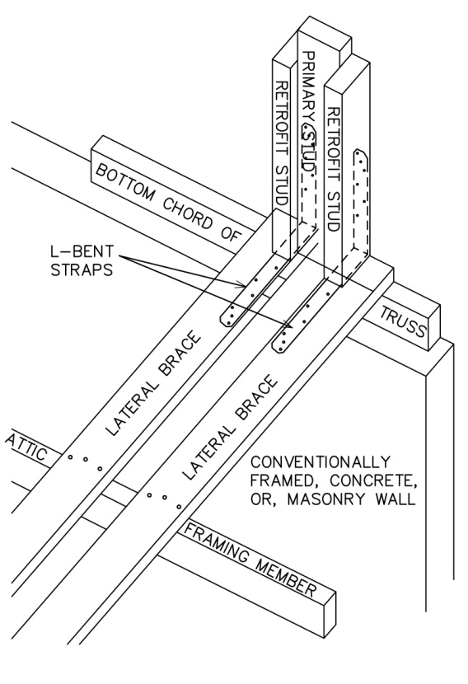
Conventionally framed gable end wall Truss framed gabled end wall
Compression blocks are not shown for clarity. Views are from within the attic.

FIGURE 1708.1.1(2)
L-BENT STRAP METHOD FOR CONFIGURATION D

1708.1.2 U-bent strap method. For Configurations A, B, and C, retrofit studs shall be attached to lateral braces in accordance with Figure 1708.1.2 and Figure 1707.1(3) or 1707.1(4). For Configuration D, retrofit studs shall be attached to lateral braces in accordance with Figure 1708.1.3 and Figure 1707.1(3) or Figure 1707.1(4). Attachments shall comply with the following conditions except where attachments of retrofit studs at omitted lateral braces are in conformance with Section 1707.4.1.
- A strap of the gage specified in Table 1704.1 shall be wrapped around the back edge of the retrofit or primary stud and extended onto the two narrow edges of the lateral brace.

- Lateral braces shall be placed such that one narrow face of the lateral brace is aligned with one wide face of the primary or retrofit stud and the strap shall be bent such that it is in contact with the narrow edge closest to the gable end wall of the primary or retrofit stud being wrapped.

- At the back of primary or retrofit studs, the two bends of straps shall be crisp.

- Lateral braces shall butt snugly against the primary or retrofit stud with a maximum gap of ¼ inch.

- Straps shall be attached to lateral braces using the number of 1-1/2 inch long fasteners specified in Table 1704.1. Fasteners for straps shall be placed minimum 2-3/4 inches from ends of lateral braces.

- Straps shall be permitted to be twisted or bent where they transition between the tops of retrofit studs and lateral braces that follow roof pitch. Straps shall be bent only once at a given location though it is permissible that they be bent or twisted at multiple locations along their length.

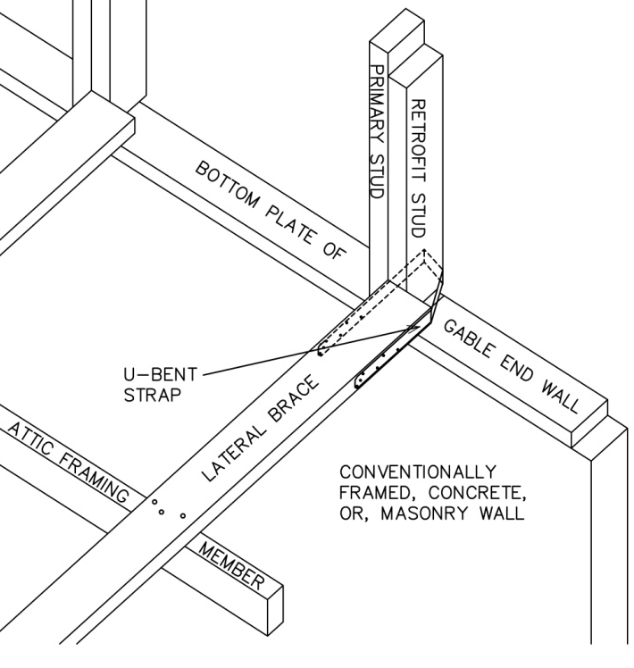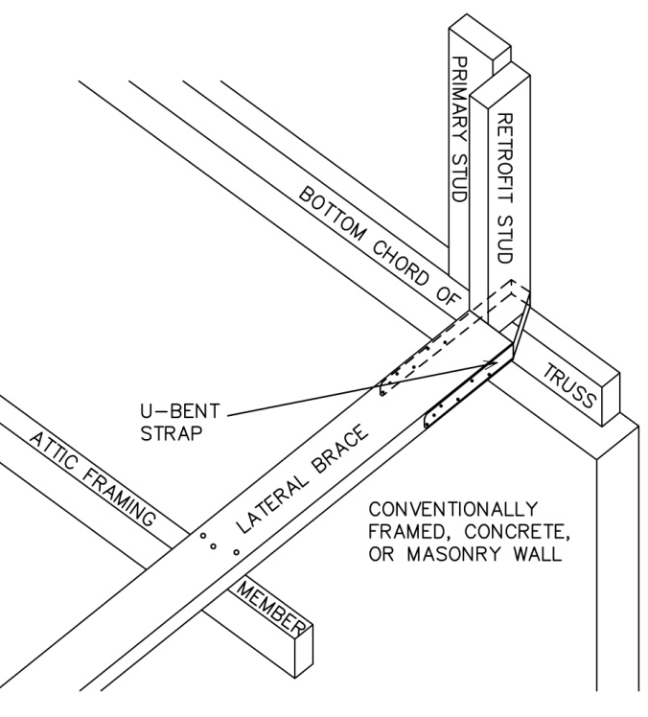
Conventionally framed gable end wall Truss framed gable end wall
Views are from within the attic.
FIGURE 1708.1.2(1)
U-BENT STRAP METHOD FOR CONFIGURATIONS A, B, AND C

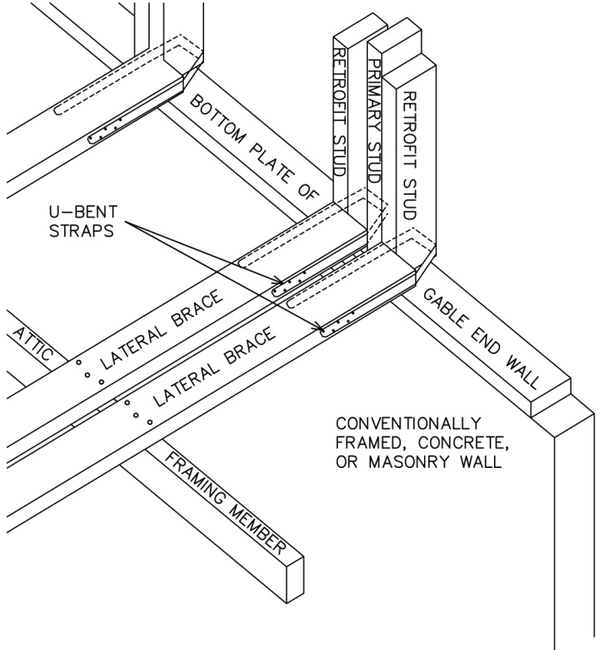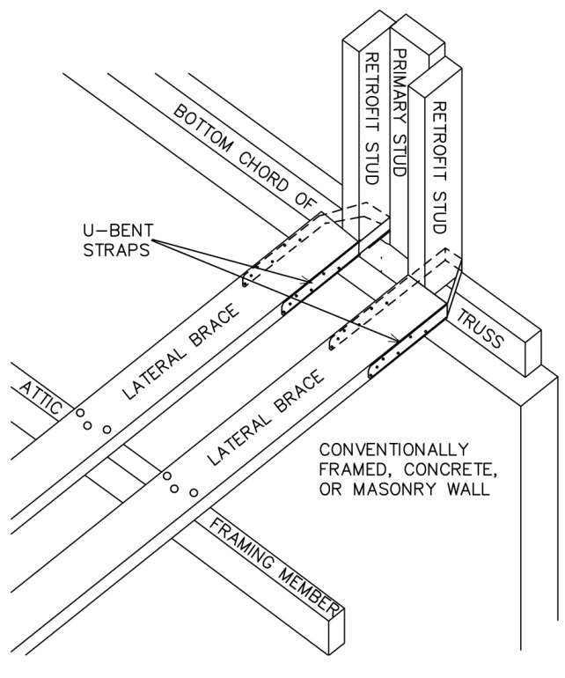
Conventionally framed gable end wall Truss framed gable end wall

FIGURE 1708.1.2(2)
U-BENT STRAP METHOD FOR CONFIGURATION D

SECTION 1709
CONNECTIONS TO WALL BELOW

1709.1 Requirements. Along gable ends where primary studs are longer than 3 feet, gable end walls shall be connected to the wall below using the methods prescribed in Section 1709.1.

1709.1.1 Truss gable end wall. Truss gable end walls shall be attached to the wall below using gusset angle brackets fastened to the bottom chord of roof trusses and to the wall below and spaced in accordance with Table 1704.1. Fasteners shall be placed a minimum of 5/8 inch from edges of lumber. Fasteners shall be permitted to penetrate truss plates. Four fasteners shall be effectively installed through each leg of gusset angles.
Exception: Where existing conditions prevent effective installation of all four fasteners into each leg of a gusset angle bracket, a supplementary gusset angle bracket shall be installed a minimum of 2 ¾ inches from and a maximum of 8 inches from the one without the four fasteners in each leg. The number of effectively installed fasteners securing the corresponding leg of the supplementary gusset angle bracket shall at least equal the number not effectively installed on the first gusset angle bracket.

1709.1.1.1 Wood Frame Wall Below. Where the wall below a gable end is a wood frame wall, a gusset angle bracket specified by the manufacturer for lumber-to-lumber applications shall be installed using fasteners of the same type supplied / specified by the manufacturer. Fasteners installed in top plates shall extend through the full depth of the lowest top plate.
1709.1.1.2 Concrete or Masonry Wall Below. Where the wall below a gable end wall is a concrete or masonry wall, connections shall be by one of the following methods.

  - Where the wall below does not have a sill plate on top of the bond beam, a gusset angle bracket specified by the manufacturer for lumber-to-concrete or lumber-to-masonry applications shall be installed directly to the concrete or masonry of the wall below and to the bottom chord of the truss.

  - Where there is a sill plate of any thickness on top of the bond, beam a gusset angle bracket specified by the manufacturer for lumber-to-concrete or lumber-to-masonry applications shall be installed on the sill plate with fasteners passing vertically through the gusset angle bracket and sill plate and connecting directly into the concrete or masonry wall below. Fasteners of the same diameter and style supplied / specified by the gusset manufacturer shall be installed that have sufficient length to penetrate the sill plate and embed into the concrete or masonry to the same depth provided by the fasteners supplied / specified by the gusset angle bracket manufacturer for installation directly into concrete.

  - Where there is a sill plate on top of the bond beam that is a minimum 1 ½ inches thick, a gusset angle bracket specified by the manufacturer for lumber-to-lumber applications shall be fastened to the sill plate. Gusset angle brackets shall be fastened to the sill plate using 4 each 1 ½ inch long fasteners of the same type supplied / specified by the gusset angle manufacturer for wood connections. Regardless of how well the sill plate may be attached to the wall, it shall be anchored to the wall below on each side of the gusset angle bracket using concrete screws of the same type and size and number as those supplied / specified by the gusset manufacturer for concrete or masonry connections. They shall be embedded into the concrete or masonry to the same depth intended for the fasteners supplied / specified by the manufacturer of gusset angles installed in concrete. Washers of minimum 3/8 inch diameter shall be placed under heads of those fasteners. Fasteners shall be placed a minimum of 2 ¾ inches and a maximum of 8 inches from the required gusset angle bracket.

1709.1.2 Platform framed gable end wall. Conventionally framed gable end walls shall be attached to the wall below in accordance with one of the following methods.

1709.1.2.1 Stud connections. The bottom end of each primary stud of gable end walls shall be connected to bottom members using one of the following methods.
- Where a sill plate for the gable end wall exists, the bottom end of each primary stud shall be connected to the sill plate using a stud-to-plate metal connector with minimum uplift capacity of 175 pounds.

- Where a wood frame gable end wall has a ceiling joist as the lowest outer member of the gable end wall, the primary studs shall be connected to the joist using a stud-to-plate metal connector with minimum uplift capacity of 175 pounds positioned on the wide face of the joist near the top of the joist so that it extends up the stud where the stud is full width.

1709.1.2.2 Wall connections. The gable end walls shall be connected to the wall below using one of the following methods.
1. Where there is a wood frame wall below a gable end wall and where the gable end wall above has a sill or bottom plate atop the plates of the wall below, the sill of the gable end wall shall be connected to the top plates of the wall below using minimum 5/8 inch diameter lag bolt of sufficient length to penetrate through the lower top plate of the wall below. Lag bolts shall be placed minimum 1-5/8 inches from edges of lumber. The lag bolts shall be installed at the spacing indicated in Table 1704.1. using wood screw fasteners with minimum shear Z perpendicular of 150 pounds (667 N) for 1-1/2” side member. [1]Threads of screws shall substantially engage the lower top plate. [2]Screws shall be placed minimum of 1-3/4 inches from the edges of lumber and minimum of 2-3/8 inches [3]from the ends of lumber. [4] The screws shall be installed at the spacing indicated in Table 1704.1. [5] [6]
2. Where a wood frame gable end wall has a ceiling joist as the lowest outer member of the gable end wall, that joist shall be connected to the wall below using the method Section 1709.1.1(1) or 1709.1.1 except read `ceiling joist’ for `bottom chord of roof truss’.
3. Where the wall below a gable end wall is a concrete or masonry wall, the sill or bottom plate of the gable end wall shall be connected to the wall below using ¼ inch diameter concrete or masonry screws of the same type used for gusset angles and of sufficient length to provide a minimum embedment of 1-1/2” into the concrete of the wall or a minimum 2-3/4 inches into the masonry of the wall. A washer sized for the diameter of the lag bolt or wood screw shall be placed under the head of each lag bolt. The fasteners shall be installed at the spacing indicated in Table 1704.1. (S5888 AM A2)

1709.1.3 Balloon framed gable end wall. The retrofits presented in this chapter are specifically intended for platform framed gable end walls. (S5888 AM)

APPENDIX B

STANDARD FOR REHABILITATION

THE SECRETARY OF THE INTERIOR'S STANDARDS FOR REHABILITATION AND GUIDELINES FOR REHABILITATING HISTORIC BUILDINGS

U.S. Department of the Interior National Park Service Preservation Assistance Division Washington, D.C.

For sale by the U.S. Government Printing Office
Superintendent of Documents, Mail Stop: SSOP, Washington, DC 20402-3329

For additional information about historic building rehabilitation and Florida’s state historic preservation program, please contact the Department of State’s Bureau of Historic Preservation.

Bureau of Historic Preservation
R.A. Gray Building
500 South Bronough Street
Tallahassee, Florida 32399-0250
Telephone: (850) 245-6333
FAX: (850) 245-6437

INTRODUCTION

The Secretary of the Interior is responsible for establishing standards for all programs under Departmental authority and for advising Federal agencies on the preservation of historic properties listed or eligible for listing in the National Register of Historic Places. In partial fulfillment of this responsibility, the Secretary of the Interior’s Standards for Historic Preservation Projects have been developed to guide work undertaken on historic buildings – there are separate standards for acquisition, protection, stabilization, preservation, rehabilitation, restoration, and reconstruction. The Standards for Rehabilitation (codified in 36 CRF 67) comprise that section of the overall preservation project standards and addresses the most prevalent treatment. “Rehabilitation” is defined as “the process of returning a property to a state of utility, through repair or alteration, which makes possible an efficient contemporary use while preserving those portions and features of the property which are significant to its historic, architectural, and cultural values.”

Initially developed by the Secretary of the Interior to determine the appropriateness of proposed project work on registered properties within the Historic Preservation Fund grant-in-aid program, the Standards for Rehabilitation have been widely used over the years – particularly to determine if a rehabilitation qualifies as a certified Rehabilitation for Federal tax purposes. In addition, the Standards have guided Federal agencies in carrying out their historic preservation, responsibilities for properties in Federal ownership or control; and State and local officials in reviewing both Federal and nonfederal rehabilitation proposals. They have also been adopted by historic district and planning commissions across the country.

The intent of the Standards is to assist the long-term preservation of a property’s significance through the preservation of historic materials and features. The Standards pertain to historic buildings of all materials, construction types, sizes, and occupancy and encompass the exterior and interior of the buildings. They also encompass related landscape features and the building’s site and environment, as well as attached, adjacent, or related new construction. To be certified for Federal tax purposes, a rehabilitation project must be determined by the Secretary to be consistent with the historic character of the structure(s), and where applicable, the district in which it is located.

THE SECRETARY OF THE INTERIOR’S STANDARDS FOR REHABILITATION

The following Standards are to be applied to specific rehabilitation projects in a reasonable manner, taking into consideration economic and technical feasibility
(1) A property shall be used for its historic purpose or be placed in a new use that requires minimal change to the defining characteristics of the building and its site and environment.

(2) The historic character of a property shall be retained and preserved. The removal of historic materials or alteration of features and spaces that characterize a property shall be avoided.

(3) Each property shall be recognized as a physical record of its time, place, and use. Changes that create a false sense of historical development, such as adding conjectural features or architectural elements from other buildings, shall not be undertaken.

(4) Most properties change over time; those changes that have acquired historic significance in their own right shall be retained and preserved.

(5) Distinctive features, finishes, and construction techniques or examples of craftsmanship that characterize a historic property shall be preserved.

(6) Deteriorated historic features shall be repaired rather than replaced. Where the severity of deterioration requires re- placement of a distinctive feature, the new feature shall match the old in design, color, texture, and other visual qualities and, where possible, materials. Replacement of missing features shall be substantiated by documentary, physical, or pictorial evidence.

(7) Chemical or physical treatments, such as sandblasting, that cause damage to historic materials shall not be used. The surface cleaning of structures, if appropriate, shall be undertaken using the gentlest means possible.

(8) Significant archaeological resources affected by a project shall be protected and preserved. If such resources must be disturbed, mitigation measures shall be under taken.

(9) New additions, exterior alterations, or related new construction shall not destroy historic materials that characterize the property. The new work shall be differentiated from the old and shall be compatible with the massing, size, scale, and architectural features to protect the historic integrity of the property and its environment.

(10) New additions and adjacent or related new construction shall be undertaken in such a manner that if removed in the future, the essential form and integrity of the historic property and its environment would be unimpaired.

As stated in the definition, the treatment “rehabilitation” assumes that at least some repair or alteration of the historic building will be needed in order to provide for an efficient contemporary use; however, these repairs and alterations must not damage or destroy materials, features or finishes that are important in defining the building’s historic character. For example, certain treatments – if improperly applied – may cause accelerated physical deterioration of historic buildings. This can include using improper repointing or exterior masonry cleaning techniques, or introducing insulation that damages historic fabric. In almost all of these situations, use of these materials and treatments will result in a project that does not meet the Standards. Similarly, exterior additions that duplicate the form, material, and detailing of the structure to the extent that they compromise the historic character of the structure will fail to meet the standards.

Technical Guidance Publications

The National Park Service, U.S. Department of the Interior, conducts a variety of activities to guide Federal agencies, States, and the general public in historic preservation project work. In addition to establishing standards and guidelines, the Service develops, publishes, and distributes technical information on appropriate preservation treatments, including Preservation Briefs, case studies, and Preservation Tech Notes.

A Catalog of Historic Publications with stock numbers, prices, and ordering information may be obtained by writing: Preservation Assistance Division, Technical Preservation Services, P.O. Box 37127, Washington, DC 20013-7127.

GUIDELINES FOR REHABILITATING HISTORIC BUILDINGS

The Guidelines were initially developed in 1977 to help property owners, developers, and Federal managers apply the Secretary of the Interior’s “Standards for Rehabilitation” during the project planning stage by providing general design and technical recommendations. Unlike the Standards, the guidelines are not codified as program requirements. Together with the “Standards for Rehabilitation” they provide a model process for owners, developers, and Federal agency managers to follow.

It should be noted at the outset that the Guidelines are intended to assist in applying the Standards to projects generally; consequently, they are not meant to give case-specific advice or address exceptions or rare instances. For example, they cannot tell an owner or developer which features of their own historic building are important in defining the historic character and must be preserved – although examples are provided in each section – or which features could be altered, if necessary, for the new use. This kind of careful case-by-case decision making is best accomplished by seeking assistance from qualified historic preservation professionals in the planning stage of the project. Such professionals include architects, architectural historians, historians, archaeologists, and others who are skilled in the preservation, rehabilitation, and restoration of historic properties.

The Guidelines pertain to historic buildings of all sizes, materials; occupancy, and construction types; and apply to interior and exterior work as well as new exterior additions. Those approaches, treatments, and techniques that are consistent with the Secretary of the Interior’s “Standards for Rehabilitation” are listed in the “Recommended” column on the left; those approaches, treatments, and techniques which could adversely affect a building’s historic character are listed in the “Not Recommended” column on the right.

To provide clear and consistent guidance for owners, developers, and federal agency managers to follow, the “Recommended” courses of action in each section are listed in order of historic preservation concerns so that a rehabilitation project may be successfully planned and complete – one that, first, assures the preservation of a building’s important or “character-defining” architectural materials and features and, second, makes possible an efficient contemporary use. Rehabilitation guidance in each section begins with protection and maintenance, that work which should be maximized in every project to enhance overall preservation goals. Next, where some deterioration is present, repair of the building’s historic materials and features is recommended. Finally, when deterioration is so extensive that repair is not possible, the most problematic area of work is considered: replacement of historic materials and features with new materials.

To further guide the owner and developer in planning a successful rehabilitation project, those complex design issues dealing with new use requirements such as alterations and additions are highlighted at the end of each section to underscore the need for particular sensitivity in these areas.

Identify, Retain, and Preserve

The guidance that is basic to the treatment of all historic buildings – identifying, retaining, and preserving the form and detailing of those architectural materials and features that are important in defining the historic character – is always listed first in the “Recommended” column. The parallel “Not Recommended” column lists the types of actions that are most apt to cause the diminution or even loss of the building’s historic character. It should be remembered, however, that such loss of character is just as often caused by the cumulative effect of a series of actions that would seem to be minor interventions. Thus, the guidance in all of the “Not Recommended” columns must be viewed in that larger context, e.g., for the total impact on a historic building.

Protect and Maintain

After identifying those materials and features that are important and must be retained in the process of rehabilitation work, then protecting and maintaining them are addressed. Protection generally involves the least degree of intervention and is preparatory to other work. For example, protection includes the maintenance of historic material through treatments such as rust removal, caulking, limited paint removal, and re-application of protective coatings; the cyclical cleaning of roof gutter systems; or installation of fencing, protective plywood, alarm systems and other temporary protective measures. Although a historic building will usually require more extensive work, an overall evaluation of its physical condition should always begin at this level.

Repair

Next, when the physical condition of character-defining materials and features warrants additional work repairing is recommended. Guidance for the repair of historic materials such as masonry, wood, and architectural metals again begins with the least degree of intervention possible such as patching, piecing-in, splicing, consolidating, or otherwise reinforcing or upgrading them according to recognized preservation methods. Repairing also includes the limited replacement in kind – or with compatible substitute material – of extensively deteriorated or missing parts of features when there are surviving prototypes (for example, brackets, dentils, steps, plaster, or portions of slate or tile roofing). Although using the same kind of material is always the preferred option, substitute material is acceptable if the form and design as well as the substitute material itself convey the visual appearance of the remaining parts of the feature and finish.

Replace

Following repair in the hierarchy, guidance is provided for replacing an entire character-defining feature with new material because the level of deterioration or damage of materials precludes repair (for example, an exterior cornice; an interior staircase; or a complete porch or storefront). If the essential form and detailing are still evident so that the physical evidence can be used to re-establish the feature as an integral part of the rehabilitation project, then its replacement is appropriate. Like the guidance for repair, the preferred option is always replacement of the entire feature in kind, that is, with the same material. Because this approach may not always be technically or economically feasible, provisions are made to consider the use of a compatible substitute material.

It should be noted that, while the National Park Service guidelines recommend the replacement of an entire character defining feature under certain well-defined circumstances, they never recommend removal and replacement with new material of a feature that – although damaged or deteriorated – could reasonably be repaired and thus preserved.

Design for Missing Historic Features

When an entire interior or exterior feature is missing (for example, an entrance, or cast iron facade; or a principal staircase), it no longer plays a role in physically defining the historic character of the building unless it can be accurately recovered in form and detailing through the process of carefully documenting the historical appearance. Where an important architectural feature is missing, its recovery is always recommended in the guidelines as the first or preferred, course of action. Thus, if adequate historical, pictorial, and physical documentation exists so that the feature may be accurately reproduced, and if it is desirable to re-establish the feature as part of the building’s historical appearance, then designing and constructing a new feature based on such information is appropriate. However, a second acceptable option for the replacement feature is a new design that is compatible with the remaining character-defining features of the historic building. The new design should always take into account the size, scale, and materials of the historic building itself and, most importantly, should be clearly differentiated so that a false historical appearance is not created.

Alterations/Additions to Historic Buildings

Some exterior and interior alterations to the historic building are generally needed to assure its continued use, but it is most important that such alterations do not radically change, obscure, or destroy character-defining spaces, materials, features, or finishes. Alterations may include providing additional parking space on an existing historic building site; cutting new entrances or windows on secondary elevations; inserting an additional floor; installing an entirely new mechanical system; or creating an atrium or light well. Alteration may also include the selective removal of buildings or other features of the environment or building site that are intrusive and therefore detract from the overall historic character.

The construction of an exterior addition to a historic building may seem to be essential for the new use, but it is emphasized in the guidelines that such new additions should be avoided, if possible, and considered only after it is determined that those needs cannot be met by altering secondary, i.e., non character-defining interior spaces. If, after a thorough evaluation of interior solutions, an exterior addition is still judged to be the only viable alternative, it should be designed and constructed to be clearly differentiated from the historic building and so that the character-defining features are not radically changed, obscured, damaged, or destroyed.

Additions to historic buildings are referenced within specific sections of the guidelines such as Site, Roof, Structural Systems, etc., but are also considered in more detail in a separate section, NEW ADDITIONS TO HISTORIC BUILDINGS.

Health and Safety Code Requirements; Energy Retrofitting

These sections of the rehabilitation guidance address work done to meet health and safety code requirements (for example, providing barrier-free access to historic buildings); or retrofitting measures to conserve energy (for example, installing solar collectors in an unobtrusive location on the site). Although this work is quite often an important aspect of rehabilitation projects, it is usually not part of the overall process of protecting or repairing character-defining features; rather, such work is assessed for its potential negative impact on the building’s historic character. For this reason, particular care must be taken not to radically change, obscure, damage, or destroy character-defining materials or features in the process of rehabilitation work to meet code and energy requirements.

BUILDING EXTERIOR

Masonry: Brick, stone, terra cotta, concrete, adobe, stucco and mortar
Masonry features (such as brick cornices and door pediments, stone window architraves, terra cotta brackets and railings) as well as masonry surfaces (modeling, tooling, bonding patterns, joint size, and color) may be important in defining the historic character of the building. It should be noted that while masonry is among the most durable of historic building materials, it is also the most susceptible to damage by improper maintenance or repair techniques and by harsh or abrasive cleaning methods. Most preservation guidance on masonry thus focuses on such concerns as cleaning and the process of repointing.

Recommended

Identifying, retaining, and preserving masonry features that are important in defining the overall historic character of the building such as walls, brackets, railings, cornices, window architraves, door pediments, steps, and columns; and joint and unit size, tooling and bonding patterns, coatings, and color.

Protecting and maintaining masonry by providing proper drainage so that water does not stand on flat, horizontal surfaces or accumulate curved decorative features.

Cleaning masonry only when necessary to halt deterioration or remove heavy soiling.

Carrying out masonry surface cleaning tests after it has been determined that such cleaning is necessary. Tests should be observed over a sufficient period of time so that both the immediate effects and the long range effects are known to enable selection of the gentlest method possible.

Cleaning masonry surfaces with the gentlest method possible such as low pressure water and detergents, using natural bristle brushes.
Not Recommended

Removing or radically changing masonry features which are important in defining the overall historic character of the building so that, as a result, the character is diminished.

Replacing or rebuilding a major portion of exterior masonry walls that could be repaired so that, as a result, the building is no longer historic and is essentially new construction.

Applying paint or other coatings such as stucco to masonry that has been historically unpainted or uncoated to create a new appearance.

Removing paint from historically painted masonry. Radically changing the type of paint or coating or its color.

Failing to evaluate and treat the various causes of mortar joint deterioration such as leaking roofs or gutters, differential settlement of the building, capillary action, or extreme weather exposure.

Cleaning masonry surfaces when they are not heavily soiled to create a new appearance, thus needlessly introducing chemicals or moisture into historic materials.

Cleaning masonry surfaces without testing or without sufficient time for the testing results to be of value.

Sandblasting brick or stone surfaces using dry or wet grit or other abrasives. These methods of cleaning permanently erode the surface of the material and accelerate deterioration.

Using a cleaning method that involves water or liquid chemical solutions when there is any possibility of freezing temperatures.

Cleaning with chemical products that will damage masonry, such as using acid on limestone or marble, or leaving chemicals on masonry surfaces.

Applying high pressure water cleaning methods that will damage historic masonry and the mortar joints.

Recommended

Inspecting painted masonry surfaces to determine whether repainting is necessary.

Removing damaged or deteriorated paint only to the next sound layer using the gentlest method possible (e.g., handscraping) prior to repainting.

Applying compatible paint coating systems following proper surface preparation.

Repainting with colors that are historically appropriate to the building and district.

Evaluating the overall condition of the masonry to determine whether more than protection and maintenance are required, that is, if repairs to the masonry features will be necessary.

Repairing masonry walls and other masonry features by repointing the mortar joints where there is evidence deterioration such as disintegrating mortar, cracks in mortar joints, loose bricks, damp walls, or damaged plasterwork.

Removing deteriorated mortar by carefully hand-raking the joints to avoid damaging the masonry.

Duplicating old mortar in strength, composition, color, and texture.

Duplicating old mortar joints in width and in joint profile.

Repairing stucco by removing the damaged material and patching with new stucco that duplicates the old strength, composition, color, and texture.

Using mud plaster as a surface coating over unfired, unstabilized adobe because the mud plaster will bond to the adobe.
Not Recommended

Removing paint that is firmly adhering to, and thus protecting, masonry surfaces.

Using methods of removing paint which are destructive to masonry, such as sandblasting, application of caustic solutions, or high pressure waterblasting.

Failing to follow manufacturers’ product and application instructions when repainting masonry.

Using new paint colors that are inappropriate to the historic building and district.

Failing to undertake adequate measures to assure the preservation of masonry features.

Removing nondeteriorated mortar from sound joints, then repointing the entire building to achieve a uniform appearance.

Using electric saws and hammers rather than hand tools remove deteriorated mortar from joints prior to repointing.

Repointing with mortar of high portland cement content (unless it is the content of the historic mortar). This can often create a bond that is stronger than the historic material and can cause damage as a result of the differing coefficient of expansion and the differing porosity of the material and the mortar.

Repointing with a synthetic caulking compound.

Using a “scrub” coating technique to repoint instead of traditional repointing methods.
Changing the width or joint profile when repointing. Removing sound stucco; or repairing with new stucco that is
stronger than the historic material or does not convey the
same visual appearance.

Applying cement stucco to unfired, unstabilized adobe. Because the cement stucco will not bond properly, moisture can become entrapped between materials, resulting in accelerated deterioration of the adobe.

Recommended

Repairing masonry features by patching, piecing-in, or consolidating the masonry using recognized preservation methods. Repair may also include the limited replacement in kind – or with compatible substitute material – of those extensively deteriorated or missing parts of masonry features when there are surviving prototypes such as terracotta brackets or stone balusters.

Applying new or non-historic surface treatments such as water-repellent coatings to masonry only after repointing and only if masonry repairs have failed to arrest water penetration problems.

Replacing in kind an entire masonry feature that is too deteriorated to repair – if the overall form and detailing are still evident – using the physical evidence to guide the new work. Examples can include large sections of a wall, a cornice, balustrade, column or stairway. If using the same kind of material is not technically or economically feasible, then a compatible substitute material may be considered.
Not Recommended

Replacing an entire masonry feature such as a cornice or balustrade when repair of the masonry and limited replacement of deteriorated or missing parts are appropriate.

Using a substitute material for the replacement part that does not convey the visual appearance of the surviving parts of the masonry feature or that is physically or chemically incompatible.

Applying waterproof, water-repellent, or non-historic coatings such as stucco to masonry as a substitute for repointing and masonry repairs. Coatings are frequently unnecessary, expensive, and may change the appearance of historic masonry as well as accelerate its deterioration.

Removing a masonry feature that is unrepairable and not replacing it; or replacing it with a new feature that does not convey the same visual appearance.

The following work is highlighted to indicate that it represents the particularly complex technical or design aspects of rehabilitation projects and should only be considered after the preservation concerns listed above have been addressed.

Design for Missing Historic Features

Designing and installing a new masonry feature such as steps or a door pediment when the historic feature is completely missing. It may be an accurate restoration using historical, pictorial, and physical documentation; or be a new design that is compatible with the size, scale, material, and color of the historic building.
Creating a false historical appearance because the replaced masonry feature is based on insufficient historical, pictorial, and physical documentation.

Introducing a new masonry feature that is incompatible in size, scale, material and color.

Wood: Clapboard, weather-board, shingles and other wooden siding and decorative elements
Because it can be easily shaped by sawing, planing, carving, and gouging, wood is the most commonly used material for architectural features such as clapboards, cornices, brackets, entablatures, shutters, columns and balustrades. These wooden features – both functional and decorative – may be important in defining the historic character of the building and thus their retention, protection, and repair are of particular importance in rehabilitation projects.

Recommended

Identifying, retaining and preserving wood features that are important in defining the overall historic character of the building such as siding, cornices, brackets, window architraves, and doorway pediments; and their paints, finishes, and colors.

Protecting and maintaining wood features by providing proper drainage so that water is not in decorative features.

Applying chemical preservatives to wood features such as beam ends or outriggers that are exposed to decay hazards and are traditionally unpainted.

Retaining coatings such as paint that help protect the wood from moisture and ultraviolet light. Paint removal should be considered only where there is paint surface deterioration and as part of an overall maintenance program which involves repainting or applying other appropriate protective coatings.

Inspecting painted wood surfaces to determine whether repainting is necessary or if cleaning is all that is required.

Removing damaged or deteriorated paint to the next sound layer using the gentlest method possible (hand-scraping and handsanding), then repainting.
Not Recommended

Removing or radically changing wood features which are important in defining the overall historic character of the building so that, as a result, the character is diminished.

Removing a major portion of the historic wood from a facade instead of repairing or replacing only the deteriorated wood, then reconstructing the facade with new material in order to achieve a uniform or “improved” appearance.

Radically changing the type of finish or its color or accent scheme so that the historic character of the exterior is diminished.

Stripping historically painted surfaces to bare wood, then applying clear finishes or stains in order to create a “natural look.”

Stripping paint or varnish to bare wood rather than repairing or reapplying a special finish, i.e., a grained finish to an exterior wood feature such as a front door.

Failing to identify, evaluate, and treat the causes of wood deterioration, including faulty flashing, leaking gutters, cracks and holes in siding, deteriorated caulking in joints and seams, plant material growing too close to wood surfaces, or insect or fungus infestation.

Using chemical preservatives such as creosote which can change the appearance of wood features unless they were used historically.

Stripping paint or other coatings to reveal bare wood, thus exposing historically coated surfaces to the effects of accelerated weathering.

Removing paint that is firmly adhering to, and thus, protecting wood surfaces.

Using destructive paint removal methods such as propane or butane torches, sandblasting or waterblasting. These methods can irreversibly damage historic woodwork.

Recommended

Using with care electric hot-air guns or decorative wood features and electric heat plates on flat wood surfaces when paint is so deteriorated that total removal is necessary prior to repainting.

Using chemical strippers primarily to supplement other methods such as handscraping, handsanding and the above-recommended thermal devices. Detachable wooden elements such as shutters, doors, and columns may – with the proper safeguards – be chemically dip-stripped.

Applying compatible paint coating systems following proper surface preparation.

Repainting with colors that are appropriate to the historic building and district.

Evaluating the overall condition of the wood to determine whether more than protection and maintenance are required, that is, if repairs to wood features will be necessary.

Repairing wood features by patching, piecing in, consolidating, or otherwise reinforcing the wood using recognized preservation methods. Repair may also include the limited replacement in kind – or with compatible substitute material – of those extensively deteriorated or missing parts of features where there are surviving prototypes such as brackets, moldings, or sections of siding.

Replacing in kind an entire wood feature that is too deteriorated to repair – if the overall form and detailing are still evident – using the physical evidence to guide the new work. Examples of wood features include a cornice, entablature or balustrade. If using the same kind of material is not technically or economically feasible, then a compatible substitute material may be considered.
Not Recommended

Using thermal devices improperly so that the historic woodwork is scorched.

Failing to neutralize the wood thoroughly after using chemicals so that new paint does not adhere.

Allowing detachable wood features to soak too long in a caustic solution so that the wood grain is raised and the surface roughened.

Failing to follow manufacturers’ product and application instructions when repainting exterior woodwork.

Using new colors that are inappropriate to the historic building or district.

Failing to undertake adequate measures to assure the preservation of wood features.

Replacing an entire wood feature such as a cornice or wall when repair of the wood and limited replacement of deteriorated or missing parts are appropriate.

Using substitute materials for the replacement part that does not convey the visual appearance of the surviving parts of the wood feature or that is physically or chemically incompatible.

Removing an entire wood feature that is unrepairable and not replacing it; or replacing it with a new feature that does not convey the same visual appearance.

The following work is highlighted to indicate that it represents the particularly complex technical or design aspects of rehabilitation projects and should only be considered after the preservation concerns listed above have been addressed.

Design for the Replacement of Missing Historic
Features

Designing and installing a new wood feature such as a cornice of doorway when the historic feature is completely missing. It may be an accurate restoration using historical, pictorial, and physical documentation; or be a new design that is compatible with the size, scale, material, and color of the historic building.
Creating a false historic appearance because the replaced wood feature is based on insufficient historical, pictorial, and physical documentation.

Introducing a new wood feature that is incompatible in size, scale, material, and color.

Architectural Metals:
Cast iron, steel, pressed tin, copper, aluminum, and zinc
Architectural metal features – such as cast-iron facades, porches, and steps; sheet metal cornices, roofs, roof cresting and storefronts; and cast or rolled metal doors, window sash, entablatures, and hardware – are often highly decorative and may be important in defining the overall historic character of the building. Their retention, protection, and repair should be a prime consideration in rehabilitation projects.

Recommended

Identifying, retaining, and preserving architectural metal features such as columns, capitals, window hoods, or stairways that are important in defining the overall historic character of the building; and their finishes and colors.

Protecting and maintaining architectural metals from corrosion by providing proper drainage so that water does not stand on flat, horizontal surfaces or accumulate in curved, decorative features.

Cleaning architectural metals, when necessary, to remove corrosion prior to repainting or applying other appropriate protective coatings.

Identifying the particular type of metal prior to any cleaning procedure and then testing to assure that the gentlest cleaning method possible is selected or determining that cleaning is inappropriate for the particular metal.

Cleaning soft metals such as lead, tin, copper, terneplate, and zinc with appropriate chemical methods because their finishes can be easily abraded by blasting methods.

Using the gentlest cleaning methods for cast iron, wrought iron, and steel–hard metals–in order to remove paint buildup and corrosion. If handscraping and wire brushing have proven ineffective, low pressure dry grit blasting may be used as long as it does not abrade or damage the surface.

Applying appropriate paint or other coating systems after cleaning in order to decrease the corrosion rate of metals or alloys.
Not Recommended

Removing or radically changing architectural metal features which are important in defining the overall historic character of the building so that, as a result, the character is diminished.

Removing a major portion of the historic architectural metal from a facade instead of repairing or replacing only the deteriorated metal, then reconstructing the facade with new material in order to create a uniform, or “improved” appearance.

Radically changing the type of finish or its historical color or accent scheme.

Failing to identify, evaluate, and treat the causes of corrosion, such as moisture from leaking roofs or gutters.

Placing incompatible metals together without providing a reliable separation material. Such incompatibility can result in galvanic corrosion of the less noble metal, e.g., copper will corrode cast iron, steel, tin, and aluminum.

Exposing metals which were intended to be protected from the environment.

Applying paint or other coatings to metals such as copper, bronze, or stainless steel that were meant to be exposed.

Using cleaning methods which alter or damage the historic color, texture, and finish of the metal; or cleaning when it is inappropriate for the metal.

Removing the patina of historic metal. The patina may be a protective coating on some metals, such as bronze or copper, as well as a significant historic finish.

Cleaning soft metals such as lead, tin, copper, terneplate, and zinc with grit blasting which will abrade the surface of the metal.

Failing to employ gentler methods prior to abrasively cleaning cast iron, wrought iron or steel; or using high pressure grit blasting.

Failing to re-apply protective coating systems to metals or alloys that require them after cleaning so that accelerated corrosion occurs.

Recommended

Repainting with colors that are appropriate to the historic building or district.

Applying an appropriate protective coating such as lacquer to an architectural metal feature such as a bronze door which is subject to heavy pedestrian use.

Evaluating the overall condition of the architectural metals to determine whether more than protection and maintenance are required, that is, if repairs to features will be necessary.

Repairing architectural metal features by patching, splicing, or otherwise reinforcing the metal following recognized preservation methods. Repairs may also include the limited replacement in kind – or with a compatible substitute material – of those extensively deteriorated or missing parts of features when there are surviving prototypes such as porch balusters, column capitals or bases; or porch cresting.

Replacing in kind an entire architectural metal feature that is too deteriorated to repair – if the overall form and detailing are still evident – using the physical evidence to guide the new work. Examples could include cast iron porch steps or steel sash windows. If using the same kind of material is not technically or economically feasible, then a compatible substitute material may be considered.
Not Recommended

Using new colors that are inappropriate to the historic building or district.

Failing to assess pedestrian use or new access patterns so that architectural metal features are subject to damage by use or inappropriate maintenance such as salting adjacent sidewalks.

Failing to undertake adequate measures to assure the preservation of architectural metal features.

Replacing an entire architectural metal feature such as a column or a balustrade when repair of the metal and limited replacement of deteriorated or missing parts are appropriate.

Using a substitute material for the replacement part that does not convey the visual appearance of the surviving parts of the architectural metal feature or that is physically or chemically incompatible.

Removing an architectural metal feature that is unrepairable and not replacing it, or replacing it with a new architectural metal feature that does not convey same visual appearance

The following work is highlighted to indicate that it represents the particularly complex technical or design aspects of rehabilitation projects and should only be considered after the preservation concerns listed above have been addressed.

Design for the Replacement of Missing Historic
Features

Designing and installing a new architectural metal feature such as a sheet metal cornice or cast iron capital when the historic feature is completely missing. It may be an accurate restoration using historical, pictorial and physical documentation; or a new design that is compatible with the size, scale, material, and color of the historic building.
Creating a false historic appearance because the replaced architectural metal feature is based on insufficient historical, pictorial, and physical documentation.

Introducing a new architectural metal feature that is incompatible in size, scale, material, and color.

Roofs
The roof – with its shape; features such as cresting, dormers, cupolas, and chimneys; and the size, color, and patterning of the roofing material – can be extremely important in defining the building’s overall historic character. In addition to the design role it plays, a weathertight roof is essential to the preservation of the entire structure; thus, protecting and repairing the roof as a “cover” is a critical aspect of every rehabilitation project.

Recommended

Identifying, retaining, and preserving roofs – and their functional and decorative features – that are important in defining the overall historic character of the building. This includes the roof’s shape, such as hipped, gambrel, and mansard; decorative features such as cupolas, cresting, chimneys, and weathervanes; and roofing material such as slate, wood, clay tile, and metal, as well as its size, color, and patterning.

Protecting and maintaining a roof by cleaning the gutters and downspouts and replacing deteriorated flashing. Roof sheathing should also be checked for proper venting to prevent moisture condensation and water penetration; and to insure that materials are free from insect infestation.

Providing adequate anchorage for roofing material to guard against wind damage and moisture penetration.

Protecting a leaking roof with plywood and building paper until it can be properly repaired.

Repairing a roof by reinforcing the historic materials which comprise roof features. Repairs will also generally include the limited replacement in kind or with compatible substitute material – of those extensively deteriorated or missing parts of features when there are surviving prototypes such as cupola louvers, dentils, dormer roofing, or slates, tiles, or wood shingles on a main roof.

Replacing in kind an entire feature of the roof that is too deteriorated to repair – if the overall form and detailing are still evident – using the physical evidence to guide the new work. Examples can include a large section of roofing, or a dormer or chimney. If using the same kind of material is not technically or economically feasible, then a compatible substitute material may be considered.
Not Recommended

Radically changing, damaging, or destroying roofs which are important in defining the overall historic character of the building so that, as a result, the character is diminished.

Removing a major portion of the roof or roofing material that is repairable, then reconstructing it with new material in order to create a uniform, or “improved” appearance.

Changing the configuration of a roof by adding new features such as dormer windows, vents, or skylights so that the historic character is diminished.

Stripping the roof of sound historic material such as slate, clay tile, wood, and architectural metal.

Applying paint or other coatings to roofing material which has been historically uncoated.

Failing to clean and maintain gutters and downspouts properly so that water and debris collect and cause damage to roof fasteners, sheathing, and the underlying structure.

Allowing roof fasteners, such as nails and clips to corrode so that roofing material is subject to accelerated deterioration.

Permitting a leaking roof to remain unprotected so that accelerated deterioration of historic building materials – masonry, wood, plaster, paint and structural members
– occurs.

Replacing an entire roof feature such as a cupola or dormer when repair of the historic materials and limited replacement of deteriorated or missing parts are appropriate.

Using a substitute material for the replacement part that does not convey the visual appearance of the surviving parts of the roof or that is physically or chemically incompatible.

Removing a feature of the roof that is unrepairable, such as a chimney or dormer, and not replacing it; or replacing it with a new feature that does not convey the same visual appearance.

The following work is highlighted to indicate that it represents the particularly complex technical or design aspects of rehabilitation projects and should only be considered after the preservation concerns listed above have been addressed.

Recommended

Design for the Replacement of Missing Historic
Features

Designing and constructing a new feature when the historic feature is completely missing, such as a chimney or cupola. It may be an accurate restoration using historical, pictorial and physical documentation; or be a new design that is compatible with the size, scale, material, and color of the historic building.

Alterations/Additions for the New Use

Installing mechanical and service equipment on the roof such as air conditioning, transformers, or solar collectors when required for the new use so that they are inconspicuous from the public right-of-way and do not damage or obscure character-defining features.

Designing additions to roofs such as residential, office, or storage spaces; elevator housing; decks and terraces; or dormers or skylights when required by the new use so that they are inconspicuous from the public right-of-way and do not damage or obscure character-defining features.
Not Recommended

Creating a false historical appearance because the replaced feature is based on insufficient historical, pictorial, and physical documentation.

Introducing a new roof feature that is incompatible in size, scale, material, and color.

Installing mechanical or service equipment so that it damages or obscures character-defining features; or is conspicuous from the public right-of-way.

Radically changing a character-defining roof shape or damaging or destroying character-defining roofing material as a result of incompatible design or improper installation techniques.

Windows
A highly decorative window with an unusual shape, or glazing pattern, or color is most likely identified immediately as character-defining feature of the building. It is far more difficult, however, to assess the importance of repeated windows on a facade, particularly if they are individually simple in design and material, such as the large, multipaned sash of many industrial buildings. Because rehabilitation projects frequently include proposals to replace window sash or even entire windows to improve thermal efficiency or to create a new appearance, it is essential that their contribution to the overall historic character of the building be assessed together with their physical condition before specific repair or replacement work is undertaken.

Recommended

Identifying, retaining, and preserving windows – and their functional and decorative features – that are important in defining the overall historic character of the building. Such features can include frames, sash, muntins, glazing, sills, heads, hoodmolds, paneled or decorated jambs and moldings, and interior and exterior shutters and blinds.

Protecting and maintaining the wood and architectural metal which comprise the window frame, sash, muntins, and surrounds through appropriate surface treatments such as cleaning, rust removal, limited paint removal, and reapplication of protective coating systems.

Making windows weathertight by recaulking and replacing or installing weatherstripping. These actions also improve thermal efficiency.

Evaluating the overall condition of materials to determine whether more than protection and maintenance are required, i.e., if repairs to windows and window features will be required.

Repairing window frames and sash by patching, splicing, consolidating or otherwise reinforcing. Such repair may also include replacement in kind of those parts that are either extensively deteriorated or are missing when there are surviving prototypes such as architraves, hoodmolds, sash, sills, and interior or exterior shutters and blinds.
Not Recommended

Removing or radically changing windows which are important in defining the overall historic character of the building so that, as a result, the character is diminished.

Changing the number, location, size or glazing pattern of windows, through cutting new openings, blocking-in windows, and installing replacement sash which does not fit the historic window opening.

Changing the historic appearance of windows through the use of inappropriate designs, materials, finishes, or colors which radically change the sash, depth of reveal, and muntin configuration, the reflectivity and color of the glazing; or the appearance of the frame.
Obscuring historic window trim with metal or other material. Stripping windows of historic material such as wood, iron,
cast iron, and bronze.

Failing to provide adequate protection of materials on a cyclical basis so that deterioration of the windows results.

Retrofitting or replacing windows rather than maintaining the sash, frame, and glazing.

Failing to undertake adequate measures to assure the preservation of historic windows.

Replacing an entire window when repair of materials and limited replacement of deteriorated or missing parts are appropriate.

Failing to reuse serviceable window hardware such as brass lifts and sash locks.

Using a substitute material for the replacement part that does not convey the visual appearance of the surviving part of the window or that is physically or chemically incompatible.

Recommended

Replacing in kind an entire window that is too deteriorated to repair – if the overall form and detailing are still evident – using the physical evidence to guide the new work. If using the same kind of material is not technically or economically feasible, then a compatible substitute material may be considered.
Not Recommended

Removing a character-defining window that is unrepairable and blocking it in; or replacing it with a new window, that does not convey the same visual appearance.

The following work is highlighted to indicate that it represents the particularly complex technical or design aspects of rehabilitation projects and should only be considered after the preservation concerns listed above have been addressed.

Recommended

Design for the Replacement of Missing Historic
Features

Designing and installing new windows when the historic windows (frame, sash and glazing) are completely missing. The replacement windows may be an accurate restoration using historical, pictorial, and physical documentation; or be a new design that is compatible with the window openings and the historic character of the building.

Alterations/Additions for the New Use

Designing and installing additional windows on rear on other non-character-defining elevations if required by the new use. New windows openings may also be cut into exposed party walls. Such design should be compatible with the overall design of the building, but not duplicate the fenestration pattern and detailing of a character defining elevation.

Providing a setback in the design of dropped ceilings when they are required for the new use to allow for the full height of the window openings.
Not Recommended

Creating a false historical appearance because the replaced window is based on insufficient historical, pictorial, and physical documentation.

Introducing a new design that is incompatible with historic character of the building.

Installing new windows, including frames sash, a muntin configuration that are incompatible with the building’s historic appearance or obscure, damage, destroy character-defining features.

Inserting new floors or furred-down ceilings, which cut across the glazed areas of windows so that the exterior form and appearance of the windows are changed.

Entrances and Porches
Entrances and porches are quite often the focus of historic buildings, particularly when they occur on primary elevations. Together with their functional and decorative features such as doors, steps, balustrades, pilasters, and entablatures, they can be extremely important in defining the overall historic character of a building. Their retention, protection, and repair should always be carefully considered when planning rehabilitation work.

Recommended

Identifying, retaining, and preserving entrances – and their functional and decorative features – that are important in defining the overall historic character of the building such as doors, fanlights, sidelights, pilasters, entablatures, columns, balustrades, and stairs.

Protecting and maintaining the masonry, wood, and architectural metal that comprise entrances and porches through appropriate surface treatments such as cleaning, rust removal, limited paint removal, and re-application of protective coating systems.

Evaluating the overall condition of materials to determine whether more than protection and maintenance are required, that is, if repairs to entrance and porch features will be necessary.

Repairing entrances and porches by reinforcing the historic materials. Repair will also generally include the limited replacement in kind – or with compatible substitute material
– of those extensively deteriorated or missing parts of repeated features where there are surviving prototypes such as balustrades, cornices, entablatures, columns, sidelights, and stairs.

Replacing in kind an entire entrance or porch that is too deteriorated to repair – if the form and detailing are still evident – using the physical evidence to guide the new work. If using the same kind of material is not technically or economically feasible, then a compatible substitute material may be considered.
Not Recommended

Removing or radically changing entrances and porches which are important in defining the overall historic character of the building so that, as a result, the character is diminished.

Stripping entrances and porches of historic material such as wood, iron, cast iron, terra cotta, tile and brick.

Removing an entrance or porch because the building has been reoriented to accommodate a new use.

Cutting new entrances on a primary elevation.

Altering utilitarian or service entrances so they appear to be formal entrances by adding paneled doors, fanlights, and sidelights.

Failing to provide adequate protection to materials on a cyclical basis so that deterioration of entrances and porches results.

Failing to undertake adequate measures to assure the preservation of historic entrances and porches.

Replacing an entire entrance or porch when the repair of materials and limited replacement of parts are appropriate.

Using a substitute material for the replacement parts that does not convey the visual appearance of the surviving parts of the entrance and porch or that is physically or chemically incompatible.

Removing an entrance or porch that is unrepairable and not replacing it, or replacing it with a new entrance or porch that does not convey the same visual appearance.

The following work is highlighted to indicate that it represents the particularly complex technical or design aspects of rehabilitation projects and should only be considered after the preservation concerns listed above have been addressed.

Recommended

Design for Missing Historic Features

Designing and constructing a new entrance or porch if the historic entrance or porch is completely missing. It may be a restoration based on historical, pictorial, and physical documentation; or be a new design that is compatible with the historic character of the building.

Alterations/Additions for the New Use

Designing enclosures for historic porches when required by the new use in a manner that preserves the historic character of the building. This can include using large sheets of glass and recessing the enclosure wall behind existing scrollwork, posts, and balustrades.

Designing and installing additional entrances or porches when required for the new use in a manner that preserves the historic character of the building, i.e., limiting such alteration to non-character-defining elevations.
Not Recommended

Creating a false historical appearance because the replaced entrance or porch is based on insufficient historical, pictorial, and physical documentation.

Introducing a new entrance or porch that is incompatible in size, scale, material, and color.

Enclosing porches in a manner that results in a loss of historic character such as using solid materials such as wood, stucco, or masonry.

Installing secondary service entrances and porches are incompatible in size and scale with the historic building or obscure, damage, or destroy character-defining features.

Storefronts
Storefronts are quite often the focus of historic commercial buildings and can thus be extremely important in defining the overall historic character. Because storefronts also play a crucial role in a store’s advertising and merchandising strategy to draw customers and increase business, they are often altered to meet the needs of a new business. Particular care is required in planning and accomplishing work on storefronts so that the building’s historic character is preserved in the process of rehabilitation.

Recommended

Identifying, retaining and preserving storefronts – and their functional and decorative features – that are important in defining the overall historic character of the building such as display windows, signs, doors, transoms, kick plates, corner posts, and entablatures.

Protecting and maintaining masonry, wood, and architectural metals which comprise storefronts through appropriate treatments such as cleaning, rust removal, limited paint removal, and reapplication of protective coating systems.

Protecting storefronts against arson and vandalism before work beings by boarding up windows and installing alarm systems that are keyed into local protection agencies.

Evaluating the overall condition of storefront materials to determine whether more than protection and maintenance are required that is if repairs to features will be necessary.

Repairing storefronts by reinforcing the historic materials. Repairs will also generally include the limited replacement in kind – or with compatible substitute material – of those extensively deteriorated or missing parts of storefronts where there are surviving prototypes such as transoms, kick plates, pilasters, or signs.

Replacing in kind an entire storefront that is too deteriorated to repair – if the overall form and detailing are still evident – using the physical evidence to guide the new work. If using the same material is not technically or economically feasible, then compatible substitute materials may be considered.
Not Recommended

Removing or radically changing storefronts – and their features – which are important in defining the overall historic character of the building so that, as a result, the character is diminished.

Changing the storefront so that it appears residential rather than commercial in character.

Removing historic material from the storefront to create a recessed arcade.

Introducing coach lanterns, mansard overhangings, wood shakes, nonoperable shutters, and small-paned windows if they cannot be documented historically.
Changing the location of a storefront’s main entrance. Failing to provide adequate protection to materials on a
cyclical basis so that deterioration of storefront features
results.

Permitting entry into the building through unsecured or broken windows and doors so that interior features and finishes are damaged through exposure to weather or through vandalism.

Stripping storefronts of historic material such as wood, cast iron, terra cotta, Carrara glass, and brick.

Failing to undertake adequate measures to assure the preservation of the historic storefront.

Replacing an entire storefront when repair of materials and limited replacement of its parts are appropriate.

Using substitute material for the replacement parts that does not convey the same visual appearance as the surviving parts of the storefront or that is physically or chemically incompatible.

Removing a storefront that is unrepairable and not replacing it; or replacing it with a new storefront that does not convey the same visual appearance.

The following work is highlighted to indicate that it represents the particularly complex technical or design aspects of rehabilitation projects and should only be considered after the preservation concerns listed above have been addressed.

Recommended

Design for the Replacement of Missing Historic
Features

Designing and constructing a new storefront when the historic storefront is completely missing. It may be an accurate restoration using historical, pictorial, and physical documentation; or be a new design that is compatible with the size, scale, material, and color of the historic building. Such new design should generally be flush with the facade; and the treatment of secondary design elements, such as awnings or signs, kept as simple as possible. For example, new signs should fit flush with the existing features of the facade, such as the fascia board or cornice.
Not Recommended

Creating a false historical appearance because the replaced storefront is based on insufficient historical, pictorial, and physical documentation.

Introducing a new design that is incompatible in scale, material, and color.

Using new illuminated signs; inappropriately scaled signs and logos; signs that project over the sidewalk unless they were a characteristic feature of the historic building; other types of signs that obscure, damage, or destroy remaining character-defining features of the historic building.

BUILDING INTERIOR Structural System
If features of the structural system are exposed such as loadbearing brick walls, cast iron columns, roof trusses, posts and beams, vigas, or stone foundation walls, they may be important in defining the building’s overall historic character. Unexposed structural features that are not character-defining or an entire structural system may nonetheless be significant in the history of building technology; therefore, the structural system should always be examined and evaluated early in the project planning stage to determine both its physical condition and its importance to the building’s historic character or historical significance. See also Health and Safety Code Requirements.

Recommended

Identifying, retaining, and preserving structural systems
– and individual features of systems – that are important in defining the overall historic character of the building, such as post and beam systems, trusses, summer beams, vigas, cast iron columns, abovegrade stone foundation walls, or loadbearing brick or stone walls.

Protecting and maintaining the structural system by cleaning the roof gutters and downspouts; replacing roof flashing; keeping masonry, wood, and architectural metals in a sound condition; and assuring that structural members are free from insect infestation.

Examining and evaluating the physical condition of the structural system and its individual features using non-destructive techniques such as X-ray photography.

Repairing the structural system by augmenting or upgrading individual parts or features. For example, weakened structural members such as floor framing can be spliced, braced, or otherwise supplemented and reinforced.
Not Recommended

Removing, covering, or radically changing features of structural systems which are important in defining the overall historic character of the building so that, as a result, the character is diminished.

Putting a new use into the building which could overload the existing structural system; or installing equipment or mechanical systems which could damage the structure.

Demolishing a loadbearing masonry wall that could be augmented and retained and replacing it with a new wall (i.e., brick or stone), using the historic masonry only as an exterior veneer.

Leaving known structural problems untreated such as deflection of beams, cracking and bowing of walls, or racking of structural members.

Utilizing treatments or products that accelerate the deterioration of structural material such as introducing urea-formaldehyde foam insulation into frame walls.

Failing to provide proper building maintenance on a cyclical basis so that deterioration of the structural system results.

Utilizing destructive probing techniques that will damage or destroy structural material.

Upgrading the building structurally in a manner that diminishes the historic character of the exterior, such as installing strapping channels or removing a decorative cornice; or damages interior features or spaces.

Replacing a structural member or other feature of the structural system when it could be augmented and retained.

Recommended

Replacing in kind – or with substitute material – those portions or features of the structural system that are either surviving prototypes such as cast iron columns, roof rafters or trusses, or sections of loadbearing walls. Substitute material should convey the same form, design, and overall-visual appearance as the historic feature; and, at minimum, be equal to its loadbearing capabilities.
Not Recommended

Installing a replacement feature that does not convey the same visual appearance, e.g., replacing an exposed wood summer beam with a steel beam.

Using substitute material that does not equal the load bearing capabilities of the historic material and design or is otherwise physically or chemically incompatible.

The following work is highlighted to indicate that it represents the particularly complex technical or design aspects of rehabilitation projects and should only be considered after the preservation concerns listed above have been addressed.

Recommended

Alterations/Additions for the New Use

Limiting any new excavations adjacent to historic foundations to avoid undermining the structural stability of the building or adjacent historic buildings.

Correcting structural deficiencies in preparation for the new use in a manner that preserves the structural system and individual character-defining features.

Designing and installing new mechanical or electrical systems when required for the new use which minimize the number of cutouts or holes in structural members.

Adding a new floor when required for the new use if such an alteration does not damage or destroy the structural system or obscure, damage, or destroy character-defining spaces, features, or finishes.

Creating an atrium or a light well to provide natural light when required for the new use in a manner that assures the preservation of the structural system as well as character-defining interior spaces, features, and finishes.
Not Recommended

Carrying out excavations or regrading adjacent to or within a historic building which could cause the historic foundation to settle, shift, or fail; or could have a similar effect on adjacent historic buildings.

Radically changing interior spaces or damaging or destroying features or finishes that are character-defining while trying to correct structural deficiencies in preparation for the new use.

Installing new mechanical and electrical systems or equipment in a manner which results in numerous cuts, splices, or alterations to the structural members.

Inserting a new floor when such a radical change damages a structural system or obscures or destroys interior spaces, features, or finishes.

Inserting new floors or furred-down ceilings, which cut across the glazed areas of windows so that the exterior form and appearance of the windows are radically changed.

Damaging the structural system or individual features or radically changing, damaging, or destroying character-defining interior spaces, features, or finishes in order to create an atrium or a light well.

Interior: Spaces, Features, and Finishes
An interior floor plan, the arrangement of spaces, and built-in features and applied finishes may be individually or collectively important in defining the historic character of the building. Thus, their identification, retention, protection, and repair should be given prime consideration in every rehabilitation project and caution exercised in pursuing any plan that would radically change character-defining spaces or obscure, damage or destroy interior features or finishes.

Recommended
Not Recommended

Interior Spaces

Identifying, retaining, and preserving a floor plan or interior spaces that are important in defining the overall historic character of the building. This includes the size, configuration, proportion, and relationship of rooms and corridors; the relationship of features to spaces; and the spaces themselves such as lobbies, reception halls, entrance halls, double parlors, theaters, auditoriums, and important industrial or commercial use spaces.

Interior Features and Finishes

Identifying, retaining, and preserving interior features and finishes that are important in defining the overall historic character of the building, including columns, cornices, baseboards, fireplaces and mantles, paneling, light fixtures, hardware, and flooring; and wallpaper, plaster, paint, and finishes such as stenciling, marbling, and graining; and other decorative materials that accent interior features and provide color, texture, and patterning to walls, floors, and ceilings.
Radically changing a floor plan or interior spaces including individual rooms – which are important in defining the overall historic character of the building so that, as a result, the character is diminished.

Altering the floor plan by demolishing principal walls and partitions to create a new appearance.

Altering or destroying interior spaces by inserting floors, cutting through floors, lowering ceilings, or adding or removing walls.

Relocating an interior feature such as a staircase so that the historic relationship between features and spaces is altered.

Removing or radically changing features and finishes which are important in defining the overall historic character of the building so that, as a result, the character is diminished.

Installing new decorative material that obscures or damages character-defining interior features or finishes.

Removing paint, plaster, or other finishes from historically finished surfaces to create a new appearance (e.g., removing plaster to expose masonry surfaces such as brick walls or a chimney piece).

Applying paint, plaster, or other finishes to surfaces that have been historically unfinished to create a new appearance.

Stripping historically painted wood surfaces to bare wood, then applying clear finishes or stains to create a “natural look.”

Stripping paint to bare wood rather than repairing or reapplying grained or marbled finishes to features such as doors and paneling.

Radically changing the type of finish or its color, such as painting a previously varnished wood feature.

Recommended

Protecting and maintaining masonry, wood, and architectural elements which comprise interior features through appropriate surface treatments such as cleaning, rust removal, limited paint removal, and reapplication of protective coatings systems.

Protecting interior features and finishes against arson and vandalism before project work beings, erecting protective fencing, boarding-up windows, and installing fire alarm systems that are keyed to local protection agencies.

Protecting interior features such as a staircase, mantel, or decorative finishes and wall coverings against damage during project work by covering them with heavy canvas or plastic sheets.

Installing protective coverings in areas of heavy pedestrian traffic to protect historic features such as wall coverings, parquet flooring and paneling.

Removing damaged or deteriorated paints and finishes to the next sound layer using the gentlest method possible, then repainting or refinishing using compatible paint or other coating systems.

Repainting with colors that are appropriate to the historic building.

Limiting abrasive cleaning methods to certain industrial or warehouse buildings where the interior masonry or plaster features do not have distinguishing design, detailing, tooling, or finishes; and where wood features are not finished, molded, beaded, or worked by hand. Abrasive cleaning should only be considered after other, gentler methods have been proven ineffective.

Evaluating the overall condition of materials to determine whether more than protection and maintenance are required, that is, if repairs to interior features and finishes will be necessary.

Repairing interior features and finishes by reinforcing the historic materials. Repair will also generally include the limited replacement in kind – or with compatible substitute material – of those extensively deteriorated or missing parts of repeated features when there are surviving prototypes such as stairs, balustrades, wood paneling, columns; or decorative wall coverings or ornamental tin or plaster ceilings.
Not Recommended

Failing to provide adequate protection to materials on a cyclical basis so that deterioration of interior features results.

Permitting entry into historic buildings through unsecured or broken windows and doors so that interior features and finishes are damaged by exposure to weather or through vandalism.

Stripping interiors of features such as woodwork, doors, windows, light fixtures, copper piping, radiators; or of decorative materials.

Failing to provide proper protection of interior features and finishes during work so that they are gouged, scratched, dented, or otherwise damaged.

Failing to take new use patterns into consideration so that interior features and finishes are damaged.

Using destructive methods such as propane or butane torches or sandblasting to remove paint or other coatings. These methods can irreversibly damage the historic materials that comprise interior features.

Using new paint colors that are inappropriate to the historic building.

Changing the texture and patina of character-defining features through sandblasting or use of other abrasive methods to remove paint, discoloration or plaster. This includes both exposed wood (including structural members) and masonry.

Failing to undertake adequate measures to assure the preservation of interior features and finishes.

Replacing an entire interior feature such as a staircase, paneled wall, parquet floor, or cornice; or finish such as a decorative wall covering or ceiling when repair of materials and limited replacement of such parts are appropriate.

Using a substitute material for the replacement part that does not convey the visual appearance of the surviving parts or portions of the interior feature or finish or that is physically or chemically incompatible.

Recommended

Replacing in kind an entire interior feature or finish that is too deteriorated to repair – if the overall form details are still evident – using the physical evidence to guide the new work. Examples could include wainscoting, a tin ceiling, or interior stairs. If using the same kind of material is not technically or economically feasible, then a compatible substitute material may be considered.
Not Recommended

Removing a character-defining feature or finish that is unrepairable and not replacing it; or replacing it with a new feature or finish that does not convey the same visual appearance.

The following work is highlighted to indicate that it represents the particularly complex technical or design aspects of rehabilitation projects and should only be considered after the preservation concerns listed above have been addressed.

The following work is highlighted to indicate that it represents the particularly complex technical or design aspects of rehabilitation projects and should only be considered after the preservation concerns listed above have been addressed.

Design for Missing Historic Features

Designing and installing a new interior feature or finish if the historic feature or finish is completely missing. This could include missing partitions, stairs, elevators, lighting fixtures, and wall coverings; or even entire rooms if all historic spaces, features, and finishes are missing or have been destroyed by inappropriate “renovations.” The design may be a restoration based on historical, pictorial, and physical documentation; or be a new design that is compatible with the historic character of the building, district, or neighborhood.
Creating a false historical appearance because the replaced feature is based on insufficient physical, historical, and pictorial documentation or on information derived from another building.

Introducing a new interior feature or finish that is incompatible with the scale, design, materials, color, and texture of the surviving interior features and finishes.

Recommended

Alterations/Additions for the New Use

Accommodating service functions such as bathrooms, mechanical equipment, and office machines required by the building’s new use in secondary spaces such as first floor service areas or on upper floors.

Reusing decorative material or features that have had to be removed during the rehabilitation work including wall and baseboard trim, door molding, paneled doors, and simple wainscoting; and relocating such material or features in areas appropriate to their historic placement.

Installing permanent partitions in secondary spaces; removable partitions that do not destroy the sense of space should be installed when the new use requires the subdivision of character-defining interior spaces.

Enclosing an interior stairway where required by code so that its character is retained. In many cases, glazed fire-rated walls may be used.

Placing new code-required stairways or elevators in secondary and service areas of the historic building.

Creating an atrium or a light well to provide natural light when required for the new use in a manner that preserves character-defining interior spaces, features, and finishes as well as the structural system.

Adding a new floor if required for the new use in a manner that preserves character-defining structural features, and interior spaces, features, and finishes.
Not Recommended

Dividing rooms, lowering ceilings, and damaging or obscuring character-defining features such as fireplaces, niches, stairways or alcoves, so that a new use can be accommodated in the building.

Discarding historic material when it can be reused within the rehabilitation project or relocating it in historically inappropriate areas.

Installing permanent partitions that damage or obscure character-defining spaces, features, or finishes.

Enclosing an interior stairway with fire-rated construction so that the stairwell space or any character-defining features are destroyed.

Radically changing, damaging, or destroying character-defining spaces, features, or finishes when adding new code-required stairways and elevators.

Destroying character-defining interior spaces, features, or finishes; or damaging the structural system in order to create an atrium or light well.

Inserting a new floor within a building that alters or destroys the fenestration; radically changes a character-defining interior space; or obscures, damages, or destroys decorative detailing.

Mechanical Systems: Heating, Air Conditioning, Electrical, and Plumbing
The visible features of historic heating, lighting, air conditioning and plumbing systems may sometimes help define the overall historic character of the building and should thus be retained and repaired, whenever possible. The systems themselves (the compressors, boilers, generators and their ductwork, wiring and pipes) will generally either need to be upgraded, augmented, or entirely replaced in order to accommodate the new use and to meet code requirements. Less frequently, individual portions of a system or an entire system are significant in the history of building technology; therefore, the identification of character-defining features or historically significant systems should take place together with an evaluation of their physical condition early in project planning.

Recommended

Identifying, retaining, and preserving visible features of early mechanical systems that are important in defining the overall historic character of the building, such as radiators, vents, fans, grilles, plumbing fixtures, switchplates, and lights.

Protecting and maintaining mechanical, plumbing, and electrical systems and their features through cyclical cleaning and other appropriate measures.

Preventing accelerated deterioration of mechanical systems by providing adequate ventilation of attics, crawlspaces, and cellars so that moisture problems are avoided.

Repairing mechanical systems by augmenting or upgrading system parts, such as installing new pipes and ducts; rewiring; or adding new compressors or boilers.

Replacing in kind – or with compatible substitute material – those visible features of mechanical systems that are either extensively deteriorated or are missing when there are surviving prototypes such as ceiling fans, switchplates, radiators, grilles, or plumbing fixtures.
Not Recommended

Removing or radically changing features of mechanical systems that are important in defining the overall historic character of the building so that, as a result, the character is diminished.

Failing to provide adequate protection of materials on a cyclical basis so that deterioration of mechanical systems and their visible features results.

Enclosing mechanical systems in areas that are not adequately ventilated so that deterioration of the systems results.

Replacing a mechanical system or its functional parts when it could be upgraded and retained.

Installing a replacement feature that does not convey the same visual appearance.

The following work is highlighted to indicate that it represents the particularly complex technical or design aspects of rehabilitation projects and should only be considered after the preservation concerns listed above have been addressed.

Recommended

Alterations/Additions for the New Use

Installing a completely new mechanical system if required for the new use so that it causes the least alteration possible to the building’s floor plan, the exterior elevations, and the least damage to historic building material.

Installing the vertical runs of ducts, pipes, and cables in closets, service rooms, and wall cavities.

Installing air conditioning units if required by the new use in such a manner that the historic materials and features are not damaged or obscured.

Installing heating/air conditioning units in the window frames in such a manner that the sash and frames are protected. Window installations should be considered only when all other viable heating/cooling systems would result in significant damage to historic materials.
Not Recommended

Installing a new mechanical system so that character defining structural or interior features are radically changed, damaged or destroyed.

Installing vertical runs of ducts, pipes, and cables in places where they will obscure character-defining features.

Concealing mechanical equipment in walls or ceilings in a manner that requires the removal of historic building material.

Installing “dropped” acoustical ceilings to hide mechanical equipment when this destroys the proportions of character-defining interior spaces.

Cutting through features such as masonry walls in order to install air conditioning units.

Radically changing the appearances of the historic building or damaging or destroying windows by installing heating/air conditioning units in historic window frames.

BUILDING SITE
The relationship between a historic building or buildings and landscape features within a property’s boundaries – or the building site – help to define the historic character and should be considered an integral part of overall planning for rehabilitation project work.

Recommended

Identifying, retaining, and preserving buildings and their features as well as features of the site that are important in defining its overall historic character. Site features can include driveways, walkways, lighting, fencing, signs, benches, fountains, wells, terraces, canal systems, plants and trees, berms, and drainage or irrigation ditches; and archaeological features that are important in defining the history of the site.

Retaining the historic relationship between buildings, landscape features, and open space.

Protecting and maintaining buildings and the site by providing proper drainage to assure that water does not erode foundation walls; drain toward the building; nor erode the historic landscape.

Minimizing disturbance of terrain around buildings or elsewhere on the site, thus reducing the possibility of destroying unknown archaeological materials.

Surveying areas where major terrain alteration is likely to impact important archaeological sites.

Protecting, e.g., preserving in place known archaeological material whenever possible.

Planning and carrying out any necessary investigation using professional archaeologists and modern archaeological methods when preservation in place is not feasible.
Not Recommended

Removing or radically changing buildings and their features or site features which are important in defining the overall historic character of the building so that, as a result, the character is diminished.

Removing or relocating historic buildings or landscape features, thus destroying the historic relationship between buildings, landscape features, and open space.

Removing or relocating historic buildings on a site or in a complex of related historic structures – such as a mill complex or farm – thus diminishing the historic character of the site or complex.

Moving buildings onto the site, thus creating a false historical appearance.

Lowering the grade level adjacent to a building to permit development of a formerly below-grade area such as a basement in a manner that would drastically change the historic relationship of the building to its site.

Failing to maintain site drainage so that buildings and site features are damaged or destroyed; or, alternatively, changing the site grading sot that water no longer drains properly.

Introducing heavy machinery or equipment into areas where their presence may disturb archaeological materials.

Failing to survey the building site prior to the beginning of rehabilitation project work so that, as a result, important archaeological material is destroyed.

Leaving known archaeological material unprotected and subject to vandalism, looting, and destruction by natural elements such as erosion.

Permitting unqualified project personnel to perform data recovery so that improper methodology results in the loss of important archaeological material.

Recommended

Protecting the building and other features of the site against arson and vandalism before rehabilitation work begins, i.e., erecting protective fencing and installing alarm systems that are keyed into local protection agencies.

Providing continued protection of masonry, wood, and architectural metals which comprise building and site features through appropriate surface treatments such as cleaning, rust removal, limited paint removal, and re-application of protective coating systems; and continued protection and maintenance of landscape features, including plant material.

Evaluating the overall condition of materials to determine whether more than protection and maintenance are required, that is, if repairs to building and site features will be necessary.

Repairing features of buildings and the site by reinforcing the historic materials. Repair will also generally include replacement in kind – with a compatible substitute material – of those extensively deteriorated or missing parts of features where there are surviving prototypes such as fencing and paving.

Replacing in kind an entire feature of the building or site that is too deteriorated to repair – if the overall form and detailing are still evident – using the physical evidence to guide the new work. This could include an entrance or porch, walkway, or fountain. If using the same kind of material is not technically or economically feasible, then a compatible substitute material may be considered.
Not Recommended

Permitting buildings and site features to remain unprotected so that plant materials, fencing, walkways; archaeological features, etc., are damaged or destroyed.

Stripping features from buildings and the site such as wood siding, iron fencing, masonry balustrades; or removing or destroying landscape features, including plant material.

Failing to provide adequate protection of materials on a cyclical basis so that deterioration of building and site features results.

Failing to undertake adequate measures to assure the preservation of building and site features.

Replacing an entire feature of the building or site such as a fence, walkway, or driveway when repair of materials and limited replacement of deteriorated or missing parts are appropriate.

Using a substitute material for the replacement part that does not convey the visual appearance of the surviving parts of the building or site feature or that is physically or chemically incompatible.

Removing a feature of the building or site that is unrepairable and not replacing it; or replacing it with a new feature that does not convey the same visual appearance.

The following work is highlighted to indicate that it represents the particularly complex technical or design aspects of rehabilitation projects and should only be considered after the preservation concerns listed above have been addressed.

Recommended

Design for Missing Historic Features

Designing and constructing a new feature of a building or site when the historic feature is completely missing, such as an outbuilding, terrace, or driveway. It may be based on historical, pictorial, and physical documentation; or be a new design that is compatible with the historic character of the building and site.

Alterations/Additions for the New Use

Designing new onsite parking, loading docks, or ramps when required by the new use so that they are as unobtrusive as possible and assure the preservation of character-defining features of the site.

Designing new exterior additions to historic buildings or adjacent new construction which is compatible with the historic character of the site and which preserve the historic relationship between a building or buildings, landscape features, and open space.

Removing nonsignificant buildings, additions, or site features which detract from the historic character of the site.
Not Recommended

Creating a false historical appearance because the replaced feature is based on insufficient historical, pictorial, and physical documentation.

Introducing a new building or site feature that is out of scale or otherwise inappropriate.

Introducing a new landscape feature or plant material that is visually incompatible with the site of that destroys site patterns or vistas.

Placing parking facilities directly adjacent to historic buildings where automobiles may cause damage to the buildings or landscape features or be intrusive to the building site.

Introducing new construction onto the building site which is visually incompatible in terms of size, scale, design, materials, color and texture or which destroys historic relationships on the site.

Removing a historic building in a complex, a building feature, or a site feature which is important is defining the historic character of the site.

DISTRICT/NEIGHBORHOOD
The relationship between historic buildings and streetscape and landscape features within a historic district or neighborhood helps to define the historic character and therefore should always be a part of the rehabilitation plans.

Recommended

Identifying, retaining, and preserving buildings and streetscape and landscape features which are important in defining the overall historic character of the district or neighborhood. Such features can include streets, alleys, paving, walkways, street lights, signs, benches, parks and gardens, and trees.

Retaining the historic relationship between buildings and streetscape and landscape features such as a town square comprised of row houses and stores surrounding a communal park or open space.

Protecting and maintaining the historic masonry, wood, and architectural metals which comprise building and streetscape features through appropriate surface treatments such as cleaning, rust removal, limited paint removal, and reapplication of protective coating systems; and protecting and maintaining landscape features, including plant material.

Protecting buildings, paving, iron fencing, etc., against arson and vandalism before rehabilitation. Work begins by erecting protective fencing and installing alarm systems that are keyed into local protection agencies.

Evaluating the overall condition of building, streetscape and landscape materials to determine whether more than protection and maintenance are required, that is, if repairs to features will be necessary.

Repairing features of the building, streetscape, or landscape by reinforcing the historic materials. Repair will also generally include the replacement in kind – or with a compatible substitute material – of those extensively deteriorated or missing parts of features when there are surviving prototypes such as porch balustrades, paving materials, or streetlight standards.
Not Recommended

Removing or radically changing those features of the district or neighborhood which are important in defining the overall historic character so that, as a result, the character is diminished.

Destroying streetscape and landscape features by widening existing streets, changing paving material, or introducing inappropriately located new street or parking lots.

Removing or relocating historic buildings or features of the streetscape and landscape, thus destroying the historic relationship between buildings, features and open space.

Failing to provide adequate protection of materials on a cyclical basis so that deterioration of building, streetscape, and landscape features results.

Permitting buildings to remain unprotected so that windows are broken and interior features are damaged.

Stripping features from buildings or the streetscape such as wood siding, iron fencing, or terra cotta balusters; or removing or destroying landscape features, including plant material.

Failing to undertake adequate measures to assure the preservation of building, streetscape, and landscape features.

Replacing an entire feature of the building, streetscape, or landscape such as a porch, walkway, or streetlight when repair of materials and limited replacement of deteriorated or missing parts are appropriate.

Using a substitute material for the replacement part that does not convey the visual appearance of the surviving parts of the building, streetscape, or feature or that is physically or chemically incompatible.

Recommended

Replacing in kind an entire feature of the building, streetscape, or landscape that is too deteriorated to repair – when the overall form and detailing are still evident – using the physical evidence to guide the new work. This could include a storefront, a walkway, or a garden. If using the same kind of material is not technically or economically feasible, then a compatible substitute material may be considered.
Not Recommended

Removing a feature of the building, streetscape, or landscape that is unrepairable and not replacing it; or replacing it with a new feature that does not convey the same visual appearance.

The following work is highlighted because it represents the particularly complex technical or design aspects of rehabilitation projects and should only be considered after the preservation concerns listed above have been addressed.

Recommended

Design for Missing Historic Features

Designing and constructing a new feature of the building, streetscape, or landscape when the historic feature is completely missing, such as row house steps, a porch, streetlight or terrace. It may be a restoration based on historical, pictorial, and physical documentation; or be a new design that is compatible with the historic character of the district or neighborhood.

Alterations/Additions for the New Use

Designing required new parking so that it is as unobtrusive as possible, i.e., on side streets or at the rear of buildings. “Shared” parking should also be planned so that several businesses can utilize one parking area as opposed to introducing random, multiple lots.

Designing and constructing new additions to historic buildings when required by the new use. New work should be compatible with the historic character of the district or neighborhood in terms of size, scale, design, material, color, and texture.

Removing nonsignificant buildings, additions, or streetscape and landscape features which detract from the historic character of the district or the neighborhood.
Not Recommended

Creating a false historical appearance because the replaced feature is based on insufficient historical, pictorial and physical documentation.

Introducing a new building, streetscape or landscape feature that is out of scale or otherwise inappropriate to the setting’s historic character, e.g., replacing picket fencing with link fencing.

Placing parking facilities directly adjacent to historic buildings which cause the removal of historic plantings, relocation of paths and walkways, or blocking of alleys.

Introducing new construction into historic districts that is visually incompatible or that destroys historic relationships within the district or neighborhood.

Removing a historic building feature or landscape or streetscape feature that is important in defining the overall historic character of the district or the neighborhood.

Although the work in these sections is quite often an important aspect of rehabilitation projects, it is usually not part of the overall process of preserving character-defining features (maintenance, repair, replacement); rather, such work is assessed for its potential negative impact on the building’s historic character. For this reason, particular care must be taken not to obscure, radically change, damage, or destroy character-defining features in the process of rehabilitation work to meet new use requirements.

HEALTH AND SAFETY CODE REQUIREMENTS
As a part of the new use, it is often necessary to make modifications to a historic building so that it can comply with current health, safety, and code requirements. Such work needs to be carefully planned and undertaken so that it does not result in a loss of character defining spaces, features, and finishes.

Recommended

Identifying the historic building’s character-defining spaces, features, and finishes so that code-required work will not result in their damage or loss.

Complying with health and safety codes, including seismic codes and barrier-free access requirements, in such a manner that character-defining spaces, features, and finishes are preserved.

Working with local code officials to investigate alternative life safety measures or variances available under some codes so that additions to historic buildings can be avoided.

Providing barrier-free access through removable or portable, rather than permanent, ramps.

Providing seismic reinforcement to a historic building in a manner that avoids damaging the structural system and character-defining features.

Upgrading historic stairways and elevators to meet health and safety codes in a manner that assures their preservation, i.e., that they are not damaged or obscured.

Installing sensitively designed fire suppression systems, such as a sprinkler system for wood frame mill buildings, instead of applying fire-resistant sheathing to character-defining features.

Applying fire-retardant coatings, such as intumescent paints, which expand during fire to add thermal protection to steel.

Adding a new stairway or elevator to meet health and safety codes in a manner that preserves adjacent character-defining features and spaces.

Placing a code-required stairway or elevator that cannot be accommodated within the historic building in a new exterior addition. Such an addition should be located at the rear of the building or on an inconspicuous side; and its size and scale limited in relationship to the historic building.
Not Recommended

Undertaking code-required alterations to a building or site before identifying those spaces, features, or finishes which are character-defining and must therefore be preserved.

Altering, damaging, or destroying character-defining spaces, features, and finishes while making modifications to a building or site to comply with safety codes.

Making changes to historic buildings without first seeking alternatives to code requirements.

Installing permanent ramps that damage or diminish character-defining features.

Reinforcing a historic building using measures that damage or destroy character-defining structural and other features.

Damaging or obscuring historic stairways and elevators or altering adjacent spaces in the process of doing work to meet code requirements.

Covering character-defining wood features with fire resistant sheathing which results in altering their visual appearance.

Using fire-retardant coatings if they damage or obscure character-defining features.

Radically changing, damaging, or destroying character defining spaces, features, or finishes when adding a new code-required stairway or elevator.

Constructing a new addition to accommodate code required stairs and elevators on character-defining elevations highly visible from the street; or where it obscures, damages, or destroys character-defining features.

ENERGY RETROFITTING
Some character-defining features of a historic building or site such as cupolas, shutters, transoms, skylights, sun rooms, porches, and plantings also play a secondary energy conserving role. Therefore, prior to retrofitting historic buildings to make them more energy efficient, the first step should always be to identify and evaluate the existing historic features to assess their inherent energy conserving potential. If it is determined that retrofitting measures are necessary, then such work needs to be carried out with particular care to insure that the building’s historic character is preserved in the process of rehabilitation.

Recommended

District/Neighborhood

Maintaining those existing landscape features which moderate the effects of the climate on the setting such as deciduous trees, evergreen wind-blocks, and lakes or ponds.

Building Site

Retaining plant materials, trees, and landscape features, especially those which perform passive solar energy functions such as sun shading and wind breaks.

Installing freestanding solar collectors in a manner that preserves the historic property’s character-defining features.

Designing attached solar collectors, including solar greenhouses, so that the character-defining features of the property are preserved.

Masonry/Wood/Architectural Metals

Installing thermal insulation in attics and in unheated cellars and crawlspaces to increase the efficiency of the existing mechanical systems.

Installing insulating material on the inside of masonry walls to increase energy efficiency where there is no character-defining interior molding around the window or other interior architectural detailing.

Installing passive solar devices such as a glazed “trombe”
wall on a rear or inconspicuous side of the historic building.

Roofs

Placing solar collectors on non-character-defining roofs or roofs of non-historic adjacent buildings.
Not Recommended

Stripping the setting of landscape features and landforms so that the effects of the wind, rain, and the sun result in accelerated deterioration of historic materials.

Removing plant materials, trees, and landscape features, so that they no longer perform passive solar energy functions.

Installing freestanding solar collectors that obscure, damage, or destroy historic landscape or archaeological features.

Locating solar collectors where they radically change the property’s appearance; or damage or destroy character defining features.

Applying urea formaldehyde foam or any other thermal insulation with a water content into wall cavities in an attempt to reduce energy consumption.

Resurfacing historic building materials with more energy efficient but incompatible materials, such as covering historic masonry with exterior insulation.

Installing passive solar devices such as an attached glazed “trombe” wall on primary or other highly visible elevations; or where historic material must be removed or obscured.

Placing solar collectors on roofs when such collectors change the historic roofline or obscure the relationship of the roof to character-defining roof features such as dormers, skylights, and chimneys.

Recommended
Not Recommended

Windows

Utilizing the inherent energy conserving features of a building by maintaining windows and louvered blinds in good operable condition for natural ventilation.

Improving thermal efficiency with weatherstripping, storm windows, caulking, interior shades, and, if historically appropriate, blinds and awnings.

Installing interior storm windows with airtight gaskets, ventilating holes, and/or removable clips to insure proper maintenance and to avoid condensation damage to historic windows.

Installing exterior storm windows which do not damage or obscure the windows and frames.

Considering the use of lightly tinted glazing on non-character-defining elevations if other energy retrofitting alternatives are not possible.

Entrances and Porches

Utilizing the inherent energy conserving features of a building by maintaining porches and double vestibule entrances in good condition so that they can retain heat or block the sun and provide natural ventilation.

Interior Features

Retaining historic interior shutters and transoms for their inherent energy conserving features.

New Additions to Historic Buildings

Placing new additions that have an energy conserving function such as a solar greenhouse on non-character-defining elevations.

Mechanical Systems

Installing thermal insulation in attics and in unheated cellars and crawlspaces to conserve energy.
Removing historic shading devices rather than keeping them in an operable condition.

Replacing historic multi-paned sash with new thermal sash utilizing false muntins.

Installing interior storm windows that allow moisture to accumulate and damage the window.

Installing new exterior storm windows which are inappropriate in size or color or which are inoperable.

Replacing windows or transoms with fixed thermal glazing or permitting windows and transoms to remain inoperable rather than utilizing them for their energy conserving potential.

Using tinted or reflective glazing on character-defining or other conspicuous elevations.

Enclosing porches located on character-defining elevations to create passive solar collectors or airlock vestibules. Such enclosures can destroy the historic appearance of the building.

Removing historic interior features which play a secondary energy conserving role.

Installing new additions such as multistory solar green house additions which obscure, damage, or destroy character defining features.

Apply urea formaldehyde foam or any other thermal insulation with a water content or that may collect moisture into wall cavities.

NEW ADDITIONS TO HISTORIC BUILDINGS
An attached exterior addition to a historic building expands its “outer limits” to create a new profile. Because such expansion has the capability to radically change the historic appearance, an exterior addition should be considered only after it has been determined that the new use cannot be successfully met by altering non-character-defining interior spaces. If the new use cannot be met in this way, then an attached exterior addition is usually an acceptable alternative. New additions should be designed and constructed so that the character-defining features of the historic building are not radically changed, obscured, damaged, or destroyed in the process of rehabilitation. New design should always be clearly differentiated so that the addition does not appear to be part of the historic resources.

Recommended

Placing functions and services required for the new use in non-character-defining interior spaces rather than installing a new addition.

Constructing a new addition so that there is the least possible loss of historic materials and so that character-defining features are not obscured, damaged, or destroyed.

Locating the attached exterior addition at the rear or on an inconspicuous side of a historic building; and limiting its size and scale in relationship to the historic building.

Designing new additions in a manner that makes clear what is historic and what is new.

Considering the attached exterior addition both in terms of the new use and the appearance of other buildings in the historic district or neighborhood. Design for the new work may be contemporary or may reference design motifs from the historic building. In either case, it should always be clearly differentiated from the historic building and be compatible in terms of mass, materials, relationship of solids to voids, and color.

Placing new additions such as balconies and greenhouses in non-character-defining elevations and limiting the size scale in relationship to the historic building.

Designing additional stories, when required for the new use, that are set back from the wall plane and are as inconspicuous as possible when viewed from the street.
Not Recommended

Expanding the size of the historic building by constructing a new addition when the new use could be met by altering non-character-defining interior spaces.

Attaching a new addition so that the character-defining features of the historic building are obscured, damaged, or destroyed.

Designing a new addition so that its size and scale in relation to the historic building are out of proportion, thus diminishing the historic character.

Duplicating the exact form, material, style, and detailing of the historic building in the new addition so that the new work appears to be part of the historic building.

Imitating a historic style or period of architecture in new additions, especially for contemporary uses such as drive-in banks or garages.

Designing and constructing new additions that result in the diminution or loss of the historic character of the resource, including its design, materials, workmanship, location, or setting.

Using the same wall plane, roof line, cornice height, materials, siding lap, or window type to make additions appear to be a part of the historic building.

Designing new additions such as multistory greenhouse additions that obscure, damage, or destroy character-defining features of the historic building.

Constructing additional stories so that the historic appearance of the building is radically changed.

Appendix C. Change to read as shown:

APPENDIX C
GUIDELINES FOR THE WIND RETROFIT OF EXISTING BUILDINGS
Reserved.

REFER TO NFPA 914 CODE
FOR FIRE PROTECTION OF HISTORIC STRUCTURES
2001 EDITION

APPENDIX C – SURVEY CRITERIA FOR A HISTORIC STRUCTURE
AND

APPENDIX I – GUIDELINE ON FIRE RATINGS OF ARCHAIC MATERIALS AND ASSEMBLIES

Resource A. Change to read as shown:

Guidelines on Fire Rating of Archaic Materials and Assemblies. Reserved.

