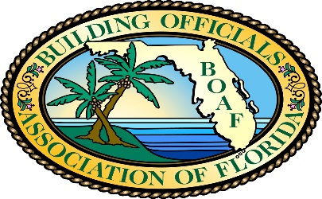

Florida Building Code Binding Interpretation Report Number 185
Date: April 29, 2020
Report: 185
Code Edition: 6th Edition (2017)
Florida Building Code, Residential P2503.7
Text of code provisions:
P2503.7 Water-supply system testing. Upon completion of the water-supply system or a section of it, the system or portion completed shall be tested and proved tight under a water pressure of not less than the working pressure of the system or, for piping systems other than plastic, by an air test of not less than 50 psi (345 kPa). This pressure shall be held for not less than 15 minutes. The water used for tests shall be obtained from a potable water source.

Appeal question requesting a response:
Is a gauge required to prove systems tight, when the water supply system is permanently tied into the local municipal water supply system. I.E. the water meter, and under working pressure?
Yes. P2503.7 requires a pressure gauge to be utilized to prove the water supply system is tight when the inspector is unable to observe the entire piping system and connections. When minor repairs or modifications are made on a water supply system, and the inspector can observe each piping connection for leaks, a pressure gauge is not required.

NOTICE:
The Building Officials Association of Florida, in cooperation with the Florida Building Commission, and the Florida Department of Business & Professional Regulation, provides this interpretation of the Florida Building Code in the interest of consistency and application of the Building Code statewide. This interpretation is binding and not subject to acceptance and approval by the local building official.

