From: Haage, Oriol (RER) [mailto:OTH@miamidade.gov]
Sent: Friday, May 13, 2016 1:27 PM
To: Madani, Mo
Subject: FW: Residential swimming barrier requirement

The new modification of swimming pool barrier requirements would be inconsistent with the standard it referenced.

This would contradict the exception by the inclusion of the standard ASTM Standard F2208. The residential swimming pool barrier required in 454.2.17.1 through 454.2.17.3 should be the first line of protection with the swimming pool alarm inside as an augmented secondary protection. Once a child or adult is in the pool, time is of great importance for survivability and the lives of these individual are depended upon the proper operation of a battery operated pool alarm. The new modification of swimming pool barrier requirements would be inconsistent with the standard it referenced.

5th Edition (2014) Florida Building Code, Building

454.2 Private swimming Pools

454.2.17 Residential swimming barrier requirement. Revise Section 454.2.17 to add exception 2 as follows:

454.2.17 Residential swimming barrier requirement. Residential swimming pools shall comply with Sections 454.2.17.1 through 454.2.17.3.
Exceptions:

1. A swimming pool with an approved safety pool cover complying with ASTM F 1346.

2. A swimming pool alarm that, when placed in a pool, sounds an alarm upon detection of an accidental or unauthorized entrance into the water. Such pool alarm must meet and be independently certified to ASTM Standard F2208, titled "Standard Safety Specification for Residential Pool Alarms," which includes surface motion, pressure, sonar, laser, and infrared alarms. For purposes of this paragraph, the term "swimming pool alarm" does not include any swimming protection alarm device designed for individual use, such as an alarm attached to a child that sounds when the child exceeds a certain distance or becomes submerged in water.

ASTM F2208 - 08(2014)
Standard Safety Specification for Residential Pool Alarms

1. Scope

1.1 This safety specification covers safety and performance requirements for pool alarms for residential swimming pools and spas.

1.2 This safety specification describes devices intended to improve personal safety and reduce injuries or deaths.

1.3 This safety specification covers devices that provide for rapid and automatic detection and alarm in cases of unintentional, unsupervised or accidental entry of a child one year of age or older into the water of swimming pools or spas.

1.4 This safety specification is not intended to replace other standard safety requirements that should be in place, that is, adult supervision, fences, gates, locks, and so forth.

1.5 This safety specification covers four different types of alarms.

1.6 The detection criteria for this safety specification is for a child one year of age and older.

1.7 The values stated in inch-pound units are to be regarded as standard. The values given in parentheses are mathematical conversions to SI units that are provided for information only and are not considered standard.

1.8 This standard does not purport to address all of the safety concerns, if any, associated with its use. It is the responsibility of the user of this standard to establish appropriate safety and health practices and determine the applicability of regulatory limitations prior to use.

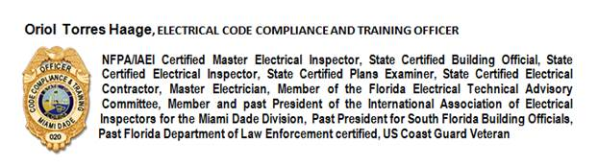
Miami-Dade County Department of Regulatory and Economic Resources
Board and Code Administration Division
11805 SW 26 Street, 2nd Floor
Miami, Florida 33175-2474
(786) 315-2557 Office
(786) 315-2560 Fax

