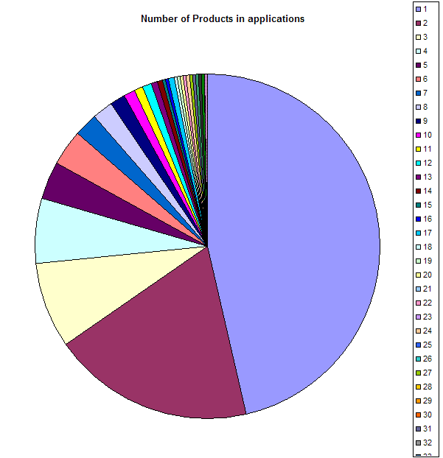
2 Products
19% of applications (2365)
3 Products
8% of
applications
(1013)
4 Products
6% of
applications
(787)
Number of Products per application
Of approximately 12500 applications
6 to 606
products
18%

