Energy Gauge USA 6.0.0.2 submittal Comments

1) ERI Report page 1 of 2

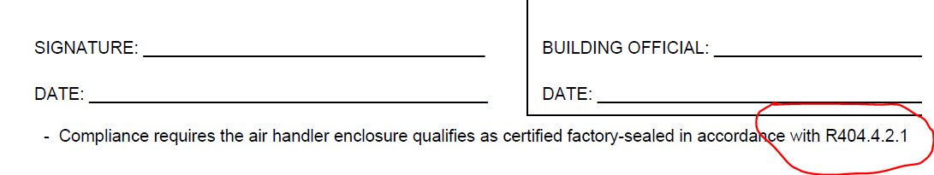
R404.4.2.1 does not exist in 6th Edition FBC. I think the correct section may be R403.3.2.1.

