Florida Building Commission
Product Approval / Manufactured Buildings
Program Oversight Committee (POC)
AGENDA – Conference Call
April 2nd 2009
10:00 a.m.
Telephone Number: 888-808-6959 Code: 1967168
Public point of access: Room 210L, 2555 Shumard Oak Boulevard, Tallahassee, Florida.
Meeting Objectives:
- To Consider/Discuss Product Approval Program Issues
- To Consider/Decide on Declaratory Statements
- To Consider/Decide on Approval of Products and Product Approval Entities
POC: Ed Carson -Chair, Chris Schulte, Paul Kidwell, Herminio Gonzalez, and Jeffrey Stone.
1. Call to Order -review/approve agenda and February 2nd Minutes.
2. Product Approval Program Issues
A. Product Approval and Entities Statistics Report
B. Product Approval Administrator’s Performance survey
C. Update on Commission action from the March 16th meeting on Hearings on Rule 9B-72.090 and 9B-72.180 held February 17, 2009.
D. Ted Berman and Associates Contract.
3. Declaratory Statements
DCA08-DEC-345 by James Reed, Southwest Progressive Enterprises, Inc
4. Ted Berman & Associates Report
A. Review product approval and entity applications.
B. Product Approval Applications with Comments.
5. Adjourn
This document prepared by the Florida Department of Community Affairs
Codes and Standards Joe Bigelow – 850-922-9160 joe.bigelow@dca.state.fl.us
Mo Madani – Manager – 850-921-2247 – mo.madani@dca.state.fl.us
Florida Building Commission
Product Approval / Manufactured Buildings
Program Oversight Committee (POC)
MINUTES
Feb 2nd 2009: 9.00 a.m. - 12.26 p.m.
Crowne Plaza Melbourne Oceanfront Hotel
2605 N AIA Highway, Melbourne FL, 1-800-980-6429 or 321-777-4100
Product Approval POC Attendees: Ed Carson- Chairman, Herminio Gonzalez, Paul Kidwell, Chris Schulte and Jeffrey Stone. Staff present: Azhar Khan, Joe Bigelow, Mo Madani, Rick Dixon and Jim Richmond. Jeff Blair facilitated the meeting. Ted Berman, Product Approval Administrator was also present.
There was a quorum.
1. Agenda was approved as presented. December 8th minutes were approved with a minor change.
The change is as follows:
3. Product Approval Program Issues
E. Standard Equivalency between ASTM E 1300-2 to ASTM E 1300-04 with limitations as applied to laminated glass as identified in the engineering report
2. Product Approval Program Issues
A. Product Approval and Entities Statistics Report
Staff presented the current entities and product statistics from inception of the program.
B. Product Approval Administrator’s Performance survey
Staff presented to the Committee the Survey Results. Although only a few results were received, the survey feedback was positive.
C. Provide Comments to the Rule Adoption Hearing for Rule 9B-72.090 and Rule 9B-72.180 on Feb 17th.
Staff presented to the Committee the comments received. Various comments were made during the meeting and the Committee worked on proposed language recommendation to the Commission. The details are attached in the Rule Matrix which will be made available as comments to the Hearings on February 17th.
Proposed Language is below:
Rule 9B-72.190
(1)(a) through (d) No change.
(e) As part of application for self-affirmation, if the evaluation report refers to the previous edition of the Code, the manufacturer of the approved product shall submit a statement from an approved evaluation or original validation entity that the product complies with the subsequent code version via an attachment uploaded and submitted through the BCIS. Self-affirmation is subject to review and verification by the Program Administrator.
(f) and (g) No change.
(2) and (3) No change.
Rule 9B-72.180
(1) and (2) No change
(3) Standard which meet or exceeds standards referenced by 2007 edition of the Code and recognized as equivalent for determining Code Compliance are:
(a) ANSI/DASMA108-02 Standard Method for Testing Sectional Garage Doors and Rolling Doors: Determination of Structural Performance under Uniform Static Air Pressure Difference equivalent to ANSI/DASMA 108-05;
(b) TPI 1-02 National Design Standards for Metal-Plate-Connected Wood Truss Construction equivalent to TPI 1-07; and
(c) ASTM E 1300-02 Practice for Determining Load Resistance of Glass in Buildings equivalent to ASTM E 1300-04.
(4)(3) Equivalence of product standards for specific product application. Standards which meet or exceed standards referenced by the Code and certified as equivalent for determining code compliance by one of the following entities shall be considered as equivalent by the Commission:
(a) An approved certification agency;
(b) An approved test lab;
(c) An approved evaluation entity;
(d) Florida licensed professional engineer or architect; or
(e) A nationally recognized standard writing organization.
(5)(4) Equivalence of accreditation standards. Where approved evaluation entities and accreditation bodies accredit testing laboratories, certification agencies and quality assurance agencies to standards other than the referenced ISO standards in Rule 9B-72.100, F.A.C., the accrediting body shall certify to the Commission that its standard is equivalent to the ISO standard. Such certification shall contain:
(a) A sworn statement by the officer of the accrediting body; and
(b) A comparison of the accrediting body’s standard to each criteria of the ISO reference standard with an explanation of why it is considered equivalent.
(6)(5) Organizations:
(a) ANSI – American National Standards Institute;
(b) AAMA – American Architectural Manufacturers Association;
(c) ASTM – American Society of Testing and Materials;
(d) DASMA – Door Access Systems Manufacturers Association; and
(e) NWWDA – National Wood Window and Door Association.

D. Revocations for the following products:
Staff consulted with the legal counsel on the revocation of these products and recommended to the Committee for them to be revoked.

FL | Mfg Name
3941-R1 6331 9945 9946 9947 | Uroll Shutters
5486, 5497 | TNT Roofing Manufacturer
7140, 7617, 7618 | Atlantic Windows and Doors, Inc.

POC Action:
The Committee voted to recommend to the Commission to proceed with the revocation process for the products listed in the table above.
E. Petition by Powers Steel Corporation to revoke FL 158.
The POC heard presentations from both Powers Steel and Cast-Crete.
POC Action:
The Committee denied the request for an investigation since no valid concern was provided. Commission Gonzalez and Commissioner Carson abstained from voting. The vote was 3 to 0 against.
4. Declaratory Statements:
DCA08-DEC-339 by Jose Sanchez, Fenestration Testing Laboratory, Inc
POC Action:
The Committee voted to dismiss DCA08-DEC-339 due to the fact that the petitioner failed to provide information that was requested by the POC at the previous meeting.
DCA08-DEC-345 by James Reed, Southwest Progressive Enterprises, Inc
POC Action:
The Committee voted to defer DCA08-DEC-345 until the next meeting.
DCA08-DEC-359 by Michael J. Wolfe, Advanced Shelter Solutions, Inc
POC Action:
The Committee voted to dismiss DCA08-DEC-359 as it is outside the scope for Declaratory Statements.
4. Ted Berman & Associates Report
A. Review product approval and entity applications.
B. Product Approval Applications with Comments.
The Committee reviewed products and applications. There were no entities up for approval at this meeting.
Public Comments were made by the following:
Steve Sincere:
Requested that an investigation by conducted on product applications FL 7350 and FL 9328. He stated that a number of problems exist in the current approval such as, testing conducted does not match the product report documentation. Testing was done as single beam without consideration to compression, deflection limits not stated etc.

Colleen Simon and Jesus Gonzalez:
Jesus Gonzalez made a presentation detailing deficiencies personally observed at Colleen Simon’s residence and another residence with similar problems to the Committee.
5. Adjourn
The Committee adjourned at 12.26

Actions needed by the Commission:
Product Approval POC:
1. The Committee recommends the products listed in Administrator's report be approved, deferred, conditionally approved or denied as per voted on by the Committee.
2. The Committee recommends the following products for revocation:
FL | Mfg Name
3941-R1 6331 9945 9946 9947 | Uroll Shutters
5486, 5497 | TNT Roofing Manufacturer
7140, 7617, 7618 | Atlantic Windows and Doors, Inc.

2. Product Approval Program Issues A. Product Approval and Entities Statistics Report
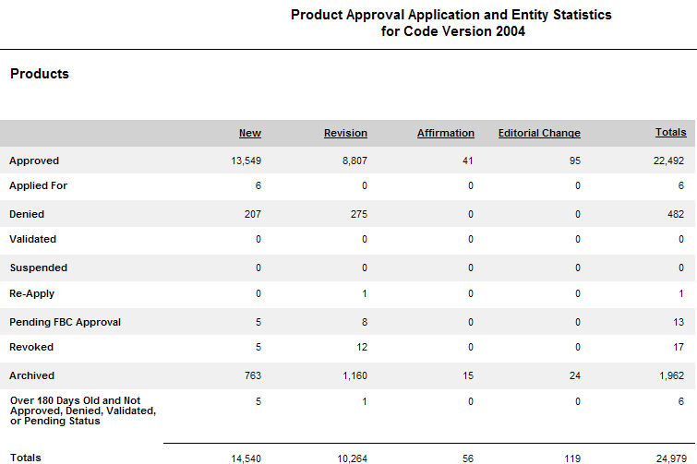
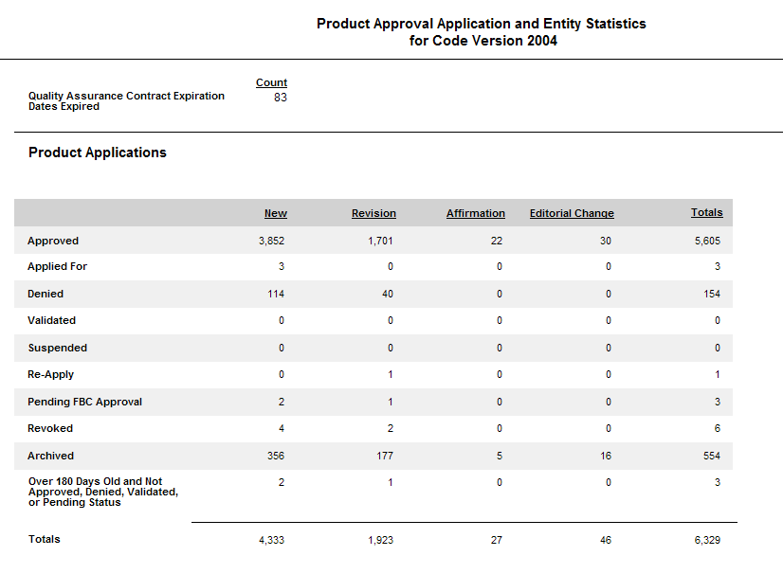
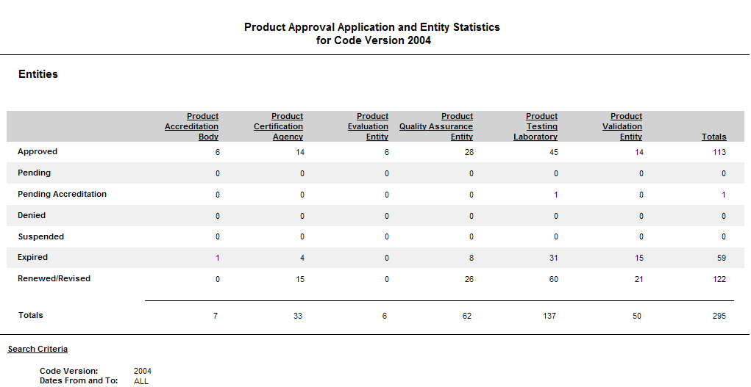
2007
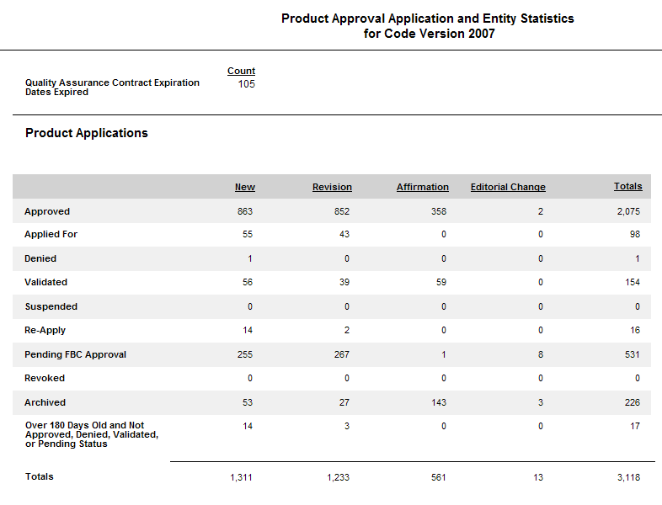
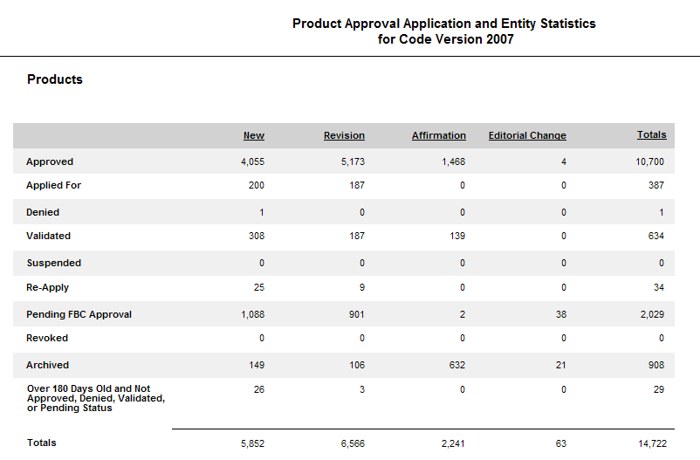
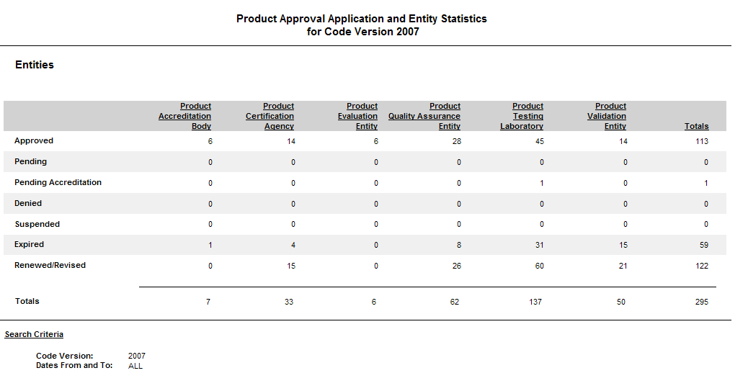

2. Product Approval Program Issues
B. Product Approval Administrator’s Performance survey
I have found dealings with TB&A to be somewhat difficult and cumbersome. My feeling of TB&A based on some experience dealing with them is their communication can be abrupt and their responsiveness is often weak or nonexistent. The relationship with TB&A feels like dealing with a large, impersonal government agency as opposed to an agency who can better facilitate the application and maintenance process of code approval listings. I would like to feel more like a customer and less like a nuisance with whoever I deal with in this process. In my opinion, TB&A needs an attitude or philosophy adjustment.
-------------------------------------------------------------------------------------------------------------------------------
1) Rating: Excellent
2) Comment on TB&A performance (including telephone support, application review and support, emails describing the results of application review, recommendation to the Product Approval Oversight Committee (POC) and timely carrying out of the final Commission Vote on your application)
I have had very good luck with getting my questions answered in a timely manner, they are always there and helpful and positive.
3) How can TB&A improve performance in the future?
They do a good job with the task they are assigned.
--------------------------------------------------------------------------------------------------------------------------------------------
1. Overall I feel the service provided by Ted Berman and Associates was excellent.
2. They provided me prompt responses and assistance with all of my questions whether via email or phone calls (Verda is great)
3. The system itself has some big flaws. For instance, I am unable to add my FBC application # to my installation instructions because if I have an item that I need to remove for some reason, all of the numbers change instead of just voiding out that one particular number. In addition, if I have a product that expires, I am expected to update the file and either remove or have the entire application go back on hold for review and in addition have to pay another revision fee. These items make this program very non-user friendly and cumbersome/costly to window manufacturers. If you would like any suggestions on how to revamp the program I would be happy to provide further input.

1) Select a rating: Excellent, Good, Fair, or Poor.
REPLY: Excellent
2) Comment on TB&A performance (including telephone support, application review and support, emails describing the results of application review, recommendation to the Product Approval Oversight Committee (POC) and timely carrying out of the final Commission Vote on your application)
REPLY: This was excellent. Verda was extremely friendly and help resolving an issue. She we above and beyond what I would have expected.
3) How can TB&A improve performance in the future? Please note that the BCIS system is not a part of TB&A's performance.
REPLY: Nothing to add.
------------------------------------------------------------------------------------------------------------------------------------------
TB&A Performance:
I had an extremely pleasant experience with TB&A in that they were most helpful in walking me through the process. The actually returned phone calls and emails in a very timely manner. They definitely know and understand the process for getting products approved. They stayed on the phone and walked me through the process. Overall the working with TB&A was great.
How can TB&A improve?
Let other companies know the importance of providing their type of excellent service. I do not know how TB&A can improve their service as it was flawless!
-------------------------------------------------------------------------------------------------------
Survey Questions:
1) Select a rating: Excellent, Good, Fair, or Poor.
REPLY: POOR
2) Comment on TB&A performance (including telephone support, application review and support, emails describing the results of application review, recommendation to the Product Approval Oversight Committee (POC) and timely carrying out of the final Commission Vote on your application)
REPLY: Slow to respond regarding clarification of review comments (1-2 weeks). Delays necessitated hurried efforts by evaluator and validator to make the completion deadline, despite initial submittal 6+ weeks prior to the “submittal deadline” of March 4th.
3) How can TB&A improve performance in the future? Please note that the BCIS system is not a part of TB&A's performance.
REPLY: Provide clear and concise review comments when pertaining to engineer’s analysis and/or specific limitations of use noted in approval drawings (“installation instructions”).
-------------------------------------------------------------------------------------------------------------------------------
1) Rating – Excellent
2) Dealing with Verda LaRue is great, questions always answered in a timely manner, never left hanging
3) Just continuing the way they handle things, they are great to deal with.

Rule 9B-72.180 Equivalence of Standards

Minutes from the February 17th Rule Hearing

Post March 16, 2009 Commission meeting
Proposed Rule Change | Comments by the Public:  Written Comments received as of February 13th 2009 | POC Comments to the Hearing Feb 2 2009:  Advise that the Commission proceed with filing the rule as proposed and remove the additional E from the referenced standards as an editorial change.  Note: The Commission at the March 16, 2009 meeting approved the proposed rule as per the POC comment above.
(1) and (2) No change

(3) Standard which meet or exceeds standards referenced by 2007 edition of the Code and recognized as equivalent for determining Code Compliance are:  (a) ANSI/DASMA108-02 Standard Method for Testing Sectional Garage Doors and Rolling Doors: Determination of Structural Performance under Uniform Static Air Pressure Difference equivalent to ANSI/DASMA 108-05;  (b) TPI 1-02 National Design Standards for Metal-Plate-Connected Wood Truss Construction equivalent to TPI 1-07; and  (c) ASTM E 1300-02 Practice for Determining Load Resistance of Glass in Buildings equivalent to ASTME E 1300-04. | Also, there is an extra E in the ASTM E 1300-04 standard.  By Kari Hebrank
(4)(3) Equivalence of product standards for specific product application. Standards which meet or exceed standards referenced by the Code and certified as equivalent for determining code compliance by one of the following entities shall be considered as equivalent by the Commission:
(a) An approved certification agency;
(b) An approved test lab;
(c) An approved evaluation entity;
(d) Florida licensed professional engineer or architect; or
(e) A nationally recognized standard writing organization.

(5)(4) Equivalence of accreditation standards. Where approved evaluation entities and accreditation bodies accredit testing laboratories, certification agencies and quality assurance agencies to standards other than the referenced ISO standards in Rule 9B-72.100, F.A.C., the accrediting body shall certify to the Commission that its standard is equivalent to the ISO standard. Such certification shall contain:
(a) A sworn statement by the officer of the accrediting body; and
(b) A comparison of the accrediting body’s standard to each criteria of the ISO reference standard with an explanation of why it is considered equivalent.

(6)(5) Organizations:  (a) ANSI – American National Standards Institute;  (b) AAMA – American Architectural Manufacturers Association;  (c) ASTM – American Society of Testing and Materials;  (d) DASMA – Door Access Systems Manufacturers Association; and  (e) NWWDA – National Wood Window and Door Association. | Please note in proposed rule Ch 9B-72.180, FAC, Equivalency of Accreditation Standards, cites the entity as NWWDA in subparagraph (5)(e).  Please consider changing NWWDA to read WDMA (Window and Door Manufacturers Association) as that is the current designation of that association.  Thank you.  Dick Wilhelm  representing the WDMA in the southeast U.S. and Gulf coast.  Chuck Anderson – there is no real need for this if the reference is to a standard –  Dick Wilhelm – it hasn’t made any drastic changes and he will propose change the rule when we have the opportunity as it will not have any impact  See the verbal comments received at the Rule Hearing below
2. Product Approval Program Issues
C. Update on Commission action from the March 16th meeting on Hearings on Rule 9B-72.090 and 9B-72.180 held February 17, 2009.

Verbal Comments received at the Rule Hearing

Kari Hebrank: In support of the standard updates
Steve Strawn: In support of the update
Bud Bulley: In support of the update –but is also recommends that the Commission looks at adding ASTM E330 and ASTM 1886 1996 to the list
Dick Wilhelm: In support of the update

Rule 9B-72.180 Equivalence of Standards

Minutes from the February 17th Rule Hearing

Post March 16, 2009 Commission meeting
Proposed Rule Change | Comments by the Public:  Written Comments received as of February 13th 2009 | POC Comments to the Hearing Feb 2 2009:  Advise that the Commission proceed with filing the rule as proposed and remove the additional E from the referenced standards as an editorial change.  Note: The Commission at the March 16, 2009 meeting approved the proposed rule as per the POC comment above.
(1) and (2) No change

(3) Standard which meet or exceeds standards referenced by 2007 edition of the Code and recognized as equivalent for determining Code Compliance are:  (a) ANSI/DASMA108-02 Standard Method for Testing Sectional Garage Doors and Rolling Doors: Determination of Structural Performance under Uniform Static Air Pressure Difference equivalent to ANSI/DASMA 108-05;  (b) TPI 1-02 National Design Standards for Metal-Plate-Connected Wood Truss Construction equivalent to TPI 1-07; and  (c) ASTM E 1300-02 Practice for Determining Load Resistance of Glass in Buildings equivalent to ASTME E 1300-04. | Also, there is an extra E in the ASTM E 1300-04 standard.  By Kari Hebrank
(4)(3) Equivalence of product standards for specific product application. Standards which meet or exceed standards referenced by the Code and certified as equivalent for determining code compliance by one of the following entities shall be considered as equivalent by the Commission:
(a) An approved certification agency;
(b) An approved test lab;
(c) An approved evaluation entity;
(d) Florida licensed professional engineer or architect; or
(e) A nationally recognized standard writing organization.

(5)(4) Equivalence of accreditation standards. Where approved evaluation entities and accreditation bodies accredit testing laboratories, certification agencies and quality assurance agencies to standards other than the referenced ISO standards in Rule 9B-72.100, F.A.C., the accrediting body shall certify to the Commission that its standard is equivalent to the ISO standard. Such certification shall contain:
(a) A sworn statement by the officer of the accrediting body; and
(b) A comparison of the accrediting body’s standard to each criteria of the ISO reference standard with an explanation of why it is considered equivalent.

(6)(5) Organizations:  (a) ANSI – American National Standards Institute;  (b) AAMA – American Architectural Manufacturers Association;  (c) ASTM – American Society of Testing and Materials;  (d) DASMA – Door Access Systems Manufacturers Association; and  (e) NWWDA – National Wood Window and Door Association. | Please note in proposed rule Ch 9B-72.180, FAC, Equivalency of Accreditation Standards, cites the entity as NWWDA in subparagraph (5)(e).  Please consider changing NWWDA to read WDMA (Window and Door Manufacturers Association) as that is the current designation of that association.  Thank you.  Dick Wilhelm  representing the WDMA in the southeast U.S. and Gulf coast.  Chuck Anderson – there is no real need for this if the reference is to a standard –  Dick Wilhelm – it hasn’t made any drastic changes and he will propose change the rule when we have the opportunity as it will not have any impact  See the verbal comments received at the Rule Hearing below

Verbal Comments received at the Rule Hearing
Kari Hebrank: In support of the standard updates
Steve Strawn: In support of the update
Bud Bulley: In support of the update –but is also recommends that the Commission looks at adding ASTM E330 and ASTM 1886 1996 to the list
Dick Wilhelm: In support of the update
3. Declaratory Statements
DCA08-DEC-345 by James Reed, Southwest Progressive Enterprises, Inc
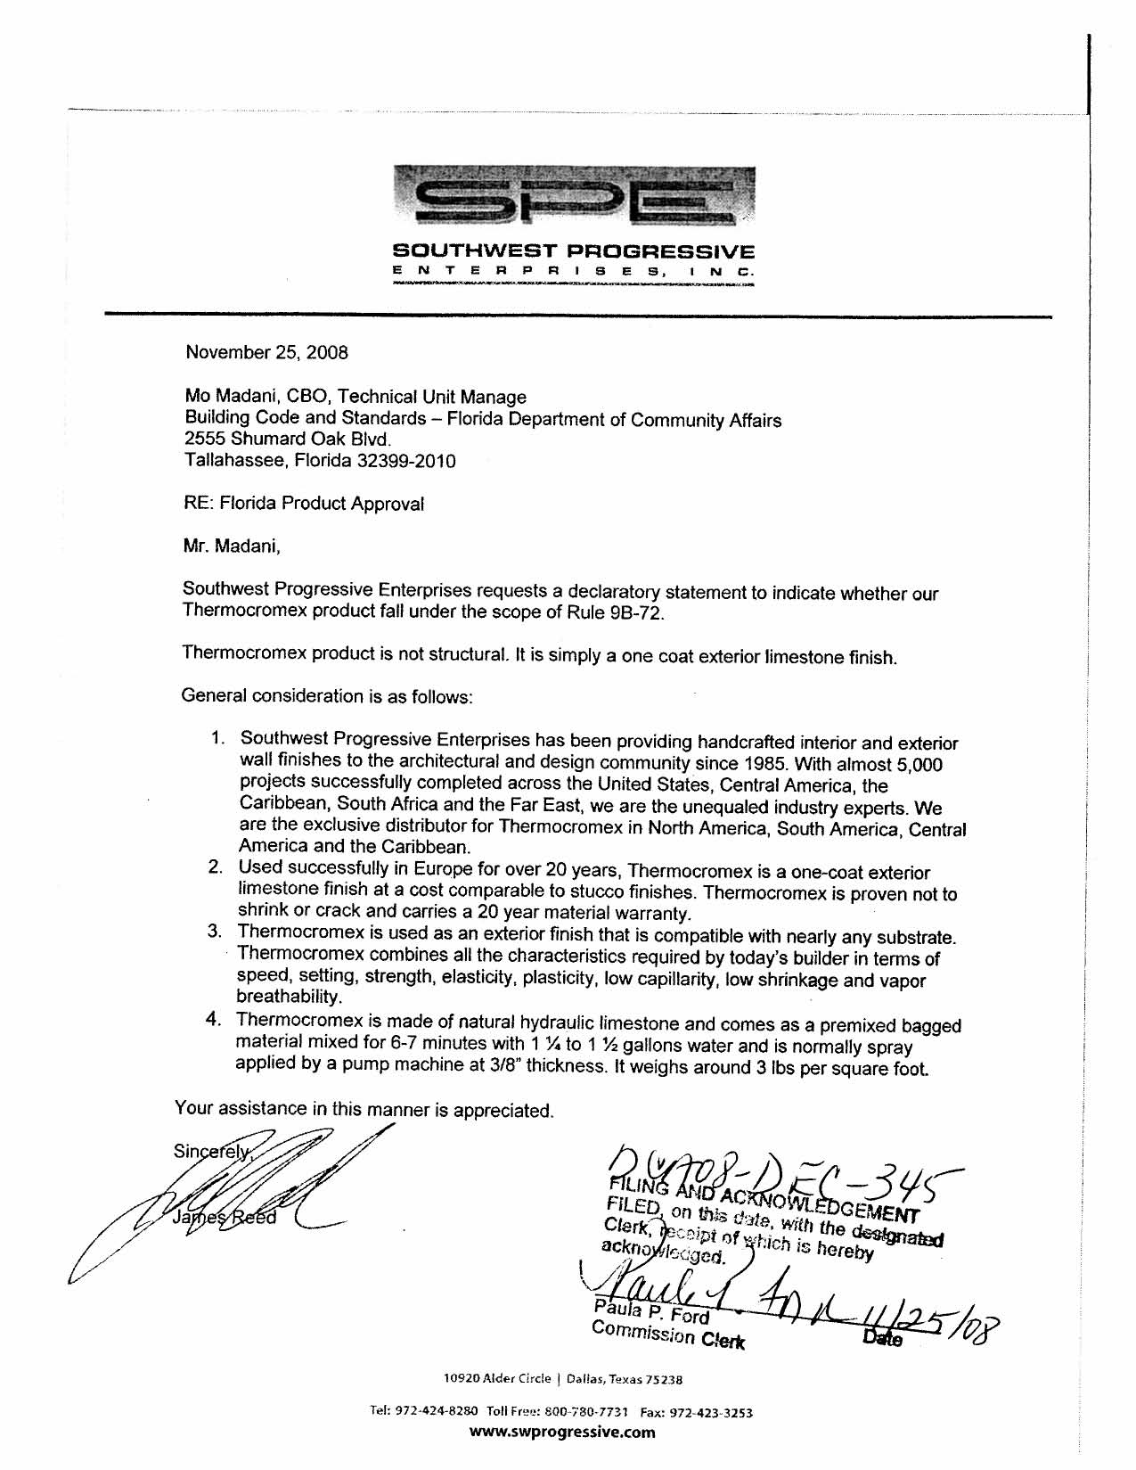

ISSUE: DCA08-DEC-345
The petitioner, James Reed of Southwest Progressive Enterprises, Inc. seeks a Declaratory Statement on Rule 9B-72 as it pertains to his product
BACKGROUND
9B-72.005 Scope (1) Products in the following categories as defined by subcategories of subsection 9B-72.010(31), F.A.C., shall be available for approval by the Commission pursuant to Rule 9B-72.090, F.A.C., for use in the state:
(a) Panel Walls;
(b) Exterior Doors;
(c) Roofing Products;
(d) Skylights;
(e) Windows;
(f) Shutters; and
(g) Structural Components.
9B-72.005 Scope (2) This rule applies to approval of products and systems, which comprise the building envelope and structural frame, for compliance with the structural requirements of the Florida Building Code.
From the declaratory statement request:
USES: Thermocromex is a one-coat exterior limestone finish on many substrates. It is made of natural hydraulic limestone and comes as a premixed bagged material that is mixed for 6-7 minutes and is spray applied by a pump machine at 3/8 inches thickness. It weighs around 3 lbs/ft sq.
Technical Data:
St. Astier One Coat Exterior Limestone Finish - Thermocromex
~Based on St. Astier natural hydraulic lime, this product is visually pleasant, durable, water resistant and cost effective.
~ A one coat easy and economical application, ready mixed product based on Natural Hydraulic lime specially formulated to work on all substrates, including light weight cement blocks, clay blocks, bricks, and stone to achieve excellent waterproofing, low capillarity, high breathability, elasticity, and vibrant colored finishes. Thermocromex is available in a variety of colors. Our color chart is by no means exhaustive and can be supplied to a custom color with substantial savings in cost of painting and maintenance.
Technical Data |  | Test std. CSTB & EN/BS 998.1
Dry Density (hardened product) | 1450 g.1 +/100g/1 | EN 459-2
Thermal conductivity | 0.54 W/m.K | EN 1745
Granulometry | 0.8 - 4.0 mm | C 136
Compressive strength 28 days | Between 4 and 6 N/mm² | C 109
Flexural strength 28 days | Between 2 and 2.5 N/mm² | C 348
Water retention (on paste) | 94% (± 2%) | C 1506
Vapour permeability | 1.61.10-9 kg/m²sPa (0.772 g x m² x h x mmHg) | EN 1015-19
Capillarity | Between 1 and 2.5 g/dm².min1/2 | EN 1015-18
Fire & Smoke | Class A (all uses)
Elasticity moduli 28 days | Between 4000 and 6000 MPa
The manufacturer has stated it to be a stucco substitute. We have approved stucco products in both the 2004 code and the 2007 as products with structural properties. The manufacturer has not as yet submitted final testing and evaluation data that determines the structural properties of this product and its compliance with the Florida Building Code. Subsequently it is difficult to say at this stage whether it falls within the scope of Rule 9B-72.
STAFF RECOMMENDATION
Staff recommends dismissal of the Declaratory Statement DCA08-DEC-345 as not enough information is provided to correctly determine the products structural properties.

