**December 4, 2019**

**Development of Design Wind Speeds Induced by Hurricanes in Florida for Application with the Wind Load Provisions of ASCE 7**

***Prepared for:***

**University of Florida**

**Prepared by:**

**L. A. Mudd and P. J. Vickery**

**Applied Research Associates, Inc.**

**8537 Six Forks Rd, Suite 600**

**Raleigh NC 27615**

# INTRODUCTION

This report provides an overview to the peer reviewed hurricane simulation model as described in Vickery et al. (2000a, 2000b, 2006, 2008a, 2008b), and Vickery and Wadhera (2008), including recent updates to the track, intensity, and wind field models and the inclusion of historical and environmental data through 2018. The hurricane simulation model outlined here is an updated version of that described in Vickery et al. (2000a, 2000b) which was used to produce the design wind speeds used in ASCE 7-98 through to the ASCE 7-16, the current version.

Section 2 of the report describes the simulation methodology, model updates and model validation results, and Section 3 presents the wind speed results which can be used in conjunction with the requirements of ASCE 7. A summary is presented in Section 4.

# METHODOLOGY

The hurricane simulation approach used to define the hurricane hazard for regions located in the Atlantic basin consists of two major components. The first component comprises a hurricane track model that reproduces the frequency and geometric characteristics of hurricane tracks as well as the variation of hurricane size and intensity as they move along the tracks. The second portion of the model is the hurricane wind field model, where given key hurricane parameters at any point in time from the track model, the wind field model provides estimates of the wind speed and wind direction at an arbitrary location. The meteorological inputs to the wind field model include the central pressure difference, Δ*p*, translation speed, *c*, radius to maximum winds (*RMW*) and the Holland *B* parameter. (For computing Δ*p,* the far field pressure is taken as 1013 mbar, and thus Δ*p* is defined as 1013 minus the central pressure, *pc*.) The geometric inputs include storm position, heading and the location of the site where wind speeds are required. The following sections describe the verification of the track model near Florida and a summary of the wind field model is also presented.

* 1. Track and Intensity Modeling

The hurricane track and intensity simulation methodology follows that described in Vickery et al. (2000c, 2008), but the coefficients used in the statistical models have been calibrated to model the variation in storm characteristics throughout the Atlantic basin, the model coverage area has been extended to 65°N and the historical meteorological data (e.g., tropopause temperature, environmental flow, and sea surface temperature) sampled during the simulation has been extended through 2018. Previously, separate models were used to assess the hurricane wind hazard in the Caribbean and the United States; and no model existed to assess the hurricane wind hazard along the eastern Canadian coastline. With the current updates, a single cohesive hurricane track and intensity model applicable to the Caribbean, the United States, and Canada now exists.

* + 1. Track Modeling

The over water hurricane track simulation is performed in two steps. In the first step, the hurricane position at any point in time is modeled using the approach given in Vickery et al. (2000a). Given the initial storm heading, translation speed, and intensity, the model estimates the new position and speed of the storm based on changes in the translation speed and storm heading over the current six hour period. The changes in the translation speed *c* and the storm heading *θ* between time steps *i* and *i+1* are obtained from Equations 1 and 2, respectively.

|  |  |
| --- | --- |
| $$∆lnc= a_{1}+a_{2}ψ+a_{3}γ+a_{4}lnc_{i}+a_{5}θ_{i}+ε$$ | 1 |

|  |  |
| --- | --- |
|  | 2 |

where *a1, a2*, etc. = constants, ψ, γ = storm latitude and longitude, respectively, *ci* = storm translation speed at time step *i*; *θi, θi+1* = storm heading at time step *i*, and *i+1*, respectively, and *ε* = random error term.

The coefficients *a1, a2*, etc. were previously developed using 5°×5° grids over the Atlantic basin to approximately 44°N latitude. Herein, additional tracking model coefficients were developed to extend coverage to 65°N, covering eastern Canada from Newfoundland inland to approximately 80°W longitude. A different set of coefficients for easterly and westerly headed storms is used. Calibrations to the coefficients were made across the basin to yield a single model applicable to the Caribbean, United States, and Canada.

* + 1. Relative Intensity Modeling

In the second step, the relative intensity, *I*, of the hurricane is modeled using regional statistical models of the form of Equation 3, where the relative intensity at any time is modeled as a function of relative intensity at the last three steps and the scaled vertical wind shear, *V*s*,* (DeMaria and Kaplan, 1999), (Vickery et al. 2000b).

|  |  |
| --- | --- |
| $$ln\left(I_{i+1}\right)=c_{1}ln\left(I_{i}\right)+c_{2}ln\left(I_{i-1}\right)+c_{3}ln\left(I_{i-2}\right)+c_{4}V_{s}+ε$$ | 3 |

where *c1*, *c2*, etc. are constants that vary with region in the Atlantic Basin, and ε is a random error term.

Calibrations to the coefficients *c1*, *c2*, etc. were made basin-wide in order to produce a single model applicable to the Caribbean, United States, and Canada. This calibration resulted in minor impacts on the intensity model output. However, significant calibrations were made in the northwest Florida coastal region due to Hurricane Michael making landfall near Mexico Beach, FL in 2018. Hurricane Michael was the first Category 5 hurricane on record to make landfall in the Florida Panhandle and significantly altered the historical hurricane hazard in the region, as shown in Figure 2‑1.



Figure 2‑1. Hurricane hazard curves (as defined by central pressure at landfall) in the Florida Panhandle region. The historical hazard before (open black squares) and after (filled black squares) Hurricane Michael and the modeled hazard before (solid blue line) and after (dashed red line) mode updates were performed are shown for comparison.

Relative intensity is a non-dimensional term relating the actual central pressure to the lowest possible central pressure. The basis of the concept is a hurricane represented as a Carnot heat engine, where the intensity is driven by the difference in temperatures at the sea surface and tropopause levels. Central pressure can be expressed in terms of the relative intensity, and vice versa. To create the regional models, the historical best-track central pressure data from the HURDAT2 database were converted to corresponding values of relative intensity. A simple one-dimensional ocean mixing model, described in Emanuel et al. (2006), was used to simulate the effect of ocean feedback on the relative intensity calculations. The ocean mixing model returns an estimate of a mixed layer depth used to compute the reduction in sea surface temperature caused by the passage of a hurricane. The reduced sea surface temperature was used to convert historical pressures to relative intensity values. Regression analysis was then performed using the historical relative intensity values to develop regional statistical models.

The relative intensity obtained from Equation 3 is then used to compute the central pressure over water. If a storm crosses land, the central pressure is computed using a filling model, where the central pressure at *t* hours after landfall is dependent on the storm pressure at the time of landfall and the number of hours that the storm has been over land.

* + 1. Radius to Maximum Winds and Holland B Modeling

The *RMW* and *B* are computed as described in Vickery and Wadhera (2008). *RMW* is computed using two models, one for the Gulf of Mexico and one for all hurricanes. The Gulf of Mexico model is applicable to storms in the Gulf, and the all hurricanes model is applied in the Atlantic basin. The models for *RMW* are given in Equations 4 and 5.

|  |  |
| --- | --- |
| $$ln\left({RMW}_{Atlantic}\right)=3.015-6.291∙{10}^{-5}∆p^{2}+0.0337ψ+ε_{Atlantic}$$ | 4 |
|  |  |
| $$ln\left({RMW}_{Gulf}\right)=3.859-7.700∙{10}^{-5}∆p^{2}+ε_{Gulf}$$ | 5 |

The two models for *RMW* are combined to yield one model for each simulated storm using Equations 6 and 7.

|  |  |
| --- | --- |
| $$RMW=a_{1}{RMW}_{Atlantic}+(1-a_{1}){RMW}_{Gulf}$$ | 6 |
|  |  |
| $$a_{1}=\frac{\sum{Δp_{Atlantic}}}{\sum{\left[Δp_{Atlantic}+Δp_{Gulf}\right]}}$$ | 7 |

where the summation is performed over all six hour time steps from storm initiation to the current simulation step.

The Holland B parameter over open water is modeled using Equation 8.

|  |  |
| --- | --- |
| $$B=1.76-1.21\sqrt{A}+ε$$ | 8 |

where A is calculated according to Equation 9.

|  |  |
| --- | --- |
| $$A=\frac{RMW∙f}{\sqrt{2R_{d}T_{s}∙ln\left(1+\frac{∆p}{p_{c}∙e}\right)}}$$ | 9 |

where *f* is the Coriolis parameter, $R_{d}$ is the gas constant for dry air, $T_{s}$ is the sea surface temperature, $p_{c}$ is the central pressure, $∆p$ is the central pressure difference, and *e* is the base of natural logarithms.

Models of *RMW* and *B* were developed using central pressure data collected during hurricane reconnaissance flights and additional information derived from the National Hurricane Center Hurricane Research Division’s H*Wind snapshots of hurricane wind fields Vickery and Wadhera (2008). The period of record of the reconnaissance data used in the model development was 1977 through 2001.

* + 1. Storm Filling

The filling models for storms making landfall are identical to those in Vickery (2005). The filling models were developed using HURDAT2 data on landfalling storms from 1926 to 2003. The landfall pressure was computed from the HURDAT2 database by extrapolating the central pressures using the last two central pressures before landfall. Using this approach, the pressure tendency of the hurricane before landfall was maintained, such that weakening storms continue to weaken and strengthening storms continue to intensify until landfall. Weakening of the hurricane after landfall was modeled using an exponential decay (filling) function in the form of Equation 10.

|  |  |
| --- | --- |
| $$∆p\left(t\right)= ∆p_{o}exp\left(-at\right)$$ | 10 |

where $∆p\left(t\right)$ is the central pressure difference t hours after landfall, ${∆p}_{0}$ is the central pressure difference at the time of landfall and *a* is an empirically derived filling coefficient.

Expressions for *a* were derived for the Gulf Coast, Florida Peninsula Coast, Mid-Atlantic Coast, and New England Coast. For the Gulf, Florida, and Mid-Atlantic coastal regions, *a* is modeled as in Equation 11.

|  |  |
| --- | --- |
| $$a=a_{o}+a_{1}\left(\frac{∆p_{o}c}{RMW}\right)$$ | 11 |

where $c$ is the translation speed. For the New England coastal region, *a* is modeled as in Equation 12.

|  |  |
| --- | --- |
| $$a=a_{o}+a_{1}\left(∆p_{o}\right)$$ | 12 |

Herein, the expression for the empirically derived filling coefficient in the New England region is also used for storms making landfall in Canada. The filling coefficient would not be expected to change with the incorporation of data since 2005 as no additional hurricanes have made landfall in New England during this period. Given the six hourly archival of storms in the HURDAT2 database and the speed at which storms travel at higher latitudes, sufficient data does not exist to derive a filling coefficient specifically for Canada using the same methodology.

* + 1. Model Validation

In the model validation/calibration process we compared the statistics of storm heading, translation speed, distance of closest approach, central pressure and annual occurrence rates for modeled and historical storms passing within 250 km of a grid-point. The distance of closest approach, *d*min, is defined as positive if a storm passes to the left of a site (center of the circle) and negative if the storm passes to the right. Storm heading, *θ,* is measured clockwise from true north, such that a heading of 0 degrees represents a storm heading due north, 90 degrees represents a storm heading due east and -90 degrees represents a storm moving towards the west. The annual storm occurrence rate, *λ*, is defined as the total number of storms that enter the circle during the period of record divided by the record length. All storms in the HURDAT2 database are used in the development of the model, not just those that reach hurricane intensity. The parameters *c*, *d*min, and *θ* are all computed at the point of closest approach to the center of the circle. The central pressure values used in the validation procedure are the minimum values measured or modeled at any time while the storm is in the circle. For this study, we perform the comparisons using overlapping 250 km radius circles centered on a 2 degree grid spanning from 10o N to 58o N, and 20o W to 98o W. Figure 2‑2 shows the location of the grid points and the extent of the 250 km radius circles used in the validation/calibration process near Florida. Note this 2 degree grid with overlapping extents was used only for validation/calibration purposes. A 5 degree grid with mutually exclusive areas was used to develop model coefficients.

The HURDAT2 dataset used in the model validation includes all tropical cyclones from the period 1900 through 2017. The United States hurricane landfall database (Blake et al. 2007) provides the central pressure at the time of landfall for almost all hurricanes that made landfall along the US coastline since 1900. Thus, even though the pressure data within HURDAT2 is sparse for pre-1970 storms, the landfall data base extends back over 100 years is considered quite reliable. This additional landfall data enables statistical models for US landfall hurricanes to be validated with data having an effective period of record in excess of 100 years. Unlike the case of the mainland US data, there is no supplemental data base of central pressures at the time of land fall extending back to 1900 for the Caribbean or Canada land falling storms. In these regions, the effective period of record for data containing information on storm intensity as defined by central pressure is in the neighborhood of about 40 to 50 years.

As discussed in Georgiou et al. (1983), Georgiou (1985), and Vickery et al. (1995), we assume that the missing central pressure data in the HURDAT2 dataset belong to a population having the same statistical distribution (given the occurrence of a storm) as the measured data. We also assume that prior to approximately 1970 (after which time central pressure data is available for nearly all storms) that there is no bias in the reporting of the sparse central pressure data given in HURDAT2.

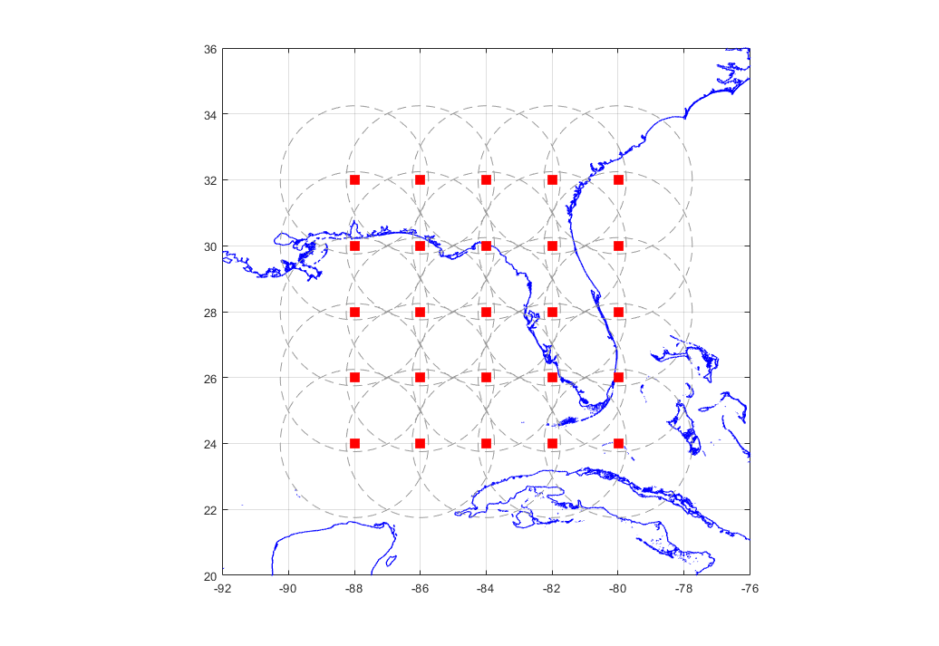

Figure 2‑2. Locations of simulation circle centers showing extent of 250 km sample circles near Florida.

In order to verify the ability of the model to reproduce the characteristics of historical storms we perform statistical tests comparing the characteristics of model and observed hurricane parameters. The statistical tests include *t*-tests for equivalence of means, *F-*tests for equivalence of variance and the Kolmogorov-Smirnov (*K-S*) tests for equivalence of the Cumulative Distribution Functions (CDF). In the case of central pressures we also used a statistical test method described in James and Mason (2005) for testing equivalence of the modeled and observed central pressure conditional distributions of pressure, and as a function of annual exceedance probability. No consideration is given to the measurement errors inherent in the HURDAT2 data in the computation of translation speed, heading, central pressure, etc., in any of the statistical tests.

Figure 2‑3 through Figure 2‑5 present graphical comparisons of the modeled and observed CDF for storm heading, translation speed, and distance of closest approach, respectively; results of the statistical tests performed at the 95% confidence level are indicated for each location. A visual comparison of the modeled and observed CDF data indicates that overall the model reproduces the observed data well. Along the Florida coastline, the r2 of the modeled and observed data ranges from about 0.93 to 0.99 across all parameters.

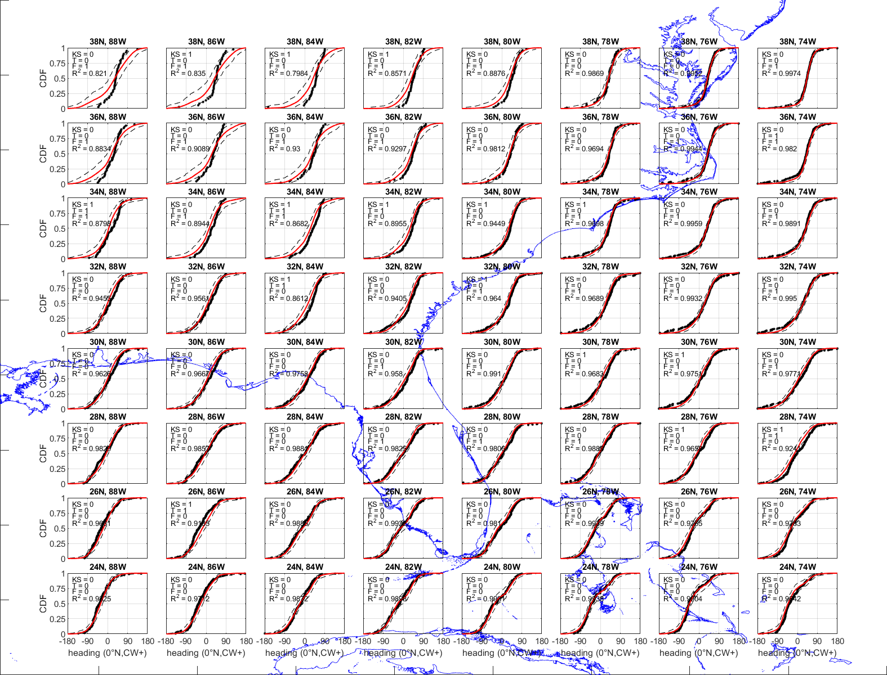

Figure 2‑3. Comparisons of modeled and observed CDF’s of storm heading for locations near Florida. F=1 indicates failure of *F*-test, T=1 indicates failure of the t-test, KS=1 indicates failure of the KS test. Dashed lines represent the 95% confidence interval.

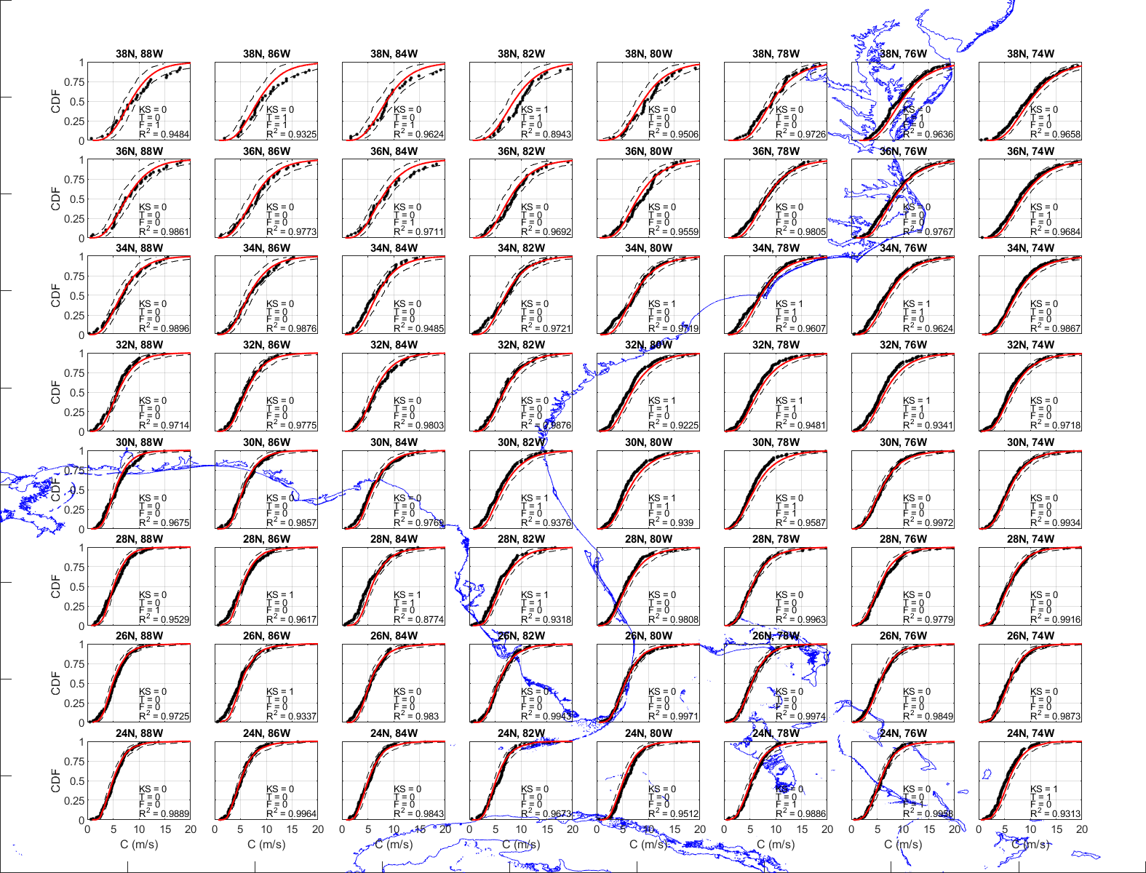

Figure 2‑4. Comparisons of modeled and observed CDF’s of storm translation speed for locations near Florida. F=1 indicates failure of *F*-test, T=1 indicates failure of the t-test, KS=1 indicates failure of the KS test. Dashed lines represent the 95% confidence interval.

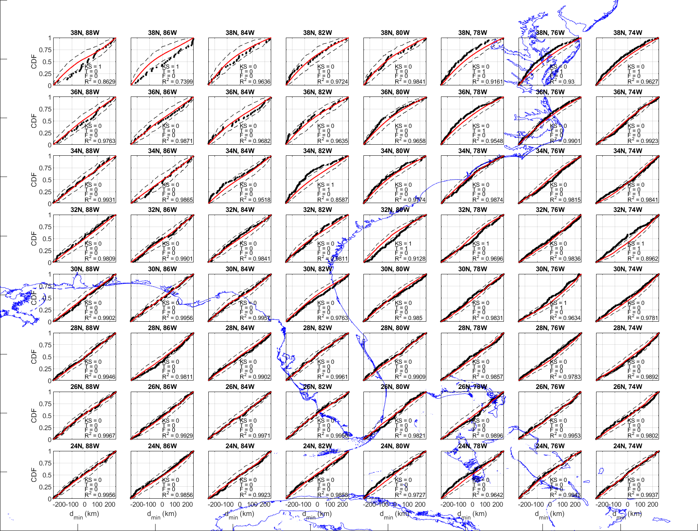

Figure 2‑5. Comparisons of modeled and observed CDF’s of distance of closest approach for locations near Florida. F=1 indicates failure of *F*-test, T=1 indicates failure of the t-test, KS=1 indicates failure of the KS test. Dashed lines represent the 95% confidence interval.

Figure 2‑6 presents a comparison of modeled and observed central pressures plotted versus return period for locations near the Florida coast. The observed central pressures plotted vs. return period were computed assuming the *Np*pressure data points obtained from a total of *N* tropical cyclones that pass through the circle are representative of the full population of *N* storms. With this assumption, the CDF for the conditional distribution for storm central pressure is computed, where each pressure has a probability of 1/(*Np*+1). The return period associated with a given central pressure is obtained from

|  |  |
| --- | --- |
| $$1/{RP}=1=exp\left[-λP\left(p_{c}<P_{c}\right)\right]$$ | 13 |

where *P(pc < Pc)* is the probability that the central pressure *pc* is less than *Pc* given the occurrence of any one storm, and *λ* is the annual occurrence rate defined as *N/NY* where *NY* is the number of years in the historical record, taken here as 118 years for locations near Florida (1900 through 2017). The model estimates of central pressure versus return period are computed using Equation 13, where *λ* equals the number of storms that enter the circle during the 100,000 simulated years divided by 100,000 and the probability distribution for central pressure is obtained by rank ordering the simulated central pressures.

Each of the plots given in Figure 2‑6 also presents the 2.5th and 97.5th percentile (95% confidence range) values of central pressures derived by sampling *Np* different values of central pressure from the simulated storm set, computing the CDF, and then the pressure RP curve using the model value of *λ*. This process was repeated 1000 times, yielding 1,000 different *RP* curves based on sampling *Np* pressures randomly from the simulated storm set. The 1,000 different *RP* curves are then used to define the 95% confidence range for the mean pressure *RP* curves. Testing for equivalence of empirical distributions using this re-sampling approach is presented in James and Mason (2005), who indicate that for sample sizes of the order of 20, the method is as powerful as either the Cramer-von Mises or Anderson-Darling tests for equivalence. Of the 25 *pc*-*RP* curves given in Figure 2‑6, four cases fail the empirical distribution equivalence testing method, as indicated by the notation *JM=n* at the top of the plot. Failure is defined as one or more observed values falling outside the bounds of the 2.5th and 97.5th percentile curves. The equivalence testing of the *pc*-*RP* curves yields a comparison that includes the combined effects of the modeling of both the central pressures and the frequency of occurrence of the storms.

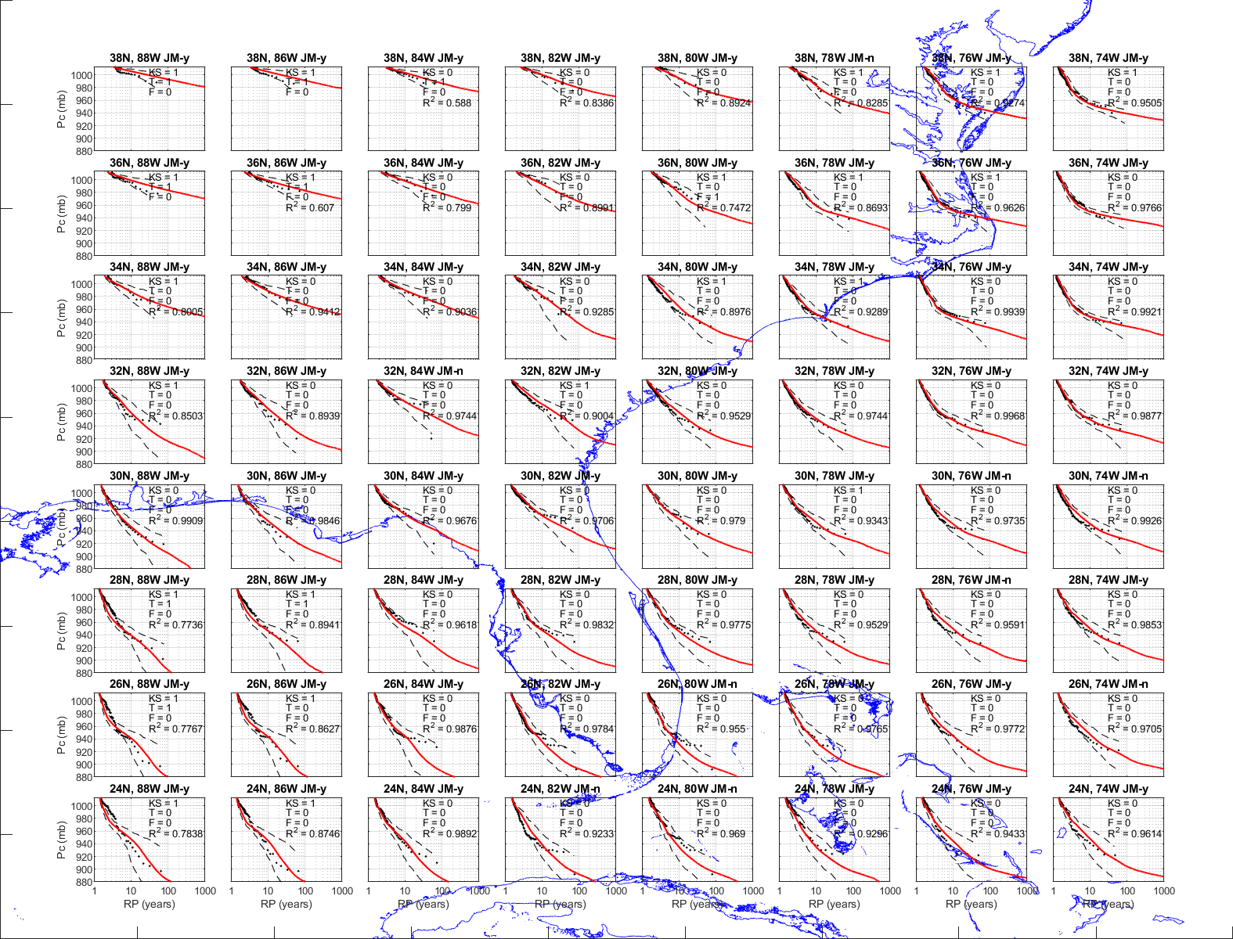

Figure 2‑6. Modeled and observed central pressures vs. return period for points located near Florida. JM = n indicates failure of the empirical distribution equivalence test proposed by James and Mason (2005). F=1 indicates failure of *F*-test, T=1 indicates failure of the t-test, KS=1 indicates failure of the KS test. Dashed lines represent the 95% confidence interval.

* 1. Wind Field Modeling

The hurricane wind field model used here is described in detail in Vickery et al. (2008b). A brief overview of the hurricane wind field model is given below. The model consists of two basic components, namely a 2-D finite difference solution for the equations of motion for a 2-D slab model used to describe the horizontal structure of the hurricane boundary layer, and a 1-D boundary layer model to describe the variation of the horizontal wind speed with height.

The main reason for using a 2-D numerical model is that it provides a means to take into account the effect of surface friction on wind field asymmetries, as well as enabling the model to predict super gradient winds, and also to model the enhanced inflow caused by surface friction, particularly at the sea-land interface. The inputs to the slab model include Δ*p*, the Holland *B* parameter, *RMW* and translation speed. Previously, translation speed inputs to the slab model greater than 15 m/s were scaled down using Equation 14.

|  |  |
| --- | --- |
| $$c=\min\left(c_{1}+\frac{c-c_{1}}{3.0},c_{2}\right) for c>c_{1}$$ | 14 |

where $c_{1}$ was set to 15 m/s and $c_{2}$ equaled 20 m/s. However, this formulation allowed the model to produce unrealistically high wind speeds for weak but fast moving storms. This was particularly problematic at higher latitudes, where storms can travel much faster than at mid and lower latitudes near the equator. To reduce the effect, the values of $c_{1}$ and $c_{2}$ were updated to 10 m/s and 15 m/s, respectively. This change was made during a study of the wind speeds produced by Hurricane Nate (2017), where we found that the use of the reduced translation speed greatly improved the comparisons between modeled and observed wind speeds.

The results from the 2-D slab model are coupled with a boundary layer model that reproduces the variation of the horizontal wind with height. This model has been developed using a combination of experimental and theoretical analyses. The experimental data consists of the analysis of dropsonde data collected in hurricanes during the period from 1997 through 2003. As described in Vickery et al. (2008b), the variation of the mean horizontal wind speed, *U*(*z*) with height *z*,in the hurricane boundary layer can be modeled using:

|  |  |
| --- | --- |
| $$U\left(z\right)=\frac{u_{*}}{k}\left[ln\left(\frac{z}{z_{o}}\right)-0.4{\left(\frac{z}{H^{*}}\right)}^{2}\right]$$ | 15 |

where, *u\**is the friction velocity, *z* is height above ground, *zo* is the aerodynamic roughness length, *k* is the von Karman constant, taken as 0.4, and *H* is the height of the boundary layer.

The boundary layer height, *H*,in meters, for winds over water is computed from:

|  |  |
| --- | --- |
| $$H=385+0.291/I$$ | 16 |

where the inertial stability parameter, *I*, is defined as:

|  |  |
| --- | --- |
| $$I= \sqrt{\left(f+\frac{2V}{r}\right)\left(f+\frac{V}{r}+\frac{∂V}{∂r}\right)}$$ | 17 |

*V* is the azimuthally averaged tangential gradient wind speed, *f* is the Coriolis parameter and *r* is the radial distance from the center of the storm in meters. As discussed in Vickery et al. (2008b), the $\frac{∂V}{∂r}$ term in Equation 17 is ignored in the model. Since *H* is a function of 1/*I*, the boundary layer height decreases with increasing wind speed and decreasing distance from the center of the storm. In the computation of *I*, *r* is constrained to be greater than or equal to the radius to maximum winds (*RMW*).

The ratio of the mean over water surface level (10 m) wind speed to the mean wind speed at the top of the boundary layer obtained from the model varies between about 0.67 and 0.74, with 0.71 being a representative value. Figure 2‑7 presents a comparison of the variation of wind speed with height derived from Equations 15, 16, and 17, to the profiles derived from dropsonde analyses. The model profiles are computed with the only input being the maximum wind speed within the boundary layer (i.e., a direct output of the numerical solution of the equations of motion of a translating hurricane as described in Vickery et al. (2008b), Vickery et al. (2000b), or Thompson and Cardone (1996)). The agreement between the modeled and measured profiles is seen to be good.



Figure 2‑7. Modeled and observed hurricane mean vertical profiles of horizontal wind speed over the open ocean for a range of mean wind speeds

Once the hurricane moves over land, the boundary layer height parameter is increased using the approach described in Vickery et al. (2008b). The full transition from a marine terrain to an open terrain results in an 18% to 20% reduction of the mean wind speed at a height of 10 m.

As the wind moves from the sea to the land, the value of the maximum wind speed at a given height in the new rougher terrain approaches the fully transitioned value, representative of the new rougher terrain, asymptotically over some fetch distance, *F.* For modeling the transition from sea to land, the ESDU (1982) boundary layer transition model is used, but the limiting fetch distance of about 100 km used in ESDU (1982) is reduced to 20 km. This smaller fetch distance is consistent with the lower boundary layer heights associated with tropical cyclones (~600 m) compared to the larger values (~3000 m) used in ESDU for winds not produced by tropical cyclones. Figure 2‑8 presents a plot showing the percentage the wind speed has transitioned (reduced) from the overwater values to the overland values as a function of distance from the coast. Note that at a distance of about 1 km from the coast, the peak gust wind speed has transitioned to about 70% of the fully reduced value. In a typical strong hurricane, the surface roughness, *z*o will be about 0.003m, and the open terrain value is 0.03m. From ESDU (1982) the full transitioned values of the peak 3 second gust and hourly mean wind speeds are about 89% and 83% of the marine winds, respectively.



Figure 2‑8. ESDU and modified ESDU wind speed transition functions at 10 m elevation.

Figure 2‑9 presents a summary comparison of the maximum peak gust wind speeds computed using the wind field model described in Vickery et al. (2008b) to observations for both marine and land based anemometers. There are a total of 245 comparisons summarized in the data presented in Figure 2‑9 (165 land based measurements and 80 marine based measurements). The agreement between the model and observed wind speeds is good, however there are relatively few measured gust wind speeds greater than 100 mph. The largest observed gust wind speed is only 128 mph. The differences between the modeled and observed wind speeds is caused by a combination of the inability of the wind field model to be adequately described by single values of *B* and *RMW*, errors in the modeled boundary layer, errors in height, terrain and averaging time adjustments applied to measured wind speeds (if required) as well as storm track position errors and errors in the estimated values of Δ*p*, *RMW* and *B*. Estimates of the wind field model error obtained from the information given in Figure 2‑9 are used in the estimates of wind speed as a function of return period as described in Section 0.



Figure 2‑9. Example comparisons of modeled and observed maximum surface level peak gust wind speeds from landfalling hurricanes. Wind speeds measured on land are given for open terrain and wind speeds measured over water are given for marine terrain.

# DESIGN WIND SPEEDS

Predictions of wind speed vs. return period, given at surface level (10 m) are based upon a 500,000-year simulation of tropical cyclones occurring in the Atlantic basin. Wind speeds are computed if a simulated cyclone passes within 250 km of a location. The wind speeds produced by the storm are retained if the peak gust wind speed at the site exceeds 20 mph.

Predicted wind speeds have been derived using the conditional wind speed exceedance probabilities obtained by rank ordering the wind speeds resulting from the 500,000-year simulation. An interpolation technique is then used to obtain wind speed exceedance probabilities.

* 1. Analysis Methodology

Upon completion of a 500,000-year simulation, the wind speed data are rank ordered and then used to define the wind speed probability distribution, *P(v>V)*, conditional on a storm having passed within 250 km of the site and producing a peak gust wind speed at ground level in open terrain at the site of at least 20 mph. The probability that the tropical cyclone wind speed (independent of direction) is exceeded during time period *t* is:

|  |  |
| --- | --- |
|  | 18 |

where $P\left(v<V | x\right)$ is the probability that velocity *v* is less than *V* given that *x* storms occur, and *pt*(*x*) is the probability of *x* storms occurring during time period *t*. $P\left(v<V | x\right)$ is obtained by interpolating from the rank ordered wind speed data. From Equation (4), with *pt(x*) defined as Poisson and defining *t* as one year, the annual probability of exceeding a given wind speed is:

|  |  |
| --- | --- |
| $$P_{a}\left(v>V\right)=1-exp\left[-λP\left(v>V\right)\right]$$ | 19 |

where *λ* represents the average annual number of storms approaching within 250 km of the site and producing a minimum 20 mph peak gust wind speed (i.e., the annual occurrence rate).

* 1. Results

The model results include the effect of uncertainties of wind speed. The wind speed uncertainty term is the same as that used in the development of the ASCE 7-10 and ASCE 7-16 wind speed maps. Thiserror term increases the 100-year return period wind speed by a few percent. The effect of the error term on the percentage increase of the nominal wind speed increases with increasing return period. The wind speed uncertainty term is modeled using a multiplicative term with a mean of 1.0 and a standard deviation, σ, of 0.10. The uncertainty term is normally distributed and truncated at ±2σ. The estimation of errors associated with tropical cyclone hazard modeling is discussed in more detail in Vickery et al., 2008a.

* + 1. Site Specific Comparisons in Florida Panhandle

Major updates to the track, intensity, and wind field models presented in Section 2 and 3, include:

* Adding historical meteorological data (sampled within the simulation routine) through 2017
* Extending tracking model coverage to include the eastern Canadian coastline
* Recalibrating tracking parameters throughout the Atlantic Basin
* Recalibrating intensity parameters near the Florida Panhandle
* Adjusting the effect of translation speed in the wind field model

Comparisons of the predicted peak gust wind speeds at a height of 10 m before and after major updates to the models are given in Figure 3‑2 through Figure 3‑6 for five locations along the Florida Panhandle, shown in Figure 3‑1. The predicted gust wind speed curves were obtained from 100,000-year simulations and do not include the effects of non-tropical cyclones on the wind hazard. Due to the impact of the unprecedented strength of Hurricane Michael making landfall near Panama City, the Panhandle region saw the largest increases in design wind speeds compared to those contained in ASCE 7-16. The largest increases occurred near Panama City. West of Apalachicola, changes in design wind speeds were insignificant.

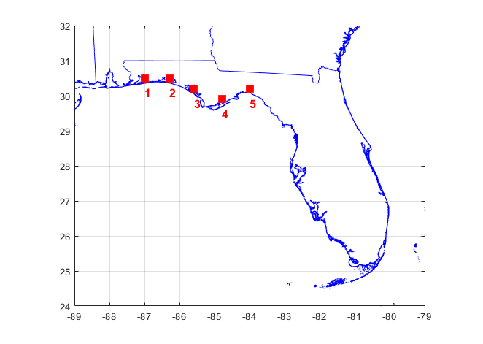

Figure 3‑1. Locations of wind speed comparisons along the Florida Panhandle.

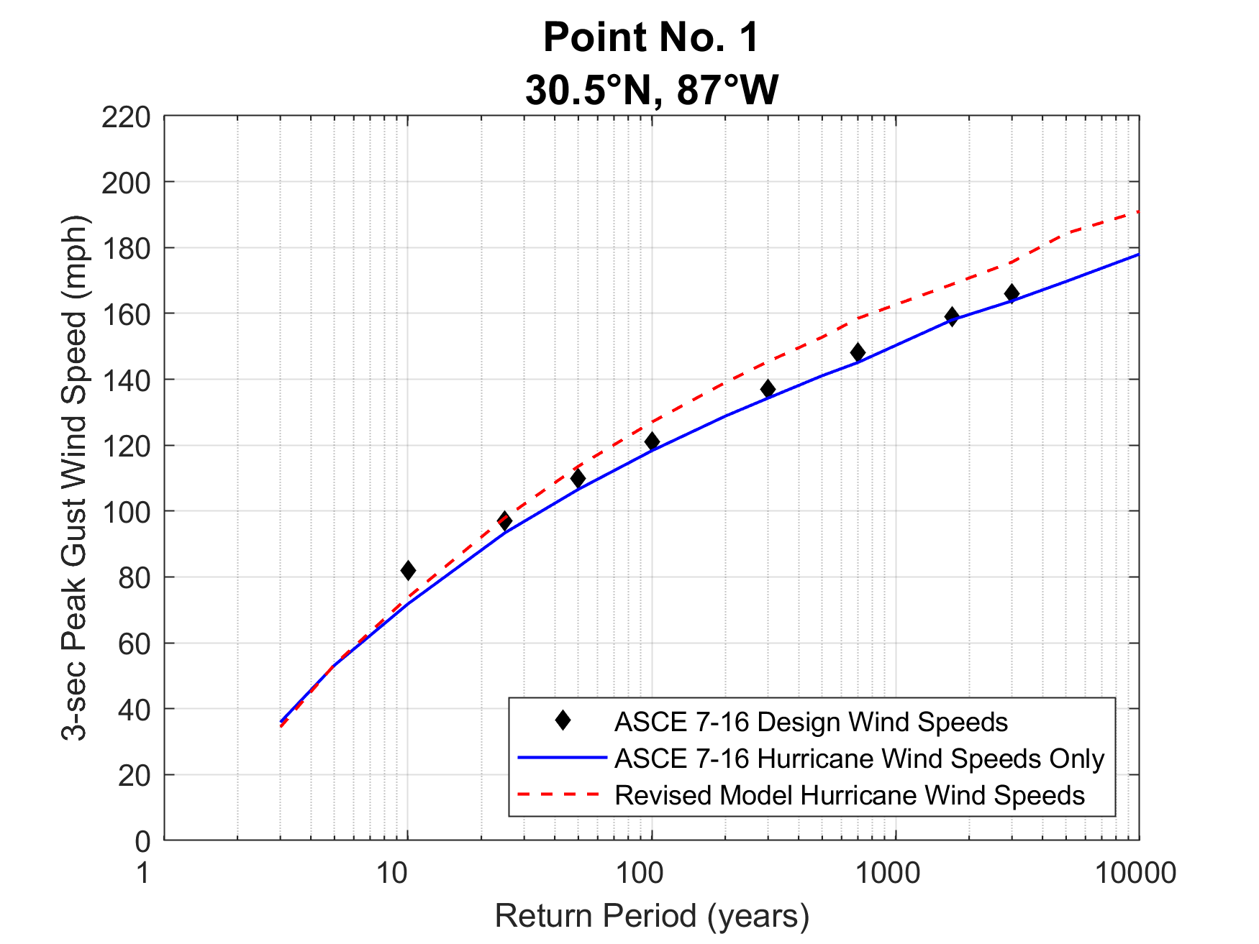

Figure 3‑2. Predicted peak gust wind speeds at a height of 10 m at 30.5°N, 87.0°W.

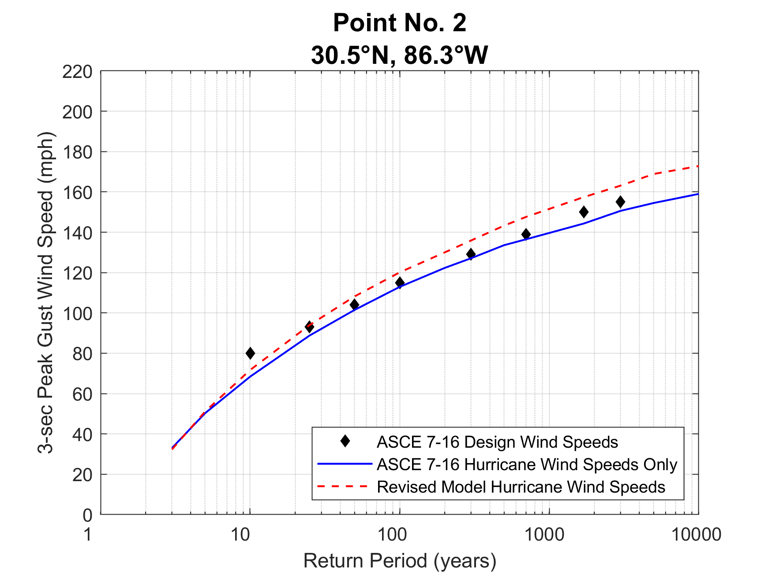

Figure 3‑3. Predicted peak gust wind speeds at a height of 10 m at 30.5°N, 86.3°W.

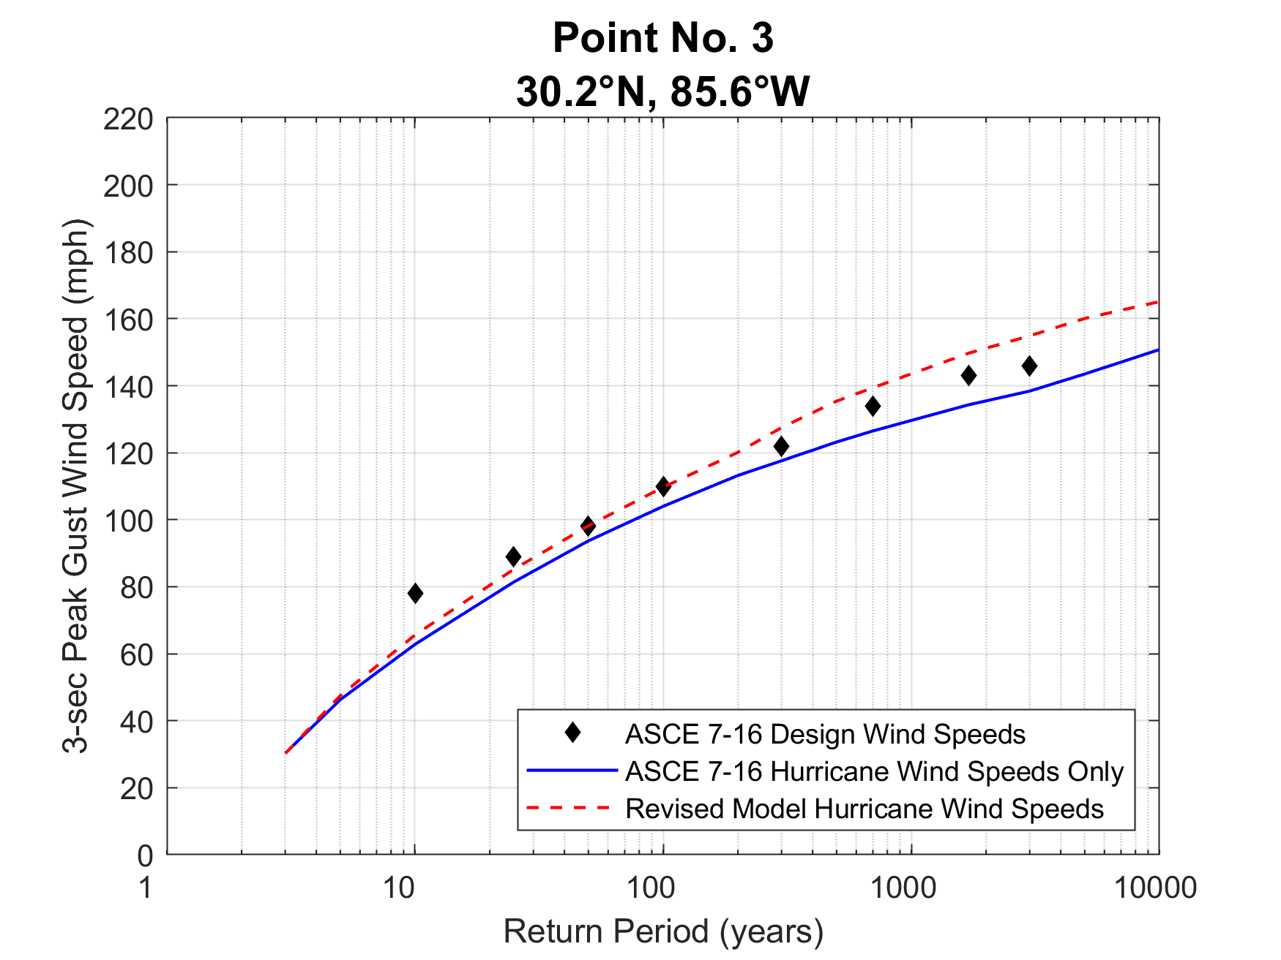

Figure 3‑4. Predicted peak gust wind speeds at a height of 10 m at 30.2°N, 85.6°W.

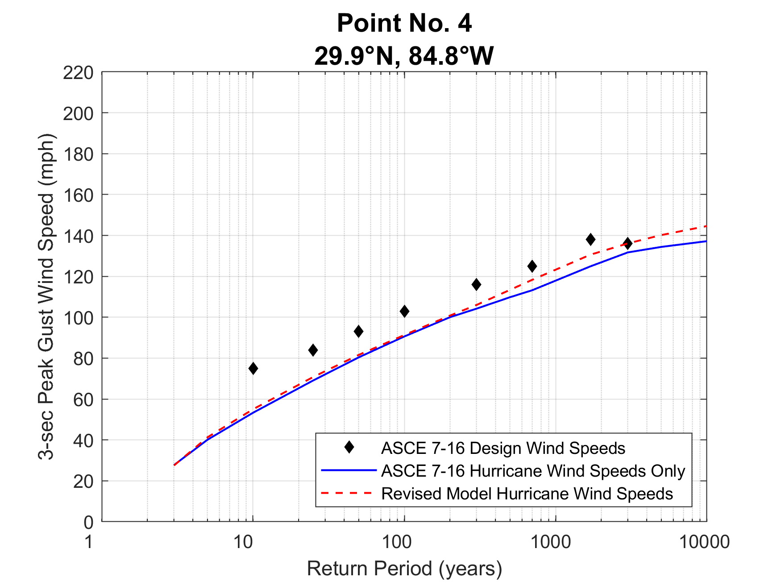

Figure 3‑5. Predicted peak gust wind speeds at a height of 10 m at 29.9°N, 84.8°W.

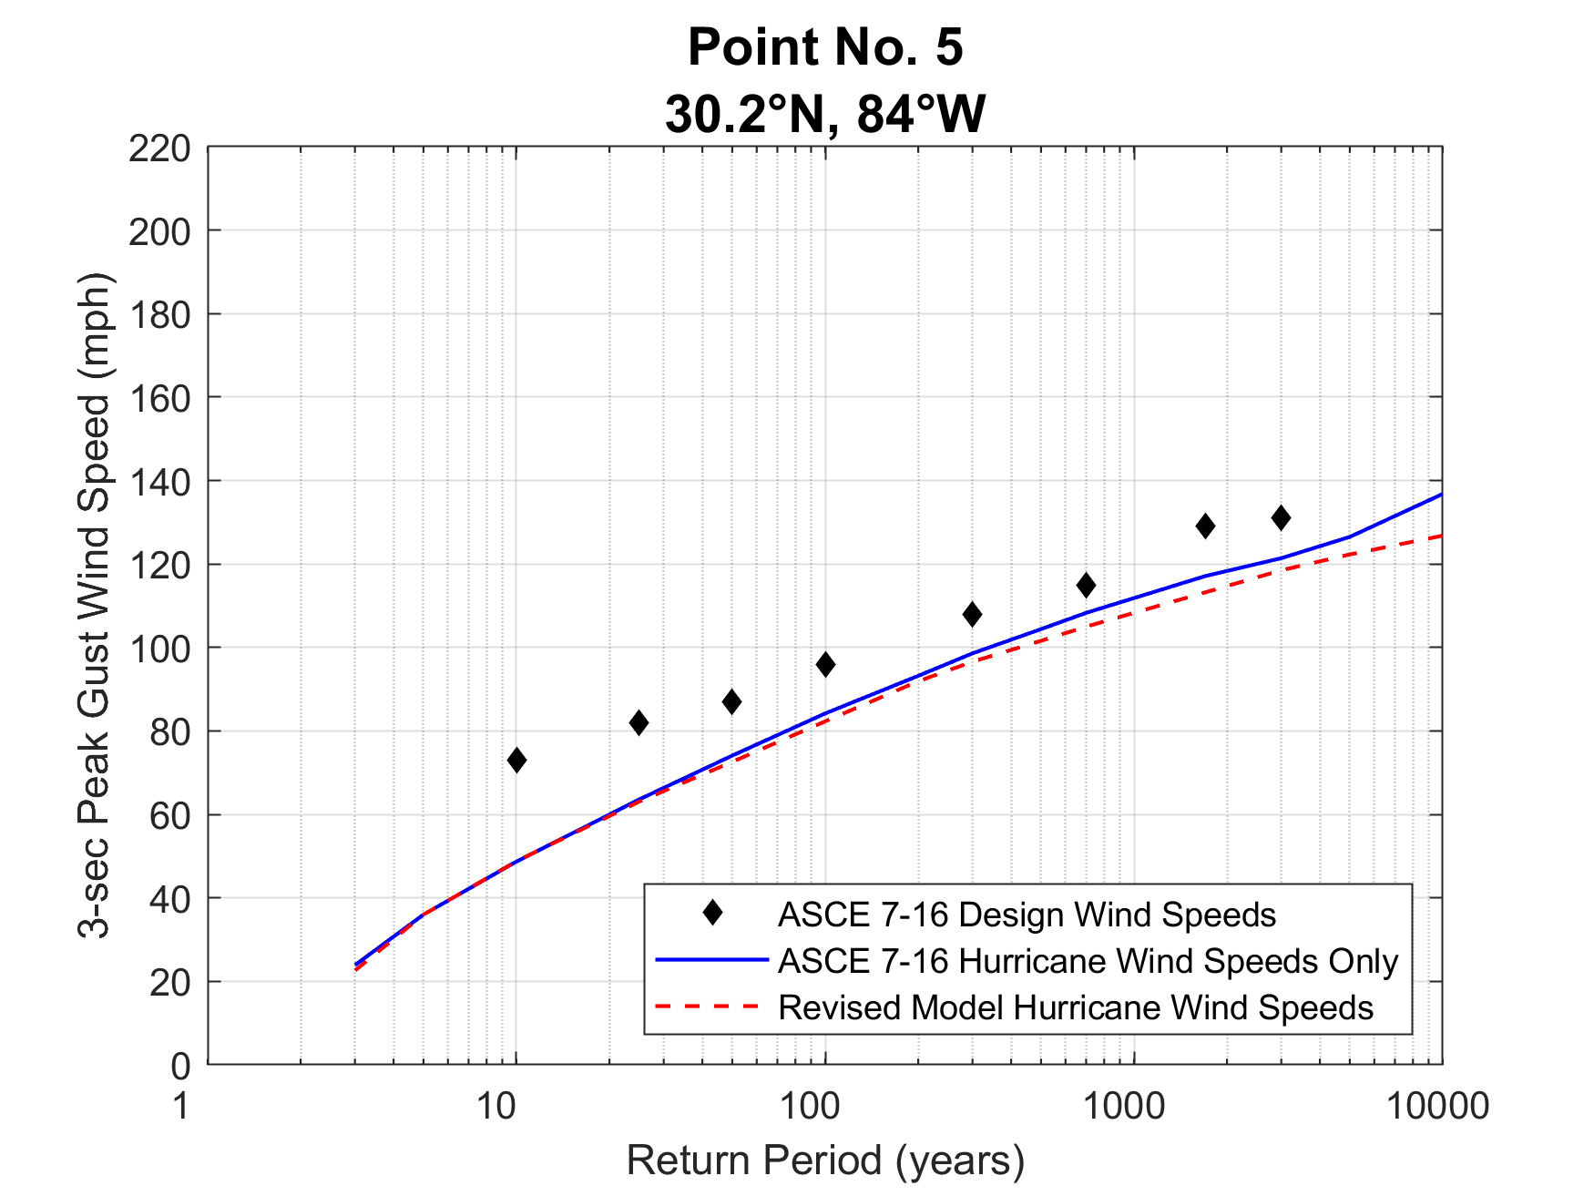

Figure 3‑6. Predicted peak gust wind speeds at a height of 10 m at 29.9°N, 84.8°W.

* + 1. Design Wind Speed Maps

**[INCOMPLETE]**

# SUMMARY

This report outlines the peer reviewed hurricane simulation model as detailed in Vickery et al. (2000a, 2000b, 2008a, 2008b), Vickery and Wadhera, (2008) used to develop design wind speed maps for Florida at return periods of 300, 700, 1700, and 3000-years. Estimates of wind speeds as a function of return period for five locations in the Florida Panhandle were presented.

Updates to the hurricane simulation methodology were discussed including: the addition of historical meteorological data through 2018, recalibration of the track and intensity models to yield a cohesive model applicable to the Atlantic basin, recalibration of the intensity model due to the recent significant landfall impact of Hurricane Michael, and an adjustment to the effect of storm translation speed in the wind field model.

The hurricane simulation model used here is an updated version of that described in Vickery et al. (2000a, 2000b) which was used to produce the design wind speeds used in the ASCE 7-98 through to the ASCE 7-16, the most current version.

# REFERENCES

DeMaria, M., and J. Kaplan (1999), “An updated Statistical Hurricane Intensity Prediction Scheme (SHIPS) for the Atlantic and Eastern North Pacific Basins”, Weather and Forecasting, **14**, 326–337.

Emanuel, K.A, S. Ravela, E. Vivant and C. Risi, (2006), “A statistical–deterministic approach to hurricane risk assessment”, *Bull. Amer. Meteor. Soc*., **19**, 299-314.

ESDU, (1982), “Strong Winds in the Atmospheric Boundary Layer, Part 1: Mean Hourly Wind Speed”, Engineering Sciences Data Unit Item No. 82026, London, England, 1982.

Georgiou, P.N., (1985), “Design Windspeeds in Tropical Cyclone-Prone Regions”, Ph.D. Thesis, Faculty of Engineering Science, University of Western Ontario, London, Ontario, Canada, 1985.

Georgiou, P.N., A.G. Davenport and B.J. Vickery, (1983) “Design wind speeds in regions dominated by tropical cyclones”, 6th International Conference on Wind Engineering, Gold Coast, Australia, 21-25 March and Auckland, New Zealand, 6-7 April.

Holland, G.J., (1980), “An analytic model of the wind and pressure profiles in hurricanes, *Mon. Wea. Rev*., **108** (1980) 1212-1218.

James, M. K. and L.B. Mason, (2005), “Synthetic tropical cyclone database”, *J. Wtrwy, Port, Coast and Oc. Engrg.*, **131,** 181-192

Jarvinen, B.R., C.J. Neumann, and M.A.S. Davis, (1984), “A Tropical Cyclone Data Tape for the North Atlantic Basin 1886-1983: Contents, Limitations and Uses”, NOAA Technical Memorandum NWS NHC 22, U.S. Department of Commerce, March, 1984.

Thompson, E.F., and V.J. Cardone (1996). “Practical modeling of hurricane surface wind fields,” *Journal of Waterway, Port, Coastal, and Ocean Engineering*, **122**, 195-205.

Vickery, P.J. and D. Wadhera, (2008), “Statistical Models of Holland Pressure Profile Parameter and Radius to Maximum Winds of Hurricanes from Flight Level Pressure and H*Wind Data”, submitted to *J. Appl. Meteor.*

Vickery, P.J.; D. Wadhera, L.A. Twisdale Jr., and F.M. Lavelle, (2008a), “United States hurricane wind speed risk and uncertainty”, submitted to *J. Struct. Eng.*.

Vickery, P.J., D. Wadhera, M.D. Powell and Y. Chen, (2008b) “A Hurricane Boundary Layer and Wind Field Model for Use in Engineering Applications”, accepted for publication in *J. Appl. Meteor.*

Vickery, P.J., J. X. Lin, P. F. Skerlj, and L. A. Twisdale Jr., (2006), “The HAZUS-MH hurricane model methodology part I: Hurricane hazard, terrain and wind load modeling”, *Nat. Hazards Rev.,* **7**, 82-93

Vickery, P.J., (2005), “Simple empirical models for estimating the increase in the central pressure of tropical cyclones after landfall along the coastline of the United States”, *J. Appl. Meteor*., **44,** 1807-1826.

Vickery, P.J., P.F. Skerlj and L.A. Twisdale Jr., (2000a) “Simulation of hurricane risk in the U.S. using an empirical track model,” *J. Struct. Eng.*, **126**, 1222-1237

Vickery, P.J., P.F. Skerlj, A.C. Steckley and L.A. Twisdale Jr., (2000b) Hurricane wind field model for use in hurricane simulations, *J. Struct. Eng.*, **126**. 1203-1221

Vickery, P.J. and P.F. Skerlj, (2000c), “Elimination of exposure D along hurricane coastline in ASCE 7”, *J. Struct. Eng.*. **126**, 545-549

Vickery, P.J., and L.A. Twisdale, (1995), “Prediction of hurricane wind speeds in the U.S.,” *J. Struct. Eng.*, **121**, 1691-1699