STATE FISCAL YEAR 2009-2010



INVITATION TO NEGOTIATE FOR

Administrative Service for the State Product Approval System
For the Florida Building Commission

ITN DCA 10-

Issued by:
Department of Community Affairs
Codes and Standards Section
2555 Shumard Oak Boulevard
Tallahassee, Florida 32399-2100
Telephone: (850) 487-1824
Fax: (850) 414-8436
TABLE OF CONTENTS

TABLE OF CONTENTS
SECTION 1 – INTRODUCTORY MATERIALS:
……………………………………………………................................................................................... 5

1.01 DEFINITIONS: ................................................................................................................................................................ 5
1.02 QUALIFICATION REQUIREMENTS:
….……………………………………................................................................................................... 6
1.03 OVERVIEW: ................................................................................................................................................................ 6
1.04 PRODUCT ENTITY APPLICATION:
…………………………………………………………………………………………………………………………………… 8
1.05 PRODUCT COMPLIANCE METHODS:
…………………………………………………………………………………………………………………………………… 10
1.06 PRODUCT APPROVAL APPLICATION:
…………………………………………………………………………………………………………………………………… 10
1.07 PRODUCT APPROVAL APPLICATION – SUBMITTAL PROCESS:
…………………………………………………………………………………………………………………………………… 12
1.08 PRODUCT APPROVAL REVIEW PROCESS AND DEADLINES:
…………………………………………………………………………………………………………………………………… 16
1.09 FISCAL YEAR 2008-09 ENTITY AND PRODUCT APPLICATION STATISTICS:
…………………………………………………………………………………………………………………………………… 18
1.10 DESCRIPTION OF ADDITIONAL REQUIREMENTS:
…………………………………………………………………………………………………………………………………… 19
1.11 TIMELINE:
…………………………………………………………………………………………………………………………………… 20

SECTION 2 – SPECIAL INSTRUCTIONS TO RESPONDENTS
THIS SECTION SERVES IN CONJUNCTION WITH ATTACHMENT B - PUR 1001 GENERAL INSTRUCTIONS TO RESPONDENTS
……………………………………………………................................................................................... 21

2.01 AMENDMENTS TO THE SOLICITATION DOCUMENTS: ……………………………………….................................................................................................... 21
2.02 QUESTIONS: ……………………………………….................................................................................................... 21
2.03 ALTERNATE REPLIES: ……………………………………….................................................................................................... 21
2.04 SPECIAL ACCOMMODATION: ……………………………………….................................................................................................... 20
2.05 CONFIDENTIAL, PROPRIETARY, OR TRADE SECRET MATERIAL: ……………………………………….................................................................................................... 21
2.06 CERTIFICATION OF DRUG-FREE WORKPLACE PROGRAM: ……………………………………….................................................................................................... 22
2.07 DIVERSITY: ……………………………………….................................................................................................... 22
2.08 INAPPLICABLE PROVISIONS OF ATTACHMENT B - PUR 1001 GENERAL INSTRUCTIONS FOR RESPONDENTS: ……………………………………….................................................................................................... 22
2.09 PRICE SHEET INFORMATION/INSTRUCTION –PRICING: ……………………………………….................................................................................................... 22
2.10 RESPONSE SUBMITTAL: ……………………………………….................................................................................................... 23
2.11 PASS / FAIL REQUIREMENTS: ……………………………………….................................................................................................... 24

2.12 RESPONSE TO CRITERIA: ……………………………………….................................................................................................... 25
2.13 NEGOTIATION PROCESS: ……………………………………….................................................................................................... 28
2.14 DISCLOSURE OF REPLY CONTENTS: ……………………………………….................................................................................................... 28
2.15 SUBCONTRACTING: ……………………………………….................................................................................................... 28

SECTION 3 – TECHNICAL SPECIFICATIONS ................................................................................................................................................................ 29

3.01 GENERAL DESCRIPTION OF SERVICES TO BE PROVIDED: ................................................................................................................................................................ 29
3.02 CONTRACTOR STAFF REQUIREMENTS: ................................................................................................................................................................ 29
3.03 REPORTING REQUIREMENTS: ................................................................................................................................................................ 30
3.04 SCOPE OF WORK: ................................................................................................................................................................ 30
3.05 DEPARTMENT RESPONSIBILITIES: ................................................................................................................................................................ 30
3.06 CONTRACT ADMINISTRATION ................................................................................................................................................................ 30

SECTION 4 – SPECIAL CONDITIONS
THIS SECTION SERVES IN CONJUNCTION WITH ATTACHMENT A - PUR 1000 GENERAL CONTRACT CONDITIONS.
............................................................................................................................................................... 31

4.01 COMPLIANCE WITH LAWS: ............................................................................................................................................................... 31
4.02 PERFORMANCE BOND: ............................................................................................................................................................... 31
4.03 BACKGROUND CHECK: ............................................................................................................................................................... 31
4.04 CONTRACT TERM: ............................................................................................................................................................... 31

SECTION 5 – FORMS INSTRUCTION AND INFORMATION ............................................................................................................................................................... 32

ATTACHMENT 1 – RESPONDENT’S CONTACT INFORMATION ............................................................................................................................................................... 33
ATTACHMENT 2– CERTIFICATION OF DRUG-FREE WORKPLACE PROGRAM ............................................................................................................................................................... 34
ATTACHMENT 3– NOTICE OF CONFLICT OF INTEREST ............................................................................................................................................................... 35
ATTACHMENT 4 – NON-COLLUSION AFFIDAVIT ............................................................................................................................................................... 36
ATTACHMENT 5 – STATEMENT OF NO INVOLVEMENT ............................................................................................................................................................... 38
ATTACHMENT 6 – BUSINESS/CORPORATE REFERENCE ............................................................................................................................................................... 39
ATTACHMENT 7 – ADDENDUM / AMENDMENT ACKNOWLEDGEMENT FORM ............................................................................................................................................................... 41
ATTACHMENT 8 – PERFORMANCE STANDARDS ............................................................................................................................................................... 42
ATTACHMENT 9 – PRICE SHEET ............................................................................................................................................................... 43

INCLUDED AS SEPARATE DOCUMENTS

ATTACHMENT A – PUR 1000 GENERAL CONTRACT CONDITIONS

ATTACHMENT B – PUR 1001 GENERAL INSTRUCTIONS TO RESPONDENTS

ATTACHMENT C – VALIDATOR CHECKLIST ............................................................................................................................................................... 45
ATTACHMENT D – REVIEW PROCESS / DEADLINES ............................................................................................................................................................... 50
ATTACHMENT 10 – EVALUATIONS SCORECARD ............................................................................................................................................................... 52
ATTACHMENT 11 – VENDOR QUESTIONS ............................................................................................................................................................... 55
ATTACHMENT 12 – SUBCONTRACTING ............................................................................................................................................................... 56

SECTION 1 – INTRODUCTORY MATERIALS

1.01 Definitions

A. Contract: Means the legally enforceable agreement, if any, that result from this solicitation. The parties to the contract will be the DCA and the Contractor.

B. Contractor: The Responsive Respondent who is awarded a contract as a result of this solicitation.

C. Subcontractor: An individual or business firm contracting to perform all or some of the Contractor’s work.

D. Florida Building Commission: authority having jurisdiction over the Product Approval System, referred to in this document as “Commission”.

E. Department: The State of Florida, Department of Community Affairs, is referred to in this document as “DCA” or “Department”.

F. Respondent: See attachment B – PUR 1001 General Instructions to Respondents for definition.

G. Response: See Attachment B – PUR 1001 General Instructions to Respondents for definition.

H. State: The State of Florida and its agencies.

I. Vendor: The person submitting a bid to this solicitation.

1.01.1 Definitions that Pertain Specifically to DCA ITN

A. Product Approval System: Process for optional statewide product approval. Referred to in this document as “PAS.”

B. Building Code Information System (www.floridabuilding.org) used for submittal of applications and payment of fees for statewide product and entity approvals.

C. Program System Administrator: referred to in this document as “Administrator”.

D. Accreditation Body: An organization that accredits and monitors the competency and performance of an agency carrying out specific tasks. Accreditation bodies are not required to register on the BCIS or pay fees.

E. Evaluation Entity: An organization that conducts product evaluation based on test report and/or rational analysis. Approved evaluation entities can certify testing labs, certification agencies, and quality assurance agencies.

F. Testing lab: Conduct product tests. Testing labs accredited by Commission approved accreditation bodies may apply for approval.

G. Certification Agency: Evaluates products based on tests and/or rational analysis, conduct quality assurance, certify compliance with standards, and list and label products. Approved certification agencies can certify quality assurance agencies. Certification agencies accredited by an approved accreditation body may apply for approval.

H. Quality Assurance Agency: Monitor product manufacturing production. Quality assurance agencies accredited by an approved accreditation body (i.e. approved certification agencies) may apply for approval.

I. Validation Entity: Certifies compliance with standards and certify to the Commission the correctness of the product approval applications. Validation entities that may apply for approval include the following: Approved evaluation entities; approved certification agencies and Florida licensed architects and engineers. Architects and engineers are not required to apply or pay fees.

1.02 QUALIFICATION/EXPERIENCE REQUIREMENTS:

The Program System Administrator (Administrator) must, at minimum, be licensed pursuant to Chapters 468, 471, or 481 (Part I), Florida Statutes, and have five years documented work experience in the structural provisions of the Florida Building Code (FBC); or, five years documented experience in building code enforcement and application; or, five years documented experience in building code product approval and evaluation or in the State Product Approval System (PAS).

1.03 Overview:

The Department of Community Affairs invites interested parties to submit responses to provide the Department with a contractor “Program System Administrator” qualified to review and process product approval and product entity documentation for compliance with Rule 9B-72, Florida Product Approval, F.A.C., and Chapter 120, Florida Statutes.

Goals:

The Administrator will accomplish the following goals:

1. Accurately process submittals of product applications from manufacturers in compliance with Chapter 120, F.S., requirements.
2. Accurately process submittals of applications for entity approvals in compliance with Chapter 120, F.S., requirements.
3. Update product and entity approval information on the BCIS.
4. Attend all scheduled and called Commission product approval related meetings and provide product and entity recommendations.
5. Develop training materials and provide training for validators.

Background:

As directed by the 2000 Florida Legislature, Section 553.842, Florida Statutes, and for the purpose of ensuring that safe products and technologies are used in building construction, the Florida Building Commission (Commission) developed and implemented the Florida Product Approval System (PAS), an optional program which provides manufacturers the choice of obtaining statewide approval of certain products. To guide the implementation and operation of the state product approval, the Commission adopted Rule 9B-72, Florida Product Approval System, Florida Administrative Code. Rule 9B-72, F.A.C., provides the technical scope and criteria that make up the PAS. The PAS is a complementary program to the Florida Building Code.

The PAS is a database module which includes a web-site, www.floridabuilding.org, for submittal of applications, payment of fees for entity approvals and state product approvals. Product approval applications, including required documentation submitted and approved using the PAS, are public information and are available through the BCIS for review and download by the general public and users in general. Product approval reports and minutes from previous proceedings are available at: www.floridabuilding.org.

The PAS is a complementary program to the Florida Building Code. Product manufacturers have the opportunity to utilize the PAS to obtain state approval for their products demonstrating compliance with the applicable standards and provisions of the Code. The Code is available on-line for access to consumers and users at the following address: www.floridabuilding.org.

The scope of the PAS is limited to approval of products and systems which comprise the building envelope and structural frame for compliance with the structural requirements of the Florida Building Code. The Florida Building Commission can approve the following products for optional statewide approval: panel walls, exterior doors, roofing products, skylights, windows, shutters, structural components and new and innovative products. More detailed information regarding the specific subcategories of products currently covered by the PAS can be found in Rule 9B-72, F.A.C.

To provide a constructive product application review process, coupled with a review / monitoring function, the Commission established a two step review process: (1) Validation of the product application by independent third parties “Validators”, and (2) Spot check review of applications submitted by Administrator.

1.04 Product Entity Application

The Commission developed criteria for the approval of public and private entities that test and evaluate products. The process for product entity approval begins with qualified entities making an on-line application. A typical entity application consists of the following documentation: (a) Name and address; (b) Name of the Commission approved accreditation body; and (c) Certificate of accreditation delineating the scope of accreditation.

The entity application is first reviewed and validated by the accreditation body selected by the applicant. The Administrator will then spot check the information for completeness. The review, at a minimum, shall include confirmation the accreditation certificate is valid and the specific approval applied for is within the scope of the entity accreditation. It is staff opinion the time required to spot check an entity application should not exceed 30 minutes. However, the estimated time does not include the time required to provide feedback to the applicant should the application be deemed incomplete, perform BCIS and other administrative process, etc., which should be included as part of the overall application review time.

Finally, qualified organizations may be approved for multiple product entities. For example, a qualified testing lab could apply for and be approved as a testing lab and a quality assurance agency. This would require separate applications for each approval. Once approved, the approvals will be valid until the Commission requirements change, the approved organization no longer qualifies under current requirements or the approval is suspended or revoked.

(Intentionally Left Blank)

1.05 Product Compliance Methods:

A. There are two methods by which a manufacturer can demonstrate the product complies with the Code:

Method 1: This method encompasses products that have code established performance criteria, standardized testing or comparative or rational analysis. Approval under this method requires submittal and validation, using one of the following compliance methods:

- Certification mark or listing,
- Test report,
- Evaluation report from an entity or
- Evaluation report from an architect or engineer.

Method 2: This method covers products that have no standardized testing or comparative or rational analysis established in the code. Approval under this method requires submittal and validation, using one of the following compliance methods:

- Evaluation report from an entity.
- Evaluation report from an architect or engineer.

1.06 Product Approval Application:

There are three ways a manufacturer can apply for product approval:

(1) New application,
(2) Revision to an existing application, and
(3) Self-Affirmation of an existing application.

A new product application and technical revision to an existing product application is required to be validated by an approved validation entity and approved by the Commission.

Rule 9B-72, F.A.C., allows a manufacturer to self-affirm the existing approval by attesting the applicable standards of the new Code have not changed. Neither validation nor Commission action is required for approval of self-affirmation. The Commission relies on the Administrator to spot check an application for self-affirmation and to approve if determined to be accurate. Since no change is allowed to an exiting application, the spot check by the Administrator is limited in scope, ensuring the standards of the updated Code have not changed. It is staff’s opinion the time required to review a self-affirmed application should not exceed 30 minutes.

1.07 Product Approval Application - Submittal Process:

The product application submittal process using the BCIS consists primarily of two steps:

Step #1: Product application submittal.

Step #2: Validation by an approved validation entity.

Step #1: Product Application Submittal.

The process for product approval begins with the manufacturer/applicant submitting an on-line application. As part of the product application submittal, the manufacturer or designee is required to login into the BCIS and complete the electronic product approval application, including uploading all the required technical documentation. A typical submittal will include, but not be limited to, the following information regarding the product:

1. Product name and model number (if any).
2. Name, address and reports of the applicable testing lab, evaluation entity, or certification agency.
3. List of requirements the product is required to comply, including Code section numbers and/or reference standards.
4. List of limitations on product’s use.
5. Product is manufactured under an audited quality assurance program (QA).
6. Product installation instructions.

In addition, the applicant is required to select from the BCIS database an approved QA program and an approved validation entity to review and validate the application. It is the responsibility of the manufacturer to contact these entities and contract directly for these services.

Step #2: Product validation by an approved validation entity.

An approved validator selected by the manufacturer from the BCIS product approval module is required to login into the BCIS, review the application, and certify the product application is correct.

Product validation is a function by which an approved validation entity certifies the product is in compliance with the standards specified in the Code or intent of the Code. To provide for uniform validation process, a verification checklist specific to each compliance method is required to be completed by the validator (Attachment C).

Validation Process

The validation process consists of two levels:

Level 1: Administrative validation, and
Level 2: Administrative validation plus technical validation

(Intentionally Left Blank)

Level 1: Administrative Validation.
This level of validation is applicable to product applications that are based on technical documentation from independent entities (i.e. a certification mark or listing from an approved certification agency, an evaluation report from a Florida Registered Architect or Licensed Engineer independent from the manufacturer, and an evaluation report from an approved evaluation entity (see Figure 1). This level of validation is purely administrative, meaning a validator is not required to perform any technical analysis or evaluation. In fact, a validator’s role at this level is to verify through inspection/observation the items on the applicable validation checklist are consistent with the information provided on the product application, including test report. The majority of the applications are processed through this level of validation.

Figure 1: Administrative validation

Level 2: Administrative plus Technical Validation.
This level of validation is required for product applications using a test report from an approved testing laboratory or an evaluation report from an approved evaluation entity that is not an independent third party from the manufacturer (see Figure 2). In addition to performing an administrative validation, the validator is required to perform a more in-depth technical review to ensure the evaluation was performed using acceptable engineering principles and the correct test was performed.

Figure 2: Administrative plus technical validation

1.08 Product Approval Review Process and Deadlines:

The Commission has established specific criteria for reviewing product applications, including all applications must be validated by an approved validation entity, are complete, and subject to public comments and review. Deadlines detailing the review process can be found in Attachment D. Applications reviewed and determined by the Administrator to be complete are posted on the Department of Community Affairs (DCA) website for seven days (7) for review by the general public. Comments from the general public on specific applications are compiled by the Administrator and published for review and consideration by the Product Approval Oversight Committee (POC). The POC, through public meetings, reviews all applications and provides recommendations for consideration by the Commission. The Commission, in a public forum, considers the POC’s recommendations and takes final action on the proposed products.

A. Specific Roles and Responsibilities of the Administrator During Review Process:

(1) After an application is validated by an approved validation entity, the Administrator shall review the application. If the application is complete, the Administrator recommends the application be approved by the Commission. However, if the application is not complete or lacks certain documentation, the Administrator informs the applicant of the deficiencies via the Building Code Information System, and requests the application be corrected and further validated prior to the established deadline.

(2) Only completed applications with recommendations for approval are posted on the Commission agenda for consideration. Comments received on the completed applications from the general public are also compiled by the Administrator and added to the agenda with response from the Administrator.

(3) The Administrator shall attend the POC and the Commission meetings and respond to inquires from members, as needed.

(4) Based on the Commission action on the applications, the Administrator updates the BCIS system within 24 hours of Commission action.

B. Review of Product Application by the Administrator:

The Administrator conducts an administrative application review, meaning the Administrator is not required to perform any technical analysis or evaluation. In fact, the Administrator role is to perform a spot check (inspection by observation) to determine whether the application as submitted complies with the rule and whether the validator has performed his or her service as intended by the rule.

Due to the variation in level of documentation between compliance methods (i.e. certification vs. test report), the level of inspection of a product application may be slightly different. The following is the minimum criteria for application review, broken down by method of compliance. If the original review determines the application to be incomplete or requires additional documentation, more than one review may be required.

- Certification method:

  - Applications submitted under this method can be classified under two sub-classifications: (1) Certification using “Notice of Product Certification” and (2) Listing.

  - Support documentation for this compliance method is very limited in scope and mainly consists of the certificate/listing (one page of information) and the installation instruction.

  - Because the documentation is limited in scope, the review/inspection of the application by the Administrator is limited to: (1) verifying the standards referenced in the application are the same as those referenced in the certificate and the Code; (2) limitation of use is consistent with the certificate; and (3) the certificate is valid.

  - It is staff’s opinion that time required to review an application using the compliance method should not exceed 15 minutes per application. However, the estimated time does not include the time required to provide feedback to the applicant should the application be deemed incomplete, perform BCIS and other administrative process, etc., which should be included as part of the overall application review time.

- Evaluation method (evaluation report from a Product Evaluation Entity or an engineer or architect):

  - Support documentation available for review under this compliance method is also limited in scope.

  - Normally documentation for this method consists of a summary report referencing standard(s) and tests report(s)/data used to evaluate the product, limitation of use for the evaluated products, statement regarding compliance with the intent of the code and installation instructions.

  - Because the documentation is limited in scope, the review/inspection is also very limited. The review/inspection is a spot check to verify the standards referenced in the application are consistent with those in the evaluation report and the code, and the limitation of use on the application is consistent with the evaluation report.

  - It is staff’s opinion the time required to review and inspect an application using this compliance method should not exceed 30 minutes per application. However, the estimated time does not include the time required to provide feedback to the applicant should the application be deemed incomplete, perform BCIS and other administrative process, etc., which should be included as part of the overall application review time.

- Test report method:

  - Support documentation available for review under this method consists of the test report and the installation instruction.

  - The review/inspection of the application will consist of a check to verify the standard(s) referenced in the application is consistent with the standard referenced in the test report, and the limitation of use and installation instruction are as tested.

  - It is staff’s opinion the time necessary to review and inspect an application should not exceed 30 minutes. However, the estimated time does not include the time required to provide feedback to the applicant should the application be deemed incomplete, perform BCIS and other administrative process, etc., which should be included as part of the overall application review time.

Finally, it is staff’s opinion the time necessary to review an application should be far less than the projected time above as the Administrator becomes more familiar with the product review process and the Code referenced standards for products; and taking into account the high frequency of similar applications, the inspection for the purpose of reviewing applications will get easier and less time demanding.

1.09 Fiscal Year 2008-09 Entity and Product Application Statistics

Product Approval Applications: 7/1/08 – 6/30/09:

Self – Affirmations 2007 Code: 440

Certification Method 1,088
Evaluation Method 94
Engineer / Architect 1,131
Test Report 68
Approved 231
TOTAL 3,052

Entities Processed 69

1.10 Description of Additional Requirements:

(1) Contractor must cease performing any other Rule 9B-72, F.A.C., functions if selected to perform this administrative service. Fees will be paid directly to the Contractor by the manufacturer, either via the Building Code Information System at www.floridabuilding.org or other means, as determined by the Department and Contractor.

(2) If the BCIS is used to process payments, Contractor shall comply with all relevant security standards and specific payment credit card industry requirements that maintain data security and compliance throughout the contract.

(3) Contractor shall provide a Statement of independence attesting that no conflict of interest exists between the Contractor and the Florida Building Commission (FBC) approved certification agencies, test laboratories, quality assurance entities, evaluation entities or Florida architects or engineers conducting product evaluations.

(4) The Contractor shall agree to any changes to the scope of work subsequently approved by the Commission.

(5) The Contractor shall establish an office in Florida to provide this service.

(6) The Contractor shall investigate product complaints and serve as expert witness for the Commission, as directed by the Commission.

(7) The Contractor shall coordinate with the Department to provide recommended BCIS enhancements on the Product Approval Module.

(8) The Contractor shall conduct all communications with the product approval and entity applicants through a specified dialogue in-box designated on the BCIS. (The BCIS will be enhanced with this function)

(9) Contractor shall provide annual certified financial statements sufficient to determine the efficacy of the program until a threshold of $300,000 in revenue is reached; thereafter, annual financial audits by a certified auditing firm, to be selected by the Contractor and approved by the Commission within 60 days after the contract is awarded, shall be provided. The annual financial audits shall be provided to the Department by November 1 of each fiscal year.

(10) Contractor shall, at a minimum, develop and conduct on-site validator training sessions at contractor’s expense every six months. The contractor shall communicate electronically (emails or telephone conference) to all validators the common validation mistakes discovered during each application cycle within ten (10) calendar days following each scheduled Commission meeting.

(11) Contractor shall comply with all applicable portions of Chapter 119, Florida Statutes.

(12) Contractor shall track, research and report on all revocations.

(13) Contractor shall be available and provide services during normal business hours, i.e., 8:00a.m. through 5:00p.m.

Note: Initialing each of the numbered items above will indicate respondent has “Read, Understood, and Agree to Satisfy the Standard”.

1.11 Timeline:

Listed below are important dates/times by which actions must be taken or completed. If the Department finds it necessary to update any of the dates/times noted it will be accomplished by an addendum to the solicitation. All times listed below are Tallahassee, Florida local time.

DATE | Time
January 4, 2010 |  | Release of Solicitation
January 11, 2010 | 12:00 pm | Questions Due
January 20, 2010 |  | Anticipated Date Answers to questions are posted on the Vendor Bid System
February 2, 2010 | 4:00 pm | Closing Date for Receipt of Proposals
February 8, 2010 |  | Anticipated Dates of Evaluations
February 15, 2010 |  | Anticipated Date to Post List of Vendors with which the Department will Negotiate
February 22-24, 2010 |  | Anticipated Dates of Negotiations
March 1, 2009 |  | Public Meeting Recommended Award
March 3, 2009 |  | Anticipated Posting of Intended Award on Vendor Bid System
July 1, 2010 |  | Anticipated Contract Start Date

SECTION 2 – SPECIAL INSTRUCTIONS TO RESPONDENTS

This section serves in conjunction with Attachment B – PUR 1001 General Instructions to Respondents.

2.01 Amendments to the Solicitation Documents:

The Department shall post amendments to the solicitation documents on the Florida Vendor Bid System (VBS) at http://vbs.dms.state.fl.us/vbs/search.criteria_form, by selecting “Department of Community Affairs” in the “Agency” drop down box. Each respondent is responsible for monitoring the VBS for new or changing information.

2.02 Questions:

Respondents shall address all questions regarding this solicitation in writing to the Contract Manager, identified on the cover sheet of this solicitation. Questions are to be submitted by the due date on the Timeline in Section 1. The Department shall post answers to questions on the VBS as noted on Section 1, Time. See PUR 1001 – General Instructions to Respondents, Section 21-Limitations on Vendor Contact with Agency during solicitation.

2.03 Alternate Replies:

Alternate replies and exceptions to this solicitation are not permitted. If the Respondent has any issues with the requirements or terms and conditions of this solicitation, such issues shall be presented to the Department and addressed by the Department during the question and answer phase of the solicitation. Including alternate replies or exceptions to this solicitation in any response may result in the response being deemed non-responsive to the solicitation.

2.04 Special Accommodations:

Any person requiring a special accommodation at the Departmental Purchasing because of a disability should call Department Purchasing at (850) 922-1622 at least five (5) workdays prior to the scheduled event. If you are hearing or speech impaired, please contact Purchasing by using the Florida Relay Service at (800) 955-8771 (TDD).

2.05 Confidential, Proprietary, or Trade Secret Material:

The Department takes its public records responsibilities as provided under Chapter 119, Florida Statutes, and Article I, Section 24 of the Florida Constitution, very seriously. If Respondent considers any portion of the documents, data or records submitted in response to this solicitation to be confidential, trade secret or otherwise not subject to disclosure pursuant to Chapter 119, Florida Statutes, the Florida Constitution or other authority, Respondent must also simultaneously provide the Department with a separate redacted copy of its response and briefly describe in writing the grounds for claiming exemption from the public records law, including the specific statutory citation for such an exemption. This redacted copy shall contain the Department’s solicitation name, number, and the name of the respondent on the cover, and shall be clearly titled “Redacted Copy.” The Redacted Copy shall be provided to the Department at the same time Respondent submits its response to the solicitation and must only exclude or obliterate those exact portions that are claimed confidential, proprietary, or trade secret. The Respondent shall be responsible for defending its determination that the redacted portions of its response are confidential, trade secret or otherwise not subject to disclosure. Further, Respondent shall protect, defend and indemnify the Department for any and all claims arising from or relating to Respondent’s determination that the redacted portions of its response are confidential, proprietary, trade secret or otherwise not subject to disclosure. If Respondent fails to submit a Redacted Copy with its response, the Department is authorized to produce the entire documents, data or records submitted by Respondent in answer to a public records request for these records.

2.06 Certification of Drug-Free Workplace Program:

The State supports and encourages initiatives to keep the workplaces of Florida’s suppliers and contractors drug-free. Section 287.087, F.S., provides that, where identical tie proposals are received, preference shall be given to a proposal received from a Respondent that certifies it has implemented a drug-free workforce program. If applicable, Respondent shall sign and submit the attached “Certificate of Drug-Free Workplace Program” form to certify that the Respondent has a drug-free workplace. The Contractor shall describe how it will address the implementation of a drug-free workplace in offering the items of bid.

2.07 Diversity:

Florida is a state rich in its diversity and is dedicated to fostering the continued development and economic growth of small and minority and women-owned businesses. Participation of a diverse group of vendors doing business with the State is central to our effort. To this end, it is vital that small and minority and women-owned business enterprises participate in the State’s procurement process as both prime contractors and subcontractors under prime contracts. Small and minority and women-owned businesses are strongly encouraged to submit replies to this solicitation.

2.08 Inapplicable Provisions of Attachment B – PUR 1001 General Instructions to Respondents:

The following Sections of the PUR 1001 are not applicable to this ITN:

A. Section 3. Electronic Submission of Responses
Responses shall be submitted in accordance with Section 2.10 of this solicitation.

B. Section 5. Questions
Questions shall be submitted in accordance with Section 2.02 of this solicitation.

2.09 Price Sheet Information/Instruction – Pricing:

The Price Sheets shall be provided to the Department in TAB 5 of the Respondent’s
submittal. By submitting a response under this solicitation, each Respondent warrants its agreement to the prices submitted.

A. The Respondent shall price the review for each application as detailed in Section 2.12C on the Price Sheet. Failure to price each Method shall deem the Respondent non-responsive.

B. The Respondent shall print and sign the completed Price Sheet(s) and submit in accordance with Section 2.10, A.

C. The Respondent will save an electronic version of its completed Price Sheet on a CD—Rom and submit with its response (see Section 2.10, B., 3.). Best and Final Offers from qualified Respondents will be solicited to establish the best value for the Department.

2.10 Response Submittal:

Responses should be prepared simply and economically, providing a straightforward, concise description of the Respondent’s ability to provide the services sought by the solicitation. Excessive information distracts readers from focusing on the essentials. When responding to specific questions, please reprint each question in its entirety before the response.

The response shall be limited to a page size of eight and one-half by eleven inches (8 1/2” x 11”), unless otherwise indicated. Type size shall not be less than 12-point font. The response should be indexed and all pages sequentially numbered. Bindings and covers will be at the Respondent’s discretion. However, elaborate notebooks/hard back binders are discouraged.

Elaborate brochures, artwork, expensive paper and expensive visual and other presentation aids are neither necessary nor desired.

The overall response must be written in a concise manner, which is conducive to effective evaluation and selection.

The Respondent may not apply any conditions to any aspect of the solicitation (see Section 2.03). The only recognized changes to the solicitation prior to the opening will be by written amendments issued by the Department.

A. The Respondent shall organize each response submittal content as follows:

Tab 1 A cover letter on the Contractor’s letterhead with the following information:

a) Name and headquarters location of the Respondent.
b) Primary location from where the work will be executed.

Tab 2 Completed Attachments 1

Tab 3 Pass/Fail Requirements as indicated in Section 2.12.

Tab 4 Response Evaluation Criteria as indicated in Section 2.12

Tab 5 Price Sheet – Attachment 9

B. The Respondent shall submit:

1. One (1) original version of the response submittal, with five (5) copies.
2. One (1) original signed version of the price sheet, with five (5) copies.
3. One (1) scanned copy of the entire response and price sheet (see Section 2.09, C.) on a CD-ROM (with large files scanned as several separate PDF files).
4. One (1) REDACTED scanned copy of the response, if applicable (see Section 2.05).
5. Sealed packages to be delivered clearly marked on the outside of the package with the solicitation number and company name.
6. Submitted hardcopies contained within the sealed packages clearly marked with the Respondent’s company name and solicitation number.

Respondents are responsible for submitting responses to the Contract Manager by the date and time specified in Section 1 of the solicitation. The Department shall not consider late responses.

2.11 Pass/Fail Requirements:

The Respondent must satisfy the requirements listed below. By submitting a response the Respondent certifies that it either meet or exceed the requirements listed in this ITN. The Respondent will place this information under Tab 3 of its response.

A. Convicted Vendor List
The Respondent has not been disqualified from the public contracting and purchasing process in accordance with Section 287.133(3)(d), Florida Statutes.

B. Suspended Vendor List
The Respondent has not been removed from the Department of Management Services (DMS) vendor list pursuant to Rule 60A-1.006, Florida Administrative Code.

C. MyFloridaMarketPlaceRegistration
Respondents desiring to sell commodities or contractual services to the State are required by Rule 60A-1.030, Florida Administrative Code, to register in MyFloridaMarketPlace. Also see Attachment A-PUR 1000 General Contract Conditions.

The Respondent will provide the Department copies of its Articles of Incorporation or registration documents demonstrating the entity is authorized to transact business in the State of Florida.

NOTE: Pursuant to Section 4.02 Compliance with Laws, out-of-state corporations are required to obtain a Florida Certificate of Authorization from the Florida Department of State, Division of Corporations, to transact business in the State of Florida. The Respondent agrees to attain such authorization within seven (7) business days of award, should the Respondent be awarded. Website: www.sunbiz.org

2.12 Response to Criteria:

An Evaluation Team will be established to review and evaluate responses received on this solicitation, using a point scale for each Section as outlined in the Evaluation Scorecard, Attachment 10. For the purposes of evaluation, scoring and ranking are divided into three categories. The following shows the maximum number of weighed points that may be awarded by category. See Evaluation Scorecard, Attachment 10.

Section A - Qualifications/Performance/References 50 Points

Section B - Scope of Work 30 Points

Section C – Price 20 Points

Using the Evaluation Scorecard in Attachment 10, the following criteria will be used to evaluate Respondent Proposals.

A. Qualifications/Performance/References (Maximum 50 Points)

The Respondent shall provide the following information to support Respondent’s qualifications and experience. Points for this Section will be awarded as follows:

1. Qualifications and Experience (15 Points)
The Respondent’s ability to provide the following:
- A copy of an active licensed pursuant to Chapter 468, 471 or 481 (Part I), Florida Statutes.

- Documentation of work experience (minimum of 5-years) in the structural provisions of the Florida Building Code; or

- Documentation of work experience (minimum of 5-years) in building code enforcement; or

- Documentation of work experience (minimum of 5-years) in building code product approval or the State Product Approval System.

- A listing of all service personnel Respondent proposes to use to provide the services, including those who will be at the site, and their tenure in the field of building code. Please list each person’s duties and responsibilities.

2. Past Performance References (10 Points)

The Respondent shall furnish a minimum of three (3) references with their response, utilizing the form provided as Attachment 6 of this solicitation, to support their experience in Building Code and building code enforcement or product approval. The experience described in the references shall be ongoing or have been completed within the five (5) years preceding the issue date of this solicitation.

References should be directly related to the services of the solicitation. References that do not support the service delivery experience along with any incomplete Reference forms may be rejected.

References will not be accepted from:

1. Current employees of the Department.
2. Former employees of the Department within the past three (3) years.
3. Persons currently or formerly employed by the Respondent’s organization.
4. Board members of the Respondent’s organization.
5. Relatives.
6. Current or former Commissioners.

The Contract Manager reserves the right to contact the Respondent’s references as well as resources not listed in the response.

3. Current Contracts/Employment (5 Points)

Provide a list of at least 2 contracts of similar size and scope to the services described in this ITN, entered into within the past five (5) years, where the Respondent provided services as a Contractor, subcontractor, or partner or employee. For each listed contract, please describe the services provided by the Respondent.

The list shall also contain the name, contact name and address, telephone number and e-mail address of the customer under that contract. Consideration shall be given to the scope and duration of such contracts, the volume of services, and quality of services provided.

4. Application review (20 Points)

Certification method (see Section 1.04)
Evaluation method by an evaluation entity (see Section 1.04)
Evaluation method by an engineer or architect (see Section 1.04)
Test report method (see Section 1.04).

B. Scope of Work (Maximum 30 Points):

The Respondent must respond to Section 3 by inserting a response immediately below the text of each numbered section and subsection. If a particular section or subsection does not require a response, but rather a work or performance standard or guarantee, the Respondent will indicate they have “Read, Understood, and Agree to Satisfy the Standard” below that particular section or subsection.

For example:

Accurately process submittals of product applications from manufacturers in compliance with Chapter 120, F.S., requirements.
Response:
Respondent will insert their response here or insert “Read, Understood and Acknowledged.”

C. Price (Maximum 20 Points)

On Attachment 9, Price Sheet, provide price for each different application method (refer to Section 1, Introductory Materials, of the ITN). Pricing for review of each method will include all costs for all services. Actual applications will be made available for review to all potential respondents at specific time and date as an addendum within 3 – 5 business days after the ITN is posted.

The Contract Manager will be responsible for calculating and awarding points for price as follows:

The Respondent for the lowest overall average total price (add price for each method and divide by number of methods) will receive up to 5 points/method. Each additional Respondent will be awarded a percentage of the 20 points relative to the lowest total (Lowest Price/Respondents’ Price x --- Points = Points Awarded).

2.13 Negotiation Process:

Using the evaluation criteria specified above, and in accordance with Section 287.057, Florida Statutes, the Department shall evaluate and rank responses. At the Department’s sole discretion, it may negotiate with more than one qualified Respondents. The Department intends to conduct negotiations with qualified Respondents whose proposed service delivery demonstrates the best ability to meet the needs of the Department, and provides the best value to the State. The Department will negotiate with Respondent(s) either serially or concurrently.

Respondent(s) may be requested to make a presentation, and provide additional references, etc. The Department reserves the right to require attendance by particular representatives of the Respondent(s). Any written summary of presentations or demonstrations shall include a list of attendees, a copy of the agenda, and copies of any visuals or handouts, and shall become a part of the Respondent(s) response. Failure to provide the requested information may result in rejection of its response.

After sufficient negotiations, the Department will request a Best and Final Offer from all qualified Respondents with whom it negotiated for final consideration prior to final award decision. After submission of Best and Final Offers to the Contract Manager (electronic version via e-mail), the Department reserves the right to clarify any element of required service delivery or further negotiate pricing with a single respondent or all qualified respondents prior to final award.

In addition, subsequent to establishing a contract resulting from this ITN, if the Department determines that additional services within the scope of the service, additional minimum specifications, modifications, or deletions are needed and it is in the Department’s best interest to amend the scope of service with regards to the specified service delivery, then the Department may enter into negotiations with the Contractor to amend the Contract.

In the event any contract resulting from the ITN is terminated early by either party, the Department reserves the right to negotiate with the next highest ranking responsive and responsible Respondent.

2.14 Disclosure of Reply Contents:

All documentation produced as part of this solicitation shall become a public record of the Department and may not be removed by the Respondent or its agents. All replies shall become a public record of the Department and cannot be returned to the Respondent. The Department shall have the right to use any or all ideas of adaptations of the ideas presented in any reply. Selection or rejection shall not affect this right.

2.15 Subcontracting:

The Respondent shall be fully responsible for all work performed under the resultant Contract of this solicitation. Should the Respondent be awarded, and need to subcontract out any services, the Respondent shall submit a written request, Amendment 12, to the Department’s Contract Manager. The written request shall include, but is not limited to, the following:

1. Name, address and other information identifying the subcontractor.
2. Component/type of services to be performed by the contractor.
3. Time of performance of the identified service.
4. How the Respondent plans to monitor the subcontractor’s performance of the identified services.
5. Certification that the subcontractor has all licenses, experience, and/or has satisfied all legal requirements to provide the services to the Department. Also, Respondent shall certify that the subcontractor is approved by the Florida Department of State to transact business in the State of Florida.
6. A copy of the written subcontract agreement.
7. Acknowledgement from the subcontractor of the Respondent’s contractual obligation to the Department and that subcontractor agrees to comply with all terms and conditions of the ITN and resulting contract.
8. The Respondent acknowledges that it shall not be released of its contractual obligation to the Department because of the subcontract.

SECTION 3 – TECHNICAL SPECIFICATIONS

3.01 General Description of Services to be Provided:

Review and process product approval and product entity documentation for compliance with Rule 9B-72, Florida Product Approval, F.A.C., and Chapter 120, Florida Statutes.

3.02 Contractor Staff Requirements:

A. Contractor’s staff that perform application reviews shall be licensed pursuant to Chapter 468, 471, 481 (Part I), with a minimum of five (5) years experience in the structural provisions of the Florida Building Code, or five (5) years experience in building code enforcement and application, or five (5) years experience in the State Product Approval System.

B. Criminal Records Check
Contractor shall provide background checks for all employees associated with this contract, to be submitted within ten calendar days of contract execution or employment, to the Department.

3.03 Reporting Requirements:

The Contractor will be required to compile various data, including but not limited to the following, and provide the following information to the Department’s Contract Manager:

1. Number of applications received/reviewed 10 days prior to the Commission meeting.
2. Number of applications notified within 30 days of apparent errors or deficiencies.
3. Number of applications submitted to the POC.
4. Number of applications approved by the Commission.
5. Number of applications denied by the Commission.

Items 1-3 will be submitted to the Department no later than 2 working days after public comment deadline. Items 4-5 will be submitted to the Department no later than 3 working days after Commission action.

Note: Initial of 3.02 and 3.03 will indicate the Respondent has “Read, Understood, and Agree to Satisfy the Standards”.

3.04 Scope of Work:

The purpose of this ITN is to solicit a contractor with the requisite license and documented work experience in the structural provisions of the Florida Building Code (FBC), building code enforcement and application, or, in building code product approval and evaluation or in the State Product Approval System (PAS), to review and process product approval and product entity documentation for compliance with Rule 9B-72, Florida Product Approval, F.A.C., and Chapter 120, Florida Statutes.

3.05 Department Responsibilities:

A. Provide the Contractor written notice of any alterations or changes that impact the PAS.

B. Maintain and upgrade the BCIS and Rule 9B-72.

C. Staff the POC and the Commission meeting.

D. Provide technical assistance to consumers and manufacturers on the Florida Building Code and Rule 9B-72.

3.06 Contract Administration:

The Contractor shall designate a senior representative to oversee all activities under the resulting contract. The Contractor shall provide this information to the Contract Manager upon contract execution.

SECTION 4 – SPECIAL CONDITIONS

This section serves in conjunction with Attachment A-PUR 1000 General Contract Conditions.

4.01 Compliance with Laws:
The Contractor shall comply with all laws, rules, codes, ordinances, and licensing requirements that are applicable to the conduct of its business, including those of federal, State, and local agencies having jurisdiction and authority. By way of non-exhaustive example, Chapter 287 of the Florida Statutes, and Chapter 60A-1 of the Florida Administrative Code, governs the contract. By way of further non-exhaustive example, the Contractor shall comply with Section 247A(e) of the Immigration and Nationalization Act, the Americans with Disabilities Act, and all prohibitions against discrimination on the basis of race, religion, sex, creed, national origin, handicap, marital status, or veteran’s status. Violation of such laws shall be grounds for Contract termination.

4.02 Performance Bond:
The Department may require the Contractor to furnish a performance bond or other form of security for the faithful performance of work under the Contract.

4.03 Background Check:
The Department will require the Contractor to have a Florida Department of Law Enforcement (FDLE) background check performed on each individual that works under this Contract. The Contractor may access the FDLE site themselves to perform this check online. The contractor is responsible for payment. The address for the site is: http://www.fdle.state.fl.us/Criminal History. If the individual has not been a resident of Florida for twelve (12) months, then a check should be done from the individual’s personal residence. Also, require a copy of a Photo ID along with a copy of a Social Security card showing the last 4 numbers of the card holder. These documents and a copy of the background check must be provided to the Contract Manager. The Department reserves the right to reject any proposed Personnel based on the background check.

4.04 Contract Term:
The term of this contract shall be for one year, with the option of two one-year renewals.

SECTION 5 – FORMS INSTRUCTION AND INFORMATION

The following Attachments shall be completed and returned in accordance with Section 2.10, Response Submittal:

ATTACHMENT 1 – RESPONDENT’S CONTACT INFORMATION

ATTACHMENT 2– CERTIFICATION OF DRUG-FREE WORKPLACE PROGRAM

ATTACHMENT 3– NOTICE OF CONFLICT OF INTEREST

ATTACHMENT 4 – NON-COLLUSION AFFIDAVIT

ATTACHMENT 5 – STATEMENT OF NO INVOLVEMENT

ATTACHMENT 6 – BUSINESS/CORPORATE REFERENCE

ATTACHMENT 7 – ADDENDUM / AMENDMENT ACKNOWLEDGEMENT FORM

ATTACHMENT 8– PERFORMANCE STANDARDS

ATTACHMENT 9 ---PRICE SHEET
ATTACHMENT 1 – RESPONDENT’S CONTACT INFORMATION

The Respondent shall identify the contact information as described below.

For solicitation purposes, the Respondent’s contact For contractual purposes, should the Respondent person shall be: awarded the contract, the contact person shall be:

Name

__________________________________ ____________________________________

Title

__________________________________ ____________________________________

Address

___________________________________ _____________________________________

___________________________________ _____________________________________

Telephone

___________________________________ _____________________________________

Fax
___________________________________ ______________________________________

E-mail
___________________________________ ______________________________________

ATTACHMENT 2 - CERTIFICATION OF DRUG-FREE WORKPLACE PROGRAM

287.087 Preference to businesses with drug-free workplace programs.--Whenever two or more bids, proposals, or replies that are equal with respect to price, quality, and service are received by the state or by any political subdivision for the procurement of commodities or contractual services, a bid, proposal, or reply received from a business that certifies that it has implemented a drug-free workplace program shall be given preference in the award process. In order to have a drug-free workplace program, a business shall:
(1) Publish a statement notifying employees that the unlawful manufacture, distribution, dispensing, possession, or use of a controlled substance is prohibited in the workplace and specifying the actions that will be taken against employees for violations of such prohibition.
(2) Inform employees about the dangers of drug abuse in the workplace, the business's policy of maintaining a drug-free workplace, any available drug counseling, rehabilitation, and employee assistance programs, and the penalties that may be imposed upon employees for drug abuse violations.
(3) Give each employee engaged in providing the commodities or contractual services that are under bid a copy of the statement specified in subsection (1).
(4) In the statement specified in subsection (1), notify the employees that, as a condition of working on the commodities or contractual services that are under bid, the employee will abide by the terms of the statement and will notify the employer of any conviction of, or plea of guilty or nolo contendere to, any violation of chapter 893 or of any controlled substance law of the United States or any state, for a violation occurring in the workplace no later than 5 days after such conviction.
(5) Impose a sanction on, or require the satisfactory participation in a drug abuse assistance or rehabilitation program if such is available in the employee's community by, any employee who is so convicted.
(6) Make a good faith effort to continue to maintain a drug-free workplace through implementation of this section.
As the person authorized to sign the statement, I certify that this firm complies fully with the above requirements. False statements are punishable at law.

Respondent’s Name: ____________________________________

By: _______________________________________________
Authorized Signature Print Name and Title

ATTACHMENT 3 - NOTICE OF CONFLICT OF INTEREST

Company or Entity Name
For the purpose of participating in the solicitation process and complying with, the provisions of Chapter 112, of the Florida Statutes, the undersigned corporate officer states as follows:

_________________________________ ________________________________

_________________________________ ________________________________

_________________________________ ________________________________

The persons listed below are corporate officers, directors or agents and are currently employees of the State of Florida or one of its agencies:

________________________________ ________________________________

________________________________ ________________________________

________________________________ ________________________________

The persons listed below are current State employees who own an interest of ten percent (10%) or more in the company/entity named above.

_________________________________ ________________________________

_________________________________ ________________________________

_________________________________ ________________________________

_________________________________ ________________________________
Name of Respondent’s Organization Signature of Authorized Representative and
Date

___________________________________
Print Name

ATTACHMENT 4 - NON-COLLUSION AFFIDAVIT

STATE OF ________________________________
COUNTY OF _______________________________

I state that I _________________________________ of ____________________________
(Name and Title) (Name of Firm)
(Name of Firm)

am authorized to make this affidavit on behalf of my firm, and its owner, directors, and officers. I am the person responsible in my firm for the price(s) the amount of this Response, and the preparation of the Response. I state that:

1. The price(s) and amount(s) of this Response have been arrived at independently and without consultation, communication or agreement with any other Provider, potential provider, Proposal, or potential Proposal.

2. Neither the price(s) nor the amount(s) of this Response, and neither the approximate price(s) nor approximate amount of this Response, have been disclosed to any other firm or person who is a Provider, potential Provider, Proposal, or potential Proposal, and they will not be disclosed before Proposal opening.

3. No attempt has been made or will be made to induce any firm or persons to refrain from submitting a Response for this contract, or to submit a price(s) higher that the prices in this Response, or to submit any intentionally high or noncompetitive price(s) or other form of complementary Response.

4. The Response of my firm is made in good faith and not pursuant to any agreement or discussion with, or inducement from, any firm or person to submit a complementary or other noncompetitive Response.

5. ____________________ , its affiliates, subsidiaries, officers, director, and employees
(Name of Firm)
are not currently under investigation, by any governmental agency and have not in the last three years been convicted or found liable for any act prohibited by State or Federal law in any jurisdiction, involving conspiracy or collusion with respect to Proposal, on any public contract, except as follows:

I state that I and the named firm understand and acknowledge that the above representations are material and important, and will be relied on by the State of Florida for which this Response is submitted. I understand and my firm understands that any miss-statement in this affidavit is and shall be treated as fraudulent concealment from the State of Florida of the true facts relating to the submission of responses for this contract.

Dated this ________________________________ day of ___________________________2009.
Name of Organization: ______________________________________________________________________________
Signed by: _________________________________________________________________________________________
Print Name: ________________________________________________________________________________________

being duly sworn deposes and says that the information herein is true and sufficiently complete so as not to be misleading.

Subscribed and sworn before me this _________________________________ day of ________________________2009.

Notary Public: ______________________________________________________________________________________
My Commission Expires: _____________________________________________________
ATTACHMENT 5 - STATEMENT OF NO INVOLVEMENT

I, __________________________________, as an authorized representative of the aforementioned company, certify that no member of this firm, nor any person having any interest in this firm, has been involved with the Department of Community Affairs Services to assist it in the development of this solicitation.

____________________________________________________________________________
Name of Respondent’s Organization Signature of Authorized Representative and Date

________________________________________
Print Name

ATTACHMENT 6 – BUSINESS/CORPORATE REFERENCE

This form must be completed by the person giving the reference on the Respondent. For purposes of this form, the Respondent is the business entity that currently or has previously provided services to your organization, and is submitting a reply to a solicitation. Upon completion of this form, please return original to Respondent. NOTE TO RESPONDENT: the Department of Community Affairs Contract Manager reserves the right to contact the reference, if deemed necessary.

This business reference is for (Respondent’s Name):

Name of the person providing the reference: _________________________________________

Title of person providing the reference: _____________________________________________

Organization name of person providing the reference: __________________________________

Telephone number of the person providing the reference: _______________________________

Please identify your relationship with the Respondent (e.g., subcontractor, customer, etc.). _____
______________________________________________________________________________

How many years have you done business with the Respondent? __________________________

Please provide dates:____________________________________________________________

If a customer, please describe the primary service the Respondent provides your organization.

_____________________________________________________________________________

Did the Respondent act as a primary provider or as a subcontractor? ______________________

Do you have a business, profession, or interest in the Respondent’s organization? If yes, what is that interest? ___________________________________________________________________

Have you experienced any contract performance problems with the Respondent’s organization?
______________________________________________________________________________

Would you conduct business with the Respondent’s organization again? ___________________

Are there any additional comments you would like to make regarding the Respondent’s organization? ______________________________________________________________________________
______________________________________________________________________________

Dated this __________________________ day of ___________________________2009.

Name of Organization: ______________________________________________________________________________

Signed by: ______________________________________________________________________________

Print Name: ______________________________________________________________________________

Being duly sworn deposes and says that this information herein is true and sufficiently complete so as not to be misleading.

Notary Public: ______________________________________________________________________________

My Commission Expires: ______________________________________________________________________________
ATTACHMENT 7 – ADDENDUM / AMENDMENT ACKNOWLEDGEMENT FORM

This acknowledgment form serves to confirm that the Respondent has reviewed, complied and/or accepted all Addendum(s) / Amendment(s) to the solicitation posted on the Vendor Bid System (VBS).

Please list all Addendum(s) / Amendment(s) below.

______________________________________________________________________________
Name of Respondent’s Organization Signature of Authorized Representative and Date

___________________________________
Print Name

ATTACHMENT 8– PERFORMANCE STANDARDS

The vendor shall perform all services in a professional, workmanlike manner in accordance with standards and quality prevailing among first-rate nationally recognized firms in the industry.

ATTACHMENT 9 - PRICE SHEET

INCLUDED AS SEPARATE DOCUMENTS:

ATTACHMENT A - PUR 1000 GENERAL CONTRACT CONDITIONS
ATTACHMENT B - PUR 1001 GENERAL INSTRUCTIONS TO RESPONDENTS
ATTACHMENT C - VALIDATOR CHECKSHEETS
ATTACHMENT D - REVIEW PROCESS/ DEADLINES
ATTACHMENT 10 - EVALUATION SCORECARD
ATTACHMENT 11 - VENDOR QUESTIONS
ATTACHMENT 12 - SUBCONTRACTING

ATTACHMENT C - VALIDATOR CHECKSHEETS

Administrative Validation Checklist, Certification Mark or Listing Method
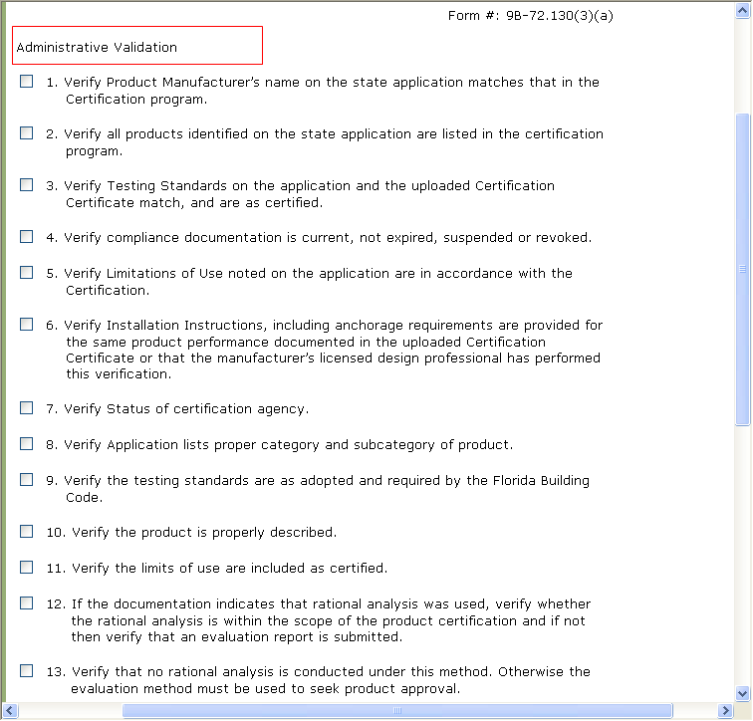
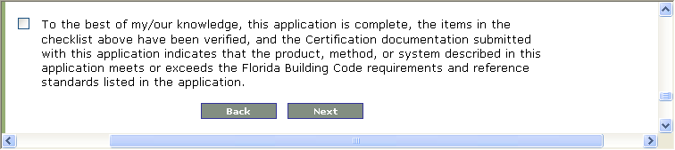

Technical Validation Checklist, Certification Mark or Listing Method
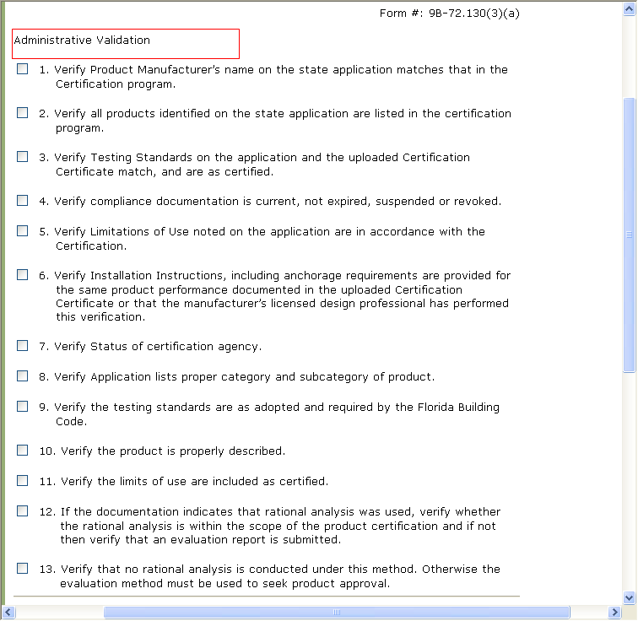
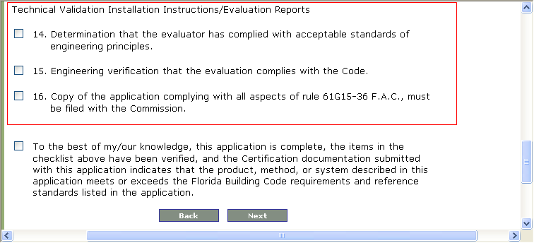

Administrative Validation Checklist, Evaluation Report from a Florida Registered
Architect or a Licensed Florida Professional Engineer Method
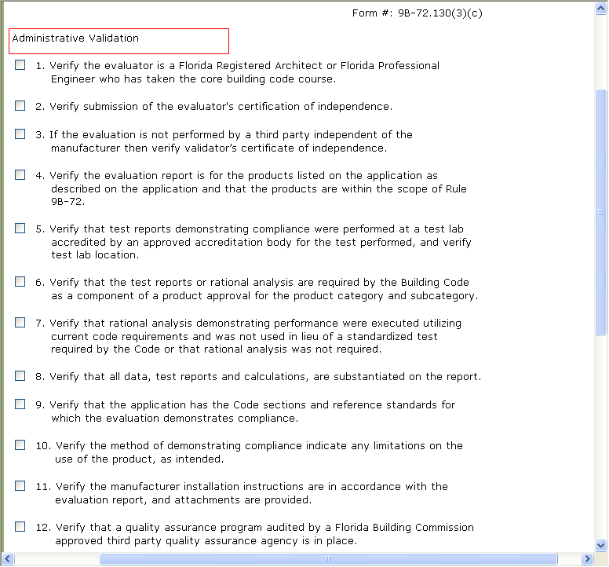
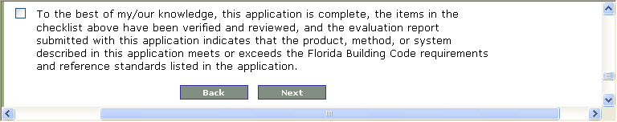

Architect or a Licensed Florida Professional Engineer Method technical validation
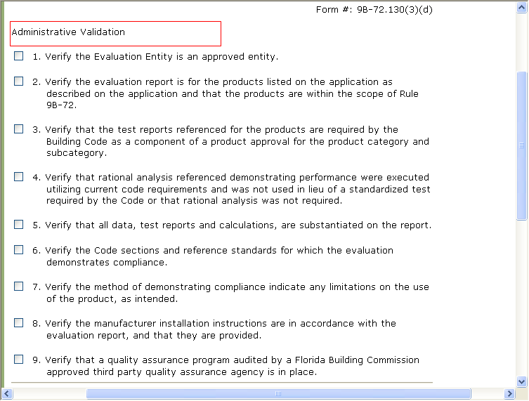
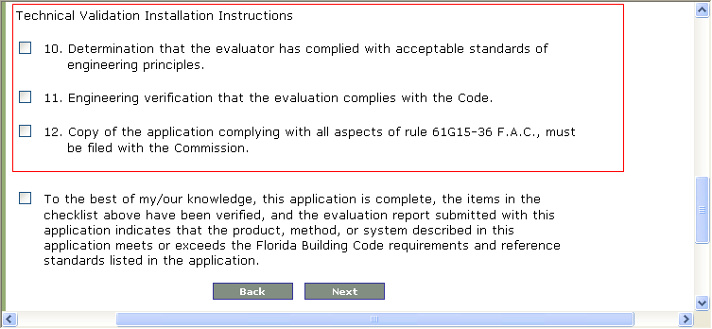

Technical Validation Checklist, Test Report Method
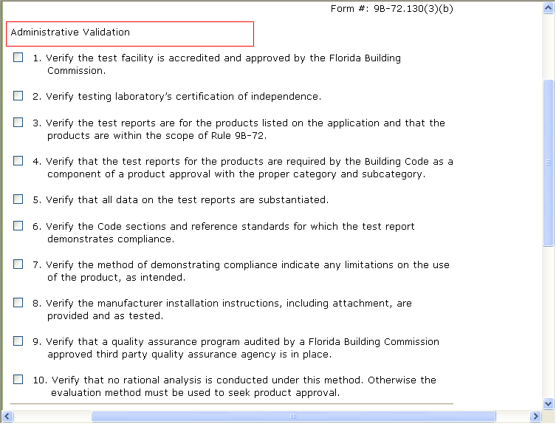
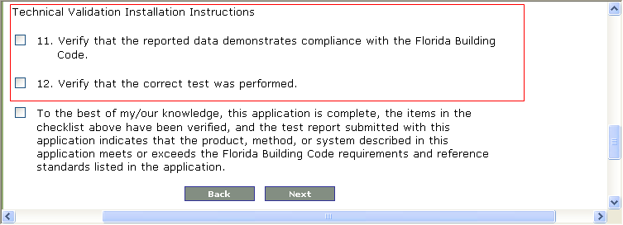

ATTACHMENT D - REVIEW PROCESS / DEADLINES
Commission Meeting Date | Deadlines
December  January | 30th – Midnight Preliminary Review  4th – Midnight Completion Deadline  11th – Report Posted for Public Comment  18th – Noon Deadline for Public Comments mailed to the Administrator  25th – Final Report Posted
February 1, 2, 3 | Commission Meeting
March | 3rd – Midnight – Preliminary Review  8th – Midnight Completion Deadline  15th – Report Posted for Public Comment  22nd – Noon Deadline for Public Comments mailed to the Administrator  29th – Final Report Posted
April 5, 6, 7 | Commission Meeting
May | 5th – Midnight – Preliminary Review  10th - Midnight Completion Deadline  17th – Report Posted for Public Comment  24th – Noon Deadline for Public Comments Mailed to the Administrator  31st – Final Report Posted
June 7, 8, 9 | Commission Meeting
July  August | 7th – Midnight Preliminary Review  12th – Midnight Completion Deadline  19th – Report Posted for Public Comment  26th – Noon Deadline for Public Comments Mailed to the Administrator  2nd – Final Report Posted
August 9, 10, 11 | Commission Meeting
September  October | 8th – Midnight Preliminary Review  13th – Midnight Completion Deadline  20th – Report Posted for Public Comment  27th – Noon Deadline for Public Comments Mailed to the Administrator  4th – Final Report Posted
October 11, 12, 13 | Commission Meeting
November | 3rd – Midnight Preliminary Review  8th – Midnight Completion Deadline  15th – Report Posted for Public Comment  22nd – Noon Deadline for Public Comments Mailed to the Administrator  29th – Final Report Posted
December 6, 7, 8 | Commission Meeting

Application Deadline Dates
1 Completion Deadline - Four weeks prior to Commission meeting. Product Approval applications must be submitted, validated, and reviewed by the Administrator and re-validated if needed by this deadline date. NOTE: To allow time for preliminary review by the Administrator, you should submit your application five days in advance of the deadline. However, there should be no reasonable expectation that the application will be placed on the consent agenda with an approval recommendation, by simply meeting this time suggestion. Recommendation for approval by the Administrator must be completed within seven days after the deadline. Under this system no specific validation deadline is set. There will be no more Administrator recommendations for Conditional Approval or Deferral. However, an application may receive a Product Approval Program Oversight Committee/Florida Building Commission recommendation other than “Approved” at the meeting.
This process will allow for greater application review and discussion time. If an applicant does not respond and any deficiencies are not rectified, the application will be incomplete and will not be considered at this meeting. Incomplete applications can be eligible for consideration at the subsequent meeting if completed.
2 Public comment report – Three weeks prior to meeting date, 7 days after Completion Deadline, public comments will be solicited on all applications recommended for approval by the administrator. All public comments and concerns must be written clearly and substantiated using technical documentation (i.e. Building Code sections, compliance reports, standards, etc.). Comments must be emailed to the Product Approval Administrator by the public comment deadline to be considered by the Administrator. The administrator's initial recommendations for approval are subject to change based on public comments. Final recommendations and responses will be posted on the website one week prior to the Commission meeting.
3 Public comment deadline – Eight days after initial report is posted, 7 days prior to meeting.
4 Final Report Posted – 1 week prior to the meeting the Administrator posts final recommendations for approval along with a response to the public comments.

ATTACHMENT 10 - EVALUATION SCORECARD

Evaluation Scorecard

Maximum Raw Score Possible | Weight Factor | Maximum Weighed Score | Maximum Raw Score
A. Qualifications/Performance/References (Maximum 50 Points)

1. Qualifications and Experience (15 Points)

(Up to 5 points for each bulleted item)

- A copy of an active licensed pursuant to Chapter 468, 471 or 481 (Part I), Florida Statutes.

- Documentation of work experience (minimum of 5-years) in the structural provisions of the Florida Building Code; or

- Documentation of work experience (minimum of 5-years) in building code enforcement; or

- Documentation of work experience (minimum of 5-years) in building code product approval or the State Product Approval System.

- A listing of all service personnel Respondent proposes to use to provide the services, including those who will be at the site, and their tenure in the field of building code. Please list each person’s duties and responsibilities.

2. Past Performance References (10 Points)

3. Current Contracts/Employment (5 Points)

4. Application review (20 Points)
(Up to 5 points for each bulleted item)

Certification method (see Section 1.04):
- Rule compliance
- Code compliance
- Cross check support documentation for application consistency

Evaluation method by an evaluation entity (see Section 1.04):

- Rule compliance
- Code compliance
- Cross check support documentation for application consistency

Evaluation method by an engineer or architect (see Section 1.04):

- Rule compliance
- Code compliance
- Cross check support documentation for application consistency

Test report method (see Section 1.04):

- Rule compliance
- Code compliance
- Cross check support documentation for application consistency

B. Scope of Work (Maximum 30 Points):

(Up to 6 points for each bulleted item)

- Detailed narrative of Work Plan
- Man-hour estimates of effort for each deliverable
- Projected Management & control mechanisms and adaptability to changes in Work Plan, Schedule & Staffing
- Technical Understanding
- Milestone Chart/Timeline

C. Price (Maximum 20 Points)

ATTACHMENT 11 - VENDOR QUESTIONS

(Intentionally Left Blank)

ATTACHMENT 12 - SUBCONTRACTING

The Respondent shall complete the information below on all subcontractors that shall provide services to the Respondent to meet the requirements of the resultant contract, should the Respondent be awarded. Submission of this form does not indicate the Department’s approval (see Section 2.18), but provides the Department with information on proposed subcontractors for review.

Please complete a separate sheet for each subcontractor.

Service:
Company Name:
Contact:
Address:
Telephone:
Fax:
Current Registered as Certified Minority Business Enterprise (CMBE); Women-Owned Business (WBE); or Disabled Veteran Owned-Business? | Yes ________ No ___________
Occupational License No:
W-9 verification: | Yes ________ No ___________

In a job description format, describe below the responsibilities and duties of the subcontractor based on the technical specifications or scope of services outlined in this solicitation.

